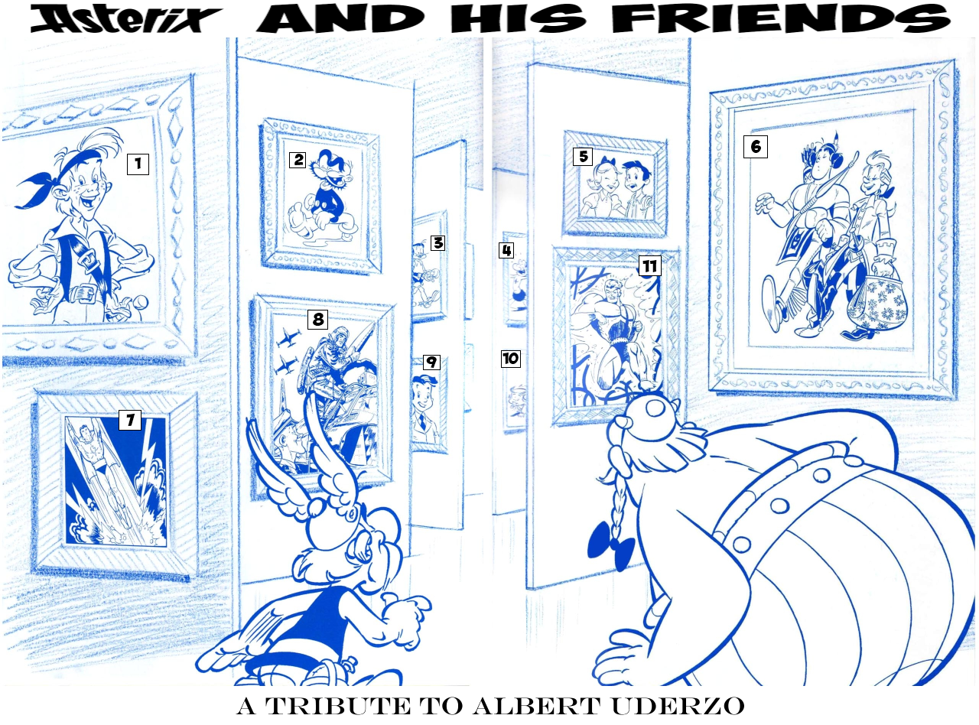
1 Jehan Pistolet
2 Clopinard
3 Flamberge
4 Zartan, the Macaque-Man
5 Benjamin & Benjamine
6 Ompa-Pa & Brother Two-Scalps
7 Captain Marvel Jr.
8 Tanguy & Laverdure
9 Luc Junior
10 Poisson & Poissonif
11 Belloy The Invulnerable
Rosinski & Van Hamme
The title comes from the lyrics of an old vaudeville song “Hello! Ma Baby”
Walthéry
Page 1, panel 6: Legrain’s dialogue comes from Airplane!, one of the best comedies of the latter half of the 20th Century.
Page 2, panel 3: Walter is unintentionally making a reference to Parc Asterix, France’s #1 theme park (I’m told there’s some other place, based on a couple of American characters, of all things… I don’t think it’ll last very long!)
Page 2, panels 5-7: Quick, Big Boy and Wimpy are all fast food chains, originating from France, USA and Great Britain respectively.
Laudec & Cauvin
Page 1, panel 5: The Citroen 2 CV is a famous car.
Page 2, panel 1: Gauls did not believe in an afterlife like most other classical civilisations.
Panel 2: Little Nicholas, Lucky Luke, Flamberge, Tanguy & Laverdure, Arys Buck and Ompa-Pa are all series Uderzo helped create.
Achdé & Gerra
Page 1, panel 3: The Musée du quai Branly, or MQB, is renowned for showing ancient art & sculpture from indigenous people from Asia, Africa and the Americas.
Panel 4: The two Native American names are derived from the characters Ompa-Pa from the book of the same name, Haroun El Plassid from Iznogoud, and Tanguy & Laverdure from the series of the same name.
Page 2, panels 1-2: Ompa-Pa can be seen in Goldfinger’s sketchbook, and as one of the “Thracians”.
Panel 7: Iz-Kwyait-Gud is a pun on Iznogoud.
Brösel
Page 1, panel 2: La Dolce Vita means “The sweet life”, and is the name of what is considered by many to be one of the best pieces of world cinema.
Page 2, panel 1: Flavio Briatore is a famous Italian businessman who's involved with Formula 1. "Pola positio" is a latinized version of "pole position". Ross Brawn is an English motorsport engineer and Formula One team principal. He's been involved with Ferrari. That's why his cart says "Scuderia Enzus Ferrarus", a reference to the "Scuderia Enzo Ferrari", the racing team division of the Ferrari. Bernie Ecclestone is president and CEO of Formula One Management and Formula One Administration.
Page 3, panel 3: Caesar’s dialogue translates to “Nuts to the rules, I’m Emperor of Rome!”
Page 4, panel 7: Enzo Ferrari was the founder of Ferrari S.p.A.
Panel 9-10: “Maseratus” is likely one of the Maseratis. The “activate the turbo” slapstick is derived from an episode of Wacky Races.
Jidehém
The title is derived from lyrics of the song “Monster Mash”
Page 1, panel 3: Spirou is one of French comicdom’s greatest heroes, almost as old as Tintin.
Dany
The title is derived from the lyrics to “Rainbow Connection”
Page 1, panel 8: This is a reference to “Back to Life (However Do You Want Me)” by Soul II Soul.
Cuzor
Page 3, panel 8: In France, the phrase “fell into it when […] were a baby” has become a way saying that somebody has had an interest in something since childhood, a phrase that is inspired entirely by the Asterix books.
Immonen
Page 1, panel 6: The rabbit is unintentionally predating Marie Antoinette by a couple of centuries!
Page 2, panels 1-4: “Crazy Horses” by The Osmonds. It’s a good song, you should listen to it.
Vicar
Page 1, panel 5: Asterix is unintentionally invoking the “Duck Test”.
Page 2, panel 2: Donald is unintentionally referencing his own theme song.
Page 2, panel 10: The nephews are unintentionally referencing the Spongebob Squarepants episode “Mermaid Man & Barnacle Boy IV”.
Graton
The title translates to “Don’t you stop! Don’t you turn around now!”, which was the first lyric of the Michel Vaillant cartoon, or “Heroes on Hot Wheels™”, as it was known in US syndication.
Deribe
Page 3, panel 9: What it’s supposed to be, Asterix, is a Ford Taurus rally car… or at least, a reasonable stone facsimile of one.
Batem
Panel 12: The “so anything goes!” refers to the end of The 12 Tasks of Asterix.
Forges
Page 1, panel 11: “Iter Faceret” translated to “My Journey”, the name of the memoirs of another beloved European politician…
Kuijpers
The title comes from a lyric from “The Lookout Is Out”, by Cook da Books…
Tarquin & Arleston
… as is this story’s title!
Panel 1: A song about a bird and a child was received far more favourably… at the 1977 Eurovision Song Contest!
Legere Mecum translates to “Read Me”.

