I think I'm done with being interviewed by women.

I am disgusted.
Jameela Jamil
Jun 20, 2025
Specifically in print. Where I speak freely, and they can liberally pepper or smother the piece with their assumptions, interpretations, insecurities and projections. I’m fine to be interviewed live, or on video where my lawyer can stipulate that I cannot be edited out of context, or to do written interviews, where my words are used verbatim. I love being interviewed by women, I love the experience and 90 percent of the media I consume is made by women. But my trust has been broken for the last time. With a special thanks to a toothy opinion piece by Liz Edwards, who is normally the travel writer at the Sunday Times. The unexpected straw that broke the camel’s back.
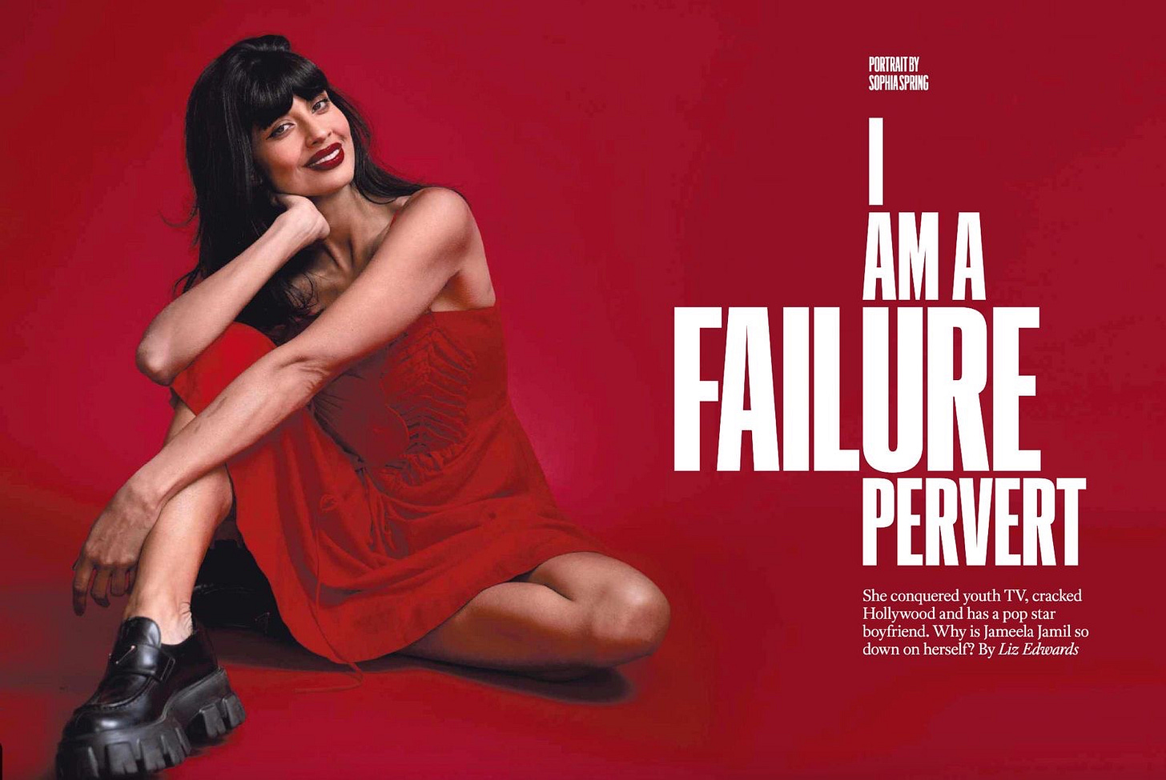
I’ve been interviewed for 17 years in print. By hundreds of women. Out of them all I can name four who portrayed me with a fair shot (isn’t that insane?), and in my true words and tone: Jessica Barrett. Ashley C Ford. Deborah Joseph and Helen Bownass. None of whom skirted away from my faults, but they were all women who dared to offer me the benefit of the doubt, and the opportunity to grow. They were more interested in what they were putting out into the world, rather than whether I was worthy of conveying the message.
Share
The others turned up with a preconceived idea of who I was, having never met me, or even known anyone who knows me. An agenda. An angle. Not one that was almost ever designed to actually uplift the audience, but to instead tear down or embarrass the woman trying and hoping to uplift the audience. They want to interview me about feminism they say, but they rarely explore my actual thoughts and ideas about our collective experience, but more seek to interrogate my character, why I have a right to speak when I have privilege, why I care, hyper fixate on my fairly innocuous mistakes compared to most men in my industry, and force me to justify why anyone should take me seriously. WHAT IS MY MOTIVE? I am a woman, I must have a motive. I can’t possibly want to just make the world a little more even keeled for the marginalized.
Even if the words I speak are about systems, and the statistics I use are objective truths, for some reason, you have to buy into me, the person, the vessel of delivery, to pay attention to the cause I’m signaling to you.
Almost every print write-up from a woman, is laced with eye rolls, raised eyebrows, and insidious digs at my character. They will acknowledge my career success, and talk about how much money I have or how nice I look… but rarely the (frankly prominent) positive impact of my advocacy for women and children, as reported to me by literally hundreds of women a month for the past decade. I was named by Time Magazine as one of the 25 most influential people on the internet for my advocacy, and was named by Harvard Striped as more effective than the FDA at raising awareness about the dangers of diet/detox products. But that doesn’t matter. They’re only intent upon finding my hypocrisies, contradictions, and ugliness. They seek to embarrass me for having opened my mouth at all. They don’t scrutinize the systems I expose, they only scrutinize me. Which would be perhaps a little more understandable if I was always talking all about how fantastic I am, and selling myself as a commodity to model yourself upon. But I don’t do that. I always call myself a feminist-in-progress and use my (typically self deprecating, very British) interviews to try to spotlight systemic issues women are facing. Like agism, sexism, men’s violence, abortion rights, fat phobia, medical discrimination, media manipulation (the irony) and women daring to take their time to live a life on their own path, encouraging women to survive mistakes and flaws, and dare to carry on. The only times I speak about myself is when I’m being asked to explain or defend my right to speak. I would far rather use the time to talk about things that matter far more, than making myself palatable to the reader.
BECAUSE YOU SHOULDN’T HAVE TO FUCKING LIKE OR EVEN TRUST A WOMAN TO DIGEST THE SYSTEMIC TRUTHS OR OBJECTIVE STATISTICAL FACTS THAT YOU CAN LOOK UP YOURSELF ONLINE, THAT SHE IS WARNING PEOPLE ABOUT. I could be a fucking murderer and what I say about society would still be true. It doesn’t matter who I am, what I look like, or how I behave.
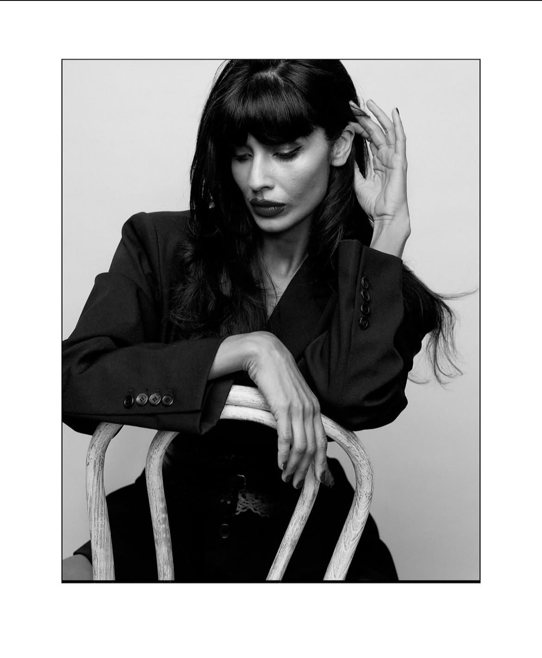
I don’t give a shit about being liked by the reader. It’s a parasocial nonsense anyway. I’m just pointing out proven injustices against women.
It’s not What is she talking about? It’s always WHY is she talking?
How fucking weird that we need the messengers to be perfect. It’s by design. The male owned media is funded by the very male owned companies that prey upon women via these systems that I call out. What a perfect way to ensure the message is rarely received. What a destructive waste of time and energy. What a backstep in progress. What a patriarchal masterpiece. Deflect, distract, dismantle. Carried out to perfection by spineless women who have survived male owned media landscapes by doing the dirty work of what we shall call Miss-ogyny. Double agents for the patriarchy I call them. Wolves in sheep’s clothing. Women consciously or subconsciously dissuading other women from stepping out of line an inch.

Subscribe

I hate to say it, but male journalists have always given me a fair shot. Possibly out of fear, because we can spot misogyny faster when it comes from a man. We are hyper vigilant for it. When a woman does it, it has to be executed with undeniable, crass vitriol for us to identify a “hit piece.” Men do seem at large more interested in actually exploring and challenging my ideas, rather than demanding my credibility to have ideas in the first place.
Most women, especially white women, when interviewing women of colour, are well aware that two accusations shall fall at their feet if they offer a blatantly uncharitable piece, so their attack is more restrained, insidious, and passive aggressive. Laced with plausible deniability, and just enough strained compliments, to be accepted as unbiased by anyone lacking media literacy.
The Sunday Times piece last week was a perfect example of this. The interview experience was lovely. She did a good job at making me feel safe and seen. I always presume a woman my age or older, will be experienced and incensed enough to see the bigger picture of having a bold subject with a big platform, willing to talk about something meatier than her fitness regime, love life, or media training laden platitudes. I imagine that she will imagine the reader, and what they can take away from it that may embolden or empower them. I imagine she will want her writing effort to be used for impact. I’ve been interviewing people for 17 years. All I ever want is something that will make the audience feel stronger, less alone, or reflective. I have hard conversations, and don’t paint my subjects as saints, I argue with them at times, or take the chat to inconvenient truths… but ultimately, hope, redemption and humanity is at the core of my agenda. That’s why 6 months after *I ended* my last podcast I Weigh With Jameela Jamil, A MINIMUM OF 40,000 PEOPLE A MONTH STILL DOWNLOAD OLD EPISODES to this day. (Yes I am flexing.)
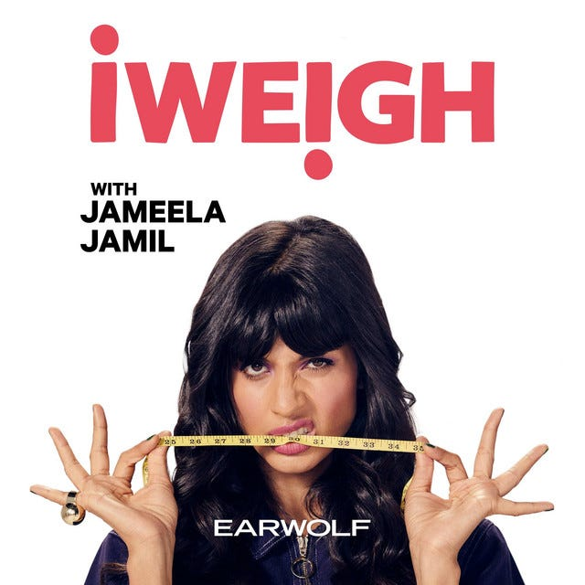
She threw away the majority of an hour of thoughtful words about grief, misogygny, beauty standards, ageism, defiance etc. I recorded it myself, openly, to signal to her that I want a record kept of my actual words, because I’m so used to journalists twisting them. So I was able to listen to it back today, (I can publish it here if she gives me her permission) and heard every word that was thrown on the cutting floor in favor of almost the first HALF of the piece being about things I have not done perfectly. very few of which even came up in the interview. She just googled me. Documenting my entire life, almost 4 DECADES of chronic health issues (Which we didn’t discuss) in one GIANT crammed list, disguised as a paragraph, which makes me look fucking crazy, to anyone who doesn’t suffer from chronic illness. Even dipping into unfounded internet rumors about me. It was like reading the gossip section of my wikipedia page. It read like a cheap, bitchy, Daily Mail blog, written by a student desperate to get clicks to keep their job. She covered old ground I’d already addressed so many times in the past. It was such tired, inelegant writing. She compressed 17 years of the natural hairy ebbs and flows that come with being a scrappy, open, outspoken woman, in an intolerant climate, into the opening SIX paragraphs, with no aim at balance. No mention of the many things I got right, the people I helped, the causes I got all the way to Parliament and Congress, the progress I made with social media platform regulations. It was only my mistakes, indignities, or a rehashing of painful attacks by a deeply sexist and dishonest media.
Share
At one point in the interview, I politely decline to comment on an old ridiculous rumor about me, saying I don’t oxygenate those things, and that we should discourage foolishness in the media. She documents that and then writes:

“The claws retract and congeniality resumes as we chat over the array of tapas that arrives.”

My courteous and restrained boundary setting is described by ANOTHER WOMAN as my fucking “claws” being out. How disgusting/degrading/old fashioned/cliche and typical of a 1980s misogynist. She writes that, even though my appalled team try to end the interview at this point, and I (foolishly) interject in defense of her and give her a further 10 minutes.
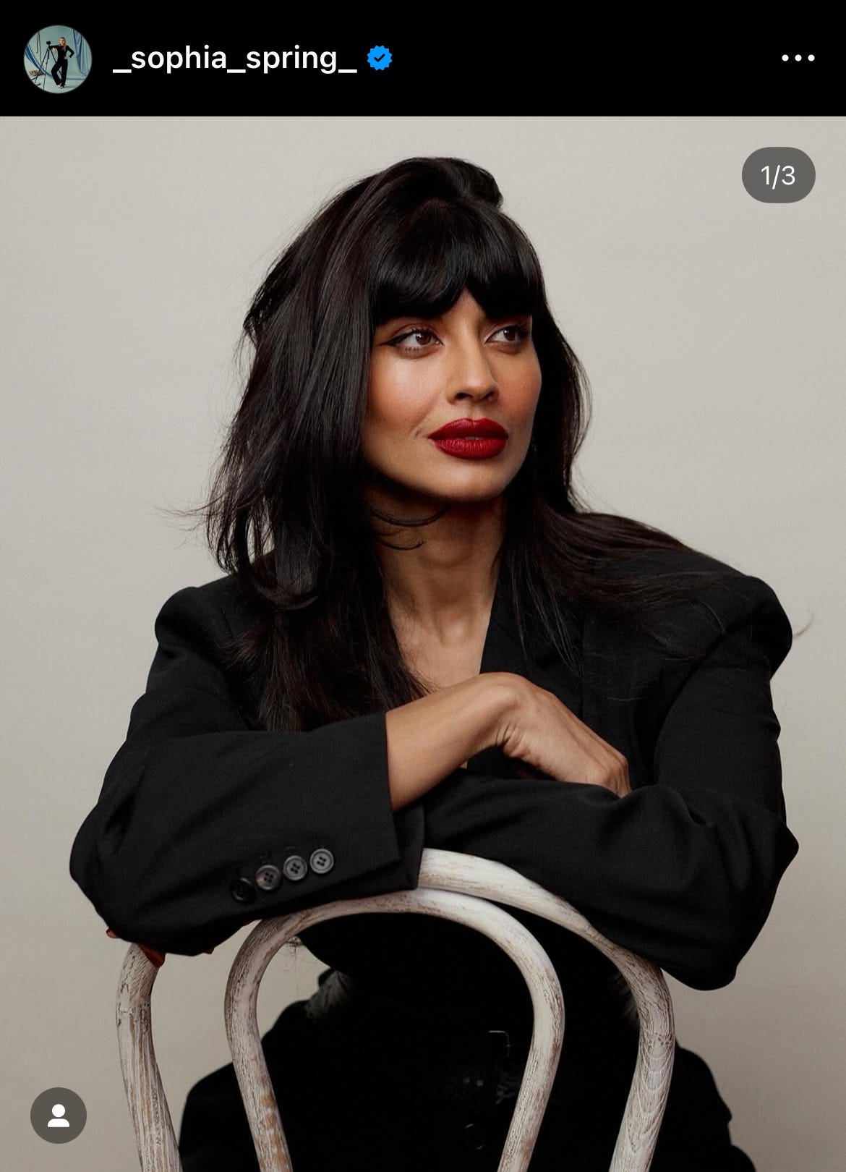
She did patronizingly mention how nice I was to the waiter, and photographer, as if that should be a commendable action, for someone like me. She also threw in how much money my house cost. (Why?) And mentioned all the starry things I do in my glittery career and fabulous “LA life.” She took some soundbites out of context about how I have learned to become such a liberated woman… where I explain that I don’t like most people so I don’t expect them to like me… which said isolated without explanation, sounds callous and toothy, unfriendly and entitled.
AND THEN SHE DID THE AGE OLD TRICK OF BRINGING UP MEGHAN MARKLE. A trick every right wing publication does to immediately drag me into their obsessive hatred of her. I immediately shut it down and told her that I am not close to Meghan, I barely know her beyond meeting a few times, and I explain that my defense of her when the media piled onto her during her pregnancy, was not motivated by friendship, as I had never met her back then, I was just standing up for a woman being openly attacked, as I do for many other women. I was short, clipped and definitive. I covered it in maybe 90 seconds. And yet of fucking course, the piece is addressed as if I have spoken willingly about Meghan and she is the headline.
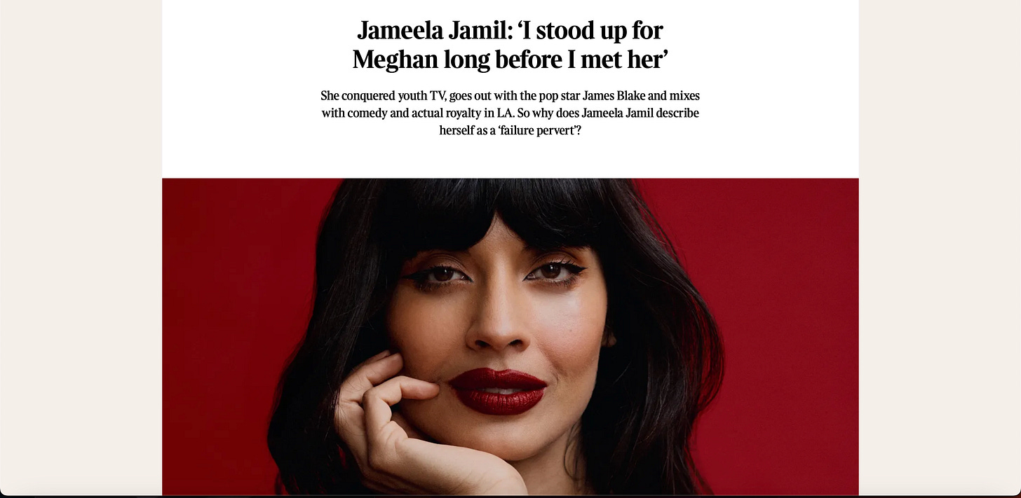
I Never bring her up. I don’t have her number. I am not in her life. She is not in mine. We were just two women who were nice to each other a few times when other people were being cruel. It shows you how the media obsession with her lives on. It’s creepy.
And just FYI I ran this past many people before writing about it, to make sure I wasn’t letting my ego run away with me. Everyone unanimously, including people who work with the paper, said it was an unkind, unnecessary piece, and mostly a waste.
Now listen I want to be clear, that I think it’s fair to bring up interesting controversies I have had in the past. I often bring them up myself, willingly, as I think they are a helpful tool of hope, to show you how an arsehole/idiot/misogynist like me, can reform. I embrace all aspects of my journey and feel no shame about the past for I have redeemed myself. MY PROBLEM is that when you start a piece with 17 years worth of someone’s least flattering moments, to introduce them to the audience, you are tampering with audience emotions.
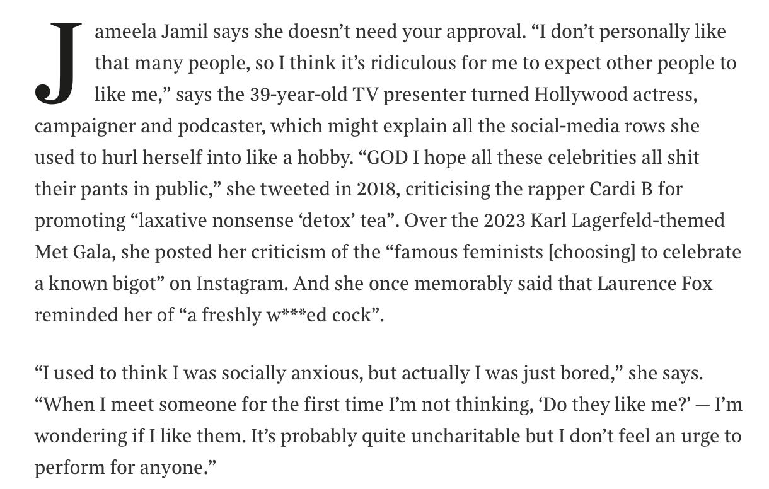
Nobody ever introduces someone at a party, leading with their life’s historical insufficiencies. Because that would be seen as manipulative and malignant.
As an interviewer I start with where someone is at now, how they arrived there, including the hairy moments, and then I end on what positive thing they have recycled that into that will nourish or help my audience.
I don’t just try to embarrass them, and guide the audience to start thinking of them as insufferable and then try to flimsily pull them back in with strategically unrelatable throw away lines and quips.
Because then I don’t impact hundreds of thousands of people. I just impact one. The subject. I humiliate them. I make them want to be smaller and quieter. I make them want to stop using their voice in a way few women in the public eye for fear of this exact outcome. And I pour more of the corrosive animosity that is destroying this world into our environment. For no reason. To no end that will make me proud of myself later.
We don’t interview men like this. We don’t seek to humble or embarrass them from the jump. We don’t open articles with paragraph upon paragraph of their controversies. Even if there are illegal/violent allegations made about them. We don’t force them to justify themselves when they are passionate about a cause. We just take them at their passionate word, and don’t seek a motive.
The story of Adam and Eve seeded in us a historical mistrust of women. It ascribed an agenda to woman kind, and denied men of agency. Painting women as manipulators, and obstacles. ADAM WAS A GROWN MAN WITH HAIR ON HIS BALLS WHO ATE THAT FUCKING APPLE. STOP EMASCULATING ADAM. DAMN.
We as a collective have got to stop normalizing this in our culture. Start looking out for it. Start reading men and women’s interviews side by side. Check the tone. Seek out the overarching message. Ask yourself how the piece made you feel about the subject.
Especially pay attention to the way the media writes about disobedient women. women who refuse to fall in line and shut their mouths. Women who take risks. Women who try, and fail, and try again. Women who don’t need to be validated.
The media say I’m too rich to speak on injustice and austerity, that I’m too thin to talk about fat phobia, I’m not sick enough to speak on ableism, I’m too attractive to speak on oppressive beauty standards, I don’t have enough wrinkles to speak on ageism…
That same media, IF they platform them at all, paint people demonstrably from those groups, as bitter, jealous, lazy, ignorant and a drain on society. They use such accusations to dismiss their words.
So who is left to speak?
It’s all a ploy to make sure the conversations barely happen. And if they do, the messenger is normally hung, drawn and quartered, every time they dare open their mouth, especially if they have a resonant voice that carries.
Almost 7 million people follow me online across social media platforms. I am a threat to the media. I will never be quiet. I will never stop trying to uplift women. I will never shut up about injustice. And I will die one day, knowing I left behind a legacy of love and hope.
Please God may I never find myself middle aged, dedicated to taking women trying to do something positive in the world, down a peg or two. I hope I’m still directing my energy towards progress, not taking the bins out for the patriarchy, for a paycheck and a pat on the head.
Share
I sometimes, more charitably wonder if female journalists hyper focus on my mistakes and flaws because they’re so constricted by their own, or fear of making some, that they can’t believe I dare still stand after breaking the rule of being perfect, liked, believed and approved of by everyone. They are perhaps offended that I have the nerve? What gives me the right to afford myself other chances they were promised didn’t exist? How did I find the map to the treasure chest of allowing myself time and space to grow up and figure out life. What makes me so special that I can just ignore the boxes women are forced into. How can I dress up and wear make up but also demand to be taken seriously? How can I jump into things I’m inexperienced for (the way men cleverly do.) Where did I find the reservation of the right to change my mind and behavior? Why do I care to deconstruct systems I benefit from with my privilege? Why am I not playing into the stereotype of the school bully or the bimbo? Why do I take the path of most resistance every time? Why do I have such A LOW DESIRE TO PLEASE?
I just wish they would join me, rather than try to drag me back down to where patriarchy put us.
We are not the sum of all of our mistakes. We are the sum of all of our parts. Even the ugly bits. They say bruised fruit makes the sweetest jam.
I am bruised, battered, ignorant, foolish, strong, supportive, smart, resilient and above all optimistic. I like that flavor. And maybe if the women who take hours of their time trying to hurt other women, liked their own spectrum of flavors more, they would make more exciting, and nourishing evergreen content.
Ugh. I hate it when my blood is spilled by other women.
I promise not all my pieces will be this navel gazing during a time of far more important things happening in the world. Things less and less people with big platforms talk about because of the way you get taken down for it. I’m just fucking sick of being encouraged to “never explain, never complain.” I think that’s the new toxic “Turn the other cheek” nonsense. Fuck the media, and the insipid bullies it deploys to force the resistance into submission. We need loud voices.
That’s why I came to Substack. The final boss against legacy media.

