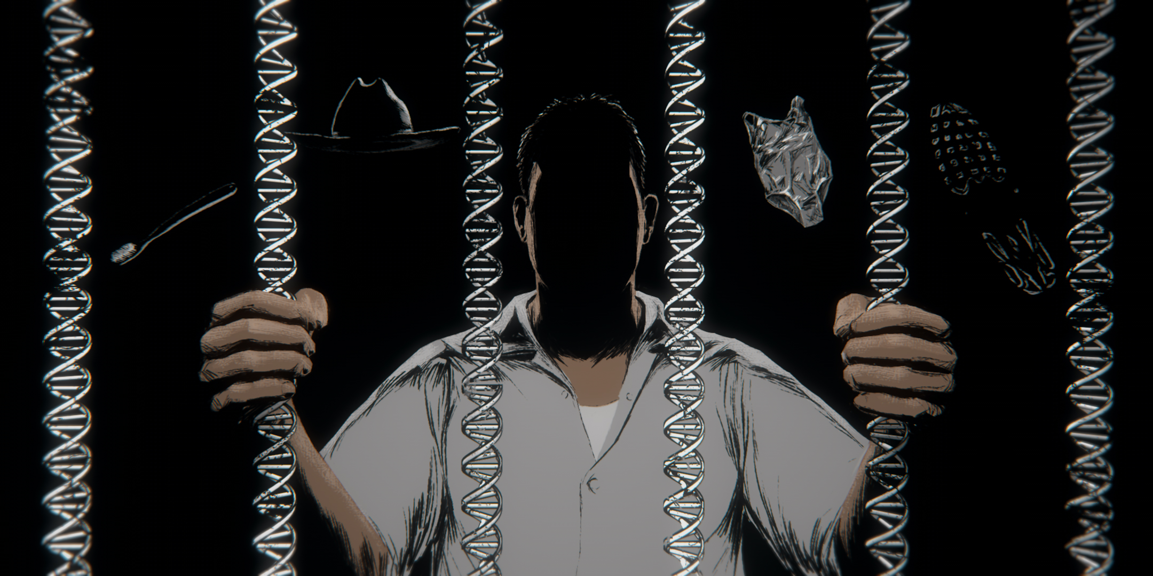

THE SECRETS DNA KEEPS

DNA Evidence Sent Anthony Sanchez to Death Row. But Did It Actually Solve the Crime?
BECOME
A MEMBER
Illustration: Clay Rodery for The Intercept

Liliana Segura
CHARLOTTE BEATTIE COULDN’T say when she began to suspect that her boyfriend had committed the murder that sent his own son to death row. It probably crossed her mind almost 20 years ago, when an Oklahoma City police detective showed up to ask about Anthony Sanchez, who had been charged with killing a young woman found at a nearby lake. Jewell “Juli” Busken, a 21-year-old ballet student at the University of Oklahoma, was raped and murdered just before Christmas in 1996. The case remained cold until 2004, when Sanchez’s DNA was linked to the crime. But when the homicide detective showed Beattie a forensic artist’s sketch of the supposed killer, it didn’t look like Sanchez, she recalled. It looked more like his father, Glen.
Like many who knew Sanchez, Beattie couldn’t believe he’d committed such a horrible crime. She’d never known him to be violent — not like Glen, who could be terrifying. One Valentine’s Day, she said, Glen put a gun to his head at his home in Norman, Oklahoma, only to swing it around and put a bullet in the wall. Other times she saw Glen put a gun to Sanchez’s head. Although she said he never hit her — she threatened to stab him the one time he tried — Glen inflicted “mental abuse.” He was especially sadistic during sex, raping her repeatedly.
Still, it wasn’t until many years after Sanchez was sentenced to death that Glen started dropping hints that there was more to the story of his son’s case. On Friday nights, they would drink in a shed behind Beattie’s house, where Glen had put a warning sign: “WHAT HAPPENS IN THE MAN CAVE STAYS IN THE MAN CAVE.” It was there that Glen brought up Busken.
“He’d just all of a sudden start talking about her,” Beattie said. He said ugly things, calling her “the ballerina girl” or “that Busken bitch.” Perhaps most chilling, “He’d always say, ‘I should’ve done a better job at it.’” When Beattie asked Glen if he was saying what it sounded like, he deflected. She didn’t press him. But she came to call those nights “his confession time.”
Beattie always knew Glen had secrets. In the decades he came in and out of her life, he showed up when he needed a place to crash and refused to answer questions. He parked his black Trans Am behind her house so it wasn’t visible from the street. “Probably because he was running from something,” she said.
But in the spring of 2022, Glen was dying of cancer and spending his time on the couch in her home. Oklahoma was on the verge of setting a slew of execution dates, and Sanchez was likely to be among the men scheduled to die. One day Glen brought up the murder again. “He just made it sound like he was there,” Beattie said. He said his son didn’t know how to tie the knots that had bound Busken’s wrists. And he repeated something he often said: that he never could have survived prison like Sanchez. “‘He’s a bigger man than I am,” Glen said.
On April 24, 2022, Beattie was in her bedroom talking on the phone. The 10 o’clock news had just come on when she heard a gunshot. She ran outside to find Glen dead on her front porch. Beattie was still processing his suicide months later. “You sit here and wonder: Did you really want to die because you don’t want the truth out there? Are you making your son pay for what you did?”

Join Our Newsletter

Original reporting. Fearless journalism. Delivered to you.
I'm in
Beattie told her story on an icy morning in late January, at her home outside Oklahoma City. Her adult son Charles played “Assassin’s Creed” in the living room. Charles had negative memories of Glen from childhood. “Whenever I knew that he was coming back, I had bad dreams,” he recalled.
Beattie first shared her account with Sanchez’s death row spiritual adviser, who persuaded Sanchez’s attorneys to look into it. Although the lawyers, Mark Barrett and Randall Coyne, had sought funds to hire an investigator before filing Sanchez’s federal habeas petition in 2011, their motion was denied. In an unusual arrangement, they agreed to use money raised by the abolitionist group Death Penalty Action. Last December, a private investigator named David Ballard came to Beattie’s home and took a statement. He also collected personal items belonging to Glen, including a cowboy hat and a toothbrush. They planned to test the items for DNA.
In February, Barrett and Coyne filed a state post-conviction petition with the Oklahoma Court of Criminal Appeals. It included an affidavit from Beattie recounting Glen’s “confessions” and explaining why she had never come forward before. “I was too scared of Glen while he was alive to even consider revealing what he admitted to doing,” it read. The attorneys asked for a hearing on the new evidence.
Three weeks later, Oklahoma Attorney General Gentner Drummond filed a response. The office had obtained a blood sample from Glen through the medical examiner’s office, which was analyzed by the Oklahoma State Bureau of Investigation. The DNA “does not match” the profile from the case, the bureau said. The results confirmed “what the state and the courts have already known for many years now,” Drummond wrote. Sanchez — and Sanchez alone — was responsible for murdering Busken.
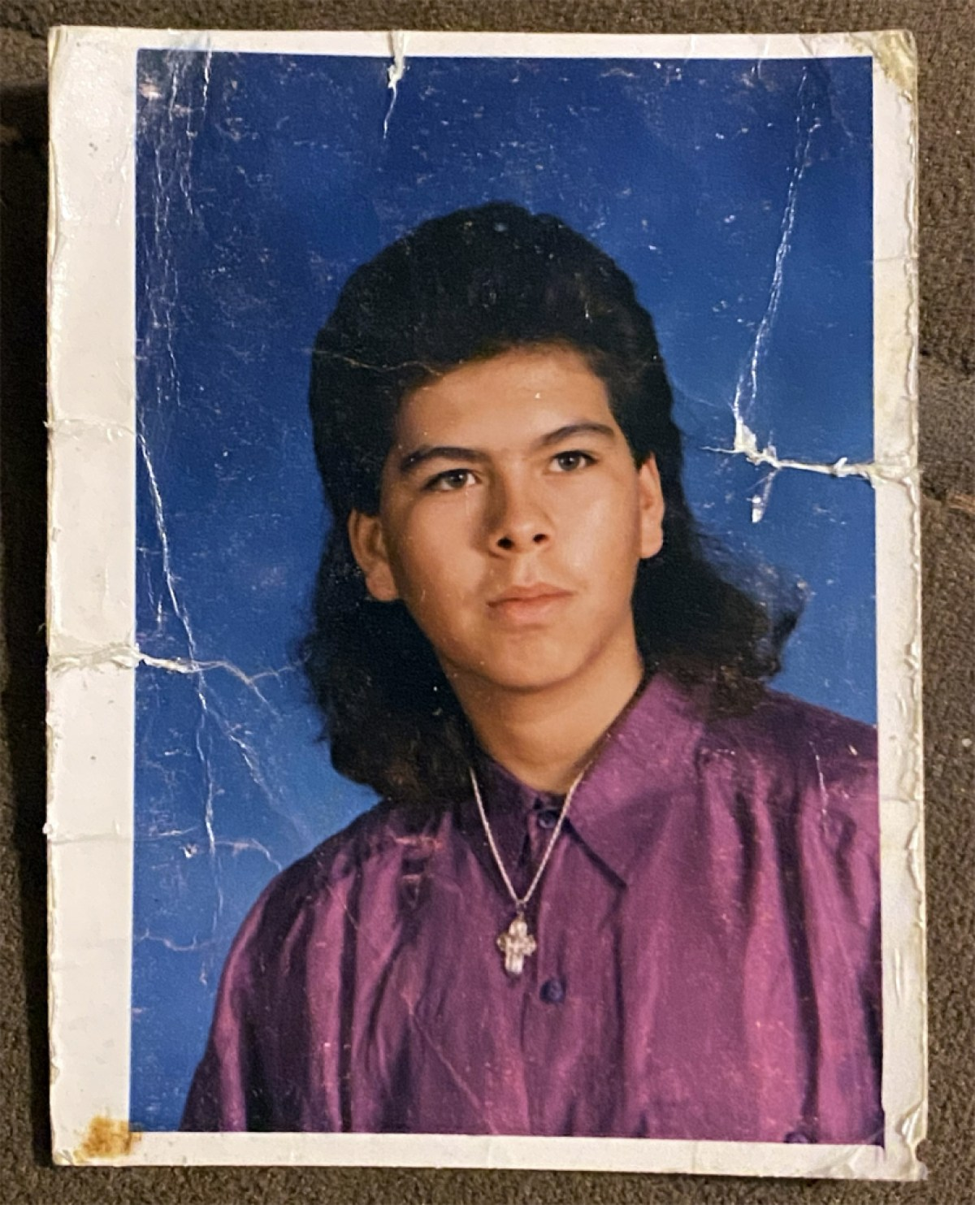
Anthony Sanchez in high school.

NOW 44, SANCHEZ is scheduled to die at the Oklahoma State Penitentiary in McAlester on September 21. He has insisted on his innocence for almost 20 years. His pleas have been dismissed by prosecutors, the courts, and, according to Sanchez, his own attorneys, who have never been able to overcome the incriminating DNA. Earlier this year, Sanchez asked a federal judge to replace Barrett and Coyne with an attorney introduced to him by his spiritual adviser, Jeff Hood. After his motion was denied, Sanchez waived his clemency hearing. A month later, Barrett and Coyne withdrew from the case.
The state of Oklahoma maintains that its evidence against Sanchez was overwhelming. Prosecutors say he abducted Busken from her Norman apartment complex early on the morning of December 20, 1996. He forced her into her car and drove to Lake Stanley Draper, where he raped her and shot her in the back of the head. The case hinged on two critical pieces of evidence: DNA taken from sperm found on Busken’s underwear as well as a leotard left at the scene.
Sanchez has long contended that the DNA evidence must have been planted or manipulated. He blames his court-appointed lawyers for failing to defend him at his 2006 trial and accuses Barrett and Coyne of abandoning him. The allegations have been amplified by Hood and Death Penalty Action, which launched a Free Anthony Sanchez campaign earlier this year. The activists insist that Glen Sanchez, not his son, killed Busken. Over the summer they placed billboards from Norman to McAlester urging people to watch a short film they produced called “Evidence Unraveled.”
In a state where 10 people have been exonerated from death row, the risk of executing someone for a crime they did not commit is real. “It is undeniable that innocent people have been sentenced to death in Oklahoma,” a bipartisan commission on capital punishment found in 2017. Poor lawyering, a lack of funding for capital defense, and overzealous prosecutors have contributed to wrongful convictions in the state. Particularly disturbing is the sordid history of misconduct within the Oklahoma City Police Department crime lab, where a forensic chemist named Joyce Gilchrist was fired for manipulating evidence — including in death penalty cases. Although Gilchrist was not the analyst in Anthony Sanchez’s case, she was a supervisor during the time that evidence from the case was examined and stored.
There are good reasons to question the forensic evidence behind any criminal case from that era. Yet some of the activists’ claims do not withstand scrutiny. “Evidence Unraveled” downplays and mischaracterizes the DNA. Ballard, the private investigator, now a vocal advocate for Sanchez, insists that the evidence was contaminated based on the fact that the DNA profiles for Busken and Sanchez, who were unrelated, shared alleles: the pairs of genes that appear on a specific location on a chromosome. Veteran DNA scientist Laura Schile, the forensic analyst who blew the whistle on Gilchrist’s misconduct more than 20 years ago, rejects this as egregiously misinformed. Ballard is not a DNA expert, she points out. “It takes a lot of years to understand DNA. And people share alleles with other people.”
Schile is one of dozens of people I interviewed while probing Sanchez’s case. A monthslong investigation and review of the available record — including trial and hearing transcripts, appellate briefs, and portions of the case file — left me with more questions than answers. But it also revealed significant problems that are all too familiar in Oklahoma death penalty cases. Sanchez, who is part Mexican and Choctaw, was convicted by an all-white jury, a fact his attorneys did not challenge at trial. No witnesses were called on Sanchez’s behalf at the guilt phase. And despite several mitigating factors that could have moved jurors to spare his life — Sanchez had just turned 18 at the time of the crime and grew up amid violence, abuse, and addiction — his trial team did little to develop such evidence.
“DNA is an investigative tool. It is not an investigation in and of itself.”
In Oklahoma, these problems have been eclipsed by the debate over Sanchez’s innocence and controversy over the Free Anthony Sanchez campaign. Local abolitionists have publicly disavowed Hood and Death Penalty Action for their incendiary rhetoric against the attorney general and lawyers appointed to represent people on death row. Barrett and Coyne have denied that they abandoned Sanchez. They accuse Hood of turning their former client against them and persuading him to forgo clemency. Sanchez has maintained that the decisions were his alone. He accuses his former attorneys of sabotaging his case by refusing to turn over his case files — a collection of more than 50 boxes. Last week, a federal judge reversed a previous order denying Sanchez the files but refused to stay the execution to give Sanchez’s new attorney time to review them.
With his execution imminent, unanswered questions still linger over Sanchez’s case. Among them is what role, if any, his father had in the crime. Sanchez’s trial lawyers either declined to be interviewed or could not be reached for comment. But documents in the case file show that his defense team suspected Glen was the real murderer — even if the DNA suggested Sanchez sexually assaulted Busken.
Indeed, even if the DNA implicates Sanchez, it is not at all clear what actually happened on the day Busken was killed. The rest of the state’s case was assembled from flimsy circumstantial evidence that did little to connect Sanchez to the murder. “Nothing else adds up besides the DNA,” Barrett told me. “I can’t believe that for so long the prosecution convinced the courts there was some meaningful corroborating evidence.”
“DNA is an investigative tool,” Schile said. “It is not an investigation in and of itself.” Even in a cold case, it is incumbent on prosecutors to close evidentiary holes that surround it. To forensic DNA expert Tiffany Roy, a death penalty case that relies solely on DNA is a red flag. “If it’s just the DNA, and that’s all you have, then it isn’t enough,” she said. If you can’t go back and put the DNA in context to ensure it is proof of the alleged crime, then it is certainly not enough to justify an execution. “The chances that you’re going to get it wrong, for me, the risk is just too high.”
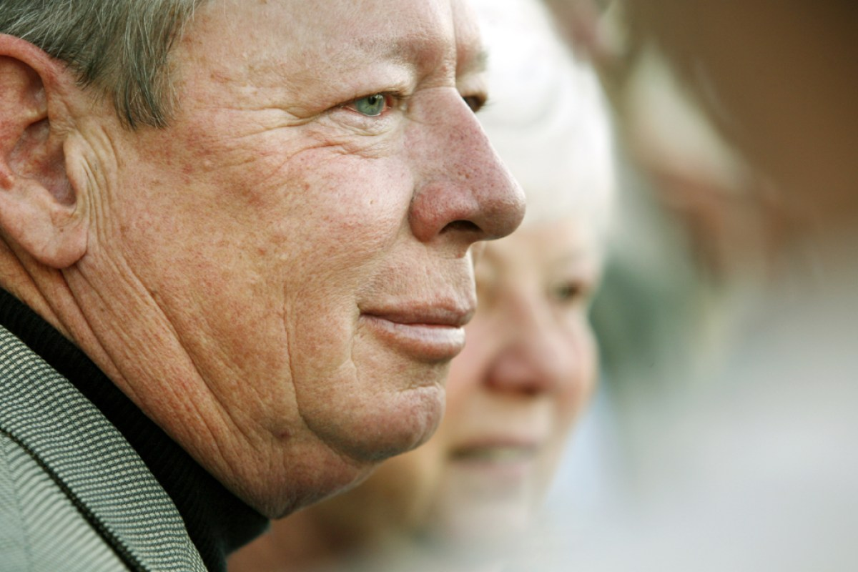
Bud and Mary Jean Busken react to the guilty verdict at Anthony Sanchez’s murder trial on Feb. 15, 2006.

JULI BUSKEN’S MURDER was any parent’s nightmare.
Five days before Christmas in 1996, Bud and Mary Jean Busken drove a U-Haul from Benton, Arkansas, to Norman to help their daughter pack up her apartment. Busken had studied ballet at the University of Oklahoma, most recently performing in “Swan Lake.” She finished a semester early and was accepted to the University of Arkansas for a graduate degree in elementary education. Busken planned to go home for the holidays, then return to Norman so she could walk across the graduation stage with her friends.
Busken lived in an apartment complex on East Lindsey Street, just east of campus. As her parents pulled up around 11:30 p.m., they expected to see her red 1991 Eagle Summit parked outside. But it wasn’t there. On the door of her apartment, Busken’s mother found a note that said to contact the University of Oklahoma Police Department.
At the station, the campus police chief told them Busken had been reported missing earlier that day. He also said there had been a body found at Lake Stanley Draper, a large recreation area 15 miles north of Norman. He asked the Buskens for a photo of their daughter, then stepped out of the room. When he returned, he broke the news. The body at the lake was Juli. She had died from a gunshot wound to the head.
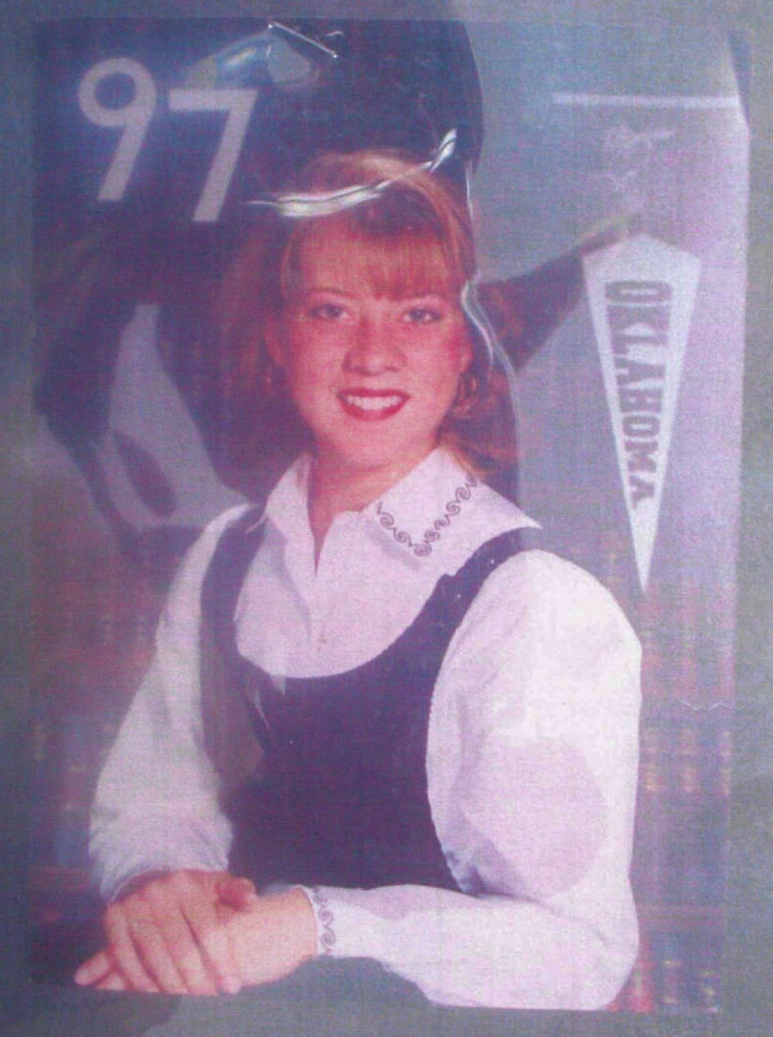
A photo of Jewell “Juli” Busken shown to jurors at Anthony Sanchez’s 2006 trial.

News of the murder shocked the college community. Some 300 people attended Busken’s funeral, and a scholarship was swiftly established in her name. Meanwhile, multiple law enforcement agencies began investigating the crime, including both the Oklahoma City and Norman police departments, along with members of the university police, the Oklahoma State Bureau of Investigation, and the FBI.
The overlapping efforts did not ensure all leads were followed. In the days after the murder, multiple tips to police were apparently missed, including calls from eyewitnesses who believed they saw Busken’s car on the morning she disappeared.
The last person to see Busken alive was her friend Megan Schreck, a fellow ballerina who spent the night with her on the eve of her death. Around 10 p.m., Schreck met Busken at a mutual friend’s apartment, where they exchanged Christmas gifts; Busken gave Schreck a pair of angel earrings. Busken planned to drive Schreck to the airport for an early flight the next morning, so the two decided to stay up all night, going out to eat around 2 a.m. They drove separate cars back to Schreck’s apartment, splitting up while Busken went to get gas.
Years after the case went cold, Schreck told a reporter that Busken seemed to take a long time filling up her car — and that she noticed a man’s name on Busken’s cellphone when she finally returned. For years Schreck wondered if this was important. When she was called as a witness at Sanchez’s trial, however, the name on the phone did not come up.
Instead, Schreck testified that Busken showed up with a cappuccino, then took a nap before heading to the airport before 5 a.m. “She drove me to the Delta check-in,” Shreck said. “She dropped me off and that was the last I saw of her.”
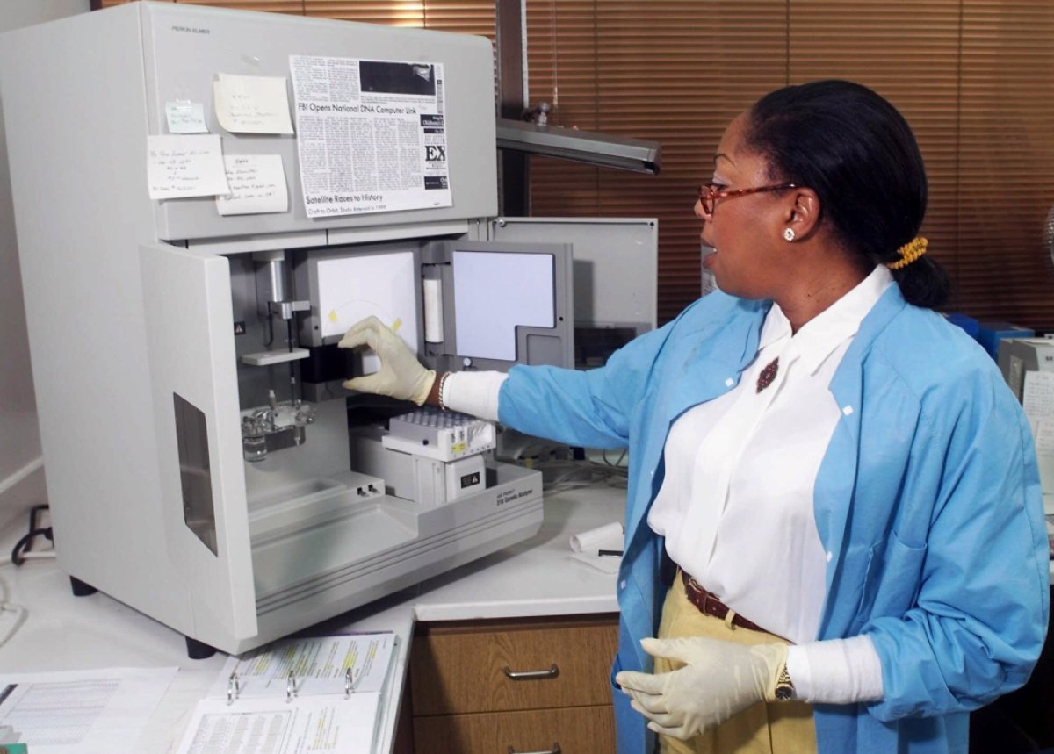
Forensic chemist Joyce Gilchrist working at the Oklahoma City Police Department crime lab in 1999.

WHEN A VIOLENT crime took place in Oklahoma County or its surroundings in 1996, the evidence went to the Oklahoma City Police Department crime lab. The lab had attracted good press over the years for its crop of forensic analysts — the “detectives behind the detectives,” as The Oklahoman put it. The year before Busken’s murder, the newspaper ran a flattering story about forensic analyst Joyce Gilchrist and two of her colleagues. “Criminals beware!” it read. “It’s getting harder and harder to go undetected.”
At the time, Gilchrist was in charge of opening the lab’s new DNA section. “We’ll be able to extract DNA from the root of one hair or a very small sample of semen or blood and establish a profile,” she told The Oklahoman. “It wouldn’t be an exaggeration to say that a single drop of blood will give us all the information we need.”
At first glance, there was plenty of potential forensic evidence in Busken’s case. Her unlocked car had been found at an apartment complex a block away from hers. There was reddish sand on the floorboard of the driver’s side. The car was messy, filled with papers, CDs, and a bunch of clothes, including pajama bottoms and multiple pairs of underwear. Half a dozen hairs were lifted from the car. Forty-nine latent fingerprints were found on the inside and outside.
At the autopsy, the medical examiner noted that Busken’s blue jeans were undone; her underwear was soiled and “slightly rolled down.” There was bruising on her thighs and labia and a small scrape on her anus. Her hands were bound behind her back “by a black shoestring ligature.” She had been shot at close range; a “significantly distorted” small caliber projectile was recovered from her skull. A ballistics analyst said it came from a .22.
Yet the murder weapon was never recovered. Neither were a number of key items: an opal ring belonging to Busken, as well as a radar detector, small stereo, and cellphone she kept in her car. Although phone records would provide critical clues — dozens of calls were made from the device following her murder — they did not lead to a suspect.
Evidence found at the lake was largely inconclusive. Shoe prints leading to the spot where Busken was found were not documented before the wind filled them with sand overnight, rendering them “useless,” as one evidence technician later testified. A discarded beer bottle and Coke can were examined for prints but yielded none.
Other items were disregarded, like a small purse found in some tall grass. It was red, with a square pattern that looked like a Native American design. “The sun kind of glimmered on it,” the sergeant who spotted it testified. “It was something that didn’t look like just some trash laying there.” The purse contained what appeared to be drug paraphernalia: a plastic-tipped cigar, two brass faucet screen aerators, and a pair of razor blades, along with a small jar of Carmex lip balm.
Authorities decided the purse had nothing to do with the case. But one item found a few feet away would prove vitally important: a crumpled pink dance leotard. It was marked with Busken’s initials, and according to a forensic analyst, it was stained with semen.
POLICE CALLS TO Lake Stanley Draper were not particularly rare. With 34 miles of shoreline, the lake made an attractive place for illicit activity, from illegal dumping and drug use to more serious crimes. In 1980, at least eight women were reported to have been raped on the north side of the lake by a man dubbed the “Draper Raper.”
Not long after Busken’s murder, there was another attack at the lake. On the night of December 29, 1996, an 18-year-old woman was assaulted by a man in a 7-Eleven parking lot nearby. He forced her inside his car at knifepoint, “struck her in the face,” according to a police report, and drove to Draper Lake. He told her to “cooperate and you won’t get hurt,” ordered her to pull down her pants, and sodomized her.
The man was described as 6 feet tall and 180 pounds, between 31 and 35 years old. He had a medium complexion, medium build, and brown “short, shoulder length” hair. The victim briefly got ahold of the knife, according to the report; after struggling over the weapon, she managed to flee to the nearest building and call the police.
It’s not clear how much police probed a connection between the rape and Busken’s murder. But there are indications they tried to find a link. According to a report obtained by The Intercept, a detective submitted underwear and a vaginal swab from the rape case for DNA testing at the Oklahoma State Bureau of Investigation, or OSBI, on the same day that he submitted a cutting from Buskin’s leotard.
An OSBI analyst later reported DNA results in both cases. From Busken’s leotard, a complete male profile was found. From the underwear in the rape case, there were only partial results.
The rape case was never solved. In a phone call, the victim told me no one ever spoke to her following her initial report to police. She did not learn the results of the rape kit or whether it yielded any DNA. “Nobody ever contacted me afterwards to follow up,” she said.
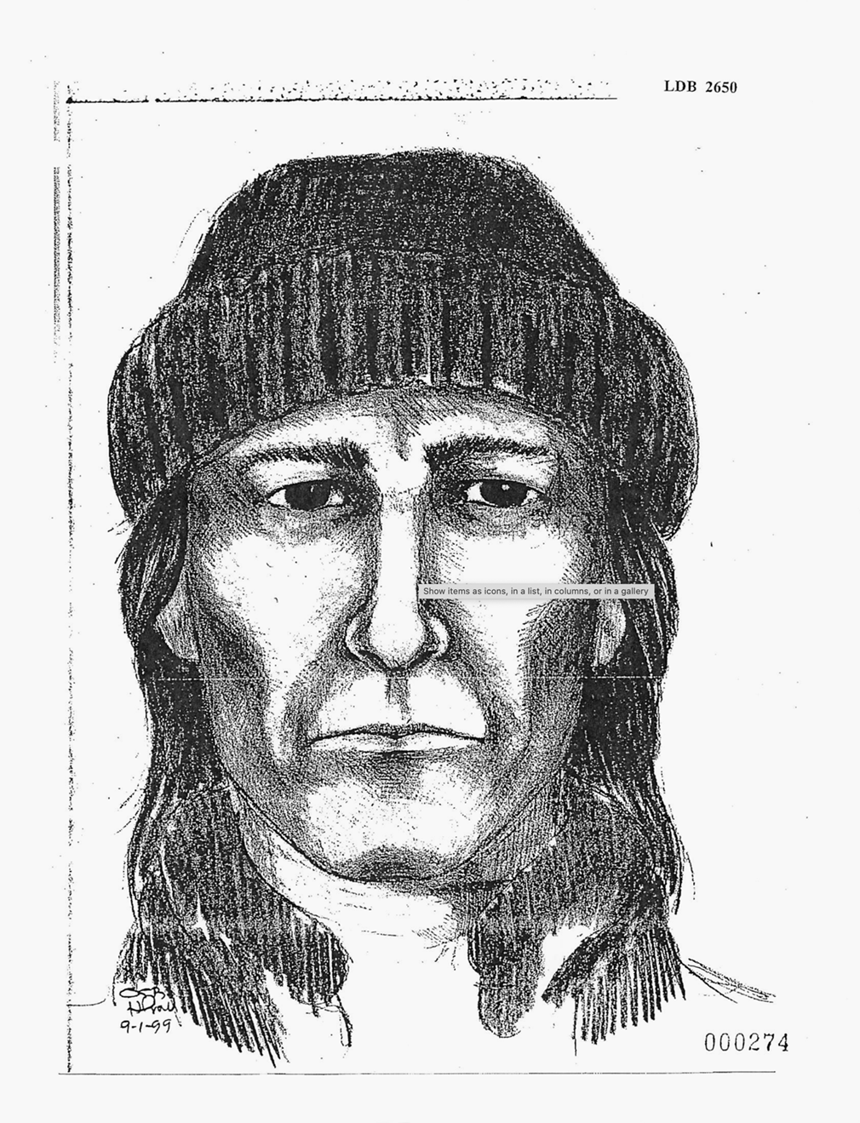
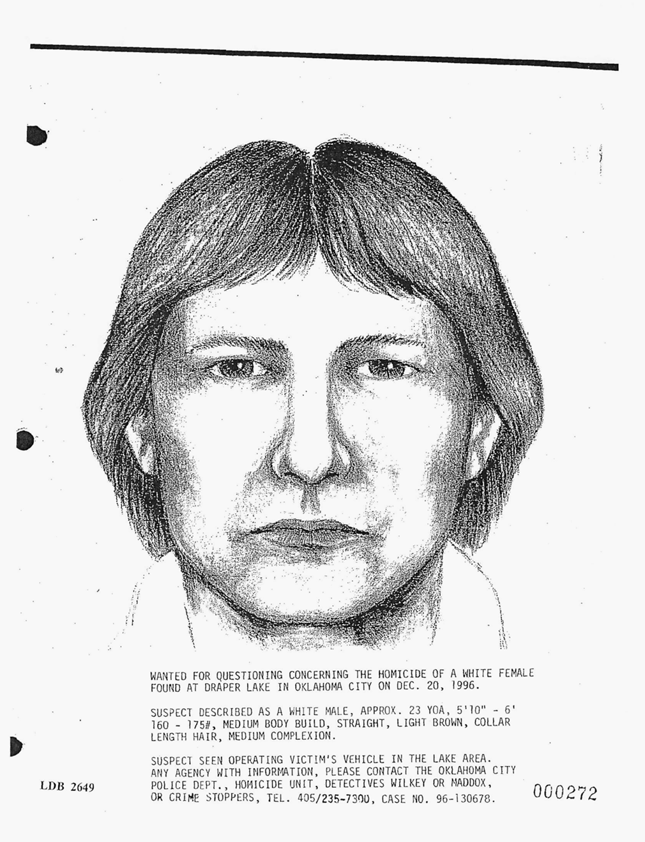
Left/Top: A forensic sketch of the suspect in Juli Busken’s murder based on the eyewitness account of Kay Keller Merryman. Right/Bottom: A forensic sketch of the suspect based on the eyewitness account of David Kill. Credit: Oklahoma City Police Department
THE OKLAHOMA CITY POLICE released the first in a series of forensic sketches of a possible suspect in late January 1997. All of them came from drivers who had spotted a vehicle resembling Busken’s car — small and red, with Arkansas plates — on the morning of December 20. Residents of Busken’s apartment complex had said they heard a woman’s scream at around 5:30 a.m., followed by a door slamming and a man’s voice. Investigators concluded that Busken had been abducted, driven to the lake, raped, and murdered within two hours.
This time frame was based on the eyewitness account of David Kill, an aircraft mechanic at Tinker Air Force Base, just north of the lake. Kill told police that around 7 or 7:15 a.m., he was driving along the lake’s perimeter when a red car with Arkansas plates suddenly pulled out in front of him. The driver looked over at Kill, who decided to follow him, driving as fast as 80 miles an hour. Although it was still dark and he only saw the man from behind, Kill described him as roughly 23 years old, with collar-length, light brown hair and a medium complexion. There was nobody else in the car.
Kill gave his description to veteran law enforcement officer Harvey Pratt, who was Oklahoma’s only full-time forensic artist. Pratt was renowned for his skills, drawing countless composites in high-profile cases. The resulting sketch was heavily publicized, appearing on “America’s Most Wanted.”
Forensic sketches are highly fallible. They rely on the memory of an eyewitness, as well as the interpretation of a forensic artist with their own unconscious biases. As with any eyewitness account, the most accurate descriptions are likely to come soon after an event; the more time passes, the more memories can be distorted by new information. In Busken’s case, most eyewitnesses did not share their descriptions until months or even years after the murder.
With few apparent leads, however, police relied on the drawings to solicit tips. In March 1997, they released a second forensic sketch that bore little resemblance to the first. It came via a man who said he was driving in Norman around 6:30 a.m. on December 20 when he did a “lane dance” with a red car with Arkansas plates. A white woman with blonde hair was in the passenger seat. According to the police report, the witness sensed that the people in the car “had just finished arguing or fighting and were stewing in it.” The driver was white, in his mid-20s, with brown hair “about one inch long.”
A third man, John Henderson, contacted police in October. He had tried to call 10 months earlier, the day after Busken’s murder. But no one called back. Henderson worked at a water treatment plant on the grounds of Lake Stanley Draper. He said he was driving to work between 11:30 a.m. and noon when he saw a red car with Arkansas plates driving erratically. “The driver acted as if he was looking for some place to pull off the main street and stop,” Henderson said. There was a blonde woman in the passenger’s seat, but he could not see her face; she was hunched over in such a way that he thought she might be performing oral sex on the driver. The man was white with a dark complexion, Henderson said. He wore a military-style haircut and a black baseball cap.
Henderson’s account didn’t fit with the timeline the state later presented at trial. Although Busken’s body was not found until around 1 p.m., prosecutors argued that by 7:30 a.m., she had already been killed and left at the lake. Police spoke to Henderson twice; he led them to the location where he spotted the car. But he was not asked to help produce a forensic sketch. Instead, they asked him to submit blood and saliva samples. “They were never really interested in much of anything I had to say,” Henderson told me. He was not interviewed by Sanchez’s defense attorneys, despite his account casting doubt on the state’s version of events.
The last forensic sketch was not revealed until the fall of 1999. Like Henderson, Kay Keller Merryman had tried to come forward with information in December 1996 but never heard back from police. When they finally got in touch with her, she said she was on her way to work at Tinker Air Force Base early on the morning of the murder when she pulled up at a stop sign next to a red car that she would later see on the news. The car was making a right toward the southern part of the lake. The driver was a man between 25 and 30. He looked unkempt, with hollow cheeks, a “day or two’s worth of beard,” and long, dark hair. He wore a stocking cap and looked angry, Merryman said. A young blonde woman next to him looked scared.
According to the police report, Merryman said it was 6:37 a.m. when she pulled up next to the car. She remembered because she was planning to get to work early, and she had been checking her watch. Lead Detective John Maddox wrote that, according to Merryman’s account, the suspect would have had “just had enough time” to drive from the spot, “rape and execute the victim Busken, then leave the crime scene between 7:00-7:15 and be spotted by the witness David Kill.”
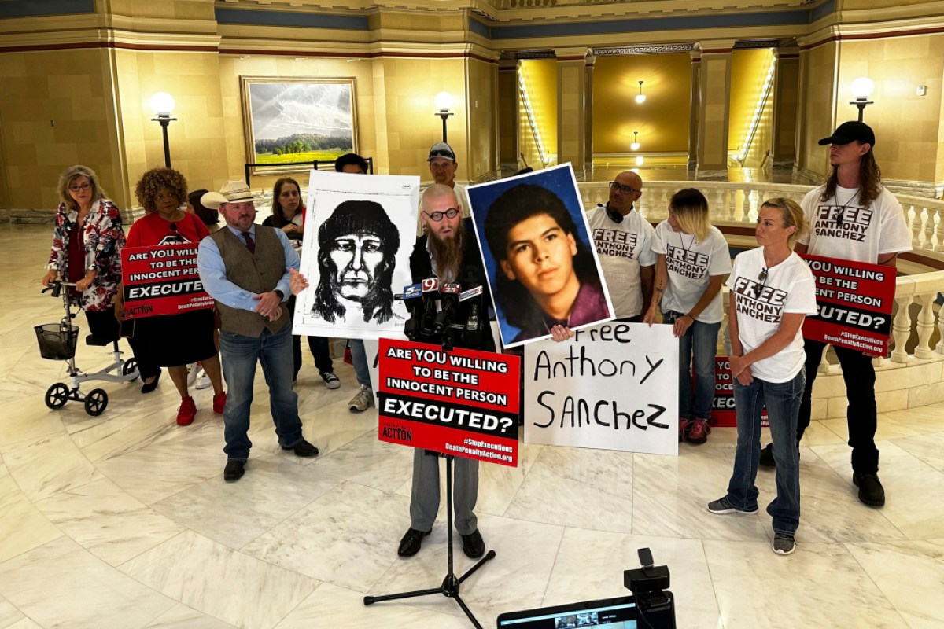
Death row spiritual adviser Jeff Hood and members of the Free Anthony Sanchez campaign at a press conference in Oklahoma City on May 23, 2023.

BUSKEN’S CASE HAD gone cold by the time Cleveland County District Attorney Tim Kuykendall ran for reelection in 1998. The veteran prosecutor found himself embroiled in an ethics scandal over a memo he’d sent to the homes of his staff. “Every employee should be doing everything they can to see that I get reelected and their job is secure,” Kuykendall had written. Defense attorneys called the memo coercive; Kuykendall’s opponent called for him to resign. The Oklahoma Ethics Commission reprimanded Kuykendall, but by then, he had already been reelected.
In an interview with The Oklahoman, Kuykendall was ready to leave the scandal behind. He discussed his love of beans and cornbread over steak and his habit of keeping raccoons as pets. More importantly, he emphasized his “tremendous success” winning murder cases. “We have gotten seven death penalties, 15 life without paroles, and nine life sentences,” he said of the three counties he represented as district attorney. Kuykendall did not discuss the Busken case. But it was never far from his mind. “This is the case I think about every week,” he later told reporters.
Kuykendall’s tenure as district attorney coincided with the advent of forensic DNA analysis in Oklahoma. The OSBI opened its DNA lab in 1994, the year he was first elected. In 1998, the federal government launched the Combined DNA Index System, or CODIS, which provided a national database of DNA profiles taken from people convicted of crimes.
Some experts sought to make clear that DNA was not a magic bullet. “We are not specifically identifying a person,” OSBI analyst Mary Long told The Oklahoman, explaining that results are expressed in terms of probabilities: the chance that an identical profile would appear in a given population. But such nuances were mostly lost on juries. As an expert witness on the stand, Long told me, it was important not to conflate the presence of DNA with the guilt of the defendant. “Unless you saw him do it, you don’t have any idea who did it,” she said.
From the earliest days of the Busken case, the one thing investigators had was DNA. In 1997, the OSBI used an early form of DNA typing that required a large sample of biological material. The pink leotard contained enough sperm for analysts to obtain a male profile using this method. Later, the OSBI analyzed the garment again using PCR testing, which is still in use today. The resulting male profile included alleles at 13 locations, or loci. If a suspect could be found whose profile corresponded with all 13 loci, it would be considered a match.
On March 20, 2000, Kuykendall held a press conference in Norman. He announced that he was filing charges of first-degree murder, first-degree rape, forcible sodomy, and kidnapping against a “John Doe” in the Busken case. In lieu of a name, there was a series of numbers and letters: the DNA profile found on the leotard.
Kuykendall acknowledged how unusual it was to file charges against an unnamed defendant. But he maintained that the evidence was strong enough for a murder charge, and the DNA would be the crux of the case. He hoped that the profile might produce a random hit in a DNA database.
In the meantime, the profile spurred detectives back into action. The Oklahoma City Police Department undertook a DNA dragnet, requesting blood and saliva samples from men in and around Norman. The sweep raised the concerns of civil libertarians. One criminal defense attorney criticized detectives for violating people’s right to privacy rather than doing a more thorough investigation. “Police are basically saying, ‘If we pop a needle into enough arms, we’re bound to get lucky sooner or later,” he told The Associated Press.
Bo Ireland, now an Oklahoma City pastor, was one of the many men who submitted to testing. He remembers being called to the OU campus to answer questions only to find himself surrounded by 75 to 100 others at the health center, all being asked for blood and saliva. “I was like, ‘Wait, What? … I thought you had to have a warrant for that.’” As he recalls, his reaction sparked the officers’ interest — “like, ‘Do we need to get a warrant?’” Like almost everyone else, Ireland agreed to give a sample.
Maddox, the lead detective, bluntly acknowledged that refusal would be viewed with suspicion. “For them not to cooperate with us,” he told CBS News, “it leaves an open end out there for us to look at.” Busken’s father told the media that he did not understand why someone would not willingly give their DNA. “If you don’t want to give your DNA, you have something to hide,” he said.
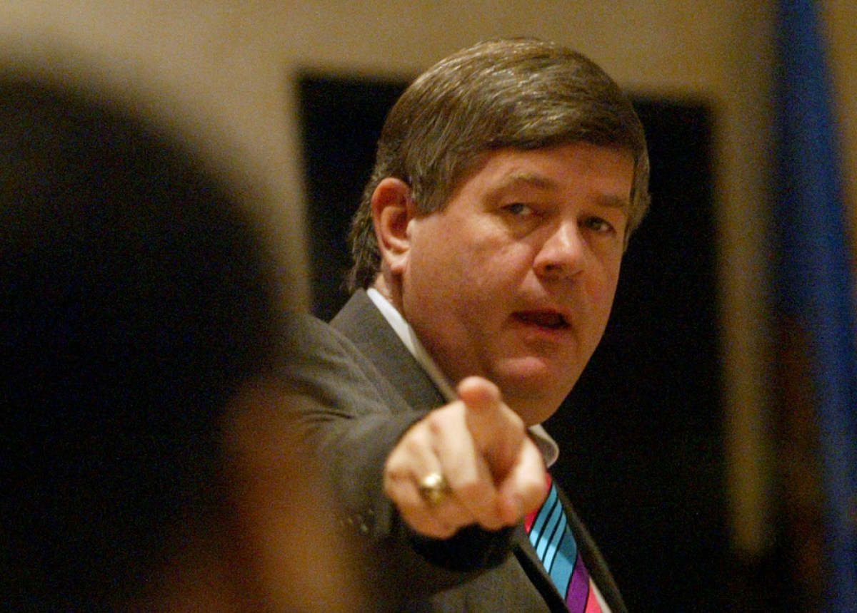
Cleveland County District Attorney Tim Kuykendall points at a defendant during closing arguments at a 2005 trial.

IN THE SUMMER of 2004, Kuykendall finally got what he’d been waiting for. An OSBI letter to the Oklahoma City Police Department reported that an autosearch had been conducted of the CODIS database, seeking a match between a forensic item in the Busken case and a sample from a man named Anthony Sanchez. According to the letter, “a candidate match was obtained.”
Prosecutors in Kuykendall’s office were familiar with Sanchez. In 2001, he had been accused by an ex-girlfriend of rape. She told police that she had come home at 2 a.m. to find Sanchez in her living room, where he tied her up and assaulted her. Sanchez insisted it was a false allegation — and the rape charge was ultimately dropped. Sanchez pleaded guilty to burglary. But there was one detail that leapt out from the police report: The girlfriend said Sanchez had tied her up with shoelaces.
There is “no question that this is our guy,” Kuykendall told The Oklahoman.
Sanchez swore from the start that he was innocent. He said he had no idea how his DNA would have ended up at the scene, but he believed it could have been planted using evidence from the alleged rape. As he tells it, he had never heard Busken’s name until two detectives came to see him at the Lawton Correctional Facility, where he was incarcerated on the burglary charge. After he refused to speak without an attorney, he was escorted back to his cell. It was the prison guards who told him that he was a suspect in Busken’s murder.
Someone in Sanchez’s position had good reason to question forensic evidence that had been handled by the Oklahoma City Police Department lab. Just a few years earlier, the lab had been the center of a national scandal when Gilchrist, the lab’s supervisor, was revealed to have manipulated evidence in criminal cases, sending innocent people to prison. One man had already been exonerated and released after being wrongly imprisoned for rape.
The forensic analyst who blew the whistle on Gilchrist’s misconduct was Laura Schile, a DNA scientist who arrived at the lab in 2000 and took over from Gilchrist. Schile had worked with DNA at a cancer research center, then spent three years at the Texas Department of Public Safety. What she found at the OCPD lab was disturbing. “The evidence was scattered throughout the police department,” she later told the OCPD’s departmental review board. There were boxes in the hallway, in the lab itself, and in the old jail. “It was quite obvious that all of the evidence was being compromised, potentially compromised,” she said.
In the case of Jeffrey Todd Pierce, the man who was exonerated of rape, Schile found a box of evidence that also contained evidence from an unsolved homicide. The items were “loose and unsealed,” she wrote in a memo. “Trace evidence was being potentially mixed and evidence was being contaminated.” Gilchrist, she learned, had packaged the items together because she suspected that Pierce was responsible for both crimes.
“It looks like they killed someone who didn’t do it.”
Especially concerning was Gilchrist’s role in some two dozen death penalty convictions, including the case of Malcolm Rent Johnson. A Black man convicted by an all-white jury, he professed his innocence until his execution in early 2000. Schile later reexamined forensic slides in the case and found that, contrary to Gilchrist’s testimony at Johnson’s trial, they did not contain his sperm after all. Although prosecutors insisted the rest of the evidence against Johnson was strong, the case was full of holes. “It looks like they killed someone who didn’t do it,” a defense attorney who reviewed the evidence told The Associated Press.
Gilchrist was fired in 2001. Schile left the OCPD the same year, after getting the DNA lab up and running. She went to work for the Oklahoma Indigent Defense System as the organization’s first in-house forensic analyst. The office provided state-funded trial and appellate representation throughout Oklahoma. For defense attorneys who wanted to challenge forensic evidence in the wake of the Gilchrist scandal, there was no better resource. Schile knew what to look for; she helped with discovery requests, asking defense lawyers to get everything she would need to review forensic evidence, including chain of custody documents, testing methods, lab notes, and raw data. “I would have had no control whether they got it for me or not — that was often the problem,” she told me.
Court records show that Sanchez’s lawyers fought for almost a year to get the Cleveland County District Attorney’s Office to turn over materials related to the DNA evidence in his case. A private attorney who was initially hired by Sanchez’s family filed a motion for discovery in September 2004, only to leave the case a few weeks later because he was not being paid. Lawyers with the Oklahoma Indigent Defense System took over. In August 2005, they wrote that while multiple labs had been involved in “the collection, storage, and/or analysis of evidence in this case,” the lawyers had yet to receive records documenting their work. “Thus far, the information provided has been limited, scant, and obviously incomplete.”
Sanchez had an additional reason to harbor suspicion about the DNA evidence. The earliest filings in the case show that defense attorneys were under the impression that there was only one piece of evidence containing Sanchez’s DNA — and it was so small that further testing would completely consume it. But later they learned that there were multiple items containing DNA. Nobody ever explained the discrepancy, according to Sanchez and his family. To them, the evidence seemed to appear out of nowhere.
The fight over discovery was ultimately resolved at a hearing on the DNA, where Sanchez’s defense team told the judge they had reached an agreement with the state. According to the trial transcript, Schile met with OCPD forensic analyst Melissa Keith, who had tested the leotard and other items in the recently opened DNA lab. They examined the evidence item by item, Keith testified. “I believe we spent the better part of a whole day.” Schile said this would be consistent with her job at the time. Although she has no specific recollection of reviewing the evidence, she confirmed that she received the necessary items from Keith prior to Sanchez’s trial. “I looked at this case,” Schile said. “I can say that I did not see any issues in the DNA testing.”
Sanchez came to mistrust his legal team. He was especially outraged upon learning that one of his attorneys — who later went to work for the Oklahoma Attorney General’s Office — was a member of the same church Busken had attended in Norman.
Today, Sanchez has a term for loyalty he sees among the network of people in Norman’s legal community: the “Crimson blanket.” “They all stick together,” he told me. “It’s like a gang. The cops all go to OU, the judges go to OU.” Sanchez had been raised on the east side of town, which he described as “the ghetto side.” Growing up poor in Norman meant being outside of this powerful, insular world.
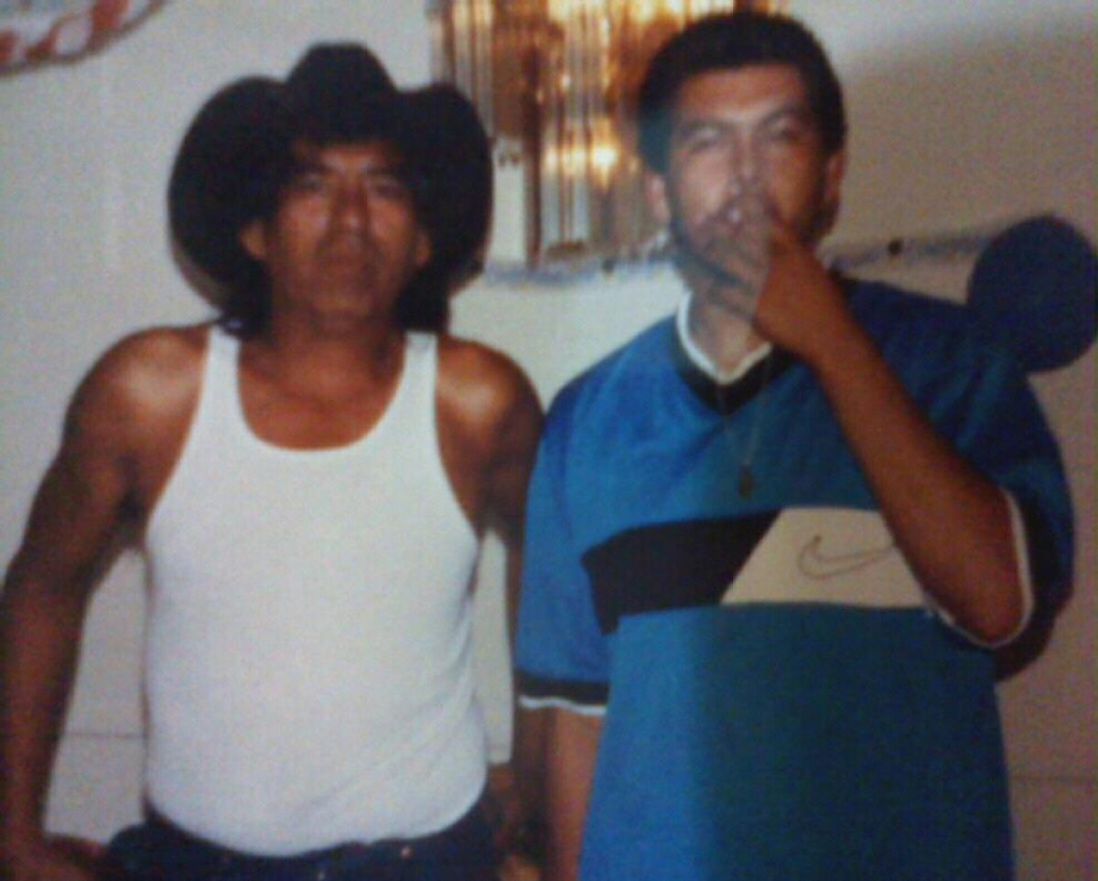
Glen and Anthony Sanchez in an undated photo.

SANCHEZ WAS BORN in Ardmore, Oklahoma, in 1978. His father, Glen, who was part Choctaw, had grown up in a large Mexican family in Lampasas, Texas. His mother, Gloria Faulkner, who was Choctaw and Chickasaw, was raised in Ardmore. Glen and Faulkner separated around the time that Sanchez was born. Both had severe substance abuse problems; Faulkner was addicted to drugs, Sanchez said. “I think I was like 6 or 7 years old when her house got raided the first time,” he told me. He was hiding under some covers when it happened, and the cops mistook him for someone trying to evade arrest. “That was the first time police beat me up.”
Sanchez’s older sister Lujuana remembers trying to protect him from their father as a child. “I tried to get him to run away with me,” she said. “Today it’s called abuse, but Daddy was just trying to make him tough.” At Sanchez’s trial, his grandmother recalled seeing Glen hit Sanchez in the chest when he was just 2 years old. “I said, no, you’ll make his heart fibrillate doing that,” she testified. But Glen responded that it would toughen him up.
“Today it’s called abuse, but Daddy was just trying to make him tough.”
When Sanchez was young, Faulkner suffered a disfiguring burn. Glen told Sanchez that his mother had been cooking meth. But Lujuana said that she had been burned by a man she’d gotten together with after the divorce. “Anthony was told that she was making drugs. And she wasn’t. She was trying to get away from an abusive relationship.” Sanchez remembers visiting Faulkner in the hospital and running away when he saw her. “She looked like Freddy Krueger,” he told me. “That’s how bad she was burned.”
Documents in Sanchez’s appellate file show that, according to family members, Glen tried to turn his son against Faulkner, taking him to live with Glen’s new wife, Cathy Hodge, when Sanchez was about 18 months old. According to Hodge, Glen wanted to save Sanchez from an unsuitable environment. But their own home life soon became violent.
“He was fine whenever he wasn’t drinking,” Hodge said about Glen. On weekends he would get drunk and beat her. During one particularly violent attack, Hodge tried to hide in a closet, but Glen found her; Sanchez yelled at his father to leave Hodge alone. Nonetheless, Hodge remembers Sanchez as a mostly happy kid. She showed me childhood photos of Sanchez wearing orange floaties in a swimming pool, sitting on Santa’s lap, and posing in a school football uniform. “The only time that I’d seen [Glen] really being ugly with Anthony was when he was trying to protect me,” she said.
Another one of Glen’s ex-wives remembers him treating Sanchez as “his golden boy.” But Beattie, Glen’s longtime girlfriend, said he “beat the crap out of Anthony.” As she described it, Glen was confident that Sanchez wouldn’t tell anyone.
According to his friends, Sanchez did not talk about his relationship with his dad. Adam Sheets, who knew Sanchez as a teenager, remembers Glen as a “mean, nasty” man who “talked to Anthony like he was a piece of shit.” Sanchez seemed to fear his father while also seeking his approval.
“I saw Anthony pretty much every day of my whole adolescent life,” said Kristina Bryan, Sanchez’s best friend. “We would just like hang out, smoke weed together. … I mean stupid teenage stuff.” Glen was clearly abusive, she said — he even pointed a gun at her once, which her mother also remembers. Bryan and Sanchez later had a temporary falling out over Sanchez’s drug use. As she recalls, he was doing crank, which “was changing who he was.” During a heart-to-heart, he opened up about physical abuse inflicted by his father. But that was the only time Bryan could remember him talking about it.
Hodge finally left Glen for good when Sanchez was about 15. That’s when Sanchez’s run-ins with police seemed to start. “I don’t know if he just didn’t have a family life,” she said. “I think he was just running the streets.” Before that, she said he was often followed in stores and wrongly suspected of crimes based on his ethnicity. One neighbor accused him of breaking into her house when he was actually in school. “She didn’t like them because they were Hispanic,” Hodge said.
The population of Norman was almost entirely white in the years Sanchez grew up there. As late as 1967, it was a sundown town: Black people were explicitly prohibited from staying out after dark under threat of violence. As Norman became more diverse in the early 1990s, racist backlash followed; The Oklahoman reported a rise in racist graffiti and police harassment of nonwhite residents.
Sanchez remembers facing plenty of racism growing up in Norman. “People would tell me to go back to my country, go back where I was from,” he said. He doesn’t remember it affecting him all that much. Most of his friends in Norman were Native American, he said. It was harder to feel like he didn’t fit neatly in either community. “If you’re not fully bilingual, you’re not Mexican,” he said. “If you don’t speak Choctaw, you’re not Choctaw.”
But facing a murder trial in Norman was a wake-up call. “It was all white people, even in the audience,” he said.
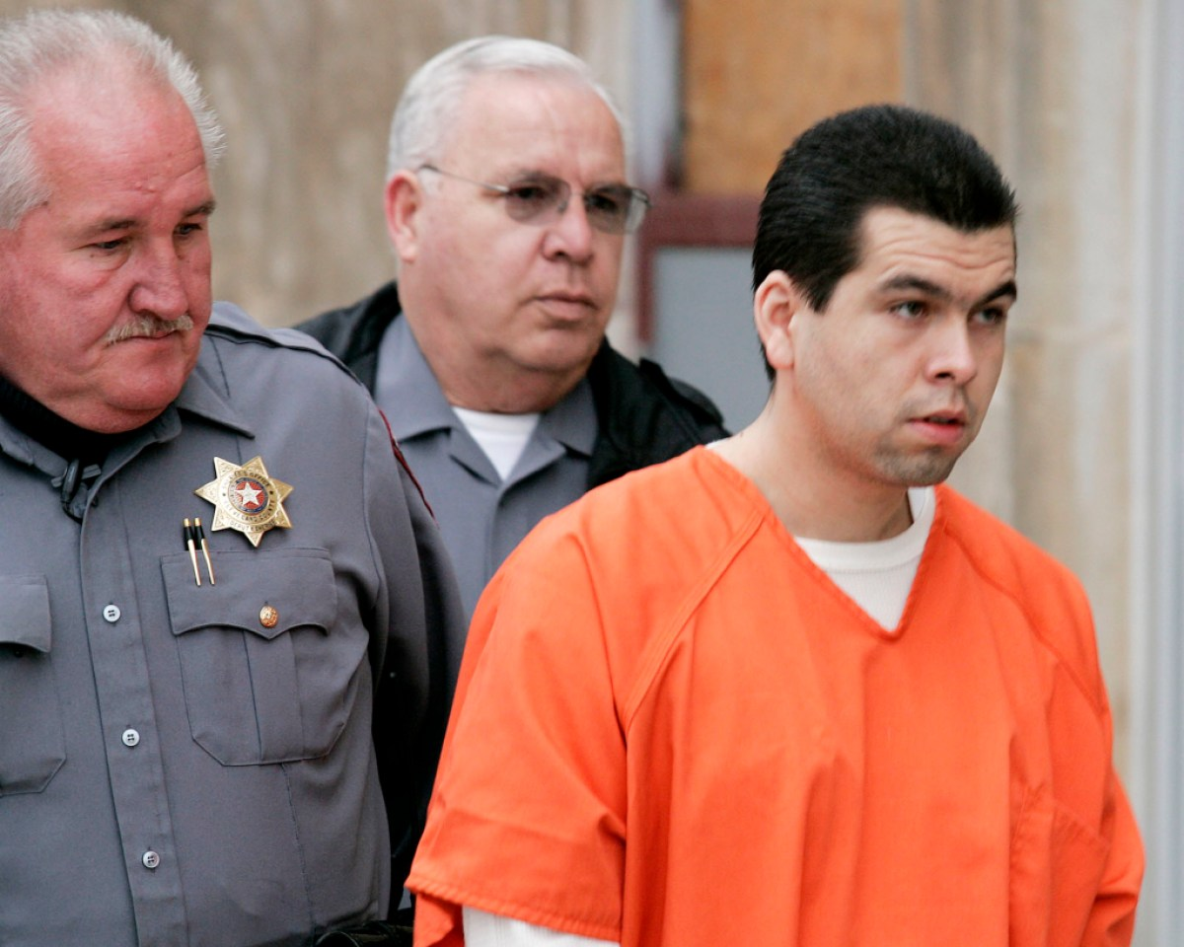
Anthony Sanchez is escorted into a Cleveland County courtroom for a preliminary hearing in February 2005.

SANCHEZ’S TRIAL BEGAN on January 30, 2006, at the Cleveland County District Court in downtown Norman. Media and spectators filled the gallery, including at least one local celebrity, famed football coach Barry Switzer, who attended almost every day. There was a heavy security presence; Sanchez remained shackled throughout. The Court of Criminal Appeals later found that the shackling was illegal but it would not have changed the outcome.
The jury was all white, which did not seem to faze Sanchez’s lawyers or the presiding judge. In a post-trial questionnaire, the judge acknowledged that there were no Hispanic or Native American people on the jury but said Sanchez’s attorneys had not objected. Asked if jurors had been instructed to “exclude race as an issue,” the judge answered only with a question mark.
Hodge brought a suit for Sanchez to wear but was barred from giving it to him. Along with the rest of his family, she was prevented from watching most of the proceedings. “We went and sat at restaurants or sat outside,” she said. She was distressed to realize that the lawyers did not plan to call anyone at the guilt phase of the trial. Like another person close to Sanchez I interviewed, Hodge said the lead attorney, Silas Lyman, told them that his goal was not to prove Sanchez’s innocence but to keep him off death row. Lyman declined to be interviewed about the case.
Representing the state was Assistant District Attorney Richard Sitzman, a veteran of the office who had been prosecuting homicides since the 1980s. As he described it, he did not want to rely too heavily on the DNA. “There are some people who think that DNA is hocus pocus,” he told me. “So it was very important to me and to the police department to prove this case without the DNA.”
“Evil sits right here in front of you today. And it’s Anthony Castillo Sanchez.”
In his opening, Sitzman emphasized how long it had been since Busken’s was killed. “Nine years, one month, and about 16 days,” he said. “That’s how long I’ve been waiting to tell you this story.” He told the tale of a ballerina with a bright future whose life was violently cut short. But instead of explaining how the crime took place, Sitzman described how DNA had finally identified the killer years later. “I call him ‘the cold hit guy,’” Sitzman said. “And the DNA is going to tell you what it’s told the rest of us, and that is that evil sits right here in front of you today. And it’s Anthony Castillo Sanchez.”
Despite Sitzman’s claims about proving the case without DNA, the additional evidence implicating Sanchez was elusive. One of Busken’s neighbors described hearing the scream at 5:30 a.m. on December 20, followed by a man’s voice saying, “Shut up and get in the car.” The state theorized that Sanchez was breaking into cars when he spotted Busken returning from the airport. But there was nothing placing him at her apartment complex that morning. Merryman, the eyewitness who told police she saw a blonde woman looking scared in the passenger seat of a red car, was not asked to identify Sanchez from the stand. Neither was Kill, the eyewitness who testified that a red car had cut him off later that morning. Of the 49 fingerprints found on the car, none of them matched Sanchez.
An acquaintance of Sanchez’s who allegedly told police he’d once seen Sanchez with a .22 caliber pistol testified that it was actually a .25. “I felt like they were wanting me to say something that didn’t happen,” the man told me, adding that he didn’t believe Sanchez had killed Busken. Sanchez’s former landlord testified that, after police tore apart the walls of Sanchez’s old apartment in search of a .22-caliber projectile, the landlord discovered a slug in the debris. Yet there was nothing directly linking it to Sanchez. His ex-girlfriend, Christin Martin Setzer, testified that Glen, not Sanchez, had shot bullets into the wall. “Glen was drunk, and Anthony made me stay in the bedroom,” she said.
Nor was there much linking Sanchez to the slew of numbers found in Busken’s cellphone records in the days after the murder. Prosecutors called a man whose phone number was on the list, but he testified that he did not know Sanchez or Busken — he couldn’t say why his phone would have been called by the killer. There was one compelling piece of circumstantial evidence pointing at Sanchez, however: an old day planner belonging to Setzer, in which she had listed the phone numbers of friends in their social circle. One of them was Melanie Crain, who had dated Sanchez. The number under her name matched one of the numbers in the phone records.
“I hadn’t spoken with Anthony in years by the point that he would have called that number.”
Crain now goes by Melanie Thompson. She remembers being bewildered when detectives contacted her to say that her number had shown up in the records. But she also said that the number in question was no longer hers in December 1996, which made her doubt that the person who used the phone was trying to reach her. When detectives contacted her again to say that the DNA matched Sanchez, “I was really confused,” she said. “Because I hadn’t spoken with Anthony in years by the point that he would have called that number.”
Of all the pieces of circumstantial evidence presented at trial, Sanchez is perhaps most adamant about debunking one: shoe prints found at the scene that investigators ostensibly linked to a pair of Nike sneakers he owned. For years Sanchez has argued that, according to the state, the prints were left by a man who wore a size 9. “I wear a size 11 1/2 wide and have since I was 12 or 13,” he told me.
There were other reasons why the shoe-print evidence was absurd on its face. OCPD officers testified that sand had blown into the prints on the lakeshore, making them impossible to examine. This was clear from a crime scene photograph entered into evidence, which captured a barely discernible shoe print with a vaguely waffle-patterned sole. Even if the print had been left by the killer, there was no way to determine which specific shoe had created the print — and the state did not call a footprint examiner to try.
Instead, OCPD detectives described how a pair of colleagues had taken the photograph of the print to local stores and compared the sole to athletic shoes in stock. “They believed it to be a Nike Max Air 2,” Maddox, the lead detective, testified.
Investigators contacted the Nike corporation and requested an overlay of the shoe model, which was presented to jurors. The visual insinuated a match between the shoe print and the Nike Air Max 2. Prosecutors then utilized Setzer’s planner to show that Sanchez had purchased a pair of Nikes in the months leading up to the murder. In bubbly handwriting on October 14, 1996, Setzer, who was pregnant at the time, wrote that Sanchez had given her a necklace, a baby bed, and a pair of Nikes. “He got matching shoes but boy style,” the planner read.
The link was tenuous. In an interview with detectives, Setzer was shown a photo of a pair of Nike Air Max shoes. “I can’t say they were identical,” she testified.
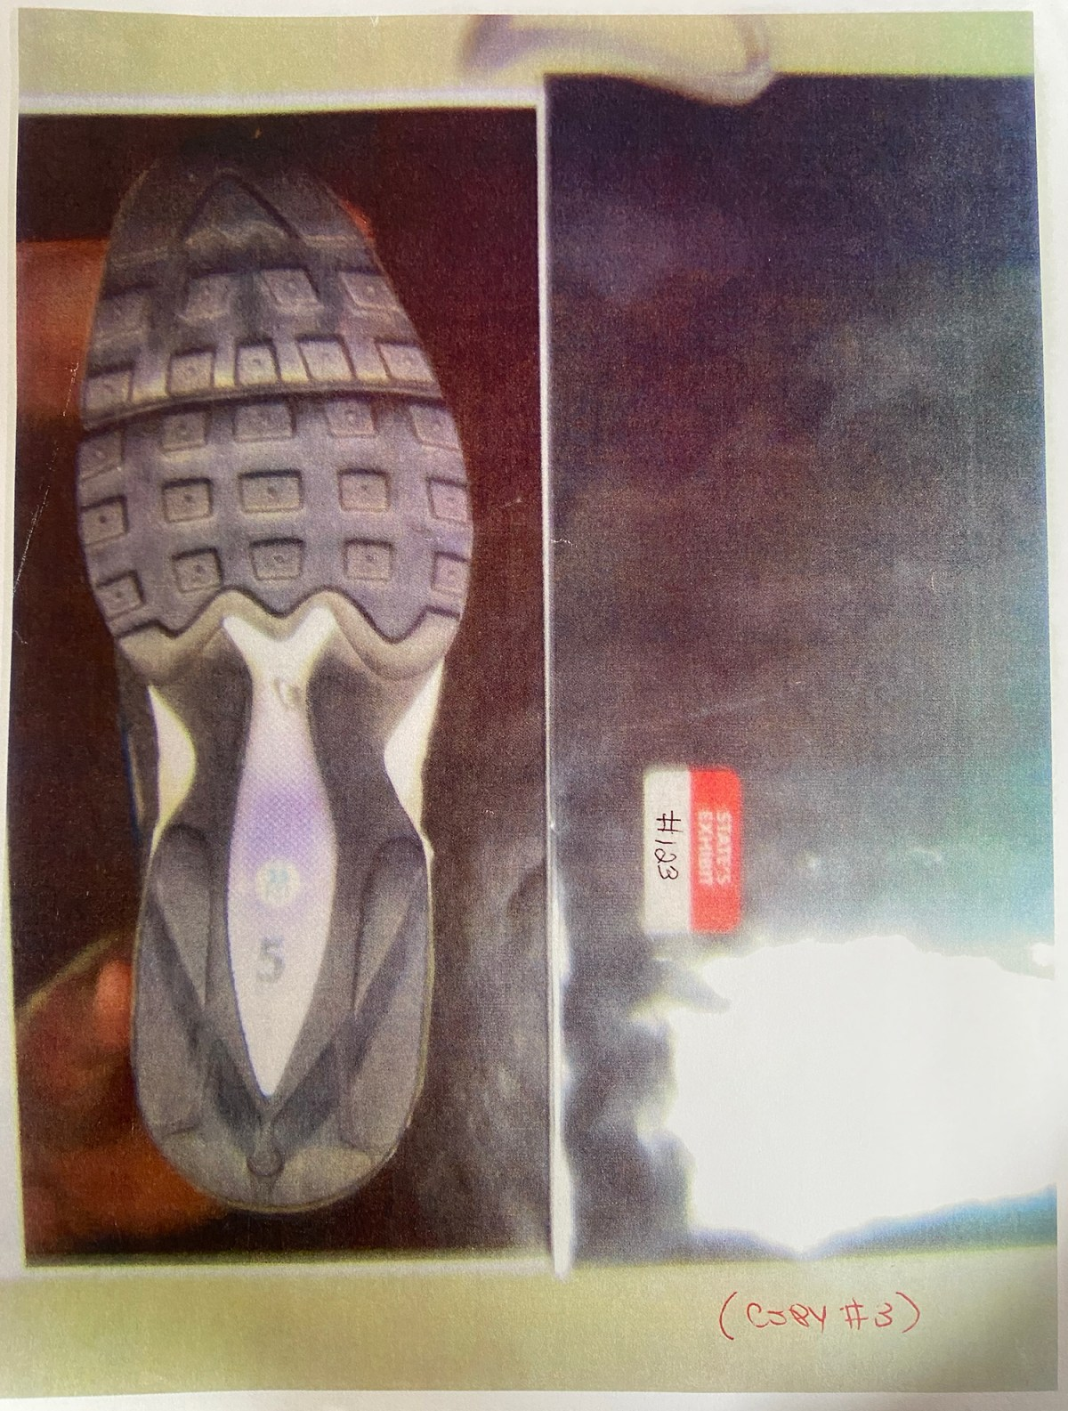
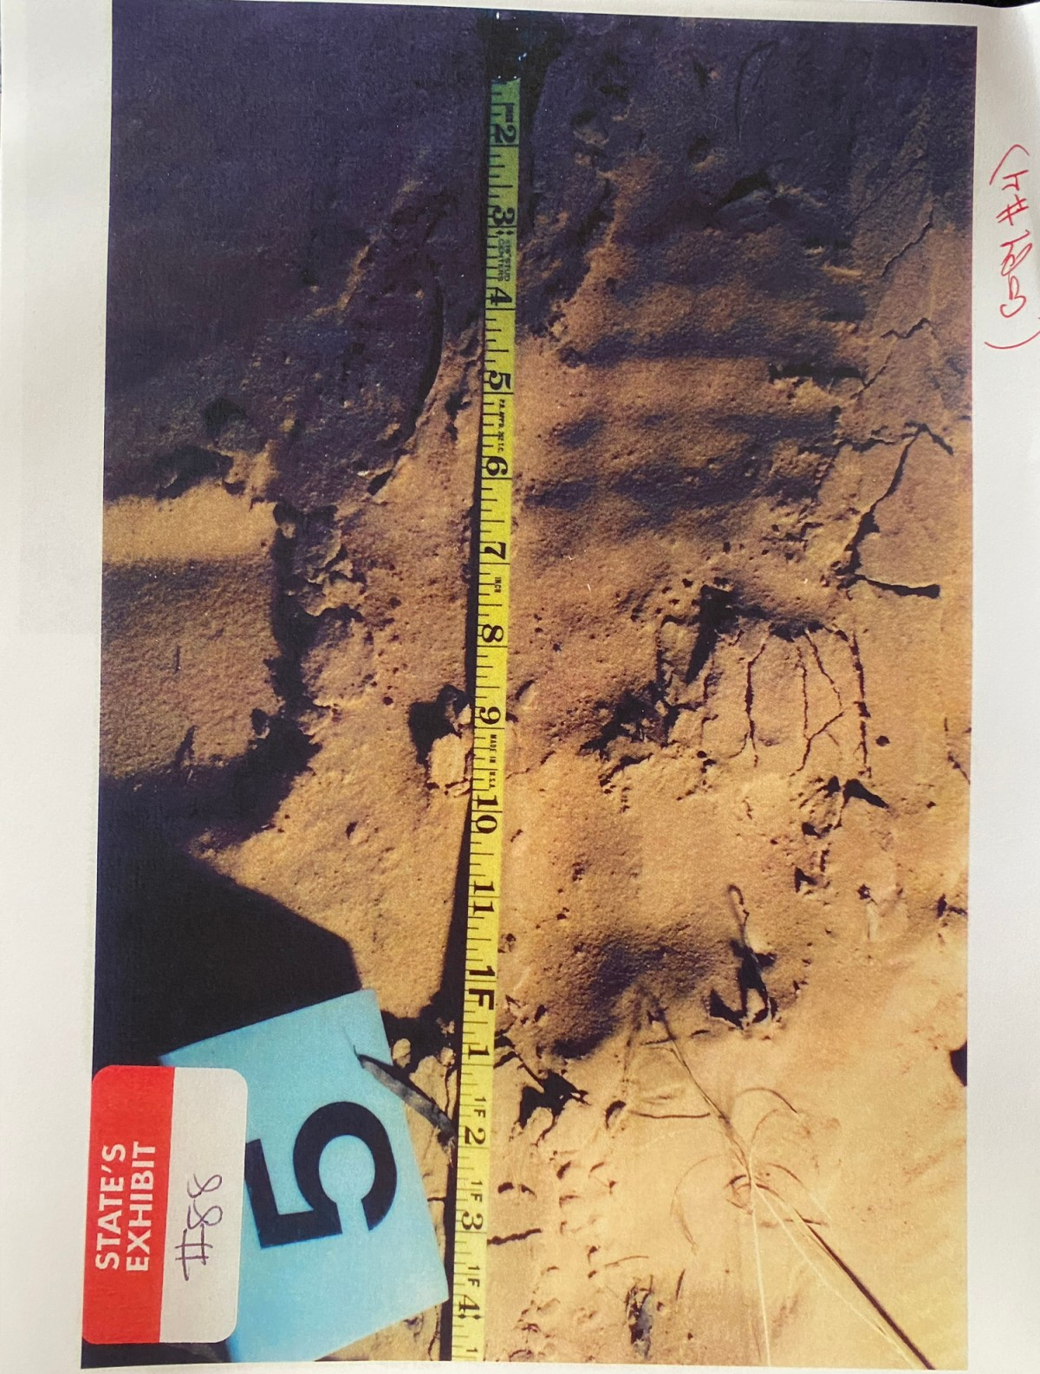
Left/Top: The Nike Air Max Tailwind, pictured, which had the same sole as the Air Max 2, was shown to jurors at Anthony Sanchez’s 2006 trial. Right/Bottom: A shoe print believed to belong to the man who killed Juli Busken found on the shore of Lake Stanley Draper on Dec. 20, 1996. Detectives said the print was unusable but claimed to match it to a Nike Air Max 2. Credit: Courtesy of Oklahoma Attorney General’s Office
The strength of the shoe-print evidence became strikingly distorted in the years after the trial. Sitzman remembers the prints at the lake as being “pristine.” Kuykendall, the district attorney, has attributed the match to the Nike corporation itself, claiming in a “Forensics Files” episode that “they were able to identify the specific shoe that they believed made this impression in the sand.”
The star witness for the state was Melissa Keith, the DNA manager for the biology unit of the OCPD lab, who laid out her handling of the leotard. “In 1996, when I originally received this item, I examined it. I marked areas for testing,” she said. When she found sperm on the leotard, she sent it for DNA testing at the OSBI. Later, she did DNA testing on the leotard and other items herself. She got a complete male profile from the leotard and the underwear. Sitzman asked her to go through the profile step by step for the jury. The results were decisive. The profile and the reference sample from Sanchez “were found to be the same at all loci tested.”
“If I find a sample to be consistent with a certain person, I can then take that DNA profile, put it into a program called population statistics, and calculate how, let’s say, rare that profile would be,” Keith testified. The probability of finding another donor with exactly the same DNA profile as Sanchez was 1 in 200 quadrillion Caucasians, 1 in 20 quintillion African Americans, and 1 in 94 quadrillion Southwest Hispanics, she said.
On February 15, 2006, Sanchez was convicted on all counts. Two days later, jurors sentenced him to die.
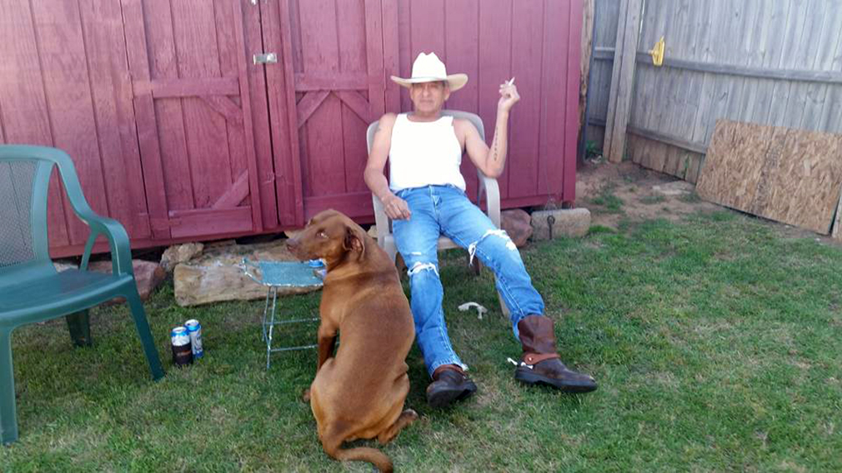
An undated photo of Glen Sanchez and his dog at Charlotte Beattie’s home outside Oklahoma City.

IT WASN’T LONG after Sanchez was sent to death row that his aunt had an odd interaction with her brother, Glen, who came by her house while she was watching TV. “Out of the clear blue sky he said, ‘I might be a woman beater and a drunk, but I’m not a killer,’” she said. “And I thought, ‘Why would he say that?’”
Another time, he pulled up in his truck while she was smoking a cigarette. She can’t remember exactly when. But he gave her a black beanie-style hat and said something like, “Here, you do something with this.” Although his son’s trial was over, Glen seemed concerned that he might still be targeted as a suspect. “Before I know it, they’ll be trying to pin that on me,” his sister remembered him saying.
“Before I know it, they’ll be trying to pin that on me.”
Glen was not wrong to think he was suspected of being involved. Documents in the case file show that Sanchez’s trial lawyers believed that Glen might have been the real killer. Even if the DNA showed that Sanchez had sexually assaulted Busken, there was no real proof that he was the one who shot her. At least one of the crime scene photos also showed what appeared to be a print from a cowboy boot in the sand; Glen was known to wear cowboy boots.
Unlike the vast majority of men questioned by Oklahoma City police, Glen was not asked to give blood or saliva samples. During an interview in 2004, he was evasive and “difficult,” according to a police report. He couldn’t answer basic details about his son’s life, such as where he’d gone to high school or where he was living around Christmas 1996. When he was told about the DNA evidence implicating Sanchez, Glen got agitated, suggesting this was another false accusation, like the one by his son’s ex-girlfriend — “just because of a woman’s loud mouth, a lie.”
According to Glen, “Anthony wasn’t capable of killing at 17 or 18 years old,” the detective wrote. When he asked Glen if he ever went fishing with his son at Lake Stanley Draper, Glen said, “I think so.” The location he gave caught the detective’s attention. It was on the lake’s south side, “just west of the location where the body of Jewell Busken was located.”
According to Sitzman, Glen was investigated alongside the rest of his son’s friends and acquaintances. “I’m not aware of anything that ever raised him to the level of suspect or even a person of interest,” he said. Despite the trial lawyers’ suspicions, it is unclear how thoroughly the legal team investigated the theory. A defense investigator’s memo shows that Glen was interviewed only once before Sanchez’s trial. “After that, he has refused to talk to anyone on the defense team,” the investigator wrote. “Glen is paranoid, does not trust lawyers, cops, or white people.”
Nevertheless, Sanchez’s appellate lawyers argued that evidence of the murder pointed more directly at Glen than his son. To support the argument, they cited the forensic sketch based on Merryman’s account. In Sanchez’s direct appeal, his lawyers noted that Merryman had described the driver as older than the 21-year-old Busken. “Sanchez had just turned 18 at the time and looked quite young,” the lawyers wrote. The state’s own timeline also suggested that Busken was not raped at the lake. There was too much time between her apparent abduction at 5:30 a.m. and Merryman’s sighting well over an hour later. It was more likely that she had been taken to “some other location,” which opened up the possibility that someone else — possibly Glen — had driven Busken to the lake.
“I wish you could look into my eyes and see what I saw because it’s indelibly etched in my mind.”
If his lawyers’ theory cleared Sanchez of murder, it did not offer much proof against his father. What’s more, although the lawyers argued that the evidence was insufficient to convict Sanchez of first-degree rape, they conceded the “presence of what appears to be his DNA at the crime scene.” In a letter after his direct appeal was rejected, Sanchez assailed his attorney for arguing that his father had killed Busken. “What kind of demented lawyer are you?” he wrote. “I feel that you have done your best to help seal my fate at death.” The attorney replied that he had done his best under the circumstances. “The one fact that could not be overcome in your case was the fact that your semen was present at the crime scene.” He reminded Sanchez that they tested his DNA themselves, and the results were the same. “You wish to ignore this aspect of your case, but wishing it away won’t make it so.”
Sanchez’s advocates have continued to use the sketch based on Merryman’s account. It is prominently displayed by the Free Anthony Sanchez campaign — and it’s easy to see why. The drawing shows a man of possible Indigenous ancestry, who looks quite a bit older than 18. With long black hair, the man in the drawing bears a striking resemblance to Glen.
Yet Merryman remembers being frustrated by the sketch. In a phone call, she told me that the forensic drawing didn’t look much like the man she saw. “I said to the artist, ‘I wish you could look into my eyes and see what I saw because it’s indelibly etched in my mind. I don’t seem to be able to convey it to you,’” she said. Today she believes that the man was Sanchez and the frightened woman was Busken. “I couldn’t understand why she didn’t attempt to notify me or say help or something,” Merryman said. “It weighs on me to this very day.”
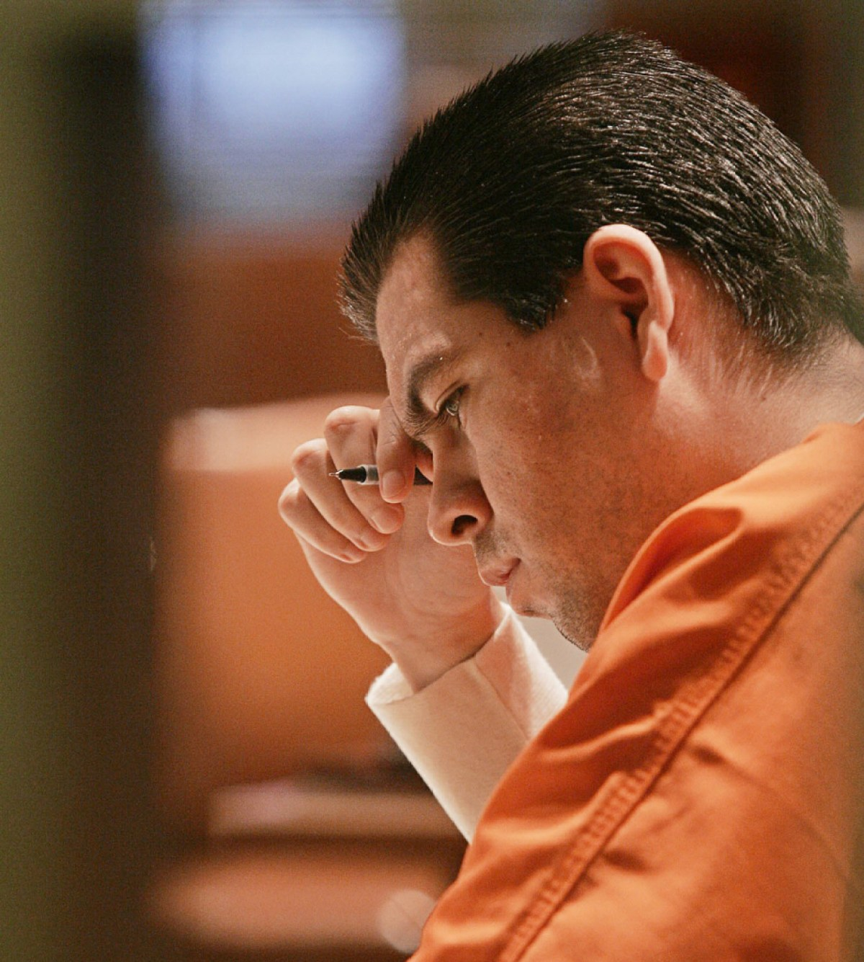
Anthony Sanchez at a pretrial hearing in 2005.

IN NOVEMBER 2010, Sanchez was appointed a new attorney to challenge his conviction in federal court: veteran post-conviction lawyer Mark Barrett. In many ways, Barrett seemed ideally suited to litigate Sanchez’s innocence claim: He had helped exonerate two different clients from death row, including Ron Williamson, whose story was later immortalized by John Grisham in “The Innocent Man.”
Barrett was joined by Randall Coyne, a University of Oklahoma law professor and seasoned capital defense attorney who had been part of the legal team that defended Oklahoma City bomber Timothy McVeigh. Like Barrett, Coyne had a heavy workload; when he entered his appearance in Sanchez’s case in June 2011, he was facing deadlines for the fourth edition of his reference book, “Capital Punishment and the Judicial Process,” while also editing a professional journal covering death penalty trends.
Sanchez was hopeful about his new attorneys at first. In a letter to Coyne, he wrote that he and Barrett were the first lawyers to listen to what he had to say. “All of my other lawyers always say, ‘There is DNA, you did it, nothing else matters.’” Still, Sanchez admitted that he was leery of Coyne given his affiliation with the university. Sanchez asked him to answer questions, including “Where do you go to church?” In a P.S. Sanchez wrote, “For what it’s worth, I am innocent!”
Barrett remembers getting along well with Sanchez in the beginning. “He clearly was a person that had had a rough life in some ways but still wasn’t all that hardened,” he said. Given his age at the time of the crime, Sanchez was “barely eligible for the death penalty,” he said. Yet the state had gone out of its way to make him into a monster. “He was sentenced on 6/6/06,” Barrett said. “I’m almost certain they did that on purpose.”

MOST READ
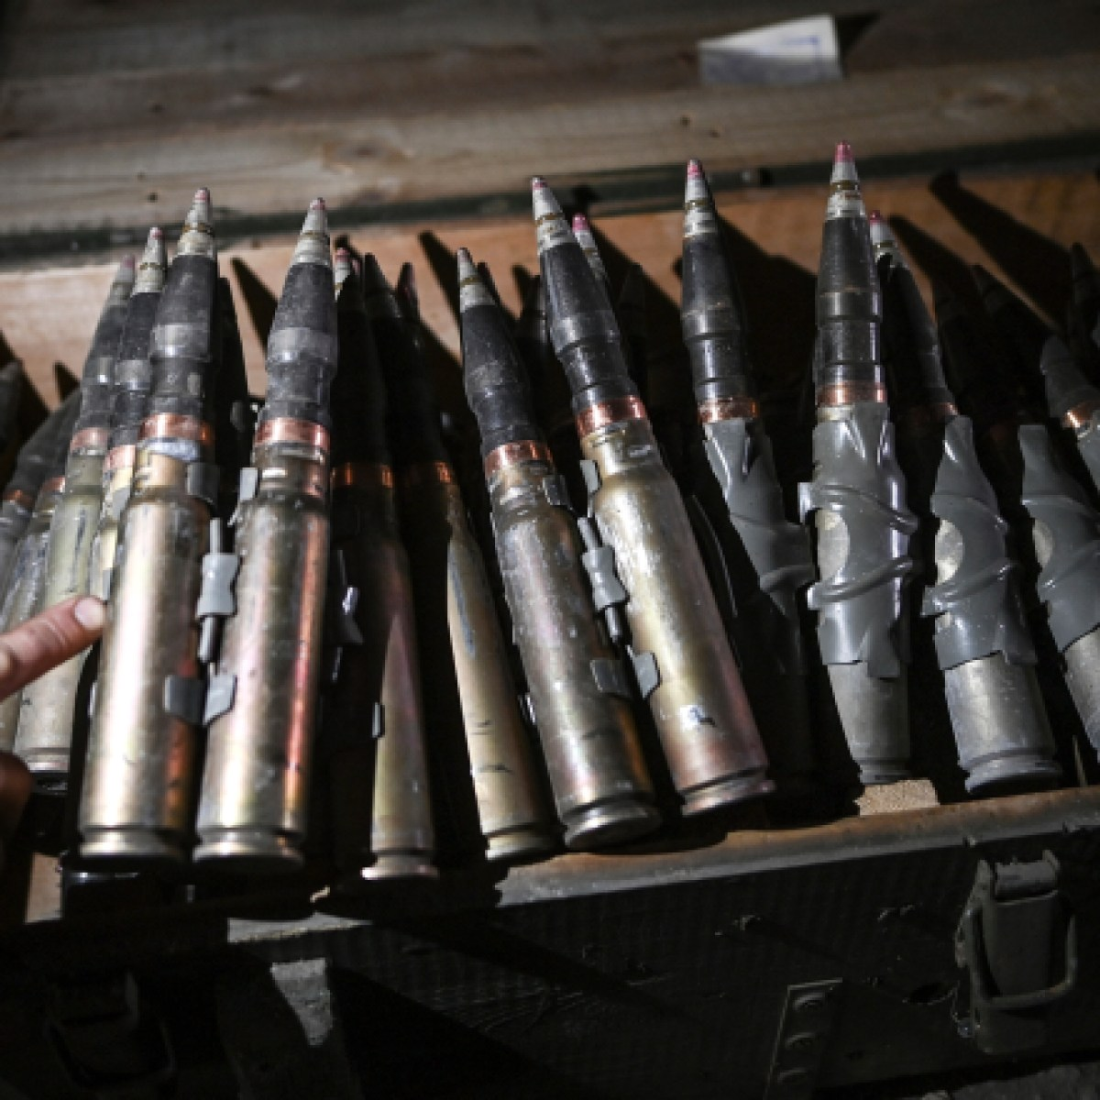
U.S. Helped Pakistan Get IMF Bailout With Secret Arms Deal for Ukraine, Leaked Documents Reveal
Ryan Grim, Murtaza Hussain
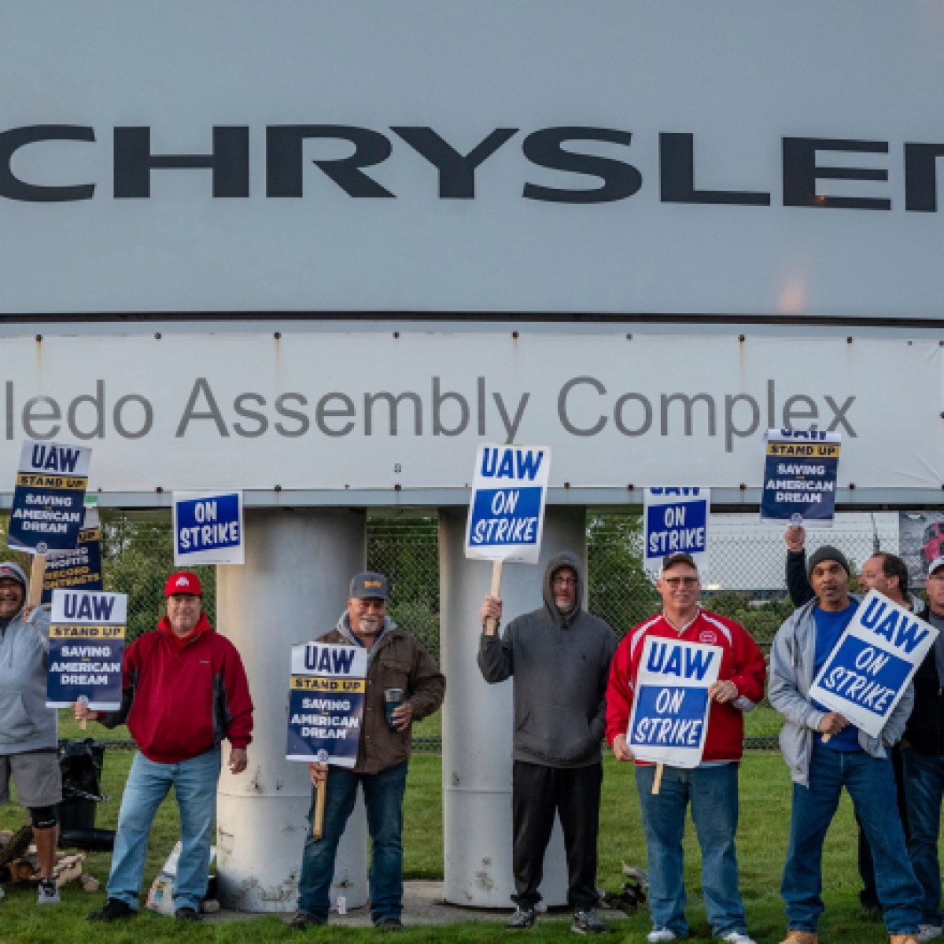
Confused Automakers Braced for Strike at the Wrong Plants
Daniel Boguslaw
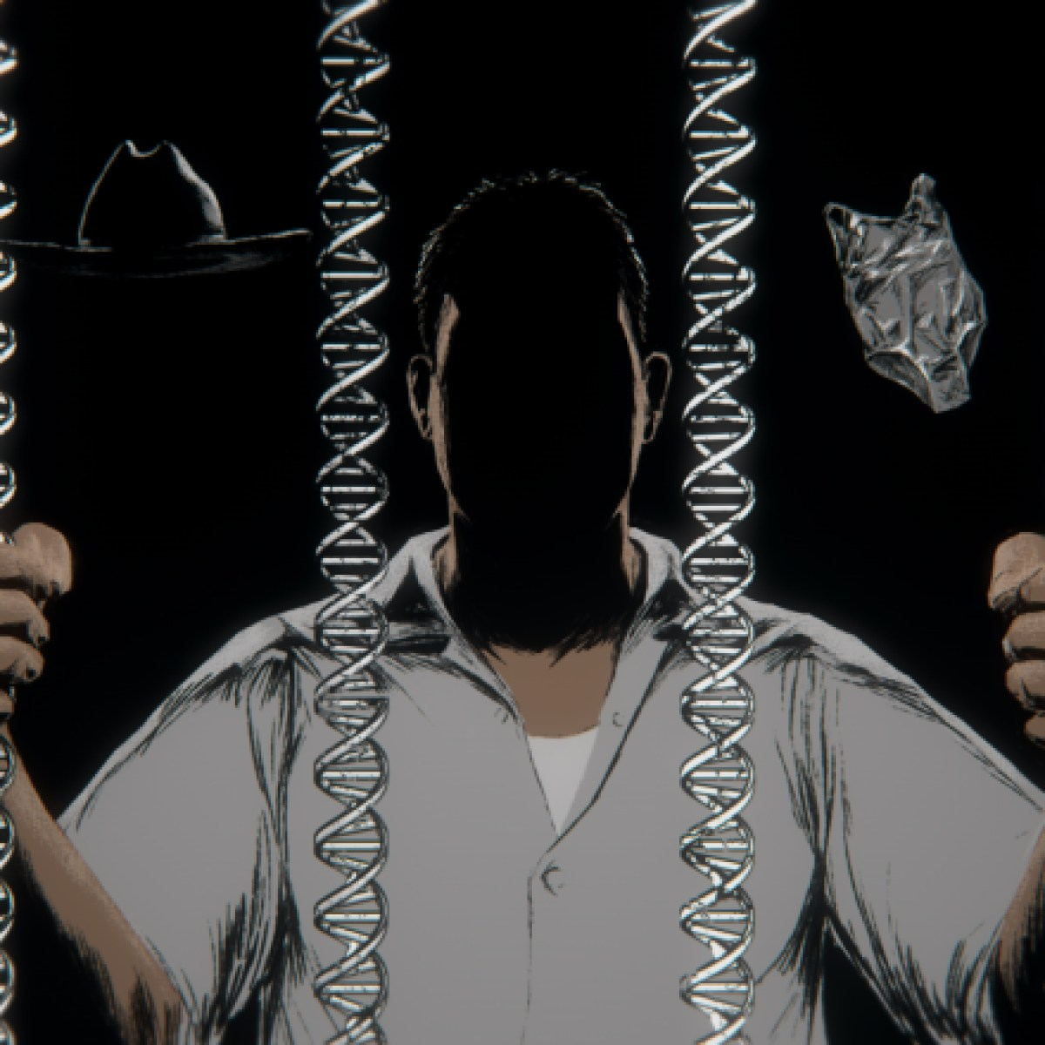
DNA Evidence Sent Anthony Sanchez to Death Row. But Did It Actually Solve the Crime?
Liliana Segura
Like any federal habeas lawyer in Oklahoma, Barrett was hamstrung by the work of Sanchez’s previous appellate attorneys, who themselves faced daunting procedural hurdles. In most death penalty states, a direct appeal and state post-conviction proceedings are two distinct phases of a capital case. When a direct appeal is denied, a person on death row has a couple of months to a year before their state post-conviction appeal is due. This is critical because the latter is the first opportunity for an appellate lawyer to investigate and present evidence outside of the trial record. When it comes to arguing that a client received ineffective assistance of counsel, often the most viable path to relief, an investigation is usually the best way to reveal a trial lawyer’s failures.
But in Oklahoma, the direct appeal and state post-conviction proceedings happen simultaneously. What’s more, the Court of Criminal Appeals has held that a claim of ineffective assistance of trial counsel must be raised on direct appeal. The practical effect is to prevent appellate lawyers from uncovering evidence that could have been presented at trial. “At the point we come in, if it wasn’t brought up by the lawyers ahead of us, it’s pretty much unusable by us,” Barrett said.
“There has to be another way that this has happened.”
Barrett and Coyne sought to build on the argument that there were alternate suspects. They met with Sanchez’s stepmother, Cathy Hodge, who shared documents that pointed to other potential perpetrators. “There has to be another way that this has happened,” she wrote. “I truly believe that Anthony is innocent.”
Among the documents were two letters from a man named Rocky Dodd, who was on death row when Sanchez arrived in McAlester. The two had known each other in Norman. The letters said that Dodd had spoken with his younger brother Shaun, who had information that Sanchez might be able to use. Around the time of Busken’s murder, Shaun said, two men named Tony and Scott showed up at his mother’s house looking nervous and “in a hurry to get out of town.” They asked Shaun to go to Tennessee with them and he did. There, Tony pawned a number of items, although Shaun did not know what they were. But he suspected the items might have belonged to Busken.
The Tony in question was Tony Reynolds, an acquaintance of Sanchez’s who had been identified by police as a “person of interest” in the Busken case. He had a long rap sheet and lived with his girlfriend in the apartment complex where Busken lived. They moved out shortly after the murder. An OCPD detective testified at trial that Reynolds had answered questions over the phone from Tennessee. Maddox, the lead detective, said they obtained DNA from Reynolds. But rumors persisted long after the trial that Reynolds was involved — and that he had pawned Busken’s opal ring and other belongings after leaving the state.
Dodd said it was possible that Shaun knew more than he’d shared in their phone conversation, which took place over the prison’s monitored line. “Are you wanting to have an investigator talk to Shaun?” Dodd asked Sanchez. “Just let me know and we can get it arranged.”
Barrett and Coyne filed a motion in federal court seeking an investigator. They planned to argue in Sanchez’s federal habeas petition that his trial attorneys had provided ineffective representation by failing to present any proof of his innocence, even though there was evidence pointing to alternate suspects. They also wanted to show that the trial attorneys failed to uncover “substantial mitigating evidence” that could have spared Sanchez a death sentence. Although the trial lawyers called some witnesses during the sentencing stage, they presented a limited view of the abuse and trauma Sanchez experienced as a child.
At the time of Sanchez’s trial, the American Bar Association had developed specific guidelines defining the importance of mitigation. Today, capital cases involve mitigation specialists — people trained to investigate a defendant’s family history to shed light on things like generational trauma, addiction, and violence. But Sanchez’s trial team did not include such a person. Family members mistrusted the lawyers; although a defense investigator interviewed Faulkner, Sanchez’s biological mother, she was “unable to provide the kind of testimony we needed,” according to a subsequent memo. Faulkner then asked to be released from her subpoena and threatened that if she wasn’t, she would “go to the DA and testify for their side.”
Federal District Judge Joe Heaton denied the motion for an investigator. Barrett and Coyne had failed to show why that was necessary, he wrote. Besides, the U.S. Supreme Court had recently decided a case that further restricted the right of petitioners to present new evidence in federal court. In light of this ruling, an investigator would “fail to serve any purpose.”
The lawyers’ resulting petition challenging Sanchez’s conviction was thin, largely reiterating points made by his previous attorneys. There was no new mitigation evidence or evidence pointing to different potential perpetrators. Although the petition mentioned Reynolds by name, it did not explain who he was or why he should have been investigated in the first place.
The following year, Sanchez’s petition was denied.
I FIRST TRAVELED to Oklahoma in January. At that time, Sanchez was set to be executed in April. But Drummond, the attorney general, asked the Court of Criminal Appeals to slow down the state’s frenzied execution schedule. After news broke that Sanchez’s date had been pushed to September, I wrote to get his reaction. He told me I was the first to share the news. He did not hear from his attorneys often.
At the time, Barrett and Coyne were still collaborating with Hood, Sanchez’s spiritual adviser. But after the Court of Criminal Appeals rejected the state post-conviction petition containing the affidavit from Beattie, Glen’s longtime girlfriend, the relationships fell apart. Sanchez and his family sided firmly with Hood. If not for his activism, they told me, no one would know about Sanchez’s case.
Much of my time in Norman was spent seeking records in the case. Some were at the Cleveland County Courthouse. Others were stored in dozens of boxes at Barrett’s office. Among the documents I hoped to review were the police reports, which the OCPD would not release, and additional records related to forensic testing. Barrett did not share them. Over time, our conversations gave me the sense that their contents would not necessarily help Sanchez’s case.
One of the questions I wanted to answer was not about Sanchez but about Busken. A woman who briefly worked as a defense investigator for Sanchez’s original trial attorney told me that she had uncovered evidence that Busken was involved in dealing drugs. She had found multiple witnesses who could testify to this. The red purse found at the lake was almost certainly Busken’s, she said.
The woman said she’d given all her materials to the trial lawyers with the Oklahoma Indigent Defense System. But they did not use what she found. This didn’t surprise her. Although presenting such evidence could have undermined the state’s case, it also could have backfired. “We go from this innocent ballerina OU student that does no wrong to ‘Oh my god, she’s into drugs,’” she said. It would have looked like they were attacking the victim.
Ryan James, a close friend of Busken’s, was the first to report her missing when she failed to meet him for a lunch date on December 20, 1996. James rejected the notion that Busken was dealing drugs. “She was the furthest thing from anything to do with any kind of drugs or alcohol,” he said. Barrett’s recollection was that Busken “was supposed to be a super clean, strait-laced lady.” He didn’t remember evidence pertaining to drugs, but he conceded that it could have been pursued by the trial lawyers if it offered an alternate theory of the crime. “If it helps the client, you have to use it, but you have to be very careful in how you use it.”
Documents in the case file show that at one point, Sanchez said Busken looked like a drug dealer he knew. When I asked Sanchez about this, he said he had no recollection of it. As for Reynolds, Sanchez said the two did not get along, but he did not know whether he was involved in Busken’s murder. “There’s a lot of people who say that he was bragging about it, but I don’t know,” Sanchez said. “I wouldn’t put it past him.” Reynolds did not respond to multiple messages seeking comment.
In the months I spent investigating the case, I was struck by the number of people who believed Sanchez was innocent. Most of his friends and family members said that he was not capable of murder but his father definitely was. Still, many found it hard to believe that Glen would have allowed his son to be executed for a crime he himself committed. And they balked at some of the wild claims made by the activists, like the open speculation that Glen might have been a serial killer.
I also came to wonder what, exactly, Glen told Beattie before he died. In our conversation, she described more insinuations than confessions. But the more she spoke publicly, the more detailed and vivid her accounts became. With no other direct proof of Glen’s involvement, it was impossible to conclude that he was responsible for the crime. But as in so many cases I’ve written about, it also seemed clear that Sanchez was profoundly shaped by his father in ways that led him to death row.
When I first asked Sanchez how he felt when the attorney general’s office released Glen’s DNA results in February, he said he felt “relieved.” He didn’t want his father implicated in the crime. “Don’t get me wrong, I know my dad had his flaws,” he said. “But if he wasn’t drinking, he was a really actually good guy.” Glen’s alcoholism made him act “like an idiot,” Sanchez said. “He was very violent.” But Sanchez had also been accustomed to it from an early age. “I mean, that’s my dad … that’s what I grew up knowing. I didn’t know no different.”
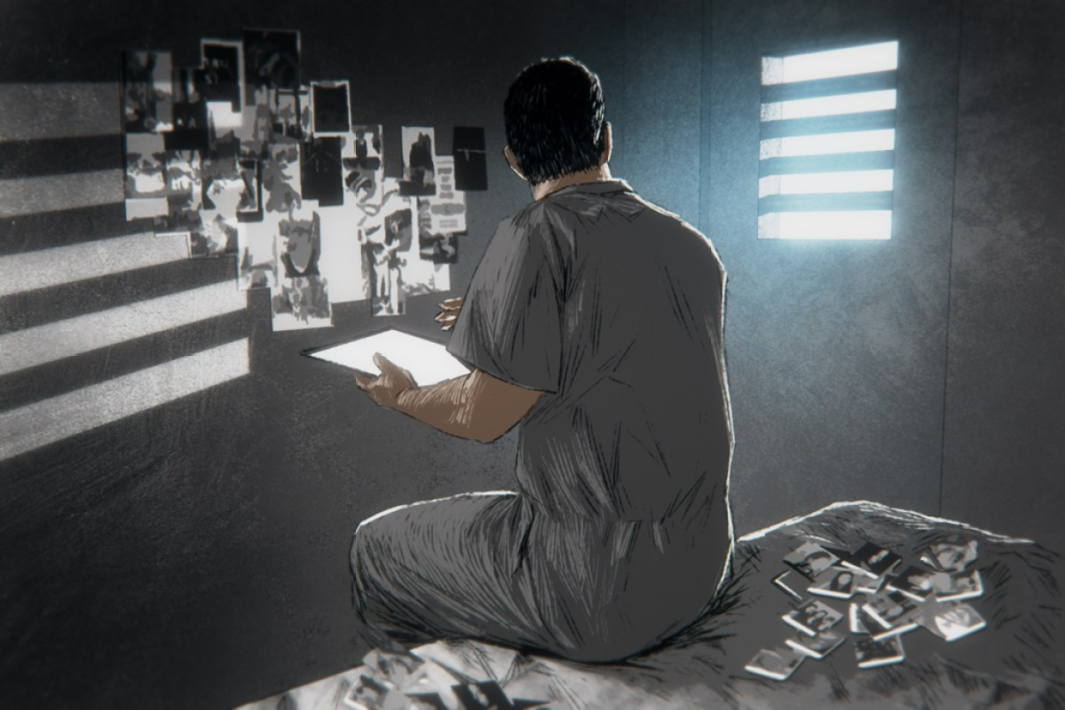
ON SEPTEMBER 13, the day before Sanchez was transferred to death watch, he went outside for the last time. He had already given away his belongings — mostly clothes and art supplies he used to send paintings and cards to his family over the years. Now he just had to pack up his cell, including the photos that decorated the wall. “I have a lot of family photos,” he said. “I have my three kids. I have my grandbabies. I have my mom, my dad.”
It was a beautiful day in McAlester, he told me. It had been nice to see other people, even if he could only talk to them inside a cage. The recreation yard looked like a “dog pound,” he said, but he was used to it. He’d been at McAlester for almost his whole adult life. “I know a lot of people in prison,” he said. Some of them were pretty cool. But “if I was to get out today, I would not take none of these people home.”
For a man so close to execution, Sanchez sounded calm, if not particularly hopeful. There had been a hearing in Oklahoma City earlier that day about the boxes of files in Sanchez’s case. Heaton, the same judge who denied him an investigator in 2011, had agreed to allow Sanchez’s new attorney access to the records. But he also denied a request for a stay of execution. There was no way the lawyer would have time to go through the boxes before Sanchez was scheduled to die.
Sanchez was looking forward to a visit from Hodge. She was supposed to bring one of his daughters and a grandchild he’d never met. But he refused to put any family or friends on the witness list for his execution: “I don’t want this being the last vision of me for people that I love.”
We talked about what he might say when it came time for his last words. He said he wanted to acknowledge the Buskens. The worst thing about his decades on death row was that it kept him away from his children, he said. The Buskens had lost their child too. “What happened to their daughter was a tragedy. It should have never happened. And if this is what they need to feel closure, then I hope it helps.” Still, he said, “I didn’t kill Juli Busken.”
Now he mostly seemed to want to shut out the world. For the past few weeks, he’d been watching movies on his tablet. “I can put my earphones in and turn it all the way up and I don’t hear nothing.” He’d watched the “Lord of the Rings” series and “The Fast and the Furious.” And he’d watched “Harry Potter,” but he didn’t like it. “I don’t believe in magic like that.”

