THE EDITORIAL BOARD

To Serve His Country, President Biden Should Leave the Race
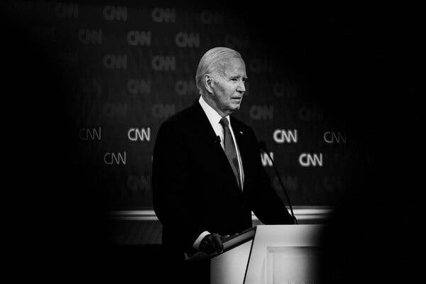
Damon Winter/The New York Times
Credit...
- Share full article
- 4.7K
By The Editorial Board
The editorial board is a group of opinion journalists whose views are informed by expertise, research, debate and certain longstanding values. It is separate from the newsroom.
Leer en español
President Biden has repeatedly and rightfully described the stakes in this November’s presidential election as nothing less than the future of American democracy.
Donald Trump has proved himself to be a significant jeopardy to that democracy — an erratic and self-interested figure unworthy of the public trust. He systematically attempted to undermine the integrity of elections. His supporters have described, publicly, a 2025 agenda that would give him the power to carry out the most extreme of his promises and threats. If he is returned to office, he has vowed to be a different kind of president, unrestrained by the checks on power built into the American political system.
Mr. Biden has said that he is the candidate with the best chance of taking on this threat of tyranny and defeating it. His argument rests largely on the fact that he beat Mr. Trump in 2020. That is no longer a sufficient rationale for why Mr. Biden should be the Democratic nominee this year.
At Thursday’s debate, the president needed to convince the American public that he was equal to the formidable demands of the office he is seeking to hold for another term. Voters, however, cannot be expected to ignore what was instead plain to see: Mr. Biden is not the man he was four years ago.
The president appeared on Thursday night as the shadow of a great public servant. He struggled to explain what he would accomplish in a second term. He struggled to respond to Mr. Trump’s provocations. He struggled to hold Mr. Trump accountable for his lies, his failures and his chilling plans. More than once, he struggled to make it to the end of a sentence.

Mr. Biden has been an admirable president. Under his leadership, the nation has prospered and begun to address a range of long-term challenges, and the wounds ripped open by Mr. Trump have begun to heal. But the greatest public service Mr. Biden can now perform is to announce that he will not continue to run for re-election.
As it stands, the president is engaged in a reckless gamble. There are Democratic leaders better equipped to present clear, compelling and energetic alternatives to a second Trump presidency. There is no reason for the party to risk the stability and security of the country by forcing voters to choose between Mr. Trump’s deficiencies and those of Mr. Biden. It’s too big a bet to simply hope Americans will overlook or discount Mr. Biden’s age and infirmity that they see with their own eyes.
If the race comes down to a choice between Mr. Trump and Mr. Biden, the sitting president would be this board’s unequivocal pick. That is how much of a danger Mr. Trump poses. But given that very danger, the stakes for the country and the uneven abilities of Mr. Biden, the United States needs a stronger opponent to the presumptive Republican nominee. To make a call for a new Democratic nominee this late in a campaign is a decision not taken lightly, but it reflects the scale and seriousness of Mr. Trump’s challenge to the values and institutions of this country and the inadequacy of Mr. Biden to confront him.
Ending his candidacy would be against all of Mr. Biden’s personal and political instincts. He has picked himself up from tragedies and setbacks in the past and clearly believes he can do so again. Supporters of the president are already explaining away Thursday’s debate as one data point compared with three years of accomplishments. But the president’s performance cannot be written off as a bad night or blamed on a supposed cold, because it affirmed concerns that have been mounting for months or even years. Even when Mr. Biden tried to lay out his policy proposals, he stumbled. It cannot be outweighed by other public appearances because he has limited and carefully controlled his public appearances.
It should be remembered that Mr. Biden challenged Mr. Trump to this verbal duel. He set the rules, and he insisted on a date months earlier than any previous general election debate. He understood that he needed to address longstanding public concerns about his mental acuity and that he needed to do so as soon as possible.
The truth Mr. Biden needs to confront now is that he failed his own test.
In polls and interviews, voters say they are seeking fresh voices to take on Mr. Trump. And the consolation for Mr. Biden and his supporters is that there is still time to rally behind a different candidate. While Americans are conditioned to the long slog of multiyear presidential elections, in many democracies, campaigns are staged in the space of a few months.
It is a tragedy that Republicans themselves are not engaged in deeper soul-searching after Thursday’s debate. Mr. Trump’s own performance ought to be regarded as disqualifying. He lied brazenly and repeatedly about his own actions, his record as president and his opponent. He described plans that would harm the American economy, undermine civil liberties and fray America’s relationships with other nations. He refused to promise that he would accept defeat, returning instead to the kind of rhetoric that incited the Jan. 6 attack on Congress.
The Republican Party, however, has been co-opted by Mr. Trump’s ambitions. The burden rests on the Democratic Party to put the interests of the nation above the ambitions of a single man.
Democrats who have deferred to Mr. Biden must now find the courage to speak plain truths to the party’s leader. The confidants and aides who have encouraged the president’s candidacy and who sheltered him from unscripted appearances in public should recognize the damage to Mr. Biden’s standing and the unlikelihood that he can repair it.
Mr. Biden answered an urgent question on Thursday night. It was not the answer that he and his supporters were hoping for. But if the risk of a second Trump term is as great as he says it is — and we agree with him that the danger is enormous — then his dedication to this country leaves him and his party only one choice.
The clearest path for Democrats to defeat a candidate defined by his lies is to deal truthfully with the American public: acknowledge that Mr. Biden can’t continue his race, and create a process to select someone more capable to stand in his place to defeat Mr. Trump in November.
It is the best chance to protect the soul of the nation — the cause that drew Mr. Biden to run for the presidency in 2019 — from the malign warping of Mr. Trump. And it is the best service that Mr. Biden can provide to a country that he has nobly served for so long.

