Two Women Fell Sick From the Coronavirus. One Survived.
By Sui-Lee Wee and Vivian Wang
The young medical professionals, who worked long hours on the front lines in Wuhan, first came down with fevers. Within weeks, both were in hospital beds, hooked up to IVs or oxygen machines.
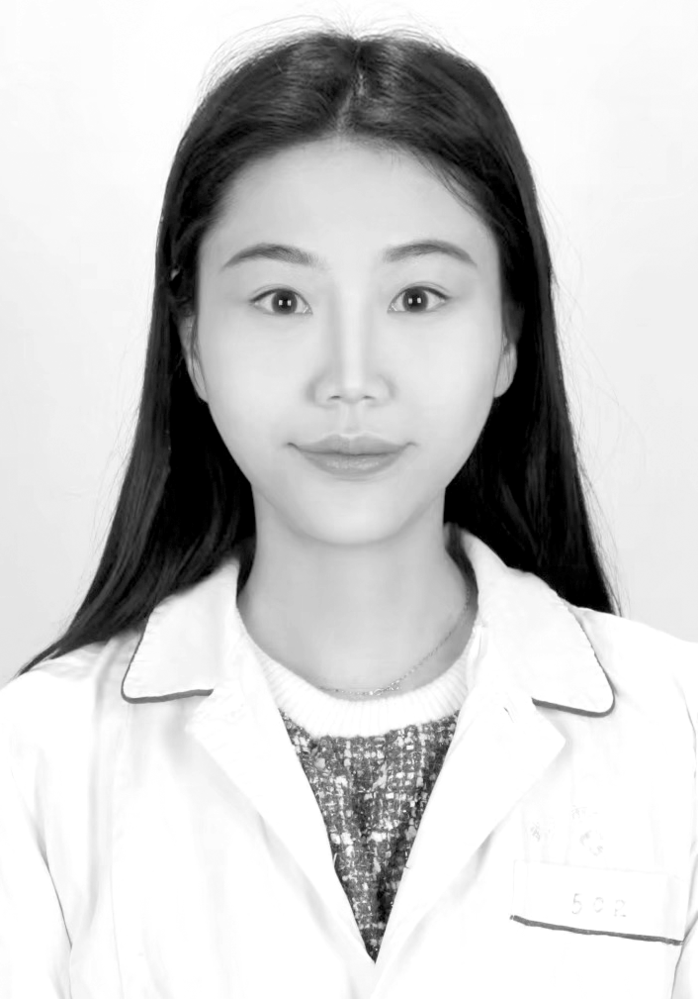
Deng Danjing

Xia Sisi
THE YOUNG MOTHERS didn’t tell their children they had the coronavirus. Mama was working hard, they said, to save sick people.
Instead, Deng Danjing and Xia Sisi were fighting for their lives in the same hospitals where they worked, weak from fever and gasping for breath. Within a matter of weeks, they had gone from healthy medical professionals on the front lines of the epidemic in Wuhan, China, to coronavirus patients in critical condition.
The world is still struggling to fully understand the new virus, its symptoms, spread and sources. For some, it can feel like a common cold. For others, it is a deadly infection that ravages the lungs and pushes the immune system into overdrive, destroying even healthy cells. The difference between life and death can depend on the patient’s health, age and access to care — although not always.
The virus has infected more than 132,000 globally. The vast majority of cases have been mild, with limited symptoms. But the virus’s progression can be quick, at which point the chances of survival plummet. Around 68,000 people have recovered, while nearly 5,000 have died.
The fates of Ms. Deng and Dr. Xia reflect the unpredictable nature of a virus that affects everyone differently, at times defying statistical averages and scientific research.
As the new year opened in China, the women were leading remarkably similar lives. Both were 29 years old. Both were married, each with a young child on whom she doted.
Ms. Deng, a nurse, had worked for three years at Wuhan No. 7 Hospital, in the city where she grew up and where the coronavirus pandemic began. Her mother was a nurse there, too, and in their free time they watched movies or shopped together. Ms. Deng’s favorite activity was playing with her two pet kittens, Fat Tiger and Little White, the second of which she had rescued just three months before falling sick.
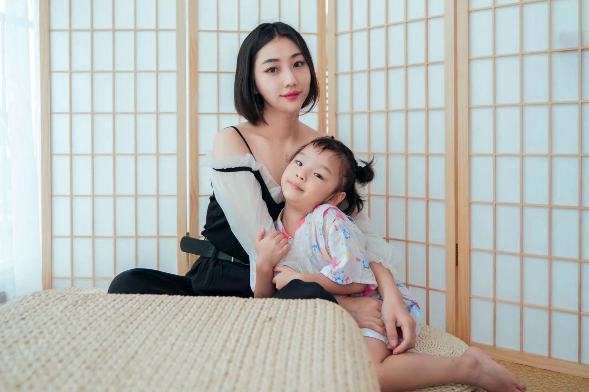
Before the epidemic, Ms. Deng had promised to take her 5-year-old daughter to the aquarium.
Dr. Xia, a gastroenterologist, also came from a family of medical professionals. As a young child, she had accompanied her mother, a nurse, to work. She joined the Union Jiangbei Hospital of Wuhan in 2015 and was the youngest doctor in her department. Her colleagues called her “Little Sisi” or “Little Sweetie” because she always had a smile for them. She loved Sichuan hot pot, a dish famous for its numbingly spicy broth.
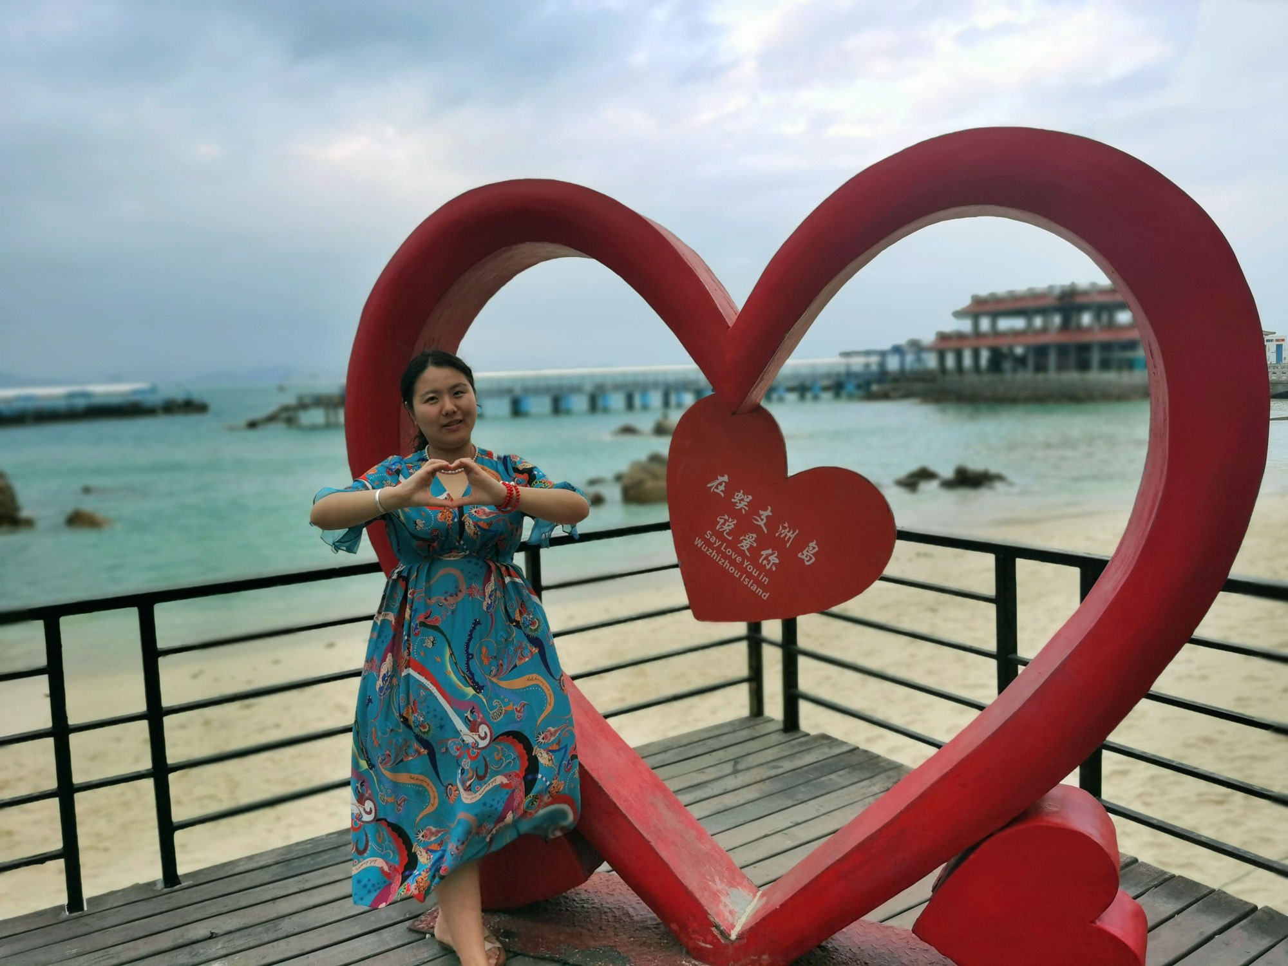
Dr. Xia loved traveling with her family. She had recently visited Wuzhizhou Island, a resort destination off the southern coast of China.
When a mysterious new virus struck the city, the women began working long hours, treating a seemingly endless flood of patients. They took precautions to protect themselves. But they succumbed to the infection, the highly contagious virus burrowing deep into their lungs, causing fever and pneumonia. In the hospital, each took a turn for the worse.
One recovered. One did not.
Symptoms
Onset of virus & hospitalization

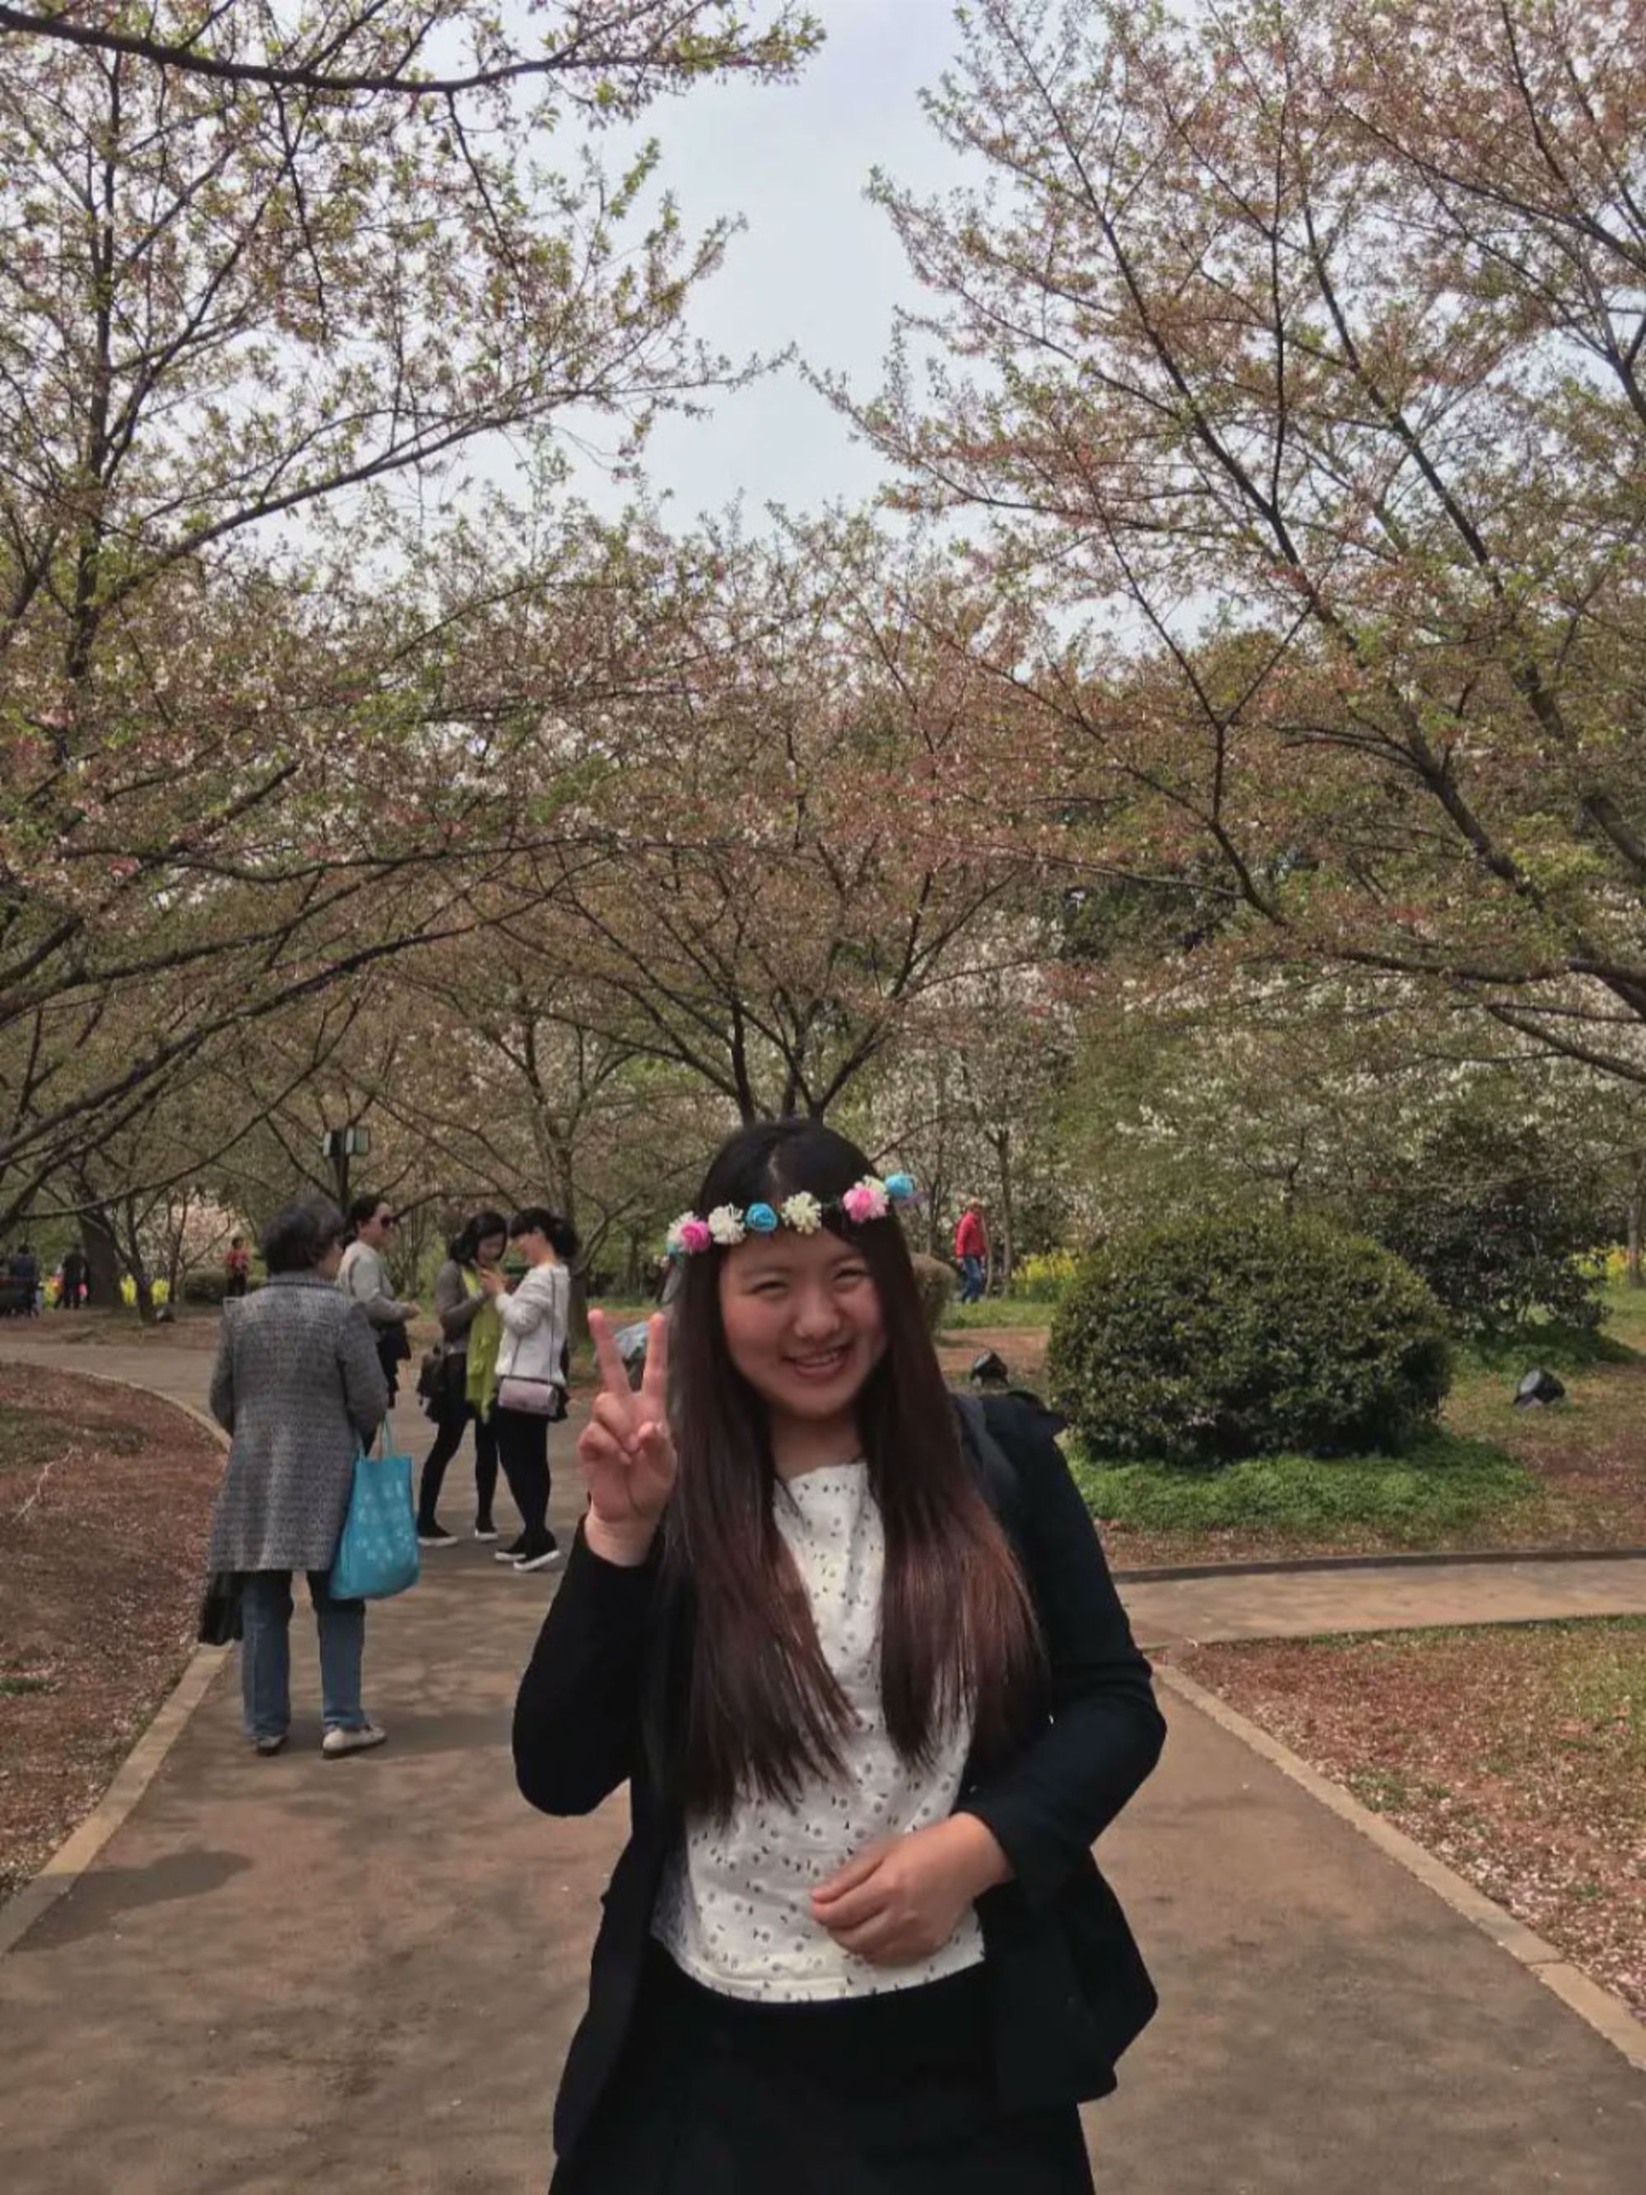
Ms. Deng, a Wuhan native who liked makeup and hanging out with her friends at Starbucks, had worked for eight years as a nurse, following her mother’s career path. Dr. Xia, who was a favorite among elderly patients, spent long hours at the hospital helping to treat people suspected of having the virus.
The symptoms came on suddenly.
Dr. Xia had ended her night shift on Jan. 14 when she was called back to attend to a patient — a 76-year-old man with suspected coronavirus. She dropped in frequently to check in on him.
Five days later, she started feeling unwell. Exhausted, she took a two-hour nap at home, then checked her temperature: It was 102 degrees. Her chest felt tight.
A few weeks later, in early February, Ms. Deng, the nurse, was preparing to eat dinner at the hospital office, when the sight of food left her nauseated. She brushed the feeling aside, figuring she was worn out by work. She had spent the beginning of the outbreak visiting the families of confirmed patients and teaching them to disinfect their homes.
After forcing down some food, Ms. Deng went home to shower, and then, feeling groggy, took a nap. When she woke up, her temperature was 100 degrees.
Fever is the most common symptom of the coronavirus, seen in nearly 90 percent of patients. About a fifth of people experience shortness of breath, often including a cough and congestion. Many also feel fatigued.
Both women rushed to see doctors. Chest scans showed damage to their lungs, a tell-tale sign of the coronavirus that is present in at least 85 percent of patients, according to one study.
In particular, Ms. Deng’s CT scan showed what the doctor called ground-glass opacities on her lower right lung — hazy spots that indicated fluid or inflammation around her airways.
The hospital had no space, so Ms. Deng checked into a hotel to avoid infecting her husband and 5-year-old daughter. She sweated through the night. At one point, her calf twitched. In the morning, she was admitted to the hospital. Her throat was swabbed for a genetic test, which confirmed she had the coronavirus.
Her room in a newly opened staff ward was small, with two cots and a number assigned to each one. Ms. Deng was in bed 28. Her roommate was a colleague who had also been diagnosed with the virus.
At Jiangbei Hospital, 18 miles away, Dr. Xia was struggling to breathe. She was placed in an isolation ward, treated by doctors and nurses who wore protective suits and safety goggles. The room was cold.
Treatment
Day 1, hospitalization begins
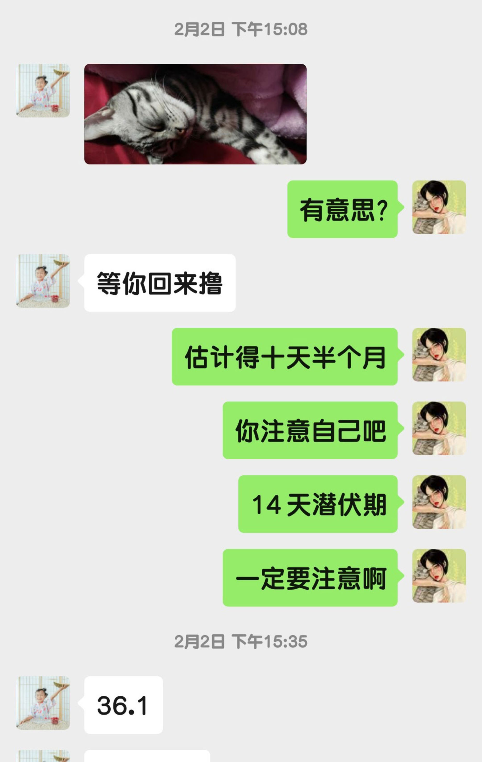
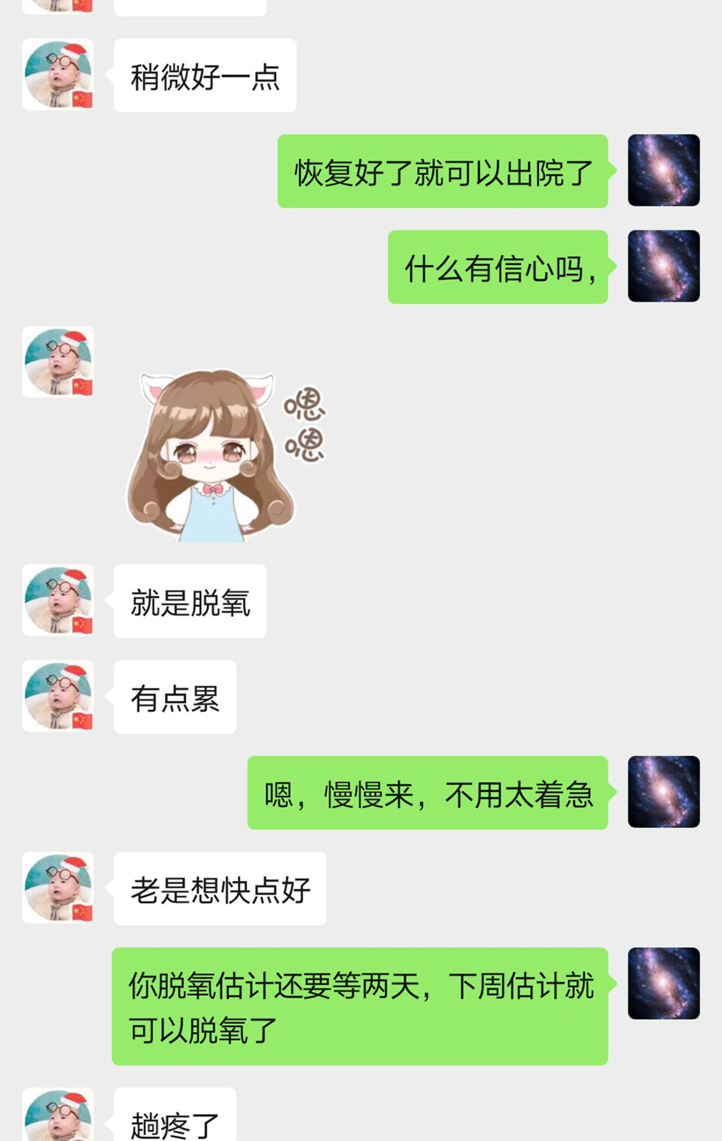
After Ms. Deng was admitted to the hospital, she told her husband to take care of himself, reminding him of the 14-day incubation period for the virus. He assured her his temperature was normal. Dr. Xia asked her husband about the possibility of getting off oxygen therapy soon. He responded optimistically.
When Ms. Deng checked into the hospital, she tried to stay upbeat. She texted her husband, urging him to wear a mask even at home, and to clean all their bowls and chopsticks with boiling water or throw them out.
Her husband sent a photograph of one of their cats at home. “Waiting for you to come back,” he said.
“I think it’ll take 10 days, half a month,” she replied. “Take care of yourself.”
There is no known cure for Covid-19, the official name for the disease caused by the new coronavirus. So doctors rely on a cocktail of other medicines, mostly antiviral drugs, to alleviate the symptoms.
Ms. Deng’s doctor prescribed a regimen of arbidol, an antiviral medicine used to treat the flu in Russia and China; Tamiflu, another flu medicine more popular internationally; and Kaletra, an HIV medicine thought to block the replication of the virus. Ms. Deng was taking at least 12 pills a day, as well as traditional Chinese medicine.
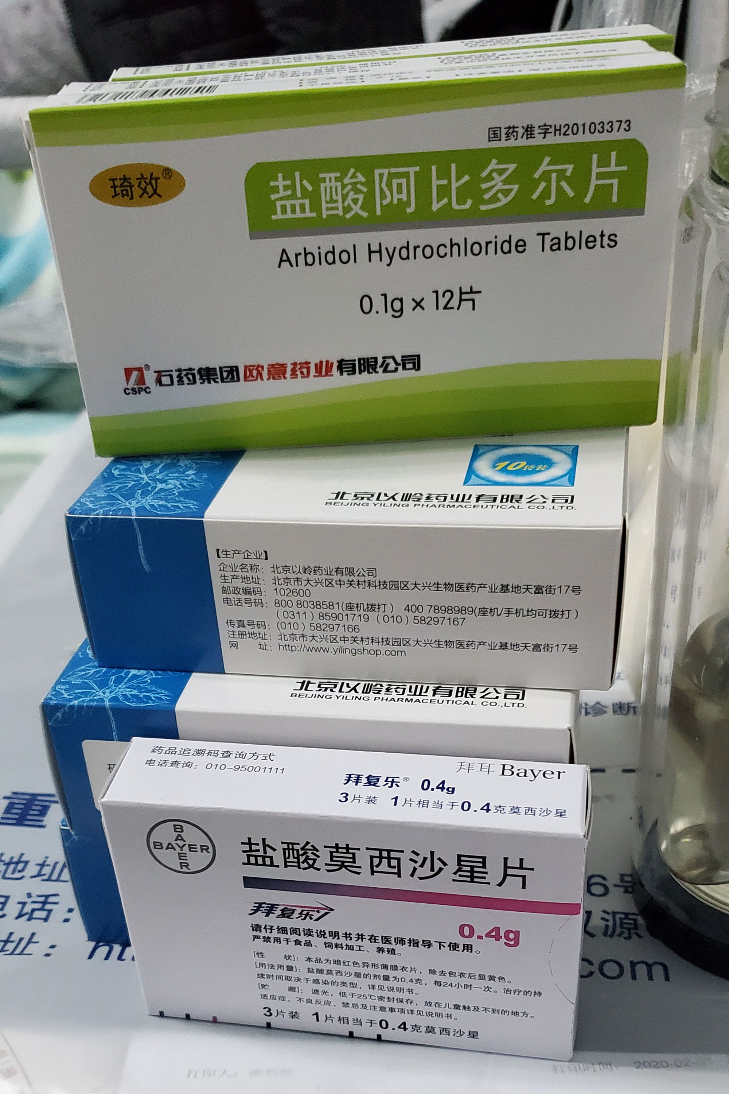
Arbidol, an antiviral medication, was prescribed to help alleviate Ms. Deng’s symptoms.
Despite her optimism, she grew weaker. Her mother delivered home-cooked food outside the ward, but she had no appetite. To feed her, a nurse had to come at 8:30 each morning to hook her up to an intravenous drip with nutrients. Another drip pumped antibodies into her bloodstream, and still another antiviral medicine.
Dr. Xia, too, was severely ill, but appeared to be slowly fighting the infection. Her fever had subsided after a few days, and she began to breathe more easily after being attached to a ventilator.
Her spirits lifted. On Jan. 25, she told her colleagues she was recovering.
“💪💪💪💪💪💪 I will return to the team soon,” she texted them on WeChat.
“We need you the most,” one of her colleagues responded.
In early February, Dr. Xia asked her husband, Wu Shilei, also a doctor, whether he thought she could get off oxygen therapy soon.
“Take it easy. Don’t be too anxious,” he replied on WeChat. He told her that the ventilator could possibly be removed by the following week.
“I keep on thinking about getting better soon,” Dr. Xia responded.
There was reason to believe she was on the mend. After all, most coronavirus patients recover.
Later, Dr. Xia tested negative twice for the coronavirus. She told her mother she expected to be discharged on Feb. 8.
Decline
Day 4 to 16 after hospitalization
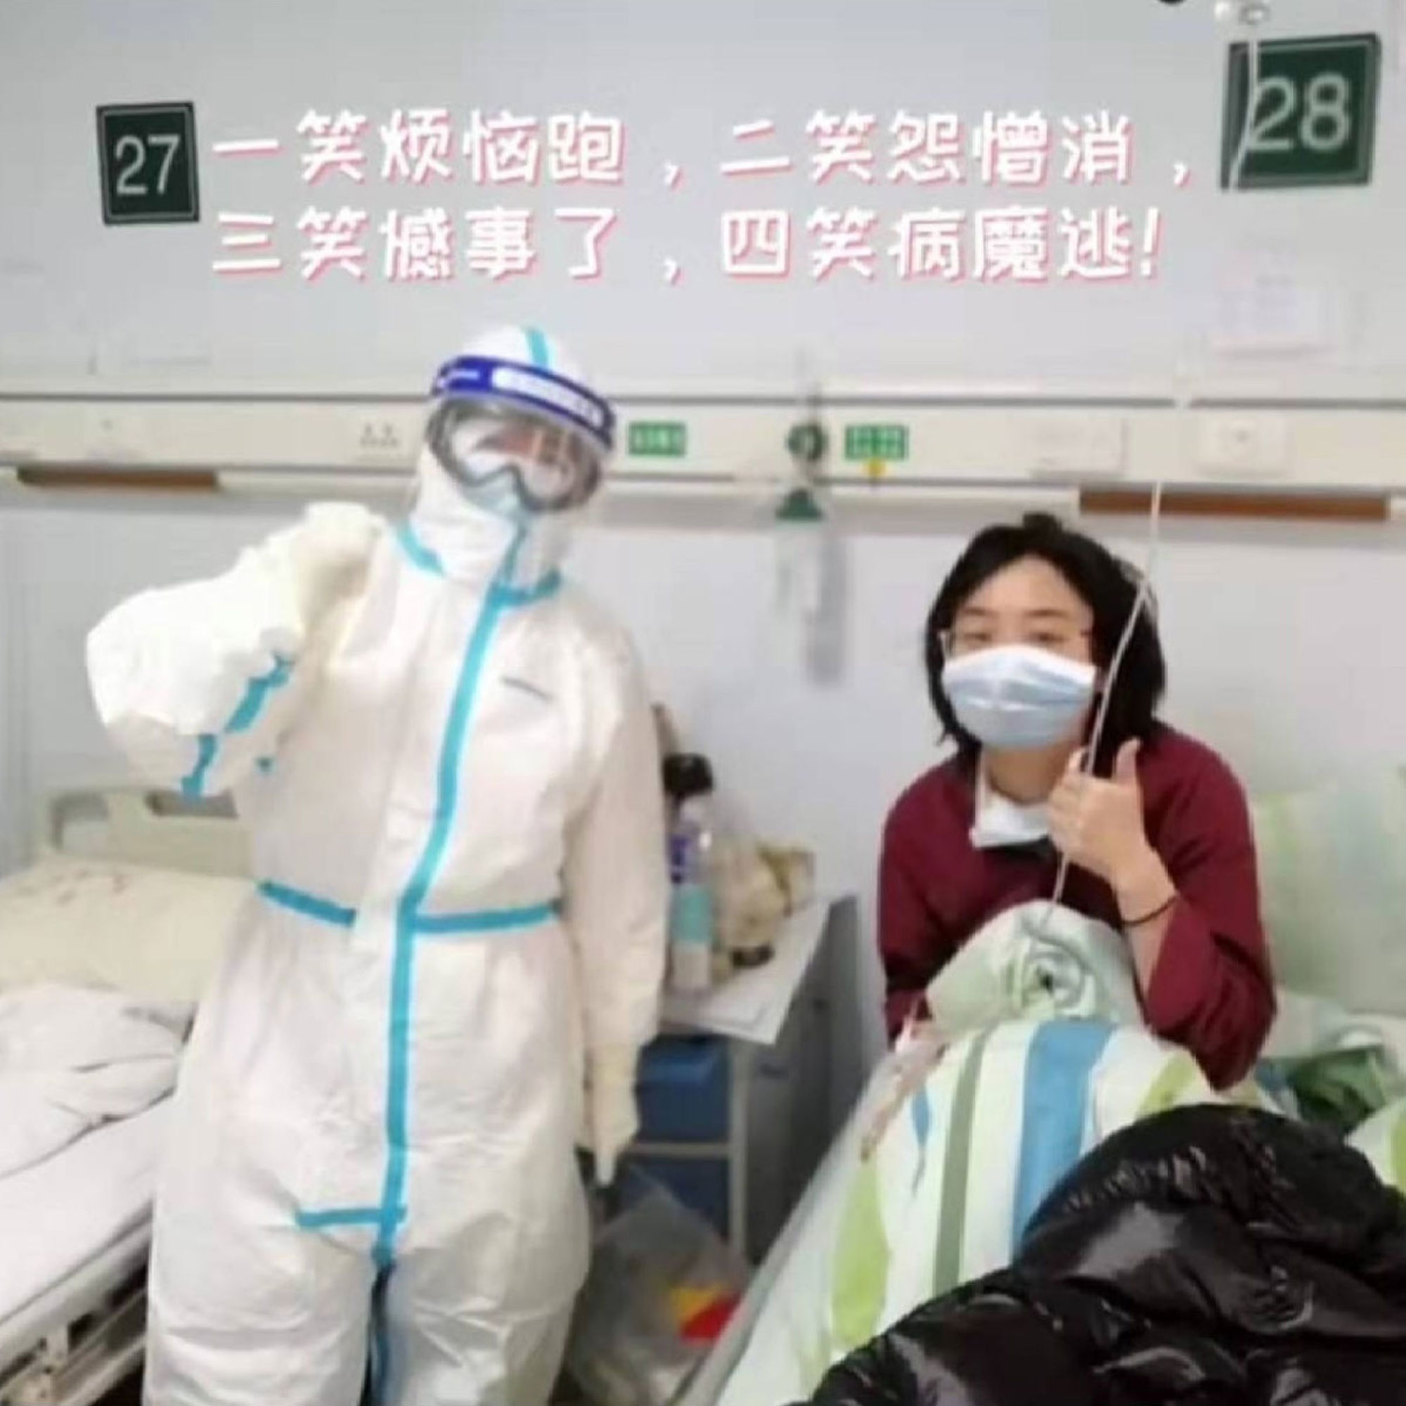
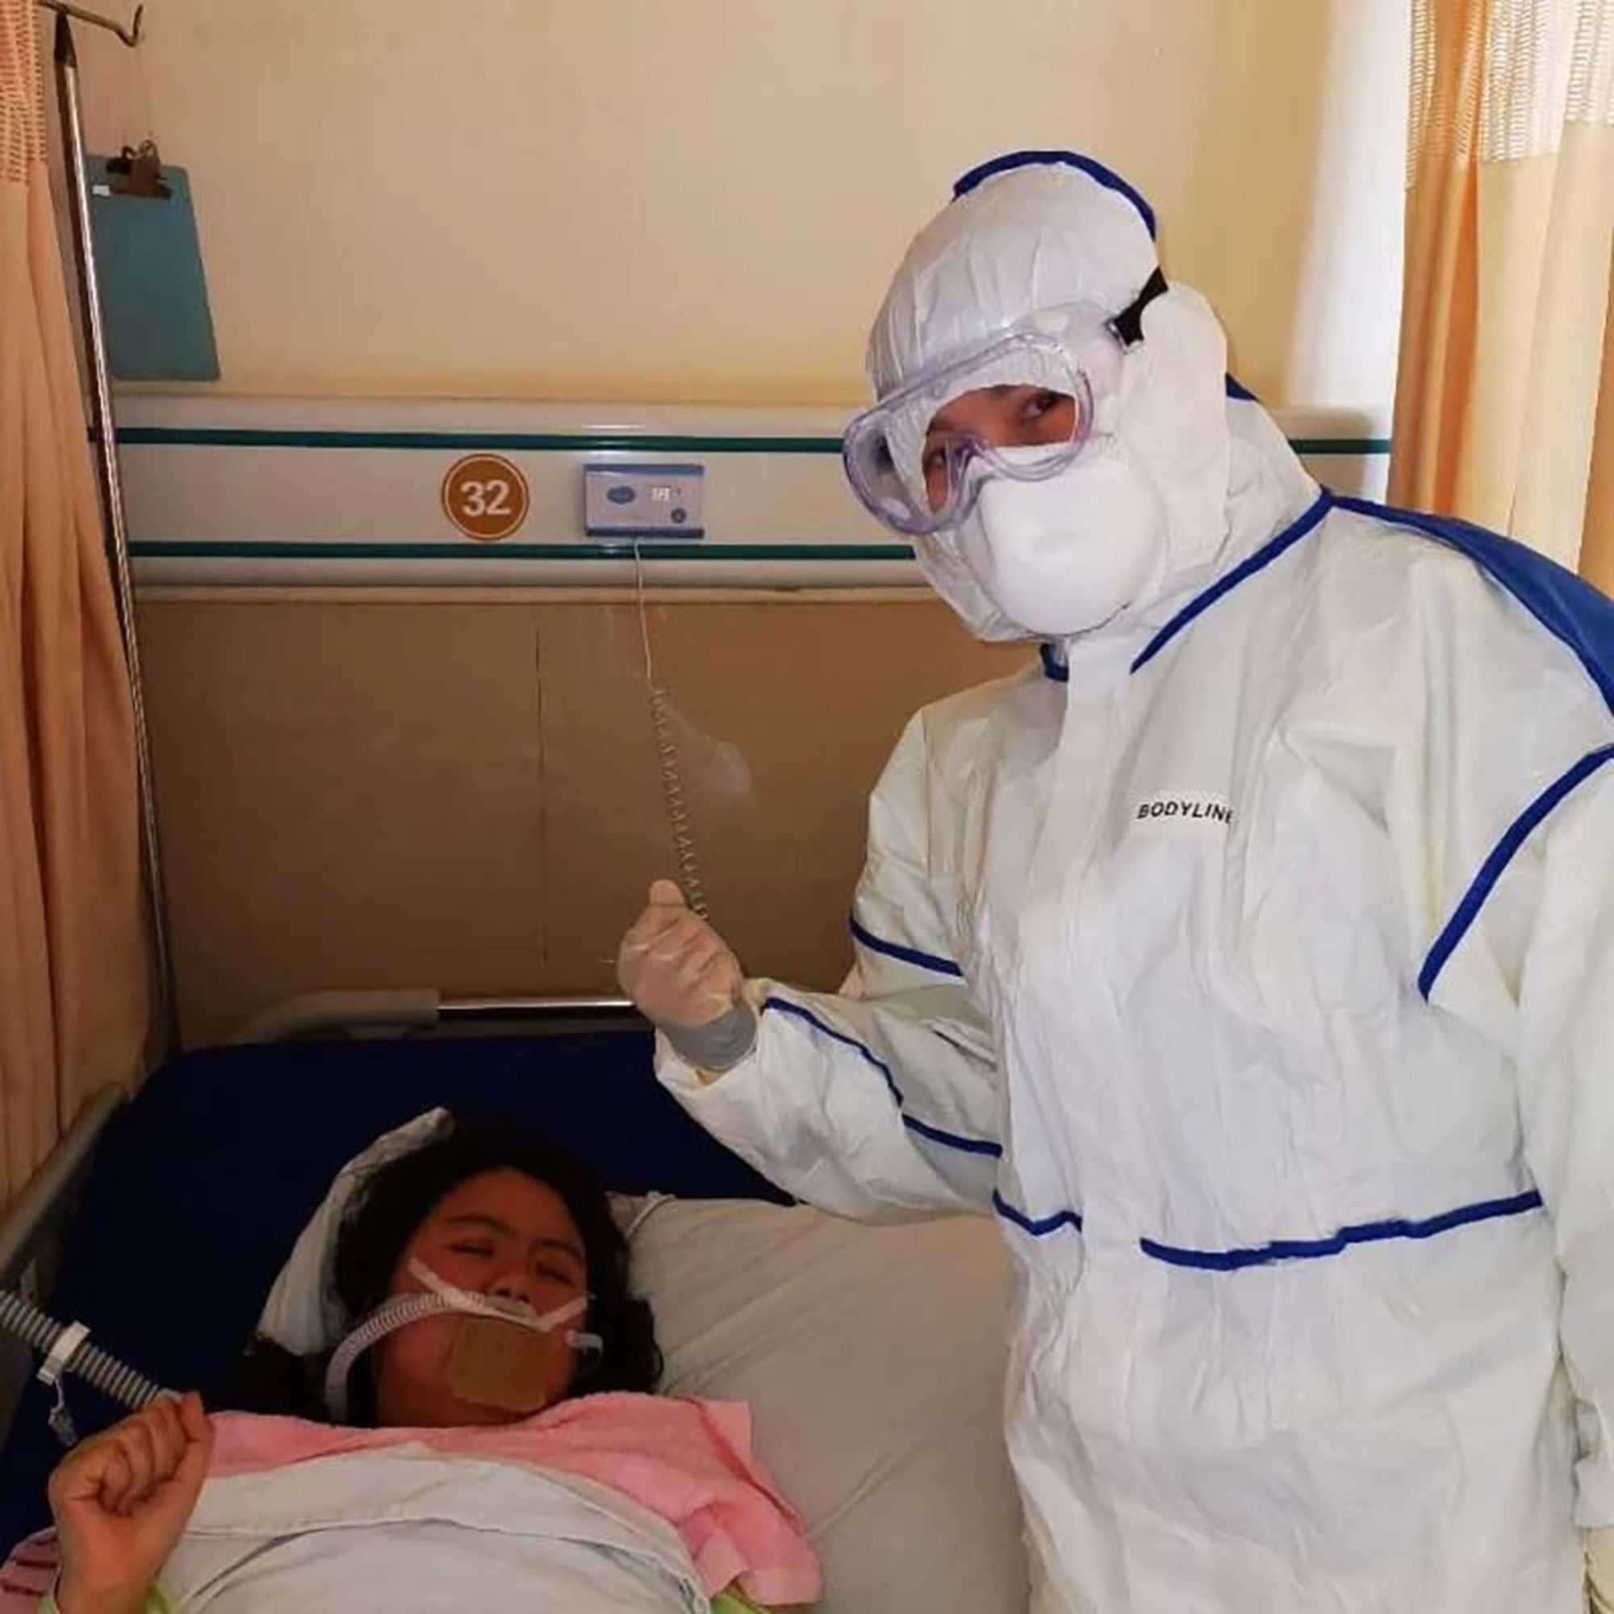
In the hospital, Ms. Deng’s only contacts were her roommate and the medical staff. She added a caption to a photo with her doctor, saying laughter would help chase the illness away. Two tests indicated that Dr. Xia was free of the virus, but her condition suddenly deteriorated.
By Ms. Deng’s fourth day in the hospital, she could no longer pretend to be cheerful. She was vomiting, having diarrhea and relentlessly shivering.
Her fever jumped to 101.3 degrees. Early in the morning on Feb. 5, she woke from a fitful sleep to find the medicine had done nothing to lower her temperature. She cried. She said she was classified as critically ill.
The next day, she threw up three times, until she was left spitting white bubbles. She felt she was hallucinating. She could not smell or taste, and her heart rate slowed to about 50 beats per minute.
On a phone call, Ms. Deng’s mother tried to reassure her that she was young and otherwise healthy, and that the virus would pass like a bad cold. But Ms. Deng feared otherwise. “I felt like I was walking on the edge of death,” she wrote in a social media post from her hospital bed the next day.
China defines a critically ill patient as someone with respiratory failure, shock or organ failure. Around 5 percent of infected patients became critical in China, according to one of the largest studies to date of coronavirus cases. Of those, 49 percent died. (Those rates may eventually change once more cases are examined around the world.)
While Dr. Xia appeared to be recovering, she was still terrified of dying. Testing can be faulty, and negative results don’t necessarily mean patients are in the clear.
She asked her mother for a promise: Could her parents look after her 2-year-old son if she didn’t make it?
Hoping to dispel her anxiety with humor, her mother, Jiang Wenyan, chided her: “He’s your own son. Don’t you want to raise him yourself?”
Dr. Xia also worried about her husband. Over video chat, she urged him to put on protective equipment at the hospital where he worked. “She said she would wait for me to return safely,” he said, “and go to the frontline again with me when she recovered.”
Then came the call. Dr. Xia’s condition had suddenly deteriorated. In the early hours of Feb. 7, her husband rushed to the emergency room.
Her heart had stopped.
Recovery
Day 17 after hospitalization
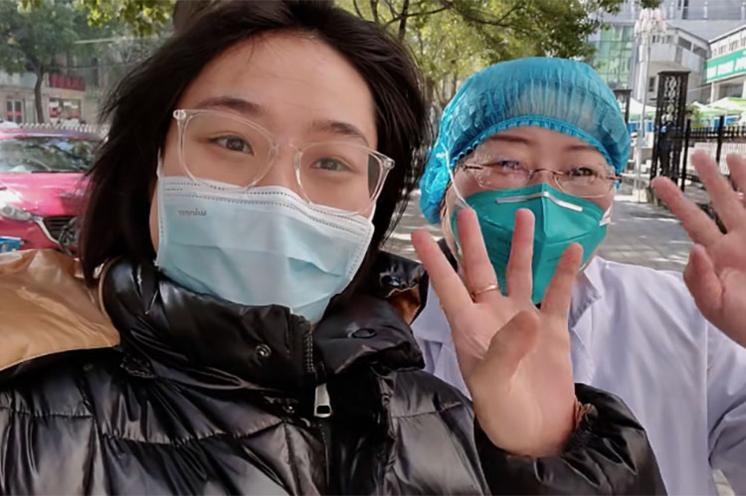
After being discharged, Ms. Deng briefly got to see her mother, who had been working at the hospital during her illness. She then went home to isolate herself for two weeks.
In most cases, the body repairs itself. The immune system produces enough antibodies to clear the virus, and the patient recovers.
By the end of Ms. Deng’s first week in the hospital, her fever had receded. She could eat the food her mother delivered. On Feb. 10, as her appetite returned, she looked up photos of meat skewers online and posted them wishfully to social media.
On Feb. 15, her throat swab came back negative for the virus. Three days later, she tested negative again. She could go home.
Ms. Deng met her mother briefly at the hospital’s entrance. Then, because Wuhan remained locked down, without taxis or public transportation, she walked home alone.
“I felt like a little bird,” she recalled. “My freedom had been returned to me.”
She had to isolate at home for 14 days. Her husband and daughter stayed with her parents.
At home, she threw out her clothing, which she had been wearing for her entire time in the hospital.
Since then, she has passed the time by playing with her cats and watching television. She jokes that she is getting an early taste of retirement. She does daily deep breathing exercises to strengthen her lungs, and her cough has faded.
The Chinese government has urged recovered patients to donate plasma, which experts say contains antibodies that could be used to treat the sick. Ms. Deng contacted a local blood bank soon after getting home.
She plans to go back to work as soon as the hospital allows it.
“It was the nation that saved me,” she said. “And I think I can pay it back to the nation.”

Death
Day 35 after hospitalization
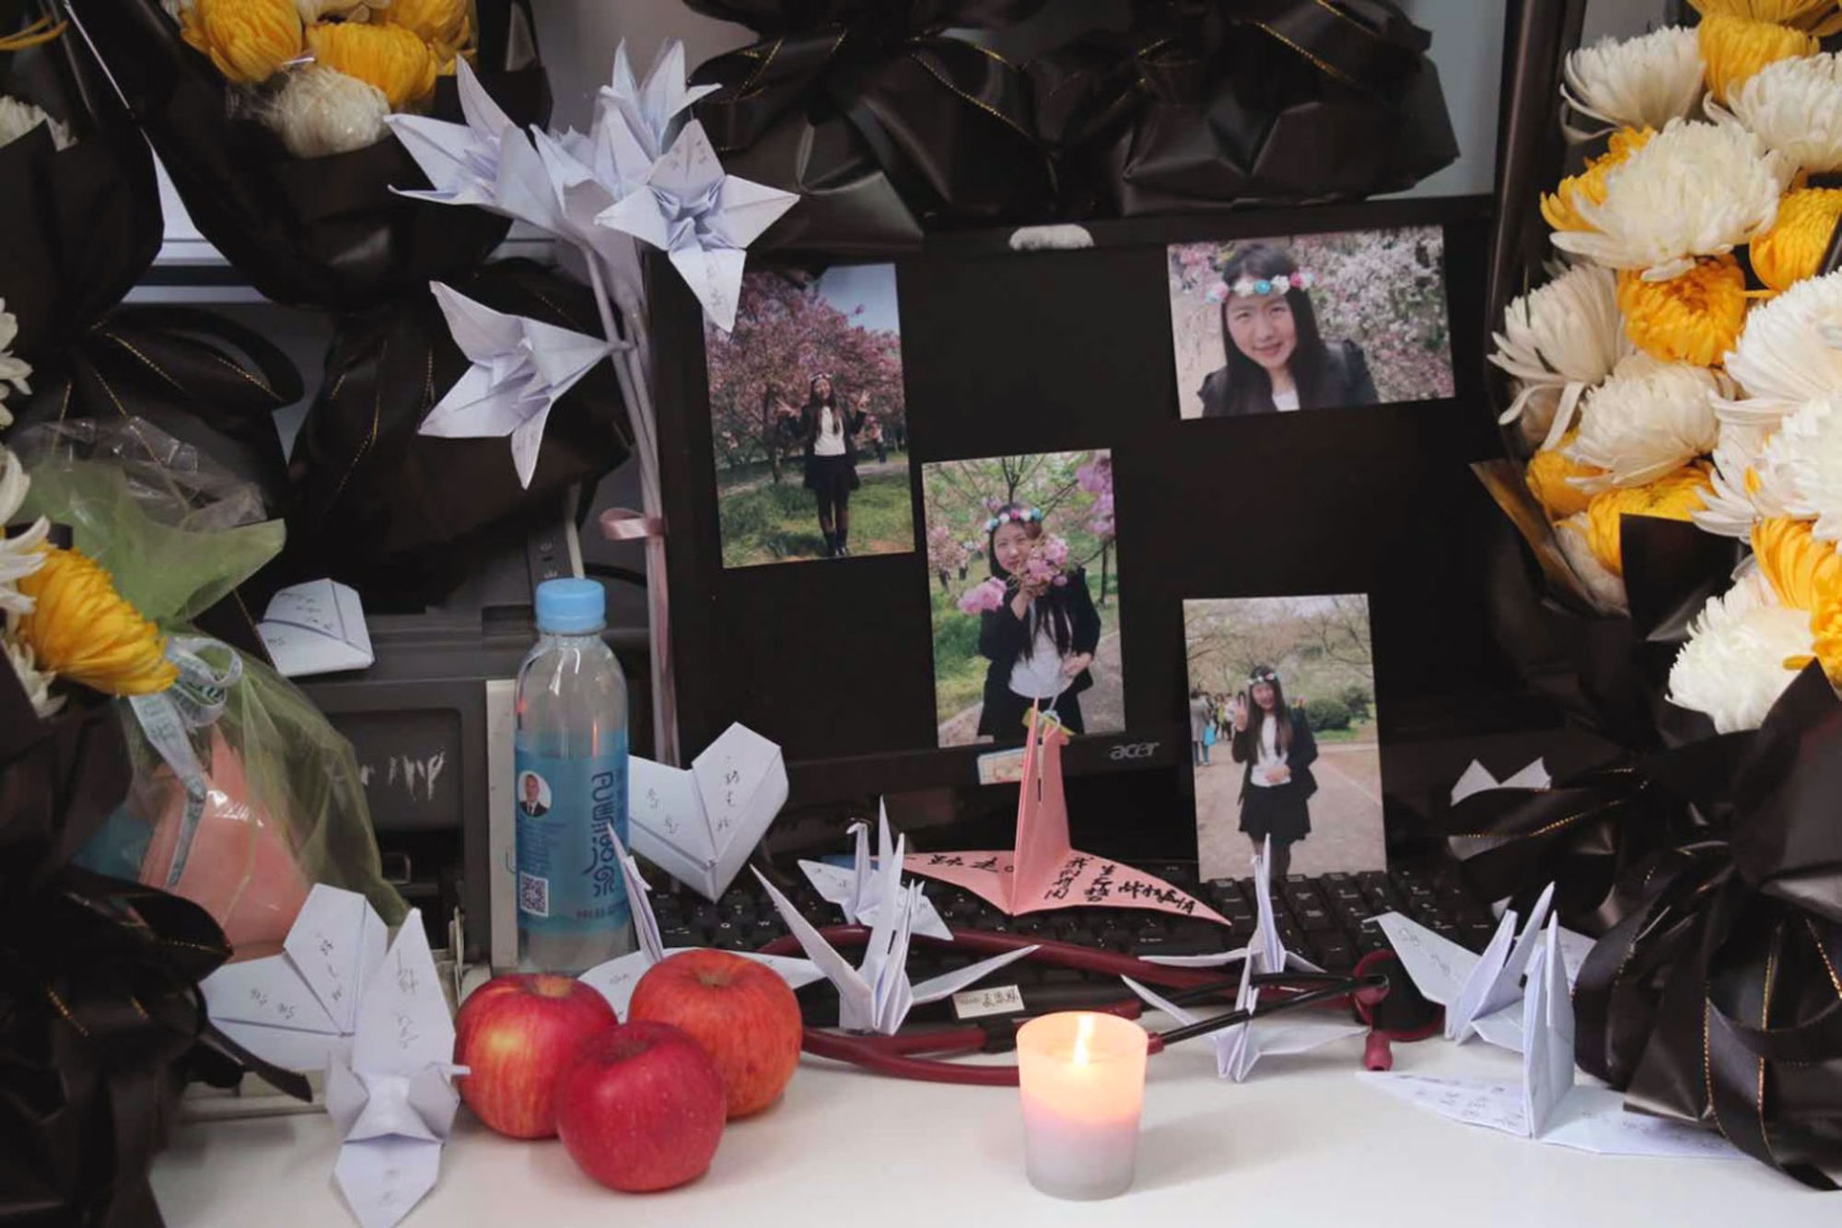
On Dr. Xia’s desk at work, her colleagues left 1,000 paper cranes — a Chinese symbol of hope and blessings. Written on the wings was a message: “Rest in peace, we will use our lives to continue this relay race and prevail over this epidemic.”
It was sometime after 3 a.m. on Feb. 7 when Dr. Xia was rushed to intensive care. Doctors first intubated her. Then, the president of the hospital frantically summoned several experts from around the city, including Dr. Peng Zhiyong, head of the department of critical care at Zhongnan Hospital.
They called every major hospital in Wuhan to borrow an extracorporeal membrane oxygenation, or Ecmo, machine to do the work of her heart and lungs.
Dr. Xia’s heart started beating again. But the infection in her lungs was too severe, and they failed. Her brain was starved of oxygen, causing irreversible damage. Soon, her kidneys shut down and doctors had to put her on round-the-clock dialysis.
“The brain acts as the control center,” Dr. Peng said. “She couldn’t command her other organs, so those organs would fail. It was only a matter of time.”
Dr. Xia slipped into a coma. She died on Feb. 23.
Dr. Peng remains baffled about why Dr. Xia died after she had seemed to improve. Her immune system, like that of many health workers, may have been compromised by constant exposure to sickness. Perhaps she suffered from what experts call a “cytokine storm,” in which the immune system’s reaction to a new virus engulfs the lungs with white blood cells and fluid. Perhaps she died because her organs were starved of oxygen.
Back at Dr. Xia’s home, her son, Jiabao — which means priceless treasure — still thinks his mother is working. When the phone rings, he tries to grab it from his grandmother’s hands, shouting: “Mama, mama.”
Her husband, Dr. Wu, doesn’t know what to tell Jiabao. He hasn’t come to terms with her death himself. They had met in medical school and were each other’s first loves. They had planned to grow old together.
“I loved her very much,” he said. “She’s gone now. I don’t know what to do in the future, I can only hold on.”
Research was contributed by Amber Wang.
Produced by Rumsey Taylor and Josh Williams.

