Study finds that COVID-19 could cause brain cells to fuse, leading to permanent damage

Philip Guelpa, Evan Blake

A new study published last week in Science Advances develops the understanding of the effects of COVID-19 and other viruses on the brain. The findings are believed to help explain “brain fog”—one of the most common Long COVID symptoms which can involve headaches, difficulty concentrating, forgetfulness and other symptoms—as well as other neurological manifestations, such as the loss of taste or smell, and potentially death.
Long COVID advocates often note that “brain fog” is simply a euphemism for brain damage, and the findings of this study underscore this point. Published shortly after the World Health Organization (WHO) and the Biden administration in the US formally ended their declarations of public health emergency due to COVID-19, the study reaffirms that these decisions were premature and unscientific. The coronavirus continues to spread unchecked throughout the world, killing thousands and damaging the brains and other organs of an untold number of people each day.
Conducted by a collaborative of researchers at Macquarie University, Sydney, and the University of Queensland in Brisbane, both in Australia, along with the University of Helsinki, Finland, the study found that when brain cells (neurons and glia) are infected by SARS-CoV-2, the virus that causes COVID-19, the cell membrane is altered, causing the cells to fuse together. The result is that the fused neurons, which transmit information by generating electrical impulses, either cease to fire or fire simultaneously, likely with unintended consequences.
The lead author of the study, Massimo Hilliard, draws an analogy with the effect of fusing household circuitry controlling lights in different rooms. The messages that these neurons normally transmit become either scrambled or cut off, potentially wreaking havoc with a whole range of bodily functions.
The research involved the use of brain organoids, which are accumulations of brain cells grown in vitro (i.e., artificially in the lab from human stem cells). These provide a simulation of conditions in the brain.
The study examined the process by which specialized molecules, known as fusogens, which are associated with the viral spike (S) protein, are used by the virus to penetrate cells, enabling the virus to hijack the cell’s machinery to produce more viruses which then spread to adjacent cells.
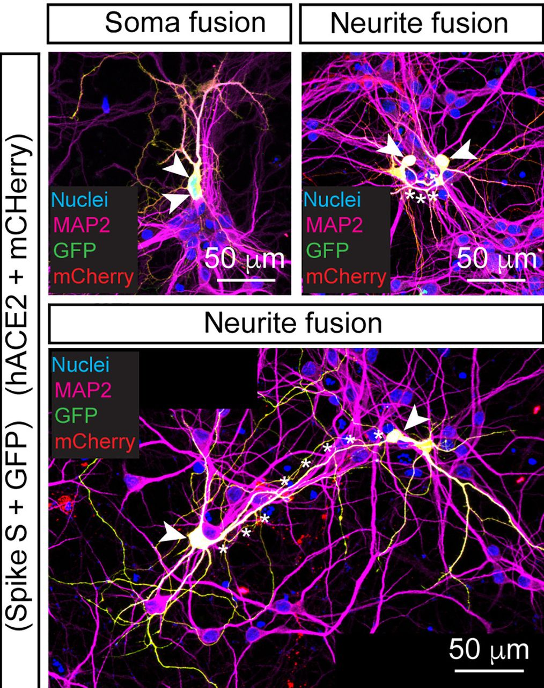
[Photo by Ramón Martínez-Mármol et al. / CC BY 4.0]
Understanding of that basic mechanism of viral infection was already known. What is new is the observation that in infected cells the fusogens alter the cell’s membrane, which then causes separate cells, both neurons and non-neurons known as glia, which provide structural support to the neurons, to fuse together. They also found that dendrites and axons, components of neurons involved in cell-cell communication, can be sites of cellular fusion.

The study found that 90 percent of the fused cells do not die but “resulted in synchronized neuronal activity,” while in the remaining 10 percent of fused cells, “neuronal activity completely stopped.”
The authors write, “Our results indicate that viral infections, driving the expression of viral fusogens, can initiate the irreversible fusion of brain cells, causing alteration in neuronal communication and revealing a possible pathomechanism of neuronal malfunction caused by infection.” They add, “The impact on neuronal fusion will depend on the viral load in the brain and the specific areas infected.”
The study authors further propose that the intracellular environments created by masses of fused cells might allow viral replication in an environment shielded from a body’s immune system. In effect, this could produce a reservoir for repeated bouts of disease as the replicating viruses periodically emerge from their sanctuaries, even without exposure to an external source of infection. This has implications for the course of other neurological diseases as well, such as Alzheimer’s disease, Parkinson’s disease, and multiple sclerosis.
An article on the study published in Science reports that similar fused cell masses, known as syncytia, have previously been observed in other organs of patients with COVID-19, such as the lungs. Examination of the brains of human patients who have died of COVID-19 for the presence of syncytia, has yet to be reported.
The real-world implications of this study and many others done on the neurological impacts of COVID-19 are staggering. The damage to brain cells shown in the study is irreversible. Repeated bouts of COVID-19 are likely to compound the effect, leading to progressive neurological decline in individuals who are repeatedly reinfected, not to mention effects on other organ systems.
The horrifying results of this study were shared widely by scientists and anti-COVID advocates on Twitter. Dr. Eric Topol of the Scripps Institute, who has done important research on Long COVID, shared an image from the study with the comment, “Not a pretty picture.”

Another widely shared post from anti-COVID activist @1goodtern embedded a video interview with study co-author Dr. Yazi Ke of Macquarie University. Commenting on the fact that COVID-19 has caused millions of individuals to lose the sense of taste and smell, Dr. Ke states, “I would imagine that the virus is causing, wreaking havoc in these brain areas.”

MEHRING BOOKS
COVID, Capitalism, and Class War: A Social and Political Chronology of the Pandemic
A compilation of the World Socialist Web Site's coverage of this global crisis, available in epub and print formats.
BUY YOUR COPY TODAY
Asked whether she believes that the neurological damage caused by COVID-19 is permanent, Dr. Ke replies, “Knowing what I know, I would say that it’s quite permanent. And over time, I can imagine that these large structures of cells actually eventually might die because they don’t get to do what they’re supposed to do.”
In the interview, Dr. Ke also notes that the study’s findings indicate a potential source of neurological symptoms associated with many other viruses. In the study, the authors write:
Our results also imply that other viral infections can potentially cause neuronal fusion. Several viruses can cause severe neurological symptoms and/or death, such as HIV, rabies virus, Japanese encephalitis virus, vesicular stomatitis virus, poliovirus, measles virus, herpes simplex virus, varicella-zoster virus, Zika virus, cytomegalovirus, dengue virus, Nipah virus, and chikungunya virus, among others. Cell-to-cell contact has been shown to be involved in the spreading of HIV, measles, and SARS-CoV-2, but viral-mediated neuronal fusion remained poorly understood.
The “forever COVID” policy adopted by governments around the world—i.e. allowing the pandemic to rage on without any effective control—means that the vast majority of the world’s population will suffer repeated bouts of COVID-19 annually, with potentially increasingly severe impacts and a growing section of the population developing Long COVID. The result, as the WSWS has stated, will be a deepening “mass debilitating event,” which will reverberate for generations to come.
Neurologists and care providers are already reporting upticks in patients suffering from early-onset dementia and other neurological disorders, and many are deeply concerned that recurring waves of COVID-19 will produce a deluge of patients suffering from these afflictions in the years ahead. How many children growing up today, whose parents were misled into believing that COVID-19 is essentially harmless to them, will have their lives or well-being cut drastically short?
The capitalist policy of “forever COVID” is a barbaric experiment on all of society, with untold ramifications. It is nothing less than a crime against humanity. It must be treated as such, and the criminals brought to justice. At the same time, the well-known public health measures necessary to reverse these policies and stop the pandemic must be implemented. It is now abundantly clear that only the united action of the international working class, in coordination with principled scientists and anti-COVID advocates, can bring this about.

Could fused neurons explain COVID-19’s ‘brain fog’?

Studies in dish suggest SARS-CoV-2 causes brain cells to stick together, but more research is needed to determine the significance
- 7 JUN 2023
- 2:00 PM
- BYCLAUDIA LOPEZ LLOREDA
Mouse neurons (in magenta) fuse (yellow) when they express the SARS-CoV-2 protein and its receptor.RAMON MARTINEZ-MARMOL
SHARE:

Twitter
Linked In
Facebook
Reddit
Wechat
Email
Of all of COVID-19’s symptoms, one of the most troubling is “brain fog.” Victims report headaches, trouble concentrating, and forgetfulness. Now, researchers have shown that SARS-CoV-2 can cause brain cells to fuse together, disrupting their communication. Although the study was only done in cells in a lab dish, some scientists say it could help explain one of the pandemic’s most confounding symptoms.
“This is a first important step,” says Stefan Lichtenthaler, a biochemist at the German Center for Neurodegenerative Diseases who was not involved with the work.
Researchers already knew that SARS-CoV-2 could cause certain cells to fuse together. The lungs of patients who die from severe COVID-19 are often riddled with large, multicellular structures called syncytia, which scientists believe may contribute to the respiratory symptoms of the disease. Like other viruses, SARS-CoV-2 may incite cells to fuse to help it spread across an organ without having to infect new cells.

SIGN UP FOR THE SCIENCEADVISER NEWSLETTER
The latest news, commentary, and research, free to your inbox daily
SIGN UP
To see whether such cell fusion might happen in brain cells, Massimo Hilliard, a neuroscientist at the University of Queensland, and his colleagues first genetically engineered two populations of mouse neurons: One expressed a red fluorescent molecule, and the other a green fluorescent molecule. If the two fused in a lab dish, they would show up as bright yellow under the microscope. That’s just what the researchers saw when they added SARS-CoV-2 to a dish containing both types of cells, they report today in Science Advances. The same fusion happened in human brain organoids, so-called minibrains that are created from stem cells.
The key appears to be angiotensin-converting enzyme 2 (ACE2), the protein expressed on the surface of mammalian cells that SARS-CoV-2 is known to target. The virus uses a surface protein called spike to bind to ACE2, triggering the virus to fuse to a cell and release its genetic material inside. Seemingly, the spike protein in infected cells may also make other ACE2 on a cell trigger fusion to a neighboring cell. When the team engineered neurons to express the spike protein, only cells that also expressed ACE2 were able to fuse with each other. The findings parallel previous work in lung cells: The ACE2 receptor seems to be critical in mediating their fusion during SARS-CoV-2 infection.
However, the neuronal syncytia seen in the lab dishes and organoids also had some peculiarities that made them stand out from those seen in lungs. When lung cells fused, only the main parts of the cell body connected to each other. Among neurons, in contrast, the fusion happened farther away from the cell body, at long, thin extensions known as dendrites and axons, which are critical for cell-cell communication.
The fusions seemed to disrupt this communication. Neurons typically fire independently, propagating signals throughout the brain. But 90% of the fused neurons fired at the same time, whereas the remaining 10% stayed silent. This massive amount of synchronous activity “is almost like a seizure,” Hilliard says. Brain fog could result when this delicate communication is disrupted, he says. Hillard’s group has previously shown that inducing neurons to fuse in the nervous system of the worm Caenorhabditis elegans blunted their ability to sense odors.
“These neurons are like Siamese twins, they are joined at the hip,” says Adonis Sfera, a psychiatrist associated with Patton State Hospital and Loma Linda University who was not involved with the study. “Can they function as neurons? Nobody knows that yet. But chances are they have lost some of that function.”
It remains to be seen whether these findings will hold up in the brains of animals infected with SARS-CoV-2, however, much less humans, says Olivier Schwartz, a virologist at the Pasteur Institute. He and others say no one has really looked for neuronal syncytia in COVID-19 patients who died. Still, he says, the work makes sense and is worth exploring further. He also says neuronal fusion may be more relevant to other viruses that infect more neurons than SARS-CoV-2 typically does, such as the rabies virus. The findings might even provide another reason rabies wreaks havoc on the brain, Schwartz says.
“We think [neuronal fusion] might be really widespread,” Hilliard agrees. “It just hasn’t been seen,” he says, “I think it’s really under our eyes.”

