Farang Cycle of Life and Death in Thailand

Last edited: October 04, 2021 at 09:26:19

Cet article en français – OTHER TOP RATED ARTICLES: DRINKING WATER QUALITY IN THAILAND
Buddhist temples (mainly in Tibet) display pictures of the Buddhist cycle of life and death, Samsara or the Wheel of Life.
I've noticed that foreigners living in Thailand have their own life cycle, where actions, endeavours and failures make one go on forever in circles or drop out at some stage.
Your individual stay or life cycle in Thailand may be different, but overall, numbers make statistics and I bet you know someone who's in stage X of what I call 'the Farang Cycle of Life and Death in Thailand'.
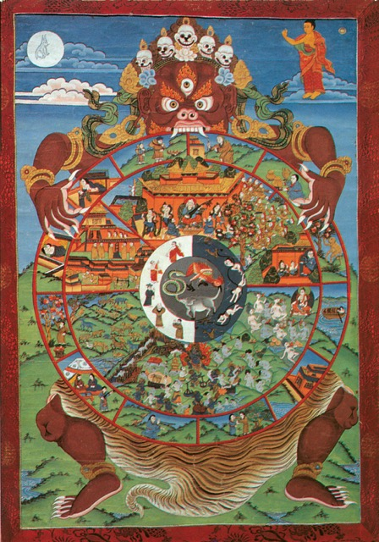
Buddhist Cycle of Life (Tibetan style painting)
The Farang Cycle of Life and Death in Thailand, or in short: Farang Life Cycle, counts 9 phases but it could last 2 months, 10 years or the remainder of your life time. It all depends on your personal life path, your preferences, your individual situation and, most of all: your choices. Some people go through the cycle faster than others, others get stuck somewhere forever and are doomed to stay (t)here.
With the word death, I mean the end of your stay here in Thailand, but some guys take it very literally and get blown off a balcony in Pattaya, so they say, or jump from a floor in Suvarnabhumi airport on their way back home.
If you've lived in other third world countries before, you may adjust through the 9 phases faster than others and reach your destination sooner.
Interestingly, in numerology there is a 9-years life cycle and I've found that in my own life, I often drastically change directions after 9 years, but your life might be different and again 9 phases don't necessarily correspond to 9 years.
The Farang Cycle of Life and Death in Thailand bears some similarities with the so-called SARAH concept in psychological charts: the phases of SHOCK - ANGER - REJECTION - ACCEPTANCE and HELP or HOPE that people have to work through when experiencing something deeply disturbing. The way out of SARAH is simply to work your way through all these phases towards healing to reach the point of Hope or Help. Not everybody can, some people remain stuck in REJECTION, for example, and never become free from that disturbing experience.
Like SARAH, the Farang Cycle of Life and Death in Thailand is a sequence of phases that you can or have to work through to really feel at home in Thailand or .. to just leave it all together.
I've seen many foreigners come and go, some stayed for years, others for decades, but not all of them really work through the phases until the end, most get stuck somewhere in the middle and never leave Thailand but are never really happy either.
[ I've indicated with markers what you become when you drop out of a phase and leave Thailand from there (✖︎ EXIT POINT ►) or when you remain stuck in a certain phase and stay (t)here forever (✖︎ STUCK DESTINATION ►).
It's possible you're not progressing from one phase to another in a strict order but merely 'vibrating' between different phases, the Farang Life Cycle is not a rigid timeline but more of a mental framework to understand where you are with regard to aspects of living in Thailand. For the sake of simplicity of the story, I use generalisations but they may not apply to you nor to everyone. ]
Check out in which phase(s) you are, be a little self-critical, but treat yourself with a bit of humor and treat this article like a self-improvement game and figure out where you are in your stay in Thailand.

CYCLE OF LIFE AND DEATH OF FOREIGNERS IN THAILAND

PHASE 1: DELIGHT
The vast majority of foreigners coming to Thailand for the first time are probably rather pleased with how easy it is to travel, meet locals and live in Thailand. Everything simply seems fun and easy, the people are friendly, the food is great, and the prices are very affordable.
No doubt, you've been there, if not, come and experience it.
Compared to a whole bunch of other countries, including neighboring countries in Southeast Asia, living in Thailand is so easy and pleasant that months simply pass without you noticing.
In this phase, you don't have that much eye for what's wrong with this country, you don't really care and it doesn't really disturb you because you're not really intensively involved with Thai society, you don't work here, you don't have to motivate local staff, you don't have to solve problems, first and foremost you're a consumer and that coffee can come a little later because you're not in a hurry.
Yeah, perhaps you notice one or two things that aren't really in order and don't happen so often in a civilised country like where you're from, but hey it doesn't bother you because you're still indulging in all that cheap and good stuff that Thailand's got to offer and that you didn't have in your home country: 100 baht massages, plenty of attention from the other sex, nice hot weather and hot cooked food at a bargain everywhere.
If this is a holiday or short stay, sure you'll be wanting more of it when you're back in your office in your cold home country.
Living in Thailand becomes a dream, and you want to Live the Dream.
✖︎ EXIT POINT ► This phase could end 'prematurely' when your holiday is over and you've got to go back to home country, but you crave to come back to Thailand and experience the free life. You become the DREAMER.
✖︎ STUCK DESTINATION ► If you don't move on to a next phase and stay love blind with Thailand, you become the ETERNAL TOURIST and you'll never know the real Thailand, you didn't dig deep enough. A lot of shorter-term travellers remain stuck in this phase, then drop out.
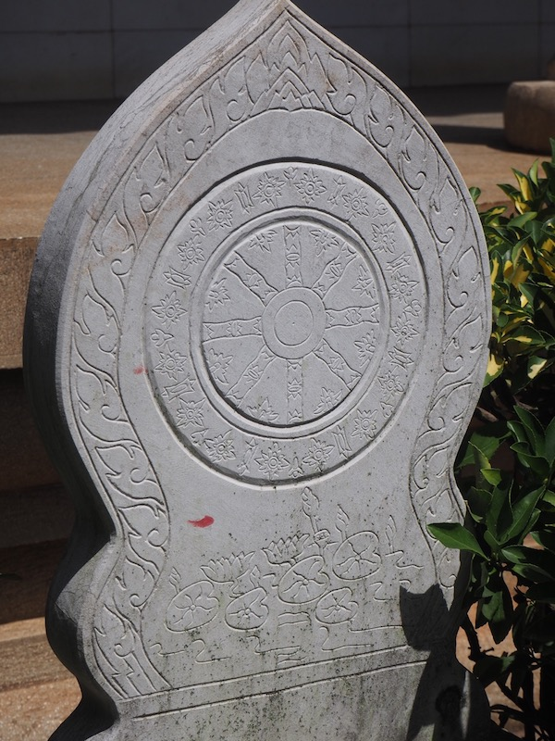
Wheel of Life symbol in the famous Yuantong Zen Buddhist Temple in Kunming, China

PHASE 2: THE COMFORT ZONE
Phase 1 seamlessly goes over into the next phase if you have time enough to stay longer in Thailand. This is a phase of total comfort: you like or even love this country with all the great things it's got to offer, you're spending hours at the pool or hanging out with friends, enjoying all the free time you now have and never had in your own country because the lifestyle there is too hasty and you needed to make money to survive. Of all the great things Thailand has got to offer a lot of FREE TIME at hand is probably one of your favourites, if not it's cheap and good food, happy smiles, a decent level of facilities, or pretty and willing girls that keep you sealed to Thai soil.
You can't get enough of your favourites, so you're taking a massage a few times a week and dating just as many women. Now you look back at your time in your home country nearly as wasted and unhappy.
Many foreigners in this phase feel like a rich man: whatever income they have, it suffices to let them enjoy a luxury lifestyle compared to what they could get at home.
This is the phase where you fall in love with Thailand but where you are still blind by love to see some more of its real sides.
If you're a guy, you're having the time of your life with plenty of pretty girls just around the corner who could be a model in your country. Moreover, you can get them at any age and often you find yourself as old as her father or one third of your age (but you don't tell her). You know you could never have such gorgeous girls back home and you totally loose interest in Caucasian girls. You're having Thailand Fever because of the FROM-ZERO-TO-HERO syndrom.
If you make short trips back home, you can't wait to go back to Thailand and getting your next visa is always a bit exciting because you want to get the longest visa possible. You try to find ways to get a 1-year visa, whatever it takes, volunteering or studying Thai, just to stay and don't leave.
You can keep drifting in this Comfort Zone for a very long time, why would you change anyway? You're comfortable and (you think) you've got all you need. You're living the dream, and by the way, it's also the Thai Dream because most Thais' ultimate goal in life is to be sabai (comfortable).
Comfort Zones are places animals and humans naturally like to stay in, remember the red pill versus the blue pill in the Matrix? Well, some people just choose to take the blue pill although deep inside, they know that something is ultimately lacking.
✖︎ EXIT POINT ► This phase could end abruptly for some foreigners for example when their savings have dried up or when they didn't manage to make an income online and live in Thailand forever. It's a painful end to living a life of luxury and comfort and some take it so seriously they commit suicide when they are forced to live or become totally depressed when living back home.
You become the DEPRIVED.
✖︎ STUCK DESTINATION ► If you don't move on from this phase to the next, you'll enjoy the good things of Thailand and you're living the Thai dream. Perhaps there are signs that something is wrong or lacking, but you're not listening or you don't (want to) see them, you decide to keep taking the blue pill and you never come to realise more. You become the INDULGER. You keep focusing on some of your basic needs and you shut off calls from your inner needs. If you remain stuck in this phase, you enjoyed Thailand but you never really got to learn something about the country, you didn't dig deep enough.
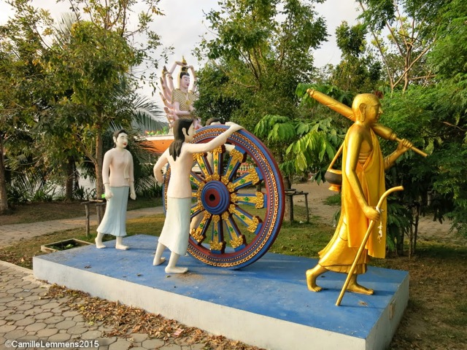
Wheel of life statues in Phuket, Thailand.

PHASE 3: SURPRISE ’N WONDER
This phase happens all throughout your stay in Thailand (or a foreign country) to the alert and interested traveller and long-stayer. It’s interest for a foreign culture, language and society that leads you to probing deeper and getting to understand more about it. Wondering why things are the way they are in Thailand, both the negative and the positive, can lead you on a journey that’s never going to end.
If you were dwelling in your Comfort Zone and now you’re starting to discover deeper layers of Thai society, chances are the first cracks are appearing in your initial Image of Paradise.
Why are your requests or complaints at a shop being answered by the infamous maipenrai? Why doesn't your date show up even although you confirmed the meeting a few times earlier this week? Why do some locals involved in a traffic accident drive away quickly? What does loosing face really mean? What is the function of using excuses in Thai social conventions? What does corruption really mean? What drives a Thai? Who really runs this country? How to find the mafia in Thailand?
Just a few questions you can wonder about. Some of us understand more than others, but that's not the point and it's not a (bragging) competition. The point is, it’s hard to know when you thoroughly understand a foreign culture like Thai, when you think you got it, you may realize a year later you were wrong and the truth was at a deeper level, a layer-behind-a-layer. Staying interested is key to keep moving, rather than being stuck in this phase and concluding that you totally understand everything about this country.
If you notice that you hardly get surprised anymore in Thailand, perhaps it’s time to be alert on the next thing you didn’t know and open your eyes, ears and mind.
✖︎ EXIT POINT ► Some people exit their existence in Thailand in this phase because they found out a few things, true or not, about Thai society that they don’t like or they feel Thailand doesn’t have enough to offer. Others never truly reach deep enough into this phase, when they aren’t really interested in a foreign culture but merely want to keep living their comfortable life in a little oasis tucked away in a country that happens to be Thailand.
✖︎ STUCK DESTINATION ► People stuck in this phase typically become a THAILAND EXPERT. They got to figure out a few things about Thailand and now think they know all. Typically, they start advising other foreigners and often apply generalisations which may be true overall but not for every person and every situation. You can’t trust Thai, they are all lazy, this country is corrupt and so on. A favourite concept many THAILAND EXPERTS like to explain to you is their understanding of losing face.
Beginning THAILAND EXPERTS often become travel bloggers who like to write or explain things about Thailand they’ve just discovered. How deep the blog goes depends, often it’s stuck at a level that recommends the best places to have a coffee or to use internet. Most travel bloggers repeat the same information over and over again on social network sites or on their own websites without much added value.
Other THAILAND EXPERTS become hyper-active Facebook posters and spend hours every day commenting on each and every thread, or start their own Facebook group and become Admin, which gives them some sense of control over this otherwise lost world.
Read more about foreigners who don’t really work their way through this phase: Ten Signs You're Not a Local In Chiang Mai
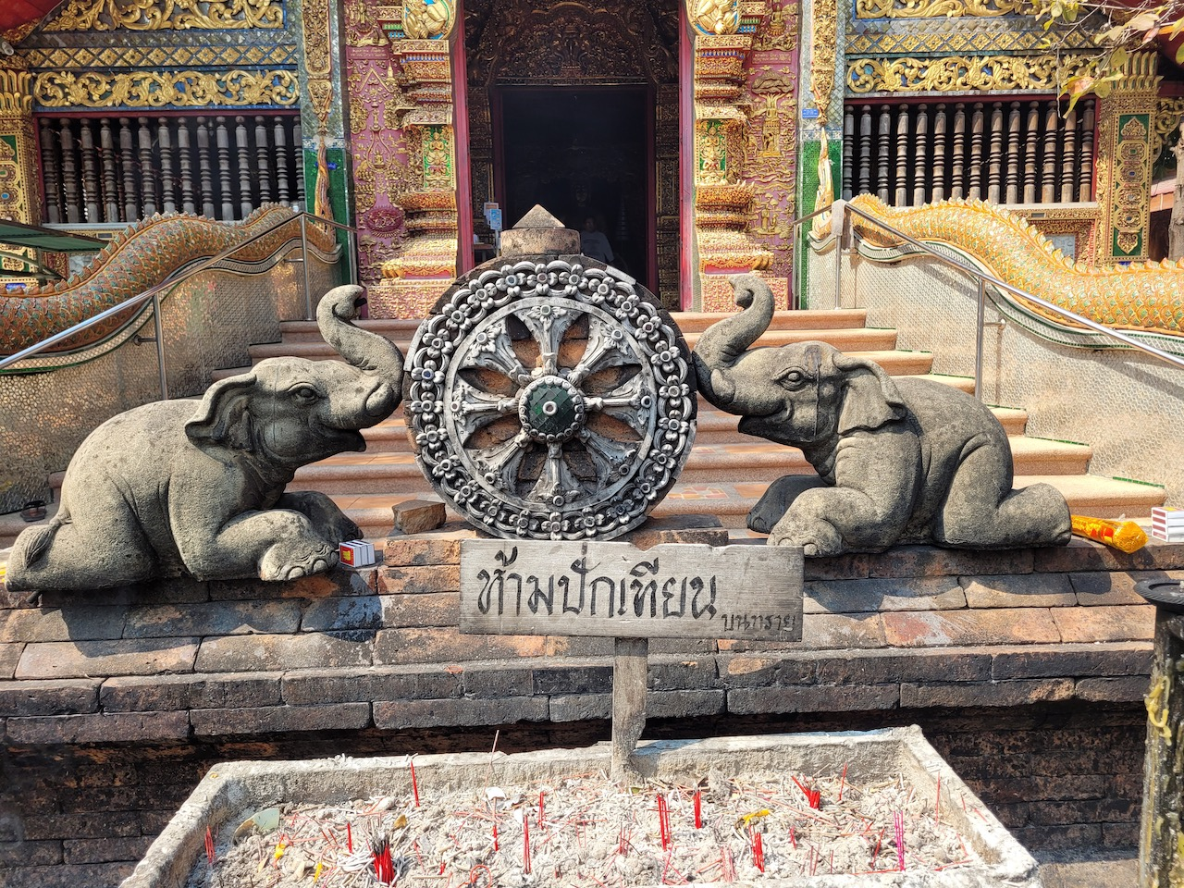
Wheel of life between elephants in Wat Chai Mongkhon Chiang Mai temple

PHASE 4: IRRITATION & SURPRISE
At this stage in your Thailand experience you’re getting irritated about all kinds of things that simply don’t work in Thailand.
You’re getting irritated about the entire Thai visa mess, the rules about visa and the need for you to report every 90 days or to make a trip to the border just to get one stamp. You’re irritated about the waiting queues at the Immigration office and the lack of organisation.
You’re annoyed when your date doesn’t show up, cancels last minute or expects you to pay an expensive dinner for her and her friend.
You wonder why the sales guy in a department store doesn’t know a product line two rows further on, you’re frustrated that you have to loose time as a customer because Thai staff don’t make the effort to make your life any easier.
The list could go on and on, depending on what your sensitivities are.
At this stage, your irritation level is just at the start, it’s a combination of irritation and being flabbergasted how badly things are organised in Thailand. You can’t believe that the manager of a hotel just told you to come back another day because of some lame excuse while you were ready to pay a deposit for a room. Any sensible businessman would take a customer who’s willing to pay, why do Thai staff let you go, it simply doesn’t make sense and you’re both flabbergasted and irritated.
If you foster a ‘healthy level’ of irritation and keep your interested for this country, you can actually use this intially negative energy as a powerful drive to understand more about how Thailand is organised. But if the irritation level grows stronger and becomes anger, you’ve lost control of that power and it overtakes you. Then you’ve reached the next phase: ANGER.
✖︎ EXIT POINT ► Some people already give up on Thailand after getting a bit irritated and simply opt for easier, more organised countries or places where they don't get bugged in their sensitivities.
✖︎ STUCK DESTINATION ► Some people move on and vibrate back to this phase now and then. This can be rather useful, if you use the energy of irritation to get to know more about this country. But most people move on to the next phase and remain stuck there.
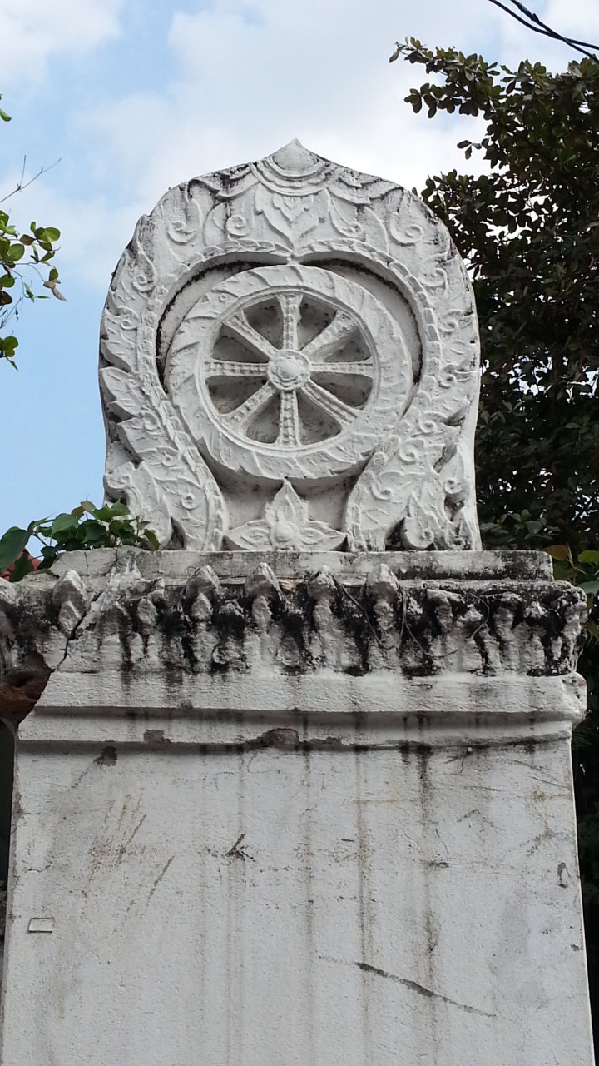
Wheel of life figure in Chiang Mai, Thailand

PHASE 5: ANGER, COMPLAINTS & THE WISH TO CHANGE THEM
In my experience, this is the phase where most long-term foreigners in Thailand remain stuck. Go on any social network site or forum like Thaivisa or Facebook, hang out with groups of expats and you know what I’m talking about. Loads and loads of grumpy farang complaining about everything that’s wrong in this country.
Yes, they are right, most of the time, but that’s not the point. If you’ve landed here, you’ve realised that nearly every prejudice about Thailand and Thai people, both positive and negative, is true, but you’re mainly bugged by the negative ones.
For example: Thai are lazy, they don’t make an effort, they don’t give a sh☠t about anything, they don’t have any decent education, worse: don’t have any interest to learn something. They are stupid. They just want money but don’t want to work (hard) for it. The entire visa system doesn’t make sense, worse: any system in Thailand doesn’t make sense or it’s extremely ill-designed and carried out poorly. Thai aren’t good at anything except for Thai food and some carpentry perhaps. They don’t excel in anything except for cutting corners. Etc. etc.
Things are much better in your own home country, the solutions are so obvious to you that you can simply point them out to Thai but they don’t want to learn and see. Why they don’t change it? This sentence ‘why don’t they ….’ pops up in your mind quite a few times every day.
The government posts propaganda with a hotline number to report bad exhaust pipes, but you know the solution already. Why don’t they check the exhaust pipes of all the songtaews and tuc tucs in town? Then we’d get rid of half of the pollution.
You're often quite upset with this f☠cking country and wondering what you're doing here in the first place. You’re constantly getting irritated, angry at things and people and you want to change them.
Yes, you’re right and you’re right about a whole lot of things, but that’s not the point. You’re at war with the world you live in and you’re not really happy. It’s a war you’re going to loose, unless you move on to the next phase.
✖︎ EXIT POINT ► It’s very well possible that you exit here, you simply can’t stand it anymore and in a way it’s better to leave this country than to stay and moan about it forever. Leave here, give up on Thailand and become the RELINQUISHER.
✖︎ STUCK DESTINATION ► If you remain stuck in this phase, you’re not alone, in fact you’re in the good company of tens of thousands of foreigners stuck in Thailand forever. Put differently, most foreigners stuck in Thailand are stuck in this very phase, and they'll never get out. This is because deep inside, they find some pleasure in complaining about someone else, perhaps it makes them feel superior or for another reason, but they don't realise that.
They like certain things about this country but they hate a lot of other things much more, yet they can’t leave. They become the COMPLAINER.
Typical COMPLAINERS are Thaivisa posters who hide behind computer screens day in and day out, commenting on every thread, often funny but mostly useless. Other COMPLAINERS are active in certain Facebook groups.
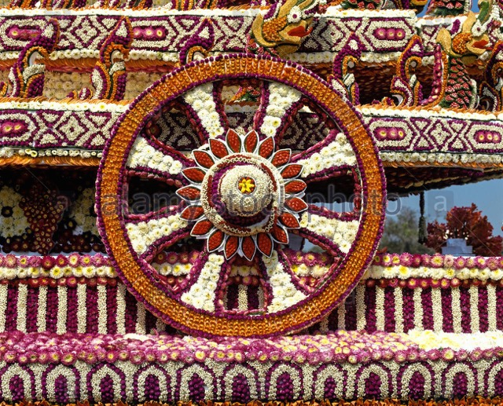
Wheel of Life made of flowers in Chiang Mai

PHASE 6: ACCEPTANCE
If you’re mild-hearted or clear-minded enough, you’ll be lucky to pull yourself out of the swamp that sucked you in during the previous phase of ANGER, COMPLAINTS AND THE WISH TO CHANGE THEM.
You have (finally) come to realise that there is no point in complaining about Thailand and its people: they won’t change in a hundred years and certainly not because you want them to. The system is what it is and they will do it their way, no matter how stupid or poorly done it is, it’s the Thai way and you gain nothing from wanting to change them. Now you can start laughing about it again, perhaps some things still irritate you now and then but you won’t let them overtake you into anger.
You've decided to accept the way things are.
In spiritual terms, you’re actually making a big leap forward because you’re coming to peace with the world outside you.
Accepting the way things are in Thailand doesn't mean being indifferent or complacent, it means abandoning a fight with reality where reality usually wins and choosing to have peace in yourself over the meaningless desire to change others.
The whirlwind has sunk down and you now have a space and silence within yourself from where you are ready to live with Thailand in the way you choose to. You're entering a more peaceful period for a while, where you can enjoy Thailand again without getting upset.
✖︎ EXIT POINT ► If you reached this phase, most likely you won't exit Thailand here, because your heart just came to peace and you look at the world around you with a new perspective.
✖︎ STUCK DESTINATION ► If you remain stuck here, you did well, but you just didn’t move on to some next phases.
You’ve become the ACCEPTOR. Things are what they are in Thailand and it’s fine with you.

PHASE 7: LACKS & LONELINESS
In the previous phase you managed to truly accept the way Thailand is and all the bad things that come with it, a burden was relieved from your heart and you could enjoy Thailand in a new way for a while. Perhaps you had a quiet time after for a while and enjoyed Thailand in a new way. In other words, you faced and embraced what Thailand has to offer.
The next challenge comes when you face what Thailand doesn’t have, in other words what’s missing for you while living in this country.
In the beginning, you didn’t focus too much on this side of living in Thailand, because you just came from your home country and you had enough of the things that you now feel are lacking. These could be: really good friends, trustworthy friends, good conversations, interaction with educated, motivated or passionate people, real culture, etc. Things which are often scarcer in Thailand, both with local people and with foreigners.
You start to feel these lacks as something more essential to your well-being than you at first thought. After your more basic needs (food, shelter, sex and entertainment) have been satisfied for a while, the lack of satisfaction of your higher needs starts to eat at you. You feel lonely, unsatisfied, maybe even lost in world you have little real affection with.
Maybe you feel you’re losing your mind, what are you doing here, are you getting crazy? Other people seem to make less sense, or seem to be losers. Are you one yourself?
You realise you’re spending time with people here whom you wouldn't spend time with back in your own country just because there aren't any other interesting people left.
There seems to be something wrong, a certain degree of looser-mind in almost everyone here, you even question yourself and you realize that the term economic refugees not only applies to Syrians but also to a whole lot of foreigners who stay in Thailand just because it's cheap.
You now realize that living cheap in Thailand comes at a cost: a lower level of facilities, pollution, lack of 'quality people, low education and so on, and you realize that there was no free lunch.
Perhaps for the first time during your stay in Thailand, you experience a feeling of Home Sickness.
The once gorgeous girls you were dating now appear to you like barbies addicted to smartphones, empty shells of beautiful flesh without a mature mind. You can't bother to go on first dates anymore, you might even loose interest for in sex.
If you’re not working in Thailand, you also feel a lack of purpose. Being on a long holiday sounded good in the beginning, but starts to get boring now. Even if you’re retired, you feel you need a project at hand but you don’t have it yet.
The Comfort Zone that sucked you in in the beginning now shows its vile side: you realize it's a trap, you've been trapped in Thailand, you don't know where else to go now, you don't see other opportunities. You gave up your job, how can you go back to work, you wouldn't fit in, they wouldn't want to hire someone like you anyway. You can't live with and without things here but you can't go back to your own country either. You've just discovered another meaning of the infamous TIT (This Is Thailand): Trapped In Thailand.
If this feeling exacerbates, you start to feel like a prisoner in a golden cage. You want to get out but you can't. Something is still keeping you or your mind is still cluttered.
The Dream has become a Nightmare and you have fallen out of love with Thailand. You are getting more hints from your intuition that you're not in the right place, you're having dreams showing you what you really want or what you're missing, it's your heart trying to give you signs and directions but it depends on your clear-mindedness whether you take its advice and remember after you wake up. Perhaps waking up is going back in the dream.
The delirium effects of the blue pill are fading out and you're reaching out for the next pill but you're hesitating if it should be the blue pill or the red one. It's a good sign: you're entering the next phase of making CHOICES.
✖︎ EXIT POINT ► It’s very well possible that you drop out of Thailand in this phase of the cycle. Perhaps you managed to accept most of the negative things of living in Thailand, but you decided you can’t live without some, for you essential, things that Thailand simply doesn’t offer. If you do drop out here, at least you didn't remain stuck in the prison, the trap that Thailand has become for you.
✖︎ STUCK DESTINATION ► If you remain stuck here, probably there are commitment or impediments that keep you from leaving: you made someone pregnant, you have a business involvement and you can’t take your money out yet, you can’t stand living in your home country anymore after your Thai experience, you can't gather the energy to try and live somewhere else, or somehow you’re a looser. You become the MISERABLE.
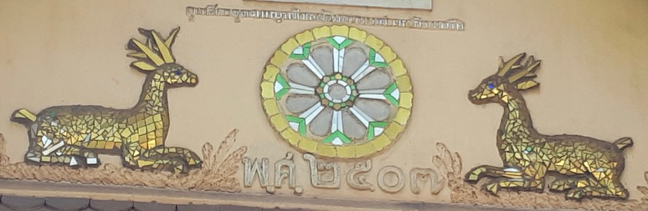

PHASE 8: CHOICES
Now you've arrived at a crucial phase in your existence in a foreign country: you’ve enjoyed the good sides, you’ve accepted the bad sides, you can embrace it all and now you’ve got to decide if what this country can offer you is what you need. This is a phase of contemplation and reflection. You know that nowhere is perfect, you left your home country already, but now you’re more aware of what Thailand means to you and what you want.
If you weren't bound by commitments or hindered by impediments, you can make a very clear-minded choice as to whether Thailand is the place where you want to keep living. If you do have some attachments or binding reasons to stay, you choices are within boundaries and you must stay perhaps, for the time being. Perhaps you're split for some time, your bottom half want to stay while your upper half wants to go.
Often, we need a combination of both a mental (or spiritual) reason to start moving as well as a physical reason, only the hints from your intuition may not be enough because we tend to ignore them. Luckily, the universe conspires and so when the time is right you will encounter a physical reason to help you make choices.
If it's 'negative', perhaps you start to have health problems, the pollution in Thailand is finally taking its toll and you're having breathing problems. You've developed an allergy for certain food types due to the widespread use of pesticides in Thailand, or so you believe. Your back if really hurting and forcing you to go back to your home country where you trust the hospitals more than here. Or you have some financial issue that you can't solve while staying in Thailand and so it's better to go home.
If it's 'positive', perhaps you can get a job at home or something attracts you.
I've more often heard of a combination of reasons to go back rather than one single reason to leave, usually it's the combination of feeling DONE WITH THAILAND and something tangible that makes people leave.
✖︎ EXIT POINT ► A lot of people decide at this stage to leave. Even die-hard figures such as Stickman Bangkok made this choice after probably seeing every filthy street corner of the Big Mango, dealing and wheeling with locals and farang for years, and perhaps having more girls than he could count hairs on his head.
If you leave at this point, you make a conscious decision that you’re DONE WITH THAILAND.
✖︎ STUCK DESTINATION ► If you remain stuck in this phase, perhaps you can’t make up your mind about where you want to live, or there are attachments that keep you here or impediments that keep you from going back to your own country. If you can’t make up your mind about staying or leaving, you become the LINGERER.

PHASE 9: OPPORTUNITIES
If you’ve survived all the challenges and you’re still in Thailand, hopefully it’s because you have found something new that keeps you interested in the country and the people. You have a new opportunity, it could be a business or a new project or you found a great partner and you have a family. There is an eye-opening positive opportunity that makes you decide to stay on, despite all you like and dislike and all you lack in Thailand.
You’re able to live life to the full with a vibrant energy but you’re not ignorant of Thailand’s downsides and neither of your own.
I didn’t meet many foreigners in Thailand who make this choice consciously. Truly, most just stay because they don’t have (or don't see) another option, the idea of going back to their own cold country just seems even more horrific, so they stay because it’s the least worse option, not because it’s the best.
Most of those who reach this phase are involved in work or have their own business, because it is work and total involvement with local Thai that makes you aware of what Thailand really is, not sipping another cafe latte at a terrace.
If you stay on because you take a new opportunity, you spiral up into a new life cycle at a different level than the one elaborated on here. You'll be in unknown grounds, unknown to me at least.
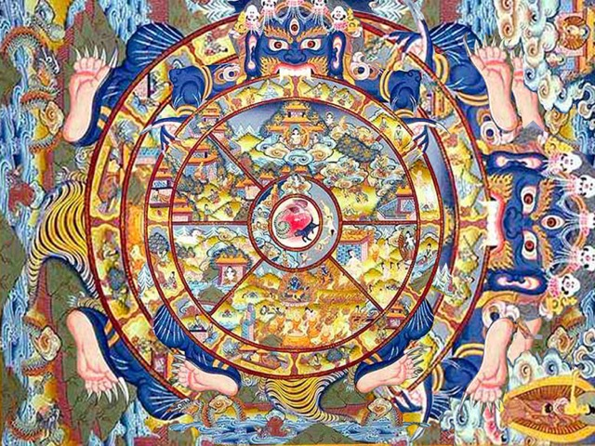
Buddhist Cycle of Life (Tibetan style painting)
Perhaps to some, it's tempting to browse over this article and quickly conclude that you've been there, in all phases of this so-called FARANG CYCLE OF LIFE AND DEATH IN THAILAND. You like to tell others you know already and you know about loosing face in Thailand too, by the way. Yeah, you're the THAILAND EXPERT and some of us know things better than others. But again, this is not a competition game to exceed others in who knows life in Thailand better. It's a tool to investigate yourself and if there is any 'fight' at all, it's between you and your mirror of the outside world or it's the fight-to-abandon-the-fight between you and your subconscious where you are both finally aligned.
To take myself as an example, I guess I'm in my 8th phase of making CHOICES and interestingly that corresponds to my 8th year in Thailand. As said before, I've made drastic changes in my life's direction after a 9-year cycle. I haven't found new opportunities in Thailand yet, so perhaps my life in Thailand is over next year.
For Chiang Mai Locator, by Mark C.

