DIC Question

#1 by LouiseScot » Thu May 20, 2021 4:21 pm
Hi all
Can anyone who has DIC tell me what a prepared/stained slide might look like under DIC - (an example image, if you have one, would be good ) ? Failing that, if anyone could recommend a subject for a test slide (preferably inanimate at this stage) that would be helpful. I've been having a go at making a Sanderson Prism DIC setup as per the DIY DIC thread and the paper by Rathi et al. posted about a month ago. I can certainly get an image but I'm not convinced it's as expected as with actual DIC. I've just used a handy Chinese prepared slide of a kidney section as it's fairly easy to focus on. But it may not be the best test subject? I'm also only using a cheap 20x infinity objective so that probably won't be optimal either! Still, I do get an image on a dslr I've done my best to set everything up properly so I feel I'm getting close (fingers crossed), but maybe it's still not right yet. At the moment, everything is set up / prototyped horizontally, and using aluminium extrusion t-sections, so not an actual microscope stand.
Many thanks
Louise
A Nikon CF plan 20x; A Swift 380T; A DIY infinity corrected focus rail system with a 40x/0.65 Olympus Plan, a 10x/0.30 Amscope Plan Fluor, and a 20x/0.75 Nikon Plan Apo
Top
Quote
Post
75RR
Posts: 8197
Joined: Sun Oct 12, 2014 2:34 am
Location: Estepona, Spain

Re: DIC Question

#2 by 75RR » Thu May 20, 2021 6:44 pm
.
Here is a link to a series of tests done comparing the compatibility of several objectives with DIC sliders.
Most are done with diatoms but some are with 'sections'.
Since the quality of the DIC varies with each objective and on the slider used the images may well prove useful to you.
https://www.photomacrography.net/forum/ ... hlight=dic
Zeiss Standard WL (somewhat fashion challenged) & Wild M8
Olympus E-P2 (Micro Four Thirds Camera)
Top
Quote
Post
LouiseScot
Posts: 1001
Joined: Tue Jul 07, 2020 1:51 pm
Location: Scotland

Re: DIC Question

#3 by LouiseScot » Thu May 20, 2021 8:00 pm
Ah, yes, thanks. I didn't think frustules would be such good subjects. But my current optics don't compare with the Photomacrography thread:
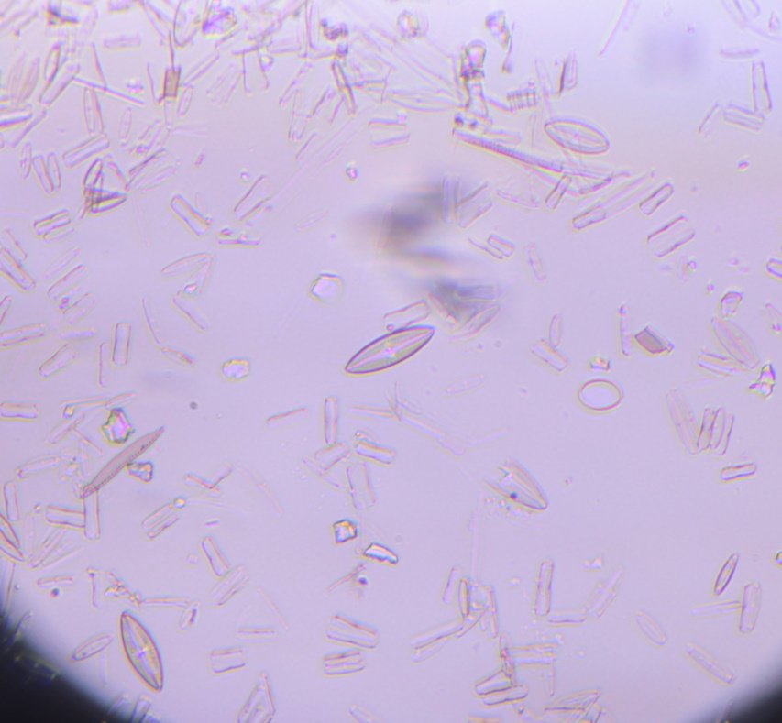
DiatomsCrop2_0112.jpg (75.73 KiB) Viewed 6811 times
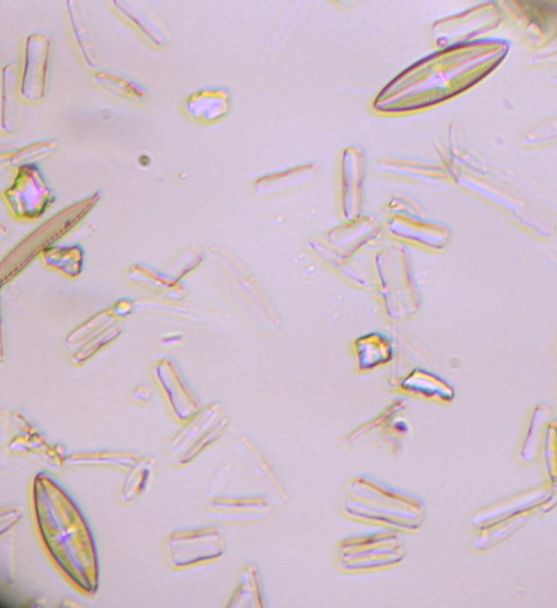
Diatoms_011278pc.jpg (65.26 KiB) Viewed 6811 times
I'm not sure whether what I see is simply down to polarization... I'll try with a different objective. I have an Olympus UIS2 40x and a recently acquired 60x. The quoted paper used a 60x.
Louise
A Nikon CF plan 20x; A Swift 380T; A DIY infinity corrected focus rail system with a 40x/0.65 Olympus Plan, a 10x/0.30 Amscope Plan Fluor, and a 20x/0.75 Nikon Plan Apo
Top
Quote
Post
Hobbyst46
Posts: 3905
Joined: Mon Aug 21, 2017 9:02 pm

Re: DIC Question

#4 by Hobbyst46 » Thu May 20, 2021 9:08 pm
Diatoms are not especially colorful under polarized light (when a polarizer and an analyzer are fitted in the microscope). In that sense, they are distinguished from quartz and mica particles that may be present on the slide.
Zeiss Standard GFL+Canon EOS-M10, Olympus VMZ stereo
Top
Quote
Post
LouiseScot
Posts: 1001
Joined: Tue Jul 07, 2020 1:51 pm
Location: Scotland

Re: DIC Question

#5 by LouiseScot » Thu May 20, 2021 9:29 pm
Hobbyst46 wrote: ↑
Thu May 20, 2021 9:08 pm
Diatoms are not especially colorful under polarized light (when a polarizer and an analyzer are fitted in the microscope). In that sense, they are distinguished from quartz and mica particles that may be present on the slide.
Oh ok. The ones in the Photomacrography link above seem quite colourful? DIC is based on polarization, of course. Attempting to build my own DIC is tricky without something to easily compare to - almost a leap of faith! My focus mechanism is very crude - an Allen key and a M4 bolt! The 'tube lens' is from a 50mm astronomy finder - a coated achromat but could be improved. I'd want to know if it's working at all before spending money on a better lens. If I can confirm that DIC has been achieved then I can start optimizing the various components
Louise
A Nikon CF plan 20x; A Swift 380T; A DIY infinity corrected focus rail system with a 40x/0.65 Olympus Plan, a 10x/0.30 Amscope Plan Fluor, and a 20x/0.75 Nikon Plan Apo
Top
Quote
Post
PeteM
Posts: 2306
Joined: Tue Dec 06, 2016 6:22 am
Location: N. California

Re: DIC Question

#6 by PeteM » Thu May 20, 2021 9:44 pm
Tiny and more or less transparent bubbles under a cover slip can make a good DIC subject, since there is an abrupt phase change at the edges. These could be saliva, bubbles in a poorly-mounted slide, or some oil/water/fat mix that ends up with bubbles under the cover slip.
Top
Quote
Post
LouiseScot
Posts: 1001
Joined: Tue Jul 07, 2020 1:51 pm
Location: Scotland

Re: DIC Question

#7 by LouiseScot » Thu May 20, 2021 9:51 pm
PeteM wrote: ↑
Thu May 20, 2021 9:44 pm
Tiny and more or less transparent bubbles under a cover slip can make a good DIC subject, since there is an abrupt phase change at the edges. These could be saliva, bubbles in a poorly-mounted slide, or some oil/water/fat mix that ends up with bubbles under the cover slip.
Funnily enough I had some strange effects from the edge of the diatom slide where the mounting medium hasn't filled properly - but is it DIC?
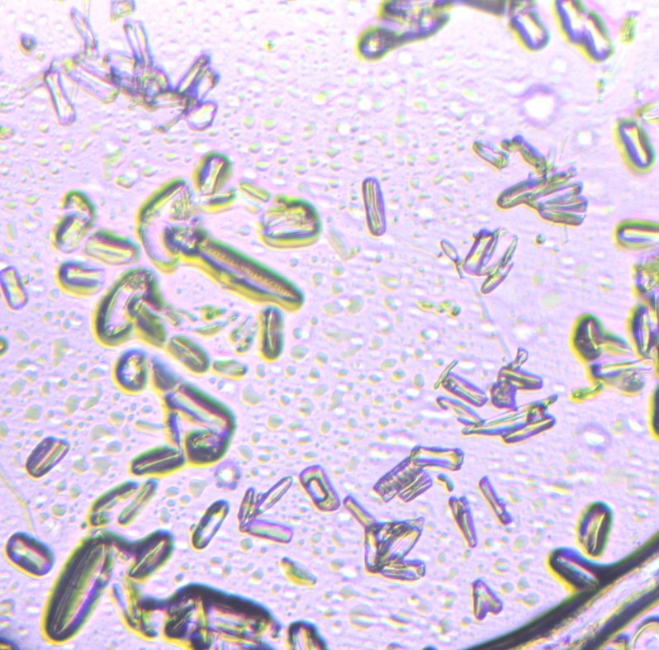
Diatoms49pc_0109.jpg (140.54 KiB) Viewed 6783 times
Louise
A Nikon CF plan 20x; A Swift 380T; A DIY infinity corrected focus rail system with a 40x/0.65 Olympus Plan, a 10x/0.30 Amscope Plan Fluor, and a 20x/0.75 Nikon Plan Apo
Top
Quote
Post
PeteM
Posts: 2306
Joined: Tue Dec 06, 2016 6:22 am
Location: N. California

Re: DIC Question

#8 by PeteM » Thu May 20, 2021 11:28 pm
My inclination is to say no, not DIC and mostly polarization with maybe a prism adding some color.
It's tricky, with a sort of experimental setup and less than sharp images, to know if you're getting close.
Between polarization, a prism acting as a wave plate (shifting colors), and a bit of oblique illumination one get get some pretty interesting effects. With standard DIC and two prisms, one can pull out one of the prisms and realize that most of the effect remains (e.g. not DIC). I haven't a clue with "Sanderson" DIC. You and Saul seem to be the pioneers here.
Top
Quote
Post
LouiseScot
Posts: 1001
Joined: Tue Jul 07, 2020 1:51 pm
Location: Scotland

Re: DIC Question

#9 by LouiseScot » Thu May 20, 2021 11:43 pm
PeteM wrote: ↑
Thu May 20, 2021 11:28 pm
My inclination is to say no, not DIC and mostly polarization with maybe a prism adding some color.
It's tricky, with a sort of experimental setup and less than sharp images, to know if you're getting close.
Between polarization, a prism acting as a wave plate (shifting colors), and a bit of oblique illumination one get get some pretty interesting effects. With standard DIC and two prisms, one can pull out one of the prisms and realize that most of the effect remains (e.g. not DIC). I haven't a clue with "Sanderson" DIC. You and Saul seem to be the pioneers here.
Thanks - I'll try and do one with and without one of the prisms but I'd have to also take a polarizer out as it's obviously dark with both polarizers in and no prism(s) .
Louise
A Nikon CF plan 20x; A Swift 380T; A DIY infinity corrected focus rail system with a 40x/0.65 Olympus Plan, a 10x/0.30 Amscope Plan Fluor, and a 20x/0.75 Nikon Plan Apo
Top
Quote
Post
75RR
Posts: 8197
Joined: Sun Oct 12, 2014 2:34 am
Location: Estepona, Spain

Re: DIC Question

#10 by 75RR » Fri May 21, 2021 6:54 am
.
Had a quick look (again?) at the Rathi-DIC-plastic-Sanderson-prisms pdf
https://www.quekett.org/wp-content/uplo ... prisms.pdf
I imagine a comparison image (which you can reproduce) would be the way to go for testing.
(Linked image is a little over-magnified, you might want to reduce the size)
https://duckduckgo.com/?t=ffsb&q=bucal+ ... ared-l.jpg
.
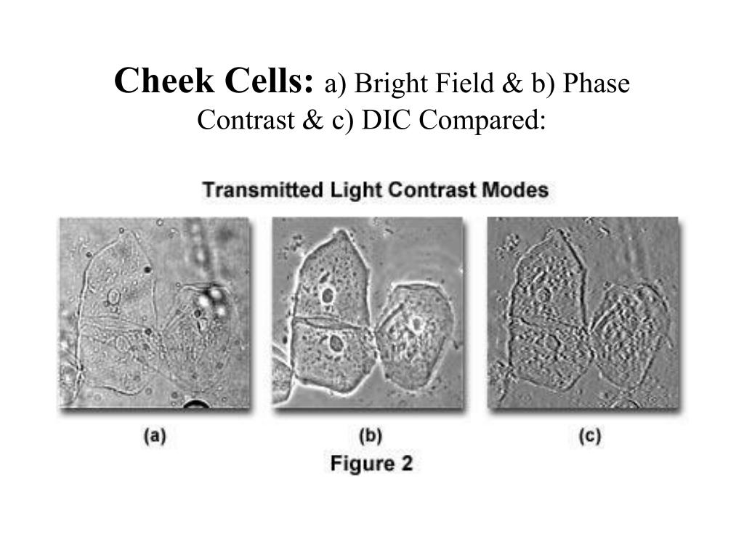
Zeiss Standard WL (somewhat fashion challenged) & Wild M8
Olympus E-P2 (Micro Four Thirds Camera)
Top
Quote
Post
LouiseScot
Posts: 1001
Joined: Tue Jul 07, 2020 1:51 pm
Location: Scotland

Re: DIC Question

#11 by LouiseScot » Fri May 21, 2021 9:03 am
75RR wrote: ↑
Fri May 21, 2021 6:54 am
.
Had a quick look (again?) at the Rathi-DIC-plastic-Sanderson-prisms pdf
https://www.quekett.org/wp-content/uplo ... prisms.pdf
I imagine a comparison image (which you can reproduce) would be the way to go for testing.
(Linked image is a little over-magnified, you might want to reduce the size)
https://duckduckgo.com/?t=ffsb&q=bucal+ ... ared-l.jpg
.
Yeah I tried cheek cells initially but they aren't very 'positive'. Anyway, I suspect my prisms may not be working as expected. I'll keep at it!
Louise
A Nikon CF plan 20x; A Swift 380T; A DIY infinity corrected focus rail system with a 40x/0.65 Olympus Plan, a 10x/0.30 Amscope Plan Fluor, and a 20x/0.75 Nikon Plan Apo
Top
Quote
Post
MicroBob
Posts: 3106
Joined: Sun Dec 25, 2016 9:11 am
Location: Northern Germany

Re: DIC Question

#12 by MicroBob » Fri May 21, 2021 10:39 am
Hi Louise,
I can't recommend stained sections for evaluation of DIC systems. The colour contrast would be overlayed with the DIC relief effect and the result would not look improved and difficult to evaluate. I would suggest typical phase objects, transparent stuff that is only different to it's surrounding in it's refractive index. The cheeks cells are probably already one of the best test objects.
Bob
Top
Quote
Post
LouiseScot
Posts: 1001
Joined: Tue Jul 07, 2020 1:51 pm
Location: Scotland

Re: DIC Question

#13 by LouiseScot » Fri May 21, 2021 10:54 am
MicroBob wrote: ↑
Fri May 21, 2021 10:39 am
Hi Louise,
I can't recommend stained sections for evaluation of DIC systems. The colour contrast would be overlayed with the DIC relief effect and the result would not look improved and difficult to evaluate. I would suggest typical phase objects, transparent stuff that is only different to it's surrounding in it's refractive index. The cheeks cells are probably already one of the best test objects.
Bob
Thanks, though I think I'll stick to the good old diatoms for now as they are easy to focus on, and easily reproducible for before and after tests. There does seem to be some difference between having one prism in and both in. It's almost black with no prisms. There are a number of variables though - the pressure on each of the prisms and their orientation relative to the cross polarizers and other things, no doubt!
Cheers
Louise
A Nikon CF plan 20x; A Swift 380T; A DIY infinity corrected focus rail system with a 40x/0.65 Olympus Plan, a 10x/0.30 Amscope Plan Fluor, and a 20x/0.75 Nikon Plan Apo
Top
Quote
Post
apochronaut
Posts: 5210
Joined: Fri May 15, 2015 12:15 am

Re: DIC Question

#14 by apochronaut » Fri May 21, 2021 11:26 am
You didn't mention, I don't think , whether you are viewing your results through a properly corrected eyepiece or whether your results are being entirely interpreted as photographed through your tube lens?
Top
Quote
Post
LouiseScot
Posts: 1001
Joined: Tue Jul 07, 2020 1:51 pm
Location: Scotland

Re: DIC Question

#15 by LouiseScot » Fri May 21, 2021 11:38 am
apochronaut wrote: ↑
Fri May 21, 2021 11:26 am
You didn't mention, I don't think , whether you are viewing your results through a properly corrected eyepiece or whether your results are being entirely interpreted as photographed through your tube lens?
Hiya
I've constructed a setup which is similar to the one in Rathi paper (Fig 4) (Linked above by 75RR's post) - except I don't have an Olympus IX81 to start with! So I'm imaging through an objective plus tube lens plus the 4F relay optics. It seems to work surprisingly well though I'm still working on achieving DIC. It's a challenge to do it all in my living room and without a proper optical bench...
Louise
A Nikon CF plan 20x; A Swift 380T; A DIY infinity corrected focus rail system with a 40x/0.65 Olympus Plan, a 10x/0.30 Amscope Plan Fluor, and a 20x/0.75 Nikon Plan Apo
Top
Quote
Post

Re: DIC Question

#16 by apochronaut » Fri May 21, 2021 12:16 pm
So everything is going to a sensor through that relay lens? You aren't actually viewing your d.i.y. D.I.C. set up through a pair of properly corrected eyepices independent of the relay lens?
apochronaut
Posts: 5210
Joined: Fri May 15, 2015 12:15 am
Top
Quote
Post
LouiseScot
Posts: 1001
Joined: Tue Jul 07, 2020 1:51 pm
Location: Scotland

Re: DIC Question

#17 by LouiseScot » Fri May 21, 2021 12:28 pm
apochronaut wrote: ↑
Fri May 21, 2021 12:16 pm
So everything is going to a sensor through that relay lens? You aren't actually viewing your d.i.y. D.I.C. set up through a pair of properly corrected eyepices independent of the relay lens?
Through the tube lens + 4F relay - Yep. And nope. No need for corrected EPs. I'm just using a dslr + generic infinity 20x objective on my 'bench' at the moment. I will be trying it with an Olympus UIS2 40x objective later but that doesn't require corrected EPs either. I'm just printing some holders which will allow rotation of the prisms in a similar manner to the polarizers.
Louise
A Nikon CF plan 20x; A Swift 380T; A DIY infinity corrected focus rail system with a 40x/0.65 Olympus Plan, a 10x/0.30 Amscope Plan Fluor, and a 20x/0.75 Nikon Plan Apo
Top
Quote
Post
deBult
Posts: 313
Joined: Tue Jul 16, 2019 3:20 pm

Re: DIC Question

#18 by deBult » Fri May 21, 2021 12:35 pm
To my understanding the Olympus UIS2 requires a correction via the Telan lens in the modern Olympus scopes (actually I assume the Telan lens is in the Bino\Trino head).
Top
Quote
Post
apochronaut
Posts: 5210
Joined: Fri May 15, 2015 12:15 am

Re: DIC Question

#19 by apochronaut » Fri May 21, 2021 12:46 pm
LouiseScot wrote: ↑
Fri May 21, 2021 12:28 pm
apochronaut wrote: ↑
Fri May 21, 2021 12:16 pm
So everything is going to a sensor through that relay lens? You aren't actually viewing your d.i.y. D.I.C. set up through a pair of properly corrected eyepices independent of the relay lens?
Through the tube lens + 4F relay - Yep. And nope. No need for corrected EPs. I'm just using a dslr + generic infinity 20x objective on my 'bench' at the moment. I will be trying it with an Olympus UIS2 40x objective later but that doesn't require corrected EPs either. I'm just printing some holders which will allow rotation of the prisms in a similar manner to the polarizers.
Louise
So you aren't looking through eyepieces, you are trying to do d.i.y. D.I.C. using the objective doublet from a spotting scope as a tube lens? Don't objective lenses from spotting scopes happen to have pretty high levels of ca? They are all marked coated achromat in 2021, which makes them only marginally better than an uncoated achromat, which is the bottom of the barrel when it comes to lens corrections, unless you include magnifying glasses.
Top
Quote
Post
LouiseScot
Posts: 1001
Joined: Tue Jul 07, 2020 1:51 pm
Location: Scotland

Re: DIC Question

#20 by LouiseScot » Fri May 21, 2021 12:59 pm
apochronaut wrote: ↑
Fri May 21, 2021 12:46 pm
LouiseScot wrote: ↑
Fri May 21, 2021 12:28 pm
apochronaut wrote: ↑
Fri May 21, 2021 12:16 pm
So everything is going to a sensor through that relay lens? You aren't actually viewing your d.i.y. D.I.C. set up through a pair of properly corrected eyepices independent of the relay lens?
Through the tube lens + 4F relay - Yep. And nope. No need for corrected EPs. I'm just using a dslr + generic infinity 20x objective on my 'bench' at the moment. I will be trying it with an Olympus UIS2 40x objective later but that doesn't require corrected EPs either. I'm just printing some holders which will allow rotation of the prisms in a similar manner to the polarizers.
Louise
So you aren't looking through eyepieces, you are trying to do d.i.y. D.I.C. using the objective doublet from a spotting scope as a tube lens? Don't objective lenses from spotting scopes happen to have pretty high levels of ca? They are all marked coated achromat in 2021, which makes them only marginally better than an uncoated achromat, which is the bottom of the barrel when it comes to lens corrections, unless you include magnifying glasses.
It's an achromatic doublet from an astro guide scope. I figured it would be ok for prototyping since Rathi et al. used achromatic doublets for their extended optics and most of my objectives are just achromats too. If I can determine that the DIC is actually working then I'll get a better tube lens .
Louise
I'm only trying to get the prisms to apparently work. I can maybe optimize the optics later.
A Nikon CF plan 20x; A Swift 380T; A DIY infinity corrected focus rail system with a 40x/0.65 Olympus Plan, a 10x/0.30 Amscope Plan Fluor, and a 20x/0.75 Nikon Plan Apo
Top
Quote
Post
Greg Howald
Posts: 1117
Joined: Tue Oct 20, 2020 6:44 am

Re: DIC Question

#21 by Greg Howald » Fri May 21, 2021 1:16 pm
Prepared animal slides like skin, spinal cord, etc. really pop under DIC and make very good test slides that can always be referred to.
Greg
Top
Quote
Post

Re: DIC Question

#22 by 75RR » Fri May 21, 2021 1:20 pm
.
Have you been able to observe the interference pattern as shown in the image below? (from post #10 link)
.
ATTACHMENTS
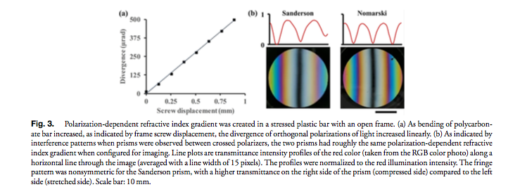
Interference pattern.png (99.56 KiB) Viewed 6669 times
Zeiss Standard WL (somewhat fashion challenged) & Wild M8
Olympus E-P2 (Micro Four Thirds Camera)
75RR
Posts: 8197
Joined: Sun Oct 12, 2014 2:34 am
Location: Estepona, Spain
Top
Quote
Post
LouiseScot
Posts: 1001
Joined: Tue Jul 07, 2020 1:51 pm
Location: Scotland

Re: DIC Question

#23 by LouiseScot » Fri May 21, 2021 1:22 pm
Greg Howald wrote: ↑
Fri May 21, 2021 1:16 pm
Prepared animal slides like skin, spinal cord, etc. really pop under DIC and make very good test slides that can always be referred to.
Greg
MicroBob (#12) says not? Anyway, I'll stick to the diatoms for now
Louise
A Nikon CF plan 20x; A Swift 380T; A DIY infinity corrected focus rail system with a 40x/0.65 Olympus Plan, a 10x/0.30 Amscope Plan Fluor, and a 20x/0.75 Nikon Plan Apo
Top
Quote
Post

Re: DIC Question

#24 by apochronaut » Fri May 21, 2021 1:24 pm
LouiseScot wrote: ↑
Fri May 21, 2021 12:59 pm
apochronaut wrote: ↑
Fri May 21, 2021 12:46 pm
LouiseScot wrote: ↑
Fri May 21, 2021 12:28 pm
Through the tube lens + 4F relay - Yep. And nope. No need for corrected EPs. I'm just using a dslr + generic infinity 20x objective on my 'bench' at the moment. I will be trying it with an Olympus UIS2 40x objective later but that doesn't require corrected EPs either. I'm just printing some holders which will allow rotation of the prisms in a similar manner to the polarizers.
Louise
So you aren't looking through eyepieces, you are trying to do d.i.y. D.I.C. using the objective doublet from a spotting scope as a tube lens? Don't objective lenses from spotting scopes happen to have pretty high levels of ca? They are all marked coated achromat in 2021, which makes them only marginally better than an uncoated achromat, which is the bottom of the barrel when it comes to lens corrections, unless you include magnifying glasses.
It's an achromatic doublet from an astro guide scope. I figured it would be ok for prototyping since Rathi et al. used achromatic doublets for their extended optics and most of my objectives are just achromats too. If I can determine that the DIC is actually working then I'll get a better tube lens .
Louise
I'm only trying to get the prisms to apparently work. I can maybe optimize the optics later.
Achromatic doublets are corrected by oculars in finder scopes and even with that they show coloured borders. I'm thinking a bunch of your chroma and distortion in your system is coming from that lens.
Achromatic lenses are only a a-chromatic in the sense that they are less chromatic than one that is chromatic. That's why apochromats exist or systems that correct for an achromatic doublet's deficiencies, usually known as corrective optics in microscopes.
apochronaut
Posts: 5210
Joined: Fri May 15, 2015 12:15 am
Top
Quote
Post

Re: DIC Question

#25 by LouiseScot » Fri May 21, 2021 1:40 pm
75RR wrote: ↑
Fri May 21, 2021 1:20 pm
.
Have you been able to observe the interference pattern as shown in the image below? (from post #10 link)
.
I can certainly see the stress/polarization effects in a prism:
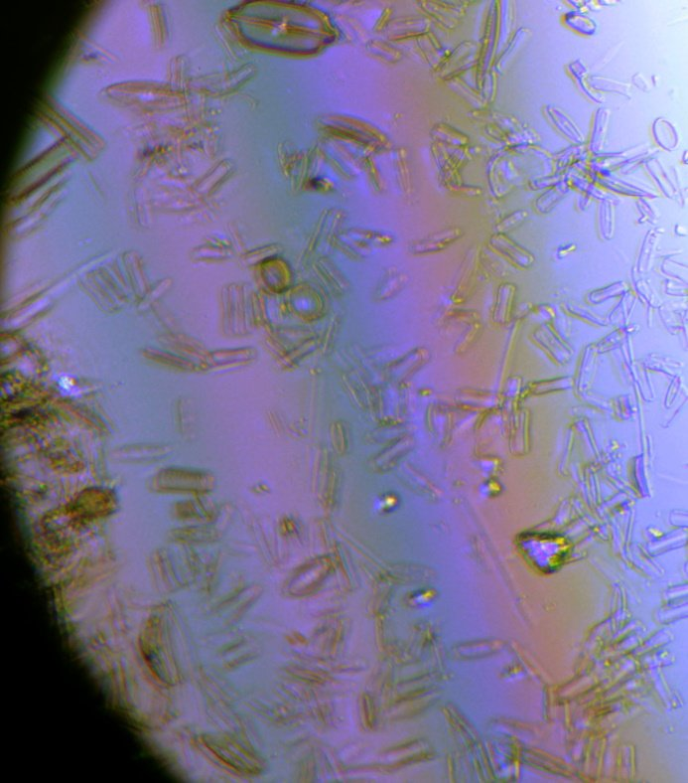
StressedPC_Crop_0122.jpg (88.87 KiB) Viewed 6655 times
I'm unsure whether I have correct/sufficient bending pressure on the prisms. I'll have to experiment a bit
I'll have to check whether there are interference fringes with the two prisms. I'm not doing quite the same as Sanderson in that I'm aiming to focus on the objective BFP via the relay optics. I'm just waiting for a second prism rotation holder to print out and then I'll see what I can see if the prisms are rotated in respect of each other and also the polarizers..
Louise
ps I'll try and do a test with the prisms either side of just the relay optics - I'm not sure exactly how Rathi et al. did their gradient test. I don't think I have a dark central band. I've kindof skipped over some bits that I should have put more effort into... I don't actually have a 6mm bar as per Rathi and Sanderson. I went straight to making two 3x12mm prisms. I have now ordered some 6mm polycarbonate so I'll then be able to duplicate the open frame setup. Probably a good idea ha ha.
Last edited by LouiseScot on Fri May 21, 2021 2:08 pm, edited 1 time in total.
A Nikon CF plan 20x; A Swift 380T; A DIY infinity corrected focus rail system with a 40x/0.65 Olympus Plan, a 10x/0.30 Amscope Plan Fluor, and a 20x/0.75 Nikon Plan Apo
LouiseScot
Posts: 1001
Joined: Tue Jul 07, 2020 1:51 pm
Location: Scotland
Top
Quote
Post
LouiseScot
Posts: 1001
Joined: Tue Jul 07, 2020 1:51 pm
Location: Scotland

Re: DIC Question

#26 by LouiseScot » Fri May 21, 2021 1:46 pm
apochronaut wrote: ↑
Fri May 21, 2021 1:24 pm
LouiseScot wrote: ↑
Fri May 21, 2021 12:59 pm
apochronaut wrote: ↑
Fri May 21, 2021 12:46 pm
So you aren't looking through eyepieces, you are trying to do d.i.y. D.I.C. using the objective doublet from a spotting scope as a tube lens? Don't objective lenses from spotting scopes happen to have pretty high levels of ca? They are all marked coated achromat in 2021, which makes them only marginally better than an uncoated achromat, which is the bottom of the barrel when it comes to lens corrections, unless you include magnifying glasses.
It's an achromatic doublet from an astro guide scope. I figured it would be ok for prototyping since Rathi et al. used achromatic doublets for their extended optics and most of my objectives are just achromats too. If I can determine that the DIC is actually working then I'll get a better tube lens .
Louise
I'm only trying to get the prisms to apparently work. I can maybe optimize the optics later.
Achromatic doublets are corrected by oculars in finder scopes and even with that they show coloured borders. I'm thinking a bunch of your chroma and distortion in your system is coming from that lens.
Achromatic lenses are only a a-chromatic in the sense that they are less chromatic than one that is chromatic. That's why apochromats exist or systems that correct for an achromatic doublet's deficiencies, usually known as corrective optics in microscopes.
Guide scopes just use the lens with a camera - with software, they fix on a star to enable guiding the imaging telescope.
Of course, I know my 20x objective isn't great but I should still be able to spot a difference between DIC and not DIC.
Louise
A Nikon CF plan 20x; A Swift 380T; A DIY infinity corrected focus rail system with a 40x/0.65 Olympus Plan, a 10x/0.30 Amscope Plan Fluor, and a 20x/0.75 Nikon Plan Apo
Top
Quote
Post
Scarodactyl
Posts: 2040
Joined: Sat Mar 03, 2018 9:09 pm

Re: DIC Question

#27 by Scarodactyl » Fri May 21, 2021 6:02 pm
deBult wrote: ↑
Fri May 21, 2021 12:35 pm
To my understanding the Olympus UIS2 requires a correction
All UIS/UIS2 olympus infinity objectives are fully internally corrected.
The chrimatic aberrations showing up in photos are well beyond what you should be seeing, even with a pretty low end objective. I think getting that more dialled in should be the first step which will make everything else a lot easoer and more rewarding.
Top
Quote
Post

Re: DIC Question

#28 by LouiseScot » Fri May 21, 2021 7:03 pm
Scarodactyl wrote: ↑
Fri May 21, 2021 6:02 pm
deBult wrote: ↑
Fri May 21, 2021 12:35 pm
To my understanding the Olympus UIS2 requires a correction
All UIS/UIS2 olympus infinity objectives are fully internally corrected.
The chrimatic aberrations showing up in photos are well beyond what you should be seeing, even with a pretty low end objective. I think getting that more dialled in should be the first step which will make everything else a lot easoer and more rewarding.
My living room setup is rather challenging to work with - the imaging train is a metre long from slide to sensor, so sensitive to any vibrations. My slide holder and focusing mechanism are very crude. The objective I've been using is itself a bit dodgy! I bought it a few years ago off a well-known UK-based Chinese lady importer/seller. It's marked as 20x/0.40 with an infinity symbol but was sold to me at the time as a DIN finite objective. Even stranger, it has an apparent working distance of about 5mm. Not sure how that happens! I've been using it because of it's apparent long working distance - makes life a little easier, and because I didn't want to risk damaging a decent objective whilst I was messing about (I'm old, my hands shake, I've no grip and I frequently drop things ). However, I'll definitely put the Olympus 40x on tomorrow. It makes sense to work with a known quantity Also, the diatom images I've been posting are very much enlarged. It's surprising I'm getting anything recognisable ha ha.
Louise
A Nikon CF plan 20x; A Swift 380T; A DIY infinity corrected focus rail system with a 40x/0.65 Olympus Plan, a 10x/0.30 Amscope Plan Fluor, and a 20x/0.75 Nikon Plan Apo
LouiseScot
Posts: 1001
Joined: Tue Jul 07, 2020 1:51 pm
Location: Scotland
Top
Quote
Post

Re: DIC Question

#29 by deBult » Fri May 21, 2021 7:17 pm
Scarodactyl wrote: ↑
Fri May 21, 2021 6:02 pm
deBult wrote: ↑
Fri May 21, 2021 12:35 pm
To my understanding the Olympus UIS2 requires a correction
All UIS/UIS2 olympus infinity objectives are fully internally corrected.
Hmm: from the Olympus guide on selecting objectives:
“ The UIS2 optical system optimally corrects aberration with a dedicated telan lens and an eyepiece so that the coma aberration and flatness are not degraded even when the telan lens exit pupil position is changed by changing the objective lens and telan distance. ”
http://resources.olympus-europa.com/mic ... _0310B.pdf
deBult
Posts: 313
Joined: Tue Jul 16, 2019 3:20 pm
Top
Quote
Post
Hobbyst46
Posts: 3905
Joined: Mon Aug 21, 2017 9:02 pm

Re: DIC Question

#30 by Hobbyst46 » Fri May 21, 2021 7:27 pm
LouiseScot wrote: ↑
Fri May 21, 2021 7:03 pm
It's marked as 20x/0.40 with an infinity symbol but was sold to me at the time as a DIN finite objective. Even stranger, it has an apparent working distance of about 5mm. Not sure how that happens! I've been using it because of it's apparent long working distance - makes life a little easier,...
If it is a finite optics 20x0.40 objective, 5mm is a long working distance IMO.

Quote
Post

Re: DIC Question

#31 by LouiseScot » Fri May 21, 2021 7:30 pm
Oh well, I couldn't wait! Here is a diatom taken with the UIS2 40x objective. It's a 100% crop from my Canon 550d:
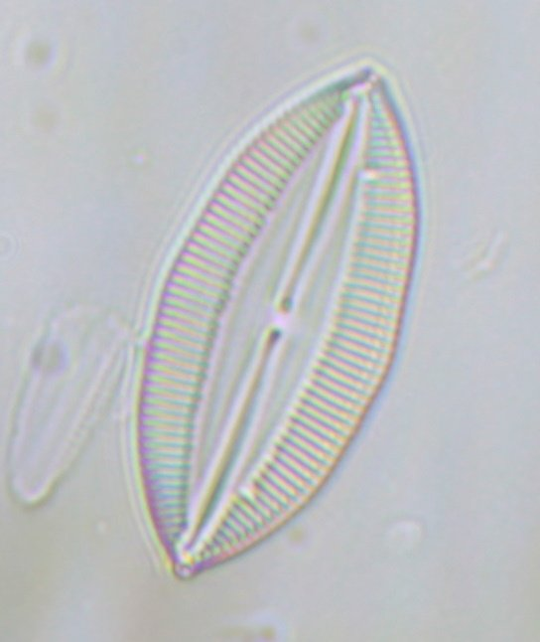
Diatoms_40x_Crop100pc_0125.jpg (37.97 KiB) Viewed 3915 times
Better, I think. More work to do.
Louise
A Nikon CF plan 20x; A Swift 380T; A DIY infinity corrected focus rail system with a 40x/0.65 Olympus Plan, a 10x/0.30 Amscope Plan Fluor, and a 20x/0.75 Nikon Plan Apo
Top
Quote
Post
LouiseScot
Posts: 1001
Joined: Tue Jul 07, 2020 1:51 pm
Location: Scotland

Re: DIC Question

#32 by LouiseScot » Fri May 21, 2021 7:37 pm
Hobbyst46 wrote: ↑
Fri May 21, 2021 7:27 pm
LouiseScot wrote: ↑
Fri May 21, 2021 7:03 pm
It's marked as 20x/0.40 with an infinity symbol but was sold to me at the time as a DIN finite objective. Even stranger, it has an apparent working distance of about 5mm. Not sure how that happens! I've been using it because of it's apparent long working distance - makes life a little easier,...
If it is a finite optics 20x0.40 objective, 5mm is a long working distance IMO.
I know - it's very odd! I've not really used it before as I couldn't get a sharp image on a finite scope and can't seem get one on an infinite scope either! I have a Nikon CF 20x on the Swift, which is great. I have a Nikon CFI60 APO 20x infinity objective but I don't like to get it out of it's container! I do intend using it at some point though As you can see below/above the Olympus 40x seems ok but I don't have any kind of fine focus mechanism on my DIC prototype.
Louise
A Nikon CF plan 20x; A Swift 380T; A DIY infinity corrected focus rail system with a 40x/0.65 Olympus Plan, a 10x/0.30 Amscope Plan Fluor, and a 20x/0.75 Nikon Plan Apo
Top
Quote
Post
Scarodactyl
Posts: 2040
Joined: Sat Mar 03, 2018 9:09 pm

Re: DIC Question

#33 by Scarodactyl » Fri May 21, 2021 11:17 pm
deBult wrote: ↑
Fri May 21, 2021 7:17 pm
Scarodactyl wrote: ↑
Fri May 21, 2021 6:02 pm
deBult wrote: ↑
Fri May 21, 2021 12:35 pm
To my understanding the Olympus UIS2 requires a correction
All UIS/UIS2 olympus infinity objectives are fully internally corrected.
Hmm: from the Olympus guide on selecting objectives:
“ The UIS2 optical system optimally corrects aberration with a dedicated telan lens and an eyepiece so that the coma aberration and flatness are not degraded even when the telan lens exit pupil position is changed by changing the objective lens and telan distance. ”
http://resources.olympus-europa.com/mic ... _0310B.pdf
I can see how it reads that way, but it's just poorly phrased marketing fluff about being infinity corrected from what I can tell
Top
Quote
Post
apochronaut
Posts: 5210
Joined: Fri May 15, 2015 12:15 am

Re: DIC Question

#34 by apochronaut » Sun May 23, 2021 5:40 pm
The term correction can be general or specific. One always has to ask, corrected for what?
If an objective yields an image to a telan lens that is truly, completely corrected, then whatever the purpose of the telan lens is ; whether it be be to install a focal length, magnify, reduce or change the focal length ; it must be done without inducing a change in the objective's corrections. It must be completely neutral in chromatic aberration and all other aberrations and distortions. It cannot therefore be a cemented doublet and must be itself a highly corrected lens purpose built for one simple job, elst it would not be necessary at all.
If the objective is only corrected for certain aberrations, having complete correction for chromatic aberration for instance , then it will still have correction deficiencies for other aberrations and require a very specific telan lens or telan lens/eyepiece combination, critically engineered to impose an equal and opposite condition to that of the objective.
Therefore, irregardless of the degree or degrees of correction of the objective , any telan lens used with it must be matched to the characteristics of those corrections, otherwise it will impose aberrations or distortions on the system.
Top
Quote
Post
LouiseScot
Posts: 1001
Joined: Tue Jul 07, 2020 1:51 pm
Location: Scotland

Re: DIC Question

#35 by LouiseScot » Sun May 23, 2021 5:52 pm
apochronaut wrote: ↑
Sun May 23, 2021 5:40 pm
The term correction can be general or specific. One always has to ask, corrected for what?
If an objective yields an image to a telan lens that is truly, completely corrected, then whatever the purpose of the telan lens is ; whether it be be to install a focal length, magnify, reduce or change the focal length ; it must be done without inducing a change in the objective's corrections. It must be completely neutral in chromatic aberration and all other aberrations and distortions. It cannot therefore be a cemented doublet and must be itself a highly corrected lens purpose built for one simple job, elst it would not be necessary at all.
If the objective is only corrected for certain aberrations, having complete correction for chromatic aberration for instance , then it will still have correction deficiencies for other aberrations and require a very specific telan lens or telan lens/eyepiece combination, critically engineered to impose an equal and opposite condition to that of the objective.
Therefore, irregardless of the degree or degrees of correction of the objective , any telan lens used with it must be matched to the characteristics of those corrections, otherwise it will impose aberrations or distortions on the system.
Hiya
I believe Nikon CF/CFI and Olympus UIS2 objectives are 'correction-free'. The tube lens is there simply to bring the rays coming from the (infinity) objective to a focus. The tube lenses are relatively long focal lengths i.e. 180mm for Olympus, 200mm for Nikon. The longer focal lengths are less susceptible to aberrations so I think achromatic doublets will likely do the job, certainly if the objectives are themselves only (plan) achromats. Anyway, for my purposes I'm sure they'll do
Louise
A Nikon CF plan 20x; A Swift 380T; A DIY infinity corrected focus rail system with a 40x/0.65 Olympus Plan, a 10x/0.30 Amscope Plan Fluor, and a 20x/0.75 Nikon Plan Apo
Top
Quote
Post
deBult
Posts: 313
Joined: Tue Jul 16, 2019 3:20 pm

Re: DIC Question

#36 by deBult » Sun May 23, 2021 8:18 pm
From the Olympus website:
https://www.olympus-lifescience.com/en/ ... nityintro/
“ The tube length in infinity-corrected microscopes is referred to as the reference focal length and ranges between 160 and 200 millimeters, depending upon the manufacturer (see Table 1). Correction for optical aberration in infinity systems is accomplished either through the tube lens or the objective(s). Residual lateral chromatic aberration in infinity objectives can be easily compensated by careful tube lens design, but some manufacturers, including Nikon, choose to correct for spherical and chromatic aberrations in the objective lens itself. This is possible because of the development of proprietary new glass formulas that have extremely low dispersions. Still other manufacturers (notably, Zeiss ICS systems) utilize a combination of corrections in both the tube lens and objectives.”
Olympus even sells a seprate Telan / tube lens, to combine with the UIS objectives when using them in a non Olympus optical system.
This of course is because the Telan is not required?
https://www.olympus-lifescience.com/en/ ... _US&inline
Last edited by deBult on Sun May 23, 2021 8:27 pm, edited 2 times in total.
Top
Quote
Post
LouiseScot
Posts: 1001
Joined: Tue Jul 07, 2020 1:51 pm
Location: Scotland

Re: DIC Question

#37 by LouiseScot » Sun May 23, 2021 8:24 pm
deBult wrote: ↑
Sun May 23, 2021 8:18 pm
From the Olympus website:
“ The tube length in infinity-corrected microscopes is referred to as the reference focal length and ranges between 160 and 200 millimeters, depending upon the manufacturer (see Table 1). Correction for optical aberration in infinity systems is accomplished either through the tube lens or the objective(s). Residual lateral chromatic aberration in infinity objectives can be easily compensated by careful tube lens design, but some manufacturers, including Nikon, choose to correct for spherical and chromatic aberrations in the objective lens itself. This is possible because of the development of proprietary new glass formulas that have extremely low dispersions. Still other manufacturers (notably, Zeiss ICS systems) utilize a combination of corrections in both the tube lens and objectives.”
Olympus even sells a seprate Telan / tube lens, to combine with the UIS objectives when using them in a non Olympus optical system.
This of course is because it is not required as you guys keep repeating?
https://www.olympus-lifescience.com/en/ ... _US&inline
Thorlabs and Edmunds Optics also sell tube lenses separately - at a price, of course!
Louise
A Nikon CF plan 20x; A Swift 380T; A DIY infinity corrected focus rail system with a 40x/0.65 Olympus Plan, a 10x/0.30 Amscope Plan Fluor, and a 20x/0.75 Nikon Plan Apo
Top
Quote
Post
deBult
Posts: 313
Joined: Tue Jul 16, 2019 3:20 pm

Re: DIC Question

#38 by deBult » Sun May 23, 2021 8:32 pm
Louise,
the point I'm making is - for optimal optical quality it may be wise to use the optical components in a matched system, usually the same “design period” of a single supplier. Mix and match is not a sound approach in my (limited) experience, YMMV though.
Top
Quote
Post
LouiseScot
Posts: 1001
Joined: Tue Jul 07, 2020 1:51 pm
Location: Scotland

Re: DIC Question

#39 by LouiseScot » Sun May 23, 2021 9:12 pm
deBult wrote: ↑
Sun May 23, 2021 8:32 pm
Louise,
the point I'm making is - for optimal optical quality it may be wise to use the optical components in a matched system, usually the same “design period” of a single supplier. Mix and match is not a sound approach in my (limited) experience, YMMV though.
Hiya
Well I'm currently using an Olympus 40x plan achro UIS2 objective (I know it's not specified by Olympus for DIC) with a 180mm fl achromatic doublet as a tube lens. It actually seems to work quite well. I've been experimenting with shorter working distances i.e. less than 180mm. There seem to be two distances either side of the 'tube lens' to bear in mind. One is the infinity space or 'pupil distance, and the other is the working distance. I've not found any definite info on how the two can/should be combined. Just that pupil distance should be 50-150mm and working distance should be 130mm with a housing length of ~33mm - for Thorlabs 180mm tube lens. I originally had a working distance of 180mm but I think a smaller distance still works ok - maybe better. Presumably the pupil distance can be varied within the specified limits with no problems.
I've had lots of trouble with camera vibrations as a consequence of relatively long exposures, and problems with focusing on the test slide. I've made an improved slide holder (though still quite crude) and that should help. I've taken the camera off the flimsy tripod so that should help too. Hopefully, tomorrow I'll get some better images - fingers crossed!
Here's a pic I took earlier but before I made the latest changes. It has some interesting effects! (It appears blurrier on here compared to on my monitor it's been downsized from 175KB to 58KB.)
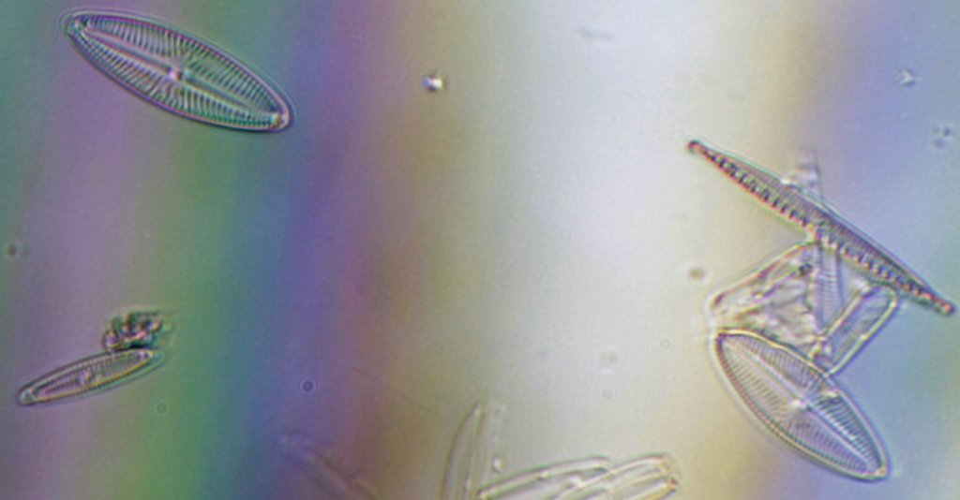
DiatomsCrop2_0130.jpg (58.07 KiB) Viewed 3810 times
Louise
A Nikon CF plan 20x; A Swift 380T; A DIY infinity corrected focus rail system with a 40x/0.65 Olympus Plan, a 10x/0.30 Amscope Plan Fluor, and a 20x/0.75 Nikon Plan Apo
Top
Quote
Post
viktor j nilsson
Posts: 659
Joined: Thu Aug 23, 2018 10:12 pm
Location: Lund, Sweden

Re: DIC Question

#40 by viktor j nilsson » Sun May 23, 2021 9:28 pm
deBult wrote: ↑
Sun May 23, 2021 8:32 pm
Louise,
the point I'm making is - for optimal optical quality it may be wise to use the optical components in a matched system, usually the same “design period” of a single supplier. Mix and match is not a sound approach in my (limited) experience, YMMV though.
Usually, yes. But lots of folks over at photomacrography.com have shown over and over again that the UIS/UIS2 objectives work just as well, if not better, with non-compensating tube lenses from other manufacturers. Nikon, Olympus and Mitutoyo infinity objectives work really well with each other's tube lenses, as well as with optically "neutral" tube lenses such as Raynox DCR-150, Thorlabs ITL200, Sigma LSA, etc. Of course some combinations work slightly better than others, but I would say that it is rare that the optimal combination is when using it exactly as intended by the manufacturer.
Top
Quote
Post
viktor j nilsson
Posts: 659
Joined: Thu Aug 23, 2018 10:12 pm
Location: Lund, Sweden

Re: DIC Question

#41 by viktor j nilsson » Sun May 23, 2021 9:45 pm
That said, it would be good to see a clean brightfield image taken without the prisms to see which of the aberrations in the image are caused by the prisms, and which ones are caused by the rest of your setup.
And it really helps to be able to view the back focal plane when you are setting up a DIY DIC system. When I'm trialling different prism combinations I always remove an eyepiece and peek down the tube. It literally takes less than a second to see if a prism combination has any promise whatsoever, or if it's totally off. With one prism in, you see the colored interference fringes at the BFP with a dark central band, then, when you introduce the second prism, the BFP either become evenly colored (match!) or becomes totally covered with thin sharp interference stripes (mismatch).
Not sure what to expect with the Sanderson prisms, but I think you would expect something similar.
Is it impossible to do this your microscope?
Top
Quote
Post
LouiseScot
Posts: 1001
Joined: Tue Jul 07, 2020 1:51 pm
Location: Scotland

Re: DIC Question

#42 by LouiseScot » Sun May 23, 2021 10:05 pm
viktor j nilsson wrote: ↑
Sun May 23, 2021 9:45 pm
That said, it would be good to see a clean brightfield image taken without the prisms to see which of the aberrations in the image are caused by the prisms, and which ones are caused by the rest of your setup.
And it really helps to be able to view the back focal plane when you are setting up a DIY DIC system. When I'm trialling different prism combinations I always remove an eyepiece and peek down the tube. It literally takes less than a second to see if a prism combination has any promise whatsoever, or if it's totally off. With one prism in, you see the colored interference fringes at the BFP with a dark central band, then, when you introduce the second prism, the BFP either become evenly colored (match!) or becomes totally covered with thin sharp interference stripes (mismatch).
Not sure what to expect with the Sanderson prisms, but I think you would expect something similar.
Is it impossible to do this your microscope?
I wouldn't call it a microscope, exactly! It uses relay optics to (hopefully!) shift the BFP :
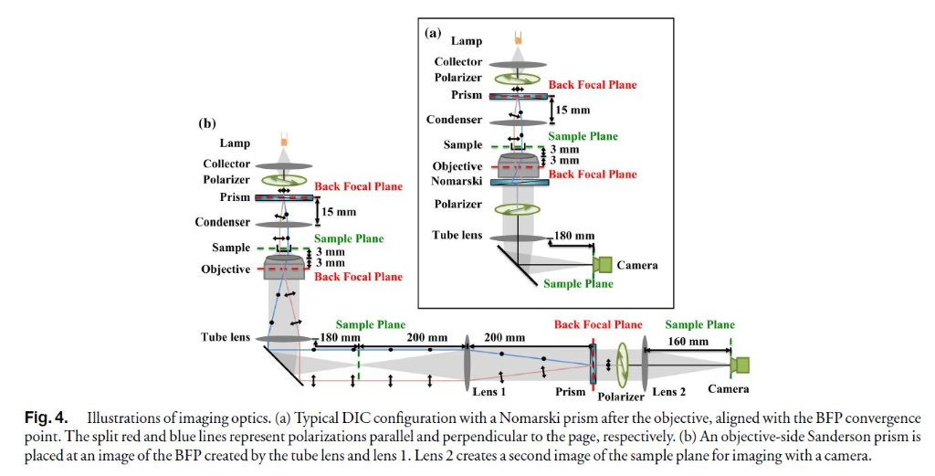
RathiFig4.JPG (80.04 KiB) Viewed 3804 times
I'll try what you say with viewing through the optical train without the camera lens - thanks for the advice!
This is a pic I took of the setup:

FullLength2_75pc_103926.jpg (41.42 KiB) Viewed 3804 times
I've made a few changes since taking that image though it's essentially the same.
Louise
A Nikon CF plan 20x; A Swift 380T; A DIY infinity corrected focus rail system with a 40x/0.65 Olympus Plan, a 10x/0.30 Amscope Plan Fluor, and a 20x/0.75 Nikon Plan Apo
Top
Quote
Post
Scarodactyl
Posts: 2040
Joined: Sat Mar 03, 2018 9:09 pm

Re: DIC Question

#43 by Scarodactyl » Sun May 23, 2021 10:09 pm
deBult wrote: ↑
Sun May 23, 2021 8:18 pm
From the Olympus website:
“ The tube length in infinity-corrected microscopes is referred to as the reference focal length and ranges between 160 and 200 millimeters..."
The same guy wrote up these introductory articles for Olympus, Nikon and Zeiss with minor variations (though you can see a few parts where he accidentally praises one brand on another's page, whoops). As such you shouldn't read too much into the specifics.
deBult wrote: ↑
Sun May 23, 2021 8:18 pm
Olympus even sells a seprate Telan / tube lens, to combine with the UIS objectives when using them in a non Olympus optical system.
This of course is because the Telan is not required?
These are not so much for using the objectives on a non-olympus system as they are for incorporating the objectives into an OEM system at the rated magnification. Every major manufacturer offers tube lenses for this purpose, with or without specific corrections, because it's a component you're going to need one way or another and it's nice to have one that works at the rated magnification. And even though specific corrections aren't needed, you do need a lens which is well-corrected in its own right and of the appropriate focal length to get really top results corner to corner on a larger sensor. Which isn't to say all OEM manufacturers go that route--there's one atomic force microscope I've seen partially disassembled that uses an off-the-shelf video lens as a tube lens with a mitutoyo objective.
edit: I see Viktor beat me to the punch. It is a little frustrating to seemingly have to relitigate this every time it comes up here (not meaning to single you ojt here, deBult, more a general thing). I occasionally use Olympus objectives on my Nikon stand and the only incompatibilities are the mismatched parfocal length (especially difficult going back and forth from mitutoyos) and poor epi DIC compatibility (which would be unfair to expect anyway). Planarity and color correction are not a problem.
Last edited by Scarodactyl on Mon May 24, 2021 12:54 am, edited 1 time in total.
Top
Quote
Post

Re: DIC Question

#44 by Scarodactyl » Sun May 23, 2021 10:14 pm
LouiseScot wrote: ↑
Sun May 23, 2021 9:12 pm
DiatomsCrop2_0130.jpg
This is definitely intriguing, and looks like it's moving in the right direction.
LouiseScot wrote: ↑
Sun May 23, 2021 10:05 pm
This is a pic I took of the setup:
That looks a bit different than I expected--I would guess putting it through two additional lenses after the tube lens might be having a detrimental effect here, assuming the issue isn't in the objective itself. I'll admit I find the diagram a bit confusing too--I'm guessing there is a good reason they don't put the sanderson prism right above the objective but I haven't read the paper yet. I'd also be a bit worried about flare with how narrow it seems to get at some points, though maybe the tubes are flocked?
Scarodactyl
Posts: 2040
Joined: Sat Mar 03, 2018 9:09 pm
Top
Quote
Post

Re: DIC Question

#45 by LouiseScot » Sun May 23, 2021 10:27 pm
Scarodactyl wrote: ↑
Sun May 23, 2021 10:14 pm
LouiseScot wrote: ↑
Sun May 23, 2021 9:12 pm
DiatomsCrop2_0130.jpg
This is definitely intriguing, and looks like it's moving in the right direction.
LouiseScot wrote: ↑
Sun May 23, 2021 10:05 pm
This is a pic I took of the setup:
That looks a bit different than I expected--I would guess putting it through two additional lenses after the tube lens might be having a detrimental effect here, assuming the issue isn't in the objective itself. I'll admit I find the diagram a bit confusing too--I'm guessing there is a good reason they don't put the sanderson prism right above the objective but I haven't read the paper yet. I'd also be a bit worried about flare with how narrow it seems to get at some points, though maybe the tubes are flocked?
I hadn't noticed any flare. It's mostly T2/M42 sections plus the 50mm and 60mm finders, and is only narrow at the tube lens sample plane - and that's because I just shoved a a short section of tube between the two sections . The BFP is within the objective with the Sanderson Prisms so the relay optics are required to move it to the position indicated in the diagram.
This is only a prototype system I've kinda put together mostly out of parts I already had. I've had to create an infinity microscope out of parts!
Louise
A Nikon CF plan 20x; A Swift 380T; A DIY infinity corrected focus rail system with a 40x/0.65 Olympus Plan, a 10x/0.30 Amscope Plan Fluor, and a 20x/0.75 Nikon Plan Apo
LouiseScot
Posts: 1001
Joined: Tue Jul 07, 2020 1:51 pm
Location: Scotland
Top
Quote
Post

Re: DIC Question

#46 by LouiseScot » Mon May 24, 2021 1:05 pm
viktor j nilsson wrote: ↑
Sun May 23, 2021 9:45 pm
That said, it would be good to see a clean brightfield image taken without the prisms to see which of the aberrations in the image are caused by the prisms, and which ones are caused by the rest of your setup.
And it really helps to be able to view the back focal plane when you are setting up a DIY DIC system. When I'm trialling different prism combinations I always remove an eyepiece and peek down the tube. It literally takes less than a second to see if a prism combination has any promise whatsoever, or if it's totally off. With one prism in, you see the colored interference fringes at the BFP with a dark central band, then, when you introduce the second prism, the BFP either become evenly colored (match!) or becomes totally covered with thin sharp interference stripes (mismatch).
Not sure what to expect with the Sanderson prisms, but I think you would expect something similar.
Is it impossible to do this your microscope?
Hi again
I took a few pics with my slightly improved setup. Focus is still problematic but I can live with that for the moment. Simply peeking down the optical train really only shows what the camera sees. I did a few more tests with and without prisms. It's the objective prism (next to the camera!) that makes the main difference.
I can get a darkish line across the fov with just the condenser prism in place. I can then insert the objective prism and rotate it to get the most even effect (or not). I'm not really getting the pronounced bands that Rathi et al. discuss (their Fig 3). It could be to do with the prism bending moment which I haven't done any real testing with. I'm waiting on a 6mm polycarbonate sheet so I can experiment with Sanderson's 'open frame' design and which Rathi et al. used for their objective prism. At least, though, I am getting some prism effects I'm not sure what the angle should be between the prisms and the cross-polarizers but with no prisms in the optical train the output is dark so the prisms are, at least, behaving as polarizers.
I used the prepared (Chinese) Kidney slide this time:
No prisms, polarizers rotated to allow passage of light:
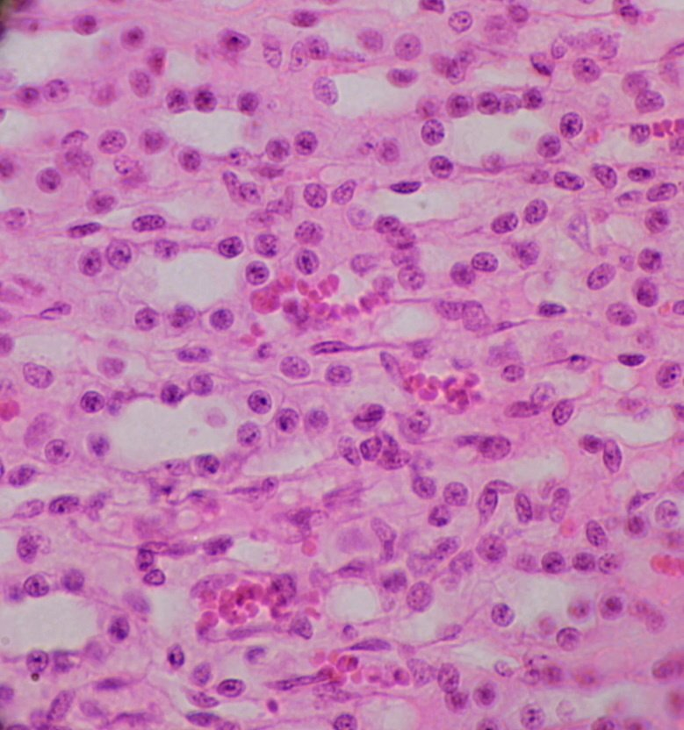
NoPrisms_Crop_53pc0128.jpg (120.18 KiB) Viewed 3755 times
Both prisms. Objective prism rotated to give even field:
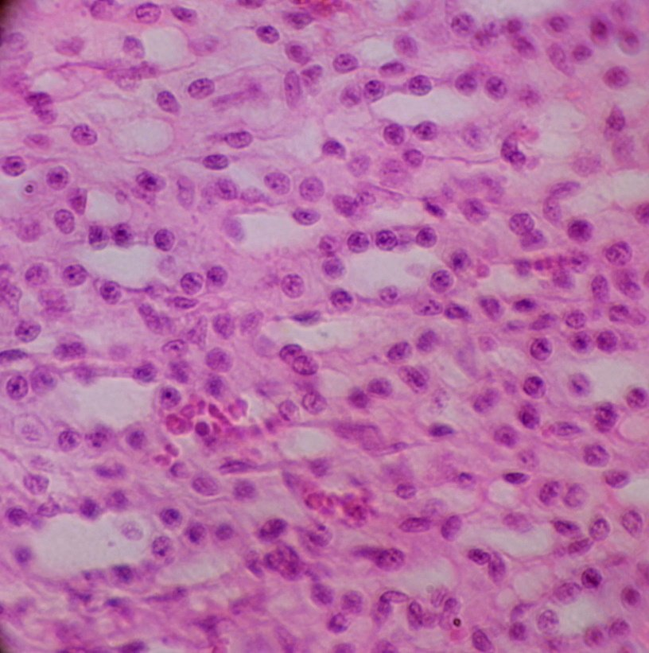
Bothg_Crop54pc0131.jpg (118.4 KiB) Viewed 3755 times
Objective Prism only showing dark band which is actually blue? This might indicate bending moment differences - something to investigate!
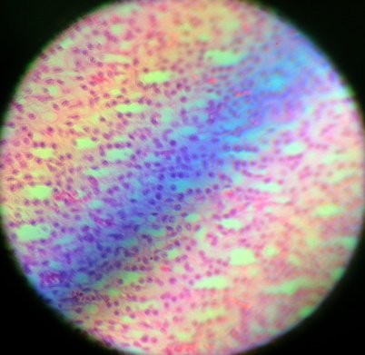
ObjPrismOnlyAdj_50pc_0130.jpg (39.71 KiB) Viewed 3755 times
Both prisms but objective prism rotated to show banding (contrast enhanced):
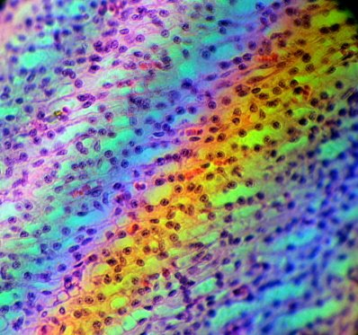
BothUnevenCropAuto_50pc_0128.jpg (58.66 KiB) Viewed 3755 times
Louise
A Nikon CF plan 20x; A Swift 380T; A DIY infinity corrected focus rail system with a 40x/0.65 Olympus Plan, a 10x/0.30 Amscope Plan Fluor, and a 20x/0.75 Nikon Plan Apo
LouiseScot
Posts: 1001
Joined: Tue Jul 07, 2020 1:51 pm
Location: Scotland
Top
Quote
Post
LouiseScot
Posts: 1001
Joined: Tue Jul 07, 2020 1:51 pm
Location: Scotland

Re: DIC Question

#47 by LouiseScot » Mon May 24, 2021 2:36 pm
I did some tightening of the two prisms. I got stronger banding but the colour order doesn't appear to be the same as Rathi et al. Hmm.. I'm doing the open frame design and construction next. Maybe the colours are related to the output of the 3W white LED I'm using?
Slight tightening:
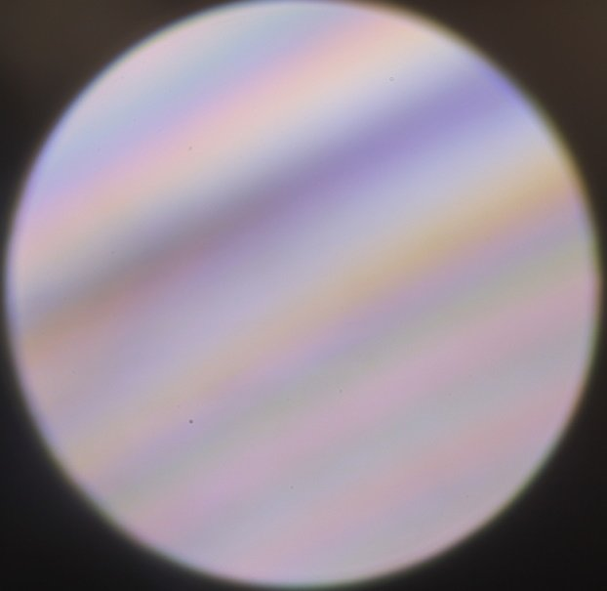
TightenedSlight_Crop_0128.jpg (27.33 KiB) Viewed 3748 times
More tightening:
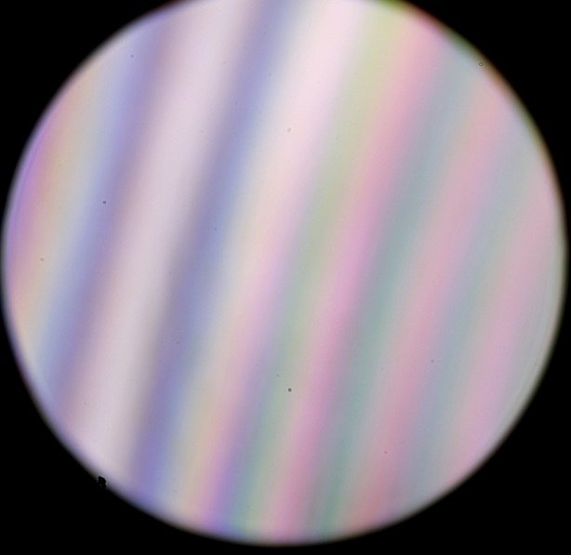
Tightened-1_Crop_25pc0129.jpg (33.97 KiB) Viewed 3748 times
Louise
A Nikon CF plan 20x; A Swift 380T; A DIY infinity corrected focus rail system with a 40x/0.65 Olympus Plan, a 10x/0.30 Amscope Plan Fluor, and a 20x/0.75 Nikon Plan Apo
Top
Quote
Post
Hobbyst46
Posts: 3905
Joined: Mon Aug 21, 2017 9:02 pm

Re: DIC Question

#48 by Hobbyst46 » Mon May 24, 2021 3:49 pm
A KR12 optical filter or (although to a lesser extent) stacked 81B filters in series will suppress the strong blue component of the white LED, although it will not reach the halogen light spectrum.
Zeiss Standard GFL+Canon EOS-M10, Olympus VMZ stereo
Top
Quote
Post
LouiseScot
Posts: 1001
Joined: Tue Jul 07, 2020 1:51 pm
Location: Scotland

Re: DIC Question

#49 by LouiseScot » Mon May 24, 2021 4:27 pm
Hobbyst46 wrote: ↑
Mon May 24, 2021 3:49 pm
A KR12 optical filter or (although to a lesser extent) stacked 81B filters in series will suppress the strong blue component of the white LED, although it will not reach the halogen light spectrum.
Hiya
I don't think I want to suppress anything - just want to make sense of the order of the coloured bands. I'm awaiting some 6mm polycarbonate so I can build the Sanderson open frame. That should help me get orientated and achieve the correct amount of bending moment. I should have done that in the first place but was cutting corners!
Thanks
Louise
A Nikon CF plan 20x; A Swift 380T; A DIY infinity corrected focus rail system with a 40x/0.65 Olympus Plan, a 10x/0.30 Amscope Plan Fluor, and a 20x/0.75 Nikon Plan Apo
Top
Quote
Post

Re: DIC Question

#50 by apochronaut » Mon May 24, 2021 4:39 pm
viktor j nilsson wrote: ↑
Sun May 23, 2021 9:28 pm
deBult wrote: ↑
Sun May 23, 2021 8:32 pm
Louise,
the point I'm making is - for optimal optical quality it may be wise to use the optical components in a matched system, usually the same “design period” of a single supplier. Mix and match is not a sound approach in my (limited) experience, YMMV though.
Usually, yes. But lots of folks over at photomacrography.com have shown over and over again that the UIS/UIS2 objectives work just as well, if not better, with non-compensating tube lenses from other manufacturers. Nikon, Olympus and Mitutoyo infinity objectives work really well with each other's tube lenses, as well as with optically "neutral" tube lenses such as Raynox DCR-150, Thorlabs ITL200, Sigma LSA, etc. Of course some combinations work slightly better than others, but I would say that it is rare that the optimal combination is when using it exactly as intended by the manufacturer.
But none of those tube lenses would be achromats, otherwise they would be compensating and all would have to be used at a specific focal length( maybe not the intended one) in order to compensate for any differences they impose in the system, compared to the lens designed by the mfg.
apochronaut
Posts: 5210
Joined: Fri May 15, 2015 12:15 am
Top
Quote
Post

Re: DIC Question

#51 by viktor j nilsson » Mon May 24, 2021 5:07 pm
apochronaut wrote: ↑
Mon May 24, 2021 4:39 pm
viktor j nilsson wrote: ↑
Sun May 23, 2021 9:28 pm
deBult wrote: ↑
Sun May 23, 2021 8:32 pm
Louise,
the point I'm making is - for optimal optical quality it may be wise to use the optical components in a matched system, usually the same “design period” of a single supplier. Mix and match is not a sound approach in my (limited) experience, YMMV though.
Usually, yes. But lots of folks over at photomacrography.com have shown over and over again that the UIS/UIS2 objectives work just as well, if not better, with non-compensating tube lenses from other manufacturers. Nikon, Olympus and Mitutoyo infinity objectives work really well with each other's tube lenses, as well as with optically "neutral" tube lenses such as Raynox DCR-150, Thorlabs ITL200, Sigma LSA, etc. Of course some combinations work slightly better than others, but I would say that it is rare that the optimal combination is when using it exactly as intended by the manufacturer.
But none of those tube lenses would be achromats, otherwise they would be compensating and all would have to be used at a specific focal length( maybe not the intended one) in order to compensate for any differences they impose in the system, compared to the lens designed by the mfg.
When used as a tube lens, these lenses are focused at infinity and stopped down considerably by the objective in front of them. Even a pretty simple achromat design (such as the 2 lens groups, 3 element Raynox DCR-150) evidently perform really well in this configuration, and add very little aberrations of their own. So even if some of them are achromats by design - when used as a primary taking lens - they act as essentially chromatically neutral when used as a tube lens. But again, different tube lenses do perform slightly differently, but differences are slight and it's not always the manufacturer's own tube lens that performs best.
viktor j nilsson
Posts: 659
Joined: Thu Aug 23, 2018 10:12 pm
Location: Lund, Sweden
Top
Quote
Post

Re: DIC Question

#52 by LouiseScot » Mon May 24, 2021 5:09 pm
Just to check, I took a pic using a halogen spotlamp (gives off a lot of heat, lol):
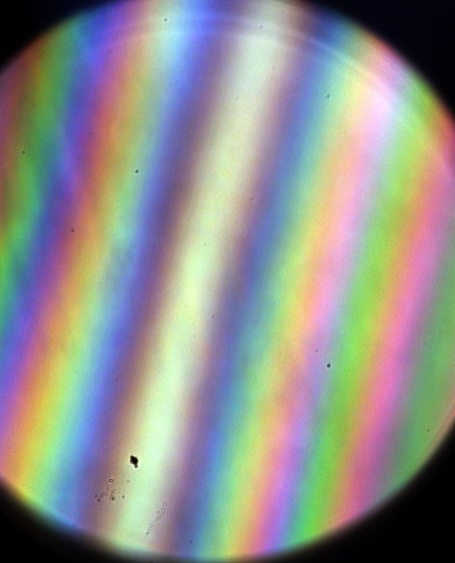
SpotlampAuto_20pc 0128.jpg (42.04 KiB) Viewed 3723 times
I enhanced it a bit.
And the previous one again to compare:
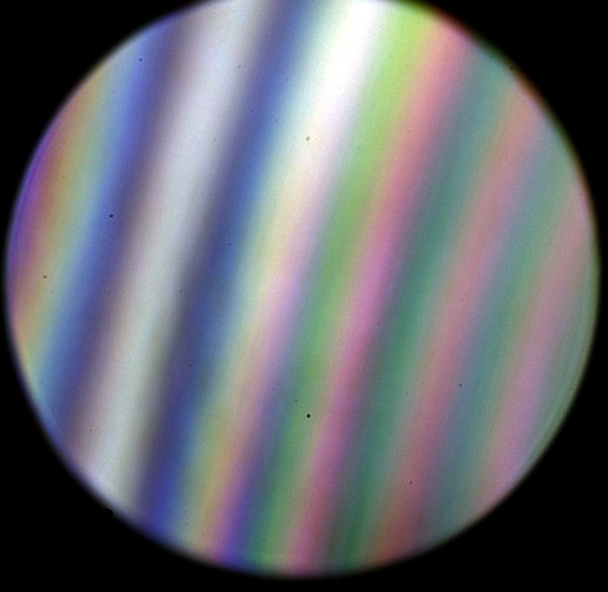
Tightened-1_Crop_25pcAdj_0129.jpg (46.82 KiB) Viewed 3723 times
They are different! And appear to be shifted in a relative way..
Louise
A Nikon CF plan 20x; A Swift 380T; A DIY infinity corrected focus rail system with a 40x/0.65 Olympus Plan, a 10x/0.30 Amscope Plan Fluor, and a 20x/0.75 Nikon Plan Apo
LouiseScot
Posts: 1001
Joined: Tue Jul 07, 2020 1:51 pm
Location: Scotland
Top
Quote
Post
apochronaut
Posts: 5210
Joined: Fri May 15, 2015 12:15 am

Re: DIC Question

#53 by apochronaut » Mon May 24, 2021 5:50 pm
viktor j nilsson wrote: ↑
Mon May 24, 2021 5:07 pm
apochronaut wrote: ↑
Mon May 24, 2021 4:39 pm
viktor j nilsson wrote: ↑
Sun May 23, 2021 9:28 pm
Usually, yes. But lots of folks over at photomacrography.com have shown over and over again that the UIS/UIS2 objectives work just as well, if not better, with non-compensating tube lenses from other manufacturers. Nikon, Olympus and Mitutoyo infinity objectives work really well with each other's tube lenses, as well as with optically "neutral" tube lenses such as Raynox DCR-150, Thorlabs ITL200, Sigma LSA, etc. Of course some combinations work slightly better than others, but I would say that it is rare that the optimal combination is when using it exactly as intended by the manufacturer.
But none of those tube lenses would be achromats, otherwise they would be compensating and all would have to be used at a specific focal length( maybe not the intended one) in order to compensate for any differences they impose in the system, compared to the lens designed by the mfg.
When used as a tube lens, these lenses are focused at infinity and stopped down considerably by the objective in front of them. Even a pretty simple achromat design (such as the 2 lens groups, 3 element Raynox DCR-150) evidently perform really well in this configuration, and add very little aberrations of their own. So even if some of them are achromats by design - when used as a primary taking lens - they act as essentially chromatically neutral when used as a tube lens. But again, different tube lenses do perform slightly differently, but differences are slight and it's not always the manufacturer's own tube lens that performs best.
Sure, stopping down will close off whatever peripheral aberrations that it does in any specific situation and the tube lens is usually thin and of low curvature and the Raynox DCR-150 is a very wide lens so benefits from it's original aperture and is used reversed, so their negative contributions might be considered somewhat benign but achromats are achromats and despite the slight curvature on these lenses, they still induce chromatism. Can you show me examples where tube lenses have been swapped willy nilly between mfg's and used without other modification and produced better results than the original settup?
Top
Quote
Post
Hobbyst46
Posts: 3905
Joined: Mon Aug 21, 2017 9:02 pm

Re: DIC Question

#54 by Hobbyst46 » Mon May 24, 2021 6:08 pm
LouiseScot wrote: ↑
Mon May 24, 2021 5:09 pm
They are different! And appear to be shifted in a relative way..
Yes, I think that the hues reflect the expected source spectrum: The top has a significant cred and orange component, is "warmer", the bottom has almost none of those, and the blue and violet are dominant.
Zeiss Standard GFL+Canon EOS-M10, Olympus VMZ stereo
Top
Quote
Post

Re: DIC Question

#55 by LouiseScot » Mon May 24, 2021 6:33 pm
Hobbyst46 wrote: ↑
Mon May 24, 2021 6:08 pm
LouiseScot wrote: ↑
Mon May 24, 2021 5:09 pm
They are different! And appear to be shifted in a relative way..
Yes, I think that the hues reflect the expected source spectrum: The top has a significant cred and orange component, is "warmer", the bottom has almost none of those, and the blue and violet are dominant.
It's supposed to look like this with a halogen bulb:
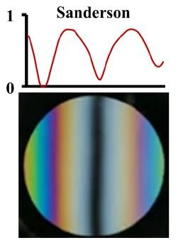
RathiInterferencePattern.JPG (18.86 KiB) Viewed 3693 times
Louise
A Nikon CF plan 20x; A Swift 380T; A DIY infinity corrected focus rail system with a 40x/0.65 Olympus Plan, a 10x/0.30 Amscope Plan Fluor, and a 20x/0.75 Nikon Plan Apo
LouiseScot
Posts: 1001
Joined: Tue Jul 07, 2020 1:51 pm
Location: Scotland
Top
Quote
Post

Re: DIC Question

#56 by viktor j nilsson » Mon May 24, 2021 6:50 pm
apochronaut wrote:Sure, stopping down will close off whatever peripheral aberrations that it does in any specific situation and the tube lens is usually thin and of low curvature and the Raynox DCR-150 is a very wide lens so benefits from it's original aperture and is used reversed, so their negative contributions might be considered somewhat benign but achromats are achromats and despite the slight curvature on these lenses, they still induce chromatism. Can you show me examples where tube lenses have been swapped willy nilly between mfg's and used without other modification and produced better results than the original settup?
Sure.
https://www.closeuphotography.com/tube-lens-test
Here's a test where a Mitutoyo 5x objective was used with a bunch of different tube lenses:
Thorlabs ITL200 Tube Lens
Mitutoyo MT-1 Tube lens
Nikon MXA20696 Tube Lens
Reichert Microscope Tube Lens
Canon 250D Close-up Lens
Century Precision Optics +4 Achromatic Diopter Lens
Century Precision Optics +7 Achromatic Diopter Lens
Cosina MMA Matched Macro Adapter Lens
Raynox +4.8 diopter
Raynox +5.9 diopter
Raynox +8 diopter
Sigma LSA Life Size Attachment Lens
The manufacturer's own tube length (Mitutoyo MT-1) performed quite poorly, and the best was the Thorlabs ITL200, which is actually made by Nikon. Interestingly, the Thorlabs-branded but Nikon-made ITL200 tube lens performs quite a bit better with Nikon and Mitutoyo objectives then the Nikon-branded MXA20696 tube lens that Nikon ships with its CFI and CFI2 microscopes...
I don't know of any equally carefully controlled comparisons with an Olympus UIS2 objective, but I've seen plenty of very clean images taken with Olympus objectives and a Raynox DCR-150 as a tube lens.
viktor j nilsson
Posts: 659
Joined: Thu Aug 23, 2018 10:12 pm
Location: Lund, Sweden
Top
Quote
Post

Re: DIC Question

#57 by deBult » Mon May 24, 2021 7:54 pm
viktor j nilsson wrote: ↑
Mon May 24, 2021 6:50 pm
I don't know of any equally carefully controlled comparisons with an Olympus UIS2 objective, but I've seen plenty of very clean images taken with Olympus objectives and a Raynox DCR-150 as a tube lens.
Check: clean images with 40* UIS2 objectives? I’m really curious to learn more, Please supply a link.
Best, deBult
deBult
Posts: 313
Joined: Tue Jul 16, 2019 3:20 pm
Top
Quote
Post
viktor j nilsson
Posts: 659
Joined: Thu Aug 23, 2018 10:12 pm
Location: Lund, Sweden

Re: DIC Question

#58 by viktor j nilsson » Mon May 24, 2021 8:12 pm
deBult wrote: ↑
Mon May 24, 2021 7:54 pm
viktor j nilsson wrote: ↑
Mon May 24, 2021 6:50 pm
I don't know of any equally carefully controlled comparisons with an Olympus UIS2 objective, but I've seen plenty of very clean images taken with Olympus objectives and a Raynox DCR-150 as a tube lens.
Check: clean images with 40* UIS2 objectives? I’m really curious to learn more, Please supply a link.
Best, deBult
Would need to search a bit to find exactly that, but in the meantime here's a *fairly* clean image taken with an Olympus UMPlanFL 50x 0.80 using a Rodenstock Omegaron 105mm enlarger lens as tube lens:
https://www.photomacrography.net/forum/ ... 27&t=43377
Top
Quote
Post

Re: DIC Question

#59 by viktor j nilsson » Mon May 24, 2021 8:16 pm
Here's another one using a Olympus UMPlanFI 50x/0,80 on a Canon EF 70-200L zoom lens as a tube lens:
https://www.photomacrography.net/forum/ ... 9&p=267397
viktor j nilsson
Posts: 659
Joined: Thu Aug 23, 2018 10:12 pm
Location: Lund, Sweden
Top
Quote
Post
Scarodactyl
Posts: 2040
Joined: Sat Mar 03, 2018 9:09 pm

Re: DIC Question

#60 by Scarodactyl » Mon May 24, 2021 8:18 pm
This should probably be split off into another discussion. LouiseScot is working on an extremely cool project and I thinj we really don't want to make it harder to discuss by retreading this in her thread.
Quote
Post

Re: DIC Question

#61 by viktor j nilsson » Mon May 24, 2021 8:20 pm
Yes, sorry. This question was always off topic here. I'll leave it at that. Go ahead Louise, looking forward to seeing more from this interesting project!
Top
Quote
Post
apochronaut
Posts: 5210
Joined: Fri May 15, 2015 12:15 am

Re: DIC Question

#62 by apochronaut » Mon May 24, 2021 8:44 pm
viktor j nilsson wrote: ↑
Mon May 24, 2021 6:50 pm
apochronaut wrote:Sure, stopping down will close off whatever peripheral aberrations that it does in any specific situation and the tube lens is usually thin and of low curvature and the Raynox DCR-150 is a very wide lens so benefits from it's original aperture and is used reversed, so their negative contributions might be considered somewhat benign but achromats are achromats and despite the slight curvature on these lenses, they still induce chromatism. Can you show me examples where tube lenses have been swapped willy nilly between mfg's and used without other modification and produced better results than the original settup?
Sure.
https://www.closeuphotography.com/tube-lens-test
Here's a test where a Mitutoyo 5x objective was used with a bunch of different tube lenses:
Thorlabs ITL200 Tube Lens
Mitutoyo MT-1 Tube lens
Nikon MXA20696 Tube Lens
Reichert Microscope Tube Lens
Canon 250D Close-up Lens
Century Precision Optics +4 Achromatic Diopter Lens
Century Precision Optics +7 Achromatic Diopter Lens
Cosina MMA Matched Macro Adapter Lens
Raynox +4.8 diopter
Raynox +5.9 diopter
Raynox +8 diopter
Sigma LSA Life Size Attachment Lens
The manufacturer's own tube length (Mitutoyo MT-1) performed quite poorly, and the best was the Thorlabs ITL200, which is actually made by Nikon. Interestingly, the Thorlabs-branded but Nikon-made ITL200 tube lens performs quite a bit better with Nikon and Mitutoyo objectives then the Nikon-branded MXA20696 tube lens that Nikon ships with its CFI and CFI2 microscopes...
I don't know of any equally carefully controlled comparisons with an Olympus UIS2 objective, but I've seen plenty of very clean images taken with Olympus objectives and a Raynox DCR-150 as a tube lens.
Yes. I've seen that and it is very weird. The author seems oblivious to the fact that a few of his test lenses are corrected for specific conditions with built in corrections and therefore are unlikely to be very usefull in his application. It's an apple and orange test. I think there might even be a kumquat in there.
So in Louise's set up she has an achromat guide lens placed somewhere as a tube lens for a ray bundle that begins at infinity, which is located 180mm from what is called the sample plane and focused at that point because it has a 180mm f.l.
That is very much a microscope set up, although in her situation she could alter those parameters if the lens was different, so she could modify the set up so that other tube lenses could work. In this case the term tube lens is being used but it is actually what I would call a telan lens. To me the tube lens is up in the photo tube.
The point was made earlier, ( not by me) that various "tube" lenses can be used with a number of infinity objectives and good to excellent results are possible. Yes, maybe in the photo tube, where things can be modified to suit but I prefaced my question with the term, unmodified, as in putting an Olympus objective in a Nikon stand, or a Nikon objective in a Mitutoyo stand or a Meiji objective in a Reichert stand.
That test uses all modified optics because he changes the location of the lens with each test, so it is a photography test, not a microscopy test. You can't really relate those results very well to an installation where each lens is in a factory set position in a microscope stand.
One thing it does show though, is that there are dramatic differences in tube lenses, so you can't just swap them willy nilly and when they are not corrected properly for a certain application or installed at the wrong distance, that they don't work well.
Top
Quote
Post
jmp
Posts: 66
Joined: Sun Feb 16, 2020 2:07 am
Location: Texas

Re: DIC Question

#63 by jmp » Wed May 26, 2021 4:38 am
I've been experimenting with Sanderson prisms too, after going over the paper from Rathi et. al. I believe there is an error in the expression that gives the divergence angle:

divergence_function.jpg (8 KiB) Viewed 5218 times
The problem is that with r and l defined as in their figure (Fig. 1):
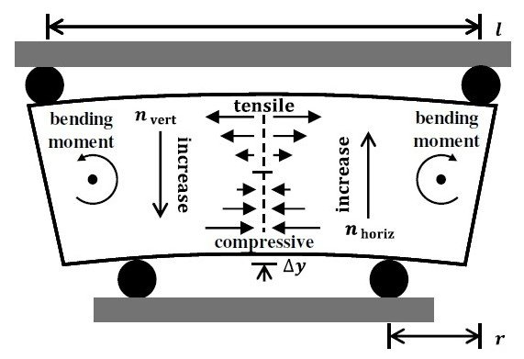
prism_schematic.jpg (32.13 KiB) Viewed 5218 times
the expression 4r^2 - 3l^2 will yield a negative number for reasonable values of r and l. I bumped into this because I was unable to replicate the linear relationship between the divergence angle and the displacement, of this figure (Fig. 3a):
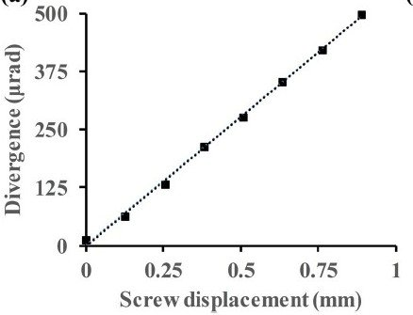
displacement_vs_divergence.jpg (15.22 KiB) Viewed 5218 times
when evaluating that expression using the measurements given in the paper. However if r is defined as the distance from the center of the prism to the inner pin, and the expression 4r^2 - 3l^2 is replaced with 3l^2 - 4r^2 then I can replicate Fig. 3a.
I wonder if I missed something and I'm wrong, or if someone else caught this too. I stumbled into that when I was trying to get an idea of the dimensions of the prism that I could use to build a slider for an inverted microscope that I wanted to try this with.
Top
Quote
Post
jmp
Posts: 66
Joined: Sun Feb 16, 2020 2:07 am
Location: Texas

Re: DIC Question

#64 by jmp » Wed May 26, 2021 5:06 am
(Continued)
In the end I built a crude 3D printed slider to accommodate a prism of 70x16x2.38mm:
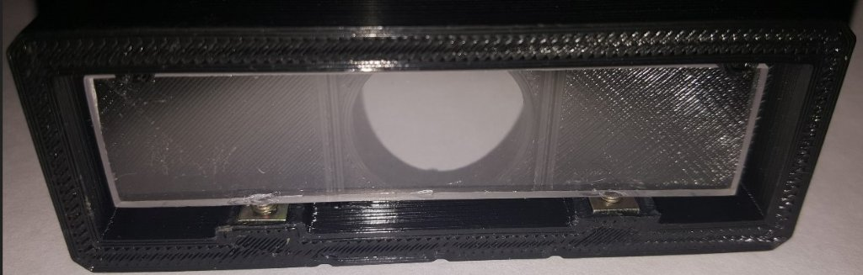
slider_prototype.jpg (55.97 KiB) Viewed 5215 times
It was quite interesting to see how the interference pattern changed as the bending force on the prism increased, when the prism was hold between a pair of crossed polar filters. Here's a snapshot of how it looked after a few turns of the displacement screws:
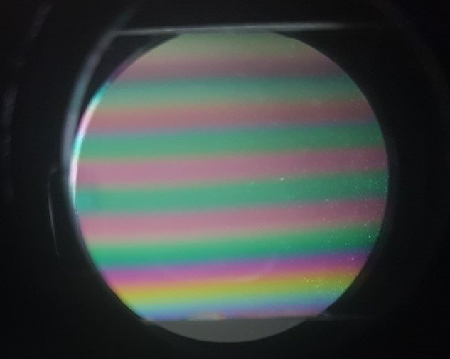
interference_pattern.jpg (23.56 KiB) Viewed 5215 times
So far so good! Thus I gave this a spin in the inverted microscope. One of the upgrades for this microscope was a plasdic kit: a slit slider with a polarizer for the condenser (which I have) and a Nomarski prism for the slider in the back focal plane of the objective (which I unfortunately don't have). Thus I placed the Sanderson prism slider in the back focal plane of the objective and used the slit condenser instead of a second Sanderson prism before the condenser, not ideal but worth a try. Here's the result of the canonical cheek cell comparison using a 10x LWD objective (only edited the white balance, and set the images to grayscale):
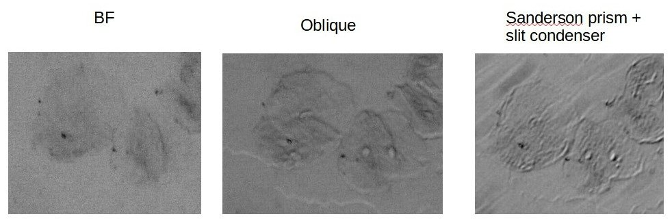
cheek_cells_test.jpg (51.86 KiB) Viewed 5215 times
While the quality of the pictures leaves a lot to be desired, I get the impression that there's a hint of DIC with the Sanderson prism, which is encouraging given how simple this procedure was. The 3D appearance of the oblique image differs from that of the Sanderson prism one.
Here's a larger view, where the pseudo-relief from the Sanderson prism seems to stand out more:
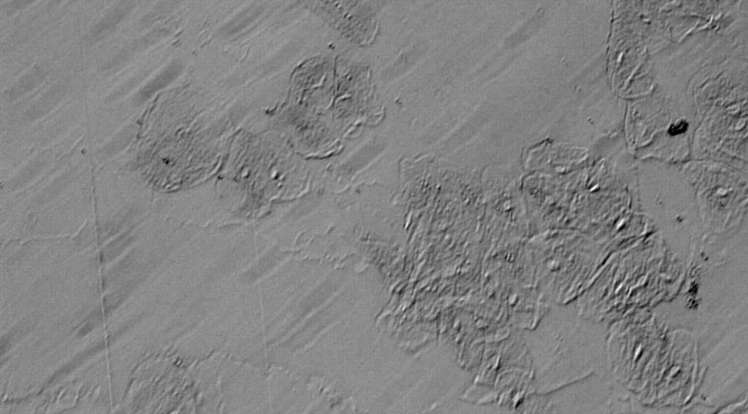
10x_cheek_cells_sanderson_prism.jpg (99.02 KiB) Viewed 5215 times
Given the results from this experiment, I'll build a second slider to place a second Sanderson prism below the condenser. It was difficult to get enough light (from the 50W halogen) with the slit condenser, it is likely that using a polycarbonate prism instead will significantly aid with the illumination of the sample and perhaps improve the quality of the images. Though I'm not expecting spectacular DIC images out of this setup, I'm doing this mostly to learn and have heaps of fun.
Top
Quote
Post
LouiseScot
Posts: 1001
Joined: Tue Jul 07, 2020 1:51 pm
Location: Scotland

Re: DIC Question

#65 by LouiseScot » Wed May 26, 2021 12:42 pm
Hi Jmp
I'm glad someone else is having a go! I don't think the equation is wrong - probably a negative solution just indicates relative direction. It's worth going back to the paper by Biss et al. which you can get here: https://af.booksc.org/book/15387605/9162f0
I think the acid test is whether you get a clearly different image with and without the prism. You obviously get birefringence from the polycarbonate under stress and that shows up between the cross polarizers. However, I'm not sure that necessarily translates into actual DIC. From both Rathi and Biss, you need to get destructive interference in the centre of the fringe pattern i.e. a dark band. That's what I'm aiming for at the moment. I've had problems with my prism holders not really working as expected. I've 3D printed them in PLA but they do tend to bend as you tighten the screw(s)! Also the PLA can tend to crush with the pressure of the polycarbonate, under tension. I've remade the 'condenser' prism (Rathi Fig 2b) using masonry nails instead of PLA (which I had originally) for the upper contact points. I've previously been using 2 of the round prism frames for both ends but yesterday printed out an open frame prism holder (I just got some 6mm polycarbonate yesterday). So I'm trying that. Again a problem with bending... A metal frame would be better but I don't have the facilities for making one. However, it might be possible to make the part that tends to bend out of aluminium bar if it proves necessary.
Another thing is imaging the objective's BFP which is likely inside the objective so requires the relay optics to shift it to a point where it can be imaged. Rathi et al. appeared to do all their imaging with a 60x water immersion lens so that would definitely have its BFP inside the Barrel. I've essentially copied the Rathi optical setup but others may work just as well (see Kurvits et al. 2015).
Louise
A Nikon CF plan 20x; A Swift 380T; A DIY infinity corrected focus rail system with a 40x/0.65 Olympus Plan, a 10x/0.30 Amscope Plan Fluor, and a 20x/0.75 Nikon Plan Apo
Top
Quote
Post
jmp
Posts: 66
Joined: Sun Feb 16, 2020 2:07 am
Location: Texas

Re: DIC Question

#66 by jmp » Wed May 26, 2021 1:50 pm
To clarify, the problem is not that the angles are negative but that the results that I get from that expression do not agree with the displacement-to-angle relationship depicted in the figure from their paper, unless I make the changes that I mentioned. I might have missed something though, its not my field after all. Thanks for the book reference, that will be useful.
I agree with you in that the results from my test are not actual DIC. The interference pattern that I observed is from a single prism, and as you noted it does not have the destructive interference band in the center (the black line in the figures from Rathi's paper), for that I'd need to have both prisms in the light path. Now that I'm getting a idea of how this works I'll build the slider for the second prism in the next test iteration, and see if I can replicate the interference pattern from that figure in their paper.
I share your thoughts regarding the drawbacks of a 3D printed prism frame, mine also deformed noticeably under the stress from the bent polycarbonate prism once screws where tightened. Its fine for the initial tests but the prism holder will need to be strengthened somehow, probably with a metal frame of some sort, for this to be usable on a regular basis. At that point screws should not directly contact and push on the prism either, like they do now in my crude test frame.
Access to the back focal plane of the objective is not a concern for me at the moment with the microscope that I'm using. Though its a finite 160mm tube length design, it includes the necessary optics to bring the BFP of 10x and 20x objectives to a plane where sliders with the respective phase rings can be inserted. A conjugate plane before the condenser lens is also accessible for a slider that holds a single phase stop that works with both objectives; this is where the slit/polarizer slider from the plasdic kit also sits and where the second Sanderson prism will go in the next test. The setup is handy for learning and tinkering with this, but it won't be usable (if ever) for anything other than 10x/20x, which is fine for my purposes at least for now. By the way, thanks for the reference to the Kurvits paper, its interesting to learn from other designs.
Once I get around to build the second prism I'll share my results here, in case someone else finds them of use.
Top
Quote
Post
Hobbyst46
Posts: 3905
Joined: Mon Aug 21, 2017 9:02 pm

Re: DIC Question

#67 by Hobbyst46 » Wed May 26, 2021 2:40 pm
Some general literature about 4-point beam bending arrives, for the maximum deflection, at the expression 3L^2-4A^2 (their A is Rathi's r) rather than the other way around. Just guessing that "jmp" is correct and the framed formula divergence_function above is incorrect -
perhaps worth further checking.
Last edited by Hobbyst46 on Wed May 26, 2021 3:23 pm, edited 1 time in total.
Zeiss Standard GFL+Canon EOS-M10, Olympus VMZ stereo
Top
Quote
Post
LouiseScot
Posts: 1001
Joined: Tue Jul 07, 2020 1:51 pm
Location: Scotland

Re: DIC Question

#68 by LouiseScot » Wed May 26, 2021 3:14 pm
Hobbyst46 wrote: ↑
Wed May 26, 2021 2:40 pm
Some general literature about 4-point beam bending arrives, for the maximum deflection, at the expression 3L^2-4A^2 (their A is Rathi's r) rather than the other way around. Just guessing that "jmp" is correct and the framed formula divergence_function above is incorrect -
perhaps worth checking by someone who really knows mechanics !
Hiya
The formula previously comes from Biss et al. But anyway, if X=A-B then -X = (B-A) so if the sign of the result doesn't matter then I don't think it makes much difference arithmetically:)
Louise
A Nikon CF plan 20x; A Swift 380T; A DIY infinity corrected focus rail system with a 40x/0.65 Olympus Plan, a 10x/0.30 Amscope Plan Fluor, and a 20x/0.75 Nikon Plan Apo
Top
Quote
Post
LouiseScot
Posts: 1001
Joined: Tue Jul 07, 2020 1:51 pm
Location: Scotland

Re: DIC Question

#69 by LouiseScot » Wed May 26, 2021 6:21 pm
I just took a quick snap of my frame prism between cross-polarizers (illuminated by daylight):
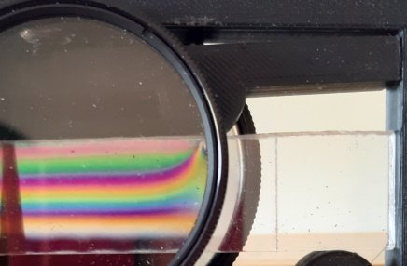
FrameBiRefCrop28pc_190631.jpg (20.55 KiB) Viewed 5163 times
It's reassuring that the birefringence is apparent. You can clearly see the unwanted Saint-Venant effect at the load point but the main fringes are ok. They seem a bit wide to me but I'll have to see how tings vary with increased tension. I just printed a thicker top bar so will try that next (if it still fits ok!)
Louise
A Nikon CF plan 20x; A Swift 380T; A DIY infinity corrected focus rail system with a 40x/0.65 Olympus Plan, a 10x/0.30 Amscope Plan Fluor, and a 20x/0.75 Nikon Plan Apo
Top
Quote
Post
jmp
Posts: 66
Joined: Sun Feb 16, 2020 2:07 am
Location: Texas

Re: DIC Question

#70 by jmp » Fri May 28, 2021 3:14 pm
Built the second prism and slider. The interference pattern between crossed polarizers from the two prisms, stacked and aligned on their main prism axes, look like this now:
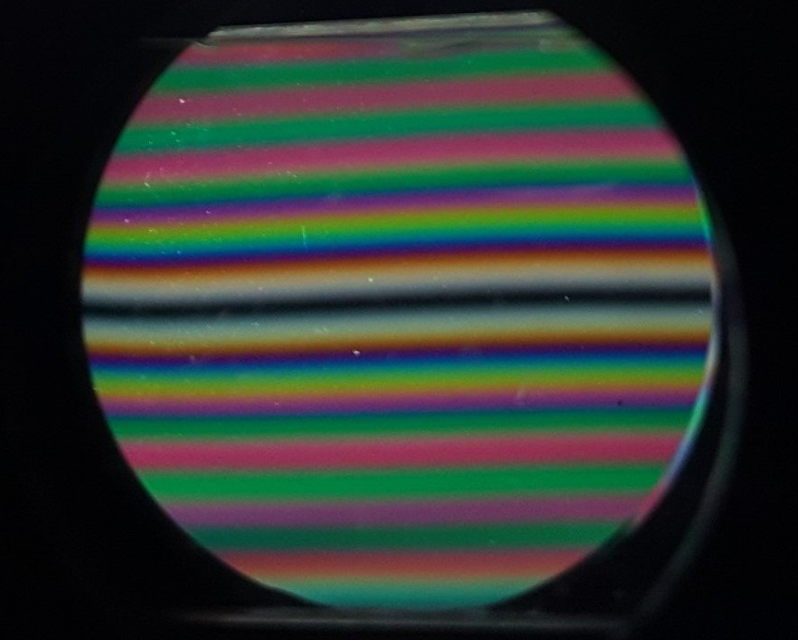
two_prism_interference_pattern.jpg (75.59 KiB) Viewed 5094 times
A bit wavy, the 2 screws were not pushing evenly on the prisms, but it approximates the pattern from Fig 3b in the Rathi paper.
For comparison, the interference pattern from a single prims between crossed polarized looks like this:
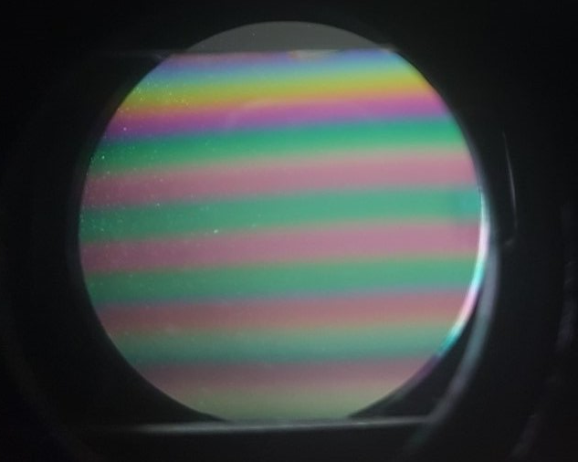
interference_pattern.jpg (38.41 KiB) Viewed 5094 times
So far so good, though I hit a snag with my setup. Until now I didn't pay attention to the orientation of the slider axes in the light path. Turns out that the slider in the back focal plane of the objective is at 45deg in relation to the slider before the condenser. Makes no difference for phase rings, but it does throw off the alignment of the Sanderson prisms in the sliders that I built. As expected with such a difference in the orientation of the prisms a quick test fails to create a DIC effect. Since the condenser can't be rotated in this scope, to align the axes of the sliders I'll need to drill an tap 4 holes to rotate the part of the tube that holds the bfp slider. An unexpected hassle, but not terribly complicated to do. The fun never ends.
Interestingly the plasdic kit for this microscope has a slit slider that sits before the condenser and the slit is at a 45deg from the main axis of the slider, which lines up the slit with the main axis of the wolaston prism slider from that kit at the bfp of the objective. It makes sense to me now. My first test with a single sanderson prism at the bfp of the objective using the slit condenser should have approximated the plasdic effect from the original kit, unfortunately since I don't have the wolaston slider from that kit I can't make a direct comparison.
Top
Quote
Post
LouiseScot
Posts: 1001
Joined: Tue Jul 07, 2020 1:51 pm
Location: Scotland

Re: DIC Question

#71 by LouiseScot » Fri May 28, 2021 5:45 pm
jmp wrote: ↑
Fri May 28, 2021 3:14 pm
Built the second prism and slider. The interference pattern between crossed polarizers from the two prisms, stacked and aligned on their main prism axes, look like this now:
two_prism_interference_pattern.jpg
A bit wavy, the 2 screws were not pushing evenly on the prisms, but it approximates the pattern from Fig 3b in the Rathi paper.
For comparison, the interference pattern from a single prims between crossed polarized looks like this:
interference_pattern.jpg
So far so good, though I hit a snag with my setup. Until now I didn't pay attention to the orientation of the slider axes in the light path. Turns out that the slider in the back focal plane of the objective is at 45deg in relation to the slider before the condenser. Makes no difference for phase rings, but it does throw off the alignment of the Sanderson prisms in the sliders that I built. As expected with such a difference in the orientation of the prisms a quick test fails to create a DIC effect. Since the condenser can't be rotated in this scope, to align the axes of the sliders I'll need to drill an tap 4 holes to rotate the part of the tube that holds the bfp slider. An unexpected hassle, but not terribly complicated to do. The fun never ends.
Interestingly the plasdic kit for this microscope has a slit slider that sits before the condenser and the slit is at a 45deg from the main axis of the slider, which lines up the slit with the main axis of the wolaston prism slider from that kit at the bfp of the objective. It makes sense to me now. My first test with a single sanderson prism at the bfp of the objective using the slit condenser should have approximated the plasdic effect from the original kit, unfortunately since I don't have the wolaston slider from that kit I can't make a direct comparison.
Well done! Looking good! I've still not managed to achieve interference yet (Though I've been fiddling about with other things like trying to improve my objective focuser). I've been wondering how Rathi et al. did it with mixes of Sanderson Prisms and Nomarski prisms and with the two different sized Sanderson prisms. Maybe I'm wrong and the relative sizes of the two prisms makes no difference? I was thinking about making a second open frame prism just to check. OTOH if size doesn't matter then my failure is probably an optical one, and to do with getting correct and exact focal lengths. As I understand it, the interference takes place in the objective-side polarizer where the two polarized beams recombine. In Rathi's diagram the BFP is imaged on the objective side prism and the polarizer is adjacent that. My camera imaging lens is actually fl = 240mm but I don't think that would make any difference as it's focussed on infinity. The other possibility is the condenser side prism. I've had to construct a 'condenser'. I've tried to ensure the condenser lens is focused on the prism and the lens is equidistant between the prism and the sample plane. I'm not sure about Rathi's diagram which shows the sample plane 3mm from the the front of the lens and the BFP 3mm behind the front. I previously thought the BFP was located further up the barrel? My Olympus 40x objective has a focal length of 4.5mm and a wd of 0.6mm. I dunno. I have a very similar setup to Rathi's - a 180mm tube lens, and a 208mm fl Lens 1 (rather than Rathi's 200mm). They appear to have used an 80mm diameter lens 2 for some reason (if their reference number is correct). Having written this, it's made me wonder if the condenser prism to condenser lens is critical - Rathi's is 15mm, mine is 40mm. Maybe that's too far?
I'll keep at it!
Louise
A Nikon CF plan 20x; A Swift 380T; A DIY infinity corrected focus rail system with a 40x/0.65 Olympus Plan, a 10x/0.30 Amscope Plan Fluor, and a 20x/0.75 Nikon Plan Apo
Top
Quote
Post
75RR
Posts: 8197
Joined: Sun Oct 12, 2014 2:34 am
Location: Estepona, Spain

Re: DIC Question

#72 by 75RR » Fri May 28, 2021 7:07 pm
.
I think that perhaps the key to all this are the prisms, their orientation, and the degree that they are bent.
Perhaps jmp could provide a birds eye view of his arrangement that provided this result:
Zeiss Standard WL (somewhat fashion challenged) & Wild M8
Olympus E-P2 (Micro Four Thirds Camera)
Top
Quote
Post
jmp
Posts: 66
Joined: Sun Feb 16, 2020 2:07 am
Location: Texas

Re: DIC Question

#73 by jmp » Fri May 28, 2021 8:53 pm
The contraption that I used to obtain the image of that interference pattern is extremely simple, and it did not involve the microscope or any complex optic setup: literally the prism sliders were directly stacked on top of each other, flanked by cross polarized filters. Just imagine two of these:
one in front of the other. Polarizer #1 is held on the back of slider #1 and polarizer #2 is held in front of slider #2, everything temporarily held together with a couple of rubber bands. A desk lamp with a CFL provided the white light behind polarizer #1, and I held my cellphone camera in front of polarizer #2 to take the picture. Despite the simplicity it the setup was quite didactic for me. It was possible to directly look at how the interference pattern changed in response to changes in the bending force applied by tightening or loosing the screws. I'll document it with a video, and post a picture of my setup.
I have not taken a picture of the interference pattern at the back focal plane of the objective yet. I briefly looked at it though, using the Bertrand lens built in the magnification changer of the trinocular, when I later mounted both sliders in the microscope. What I saw at the bfp of the objective was a different pattern, more like a crosshatch, which I suspect originates from the 45deg rotation between the slider mounts in the microscope. I saw a similar crosshatch pattern when I rotated one of the prisms by approximately 45deg in the contraption that I described at the beginning, which would confirm my suspicion. I didn't snap a picture of this but I'll do so and post it here later.
Top
Quote
Post
LouiseScot
Posts: 1001
Joined: Tue Jul 07, 2020 1:51 pm
Location: Scotland

Re: DIC Question

#74 by LouiseScot » Tue Jun 01, 2021 4:01 pm
Just a quick update.. I've managed to reproduce the interference patterns using new open-frame holders although my bands were not so narrow or so symmetric. My dark band always tends to be in the bottom half of the prisms. That may be related to my use of 6mm bars rather than 3mm ones - I don't know. I'll remake my open frame prisms with 3mm polycarbonate when I get a minute. Anyway, I've read Rathi's paper several times but find myself confused by what they've said. In their fig 3A they've plotted a graph showing the linear relationship between screw displacement and divergence. At about 0.9mm displacement they get 500 urad divergence. But.. when it comes to DIC imaging with the prisms they are talking about 65 urad and 14 urad. They say they matched the divergences to their Nomarski prisms. But if that's correct then their screw displacements must be tiny, if not negligible? Am I reading their data wrong? If not, I think it's going to be difficult to duplicate. Also, they say they get the interference bars when 'configured for imaging' but I with little screw displacement I can get background colours but not really the bands as such. I'll try it again with the 3mm polycarbonate in the open frames. Presumably, the 3mm polycarbonate will need greater tension, but smaller displacement, in order to produce the interference bands - and Rathi's polycarbonate was actually used 3/32" = ~2.4mm. 2.5mm would be the nearest though I've only seen 2 or 3mm.
Louise
A Nikon CF plan 20x; A Swift 380T; A DIY infinity corrected focus rail system with a 40x/0.65 Olympus Plan, a 10x/0.30 Amscope Plan Fluor, and a 20x/0.75 Nikon Plan Apo
Top
Quote
Post
jmp
Posts: 66
Joined: Sun Feb 16, 2020 2:07 am
Location: Texas

Re: DIC Question

#75 by jmp » Thu Jun 03, 2021 4:00 am
Some images of the setup I've been using for testing.
The individual parts:
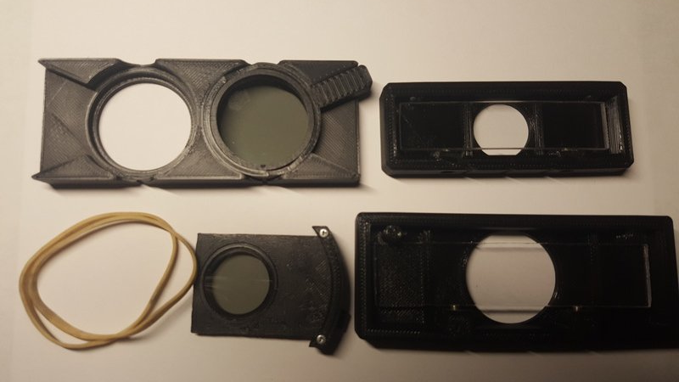
20210602_205101.jpg (49.29 KiB) Viewed 4715 times
left to wright, top to bottom: filter tray with a polarizer, sanderson prism slider #1 (for the back focal plane), rubber bands, analyzer, sanderson prism slider #2 (between light source and condenser). Both prisms are made from ~2.4mm thick polycarbonate.
Test setup with only one slider between polarizers:
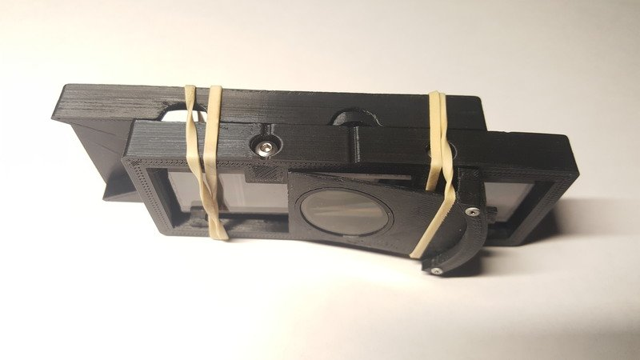
20210602_202343.jpg (42.73 KiB) Viewed 4715 times
Interference pattern from one slider:
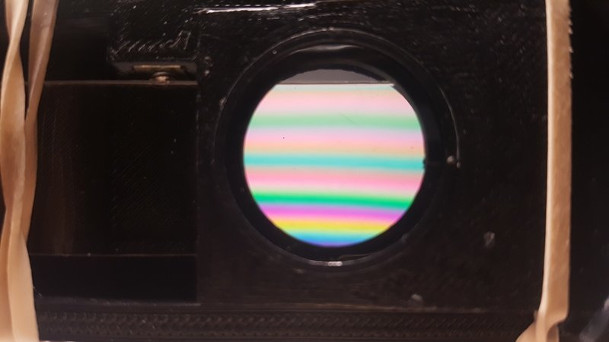
20210602_202637.jpg (44.83 KiB) Viewed 4715 times
Test setup with both sliders between polarizers:
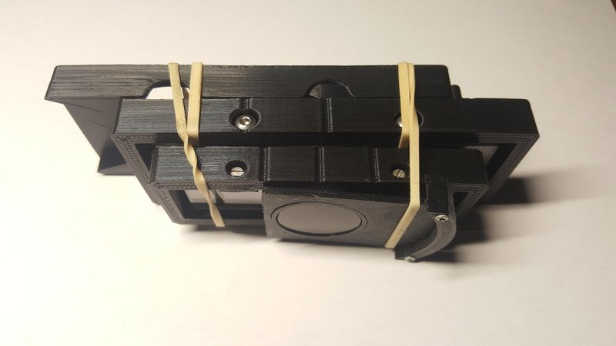
20210602_203020.jpg (44.82 KiB) Viewed 4715 times
Interference pattern from two sliders with prisms lined up:
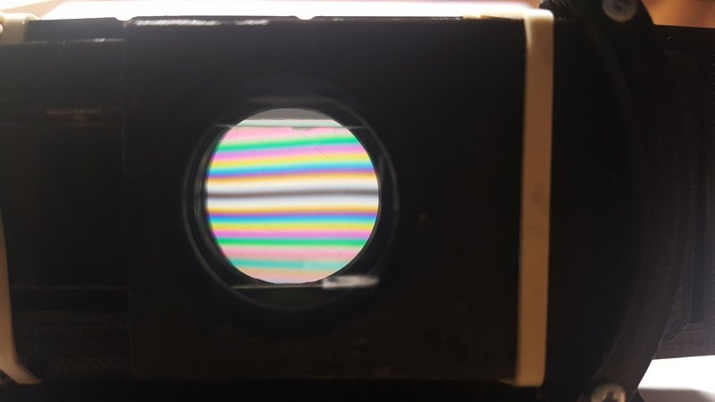
20210602_203231.jpg (33.31 KiB) Viewed 4715 times
Change of the interference pattern as the bending force of one of the prisms is adjusted:
The movement of the whole contraption does not help, but on careful inspection the video reveals that the space between the interference lines decreases when the bending force is increased (I tightened the crews pushing on opposite sides of the prism).
I've also modified the microscope that I'm using, and now both sliders have the same orientation. I can now see the interference pattern from the two sliders, like the one above and the one in Rathi's paper, on the back focal plane of the objective using a Bertrand lens. No DIC effect though. For that to happen I would need to adjust the prisms to yield specific divergence angles, unfortunately I don't know at this point what the angles should be for my setup. As Louise mentions, Rathi's paper aimed at 65 and 14 urads for the 60x objective that they used. That sounds to me like a good starting point for trial and error, but that could take a long time of basically blind guessing. I'd prefer to study more on the subject and determine if it would be possible to calculate the approximate divergence angles that I should aim for with my setup.
As Louise pointed out, the angles mentioned in Rathi's paper are small, and translate to very small displacements of the screw that was used for bending the prisms. With my current setup it would be difficult to measure the displacement with the required precision. I also still have an issue with the expression that relates bending displacement with divergence angles, since substitution of the variables with the values given in the paper does not match what they report in their figure (and I'm not referring to the sign of the angles). The underlying cause of this likely something trivial (perhaps a silly mistake on my end) not a flaw in the paper. Though now I need to get the numbers to match, if I'm to understand this and be able to move on to the next tests.
Top
Quote
Post
75RR
Posts: 8197
Joined: Sun Oct 12, 2014 2:34 am
Location: Estepona, Spain

Re: DIC Question

#76 by 75RR » Thu Jun 03, 2021 4:53 am
.
Nice work - thanks for the detailed steps!
Zeiss Standard WL (somewhat fashion challenged) & Wild M8
Olympus E-P2 (Micro Four Thirds Camera)
Top
Quote
Post
LouiseScot
Posts: 1001
Joined: Tue Jul 07, 2020 1:51 pm
Location: Scotland

Re: DIC Question

#77 by LouiseScot » Fri Jun 04, 2021 6:27 pm
jmp wrote: ↑
Thu Jun 03, 2021 4:00 am
Some images of the setup I've been using for testing.
The individual parts:
20210602_205101.jpg
left to wright, top to bottom: filter tray with a polarizer, sanderson prism slider #1 (for the back focal plane), rubber bands, analyzer, sanderson prism slider #2 (between light source and condenser). Both prisms are made from ~2.4mm thick polycarbonate.
Test setup with only one slider between polarizers:
20210602_202343.jpg
Interference pattern from one slider:
20210602_202637.jpg
Test setup with both sliders between polarizers:
20210602_203020.jpg
Interference pattern from two sliders with prisms lined up:
20210602_203231.jpg
Change of the interference pattern as the bending force of one of the prisms is adjusted:
The movement of the whole contraption does not help, but on careful inspection the video reveals that the space between the interference lines decreases when the bending force is increased (I tightened the crews pushing on opposite sides of the prism).
I've also modified the microscope that I'm using, and now both sliders have the same orientation. I can now see the interference pattern from the two sliders, like the one above and the one in Rathi's paper, on the back focal plane of the objective using a Bertrand lens. No DIC effect though. For that to happen I would need to adjust the prisms to yield specific divergence angles, unfortunately I don't know at this point what the angles should be for my setup. As Louise mentions, Rathi's paper aimed at 65 and 14 urads for the 60x objective that they used. That sounds to me like a good starting point for trial and error, but that could take a long time of basically blind guessing. I'd prefer to study more on the subject and determine if it would be possible to calculate the approximate divergence angles that I should aim for with my setup.
As Louise pointed out, the angles mentioned in Rathi's paper are small, and translate to very small displacements of the screw that was used for bending the prisms. With my current setup it would be difficult to measure the displacement with the required precision. I also still have an issue with the expression that relates bending displacement with divergence angles, since substitution of the variables with the values given in the paper does not match what they report in their figure (and I'm not referring to the sign of the angles). The underlying cause of this likely something trivial (perhaps a silly mistake on my end) not a flaw in the paper. Though now I need to get the numbers to match, if I'm to understand this and be able to move on to the next tests.
Hi again
I didn't get a forum notification for some reason so apologies for slow response. Anyway, thanks for your post jmp. I've setup one of my open frames to take a micrometer head. That should allow me to measure approximately the delta y value directly (albeit in a stepwise manner outside of the optics). With some care I should be able to create a dataset / plot of delta y against turns of the loading screw. I might also possibly be able to rig something equivalent to Rathi's expensive Thorlabs PDP90A just using a camera sensor and some image processing - and maybe some optics - well, I'll have a go! I'll have to have a think about how it might be done. At the moment I'm using a 40x/0.65 objective. Presumably that would need greater divergence angles compared to the 60x/1.2 that Rathi used? I'll try out the micrometer over the weekend and hopefully get some useful data. If I could also measure deflections with a laser that would be great - but I'm not holding my breath on that one!
I believe the divergence angle equation is correct - it's used in other papers. I'm not 100% sure of the units though - I'll do some research to check it out. I did do a quick calculation based on my 3mm thick polycarbonate, an r of 14mm and an l of 94mm which gave a divergence angle of about 0.00264 x delta y . Annoyingly Rathi didn't quote actual delta y values, only screw displacement which which they say 'scales approximately linearly' to the bending of the bar. My micrometer should measure delta y directly though only to an accuracy of about 10um, maybe to 5um. I should still be in the right ball park, hopefully, at least for larger bending moments. It's all good fun!
Louise
A Nikon CF plan 20x; A Swift 380T; A DIY infinity corrected focus rail system with a 40x/0.65 Olympus Plan, a 10x/0.30 Amscope Plan Fluor, and a 20x/0.75 Nikon Plan Apo
Top
Quote
Post
jmp
Posts: 66
Joined: Sun Feb 16, 2020 2:07 am
Location: Texas

Re: DIC Question

#78 by jmp » Fri Jun 04, 2021 9:13 pm
Louise, I agree with you, the divergence angle equation is not the problem. I am clearly plugging in the wrong values for the variables in my attempt to replicate their angle vs screw displacement plot, yet I've not been able to put my finger on what exactly I'm doing wrong... it should have been pretty straightforward. Though with your last comment you gave me a clue:
Annoyingly Rathi didn't quote actual delta y values, only screw displacement
Perhaps that's it. I've been using the screw displacement as the delta-y values, that might be why I can't replicate their figure.
I was also giving it a thought about how to go about measuring screw displacement and prism bending. It occurred to me that I can just measure the prism bending under the stereoscope. I have an old MBS-10 which I can use to get pretty accurate measurements of the displacement using the ocular micrometer, and/or use ImageJ/Hayear/Toupview to do the measuring directly from photos of the sliders taken under the stereoscope. As in your case, taking the measurements will be more involved but not too much of a hassle (in particular if just using the ocular micrometer). I'll post the measurements that I get here if/when I get them.
With measurements of the displacement it should be possible to configure the prisms for specific divergence angles (using the given equation). My guess is that the error in setting the angle will not be that bad, even with my current crude setup. The biggest problem for me will be to determine what divergence angles would work with my 10x and 20x objectives. The original plastdic kit for this microscope consists of only one wollaston prism that is used with both objectives. Given that, my impression is that there's a good chance of a large tolerance around the divergence angle that I'll need to replicate. I would just need to figure out what that angle is.
It's all good fun!
I couldn't agree more, this little project is heaps of fun!
Top
Quote
Post
LouiseScot
Posts: 1001
Joined: Tue Jul 07, 2020 1:51 pm
Location: Scotland

Re: DIC Question

#79 by LouiseScot » Fri Jun 04, 2021 9:25 pm
jmp wrote: ↑
Fri Jun 04, 2021 9:13 pm
Louise, I agree with you, the divergence angle equation is not the problem. I am clearly plugging in the wrong values for the variables in my attempt to replicate their angle vs screw displacement plot, yet I've not been able to put my finger on what exactly I'm doing wrong... it should have been pretty straightforward. Though with your last comment you gave me a clue:
Annoyingly Rathi didn't quote actual delta y values, only screw displacement
Perhaps that's it. I've been using the screw displacement as the delta-y values, that might be why I can't replicate their figure.
I was also giving it a thought about how to go about measuring screw displacement and prism bending. It occurred to me that I can just measure the prism bending under the stereoscope. I have an old MBS-10 which I can use to get pretty accurate measurements of the displacement using the ocular micrometer, and/or use ImageJ/Hayear/Toupview to do the measuring directly from photos of the sliders taken under the stereoscope. As in your case, taking the measurements will be more involved but not too much of a hassle (in particular if just using the ocular micrometer). I'll post the measurements that I get here if/when I get them.
With measurements of the displacement it should be possible to configure the prisms for specific divergence angles (using the given equation). My guess is that the error in setting the angle will not be that bad, even with my current crude setup. The biggest problem for me will be to determine what divergence angles would work with my 10x and 20x objectives. The original plastdic kit for this microscope consists of only one wollaston prism that is used with both objectives. Given that, my impression is that there's a good chance of a large tolerance around the divergence angle that I'll need to replicate. I would just need to figure out what that angle is.
It's all good fun!
I couldn't agree more, this little project is heaps of fun!
Yeah, screw displacement doesn't equal delta y but is linearly related to it. I'll do some micrometer measurements tomorrow and see if I can work out some relationship. Yeah, you should be able to take some measurements photographically also.
Louise
A Nikon CF plan 20x; A Swift 380T; A DIY infinity corrected focus rail system with a 40x/0.65 Olympus Plan, a 10x/0.30 Amscope Plan Fluor, and a 20x/0.75 Nikon Plan Apo
Top
Quote
Post
viktor j nilsson
Posts: 659
Joined: Thu Aug 23, 2018 10:12 pm
Location: Lund, Sweden

Re: DIC Question

#80 by viktor j nilsson » Fri Jun 04, 2021 10:15 pm
I haven't read up on the Sanderson prism theory, and skimmed parts of this thread, so I may be missing something obvious here, but do you really need to measure and replicate the exact same divergence angles as those used in the paper?
In regular DIC, the following criteria needs to be met to achieve proper DIC:
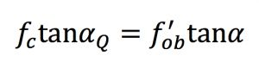
where:
fc: condenser focal length
alphaQ: condenser prism wedge angle
fob: objective focal length
alpha: objective prism wedge angle
In other words, it's not the shear angle itself that is critical, but rather the product of shear angle and the focal length of its corresponding lens.
Wouldn't the same basic principle apply for the Sanderson prisms as well? So, unless your objective and condenser lenses have the exact same focal lengths as the ones used in the paper, you still need to find a set of shear angles that satisfies the equation above. To me it seems like you could decide to fix one prism (the one that is hardest to adjust) at a reasonable shear angle and then tweak the other (by trial and error) until you get true DIC (which is easiest to see by observing the BFP).
Or am I missing something?
Top
Quote
Post
LouiseScot
Posts: 1001
Joined: Tue Jul 07, 2020 1:51 pm
Location: Scotland

Re: DIC Question

#81 by LouiseScot » Fri Jun 04, 2021 10:54 pm
viktor j nilsson wrote: ↑
Fri Jun 04, 2021 10:15 pm
I haven't read up on the Sanderson prism theory, and skimmed parts of this thread, so I may be missing something obvious here, but do you really need to measure and replicate the exact same divergence angles as those used in the paper?
In regular DIC, the following criteria needs to be met to achieve proper DIC:
where:
fc: condenser focal length
alphaQ: condenser prism wedge angle
fob: objective focal length
alpha: objective prism wedge angle
In other words, it's not the shear angle itself that is critical, but rather the product of shear angle and the focal length of its corresponding lens.
Wouldn't the same basic principle apply for the Sanderson prisms as well? So, unless your objective and condenser lenses have the exact same focal lengths as the ones used in the paper, you still need to find a set of shear angles that satisfies the equation above. To me it seems like you could decide to fix one prism (the one that is hardest to adjust) at a reasonable shear angle and then tweak the other (by trial and error) until you get true DIC (which is easiest to see by observing the BFP).
Or am I missing something?
Yes, I think the correct and useable divergence angle will indeed need to be tweaked acoording to the optics used. The Sanderson Prism angle is given by the formula quoted in the Rathi, Biss and Sanderson's papers. In this case it is a function of the photoelastic bending moment of the prism, as well as the dimensions of the prism and position of the supports etc., and what it's made of i.e. polycarbonate. I'm not trying to just replicate the divergence angles that Rathi used. But I have to find ones that will work with my objective and my diy condenser though they will likely be in the same ballpark i.e. likely <100urad. To do that, we need to work out the relationship between the change in prism deflection for a given turn of the screw, as it were. But Rathi quote beam divergences of ~14urad and 65urad, using their 60x/1.20 objective and a prism-condenser fl of 15mm (which I've tried to replicate), and they are difficult to arrive at by blindly turning the bending screws without knowing the exact relationship. Rathi et al. were able to measure deflections and compare with their Nomarski prisms. Unless I can figure out how to measure the divergence and/or the screw/divergence relationship, it will be difficult to get anywhere with this project. Unless I get lucky ha ha. I could buy a Thorlabs PDP90A lateral effect position detector to measure divergence but they are expensive (getting on for £400 in the UK). If anyone knows of where to get a cheap equivalent...
Louise
A Nikon CF plan 20x; A Swift 380T; A DIY infinity corrected focus rail system with a 40x/0.65 Olympus Plan, a 10x/0.30 Amscope Plan Fluor, and a 20x/0.75 Nikon Plan Apo
Top
Quote
Post
viktor j nilsson
Posts: 659
Joined: Thu Aug 23, 2018 10:12 pm
Location: Lund, Sweden

Re: DIC Question

#82 by viktor j nilsson » Fri Jun 04, 2021 11:29 pm
I actually think you can get pretty close to 65urad simply by looking at the interference bands between crossed polarizers (as in figure 3 in Rathi et al). High and low-magnification prisms are easy to tell apart, as in this figure from Olympus' DIC primer:
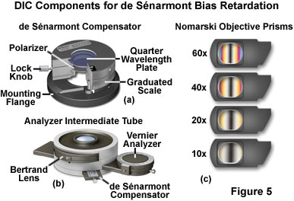
It should be pretty obvious when you are getting close.
I am also quite confident that it is a lot more important to satisfy the equivalence in the equation I posted above, and get the prisms positioned as close as possible to the the BFPs, than it is to get the divergence angle exactly right.
The BFP position seems the trickiest. There's a lot of moving parts when you use Rathi's approach of using additional lenses to project an image of the prism on the objective BFP. If I were to do this, I would start with a low-magnification objective where the BFP is located outside the objective.
Top
Quote
Post
LouiseScot
Posts: 1001
Joined: Tue Jul 07, 2020 1:51 pm
Location: Scotland

Re: DIC Question

#83 by LouiseScot » Fri Jun 04, 2021 11:55 pm
viktor j nilsson wrote: ↑
Fri Jun 04, 2021 11:29 pm
I actually think you can get pretty close to 65urad simply by looking at the interference bands between crossed polarizers (as in figure 3 in Rathi et al). High and low-magnification prisms are easy to tell apart, as in this figure from Olympus' DIC primer:
It should be pretty obvious when you are getting close.
I am also quite confident that it is a lot more important to satisfy the equivalence in the equation I posted above, and get the prisms positioned as close as possible to the the BFPs, than it is to get the divergence angle exactly right.
The BFP position seems the trickiest. There's a lot of moving parts when you use Rathi's approach of using additional lenses to project an image of the prism on the objective BFP. If I were to do this, I would start with a low-magnification objective where the BFP is located outside the objective.
I'm sure you're right but I don't have any practical experience of visible light Normarski DIC / prisms so find it hard to relate to the interference diagrams. Obviously I can get similar banding but maybe not quite the same. For example, I've not been able to replicate quite the same patterns (I think I said before) - my dark bands have not been in the centre of the prism but towards the bottom edge. That may just be to do with the amount of tension I've been applying. From their fig 3b scale bar it appears that their diagrams represent images that are ~30mm square? Not sure how they did that. There open frame prism is only 20mm in height. Maybe I missed something there... I wish they'd printed bigger versions! Anyway, I'll endeavour to do some quantitative measurements and images of interference patterns tomorrow or Sunday. I'm sure when/if I can replicate everything it will come into focus for me, so to speak!
Cheers
Louise
A Nikon CF plan 20x; A Swift 380T; A DIY infinity corrected focus rail system with a 40x/0.65 Olympus Plan, a 10x/0.30 Amscope Plan Fluor, and a 20x/0.75 Nikon Plan Apo
Top
Quote
Post
jmp
Posts: 66
Joined: Sun Feb 16, 2020 2:07 am
Location: Texas

Re: DIC Question

#84 by jmp » Sat Jun 05, 2021 6:29 pm
viktor j nilsson wrote: ↑
Fri Jun 04, 2021 10:15 pm
I haven't read up on the Sanderson prism theory, and skimmed parts of this thread, so I may be missing something obvious here, but do you really need to measure and replicate the exact same divergence angles as those used in the paper?
Replicating the divergence angles from the paper is, in my case, just part of my learning process. A matter of having a positive control... if I can't replicate it then I'm likely doing something wrong. Given that this is not my field, details that might be obvious to some are not so to me.
viktor j nilsson wrote: ↑
Fri Jun 04, 2021 10:15 pm
In regular DIC, the following criteria needs to be met to achieve proper DIC:
where:
fc: condenser focal length
alphaQ: condenser prism wedge angle
fob: objective focal length
alpha: objective prism wedge angle
In other words, it's not the shear angle itself that is critical, but rather the product of shear angle and the focal length of its corresponding lens.
That's exactly where I wanted to go next, you've given me a great starting point!
viktor j nilsson wrote: ↑
Fri Jun 04, 2021 10:15 pm
Wouldn't the same basic principle apply for the Sanderson prisms as well?
With the little I know, I would say yes.
viktor j nilsson wrote: ↑
Fri Jun 04, 2021 10:15 pm
So, unless your objective and condenser lenses have the exact same focal lengths as the ones used in the paper, you still need to find a set of shear angles that satisfies the equation above. To me it seems like you could decide to fix one prism (the one that is hardest to adjust) at a reasonable shear angle and then tweak the other (by trial and error) until you get true DIC (which is easiest to see by observing the BFP).
The key part in what you say is defining what the 'reasonable shear angle' would be. My only reference were the angles given in Rathi's paper, until I read your second post:
viktor j nilsson wrote: ↑
Fri Jun 04, 2021 11:29 pm
I actually think you can get pretty close to 65urad simply by looking at the interference bands between crossed polarizers (as in figure 3 in Rathi et al). High and low-magnification prisms are easy to tell apart, as in this figure from Olympus' DIC primer:
It should be pretty obvious when you are getting close.
I am also quite confident that it is a lot more important to satisfy the equivalence in the equation I posted above, and get the prisms positioned as close as possible to the the BFPs, than it is to get the divergence angle exactly right.
The BFP position seems the trickiest. There's a lot of moving parts when you use Rathi's approach of using additional lenses to project an image of the prism on the objective BFP. If I were to do this, I would start with a low-magnification objective where the BFP is located outside the objective.
Those images of the expected interference bands for the different magnification objectives was what I needed. That gives me a reference frame to came up with the range of angles to try. Not only that, but as you said, to try this empirically... just by directly comparing the interference patterns! Thus, I ran a few tests, mostly untightening the screws to reduce the bending force (and shear angles) and I think I got to true DIC on the 10x. This is how the canonical check cells look (with my apologies for the bad quality of the images):
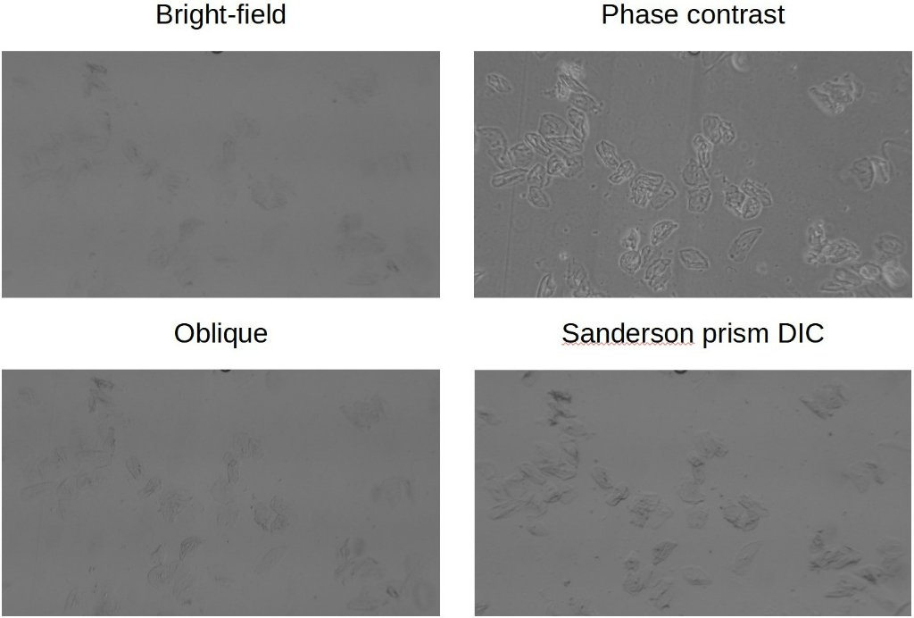
comparison.jpg (54.95 KiB) Viewed 4584 times
Not going to win a photography contest that but as you said, the difference should be pretty obvious. Indeed the difference between bright-field and DIC was striking when looking through the oculars. The effect was also clearly different from oblique.
These are (ugly) images of the back focal plane when only one of the prisms and when both prisms are inserted in the light path:
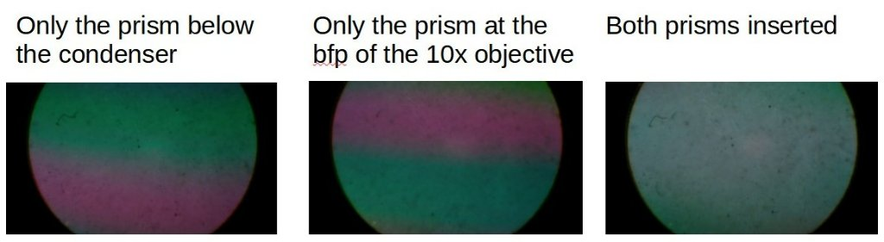
bfp_interference_comparison.jpg (35.54 KiB) Viewed 4584 times
I'm not seeing the dark interference band in the center as in the Olympus figure, which is puzzling to me. There must be some level of interference: without the prism at the bfp the image of the sample is almost the same as that from bright-field, with the prism inserted at the bfp the image looks like DIC (in both cases, polarizers and the prism below the condenser are left untouched).
I think your intuition about how much leeway one would get in terms of tolerances is likely right if I really got DIC under my test conditions.
viktor j nilsson wrote: ↑
Fri Jun 04, 2021 10:15 pm
Or am I missing something?
No, you were definitely spot on. Many thanks for your comments!
Top
Quote
Post
viktor j nilsson
Posts: 659
Joined: Thu Aug 23, 2018 10:12 pm
Location: Lund, Sweden

Re: DIC Question

#85 by viktor j nilsson » Sun Jun 06, 2021 10:02 pm
Glad you found it useful! You are clearly doing good progress. Looking forward to seeing further updates.
One thing that I started thinking about is if the Sanderson prisms are stable over time, or if the shearing characteristics will change over time due to fatigue. Have you read anything about this?
Top
Quote
Post
LouiseScot
Posts: 1001
Joined: Tue Jul 07, 2020 1:51 pm
Location: Scotland

Re: DIC Question

#86 by LouiseScot » Mon Jun 07, 2021 7:17 pm
viktor j nilsson wrote: ↑
Sun Jun 06, 2021 10:02 pm
One thing that I started thinking about is if the Sanderson prisms are stable over time, or if the shearing characteristics will change over time due to fatigue. Have you read anything about this?
Hi Viktor
I'm not sure though I think it should be. It's obviously dependent on the bending moment which, in turn, depends on the pressure exerted by the screw(s). That could drift somewhat over time. But once everything is set up it shouldn't be too difficult to recheck and tweak. Also, if the stressed polycarbonate prism optical properties do change over time, it's very cheap and easy to make new ones.
Louise
A Nikon CF plan 20x; A Swift 380T; A DIY infinity corrected focus rail system with a 40x/0.65 Olympus Plan, a 10x/0.30 Amscope Plan Fluor, and a 20x/0.75 Nikon Plan Apo
Top
Quote
Post
Hobbyst46
Posts: 3905
Joined: Mon Aug 21, 2017 9:02 pm

Re: DIC Question

#87 by Hobbyst46 » Tue Jun 08, 2021 3:17 pm
LouiseScot wrote: ↑
Mon Jun 07, 2021 7:17 pm
viktor j nilsson wrote: ↑
Sun Jun 06, 2021 10:02 pm
One thing that I started thinking about is if the Sanderson prisms are stable over time, or if the shearing characteristics will change over time due to fatigue. Have you read anything about this?
Hi Viktor
I'm not sure though I think it should be. It's obviously dependent on the bending moment which, in turn, depends on the pressure exerted by the screw(s). That could drift somewhat over time. But once everything is set up it shouldn't be too difficult to recheck and tweak. Also, if the stressed polycarbonate prism optical properties do change over time, it's very cheap and easy to make new ones.
Louise
There is a fairly extensive research over the fatigue of polycarbonate (PC) over time, for example in the University of Eindhoven (NL).
However, the conditions of measurement were fairly remote from the conditions relevant to your (admirable) efforts on the DIC - if I am not wrong.
Those tests were done under pressures of ~50 MPa or temperatures of 120C or more. I dare a cheeky guess here - really amateurish !
IF the dimensions of the PC bar are 70x16mm, and the deflection angle is 65uR, then deltaY = 70mm x sin(65uR) = 0.0045mm
So, Strain = deltaY/16mm = 0.00028.
Now, from Fig 2a in the article:
PREDICTING THE LONG-TERM FAILURE OF POLYCARBONATE: A CONSTITUTIVE APPROACH
E.T.J. KLOMPEN, T.A.P. ENGELS, R.P.M. JANSSEN, L.E. GOVAERT, H.E.H. MEIJER
Dutch Polymer Institute (DPI), Materials Technology (Mate), Eindhoven University of Technology, Eindhoven, The Netherlands
It seems that for low Strains, Strain = 0.001xStress. Hence, the stress on "our" PC bar is 0.00028x1000 = 0.28 MPa. Or about 2.8 bar.
From Fig 4 of the same article, stresses of 50 MPa cause failure within the order of at least 10000 seconds. Or 2.8 hours. BUT, at stresses below 45 MPa, the lifetime becomes a million or more seconds, and seems to be independent of the stress. So, a million seconds times 50/0.28 = 6 years.
So, for the benefit and interest of some or many of us, please create the DIC, and forget about its future lifetime
Zeiss Standard GFL+Canon EOS-M10, Olympus VMZ stereo
Top
Quote
Post
LouiseScot
Posts: 1001
Joined: Tue Jul 07, 2020 1:51 pm
Location: Scotland

Re: DIC Question

#88 by LouiseScot » Thu Jun 10, 2021 1:00 pm
Time for an update!
I still seem to be struggling to get my fringes the same as jmps I'm not sure what I'm doing wrong, or not doing right.
Here is a pic of the open frame I'm using:
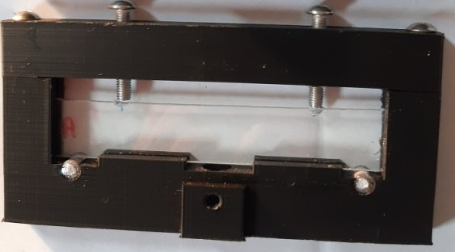
Holder1.jpg (21.56 KiB) Viewed 4428 times
It's just 3D printed with some grooves to support the polycarbonate. I've gone with jmp's method of using two set screws (M5) as using a thumbscrew just seems to cause the frame itself to bend. I've used 6mm Aluminium rod for the lower supports. The prism is 110 x 20mm with l = 94mm and r = 15.7mm (pretty much l/6). I have two prisms the same (A and B).
This are the sort of fringes I get with Prism A:
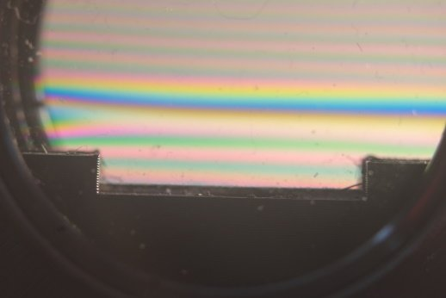
PrismA-1_0160.jpg (22.48 KiB) Viewed 4428 times
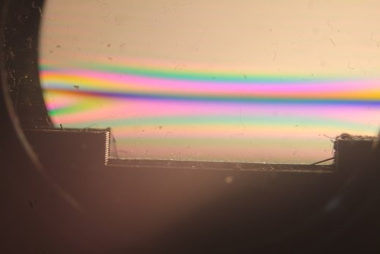
PrismA-2_0161.jpg (21.97 KiB) Viewed 4428 times
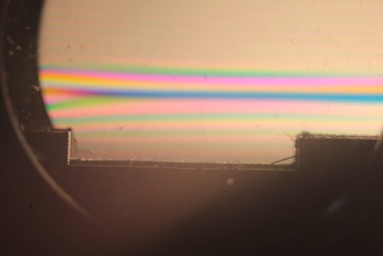
PrismA-3_0162.jpg (21.13 KiB) Viewed 4428 times
and with B:
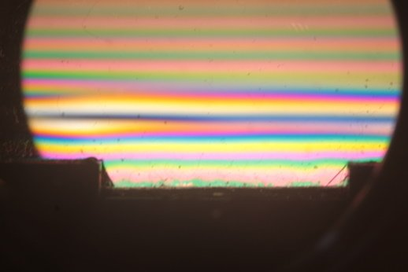
PrismB-1_0163.jpg (24.61 KiB) Viewed 4428 times
ctd in second post...
A Nikon CF plan 20x; A Swift 380T; A DIY infinity corrected focus rail system with a 40x/0.65 Olympus Plan, a 10x/0.30 Amscope Plan Fluor, and a 20x/0.75 Nikon Plan Apo
Top
Quote
Post
LouiseScot
Posts: 1001
Joined: Tue Jul 07, 2020 1:51 pm
Location: Scotland

Re: DIC Question

#89 by LouiseScot » Thu Jun 10, 2021 1:25 pm
from previous:
Another prism B:
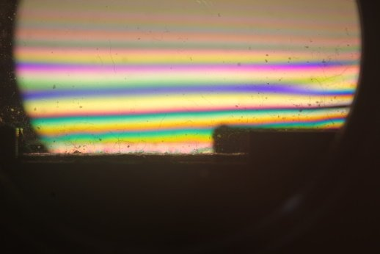
A+B-1_0165.JPG (25.16 KiB) Viewed 4428 times
Prism A+B:
A+B-1_0165.JPG (25.16 KiB) Viewed 4428 times
I can't seem to get the fringes symmetric or centred like jmps has and like the actual prisms show
I've used 3mm polycarbonate but that shouldn't make a huge difference? Lighting for the above images was with a cfl lamp.
Plus I've measured the max delta y bending using a micrometer at 1.40mm which seems huge?? But with little tension I just get wide bands. putting delta Y as 1.4 in the equation gives a deflection of 0.00075 which I presume is millirads with other dimensions in mm. So that would be 750 urads which is off of Rathi's graph's scale! If I try and tighten the screws any further a) it gets difficult to do and b) tends to cause crushing and deformation.
FWIW the polycarbonate sheet I'm using is 'Palsun' which I think is French. The open diameter of the polarizers is about 35mm (They are Hoya 40.5 mm linear polarizers)
Any ideas anyone? I'm sure I shouldn't need to bend the prisms so much especially when Rathi is talking about less than 100urads?
Thanks for any analysis and ideas
Louise
ATTACHMENTS
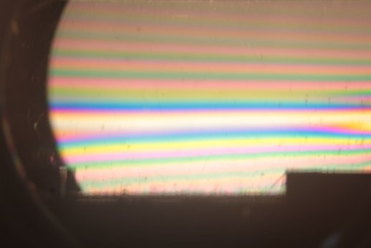
PrismB-2_0164.jpg (23.21 KiB) Viewed 4428 times
A Nikon CF plan 20x; A Swift 380T; A DIY infinity corrected focus rail system with a 40x/0.65 Olympus Plan, a 10x/0.30 Amscope Plan Fluor, and a 20x/0.75 Nikon Plan Apo
Top
Quote
Post
jmp
Posts: 66
Joined: Sun Feb 16, 2020 2:07 am
Location: Texas

Re: DIC Question

#90 by jmp » Thu Jun 10, 2021 8:39 pm
Hi Louise,
Note that for a single prism the interference pattern that I obtain within crossed polarizers is asymmetric, without a dark fringe band in the center:
The interference pattern from above is similar to the one at the top part of the ones that you showed from a single prism:
In your case the banding is much more compact due to the large bending force that you are applying. If I increase the bending force on my prism the pattern starts resembling the one that you've shown. With considerable bending I obtain a dark fringe band, but its not located in the middle of the prism, instead it appears near one edge of the prism and starts migrating towards the center as more bending force is applied (and as that happens bands start to get narrower and closer). I've not been able to move that band towards the center, the frames for my prisms start to deform, the screws start to damage the edge of the prism, etc; I've gone as far as having it between 1/4 and 1/3 of the center. Though the trend would indicate that with not much more force the dark fringe band will eventually be centered.
Another observation is that given the way in which the screws push on the edge of the prism, in my setup, there is a tendency of the prism to rotate along its longer axis (up an out of the slider on the side where the screws make contact with the prism); think twisting the prism in opposite directions from the extremes on the longer axis. As a result the bands start to appear less defined, fuzzy, as if out of focus. Pressing the prism back so that it lays flat causes the bands to appear well defined. I wonder if some of that twisting might be happening in your setup?
Up to this point I'd say that we are both pretty much doing the same and obtaining similar results.
What is different is that to observe a symmetric interference pattern like this:
I have two prisms placed within the crossed polarizers; not one, two. Have you tried that yet? It is not what is described in the papers. It wasn't clear to me at the time if that was the interference pattern that was expected from a single prism, or from both, so I tried both ways.
Very little bending force is applied to each of the prisms in this configuration. The separation and width of the fringes is easy to change with small adjustments to screws, from one or both prisms. The interference pattern looks exactly like the one from Rathi's paper but, again, its from 2 prisms, not from one as in their Paper. According to the information here the expected interference pattern from a single Nomarsky or Wollaston prism between crossed polarizers should be symmetric with a dark fringe in the center too. Clearly not what I'm doing here.
In my tests with the microscope I've also used the prisms adjusted so that when both are within crossed polars the dark fringe band is in the center. There is interference and it has a marked effect in the image contrast, but it does not seem to be true DIC... yet.
I need to study and think more about this (to busy with work at the time though). For the moment, given how easy it is to obtain the 'expected' interference pattern from 2 prisms, I wonder if it would be worth to change my setup to use 2 prisms on each slider (in spite of doubling the amount of polycarbonate in the light path) and just do some more empirical tests.
While at this, thanks to the information that Viktor shared (DIC fundaments from Olympus linked above), I learned that for Nomarksy prisms the interference pattern is projected outside the prism and not located within the prism itself, as is the case with Wollaston prisms. Because of this Nomarsky prisms can sit outside the rim of the objective, while the interference fringes appear on the back focal plane of the objective, inside the objective itself. If this were to be the case for Sanderson prisms that would be a huge advantage too; adapting existing microscopes would perhaps be easier without the need of extra optics to project the back focal plane elsewhere as in Rathi's paper.
Top
Quote
Post

Re: DIC Question

#91 by LouiseScot » Thu Jun 10, 2021 9:32 pm
Ah, ok jmp, thanks. Sounds like I'm trying too hard. I did post one pic of the two prisms together - 'Prism A+B'. I think I need to go back a step and try again. Also I think I'd get improved results if I could cut the prisms better. I only have a hacksaw so they always end up cut a little wonky! I notice that (unsurprisingly) the patterns change as the polarizers are rotated. I think the prisms are supposed to be at 45 deg relative to the cross polarizers? Is that how Nomarski prisms sit? I can get a dark band with a single prism but even with two I can't seem to get the symmetric dark central destructive two-prism interference pattern. Presumably the two prisms have to be adjusted such that each has exactly the same bending moment?
I have to do jury service tomorrow but will do some more at the weekend.
Thanks
Louise
A Nikon CF plan 20x; A Swift 380T; A DIY infinity corrected focus rail system with a 40x/0.65 Olympus Plan, a 10x/0.30 Amscope Plan Fluor, and a 20x/0.75 Nikon Plan Apo
Top
Quote
Post
75RR
Posts: 8197
Joined: Sun Oct 12, 2014 2:34 am
Location: Estepona, Spain

Re: DIC Question

#92 by 75RR » Thu Jun 10, 2021 9:37 pm
.
I notice some damage on the prisim from the screws (see image below)
wonder if a metal sheath on the edge might protect it and yet give the same effect?
Might stop it twisting as well.
.
Zeiss Standard WL (somewhat fashion challenged) & Wild M8
Olympus E-P2 (Micro Four Thirds Camera)
Top
Quote
Post
LouiseScot
Posts: 1001
Joined: Tue Jul 07, 2020 1:51 pm
Location: Scotland

Re: DIC Question

#93 by LouiseScot » Thu Jun 10, 2021 9:46 pm
75RR wrote: ↑
Thu Jun 10, 2021 9:37 pm
.
I notice some damage on the prisim from the screws (see image below)
wonder if a metal sheath on the edge might protect it and yet give the same effect?
Might stop it twisting as well.
.
I may be guilty of overtightening... I might see if I can get better results with a nut on the end of the screw - maybe a t-nut. It's supposed to be a dowel-shape so there is point contact but I don't know how to reproduce that with set screws. Dome nuts might be a possible.
Louise
A Nikon CF plan 20x; A Swift 380T; A DIY infinity corrected focus rail system with a 40x/0.65 Olympus Plan, a 10x/0.30 Amscope Plan Fluor, and a 20x/0.75 Nikon Plan Apo
Top
Quote
Post
jmp
Posts: 66
Joined: Sun Feb 16, 2020 2:07 am
Location: Texas

Re: DIC Question

#94 by jmp » Fri Jun 11, 2021 1:33 am
LouiseScot wrote: ↑
Thu Jun 10, 2021 9:32 pm
Ah, ok jmp, thanks. Sounds like I'm trying too hard. I did post one pic of the two prisms together - 'Prism A+B'.
Sorry, I didn't see the Prism A+B picture before. Though now that I've seen it, it appears to be the same photo as Prism B, right?
LouiseScot wrote: ↑
Thu Jun 10, 2021 9:32 pm
I think I need to go back a step and try again. Also I think I'd get improved results if I could cut the prisms better. I only have a hacksaw so they always end up cut a little wonky!
I cut my prisms with a serrated x-acto blade and then I sand the edges with ~400 grit sandpaper in water, mostly to avoid small pieces of the polycarbonate falling into the microscope tube when I insert the sliders. Yet, from what I've seen, I doubt that the fabrication quality of the prisms would have an impact at this stage. Your current prisms should work and let you observe the interference patterns.
I would worry more about the damage done by the screws, as 75RR mentions. Note that my prisms also have some damage from the screws, though less marked because I have not tightened them that much. Still, this damage should not prevent you to see the interference patterns. These polycarbonate prisms appear to be quite forgiving in terms of the abuse they can take.
LouiseScot wrote: ↑
Thu Jun 10, 2021 9:32 pm
I notice that (unsurprisingly) the patterns change as the polarizers are rotated.
If I keep the polarizers crossed and then I rotate the prism I see the same interference pattern but rotated in the same degree as the rotation that I applied to the prism. The interference pattern rotates with the prism and fringes are always parallel to the long edge of the prism.
LouiseScot wrote: ↑
Thu Jun 10, 2021 9:32 pm
I think the prisms are supposed to be at 45 deg relative to the cross polarizers? Is that how Nomarski prisms sit?
I don't know.
LouiseScot wrote: ↑
Thu Jun 10, 2021 9:32 pm
I can get a dark band with a single prism but even with two I can't seem to get the symmetric dark central destructive two-prism interference pattern. Presumably the two prisms have to be adjusted such that each has exactly the same bending moment?
When using two prisms at the same time, how are you orienting them? I only see the dark fringe if the bending moment from both prisms is applied from the same direction. The bending moment does not have to be the same though. I've looked at this and the interference patterns from the individual prisms are different, yet I still see the dark fringe when using both prisms together. But if I rotate one of the prisms 180deg the interference pattern changes, most fringes disappear and the space between fringes and their width increases notably.
Once I get a chance I'll capture a few videos to better illustrate what happens under these different conditions.
Top
Quote
Post
LouiseScot
Posts: 1001
Joined: Tue Jul 07, 2020 1:51 pm
Location: Scotland

Re: DIC Question

#95 by LouiseScot » Fri Jun 11, 2021 10:40 pm
Thanks for the input, jmp! Unfortunately I've not been able to do any more today. Will try and get on tomorrow (Saturday).
Sorry, the second Prism B image I posted was actually a duplicate of the two-prism image (Prism A+B). I was having trouble uploading so the duplication must have been a consequence of that.
I'll have to try remaking the prisms - maybe I can partially cut through with a box knife before sawing. I'm rather lacking in facilities for doing such things in my living room.
Have you tried measuring your delta-y?
More to follow!
Louise
A Nikon CF plan 20x; A Swift 380T; A DIY infinity corrected focus rail system with a 40x/0.65 Olympus Plan, a 10x/0.30 Amscope Plan Fluor, and a 20x/0.75 Nikon Plan Apo
Top
Quote
Post
Hobbyst46
Posts: 3905
Joined: Mon Aug 21, 2017 9:02 pm

Re: DIC Question

#96 by Hobbyst46 » Sat Jun 12, 2021 9:10 am
LouiseScot wrote: ↑
Fri Jun 11, 2021 10:40 pm
Thanks for the input, jmp! Unfortunately I've not been able to do any more today. Will try and get on tomorrow (Saturday).
Sorry, the second Prism B image I posted was actually a duplicate of the two-prism image (Prism A+B). I was having trouble uploading so the duplication must have been a consequence of that.
I'll have to try remaking the prisms - maybe I can partially cut through with a box knife before sawing. I'm rather lacking in facilities for doing such things in my living room.
Have you tried measuring your delta-y?
More to follow!
Louise
To bypass any imperfections on the edge of the prism, due to cutting, perhaps an edge protector could be 3D printed ? I mean, a narrow ח-shaped profile? so the tightening screws will press through this profile on the prism edge. A metal profile would be even better but difficult to find one with an internal space of 2.4 or 3.1 mm. Ancient 3.5" floppies had something like that...
Incidentally, some CD/DVD boxes, the "newer" thinner boxes, just a few mm overall thickness, are made of plates, the ends of which are like L-shaped profiles. Perhaps an improvised edge protector can be made by cutting and gluing parts from these plates.
Zeiss Standard GFL+Canon EOS-M10, Olympus VMZ stereo
Top
Quote
Post
LouiseScot
Posts: 1001
Joined: Tue Jul 07, 2020 1:51 pm
Location: Scotland

Re: DIC Question

#97 by LouiseScot » Sat Jun 12, 2021 9:18 am
Hobbyst46 wrote: ↑
Sat Jun 12, 2021 9:10 am
LouiseScot wrote: ↑
Fri Jun 11, 2021 10:40 pm
Thanks for the input, jmp! Unfortunately I've not been able to do any more today. Will try and get on tomorrow (Saturday).
Sorry, the second Prism B image I posted was actually a duplicate of the two-prism image (Prism A+B). I was having trouble uploading so the duplication must have been a consequence of that.
I'll have to try remaking the prisms - maybe I can partially cut through with a box knife before sawing. I'm rather lacking in facilities for doing such things in my living room.
Have you tried measuring your delta-y?
More to follow!
Louise
To bypass any imperfections on the edge of the prism, due to cutting, perhaps an edge protector could be 3D printed ? I mean, a narrow ח-shaped profile? so the tightening screws will press through this profile on the prism edge. A metal profile would be even better but difficult to find one with an internal space of 2.4 or 3.1 mm. Ancient 3.5" floppies had something like that...
I think the forces of the screws on anything 3D printed would be too great. I'm trying out the t-nuts at the moment.
Louise
A Nikon CF plan 20x; A Swift 380T; A DIY infinity corrected focus rail system with a 40x/0.65 Olympus Plan, a 10x/0.30 Amscope Plan Fluor, and a 20x/0.75 Nikon Plan Apo
Top
Quote
Post
LouiseScot
Posts: 1001
Joined: Tue Jul 07, 2020 1:51 pm
Location: Scotland

Re: DIC Question

#98 by LouiseScot » Sat Jun 12, 2021 10:12 am
Using the t-nuts is looking positive:
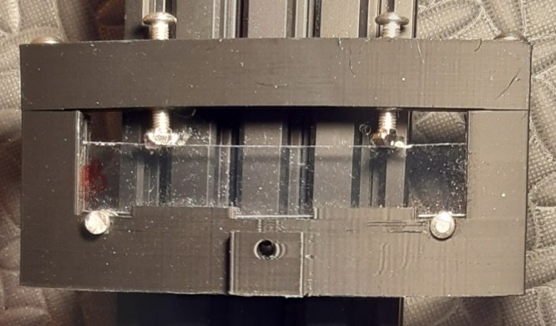
Holder-T-nuts.jpg (49.95 KiB) Viewed 4737 times
Also the 2 prisms image is looking better and more like it! I made sure both holders were the same way around - thanks jmp!
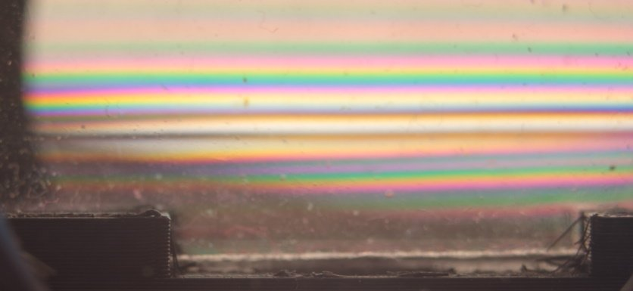
A+B_T-nutsCrop_0167.jpg (38.82 KiB) Viewed 4737 times
The black fringes are still confined to the lower half of the prisms which is the tensile side. Perhaps the tensile force is influenced by the r-value and the diameter of the lower supports relative to the set screws/t-nuts? Still, I'll try them out on the optical setup next Also, the frame itself is still tending to bend even though it's pretty hefty and printed at 100% infill. I really don't know how Rathi's group avoided frame bending (they didn't mention it). It might be possible to add some metal brackets. If it all works, though, all well and good!
Louise
A Nikon CF plan 20x; A Swift 380T; A DIY infinity corrected focus rail system with a 40x/0.65 Olympus Plan, a 10x/0.30 Amscope Plan Fluor, and a 20x/0.75 Nikon Plan Apo
Top
Quote
Post
jmp
Posts: 66
Joined: Sun Feb 16, 2020 2:07 am
Location: Texas

Re: DIC Question

#99 by jmp » Sat Jun 12, 2021 1:46 pm
Hi Louise,
Is difficult to see in this picture:
Are the short edges of the prism touching the sides of the frame? What about the prism edge and the bottom of the frame? From that photo it looks like there is uneven bending, as if the prism is making contact with the guide on the left. I would assume that there's space and that the prism is not touching the frame at those points, but I'm asking just in case.
In any case, it's looking better, great progress!
I have not yet had time to measure the displacements. I might give it a try tomorrow. I been thinking about how to modify my sliders to be able to apply more bending force to the prism without deforming the frame, and to be able to hold 2 prisms on each slider if possible. I'm toying with the idea of using the metal contact from euro-style terminal blocks as the inner adjustable points of contact with the prism, the profile is rounded on one side, and has two threaded holes on the other so it seems it might be a good fit to improve the way in which I can adjust the force on the prism.
Last edited by jmp on Sat Jun 12, 2021 2:57 pm, edited 1 time in total.
Top
Quote
Post
LouiseScot
Posts: 1001
Joined: Tue Jul 07, 2020 1:51 pm
Location: Scotland

Re: DIC Question

#100 by LouiseScot » Sat Jun 12, 2021 2:48 pm
jmp wrote: ↑
Sat Jun 12, 2021 1:46 pm
Hi Louise,
Is difficult to see in this picture:
Are the short edges of the prism touching the sides of the frame? What about the prism edge and the bottom of the frame? From that photo it looks like there is uneven bending, as if the prism is making contact with the guide on the left. I would assume that there's space and that the prism is not touching the frame at those points, but I'm asking just in case.
In any case, it's looking better, great progress!
In my case, I have not yet had time to measure the displacements. I might give it a try tomorrow. I been thinking about how to modify my sliders to be able to apply more bending force to the prism without deforming the frame, and to be able to hold 2 prisms on each slider if possible. I'm toying with the idea of using the metal contact from euro-style terminal blocks as the inner adjustable points of contact with the prism, the profile is rounded on one side, and has two threaded holes on the other so it seems it might be a good fit to improve the way in which I can adjust the force on the prism.
Hiya
There is a fair gap between the short edges and side of the frame. The screw tension may have been uneven in the pic I took. but I try to get them even in use Unfortunately I lack dexterity and grip... Um, do you know what the gap between the two dark lines should be in mm? And how that relates to the position of the specimen for each of the two prisms? I'm thinking the two prisms should be adjusted differently (as per Rathi). So they need to work together when in situ as opposed to just between the cross polarisers outside the optical system. I'm a bit in the dark, so to speak, re the comparison with Nomarski prisms. Are the fringe patterns as seen with naked eye (via cross-polarisers) i.e. with no magnification. I don't pretend to understand the mathematics and optical theory so I'm just trying to find my way. I'll look up how Nomarski is set up in practice - I have some info about that but no experience at doing it.
Cheers
Louise
A Nikon CF plan 20x; A Swift 380T; A DIY infinity corrected focus rail system with a 40x/0.65 Olympus Plan, a 10x/0.30 Amscope Plan Fluor, and a 20x/0.75 Nikon Plan Apo
Top
Quote
Post
LouiseScot
Posts: 1001
Joined: Tue Jul 07, 2020 1:51 pm
Location: Scotland

Re: DIC Question

#101 by LouiseScot » Sat Jun 12, 2021 7:24 pm
LouiseScot wrote: ↑
Sat Jun 12, 2021 2:48 pm
Hiya
Um, do you know what the gap between the two dark lines should be in mm? And how that relates to the position of the specimen for each of the two prisms? Ignore that!
I'll try what Viktor said and look at one prism via the objective i.e. the condenser prism, and see if I have the black interference line centred in the fov. If so, Then I'll add the second prism and keep my fingers crossed!
Cheers
Louise
A Nikon CF plan 20x; A Swift 380T; A DIY infinity corrected focus rail system with a 40x/0.65 Olympus Plan, a 10x/0.30 Amscope Plan Fluor, and a 20x/0.75 Nikon Plan Apo
Top
Quote
Post
LouiseScot
Posts: 1001
Joined: Tue Jul 07, 2020 1:51 pm
Location: Scotland

Re: DIC Question

#102 by LouiseScot » Sat Jun 12, 2021 9:50 pm
I had a quick look with one prism (the condenser prism) and, with a bit of fiddling about, was able to see the fringes but there seemed too many of them, and too close together. So I'll relax the screw tension a bit and try again tomorrow.
Louise
A Nikon CF plan 20x; A Swift 380T; A DIY infinity corrected focus rail system with a 40x/0.65 Olympus Plan, a 10x/0.30 Amscope Plan Fluor, and a 20x/0.75 Nikon Plan Apo
Top
Quote
Post
hans
Posts: 968
Joined: Thu May 28, 2020 11:10 pm
Location: Southern California

Re: DIC Question

#103 by hans » Sun Jun 13, 2021 2:12 am
Interesting to see these experiments and results. Hope this is not too much of a side-track but was wondering, lacking a microscope with easy access to a conjugate of the back focal plane (like jmp's inverted or Loiuse's custom setup), if anyone has heard of concrete ideas or experiments in the direction mentioned at the end of the Rathi paper:
A challenge with the adoption of Sanderson prisms for DIC imaging is the placement of a prism in the BFP of the objective. For budget and educational settings, it will likely be possible to incorporate the Sanderson prism into low-magnification objectives, since they have relatively long focal lengths. Unusual objectives, with access to the BFP, would be necessary for higher-magnification systems. Alternatively, and potentially with more benefit, it may be possible to create more sophisticated refractive index gradients that replicate Nomarski prism divergence profiles.
Top
Quote
Post
LouiseScot
Posts: 1001
Joined: Tue Jul 07, 2020 1:51 pm
Location: Scotland

Re: DIC Question

#104 by LouiseScot » Sun Jun 13, 2021 9:23 am
hans wrote: ↑
Sun Jun 13, 2021 2:12 am
Interesting to see these experiments and results. Hope this is not too much of a side-track but was wondering, lacking a microscope with easy access to a conjugate of the back focal plane (like jmp's inverted or Loiuse's custom setup), if anyone has heard of concrete ideas or experiments in the direction mentioned at the end of the Rathi paper:
A challenge with the adoption of Sanderson prisms for DIC imaging is the placement of a prism in the BFP of the objective. For budget and educational settings, it will likely be possible to incorporate the Sanderson prism into low-magnification objectives, since they have relatively long focal lengths. Unusual objectives, with access to the BFP, would be necessary for higher-magnification systems. Alternatively, and potentially with more benefit, it may be possible to create more sophisticated refractive index gradients that replicate Nomarski prism divergence profiles.
Hi Hans
I think it's open to experimentation. As mentioned, low power objectives have BFPs outside of the barrel so there is scope for fitting prisms just above it, by some means. My 'custom' approach really only consists of an additional ~200mm lens to extend the BFP. In this case I've used a 208mm DCR-150 lens as they are good quality. I will look into the possibility of shortening that fl, if I can get everything else up and running! Also, with the incorporation of the 200mm lens, there's no reason why a finite setup couldn't be used, as far as I can see. You'd just need to customise the condenser, I think. Correct me if I'm wrong, anyone.
Louise
A Nikon CF plan 20x; A Swift 380T; A DIY infinity corrected focus rail system with a 40x/0.65 Olympus Plan, a 10x/0.30 Amscope Plan Fluor, and a 20x/0.75 Nikon Plan Apo
Top
Quote
Post
LouiseScot
Posts: 1001
Joined: Tue Jul 07, 2020 1:51 pm
Location: Scotland

Re: DIC Question

#105 by LouiseScot » Sun Jun 13, 2021 7:19 pm
Hobbyst46 wrote: ↑
Sat Jun 12, 2021 9:10 am
LouiseScot wrote: ↑
Fri Jun 11, 2021 10:40 pm
Thanks for the input, jmp! Unfortunately I've not been able to do any more today. Will try and get on tomorrow (Saturday).
Sorry, the second Prism B image I posted was actually a duplicate of the two-prism image (Prism A+B). I was having trouble uploading so the duplication must have been a consequence of that.
I'll have to try remaking the prisms - maybe I can partially cut through with a box knife before sawing. I'm rather lacking in facilities for doing such things in my living room.
Have you tried measuring your delta-y?
More to follow!
Louise
To bypass any imperfections on the edge of the prism, due to cutting, perhaps an edge protector could be 3D printed ? I mean, a narrow ח-shaped profile? so the tightening screws will press through this profile on the prism edge. A metal profile would be even better but difficult to find one with an internal space of 2.4 or 3.1 mm. Ancient 3.5" floppies had something like that...
Incidentally, some CD/DVD boxes, the "newer" thinner boxes, just a few mm overall thickness, are made of plates, the ends of which are like L-shaped profiles. Perhaps an improvised edge protector can be made by cutting and gluing parts from these plates.
Hiya
Just to let you know - in the end I decided that it doesn't look like I'll have to use as much bending pressure via the screws as I'd thought. So I've 3D printed some clip-like things which will mate with the M5 screw ends. I've done it so that the contact point is a curved surface so that should be better. I've not cut any new prisms - will try and do that tomorrow.
I think I'm making progress now though the fringes incorporating the dark band is still towards the bottom of the prism. I've no idea why. However, initial experiments seem to suggest that the objective prism needs to have higher tension than the condenser prism. Also, it looks like I need to turn the objective prism 'upside down' relative to the condenser one i.e. rotated 180 deg in the plane of the specimen. When I do, then the camera view goes clear as opposed to still having some 'pastel-coloured' fringes. I tried it out on a slide (a Chinese) coloured Volvox. I notice now when I go in and out of focus I get a double image and the focus seems more critical now. That suggests something is going on!
Here's a couple of pics: (40x objective)
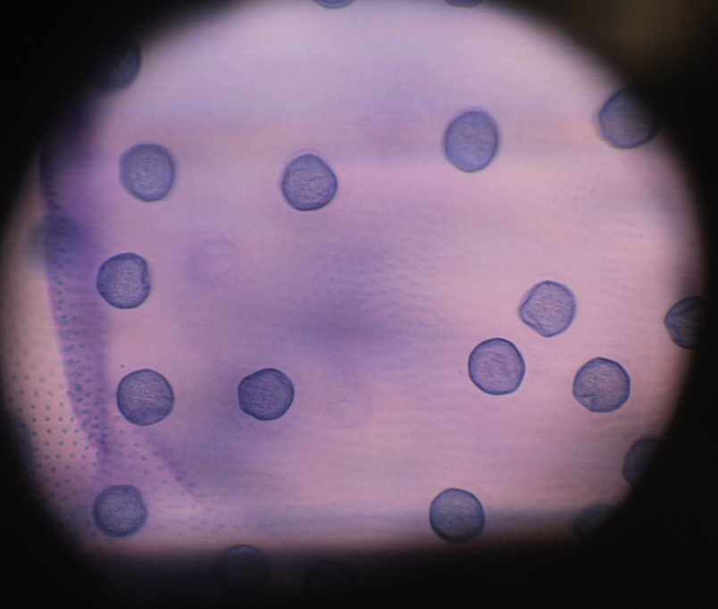
VolvoxCrop30pc.jpg (48.63 KiB) Viewed 4608 times
100% crop:
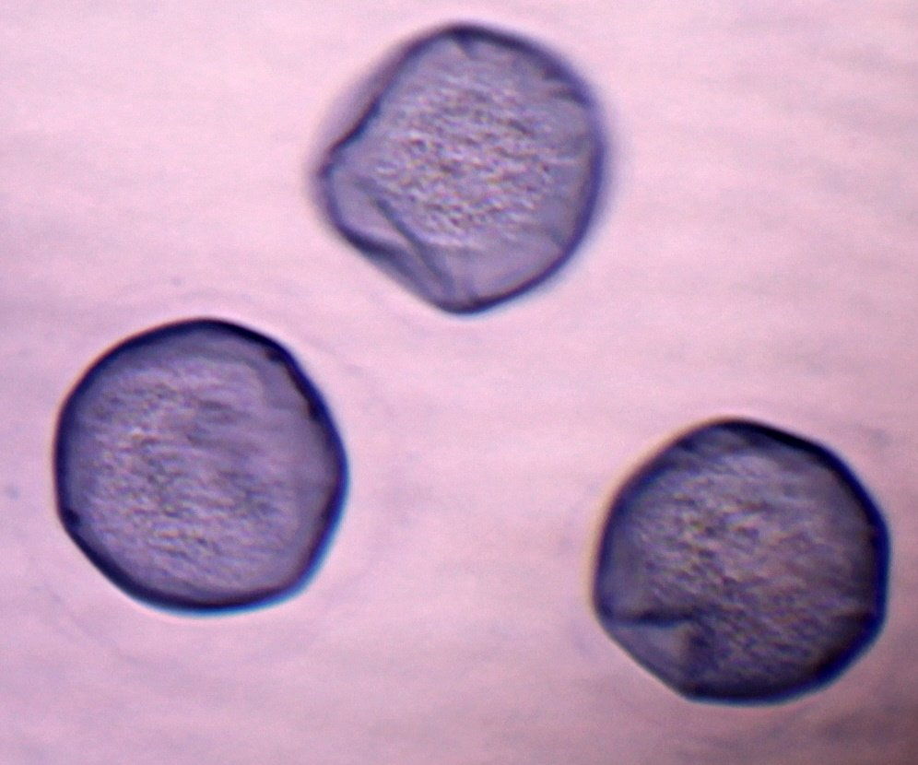
VolvoxCrop100pc.jpg (99.55 KiB) Viewed 4608 times
I don't know if I'm seeing DIC yet but making progress!
Louise
A Nikon CF plan 20x; A Swift 380T; A DIY infinity corrected focus rail system with a 40x/0.65 Olympus Plan, a 10x/0.30 Amscope Plan Fluor, and a 20x/0.75 Nikon Plan Apo
Top
Quote
Post
Scarodactyl
Posts: 2040
Joined: Sat Mar 03, 2018 9:09 pm

Re: DIC Question

#106 by Scarodactyl » Sun Jun 13, 2021 8:09 pm
That does look promising. I think a stained slide is going to mask the effect, though I am not sure what the ideal subject is for DIC. Diatoms?
Top
Quote
Post
LouiseScot
Posts: 1001
Joined: Tue Jul 07, 2020 1:51 pm
Location: Scotland

Re: DIC Question

#107 by LouiseScot » Sun Jun 13, 2021 8:13 pm
Scarodactyl wrote: ↑
Sun Jun 13, 2021 8:09 pm
That does look promising. I think a stained slide is going to mask the effect, though I am not sure what the ideal subject is for DIC. Diatoms?
Thanks. I'll try some diatoms and maybe some other things. There are some faint fringe colours so probably need some tweaks - at least!
Louise
A Nikon CF plan 20x; A Swift 380T; A DIY infinity corrected focus rail system with a 40x/0.65 Olympus Plan, a 10x/0.30 Amscope Plan Fluor, and a 20x/0.75 Nikon Plan Apo
Top
Quote
Post
LouiseScot
Posts: 1001
Joined: Tue Jul 07, 2020 1:51 pm
Location: Scotland

Re: DIC Question

#108 by LouiseScot » Mon Jun 14, 2021 6:41 pm
I cut a couple of fresh prisms today. The 3D-printed 'screw defenders' seem to work ok . I noticed with the new prisms that the strongest fringes occur towards the top this time. That suggests the fringe positioning is a property of the polycarbonate rather than anything to do with the frame or supports.
I'm a bit stuck now because I'm unsure how to set the two prisms up. I'm presuming they aren't both set to be the same tension/bending moment? The condenser prism is the beam splitter whereas the objective one is the combiner. The recombining takes place post objective so the objective prism can't be the same? I get the idea of matching fringes to what you see with a Nomarski prism for a given objective magnification (40x for me at the moment - looks like that is the black fringe plus only the nearest edges of the proximal coloured fringes, although it's hard for me to judge when is just right) but I'm assuming the condenser prism isn't set the same? Rathi did their setup by matching measured beam divergence to their existing Nomarski prisms. If the condenser prism fringe spacing is different then I think I'll have to see if I can measure its beam divergence by some means. I've been trying trial and error but not getting very far.
Louise
A Nikon CF plan 20x; A Swift 380T; A DIY infinity corrected focus rail system with a 40x/0.65 Olympus Plan, a 10x/0.30 Amscope Plan Fluor, and a 20x/0.75 Nikon Plan Apo
Top
Quote
Post
tpruuden
Posts: 59
Joined: Mon Feb 22, 2021 7:44 pm

Re: DIC Question

#109 by tpruuden » Fri Jun 25, 2021 4:03 am
Might it be, that the Hoya polarizer(s) are not inear but circular? If so, just reversing the polarizer helps. Following is the illustration of the circular/linear polarizer effect with single prism:
https://drive.google.com/file/d/188LW5W ... sp=sharing
https://drive.google.com/file/d/17xea5u ... sp=sharing
Top
Quote
Post
LouiseScot
Posts: 1001
Joined: Tue Jul 07, 2020 1:51 pm
Location: Scotland

Re: DIC Question

#110 by LouiseScot » Fri Jun 25, 2021 9:30 am
tpruuden wrote: ↑
Fri Jun 25, 2021 4:03 am
Might it be, that the Hoya polarizer(s) are not inear but circular? If so, just reversing the polarizer helps. Following is the illustration of the circular/linear polarizer effect with single prism:
https://drive.google.com/file/d/188LW5W ... sp=sharing
https://drive.google.com/file/d/17xea5u ... sp=sharing
Thanks, but I bought the Hoyas specifically because they are linear. Your prism holder looks neat, though it's hard to tell what the dimensions of it are?
My fringes are narrower (so mostly coloured) and not centred. If I slacken off the tension I can get broader bands but they become diffuse and I don't get the dark destructive interference band. As mentioned above, Whether my fringes are biased towards the top or bottom of the prism seems to depend on how I've cut them from the sheet. I've not done much with it since my previous post. I'm not sure how much difference the prism thickness makes (mine is 3mm so not far off Rathi's) or even whether the particular manufacturer matters (I'm in UK and just bought some small sheets off ebay).
Louise
A Nikon CF plan 20x; A Swift 380T; A DIY infinity corrected focus rail system with a 40x/0.65 Olympus Plan, a 10x/0.30 Amscope Plan Fluor, and a 20x/0.75 Nikon Plan Apo
Top
Quote
Post
tpruuden
Posts: 59
Joined: Mon Feb 22, 2021 7:44 pm

Re: DIC Question

#111 by tpruuden » Fri Jun 25, 2021 1:45 pm
May still be worth excluding filter type problem - the same circular filter may be called linear, assuming in photography use the orientation stays always the same.
Top
Quote
Post
LouiseScot
Posts: 1001
Joined: Tue Jul 07, 2020 1:51 pm
Location: Scotland

Re: DIC Question

#112 by LouiseScot » Sat Jun 26, 2021 2:25 pm
tpruuden wrote: ↑
Fri Jun 25, 2021 1:45 pm
May still be worth excluding filter type problem - the same circular filter may be called linear, assuming in photography use the orientation stays always the same.
Hi
They are definitely linear. I have a circular one for a camera and appreciate the difference, and have observed it with the prisms.
This is the Hoya:
https://www.amazon.co.uk/gp/product/B00 ... UTF8&psc=1
My polycarbonate (Palsun) does act as a waveplate though. If you place an unstrained piece between cross polarisers it makes the view go from dark to clear (with a tint). I have a 6mm sheet (Impex brand) which does the same so I presume it's the same with all polycarbonate?
ps I've checked the behaviours of the Hoyas against a linear polarisation sheet and two other polarisers - all the same.
Louise
A Nikon CF plan 20x; A Swift 380T; A DIY infinity corrected focus rail system with a 40x/0.65 Olympus Plan, a 10x/0.30 Amscope Plan Fluor, and a 20x/0.75 Nikon Plan Apo
Top
Quote
Post
hans
Posts: 968
Joined: Thu May 28, 2020 11:10 pm
Location: Southern California

Re: DIC Question

#113 by hans » Sat Jun 26, 2021 9:21 pm
LouiseScot wrote: ↑
Sat Jun 26, 2021 2:25 pm
My polycarbonate (Palsun) does act as a waveplate though. If you place an unstrained piece between cross polarisers it makes the view go from dark to clear (with a tint). I have a 6mm sheet (Impex brand) which does the same so I presume it's the same with all polycarbonate?
Just checked a few scraps of sheets I had laying around (unknown brand/origin, thicknesses in the 1/8 to 1/4" range) and they all show birefringence like this with no external stress. Certainly seems like that could bias the fringe pattern as you suggest. Did you see that mentioned in any of the papers? I don't remember seeing it mentioned but it has been a while and I didn't read the papers very carefully. Two of the papers specifically mention bar stock purchased from McMaster-Carr, I wonder if bars are manufactured differently than sheets might show less inherent birefringence? I will add a couple bars to my next order. They are cheap and the sheets I have are pretty scratched up anyways.
Top
Quote
Post
Scarodactyl
Posts: 2040
Joined: Sat Mar 03, 2018 9:09 pm

Re: DIC Question

#114 by Scarodactyl » Sat Jun 26, 2021 10:36 pm
Plastic is made of organic polymers which are chiral, so you expect them to be optically active. That's why you can use a plastic bag or sheet as a sprt of ersatz wave plate.
Top
Quote
Post
hans
Posts: 968
Joined: Thu May 28, 2020 11:10 pm
Location: Southern California

Re: DIC Question

#115 by hans » Sat Jun 26, 2021 11:34 pm
Scarodactyl wrote: ↑
Sat Jun 26, 2021 10:36 pm
Plastic is made of organic polymers which are chiral, so you expect them to be optically active.
Different effects, I think. With the polycarbonate sheets, packing tape, whatever is used in circular polarizing filters, etc. the transmission between crossed polarizing filters depends strongly on angle and goes through four dark/light "cycles" when rotated through 360 degrees. If I understand correctly this indicates linear birefringence with transmission when the optic axis is at a multiple of 45 degrees from the initial linear polarization and extinction when the optic axis is parallel or perpendicular to it. I don't think this necessarily requires chirality and remember reading somewhere that the birefringence in plastic films was caused by linear alignment of molecules as a result of stretching at some point in the manufacturing process.
For optical activity due to chirality the behavior between crossed polarizing filters does not depend on the angle of the initial linear polarization relative to the sample, as far as I understand. (And in the cases like sugar solution there is no large-scale anisotropy at all so how could rotation matter?)
Top
Quote
Post
tpruuden
Posts: 59
Joined: Mon Feb 22, 2021 7:44 pm

Re: DIC Question

#116 by tpruuden » Sun Jun 27, 2021 12:39 am
LouiseScot wrote: ↑
Sat Jun 26, 2021 2:25 pm
My polycarbonate (Palsun) does act as a waveplate though. If you place an unstrained piece between cross polarisers it makes the view go from dark to clear (with a tint). I have a 6mm sheet (Impex brand) which does the same so I presume it's the same with all polycarbonate?
So, this seems to indicate stressed material sheets. I used 3 mm Fluke scopemeter screen cover material for tests (assumed polycarbonate). This material has slight polarizing effect unstrained, 10..20% maximum brightening between crossed polarizers. How about hanging piece of material from the edge in oven and keeping it around 110..150c few minutes to remove residual stresses?
Top
Quote
Post
hans
Posts: 968
Joined: Thu May 28, 2020 11:10 pm
Location: Southern California

Re: DIC Question

#117 by hans » Sun Jun 27, 2021 1:45 am
tpruuden wrote: ↑
Sun Jun 27, 2021 12:39 am
So, this seems to indicate stressed material sheets.
In the sheets I have the birefringence is very uniform across the entire sheet right up to the edge, just like packing tape. Not obvious to me how that could be explained by an internal stress distribution...?
Top
Quote
Post
tpruuden
Posts: 59
Joined: Mon Feb 22, 2021 7:44 pm

Re: DIC Question

#118 by tpruuden » Sun Jun 27, 2021 4:58 am
hans wrote: ↑
Sun Jun 27, 2021 1:45 am
In the sheets I have the birefringence is very uniform across the entire sheet right up to the edge, just like packing tape. Not obvious to me how that could be explained by an internal stress distribution...?
I am not sure either but there are references of compression induced increase of impact strength of polycarbonate plates up to 700%. This might create quite uniform internal stress, that is better visible as gradient from the edge direction, not from side of the sheet. Pure speculation from my side...
https://onlinelibrary.wiley.com/doi/abs ... /app.50125
Top
Quote
Post
LouiseScot
Posts: 1001
Joined: Tue Jul 07, 2020 1:51 pm
Location: Scotland

Re: DIC Question

#119 by LouiseScot » Sun Jun 27, 2021 3:50 pm
Sorry for late reply but I've not been getting email notifications. I'm in the UK and I'm wondering whether there is some difference with European polycarbonate and US made? Obviously the Rathi lab used US material and also mentioned using a half waveplate for measuring deflections. When viewing my 3mm polycarbonate (UK Palram/Palsun) between cross polarisers I see a fairly even-coloured hue (usually purplish but can vary across/between sheets). e.g.
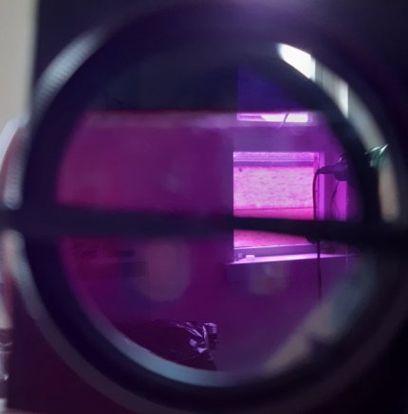
Test_162000.jpg (19.01 KiB) Viewed 4171 times
You can see the top sector where its dark, and the polarisers are crossed, but there's no polycarbonate between. It's otherwise still darker than normal but not as dark as the cross polarisers alone.
Does anyone else see this? If not, I'll have to try and get a different make though my 6mm 'Impex' brand behaves the same.
Cheers
Louise
A Nikon CF plan 20x; A Swift 380T; A DIY infinity corrected focus rail system with a 40x/0.65 Olympus Plan, a 10x/0.30 Amscope Plan Fluor, and a 20x/0.75 Nikon Plan Apo
Top
Quote
Post
hans
Posts: 968
Joined: Thu May 28, 2020 11:10 pm
Location: Southern California

Re: DIC Question

#120 by hans » Sun Jun 27, 2021 7:44 pm
LouiseScot wrote: ↑
Sun Jun 27, 2021 3:50 pm
Does anyone else see this?
How does it behave when you rotate it, relative to the direction of your polarizers? Have you checked the orientation of the Hoya PLs you have? I read conflicting things about whether or not the mark on the ring is supposed to be aligned accurately with the polarizer direction and some reports of them not being aligned even in new ones. I have several I bought used and they were all misaligned. In all mine the filters are held in with a circular spring clip and can rotated relative to the alignment mark without too much difficulty while pinching the filter between thumb and finger. I aligned them approximately using reflection from a glass microscope slide near Brewster's angle as a reference.
As mentioned in #113 and #115 all the pieces I have laying around act like waveplates. Unsure of absolute retardance but judging from the interference color charts probably third order or higher.
Top
Quote
Post

Re: DIC Question

#121 by LouiseScot » Sun Jun 27, 2021 11:49 pm
hans wrote: ↑
Sun Jun 27, 2021 7:44 pm
LouiseScot wrote: ↑
Sun Jun 27, 2021 3:50 pm
Does anyone else see this?
How does it behave when you rotate it, relative to the direction of your polarizers? Have you checked the orientation of the Hoya PLs you have? I read conflicting things about whether or not the mark on the ring is supposed to be aligned accurately with the polarizer direction and some reports of them not being aligned even in new ones. I have several I bought used and they were all misaligned. In all mine the filters are held in with a circular spring clip and can rotated relative to the alignment mark without too much difficulty while pinching the filter between thumb and finger. I aligned them approximately using reflection from a glass microscope slide near Brewster's angle as a reference.
As mentioned in #113 and #115 all the pieces I have laying around act like waveplates. Unsure of absolute retardance but judging from the interference color charts probably third order or higher.
Hiya
You mean if I rotate the polycarbonate between cross polarisers? The brightness varies and there is a minimum but it's not so dark as without having the polycarbonate sandwiched. I'm thinking this is maybe not so relevant though I'm a bit unsure. I do get the expected interference fringes but they just seem relatively narrow with the dark destructive band either towards the top or towards the bottom of the prism. However, I've been using two of the relatively large open frames based on Rathi's dimensions. Maybe I should go back to using a 'compact' holder for the condenser prism.
The hoya polarisers are camera types so rotatable, so I can set them at any angle relative to the prisms. I can set the polarisers to be crossed/opaque with no prisms in place and then position the two prisms. There doesn't seem to be an issue there. I can't remember if I previously set them to be both crossed and to have a minimum transmittance with unstressed polycarbonate in between, but it's something I'll check out next time. (Out of the top of my head, I think Rathi mentioned something about polarisers being at 45 deg. relative to the prisms - I presume this equates to the minimum transmittance - but might be a red herring!)
Is there someone in the USA who has had the same behaviour with their polycarbonate? Or anyone who has definitely and successfully achieved DIC? (I think @jmp said he did but not seen a post from him since). Anyway, I'm not sure whether all 'standard' polycarbonate sheet is the same? I think you can get sheets that have been hardened or coated (e.g. extra UV coating) but I presume any non-standard things would be stated. I imagine Rathi et al. just used the ordinary non-treated sheet here https://www.mcmaster.com/polycarbonate-sheet-stock/. Apart from it being measured in fractions of an inch thickness, it doesn't seem any different to my sheets.
Hans - sorry I either missed or didn't fully appreciate your previous 113, 115 posts. Are you in the States or Europe?
I'm likely to have to postpone working on this project until after July as I have a course and other things I have to do.
Thanks for everyone's replies
Louise
A Nikon CF plan 20x; A Swift 380T; A DIY infinity corrected focus rail system with a 40x/0.65 Olympus Plan, a 10x/0.30 Amscope Plan Fluor, and a 20x/0.75 Nikon Plan Apo
Top
Quote
Post
hans
Posts: 968
Joined: Thu May 28, 2020 11:10 pm
Location: Southern California

Re: DIC Question

#122 by hans » Mon Jun 28, 2021 12:57 am
LouiseScot wrote: ↑
Sun Jun 27, 2021 11:49 pm
You mean if I rotate the polycarbonate between cross polarisers? The brightness varies and there is a minimum but it's not so dark as without having the polycarbonate sandwiched.
Yeah, the sheets I have get quite dark with the optic axis parallel or perpendicular to the polarizer directions, hard to judge from the photo but probably darker than yours. Extinction in that orientation is quite sensitive to twisting. The optic axis is pretty close to aligned with the original factory edges which seems right for molecular alignment or residual stress from extrusion.
LouiseScot wrote: ↑
Sun Jun 27, 2021 11:49 pm
The hoya polarisers are camera types so rotatable, so I can set them at any angle relative to the prisms. I can set the polarisers to be crossed/opaque with no prisms in place and then position the two prisms.
I think I have the same ones, was just wondering whether you know angle of the prism relative to the polarization, and pointing out a possible source of confusion: mine have little marks on the rotating rings that one might reasonably assume indicate the direction of polarization but are not reliable unless you check and align them against a known reference yourself.
LouiseScot wrote: ↑
Sun Jun 27, 2021 11:49 pm
(Out of the top of my head, I think Rathi mentioned something about polarisers being at 45 deg. relative to the prisms - I presume this equates to the minimum transmittance - but might be a red herring!)
If your sheets are like mine then 45 deg (measuring from an original factory edge) is close to maximum transmission. That is why I suggest checking and marking your Hoya filters relative to some absolute reference like reflection from glass near Brewster's angle.
LouiseScot wrote: ↑
Sun Jun 27, 2021 11:49 pm
Are you in the States or Europe?
Southern California, not far from McMaster, which is why I order fairly often since shipping is usually ~$10 and comes the next day via a courier service. I will order some sheets and bars for comparison since two of the papers specifically mention bars. No idea if they are actually manufactured differently or are just cut-up sheets.
Top
Quote
Post
LouiseScot
Posts: 1001
Joined: Tue Jul 07, 2020 1:51 pm
Location: Scotland

Re: DIC Question

#123 by LouiseScot » Mon Jun 28, 2021 9:37 am
hans wrote: ↑
Mon Jun 28, 2021 12:57 am
LouiseScot wrote: ↑
Sun Jun 27, 2021 11:49 pm
You mean if I rotate the polycarbonate between cross polarisers? The brightness varies and there is a minimum but it's not so dark as without having the polycarbonate sandwiched.
Yeah, the sheets I have get quite dark with the optic axis parallel or perpendicular to the polarizer directions, hard to judge from the photo but probably darker than yours. Extinction in that orientation is quite sensitive to twisting. The optic axis is pretty close to aligned with the original factory edges which seems right for molecular alignment or residual stress from extrusion.
Yes, same here. There is a point which is darkest but, as you say, very sensitive. In my photo, I just did it to show the passive effect of being between cross polarisers. I don't think I tried to either minimise or maximise transmission through the polycarbonate.
LouiseScot wrote: ↑
Sun Jun 27, 2021 11:49 pm
The hoya polarisers are camera types so rotatable, so I can set them at any angle relative to the prisms. I can set the polarisers to be crossed/opaque with no prisms in place and then position the two prisms.
I think I have the same ones, was just wondering whether you know angle of the prism relative to the polarization, and pointing out a possible source of confusion: mine have little marks on the rotating rings that one might reasonably assume indicate the direction of polarization but are not reliable unless you check and align them against a known reference yourself.
I've no idea. There are arrow/triangle marks on the edge of the rotatable part but I always assumed they were just a point of reference. Having said that, the Hoyas are cross-polarised when one arrow is 90 deg to the other.
LouiseScot wrote: ↑
Sun Jun 27, 2021 11:49 pm
(Out of the top of my head, I think Rathi mentioned something about polarisers being at 45 deg. relative to the prisms - I presume this equates to the minimum transmittance - but might be a red herring!)
If your sheets are like mine then 45 deg (measuring from an original factory edge) is close to maximum transmission. That is why I suggest checking and marking your Hoya filters relative to some absolute reference like reflection from glass near Brewster's angle.
I could do that. Is it the case that maximum transmission through the polycarbonate would be best? Just checking with a small piece of polycarbonate I get minimum transmission at 90 degrees to cross polarisers using linear polarising sheet. Presumably the polarising sheet can be used as a reference?
LouiseScot wrote: ↑
Sun Jun 27, 2021 11:49 pm
Are you in the States or Europe?
Southern California, not far from McMaster, which is why I order fairly often since shipping is usually ~$10 and comes the next day via a courier service. I will order some sheets and bars for comparison since two of the papers specifically mention bars. No idea if they are actually manufactured differently or are just cut-up sheets.
That's a nice place to be! Unfortunately nobody seems to offer bars in the UK. If I could get 20mm bars that would save some of my dodgy sawing!
Cheers
Louise
A Nikon CF plan 20x; A Swift 380T; A DIY infinity corrected focus rail system with a 40x/0.65 Olympus Plan, a 10x/0.30 Amscope Plan Fluor, and a 20x/0.75 Nikon Plan Apo
Top
Quote
Post
tpruuden
Posts: 59
Joined: Mon Feb 22, 2021 7:44 pm

Re: DIC Question

#124 by tpruuden » Mon Jun 28, 2021 11:31 am
LouiseScot wrote: ↑
Sun Jun 27, 2021 3:50 pm
When viewing my 3mm polycarbonate (UK Palram/Palsun) between cross polarisers I see a fairly even-coloured hue (usually purplish but can vary across/between sheets). e.g.
You can see the top sector where its dark, and the polarisers are crossed, but there's no polycarbonate between. It's otherwise still darker than normal but not as dark as the cross polarisers alone.
Does anyone else see this? If not, I'll have to try and get a different make though my 6mm 'Impex' brand behaves the same.
There is minimal stresses in the Fluke screen material (and this is cracked test piece), compared to Hoya filter casing and 2 mm sheet material (crossed polarizers, 45 degrees material orientation):
https://drive.google.com/file/d/18I4q9c ... sp=sharing
https://drive.google.com/file/d/18D9w3e ... sp=sharing
https://drive.google.com/file/d/18KPJ3m ... sp=sharing
Blue hue is seen from the 2mm sheet material, I would say, that it is stressed uniformly.
Top
Quote
Post
LouiseScot
Posts: 1001
Joined: Tue Jul 07, 2020 1:51 pm
Location: Scotland

Re: DIC Question

#125 by LouiseScot » Mon Jun 28, 2021 11:39 am
tpruuden wrote: ↑
Mon Jun 28, 2021 11:31 am
LouiseScot wrote: ↑
Sun Jun 27, 2021 3:50 pm
When viewing my 3mm polycarbonate (UK Palram/Palsun) between cross polarisers I see a fairly even-coloured hue (usually purplish but can vary across/between sheets). e.g.
You can see the top sector where its dark, and the polarisers are crossed, but there's no polycarbonate between. It's otherwise still darker than normal but not as dark as the cross polarisers alone.
Does anyone else see this? If not, I'll have to try and get a different make though my 6mm 'Impex' brand behaves the same.
There is minimal stresses in the Fluke screen material (and this is cracked test piece), compared to Hoya filter casing and 2 mm sheet material (crossed polarizers, 45 degrees material orientation):
https://drive.google.com/file/d/18I4q9c ... sp=sharing
https://drive.google.com/file/d/18D9w3e ... sp=sharing
https://drive.google.com/file/d/18KPJ3m ... sp=sharing
Blue hue is seen from the 2mm sheet material, I would say, that it is stressed uniformly.
Thanks. About the same as mine then. I'll have to get back to trying to get the DIC working, when I can. I'll make a new condenser prism holder as well.
Louise
A Nikon CF plan 20x; A Swift 380T; A DIY infinity corrected focus rail system with a 40x/0.65 Olympus Plan, a 10x/0.30 Amscope Plan Fluor, and a 20x/0.75 Nikon Plan Apo
Top
Quote
Post
tpruuden
Posts: 59
Joined: Mon Feb 22, 2021 7:44 pm

Re: DIC Question

#126 by tpruuden » Mon Jun 28, 2021 12:03 pm
LouiseScot wrote: ↑
Mon Jun 28, 2021 11:39 am
Thanks. About the same as mine then. I'll have to get back to trying to get the DIC working, when I can. I'll make a new condenser prism holder as well.
I am atm testing the 2mm sheet pieces in oven at glass transition temperature to see, if the internal stress can be removed. Smells terrible for sure.
Top
Quote
Post
Hobbyst46
Posts: 3905
Joined: Mon Aug 21, 2017 9:02 pm

Re: DIC Question

#127 by Hobbyst46 » Mon Jun 28, 2021 12:10 pm
In the brochures of some sellers of Palram/Palsun products they state that Palsun includes a one-side UV protection. Some other PC sheets seem to carry double-side UV protection. I do not know what those mean, but I would suspect a UV-blocking coat layer of some sort. Would that affect the observed birefringence
Zeiss Standard GFL+Canon EOS-M10, Olympus VMZ stereo
Top
Quote
Post
tpruuden
Posts: 59
Joined: Mon Feb 22, 2021 7:44 pm

Re: DIC Question

#128 by tpruuden » Mon Jun 28, 2021 12:29 pm
Hobbyst46 wrote: ↑
Mon Jun 28, 2021 12:10 pm
In the brochures of some sellers of Palram/Palsun products they state that Palsun includes a one-side UV protection. Some other PC sheets seem to carry double-side UV protection. I do not know what those mean, but I would suspect a UV-blocking coat layer of some sort. Would that affect the observed birefringence
Good catch, it may act as 1/x waveplate there.
Although the glass transition temperature seems to be way lower than expected, the stresses significantly differ after heating. Considering, that the material shrunk and thickened, I assume, that common plate materials are rolled to thickness and thus having internal stresses. Materials specially targeted as LCD cover glasses seem to be minimally stressed to avoid polarisation changes.
The same 2mm material that was having blue hue earlier:
https://drive.google.com/file/d/18V09VN ... sp=sharing
Top
Quote
Post
LouiseScot
Posts: 1001
Joined: Tue Jul 07, 2020 1:51 pm
Location: Scotland

Re: DIC Question

#129 by LouiseScot » Mon Jun 28, 2021 12:59 pm
Hobbyst46 wrote: ↑
Mon Jun 28, 2021 12:10 pm
In the brochures of some sellers of Palram/Palsun products they state that Palsun includes a one-side UV protection. Some other PC sheets seem to carry double-side UV protection. I do not know what those mean, but I would suspect a UV-blocking coat layer of some sort. Would that affect the observed birefringence
I've dropped the seller a line to check but I would suppose it would be stated if there was. I await a reply
Louise
A Nikon CF plan 20x; A Swift 380T; A DIY infinity corrected focus rail system with a 40x/0.65 Olympus Plan, a 10x/0.30 Amscope Plan Fluor, and a 20x/0.75 Nikon Plan Apo
Top
Quote
Post
MichaelG.
Posts: 3483
Joined: Mon Apr 10, 2017 8:24 am
Location: NorthWest England

Re: DIC Question

#130 by MichaelG. » Mon Jun 28, 2021 1:24 pm
A useful source of background information on Polycarbonate materials, here:
https://www.bpf.co.uk/plastipedia/polym ... onate.aspx
MichaelG.
Too many 'projects'
Top
Quote
Post
LouiseScot
Posts: 1001
Joined: Tue Jul 07, 2020 1:51 pm
Location: Scotland

Re: DIC Question

#131 by LouiseScot » Mon Jun 28, 2021 1:28 pm
MichaelG. wrote: ↑
Mon Jun 28, 2021 1:24 pm
A useful source of background information on Polycarbonate materials, here:
https://www.bpf.co.uk/plastipedia/polym ... onate.aspx
MichaelG.
Doesn't really help but thanks anyway.
Louise
A Nikon CF plan 20x; A Swift 380T; A DIY infinity corrected focus rail system with a 40x/0.65 Olympus Plan, a 10x/0.30 Amscope Plan Fluor, and a 20x/0.75 Nikon Plan Apo
Top
Quote
Post
LouiseScot
Posts: 1001
Joined: Tue Jul 07, 2020 1:51 pm
Location: Scotland

Re: DIC Question

#132 by LouiseScot » Mon Jun 28, 2021 1:37 pm
Tut, I just lost a post - grrr. Anyway seller tells me that all polycarbonate sheeting has added UV stabiliser. It's just a kind of sunscreen added to the resin. Whether it might affect visible light properties I've no idea but it may not be possible to get it without.
Louise
A Nikon CF plan 20x; A Swift 380T; A DIY infinity corrected focus rail system with a 40x/0.65 Olympus Plan, a 10x/0.30 Amscope Plan Fluor, and a 20x/0.75 Nikon Plan Apo
Top
Quote
Post
hans
Posts: 968
Joined: Thu May 28, 2020 11:10 pm
Location: Southern California

Re: DIC Question

#133 by hans » Mon Jun 28, 2021 5:15 pm
LouiseScot wrote: ↑
Mon Jun 28, 2021 9:37 am
Having said that, the Hoyas are cross-polarised when one arrow is 90 deg to the other.
Yeah that's a good sign, maybe yours are already aligned.
LouiseScot wrote: ↑
Mon Jun 28, 2021 9:37 am
Is it the case that maximum transmission through the polycarbonate would be best?
The stress gradient (which should be perpendicular to the beam axis in the ideal case) is supposed to be 45 degree between the polarizers for DIC. If you are stuck using material with some preexisting birefringence then basically you just have a choice of how to orient the existing birefringence relative to the beam axis, depending on what orientation you cut the beam out from the sheet. Not clear to me what the least-bad orientation for existing birefringence would be, but I would guess having the optic axis parallel to the beam axis (as you already do) is probably better than having it perpendicular, or at least not as confusing to think about.
LouiseScot wrote: ↑
Mon Jun 28, 2021 9:37 am
Just checking with a small piece of polycarbonate I get minimum transmission at 90 degrees to cross polarisers using linear polarising sheet. Presumably the polarising sheet can be used as a reference?
Yeah, probably. I suggested reflection from plain, uncoated glass because it doesn't require any assumptions about the material. Extinction of the reflection is maximum when the polarizer direction is parallel to the plane of incidence. Blue sky is another reference, but maybe more convenient in Southern California than Scotland...
Top
Quote
Post
LouiseScot
Posts: 1001
Joined: Tue Jul 07, 2020 1:51 pm
Location: Scotland

Re: DIC Question

#134 by LouiseScot » Mon Jun 28, 2021 5:30 pm
hans wrote: ↑
Mon Jun 28, 2021 5:15 pm
LouiseScot wrote: ↑
Mon Jun 28, 2021 9:37 am
Having said that, the Hoyas are cross-polarised when one arrow is 90 deg to the other.
Yeah that's a good sign, maybe yours are already aligned.
LouiseScot wrote: ↑
Mon Jun 28, 2021 9:37 am
Is it the case that maximum transmission through the polycarbonate would be best?
The stress gradient (which should be perpendicular to the beam axis in the ideal case) is supposed to be 45 degree between the polarizers for DIC. If you are stuck using material with some preexisting birefringence then basically you just have a choice of how to orient the existing birefringence relative to the beam axis, depending on what orientation you cut the beam out from the sheet. Not clear to me what the least-bad orientation for existing birefringence would be, but I would guess having the optic axis parallel to the beam axis (as you already do) is probably better than having it perpendicular, or at least not as confusing to think about.
LouiseScot wrote: ↑
Mon Jun 28, 2021 9:37 am
Just checking with a small piece of polycarbonate I get minimum transmission at 90 degrees to cross polarisers using linear polarising sheet. Presumably the polarising sheet can be used as a reference?
Yeah, probably. I suggested reflection from plain, uncoated glass because it doesn't require any assumptions about the material. Extinction of the reflection is maximum when the polarizer direction is parallel to the plane of incidence. Blue sky is another reference, but maybe more convenient in Southern California than Scotland...
It's fairly easy to arrange the prisms to be 45 deg to the cross polarisers axis. It was actually hot and sunny here earlier but has since clouded over . Still, tomorrow is forecast to be sunny and warm
Louise
A Nikon CF plan 20x; A Swift 380T; A DIY infinity corrected focus rail system with a 40x/0.65 Olympus Plan, a 10x/0.30 Amscope Plan Fluor, and a 20x/0.75 Nikon Plan Apo
Top
Quote
Post
hans
Posts: 968
Joined: Thu May 28, 2020 11:10 pm
Location: Southern California

Re: DIC Question

#135 by hans » Mon Jun 28, 2021 5:57 pm
Yes, of course as I was writing that, it is actually cloudy here today.
Slight change of subject, but related: some papers on polymers appear to be making a distinction between "intrinsic orientational birefringence" (and a few other similar phrasings) vs. stress-induced (photoelastic) birefringence. I have not found a clear (to me, at least) explanation of the relationship, particularly in the case where the the material is being cooled and stretched at the same time, like extrusion...?
Top
Quote
Post
LouiseScot
Posts: 1001
Joined: Tue Jul 07, 2020 1:51 pm
Location: Scotland

Re: DIC Question

#136 by LouiseScot » Mon Jun 28, 2021 6:21 pm
hans wrote: ↑
Mon Jun 28, 2021 5:57 pm
Yes, of course as I was writing that, it is actually cloudy here today.
Slight change of subject, but related: some papers on polymers appear to be making a distinction between "intrinsic orientational birefringence" (and a few other similar phrasings) vs. stress-induced (photoelastic) birefringence. I have not found a clear (to me, at least) explanation of the relationship, particularly in the case where the the material is being cooled and stretched at the same time, like extrusion...?
If someone finds a use for it that interests me then I might delve into it more. In the meantime I'll just stick to the DIC challenge!
Louise
A Nikon CF plan 20x; A Swift 380T; A DIY infinity corrected focus rail system with a 40x/0.65 Olympus Plan, a 10x/0.30 Amscope Plan Fluor, and a 20x/0.75 Nikon Plan Apo
Top
Quote
Post
hans
Posts: 968
Joined: Thu May 28, 2020 11:10 pm
Location: Southern California

Re: DIC Question

#137 by hans » Tue Jun 29, 2021 8:44 am
Placed the order at 10:30 AM and it was dropped off at 3:30 PM, probably a new record. The 7/32" bars are clearly cut from sheet since they have the same cloudy white protective film with "TUFFAK polycarbonate sheet" printed all over as the 1/4" sheet. The 1/8" sheet is also TUFFAK. The 1/8" bar also appears to be cut from a larger sheet but has clear protective film with no branding printed on it.
Interestingly the birefringence of the 7/32" TUFFAK bar is dramatically lower than either of the 1/8" pieces. A bit less than 100 nm retardance, I believe, since if I increase path length somewhat by tilting it away from being perpendicular with the line of sight (by about 45 degrees) it behaves similar a reversed Hoya CIR-PL with little brightness variation as the analyzer is rotated, just some color shift from bluish to brownish.
The unbranded 1/8" bar on the other hand is around 1500 nm retardance despite being half as thick, so more than 30 times greater birefringence. The 1/8" TUFFAK sheet is similar. So it seems like maybe different manufacturing processes are used depending on thickness?
Here is what the 7/32" x 1" TUFFAK bar looks like with stress gradient at roughly 45 degrees between crossed polarizers. Polarizer is my monitor and analyzer is a Hoya CIR-PL installed normally on the camera lens. There is a lot of ugly color banding. I guess some of the interference colors are fairly pure and going out of gamut somewhere? The colors are prettier in person:
ATTACHMENTS
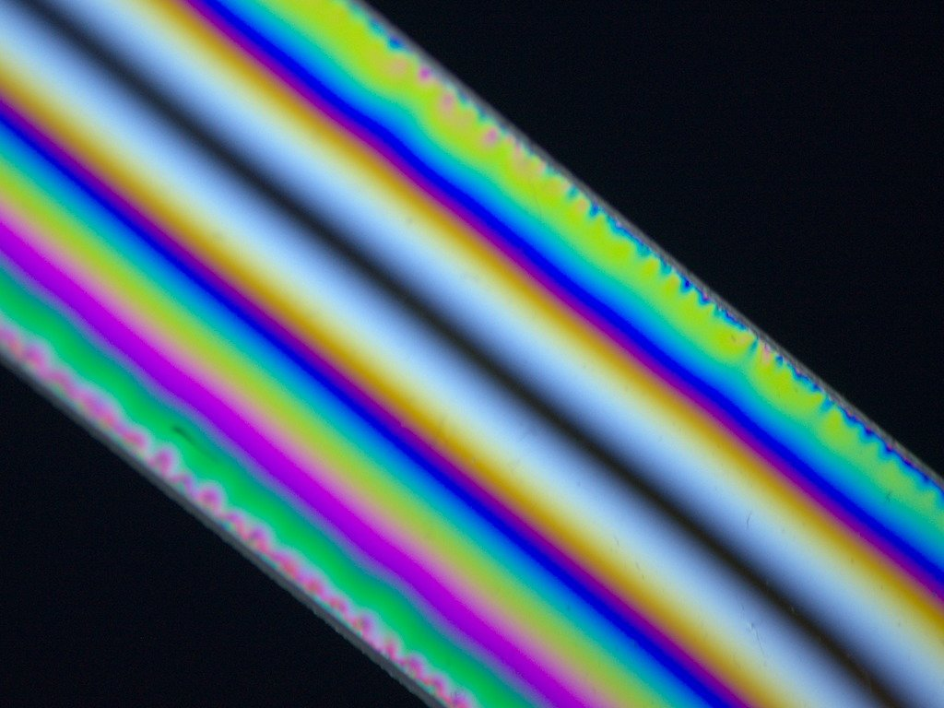
DSC_9520-1.jpg (116.9 KiB) Viewed 4858 times
Top
Quote
Post
Hobbyst46
Posts: 3905
Joined: Mon Aug 21, 2017 9:02 pm

Re: DIC Question

#138 by Hobbyst46 » Tue Jun 29, 2021 8:49 am
hans wrote:...
I have been informed that at least one brand of PC for outdoor use is coated against UV, coating thickness can be 15-50 um, and may cover one side or both sides of the sheet, depending on expected market/site demands. FWIW.
Zeiss Standard GFL+Canon EOS-M10, Olympus VMZ stereo
Top
Quote
Post
LouiseScot
Posts: 1001
Joined: Tue Jul 07, 2020 1:51 pm
Location: Scotland

Re: DIC Question

#139 by LouiseScot » Tue Jun 29, 2021 9:18 am
hans wrote: ↑
Tue Jun 29, 2021 8:44 am
Placed the order at 10:30 AM and it was dropped off at 3:30 PM, probably a new record. The 7/32" bars are clearly cut from sheet since they have the same cloudy white protective film with "TUFFAK polycarbonate sheet" printed all over as the 1/4" sheet. The 1/8" sheet is also TUFFAK. The 1/8" bar also appears to be cut from a larger sheet but has clear protective film with no branding printed on it.
Interestingly the birefringence of the 7/32" TUFFAK bar is dramatically lower than either of the 1/8" pieces. A bit less than 100 nm retardance, I believe, since if I increase path length somewhat by tilting it away from being perpendicular with the line of sight (by about 45 degrees) it behaves similar a reversed Hoya CIR-PL with little brightness variation as the analyzer is rotated, just some color shift from bluish to brownish.
The unbranded 1/8" bar on the other hand is around 1500 nm retardance despite being half as thick, so more than 30 times greater birefringence. The 1/8" TUFFAK sheet is similar. So it seems like maybe different manufacturing processes are used depending on thickness?
Here is what the 7/32" x 1" TUFFAK bar looks like with stress gradient at roughly 45 degrees between crossed polarizers. Polarizer is my monitor and analyzer is a Hoya CIR-PL installed normally on the camera lens. There is a lot of ugly color banding. I guess some of the interference colors are fairly pure and going out of gamut somewhere? The colors are prettier in person:
Wow, that's a good image! How did you stress the bar exactly? You've got a nice, almost central, destructive interference band - something I've struggled to get. The colours look good too.
ps I just tried to do the same with my 6mm x 20mm x 110mm bar. Did the same as you did, Hans, with bending performed by hand (I'm a little old lady with small hands, though - I'd need another hand to take a quick photo). I do indeed get the stress induced birefringence but I still struggle to get the dark fringe away from one edge. As soon as I apply more stress the dark fringe narrows significantly. This is the problem I've had all along It seems to be a property of the polycarbonate. It may be that I just have to adapt to this property.
Louise
A Nikon CF plan 20x; A Swift 380T; A DIY infinity corrected focus rail system with a 40x/0.65 Olympus Plan, a 10x/0.30 Amscope Plan Fluor, and a 20x/0.75 Nikon Plan Apo
Top
Quote
Post
hans
Posts: 968
Joined: Thu May 28, 2020 11:10 pm
Location: Southern California

Re: DIC Question

#140 by hans » Tue Jun 29, 2021 10:00 am
I was just bending it by hand with a pair of locking pliers at each end for better leverage and control. Extinction in the center of the fringe pattern is very sensitive to twisting, similar to the case we were discussing a few posts up with the optic axis of the inherent birefringence aligned parallel or perpendicular to the polarizer, so possibly your fixture is inadvertently twisting the beam? I am not sure the 4-roller designs in the the papers are a good idea without precise, rigid construction. They are overconstrained in the sense that they will twist the beam unless everything (the rollers and the faces of the beam and frame where they contact) is perfectly coplanar/parallel.
Hobbyst46 wrote: ↑
Tue Jun 29, 2021 8:49 am
I have been informed that at least one brand of PC for outdoor use is coated against UV, coating thickness can be 15-50 um, and may cover one side or both sides of the sheet, depending on expected market/site demands. FWIW.
McMaster sells UV-resistant variants so I could try those too. But if the coatings are 50 um or less the birefringence would need to be quite high to explain the retardance, not sure if possible unless it was crystalline?
Top
Quote
Post
LouiseScot
Posts: 1001
Joined: Tue Jul 07, 2020 1:51 pm
Location: Scotland

Re: DIC Question

#141 by LouiseScot » Tue Jun 29, 2021 10:38 am
hans wrote: ↑
Tue Jun 29, 2021 10:00 am
I was just bending it by hand with a pair of locking pliers at each end for better leverage and control. Extinction in the center of the fringe pattern is very sensitive to twisting, similar to the case we were discussing a few posts up with the optic axis of the inherent birefringence aligned parallel or perpendicular to the polarizer, so possibly your fixture is inadvertently twisting the beam? I am not sure the 4-roller designs in the the papers are a good idea without precise, rigid construction. They are overconstrained in the sense that they will twist the beam unless everything (the rollers and the faces of the beam and frame where they contact) is perfectly coplanar/parallel.
Hobbyst46 wrote: ↑
Tue Jun 29, 2021 8:49 am
I have been informed that at least one brand of PC for outdoor use is coated against UV, coating thickness can be 15-50 um, and may cover one side or both sides of the sheet, depending on expected market/site demands. FWIW.
McMaster sells UV-resistant variants so I could try those too. But if the coatings are 50 um or less the birefringence would need to be quite high to explain the retardance, not sure if possible unless it was crystalline?
Hi Hans
I'm not sure if it's a twisting moment which causes the problem since it's so consistent between different thicknesses of sheet and with different frames - as well as bending by hand in this case. It's also a property of the polycarbonate that the dark fringe is biased to either the top or the bottom depending on how it's cut from the larger sheet. I suppose the big question is, does it affect the ability of the stressed prism to perform DIC? A quick measurement of the spacing between the coloured fringes either side of the dark band gives a distance of about 10mm (~ 4/10") with the 6mm prism which is maybe a smaller distance compared to Rathi's Fig 3. Theirs is is more like 16-18mm. It's almost ironic that I get broader bands on my plastic ruler - with no external stress!
Louise
A Nikon CF plan 20x; A Swift 380T; A DIY infinity corrected focus rail system with a 40x/0.65 Olympus Plan, a 10x/0.30 Amscope Plan Fluor, and a 20x/0.75 Nikon Plan Apo
Top
Quote
Post
hans
Posts: 968
Joined: Thu May 28, 2020 11:10 pm
Location: Southern California

Re: DIC Question

#142 by hans » Tue Jun 29, 2021 5:36 pm
LouiseScot wrote: ↑
Tue Jun 29, 2021 10:38 am
I'm not sure if it's a twisting moment which causes the problem...
Which problem, poor extinction in the center or offset? I saw twisting mainly affecting extinction in the center, not offset.
As far as I can see the offset is exactly what would be expected from the inherent uniform birefringence of the unstressed beam combining with the stress-gradient-induced birefringence. (Assuming the optic axis of the inherent birefringence is parallel to the beam, which seems to be the default case unless the beam is intentionally cut at an angle relative to the original material.) As bending moment is applied the fringe pattern narrows but the color along the central neutral axis (where there is no stress-induced birefringence) stays the same. (This is how I decided ~1500 nm absolute retardance for the 1/8" material without a calibrated compensator.)
If this understanding is correct then it seems like the offset should be equivalent to bias retardation normally introduced intentionally by translating the prism or with de Sénarmont compensator. So as long as the offset is not large enough to put the required part of the fringe pattern "out of view" with the correct bending applied, I don't see any fundamental problem.
Top
Quote
Post
LouiseScot
Posts: 1001
Joined: Tue Jul 07, 2020 1:51 pm
Location: Scotland

Re: DIC Question

#143 by LouiseScot » Tue Jun 29, 2021 6:26 pm
hans wrote: ↑
Tue Jun 29, 2021 5:36 pm
LouiseScot wrote: ↑
Tue Jun 29, 2021 10:38 am
I'm not sure if it's a twisting moment which causes the problem...
Which problem, poor extinction in the center or offset? I saw twisting mainly affecting extinction in the center, not offset.
As far as I can see the offset is exactly what would be expected from the inherent uniform birefringence of the unstressed beam combining with the stress-gradient-induced birefringence. (Assuming the optic axis of the inherent birefringence is parallel to the beam, which seems to be the default case unless the beam is intentionally cut at an angle relative to the original material.) As bending moment is applied the fringe pattern narrows but the color along the central neutral axis (where there is no stress-induced birefringence) stays the same. (This is how I decided ~1500 nm absolute retardance for the 1/8" material without a calibrated compensator.)
If this understanding is correct then it seems like the offset should be equivalent to bias retardation normally introduced intentionally by translating the prism or with de Sénarmont compensator. So as long as the offset is not large enough to put the required part of the fringe pattern "out of view" with the correct bending applied, I don't see any fundamental problem.
The offset, really. I don't pretend to understand all the technicalities. I just printed out a second lower profile open frame. That should let me have both prisms the same, and with the extinction band in a good place. I'm still unsure how the condenser prism should be adjusted, in terms of tension, relative to the objective one. Rathi says there should be a difference in deflection angle between the two, but how to measure or estimate it?
Louise
A Nikon CF plan 20x; A Swift 380T; A DIY infinity corrected focus rail system with a 40x/0.65 Olympus Plan, a 10x/0.30 Amscope Plan Fluor, and a 20x/0.75 Nikon Plan Apo
Top
Quote
Post
hans
Posts: 968
Joined: Thu May 28, 2020 11:10 pm
Location: Southern California

Re: DIC Question

#144 by hans » Tue Jun 29, 2021 7:07 pm
LouiseScot wrote: ↑
Tue Jun 29, 2021 6:26 pm
I'm still unsure how the condenser prism should be adjusted, in terms of tension, relative to the objective one. Rathi says there should be a difference in deflection angle between the two, but how to measure or estimate it?
The size of the fringe pattern is supposed to match when taking into account the magnification between the respective conjugate planes. Viktor posted an equation representing that in #80:
viktor j nilsson wrote: ↑
Fri Jun 04, 2021 10:15 pm
In regular DIC, the following criteria needs to be met to achieve proper DIC...
I do wonder what the source of that is, and why variable f_ob is primed while f_c is not?
Your case with the extra image relay is a little more complicated because more focal lengths need to be taken into account to determine magnification going between your prisms, but same basic idea, I think.
Top
Quote
Post
LouiseScot
Posts: 1001
Joined: Tue Jul 07, 2020 1:51 pm
Location: Scotland

Re: DIC Question

#145 by LouiseScot » Tue Jun 29, 2021 7:53 pm
hans wrote: ↑
Tue Jun 29, 2021 7:07 pm
LouiseScot wrote: ↑
Tue Jun 29, 2021 6:26 pm
I'm still unsure how the condenser prism should be adjusted, in terms of tension, relative to the objective one. Rathi says there should be a difference in deflection angle between the two, but how to measure or estimate it?
The size of the fringe pattern is supposed to match when taking into account the magnification between the respective conjugate planes. Viktor posted an equation representing that in #80:
viktor j nilsson wrote: ↑
Fri Jun 04, 2021 10:15 pm
In regular DIC, the following criteria needs to be met to achieve proper DIC...
I do wonder what the source of that is, and why variable f_ob is primed while f_c is not?
Your case with the extra image relay is a little more complicated because more focal lengths need to be taken into account to determine magnification going between your prisms, but same basic idea, I think.
Hiya
So that just means when I look at the bfp then the apparent view of the fringes should match between the two prisms? As simple as that? (But maybe difficult to adjust in practice...) My condenser is set to 15mm but I'm not sure how the infinity objective (Olympus PLN40x/0.65, wd = 0.6mm, ref focal length = tube lens fl = 180mm) is represented in viktor;s equation? I could measure the overall mag with a micrometer slide but not sure if that would help.
Louise
A Nikon CF plan 20x; A Swift 380T; A DIY infinity corrected focus rail system with a 40x/0.65 Olympus Plan, a 10x/0.30 Amscope Plan Fluor, and a 20x/0.75 Nikon Plan Apo
Top
Quote
Post
hans
Posts: 968
Joined: Thu May 28, 2020 11:10 pm
Location: Southern California

Re: DIC Question

#146 by hans » Tue Jun 29, 2021 8:28 pm
LouiseScot wrote: ↑
Tue Jun 29, 2021 7:53 pm
So that just means when I look at the bfp then the apparent view of the fringes should match between the two prisms?
That is my understanding, but I have never actually used a DIC microscope...
LouiseScot wrote: ↑
Tue Jun 29, 2021 7:53 pm
...but I'm not sure how the infinity objective (Olympus PLN40x/0.65, wd = 0.6mm, ref focal length = tube lens fl = 180mm) is represented in viktor;s equation?
The magnification is reference focal length divided by the EFL of the objective, so that objective should have EFL 180 mm / 40 = 4.5 mm.
LouiseScot wrote: ↑
Tue Jun 29, 2021 7:53 pm
I could measure the overall mag with a micrometer slide but not sure if that would help.
If you can take two images, one with the stage micrometer in the condenser FFP and the other with the micrometer in your relay of the objective BFP, then scale them on computer to match, that might be a good way to determine the relevant magnification empirically.
Top
Quote
Post
LouiseScot
Posts: 1001
Joined: Tue Jul 07, 2020 1:51 pm
Location: Scotland

Re: DIC Question

#147 by LouiseScot » Tue Jun 29, 2021 8:34 pm
hans wrote: ↑
Tue Jun 29, 2021 8:28 pm
LouiseScot wrote: ↑
Tue Jun 29, 2021 7:53 pm
So that just means when I look at the bfp then the apparent view of the fringes should match between the two prisms?
That is my understanding, but I have never actually used a DIC microscope...
LouiseScot wrote: ↑
Tue Jun 29, 2021 7:53 pm
...but I'm not sure how the infinity objective (Olympus PLN40x/0.65, wd = 0.6mm, ref focal length = tube lens fl = 180mm) is represented in viktor;s equation?
The magnification is reference focal length divided by the EFL of the objective, so that objective should have EFL 180 mm / 40 = 4.5 mm.
LouiseScot wrote: ↑
Tue Jun 29, 2021 7:53 pm
I could measure the overall mag with a micrometer slide but not sure if that would help.
If you can take two images, one with the stage micrometer in the condenser FFP and the other with the micrometer in your relay of the objective BFP, then scale them on computer to match, that might be a good way to determine the relevant magnification empirically.
Ok, thanks. I'll see what I can do
Louise
A Nikon CF plan 20x; A Swift 380T; A DIY infinity corrected focus rail system with a 40x/0.65 Olympus Plan, a 10x/0.30 Amscope Plan Fluor, and a 20x/0.75 Nikon Plan Apo
Top
Quote
Post
viktor j nilsson
Posts: 659
Joined: Thu Aug 23, 2018 10:12 pm
Location: Lund, Sweden

Re: DIC Question

#148 by viktor j nilsson » Tue Jun 29, 2021 8:40 pm
hans wrote: ↑
Tue Jun 29, 2021 8:28 pm
LouiseScot wrote: ↑
Tue Jun 29, 2021 7:53 pm
So that just means when I look at the bfp then the apparent view of the fringes should match between the two prisms?
That is my understanding, but I have never actually used a DIC microscope...
Exactly. It's as simple as that, the fringes of both prisms should look the same when observed at the BFP. The easiest way to achieve that is in a perfectly symmetrical setup. Two identical prisms, and two identical objectives. One used as objective, and one used as condenser.
Top
Quote
Post
LouiseScot
Posts: 1001
Joined: Tue Jul 07, 2020 1:51 pm
Location: Scotland

Re: DIC Question

#149 by LouiseScot » Tue Jun 29, 2021 8:44 pm
viktor j nilsson wrote: ↑
Tue Jun 29, 2021 8:40 pm
hans wrote: ↑
Tue Jun 29, 2021 8:28 pm
LouiseScot wrote: ↑
Tue Jun 29, 2021 7:53 pm
So that just means when I look at the bfp then the apparent view of the fringes should match between the two prisms?
That is my understanding, but I have never actually used a DIC microscope...
Exactly. It's as simple as that, the fringes of both prisms should look the same when observed at the BFP. The easiest way to achieve that is in a perfectly symmetrical setup. Two identical prisms, and two identical objectives. One used as objective, and one used as condenser.
Ok, thanks, Viktor
Louise
A Nikon CF plan 20x; A Swift 380T; A DIY infinity corrected focus rail system with a 40x/0.65 Olympus Plan, a 10x/0.30 Amscope Plan Fluor, and a 20x/0.75 Nikon Plan Apo
Top
Quote
Post
viktor j nilsson
Posts: 659
Joined: Thu Aug 23, 2018 10:12 pm
Location: Lund, Sweden

Re: DIC Question

#150 by viktor j nilsson » Tue Jun 29, 2021 9:01 pm
hans wrote:The size of the fringe pattern is supposed to match when taking into account the magnification between the respective conjugate planes. Viktor posted an equation representing that in #80:
viktor j nilsson wrote: ↑
Fri Jun 04, 2021 10:15 pm
In regular DIC, the following criteria needs to be met to achieve proper DIC...
I do wonder what the source of that is, and why variable f_ob is primed while f_c is not?
Your case with the extra image relay is a little more complicated because more focal lengths need to be taken into account to determine magnification going between your prisms, but same basic idea, I think.
I got it from a post by abednego:
https://www.photomacrography.net/forum/ ... 84#p244784
But I'm not sure where it comes from originally.
Top
Quote
Post
Post Reply

Re: DIC Question

#151 by hans » Tue Jun 29, 2021 9:29 pm
viktor j nilsson wrote: ↑
Tue Jun 29, 2021 9:01 pm
I got it from a post by abednego:
https://www.photomacrography.net/forum/ ... 84#p244784
viktor j nilsson wrote:I am not really planning to shell out the dough needed to put together a DIC system, but I have been reading a lot of DIY DIC threads with great interest lately. (is that the first symptoms of DIC stepwise acquisition disorder?).
Uh oh, symptoms are starting to show, and we can see how your case turned out...
Top
Quote
Post
viktor j nilsson
Posts: 659
Joined: Thu Aug 23, 2018 10:12 pm
Location: Lund, Sweden

Re: DIC Question

#152 by viktor j nilsson » Tue Jun 29, 2021 10:07 pm
hans wrote: ↑
Tue Jun 29, 2021 9:29 pm
viktor j nilsson wrote: ↑
Tue Jun 29, 2021 9:01 pm
I got it from a post by abednego:
https://www.photomacrography.net/forum/ ... 84#p244784
viktor j nilsson wrote:I am not really planning to shell out the dough needed to put together a DIC system, but I have been reading a lot of DIY DIC threads with great interest lately. (is that the first symptoms of DIC stepwise acquisition disorder?).
Uh oh, symptoms are starting to show, and we can see how your case turned out...
Haha, thanks for reminding me!
Top
Quote
Post
75RR
Posts: 8197
Joined: Sun Oct 12, 2014 2:34 am
Location: Estepona, Spain

Re: DIC Question

#153 by 75RR » Sun Jul 11, 2021 5:55 am
.
re prism interference pattern
came across this, thought the prism interference patterns per objective type would be of interest
https://micro.magnet.fsu.edu/primer/tec ... ation.html
.
ATTACHMENTS
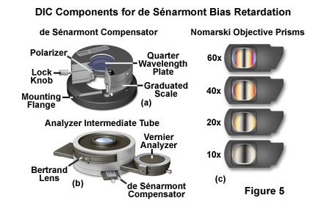
nomarski objective prisms.png (115.84 KiB) Viewed 4796 times
Zeiss Standard WL (somewhat fashion challenged) & Wild M8
Olympus E-P2 (Micro Four Thirds Camera)
Top
Quote
Post
LouiseScot
Posts: 1001
Joined: Tue Jul 07, 2020 1:51 pm
Location: Scotland

Re: DIC Question

#154 by LouiseScot » Sun Jul 11, 2021 8:45 am
75RR wrote: ↑
Sun Jul 11, 2021 5:55 am
.
re prism interference pattern
came across this, thought the prism interference patterns per objective type would be of interest
https://micro.magnet.fsu.edu/primer/tec ... ation.html
.
Thanks, though I think everyone is familiar with that reference My project is suspended until next month as I have other things I need to do.
Louise
A Nikon CF plan 20x; A Swift 380T; A DIY infinity corrected focus rail system with a 40x/0.65 Olympus Plan, a 10x/0.30 Amscope Plan Fluor, and a 20x/0.75 Nikon Plan Apo
Top
Quote
Post
75RR
Posts: 8197
Joined: Sun Oct 12, 2014 2:34 am
Location: Estepona, Spain

Re: DIC Question

#155 by 75RR » Sun Jul 11, 2021 8:51 am
LouiseScot wrote: ↑
Sun Jul 11, 2021 8:45 am
75RR wrote: ↑
Sun Jul 11, 2021 5:55 am
.
re prism interference pattern
came across this, thought the prism interference patterns per objective type would be of interest
https://micro.magnet.fsu.edu/primer/tec ... ation.html
.
Thanks, though I think everyone is familiar with that reference :) My project is suspended until next month as I have other things I need to do.
Louise
It just struck me that you all seem to be trying for an interference pattern more suitable to a 60x objective
Zeiss Standard WL (somewhat fashion challenged) & Wild M8
Olympus E-P2 (Micro Four Thirds Camera)
Top
Quote
Post
LouiseScot
Posts: 1001
Joined: Tue Jul 07, 2020 1:51 pm
Location: Scotland

Re: DIC Question

#156 by LouiseScot » Sun Jul 11, 2021 8:57 am
75RR wrote: ↑
Sun Jul 11, 2021 8:51 am
LouiseScot wrote: ↑
Sun Jul 11, 2021 8:45 am
75RR wrote: ↑
Sun Jul 11, 2021 5:55 am
.
re prism interference pattern
came across this, thought the prism interference patterns per objective type would be of interest
https://micro.magnet.fsu.edu/primer/tec ... ation.html
.
Thanks, though I think everyone is familiar with that reference My project is suspended until next month as I have other things I need to do.
Louise
It just struck me that you all seem to be trying for an interference pattern more suitable to a 60x objective
I've been using a 40x which isn't vastly different to a 60x, but the setup is different to a normal dic with the objective (polycarbonate) prism positioned a long way from the objective.
Louise
A Nikon CF plan 20x; A Swift 380T; A DIY infinity corrected focus rail system with a 40x/0.65 Olympus Plan, a 10x/0.30 Amscope Plan Fluor, and a 20x/0.75 Nikon Plan Apo
Top
Quote
Post
tpruuden
Posts: 59
Joined: Mon Feb 22, 2021 7:44 pm

Re: DIC Question

#157 by tpruuden » Wed Jul 14, 2021 6:03 pm
Palsun 3mm UV protected material seems to behave the same here - the fringes are shifted. Even then, from experiments I believe weak DIC effect can be created even with that material.
Top
Quote
Post
LouiseScot
Posts: 1001
Joined: Tue Jul 07, 2020 1:51 pm
Location: Scotland

Re: DIC Question

#158 by LouiseScot » Wed Jul 14, 2021 6:29 pm
tpruuden wrote: ↑
Wed Jul 14, 2021 6:03 pm
Palsun 3mm UV protected material seems to behave the same here - the fringes are shifted. Even then, from experiments I believe weak DIC effect can be created even with that material.
Hiya
Just to be clear... Are you saying there's a difference in optical properties (from a DIC point of view) between UV protected and unprotected polycarbonate?
Louise
A Nikon CF plan 20x; A Swift 380T; A DIY infinity corrected focus rail system with a 40x/0.65 Olympus Plan, a 10x/0.30 Amscope Plan Fluor, and a 20x/0.75 Nikon Plan Apo
Top
Quote
Post
tpruuden
Posts: 59
Joined: Mon Feb 22, 2021 7:44 pm

Re: DIC Question

#159 by tpruuden » Wed Jul 14, 2021 10:35 pm
LouiseScot wrote: ↑
Wed Jul 14, 2021 6:29 pm
Just to be clear... Are you saying there's a difference in optical properties (from a DIC point of view) between UV protected and unprotected polycarbonate?
Louise
I believe the UV protection acts as a waveplate (not sure, how much exactly the polarization is shifted). They say, that it is a co-extruded layer:
"The PALSUN range of products consists of flat polycarbonate sheets, which have a co-extruded UV protective layer on one side (PALSUN
UV2 products offer co-extruded UV protective layer on both sides)."
Top
Quote
Post
LouiseScot
Posts: 1001
Joined: Tue Jul 07, 2020 1:51 pm
Location: Scotland

Re: DIC Question

#160 by LouiseScot » Wed Jul 14, 2021 10:42 pm
tpruuden wrote: ↑
Wed Jul 14, 2021 10:35 pm
LouiseScot wrote: ↑
Wed Jul 14, 2021 6:29 pm
Just to be clear... Are you saying there's a difference in optical properties (from a DIC point of view) between UV protected and unprotected polycarbonate?
Louise
I believe the UV protection acts as a waveplate (not sure, how much exactly the polarization is shifted). They say, that it is a co-extruded layer:
"The PALSUN range of products consists of flat polycarbonate sheets, which have a co-extruded UV protective layer on one side (PALSUN
UV2 products offer co-extruded UV protective layer on both sides)."
Hi again
So does non-uv protected polycarbonate have no such waveplate properties? I can't seem to find any suppliers of non uv protected polycarbonate sheet here in the UK. Presumably it's all only made for glazing purposes.
Louise
A Nikon CF plan 20x; A Swift 380T; A DIY infinity corrected focus rail system with a 40x/0.65 Olympus Plan, a 10x/0.30 Amscope Plan Fluor, and a 20x/0.75 Nikon Plan Apo
Top
Quote
Post
MichaelG.
Posts: 3483
Joined: Mon Apr 10, 2017 8:24 am
Location: NorthWest England

Re: DIC Question

#161 by MichaelG. » Thu Jul 15, 2021 6:28 am
LouiseScot wrote: ↑
Wed Jul 14, 2021 10:42 pm
I can't seem to find any suppliers of non uv protected polycarbonate sheet here in the UK. Presumably it's all only made for glazing purposes.
.
Also used for machine safety guards, riot shields, and the visors on motorcycle helmets
… but it may all be UV protected : I don’t know.
MichaelG.
Too many 'projects'
Top
Quote
Post
75RR
Posts: 8197
Joined: Sun Oct 12, 2014 2:34 am
Location: Estepona, Spain

Re: DIC Question

#162 by 75RR » Thu Jul 15, 2021 7:34 am
This is what Wiki says:
"Standard polycarbonate resins are not suitable for long term exposure to UV radiation. To overcome this, the primary resin can have UV stabilisers added. These grades are sold as UV stabilized polycarbonate to injection moulding and extrusion companies. Other applications, including polycarbonate sheets, may have the anti-UV layer added as a special coating or a coextrusion for enhanced weathering resistance."
https://en.wikipedia.org/wiki/Polycarbonate
Zeiss Standard WL (somewhat fashion challenged) & Wild M8
Olympus E-P2 (Micro Four Thirds Camera)
Top
Quote
Post
LouiseScot
Posts: 1001
Joined: Tue Jul 07, 2020 1:51 pm
Location: Scotland

Re: DIC Question

#163 by LouiseScot » Thu Jul 15, 2021 8:14 am
MichaelG. wrote: ↑
Thu Jul 15, 2021 6:28 am
LouiseScot wrote: ↑
Wed Jul 14, 2021 10:42 pm
I can't seem to find any suppliers of non uv protected polycarbonate sheet here in the UK. Presumably it's all only made for glazing purposes.
.
Also used for machine safety guards, riot shields, and the visors on motorcycle helmets
… but it may all be UV protected : I don’t know.
MichaelG.
As far as I can make out, all polycarbonate is UV stabilised. Most polycarbonate also has one or two UV blocking coatings. Palram make a version called 'Paltuf' which doesn't have any UV coatings but I can't find anyone that sells it in the sort of sizes/quantities I'd want e.g. a single A4 sheet... I'll keep looking.
Louise
A Nikon CF plan 20x; A Swift 380T; A DIY infinity corrected focus rail system with a 40x/0.65 Olympus Plan, a 10x/0.30 Amscope Plan Fluor, and a 20x/0.75 Nikon Plan Apo
Top
Quote
Post
LouiseScot
Posts: 1001
Joined: Tue Jul 07, 2020 1:51 pm
Location: Scotland

Re: DIC Question

#164 by LouiseScot » Thu Jul 15, 2021 9:52 am
I think this UV coating business is all a red herring! Neither Rathi, Biss or Sanderson himself specify prisms should be constructed from non-standard polycarbonate sheet. Biss mentioned 'Lexan' from McMaster-Carr though the latter only say their polycarbonate is 'comparable' to Lexan, Makrolon etc.
The UV coating probably only affects wavelengths shorter than the visible violet so shouldn't affect the general visible spectrum. So I'll continue with the standard Palsun for now. I'm busy with other things at the moment but I expect to resume DIC investigations mid-August.
Louise
A Nikon CF plan 20x; A Swift 380T; A DIY infinity corrected focus rail system with a 40x/0.65 Olympus Plan, a 10x/0.30 Amscope Plan Fluor, and a 20x/0.75 Nikon Plan Apo
Top
Quote
Post
hans
Posts: 968
Joined: Thu May 28, 2020 11:10 pm
Location: Southern California

Re: DIC Question

#165 by hans » Thu Jul 15, 2021 4:29 pm
75RR wrote: ↑
Thu Jul 15, 2021 7:34 am
This is what Wiki says: ...
McMaster-Carr has three different types advertising resistance to: [impact], [impact, UV], [impact, UV, scratch]. These probably correspond to the three cases mentioned on Wikipedia: UV stabilizer added to the bulk material; additional UV-resistant coating (maybe the 15-50 um thickness Hobbyst46 mentioned in #138); coextrusion of some thicker surface layer that additionally gives scratch resistance.
tpruuden wrote: ↑
Wed Jul 14, 2021 10:35 pm
I believe the UV protection acts as a waveplate (not sure, how much exactly the polarization is shifted). They say, that it is a co-extruded layer...
I only bought the basic type but there was already very strong birefringence in the 1/8" material, 30X greater than the birefringence in the 7/32" material (#137), and enough to bias the central dark band way off the edge of the bar with reasonable bending. That gives some evidence that strong birefringence can come from the base material itself (depending on manufacturing process maybe?) without any extra coatings. Also, polycarbonate is specifically chosen for its strong photoelasticity, does not seem surprising that it would also be prone to strong inherent birefringence depending on manufacturing process. (Either due to internal stress, molecular alignment without stress, or both -- still not sure I understand that relationship mentioned in #135.)
LouiseScot wrote: ↑
Thu Jul 15, 2021 9:52 am
I think this UV coating business is all a red herring!
Seems likely, but would be interesting to compare. I already added UV/scratch-resistant sheets to my cart during the earlier discussion but have not needed to order anything else from McMaster yet.
Top
Quote
Post
LouiseScot
Posts: 1001
Joined: Tue Jul 07, 2020 1:51 pm
Location: Scotland

Re: DIC Question

#166 by LouiseScot » Thu Jul 15, 2021 4:45 pm
hans wrote: ↑
Thu Jul 15, 2021 4:29 pm
75RR wrote: ↑
Thu Jul 15, 2021 7:34 am
This is what Wiki says: ...
McMaster-Carr has three different types advertising resistance to: [impact], [impact, UV], [impact, UV, scratch]. These probably correspond to the three cases mentioned on Wikipedia: UV stabilizer added to the bulk material; additional UV-resistant coating (maybe the 15-50 um thickness Hobbyst46 mentioned in #138); coextrusion of some thicker surface layer that additionally gives scratch resistance.
tpruuden wrote: ↑
Wed Jul 14, 2021 10:35 pm
I believe the UV protection acts as a waveplate (not sure, how much exactly the polarization is shifted). They say, that it is a co-extruded layer...
I only bought the basic type but there was already very strong birefringence in the 1/8" material, 30X greater than the birefringence in the 7/32" material (#137), and enough to bias the central dark band way off the edge of the bar with reasonable bending. That gives some evidence that strong birefringence can come from the base material itself (depending on manufacturing process maybe?) without any extra coatings. Also, polycarbonate is specifically chosen for its strong photoelasticity, does not seem surprising that it would also be prone to strong inherent birefringence depending on manufacturing process. (Either due to internal stress, molecular alignment without stress, or both -- still not sure I understand that relationship mentioned in #135.)
LouiseScot wrote: ↑
Thu Jul 15, 2021 9:52 am
I think this UV coating business is all a red herring!
Seems likely, but would be interesting to compare. I already added UV/scratch-resistant sheets to my cart during the earlier discussion but have not needed to order anything else from McMaster yet.
I just feel that one or other of the Sanderson prism related authors would have mentioned something re the different types/coatings if it was relevant to either Schlieren/beamsplitting or DIC. Still, it would be interesting to have a comparison.
Louise
A Nikon CF plan 20x; A Swift 380T; A DIY infinity corrected focus rail system with a 40x/0.65 Olympus Plan, a 10x/0.30 Amscope Plan Fluor, and a 20x/0.75 Nikon Plan Apo
Top
Quote
Post
hans
Posts: 968
Joined: Thu May 28, 2020 11:10 pm
Location: Southern California

Re: DIC Question

#167 by hans » Thu Jul 15, 2021 6:32 pm
My guess is that UV protection is not the main cause of birefringence with no bending moment applied. But not sure the inherent birefringence, whatever the cause, is a red herring. Many photos posted earlier show quite strong inherent birefringence, maybe not as much as my 1/8" plain TUFFAK bar (which I did not take a photo of) but much stronger than the 7/32" bar:
- by you in #47 and #88
- by jmp in #64, #75, and #84
In all those cases it looks like the inherent birefringence is strong enough that if the bending moment is reduced to get a gradient (fringe density) more like real DIC prisms (as 75RR has suggested) then the central dark band will be biased all the way off the edge of the beam.
Top
Quote
Post
LouiseScot
Posts: 1001
Joined: Tue Jul 07, 2020 1:51 pm
Location: Scotland

Re: DIC Question

#168 by LouiseScot » Thu Jul 15, 2021 6:47 pm
hans wrote: ↑
Thu Jul 15, 2021 6:32 pm
My guess is that UV protection is not the main cause of birefringence with no bending moment applied. But not sure the inherent birefringence, whatever the cause, is a red herring. Many photos posted earlier show quite strong inherent birefringence, maybe not as much as my 1/8" plain TUFFAK bar (which I did not take a photo of) but much stronger than the 7/32" bar:
- by you in #47 and #88
- by jmp in #64, #75, and #84
In all those cases it looks like the inherent birefringence is strong enough that if the bending moment is reduced to get a gradient (fringe density) more like real DIC prisms (as 75RR has suggested) then the central dark band will be biased all the way off the edge of the beam.
Hiya
Both of the ones of mine you refer to are images taken with the prism under stress i.e. with a bending moment. Same with jmp's, I think. But there is always waveplate behaviour but with little inherent birefringence - just a backround hue which varies across a plate. I don't know what causes the waveplate properties or how that varies between different makes or types. I presume it's just a property of all
polycarbonate
Louise
A Nikon CF plan 20x; A Swift 380T; A DIY infinity corrected focus rail system with a 40x/0.65 Olympus Plan, a 10x/0.30 Amscope Plan Fluor, and a 20x/0.75 Nikon Plan Apo
Top
Quote
Post
hans
Posts: 968
Joined: Thu May 28, 2020 11:10 pm
Location: Southern California

Re: DIC Question

#169 by hans » Thu Jul 15, 2021 8:15 pm
LouiseScot wrote: ↑
Thu Jul 15, 2021 6:47 pm
Both of the ones of mine you refer to are images taken with the prism under stress i.e. with a bending moment. Same with jmp's...
Yes, quite a large bending moment judging from the fringe density. I was referring to the bias/shift of the fringe pattern away from the center of the beam, which as far as I understand is a result of the inherent birefringence combining with the stress-induced birefringence from the applied bending moment. If the inherent birefringence is so strong that the center of the fringe pattern only becomes visible with extreme (much higher fringe density than normal DIC) bending moment applied, seems like that would be a problem?
LouiseScot wrote: ↑
Thu Jul 15, 2021 9:52 am
Neither Rathi, Biss or Sanderson himself specify prisms should be constructed from non-standard polycarbonate sheet.
LouiseScot wrote: ↑
Thu Jul 15, 2021 6:47 pm
I don't know what causes the waveplate properties or how that varies between different makes or types. I presume it's just a property of all polycarbonate
The difference between 1/8" and 7/32" plain TUFFAK is huge. The original Sanderson paper says 6.35 mm thickness and I don't remember seeing any indication that the later authors tried thinner, so if they all bought ~1/4" from McMaster-Carr maybe they just never encountered material with strong inherent birefringence?
Top
Quote
Post
LouiseScot
Posts: 1001
Joined: Tue Jul 07, 2020 1:51 pm
Location: Scotland

Re: DIC Question

#170 by LouiseScot » Thu Jul 15, 2021 9:09 pm
hans wrote: ↑
Thu Jul 15, 2021 8:15 pm
LouiseScot wrote: ↑
Thu Jul 15, 2021 6:47 pm
Both of the ones of mine you refer to are images taken with the prism under stress i.e. with a bending moment. Same with jmp's...
Yes, quite a large bending moment judging from the fringe density. I was referring to the bias/shift of the fringe pattern away from the center of the beam, which as far as I understand is a result of the inherent birefringence combining with the stress-induced birefringence from the applied bending moment. If the inherent birefringence is so strong that the center of the fringe pattern only becomes visible with extreme (much higher fringe density than normal DIC) bending moment applied, seems like that would be a problem?
LouiseScot wrote: ↑
Thu Jul 15, 2021 9:52 am
Neither Rathi, Biss or Sanderson himself specify prisms should be constructed from non-standard polycarbonate sheet.
LouiseScot wrote: ↑
Thu Jul 15, 2021 6:47 pm
I don't know what causes the waveplate properties or how that varies between different makes or types. I presume it's just a property of all polycarbonate
The difference between 1/8" and 7/32" plain TUFFAK is huge. The original Sanderson paper says 6.35 mm thickness and I don't remember seeing any indication that the later authors tried thinner, so if they all bought ~1/4" from McMaster-Carr maybe they just never encountered material with strong inherent birefringence?
Oh ok - it wasn't clear to me that you were referring to the shift of the fringe pattern. In 'Flow visualization using a Sanderson prism' Schulz et al (2019) refer to this shift that I've observed as well "During initial testing, the polycarbonate material used revealed that when different sets of prisms were placed in position and stressed, the fringes that formed, formed on opposite sides. Some developed concentrated
fringes at the top of the prism, whereas others developed them in the bottom part of the prism as shown in Fig. 4 under same loading conditions"
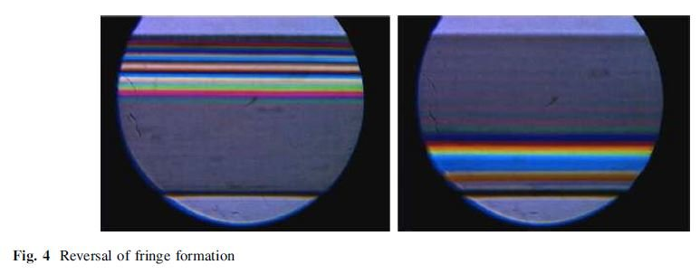
Schulz2019.JPG (28.18 KiB) Viewed 4580 times
Maybe it's this that causes the shift from the center?
Rathi used 3/32" polycarbonate in their prism. The nearest I could get was 3mm. So maybe any intrinsic birefringence not apparent, as you suggest.
Louise
A Nikon CF plan 20x; A Swift 380T; A DIY infinity corrected focus rail system with a 40x/0.65 Olympus Plan, a 10x/0.30 Amscope Plan Fluor, and a 20x/0.75 Nikon Plan Apo
Top
Quote
Post
hans
Posts: 968
Joined: Thu May 28, 2020 11:10 pm
Location: Southern California

Re: DIC Question

#171 by hans » Fri Jul 16, 2021 5:11 am
Regarding whether the fringe pattern is shifted toward the compressive or tensile side of the beam... should depend on whether the optic axis of the inherent birefringence is perpendicular or parallel to the beam axis, I think. You are cutting beams from sheets like Schulz and also saw both cases, right? Were you keeping track of what orientation you were cutting the beams relative to the original sheet? Perhaps Schulz were not and that explains the variability. Biss and Rathi both used pre-cut bars, seems likely those would have been cut with consistent orientation relative to the original sheet.
I was thinking 1/4" for Rathi, clearly you read the papers more carefully. The bias in Rathi fig 3(b) for the 3/32" bar from McMaster looks like maybe a little less then half my 7/32" bar from McMaster, so plausible it could have similar inherent birefringence with the thickness difference accounting for the greater bias in mine. The odd thing is both the 1/16" and 1/8" inch I have from McMaster show very strong inherent birefringence, impossible to get a fringe pattern looking like Rathi fig 3(b) from those as far as I can see. Guess I might as well order a 3/23" bar as well, only $1.72...
Looking at the papers again I see Biss fig 4 shows relatively large bias while fig 9 does not but I don't see that mentioned anywhere.
Top
Quote
Post
LouiseScot
Posts: 1001
Joined: Tue Jul 07, 2020 1:51 pm
Location: Scotland

Re: DIC Question

#172 by LouiseScot » Fri Jul 16, 2021 8:56 am
hans wrote: ↑
Fri Jul 16, 2021 5:11 am
Regarding whether the fringe pattern is shifted toward the compressive or tensile side of the beam... should depend on whether the optic axis of the inherent birefringence is perpendicular or parallel to the beam axis, I think. You are cutting beams from sheets like Schulz and also saw both cases, right? Were you keeping track of what orientation you were cutting the beams relative to the original sheet? Perhaps Schulz were not and that explains the variability. Biss and Rathi both used pre-cut bars, seems likely those would have been cut with consistent orientation relative to the original sheet.
I was thinking 1/4" for Rathi, clearly you read the papers more carefully. The bias in Rathi fig 3(b) for the 3/32" bar from McMaster looks like maybe a little less then half my 7/32" bar from McMaster, so plausible it could have similar inherent birefringence with the thickness difference accounting for the greater bias in mine. The odd thing is both the 1/16" and 1/8" inch I have from McMaster show very strong inherent birefringence, impossible to get a fringe pattern looking like Rathi fig 3(b) from those as far as I can see. Guess I might as well order a 3/23" bar as well, only $1.72...
Looking at the papers again I see Biss fig 4 shows relatively large bias while fig 9 does not but I don't see that mentioned anywhere.
My A5 sized sheets were bought precut. I cut the prisms from them. I originally did that without regard to orientation but then soon realised it made a difference! The solid precut bars aren't available here. It's a pity Rathi and others weren't more specific about the polycarbonate. It seems that it's possible to get 'food grade' polycarbonate without UV additives but couldn't find any sources here in the UK.
Louise
A Nikon CF plan 20x; A Swift 380T; A DIY infinity corrected focus rail system with a 40x/0.65 Olympus Plan, a 10x/0.30 Amscope Plan Fluor, and a 20x/0.75 Nikon Plan Apo
Top
Quote
Post
MichaelG.
Posts: 3483
Joined: Mon Apr 10, 2017 8:24 am
Location: NorthWest England

Re: DIC Question

#173 by MichaelG. » Fri Jul 16, 2021 12:05 pm
LouiseScot wrote: ↑
Fri Jul 16, 2021 8:56 am
It seems that it's possible to get 'food grade' polycarbonate without UV additives but couldn't find any sources here in the UK.
.
These people might be able to advise:
https://www.sndsolutions.co.uk/polycarbonate-vs-petg/
It is possible to buy Food Grade Polycarbonate, however this is quite a rare material. S&D are one of the only companies in the UK to have stocked 3mm Food Grade Polycarbonate for chute fabrications.
MichaelG.
.
Edit: __ see also : http://www.vacuumformers.co.uk/moulding-materials.aspx
Too many 'projects'
Top
Quote
Post
LouiseScot
Posts: 1001
Joined: Tue Jul 07, 2020 1:51 pm
Location: Scotland

Re: DIC Question

#174 by LouiseScot » Fri Jul 16, 2021 12:33 pm
MichaelG. wrote: ↑
Fri Jul 16, 2021 12:05 pm
LouiseScot wrote: ↑
Fri Jul 16, 2021 8:56 am
It seems that it's possible to get 'food grade' polycarbonate without UV additives but couldn't find any sources here in the UK.
.
These people might be able to advise:
https://www.sndsolutions.co.uk/polycarbonate-vs-petg/
It is possible to buy Food Grade Polycarbonate, however this is quite a rare material. S&D are one of the only companies in the UK to have stocked 3mm Food Grade Polycarbonate for chute fabrications.
MichaelG.
.
Edit: __ see also : http://www.vacuumformers.co.uk/moulding-materials.aspx
Thanks Michael, but they are 'fabricators' rather than sellers of sheet material. I'll only bother buying some if it's both cheap and easy to get hold of, and only just to compare with 'standard' sheet. As it's a polymer there could be variation of optical properties between manufacturers so I might try and get another brand just to see if there's any obvious difference.
Louise
ps I ordered a 12"x6" sheet of Lexan so will see how that behaves, when I can
A Nikon CF plan 20x; A Swift 380T; A DIY infinity corrected focus rail system with a 40x/0.65 Olympus Plan, a 10x/0.30 Amscope Plan Fluor, and a 20x/0.75 Nikon Plan Apo
Top
Quote
Post
hans
Posts: 968
Joined: Thu May 28, 2020 11:10 pm
Location: Southern California

Re: DIC Question

#175 by hans » Fri Jul 16, 2021 3:27 pm
viktor j nilsson wrote: ↑
Sun Jun 06, 2021 10:02 pm
One thing that I started thinking about is if the Sanderson prisms are stable over time, or if the shearing characteristics will change over time due to fatigue. Have you read anything about this?
Just noticed this is mentioned briefly in section 2 of:
Biss et al. - Differential schlieren-interferometry with a simple adjustable Wollaston-like prism
We further found that, due to the creep dependency of the photoelastic constants, one should avoid leaving the Sanderson prism loaded for extended periods of time, i.e., hours [18].
Top
Quote
Post
LouiseScot
Posts: 1001
Joined: Tue Jul 07, 2020 1:51 pm
Location: Scotland

Re: DIC Question

#176 by LouiseScot » Fri Jul 16, 2021 3:36 pm
hans wrote: ↑
Fri Jul 16, 2021 3:27 pm
viktor j nilsson wrote: ↑
Sun Jun 06, 2021 10:02 pm
One thing that I started thinking about is if the Sanderson prisms are stable over time, or if the shearing characteristics will change over time due to fatigue. Have you read anything about this?
Just noticed this is mentioned briefly in section 2 of:
Biss et al. - Differential schlieren-interferometry with a simple adjustable Wollaston-like prism
We further found that, due to the creep dependency of the photoelastic constants, one should avoid leaving the Sanderson prism loaded for extended periods of time, i.e., hours [18].
Yes, I read that previously but in that case they were talking about much larger beam deflections. With Rathi and DIC it's only 10's of microrads. In any case it's not a problem in practice, I don't think.
Louise
A Nikon CF plan 20x; A Swift 380T; A DIY infinity corrected focus rail system with a 40x/0.65 Olympus Plan, a 10x/0.30 Amscope Plan Fluor, and a 20x/0.75 Nikon Plan Apo
Top
Quote
Post
hans
Posts: 968
Joined: Thu May 28, 2020 11:10 pm
Location: Southern California

Re: DIC Question

#177 by hans » Sat Jul 17, 2021 12:27 am
Not ideal, but maybe useful as a workaround if low-birefringence material is hard to find -- stacking two beams with optic axes of the inherent birefringence 90 degrees apart should cause inherent (but not stress-induced) birefringence to cancel. Seems to work reasonably well in a crude test, first photo is a single beam showing high bending moment necessary to get the central dark band visible, second photo is the stacked beams with lower bending moment:
ATTACHMENTS

P1080182.jpg (92.7 KiB) Viewed 4481 times
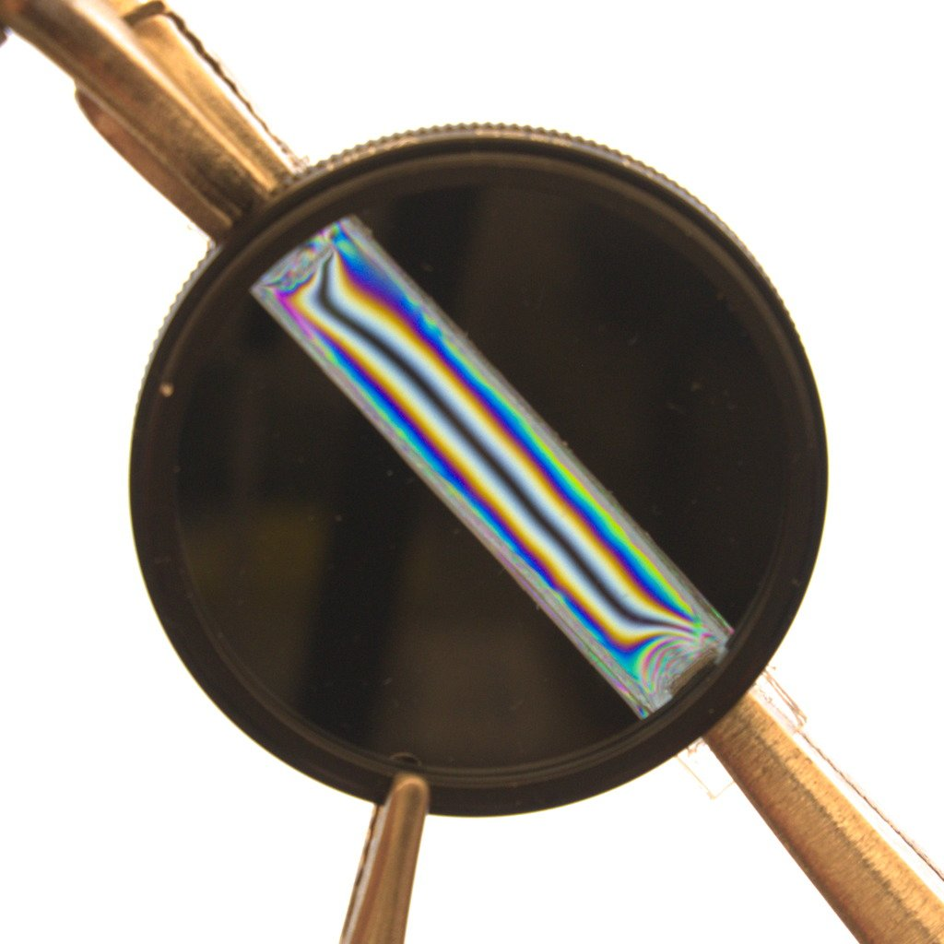
P1080181.jpg (93.97 KiB) Viewed 4481 times
Top
Quote
Post
LouiseScot
Posts: 1001
Joined: Tue Jul 07, 2020 1:51 pm
Location: Scotland

Re: DIC Question

#178 by LouiseScot » Sat Jul 17, 2021 8:45 am
hans wrote: ↑
Sat Jul 17, 2021 12:27 am
Not ideal, but maybe useful as a workaround if low-birefringence material is hard to find -- stacking two beams with optic axes of the inherent birefringence 90 degrees apart should cause inherent (but not stress-induced) birefringence to cancel. Seems to work reasonably well in a crude test, first photo is a single beam showing high bending moment necessary to get the central dark band visible, second photo is the stacked beams with lower bending moment:
That looks like magic! I can't see how you are doing the bending?
Louise
A Nikon CF plan 20x; A Swift 380T; A DIY infinity corrected focus rail system with a 40x/0.65 Olympus Plan, a 10x/0.30 Amscope Plan Fluor, and a 20x/0.75 Nikon Plan Apo
Top
Quote
Post
hans
Posts: 968
Joined: Thu May 28, 2020 11:10 pm
Location: Southern California

Re: DIC Question

#179 by hans » Sat Jul 17, 2021 11:16 pm
I haven't tried to make any sort of fixture yet, still holding the beam between my left and right hands with locking pliers and bending manually as in the previous photo with the larger 1/4" x 1" x 8" bar. The shiny things in the upper left and lower right corners are the jaws grabbing the ends of the beam. Scale may be confusing, these beams are small, roughly 10 x 50 mm cut in perpendicular directions from 1/16" TUFFAK sheet with strong inherent birefringence. The 1/16" sheet is convenient because it can be cut with heavy-duty scissors. Photos are with the camera in fully manual mode on a tripod with 10 second timer so I press the shutter release then quickly position the beam just behind the polarizing filter and fiddle with bending/twisting/shearing to get a nice fringe pattern that looks like pure bending. Took a few attempts to get decent photos.
Top
Quote
Post
LouiseScot
Posts: 1001
Joined: Tue Jul 07, 2020 1:51 pm
Location: Scotland

Re: DIC Question

#180 by LouiseScot » Sat Jul 17, 2021 11:18 pm
hans wrote: ↑
Sat Jul 17, 2021 11:16 pm
I haven't tried to make any sort of fixture yet, still holding the beam between my left and right hands with locking pliers and bending manually as in the previous photo with the larger 1/4" x 1" x 8" bar. The shiny things in the upper left and lower right corners are the jaws grabbing the ends of the beam. Scale may be confusing, these beams are small, roughly 10 x 50 mm cut in perpendicular directions from 1/16" TUFFAK sheet with strong inherent birefringence. The 1/16" sheet is convenient because it can be cut with heavy-duty scissors. Photos are with the camera in fully manual mode on a tripod with 10 second timer so I press the shutter release then quickly position the beam just behind the polarizing filter and fiddle with bending/twisting/shearing to get a nice fringe pattern that looks like pure bending. Took a few attempts to get decent photos.
Oh ok
Louise
A Nikon CF plan 20x; A Swift 380T; A DIY infinity corrected focus rail system with a 40x/0.65 Olympus Plan, a 10x/0.30 Amscope Plan Fluor, and a 20x/0.75 Nikon Plan Apo
Quote
Post

Re: DIC Question

#181 by microb » Tue Jul 20, 2021 7:42 pm
Breaking Taps had a video showing the fringing on a molded acrylic lens, which I think was actually polypropylene:
https://youtu.be/JNXgHbBIRYQ?t=1016
[I know I had added the link, but it disappeared. So added it.]
Last edited by microb on Wed Jul 21, 2021 5:53 am, edited 1 time in total.
Top
Quote
Post
hans
Posts: 968
Joined: Thu May 28, 2020 11:10 pm
Location: Southern California

Re: DIC Question

#182 by hans » Wed Jul 21, 2021 3:40 am
Got 3/32 bar from McMaster per Rathi, unsurprisingly shows similar strong inherent birefringence as the 1/16 and 1/8 I already had, didn't bother taking a photo. So why does Rathi fig. 3(b) shows so little shift of the fringe pattern? McMaster changed suppliers, or supplier changed manufacturing method? One confusing thing about fig. 3(b) is that going by the 10 mm scale bar the diameter of the circular stop is slightly more than 20 mm, but the widest bar shown in fig. 2 is 20 mm? Is your interpretation of 3(b) that it is showing close to the full width of the bar? McMaster currently does not sell bars narrower than 1" so maybe the bar in 3(b) is actually 1" and the 20 mm in 2(a) was just some preliminary sketch they didn't actually follow? (Seems like a lot of trouble for no obvious benefit to buy 1" bars and cut them down to 20 mm...)
microb wrote: ↑
Tue Jul 20, 2021 7:42 pm
Breaking Taps had a video showing the fringing on a molded acrylic lens, which I think was actually polypropylene:
Link is missing...
Top
Quote
Post
microb
Posts: 722
Joined: Wed Mar 27, 2019 6:39 am

Re: DIC Question

#183 by microb » Wed Jul 21, 2021 5:56 am
hans wrote: ↑
Wed Jul 21, 2021 3:40 am
Link is missing...
I know I had it there, so I edited it above. What I thought was interesting is that he molded the lens and where the plastic was pushed in there was more stress. So he built into the plastic a level of stress. I wonder if that could be done but I guess the rig with the screws is adjustable and the manufacture with a mold would probably be less predictable.
Top
Quote
Post
LouiseScot
Posts: 1001
Joined: Tue Jul 07, 2020 1:51 pm
Location: Scotland

Re: DIC Question

#184 by LouiseScot » Wed Jul 21, 2021 10:11 am
hans wrote: ↑
Wed Jul 21, 2021 3:40 am
Got 3/32 bar from McMaster per Rathi, unsurprisingly shows similar strong inherent birefringence as the 1/16 and 1/8 I already had, didn't bother taking a photo. So why does Rathi fig. 3(b) shows so little shift of the fringe pattern? McMaster changed suppliers, or supplier changed manufacturing method? One confusing thing about fig. 3(b) is that going by the 10 mm scale bar the diameter of the circular stop is slightly more than 20 mm, but the widest bar shown in fig. 2 is 20 mm? Is your interpretation of 3(b) that it is showing close to the full width of the bar? McMaster currently does not sell bars narrower than 1" so maybe the bar in 3(b) is actually 1" and the 20 mm in 2(a) was just some preliminary sketch they didn't actually follow? (Seems like a lot of trouble for no obvious benefit to buy 1" bars and cut them down to 20 mm...)
microb wrote: ↑
Tue Jul 20, 2021 7:42 pm
Breaking Taps had a video showing the fringing on a molded acrylic lens, which I think was actually polypropylene:
Link is missing...
The Rathi paper isn't great for an apparently peer-reviewed publication. It would appear she was just an undergraduate student at the time - https://you.stonybrook.edu/sonikarathi/ ... nd-grants/
I suspect things in the paper have been somewhat idealised (as students often do... ) The paper has never been cited by anyone else. I'll still have a go at getting it working next month. If I don't get anywhere by the end of August then I'll abandon it.
Louise
A Nikon CF plan 20x; A Swift 380T; A DIY infinity corrected focus rail system with a 40x/0.65 Olympus Plan, a 10x/0.30 Amscope Plan Fluor, and a 20x/0.75 Nikon Plan Apo
Top
Quote
Post
Hobbyst46
Posts: 3905
Joined: Mon Aug 21, 2017 9:02 pm

Re: DIC Question

#185 by Hobbyst46 » Wed Jul 21, 2021 4:43 pm
LouiseScot wrote: ↑
Wed Jul 21, 2021 10:11 am
The paper has never been cited by anyone else.
Agreed.
However, the likely audience of her paper is hobby microscopists rather than researchers, and hobby microscopists apparently rarely publish papers... Her supervisor and/or corresponding author would know more about it.
I am still crossing fingers to see a true DIY-DIC come to life !
Zeiss Standard GFL+Canon EOS-M10, Olympus VMZ stereo
Top
Quote
Post
LouiseScot
Posts: 1001
Joined: Tue Jul 07, 2020 1:51 pm
Location: Scotland

Re: DIC Question

#186 by LouiseScot » Wed Jul 21, 2021 5:00 pm
Hobbyst46 wrote: ↑
Wed Jul 21, 2021 4:43 pm
LouiseScot wrote: ↑
Wed Jul 21, 2021 10:11 am
The paper has never been cited by anyone else.
Agreed.
However, the likely audience of her paper is hobby microscopists rather than researchers, and hobby microscopists apparently rarely publish papers... Her supervisor and/or corresponding author would know more about it.
I am still crossing fingers to see a true DIY-DIC come to life !
Yeah, but as you see from the above link she did it as a freshman undergraduate summer project, not even a final year honours-type project. It won't have been done especially for amateurs as the Applied Optics journal isn't easy to access. I can get to it via my Uni (I'm a registered student). Her undergrad supervisor probably didn't pay much attention to it... She's now a 'biomedical engineer' rather than any kind of microscopist.
Louise
A Nikon CF plan 20x; A Swift 380T; A DIY infinity corrected focus rail system with a 40x/0.65 Olympus Plan, a 10x/0.30 Amscope Plan Fluor, and a 20x/0.75 Nikon Plan Apo
Top
Quote
Post
Scarodactyl
Posts: 2040
Joined: Sat Mar 03, 2018 9:09 pm

Re: DIC Question

#187 by Scarodactyl » Wed Jul 21, 2021 6:22 pm
Saul seems to have gotten it working, though he only posted the two pictures.
Top
Quote
Post
BramHuntingNematodes
Posts: 1415
Joined: Tue Jan 21, 2020 1:29 am
Location: Georgia, USA

Re: DIC Question

#188 by BramHuntingNematodes » Wed Jul 21, 2021 6:28 pm
I guess now saul is too busy looking at everything in halo-free high contrast
1942 Bausch and Lomb Series T Dynoptic, Custom Illumination
Top
Quote
Post
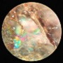Dmi3n
Posts: 120
Joined: Thu Feb 06, 2020 4:14 pm
Location: Russia, Kaliningrad

Re: DIC Question

#189 by Dmi3n » Wed Jul 21, 2021 8:09 pm
Very interesting subject, will definetely give it a try. I have some experience with metalworking, although at the monent I don't have access to milling machines and lathes. Also I know some people who make scale models of buildings and they must have lots if different polycarbonate sheets. I've read the paper and one thing really bothers me - the relay lens to move back focal plane away from the objective. I think that it is better to find some objective with lower magnification with back focal plane far enough to place the prism and polish the technique with it, and then move to all those fancy lens.
I have only one question, how to find the back focal plane? I have two sets of identical Carl Zeiss Jena Planachromat objectives, RMS/160, one set is for phase contrast and one for polarisation (strain-less glass). Also I have set of infininty-corrected planachromats and one planapochromat, for use with reflected light illuminator (Auflichtkondensor). And a phase telescope (aka centering microscope), if it will help.
Does the back focal plane of infinity-corrected objective lie before or after tube lens?
I have no idea about some optics stuff, I am closer to mechanics as I've studied jewelry and machining in college.
Gear list:
CZJ NfPk and Polmi A w/ 45mm apo objectives, Phv, Epi Pol, trinocular
CZJ Epityp-2 Pol w/ D32 microhardness tester
Gamma Hungary 3D-condenser
LOMO UV objectives set and КУФ-3 quartz condenser
Nikon D5200 DSLR
AO 820 and LOMO МС-2 microtomes
Top
Quote
Post
Saul
Posts: 182
Joined: Fri Jul 27, 2018 5:30 pm
Location: IL USA
Contact:

Re: DIC Question

#190 by Saul » Wed Jul 21, 2021 9:14 pm
BramHuntingNematodes wrote: ↑
Wed Jul 21, 2021 6:28 pm
I guess now saul is too busy looking at everything in halo-free high contrast
Ha ha , partially true , I made a little bit different setup, have to make normal photos of it and post it...
Top
Contact Saul
Quote
Post
hans
Posts: 968
Joined: Thu May 28, 2020 11:10 pm
Location: Southern California

Re: DIC Question

#191 by hans » Wed Jul 21, 2021 9:14 pm
I don't any reason to doubt the final results in Rathi, most likely just a change in the 3/32" material McMaster sells (as mentioned earlier the 7/32" I have appears roughly consistent with fig. 3(b)) and maybe some of the implementation details are incorrect due to hurried (summer project) paper-writing.
Scarodactyl wrote: ↑
Wed Jul 21, 2021 6:22 pm
Saul seems to have gotten it working, though he only posted the two pictures.
Are there any details other than these two threads?
https://www.microbehunter.com/microscop ... =6&t=11378
https://www.photomacrography.net/forum/ ... p?p=269570
I wasn't sure if that was actually DIC. I didn't see Saul claim it was, and this post seems to indicate that the splitting plane of the upper beam is not conjugate with the objective BFP?
Top
Quote
Post
viktor j nilsson
Posts: 659
Joined: Thu Aug 23, 2018 10:12 pm
Location: Lund, Sweden

Re: DIC Question

#192 by viktor j nilsson » Wed Jul 21, 2021 10:27 pm
Dmi3n wrote: ↑
Wed Jul 21, 2021 8:09 pm
I have only one question, how to find the back focal plane?
https://www.researchgate.net/post/Is_th ... ctive_lens
The method suggested by Paolo Pozzi works really well: shine a laser pointer through the objective and measure the size of the projected image at various distances.
Top
Quote
Post
Dmi3n
Posts: 120
Joined: Thu Feb 06, 2020 4:14 pm
Location: Russia, Kaliningrad

Re: DIC Question

#193 by Dmi3n » Wed Jul 21, 2021 11:02 pm
viktor j nilsson wrote: ↑
Wed Jul 21, 2021 10:27 pm
Dmi3n wrote: ↑
Wed Jul 21, 2021 8:09 pm
I have only one question, how to find the back focal plane?
https://www.researchgate.net/post/Is_th ... ctive_lens
The method suggested by Paolo Pozzi works really well: shine a laser pointer through the objective and measure the size of the projected image at various distances.
Thanks a lot, just what I needed. Time to make optical bench from Lego parts and laser pointer
By the way, how exactly the prism must be located in relation to back focal plane? The plane must "cut" it in two (for example for 6 mm thick prism the plane will be exactly 3 mm from the surface), or as long as the plane is just inside the prism everything will work?
Gear list:
CZJ NfPk and Polmi A w/ 45mm apo objectives, Phv, Epi Pol, trinocular
CZJ Epityp-2 Pol w/ D32 microhardness tester
Gamma Hungary 3D-condenser
LOMO UV objectives set and КУФ-3 quartz condenser
Nikon D5200 DSLR
AO 820 and LOMO МС-2 microtomes
Top
Quote
Post
LouiseScot
Posts: 1001
Joined: Tue Jul 07, 2020 1:51 pm
Location: Scotland

Re: DIC Question

#194 by LouiseScot » Thu Jul 22, 2021 12:39 am
hans wrote: ↑
Wed Jul 21, 2021 9:14 pm
I don't any reason to doubt the final results in Rathi, most likely just a change in the 3/32" material McMaster sells (as mentioned earlier the 7/32" I have appears roughly consistent with fig. 3(b)) and maybe some of the implementation details are incorrect due to hurried (summer project) paper-writing.
Scarodactyl wrote: ↑
Wed Jul 21, 2021 6:22 pm
Saul seems to have gotten it working, though he only posted the two pictures.
Are there any details other than these two threads?
https://www.microbehunter.com/microscop ... =6&t=11378
https://www.photomacrography.net/forum/ ... p?p=269570
I wasn't sure if that was actually DIC. I didn't see Saul claim it was, and this post seems to indicate that the splitting plane of the upper beam is not conjugate with the objective BFP?
Hi Hans
I'm keeping an open mind but still a bit sceptical now. The lack of anyone citing the paper and no supplementals is a concern. In principle it should work but I don't know that I'd trust the results from a 1st year student! I should mention that I've only recently been able to access Rathi's paper via the Applied Optics page as it wasn't accessible to me, although other papers from the same journal were. Previously I only had the copy that was posted on here. Saul's images look interesting but they are taken with a 20x objective so it's not clear exactly how he set things up - presumably in a similar manner to normal DIC? DIC is mediated by refractive index gradients and I couldn't really see/identify any of them in Saul's onion pics...
The DIC devil is in the details!
Louise
A Nikon CF plan 20x; A Swift 380T; A DIY infinity corrected focus rail system with a 40x/0.65 Olympus Plan, a 10x/0.30 Amscope Plan Fluor, and a 20x/0.75 Nikon Plan Apo
Top
Quote
Post
LouiseScot
Posts: 1001
Joined: Tue Jul 07, 2020 1:51 pm
Location: Scotland

Re: DIC Question

#195 by LouiseScot » Thu Jul 22, 2021 1:00 am
Here's the Olympus Nomarski DIC setup reference, if anyone's interested:
https://www.olympus-lifescience.com/en/ ... iguration/
Louise
A Nikon CF plan 20x; A Swift 380T; A DIY infinity corrected focus rail system with a 40x/0.65 Olympus Plan, a 10x/0.30 Amscope Plan Fluor, and a 20x/0.75 Nikon Plan Apo
Top
Quote
Post
hans
Posts: 968
Joined: Thu May 28, 2020 11:10 pm
Location: Southern California

Re: DIC Question

#196 by hans » Thu Jul 22, 2021 4:16 pm
LouiseScot wrote: ↑
Thu Jul 22, 2021 12:39 am
Saul's images look interesting but they are taken with a 20x objective so it's not clear exactly how he set things up...
I think this post is saying that the upper beam (in the slider to the left of the condenser in the first photo) goes into a slot just above the objectives where a similar 3D-printed slider containing a tube lens is shown in the first photo in this post.
Top
Quote
Post
LouiseScot
Posts: 1001
Joined: Tue Jul 07, 2020 1:51 pm
Location: Scotland

Re: DIC Question

#197 by LouiseScot » Thu Jul 22, 2021 4:28 pm
hans wrote: ↑
Thu Jul 22, 2021 4:16 pm
LouiseScot wrote: ↑
Thu Jul 22, 2021 12:39 am
Saul's images look interesting but they are taken with a 20x objective so it's not clear exactly how he set things up...
I think this post is saying that the upper beam (in the slider to the left of the condenser in the first photo) goes into a slot just above the objectives where a similar 3D-printed slider containing a tube lens is shown in the first photo in this post.
Yeah but there's no detailed info about how he set up the prisms etc. Like how he got the fringes to align etc. Maybe, unlike me, he found it easy to get the patterns to match the 20x Nomarski prism! I was hoping to get a sheet of Lexan but the seller sent me Impex brand instead It does annoy me that Ebay sellers in the UK advertise Lexan but can't supply it..
Louise
A Nikon CF plan 20x; A Swift 380T; A DIY infinity corrected focus rail system with a 40x/0.65 Olympus Plan, a 10x/0.30 Amscope Plan Fluor, and a 20x/0.75 Nikon Plan Apo
Top
Quote
Post
hans
Posts: 968
Joined: Thu May 28, 2020 11:10 pm
Location: Southern California

Re: DIC Question

#198 by hans » Thu Jul 22, 2021 5:16 pm
LouiseScot wrote: ↑
Thu Jul 22, 2021 4:28 pm
Yeah but there's no detailed info about how he set up the prisms etc. Like how he got the fringes to align etc.
I interpreted this as saying that the strong blue and magenta background was interference colors from the beams/polarizers, which would indicate that setup differs from normal DIC:
Saul wrote: ↑
Tue Dec 22, 2020 3:24 pm
MichaelG. wrote: ↑
Tue Dec 22, 2020 9:24 am
Just one thought [aside from the interesting choice of colour] ...
Did not change the color
Top
Quote
Post
LouiseScot
Posts: 1001
Joined: Tue Jul 07, 2020 1:51 pm
Location: Scotland

Re: DIC Question

#199 by LouiseScot » Thu Jul 22, 2021 5:19 pm
hans wrote: ↑
Thu Jul 22, 2021 5:16 pm
LouiseScot wrote: ↑
Thu Jul 22, 2021 4:28 pm
Yeah but there's no detailed info about how he set up the prisms etc. Like how he got the fringes to align etc.
I interpreted this as saying that the strong blue and magenta background was interference colors from the beams/polarizers, which would indicate that setup differs from normal DIC:
Saul wrote: ↑
Tue Dec 22, 2020 3:24 pm
MichaelG. wrote: ↑
Tue Dec 22, 2020 9:24 am
Just one thought [aside from the interesting choice of colour] ...
Did not change the color
Hopefully he'll clarify at some point!
A Nikon CF plan 20x; A Swift 380T; A DIY infinity corrected focus rail system with a 40x/0.65 Olympus Plan, a 10x/0.30 Amscope Plan Fluor, and a 20x/0.75 Nikon Plan Apo
Top
Quote
Post
microb
Posts: 722
Joined: Wed Mar 27, 2019 6:39 am

Re: DIC Question

#200 by microb » Fri Jul 23, 2021 2:57 am
To control the strain applied and not damage the surface, wouldn’t it be better to cut the poly sheet to have supports with more surface area that a rig can make contact with. For example, instead of press point from a rod, what about spike with these blue surfaces to interface with some metal that can be accurately pressed in, maybe even torqued?
ATTACHMENTS
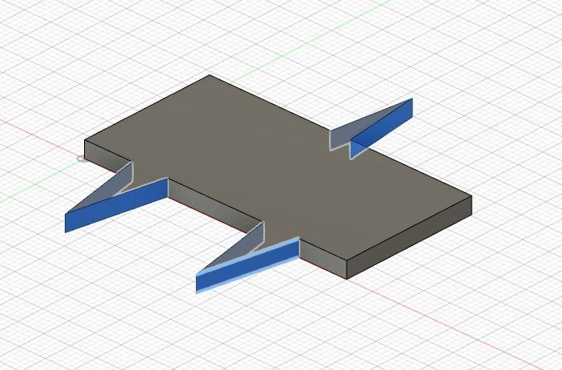
Capture.JPG (67.56 KiB) Viewed 4908 times
Top
Quote
Post
tpruuden
Posts: 59
Joined: Mon Feb 22, 2021 7:44 pm

Re: DIC Question

#201 by tpruuden » Fri Jul 23, 2021 1:08 pm
LouiseScot wrote: ↑
Thu Jul 22, 2021 12:39 am
I don't any reason to doubt the final results in Rathi, most likely just a change in the 3/32" material McMaster sells (as mentioned earlier the 7/32" I have appears roughly consistent with fig. 3(b)) and maybe some of the implementation details are incorrect due to hurried (summer project) paper-writing.
I'm keeping an open mind but still a bit sceptical now. The lack of anyone citing the paper and no supplementals is a concern. In principle it should work but I don't know that I'd trust the results from a 1st year student! I should mention that I've only recently been able to access Rathi's paper via the Applied Optics page as it wasn't accessible to me, although other papers from the same journal were. Previously I only had the copy that was posted on here. Saul's images look interesting but they are taken with a 20x objective so it's not clear exactly how he set things up - presumably in a similar manner to normal DIC? DIC is mediated by refractive index gradients and I couldn't really see/identify any of them in Saul's onion pics...
The DIC devil is in the details!
Louise
I have no doubt, that the method works - as long one has the suitable stress gradient, this is just a question in aligning the suitable parts of the material with other optics components. Indirect proof is also the images of the material between the polarisers, as the created patterns are pretty much exactly the same as with Wollaston prisms.
What considers the polycarbonate material, it seems, that there is great variability. I have tested this far following sheet materials:
*Palsun Palram 3 mm UV
*Palsun Palram 6 mm UV
*Bayer Makrolon 6 mm UV
*Plexiglass 3 mm
*Unknown polycarbonate 3 mm
There are great variabilities in the birefringence and stress required - 6mm Palram is not creating strong gradients, requiring lot of stress, the 3mm Palram has gradient but it is shifted down like with your material is. 6 mm Makrolon seems to be the best this far. Note, that at least partially the material cut orientation seems to play significant role, see following 45/0 degree cut orientations of the 6 mm Makrolon:
https://drive.google.com/file/d/196nXwM ... sp=sharing
The dark band has shifted to one side on 0 deg cut. I have to yet test the Palsun 6 mm and 3mm in different cut orientations.
Last edited by tpruuden on Sat Jul 24, 2021 9:21 am, edited 1 time in total.
Top
Quote
Post
Dmi3n
Posts: 120
Joined: Thu Feb 06, 2020 4:14 pm
Location: Russia, Kaliningrad

Re: DIC Question

#202 by Dmi3n » Fri Jul 23, 2021 7:08 pm
By the way, why didn't anyone thought about simply polishing that damn UV coat away with fine cerium oxide or other polish? I've heard that photographers polish away damaged lens coating from cheap lens this way and it works well.
Gear list:
CZJ NfPk and Polmi A w/ 45mm apo objectives, Phv, Epi Pol, trinocular
CZJ Epityp-2 Pol w/ D32 microhardness tester
Gamma Hungary 3D-condenser
LOMO UV objectives set and КУФ-3 quartz condenser
Nikon D5200 DSLR
AO 820 and LOMO МС-2 microtomes
Top
Quote
Post
tpruuden
Posts: 59
Joined: Mon Feb 22, 2021 7:44 pm

Re: DIC Question

#203 by tpruuden » Fri Jul 23, 2021 8:46 pm
There is no visible coating, it is more of co-extrusion and mixed in additives.
Dmi3n wrote: ↑
Fri Jul 23, 2021 7:08 pm
By the way, why didn't anyone thought about simply polishing that damn UV coat away with fine cerium oxide or other polish? I've heard that photographers polish away damaged lens coating from cheap lens this way and it works well.
Top
Quote
Post
tpruuden
Posts: 59
Joined: Mon Feb 22, 2021 7:44 pm

Re: DIC Question

#204 by tpruuden » Mon Jul 26, 2021 8:46 am
Quick low quality image through eyepiece, this is with one Sanderson prism after 50x objective and thin plastic film bottom sample holder - this is now PlasDIC recreation? I was unable to get it working reasonably with lower magnifications.
https://drive.google.com/file/d/1EHKyCn ... sp=sharing
I do not have full DIC setup to compare with but it seems something similar to weak DIC 3D effect is seen with just aligning the suitable areas of the stressed polycarbonate, even if the gradients are not exactly the same. This is cheek cells with two stressed polycarbonate pieces and crossed polarisers dropped to Leica beam path:
https://drive.google.com/file/d/1qBqUfW ... sp=sharing
Top
Quote
Post
tpruuden
Posts: 59
Joined: Mon Feb 22, 2021 7:44 pm

Re: DIC Question

#205 by tpruuden » Mon Aug 02, 2021 5:51 pm
Well, this is interesting - all windows are from THE SAME material. Wisely I marked the cut orientations on the protection film, that was removed... The square stress gradient piece can apparently be used on "sideways" orientation also.
https://drive.google.com/file/d/19ivjLl ... sp=sharing
Just for kicks - attempt to create the gradient directly in Leica condenser turret:
https://drive.google.com/file/d/19sVOjf ... sp=sharing
Top
Quote
Post
hans
Posts: 968
Joined: Thu May 28, 2020 11:10 pm
Location: Southern California

Re: DIC Question

#206 by hans » Tue Aug 03, 2021 7:05 pm
tpruuden wrote: ↑
Mon Aug 02, 2021 5:51 pm
Wisely I marked the cut orientations on the protection film, that was removed...
What is the orientation of the beam relative to the original sheet in those three examples?
Top
Quote
Post
tpruuden
Posts: 59
Joined: Mon Feb 22, 2021 7:44 pm

Re: DIC Question

#207 by tpruuden » Tue Aug 03, 2021 10:43 pm
hans wrote: ↑
Tue Aug 03, 2021 7:05 pm
What is the orientation of the beam relative to the original sheet in those three examples?
I believe the centered dark band version to be 45 degrees cut. I have to remove stress frames and check over other versions, as the mishap with markings happened.
Top
Quote
Post
hans
Posts: 968
Joined: Thu May 28, 2020 11:10 pm
Location: Southern California

Re: DIC Question

#208 by hans » Wed Aug 04, 2021 4:56 am
Ah, missed what you were saying about the protective film... so they are cut at 0, 45, and 90 degrees but not sure which is which?
Top
Quote
Post
LouiseScot
Posts: 1001
Joined: Tue Jul 07, 2020 1:51 pm
Location: Scotland

Re: DIC Question

#209 by LouiseScot » Wed Aug 04, 2021 12:50 pm
I was wondering if anyone could point me in the right direction as to where to buy a Nomarski prism set i.e. a condenser prism (are they all the same?) and, say, a 20x objective prism? Possibly new ones but depends on the price I see various prisms on Ebay UK but it's not clear (to me) what's what.
I'm otherwise still busy with other things but hope to be back on the case by the end of the month
Louise
A Nikon CF plan 20x; A Swift 380T; A DIY infinity corrected focus rail system with a 40x/0.65 Olympus Plan, a 10x/0.30 Amscope Plan Fluor, and a 20x/0.75 Nikon Plan Apo
Top
Quote
Post
LouiseScot
Posts: 1001
Joined: Tue Jul 07, 2020 1:51 pm
Location: Scotland

Re: DIC Question

#210 by LouiseScot » Wed Aug 04, 2021 6:03 pm
Thorlabs sell DIC prisms but, of course, everything from them is expensive! A Nikon N2 Condenser prism is about £908 with tax and a 20x prism slider is the same. So starter Nomarski DIC parts for £1800.... Tempting. If anyone knows of another source for less, I'd obviously be interested Maybe there's a cheap Chinese source?
Louise
A Nikon CF plan 20x; A Swift 380T; A DIY infinity corrected focus rail system with a 40x/0.65 Olympus Plan, a 10x/0.30 Amscope Plan Fluor, and a 20x/0.75 Nikon Plan Apo
Quote
Post

Re: DIC Question

#211 by Scarodactyl » Wed Aug 04, 2021 6:30 pm
Used on eBay would probably be cheapest if you can find the right pair.
Top
Quote
Post
LouiseScot
Posts: 1001
Joined: Tue Jul 07, 2020 1:51 pm
Location: Scotland

Re: DIC Question

#212 by LouiseScot » Wed Aug 04, 2021 6:33 pm
Scarodactyl wrote: ↑
Wed Aug 04, 2021 6:30 pm
Used on eBay would probably be cheapest if you can find the right pair.
Yeah, but I'm not keen on that and there's nothing for sale in the UK at the moment anyway. I'd rather get new if I can.
Louise
A Nikon CF plan 20x; A Swift 380T; A DIY infinity corrected focus rail system with a 40x/0.65 Olympus Plan, a 10x/0.30 Amscope Plan Fluor, and a 20x/0.75 Nikon Plan Apo
Top
Quote
Post
microb
Posts: 722
Joined: Wed Mar 27, 2019 6:39 am

Re: DIC Question

#213 by microb » Thu Aug 05, 2021 9:41 pm
LouiseScot wrote: ↑
Wed Aug 04, 2021 6:03 pm
Thorlabs sell DIC prisms but, of course, everything from them is expensive! A Nikon N2 Condenser prism is about £908 with tax and a 20x prism slider is the same. So starter Nomarski DIC parts for £1800.... Tempting. If anyone knows of another source for less, I'd obviously be interested Maybe there's a cheap Chinese source?
Louise
I think Thorlabs only sells Wollastan prisms (https://www.thorlabs.com/newgrouppage9. ... oup_id=917). I haven't seen Nomarski mentioned there.
This thread seems to cover an Olympus formfactor compatible looking set-up: viewtopic.php?f=24&t=13375
Top
Quote
Post
LouiseScot
Posts: 1001
Joined: Tue Jul 07, 2020 1:51 pm
Location: Scotland

Re: DIC Question

#214 by LouiseScot » Thu Aug 05, 2021 9:59 pm
microb wrote: ↑
Thu Aug 05, 2021 9:41 pm
LouiseScot wrote: ↑
Wed Aug 04, 2021 6:03 pm
Thorlabs sell DIC prisms but, of course, everything from them is expensive! A Nikon N2 Condenser prism is about £908 with tax and a 20x prism slider is the same. So starter Nomarski DIC parts for £1800.... Tempting. If anyone knows of another source for less, I'd obviously be interested Maybe there's a cheap Chinese source?
Louise
I think Thorlabs only sells Wollastan prisms (https://www.thorlabs.com/newgrouppage9. ... oup_id=917). I haven't seen Nomarski mentioned there.
This thread seems to cover an Olympus formfactor compatible looking set-up: viewtopic.php?f=24&t=13375
They do sell Nikon/Nomarski prisms for their DIY Cerna systems:
https://www.thorlabs.com/newgrouppage9. ... up_id=8569
Having since seen the prices for Olympus UIS2 U-DIC equivalents, maybe Thorlabs prices aren't so bad after all!
Louise
A Nikon CF plan 20x; A Swift 380T; A DIY infinity corrected focus rail system with a 40x/0.65 Olympus Plan, a 10x/0.30 Amscope Plan Fluor, and a 20x/0.75 Nikon Plan Apo
Top
Quote
Post
Scarodactyl
Posts: 2040
Joined: Sat Mar 03, 2018 9:09 pm

Re: DIC Question

#215 by Scarodactyl » Fri Aug 06, 2021 3:29 pm
Some olynpus prisms just went up on UK eBay, including condenser prisms and a nosepiece slider, not cheap but cheaper than thorlabs. The condenser prisms are mostly for specialized water immersion objectives though.
Top
Quote
Post
LouiseScot
Posts: 1001
Joined: Tue Jul 07, 2020 1:51 pm
Location: Scotland

Re: DIC Question

#216 by LouiseScot » Fri Aug 06, 2021 4:24 pm
Scarodactyl wrote: ↑
Fri Aug 06, 2021 3:29 pm
Some olynpus prisms just went up on UK eBay, including condenser prisms and a nosepiece slider, not cheap but cheaper than thorlabs. The condenser prisms are mostly for specialized water immersion objectives though.
Yeah I've seen them. I want to avoid anything 'non-standard', if possible, and I want to get matching condenser/slider prisms . At the moment, the Thorlabs/Nikon seem to be the best bet. At the same time, I'm trying to keep an open mind
Louise
A Nikon CF plan 20x; A Swift 380T; A DIY infinity corrected focus rail system with a 40x/0.65 Olympus Plan, a 10x/0.30 Amscope Plan Fluor, and a 20x/0.75 Nikon Plan Apo
Top
Quote
Post
Scarodactyl
Posts: 2040
Joined: Sat Mar 03, 2018 9:09 pm

Re: DIC Question

#217 by Scarodactyl » Fri Aug 06, 2021 6:09 pm
Looking again the slider is a normal doc slider, and a couple of the objective prisms aren't marked for water immersion. But of course that all requires more research.
Top
Quote
Post
LouiseScot
Posts: 1001
Joined: Tue Jul 07, 2020 1:51 pm
Location: Scotland

Re: DIC Question

#218 by LouiseScot » Fri Aug 06, 2021 6:19 pm
Scarodactyl wrote: ↑
Fri Aug 06, 2021 6:09 pm
Looking again the slider is a normal doc slider, and a couple of the objective prisms aren't marked for water immersion. But of course that all requires more research.
I don't have any data/info on them and they are a bit more expensive than the Thorlabs/Nikon sliders anyway.
Louise
A Nikon CF plan 20x; A Swift 380T; A DIY infinity corrected focus rail system with a 40x/0.65 Olympus Plan, a 10x/0.30 Amscope Plan Fluor, and a 20x/0.75 Nikon Plan Apo
Top
Quote
Post
Scarodactyl
Posts: 2040
Joined: Sat Mar 03, 2018 9:09 pm

Re: DIC Question

#219 by Scarodactyl » Fri Aug 06, 2021 6:44 pm
Yeah, it looks to me like the nikon nosepiece prisms are 1k or 1.6k usd depending on n1 or n2, and the condenser prisms are 1k and up, while the olympus ones on eBay are 1.2k for the slider and 250ish for the objective prisms. Not a huge savings for sure unless you want to make a full dic setup with more than one objective prism, but then you have to take all the other hardware into account which sounds like a headache anyway, and that's assuming ones not marked wi are good for nonspecialized objectives.
Hmmmmm.... thinking about it I do have an objective based on olympus's water immersion series. I wonder if it is also dic compatible with these less typical prisms....no, stop, I must resist.
Top
Quote
Post
LouiseScot
Posts: 1001
Joined: Tue Jul 07, 2020 1:51 pm
Location: Scotland

Re: DIC Question

#220 by LouiseScot » Fri Aug 06, 2021 7:02 pm
Scarodactyl wrote: ↑
Fri Aug 06, 2021 6:44 pm
Yeah, it looks to me like the nikon nosepiece prisms are 1k or 1.6k usd depending on n1 or n2, and the condenser prisms are 1k and up, while the olympus ones on eBay are 1.2k for the slider and 250ish for the objective prisms. Not a huge savings for sure unless you want to make a full dic setup with more than one objective prism, but then you have to take all the other hardware into account which sounds like a headache anyway.
Hmmmmm.... thinking about it I do have an objective based on olympus's water immersion series. I wonder if it is also dic compatible with these less typical prisms....no, stop, I must resist.
DIC impulses can be hard to resist! Um, the sliders are the objective prisms and the round prisms are for the condenser. Normally, though, sliders are objective specific though the Olympus ones don't seem to be? I just don't have the info. At least I can be sure the Thorlabs sliders will work with the specified condenser prisms - hopefully!
Louise
A Nikon CF plan 20x; A Swift 380T; A DIY infinity corrected focus rail system with a 40x/0.65 Olympus Plan, a 10x/0.30 Amscope Plan Fluor, and a 20x/0.75 Nikon Plan Apo
Top
Quote
Post
Scarodactyl
Posts: 2040
Joined: Sat Mar 03, 2018 9:09 pm

Re: DIC Question

#221 by Scarodactyl » Fri Aug 06, 2021 7:32 pm
Oh yeah, mixed up my terms there. Typically these are set up with one prism being objective specific and the other being more general (or with epi dic either one per objective or one slider for all). With the olympus system the slider goes above the objectives and is the nonspecific one, while the condenser prisms are the more specific ones. Iirc Nikon might do it in reverse with the condenser being less specific and the nosepiece taking one per objective. Or maybe they've swit hed between models, for epi nikon used to be one objective per prism but switched to a single slider.
Of course that breaks down a bit with more specific applications anyway. Olympus has the upper sliders in a few variations but also a specific prism for some water immersion objectives.
Top
Quote
Post
viktor j nilsson
Posts: 659
Joined: Thu Aug 23, 2018 10:12 pm
Location: Lund, Sweden

Re: DIC Question

#222 by viktor j nilsson » Fri Aug 06, 2021 7:39 pm
LouiseScot wrote:At least I can be sure the Thorlabs sliders will work with the specified condenser prisms - hopefully!
Louise
Well, you can only really be sure that the Thorlabs prisms will work properly IF you use them with one of the compatible Cerna condensers AND the exact same objective for which the objective prism was designed. Different condensers have different focal lengths, and objectives differ in the location of their back focal plane.
So you are using a different condenser, or a different objective - even of the same magnification - then you really can't be sure that it'll work. There really isn't such a thing as a "20x prism". It is only a prism designed to be used with one specific 20x objective, one specific condenser, and one specific condenser prism. They all need to match.
I wouldn't spend any serious money on a set of Thorlab prisms unless I wanted to use them as designed in a Cerna setup.
I think you are better off looking for a used DIC microscope, or picking up some cheaper nomarski prisms from an epi DIC setup and play with them.
Top
Quote
Post
LouiseScot
Posts: 1001
Joined: Tue Jul 07, 2020 1:51 pm
Location: Scotland

Re: DIC Question

#223 by LouiseScot » Fri Aug 06, 2021 7:45 pm
viktor j nilsson wrote: ↑
Fri Aug 06, 2021 7:39 pm
LouiseScot wrote:At least I can be sure the Thorlabs sliders will work with the specified condenser prisms - hopefully!
Louise
Well, you can only really be sure that the Thorlabs prisms will work properly IF you use them with one of the compatible Cerna condensers AND the exact same objective for which the objective prism was designed. Different condensers have different focal lengths, and objectives differ in the location of their back focal plane.
So you are using a different condenser, or a different objective - even of the same magnification - then you really can't be sure that it'll work. There really isn't such a thing as a "20x prism". It is only a prism designed to be used with one specific 20x objective, one specific condenser, and one specific condenser prism. They all need to match.
I wouldn't spend any serious money on a set of Thorlab prisms unless I wanted to use them as designed in a Cerna setup.
I think you are better off looking for a used DIC microscope, or picking up some cheaper nomarski prisms from an epi DIC setup and play with them.
It's to be used with my diy system so I can vary the prism positions as needed. They are Nikon prisms so not specific for the Cerna system. I emailed Thorlabs earlier to try and get more info on the prisms they sell.
Louise
A Nikon CF plan 20x; A Swift 380T; A DIY infinity corrected focus rail system with a 40x/0.65 Olympus Plan, a 10x/0.30 Amscope Plan Fluor, and a 20x/0.75 Nikon Plan Apo
Top
Quote
Post
viktor j nilsson
Posts: 659
Joined: Thu Aug 23, 2018 10:12 pm
Location: Lund, Sweden

Re: DIC Question

#224 by viktor j nilsson » Fri Aug 06, 2021 7:46 pm
https://www.ebay.com/itm/224515344198?h ... Sw5F5g23fB
This is the set I've been using in my DIY DIC setup. Four prisms, two are the same (10x/40x/100x). Having two of the same it's great, as it enable you to create a symmetrical setup where you use two identical objectives (one as condenser and one as objective) and two identical prisms. That automatically fulfill the DIC criteria, you just need to place the prisms at the BFP.
They show up from time to time for good prices. I paid $180 for mine.
Top
Quote
Post
viktor j nilsson
Posts: 659
Joined: Thu Aug 23, 2018 10:12 pm
Location: Lund, Sweden

Re: DIC Question

#225 by viktor j nilsson » Fri Aug 06, 2021 7:49 pm
LouiseScot wrote: ↑
Fri Aug 06, 2021 7:45 pm
viktor j nilsson wrote: ↑
Fri Aug 06, 2021 7:39 pm
LouiseScot wrote:At least I can be sure the Thorlabs sliders will work with the specified condenser prisms - hopefully!
Louise
Well, you can only really be sure that the Thorlabs prisms will work properly IF you use them with one of the compatible Cerna condensers AND the exact same objective for which the objective prism was designed. Different condensers have different focal lengths, and objectives differ in the location of their back focal plane.
So you are using a different condenser, or a different objective - even of the same magnification - then you really can't be sure that it'll work. There really isn't such a thing as a "20x prism". It is only a prism designed to be used with one specific 20x objective, one specific condenser, and one specific condenser prism. They all need to match.
I wouldn't spend any serious money on a set of Thorlab prisms unless I wanted to use them as designed in a Cerna setup.
I think you are better off looking for a used DIC microscope, or picking up some cheaper nomarski prisms from an epi DIC setup and play with them.
It's to be used with my diy system so I can vary the prism positions as needed. They are Nikon prisms so not specific for the Cerna system. I emailed Thorlabs earlier to try and get more info on the prisms they sell.
Louise
No, not specific for the Cerna system, but specific to that specific Nikon objective, and a condenser with a specific focal length, which Cerna must have chosen to match the other components.
Top
Quote
Post
LouiseScot
Posts: 1001
Joined: Tue Jul 07, 2020 1:51 pm
Location: Scotland

Re: DIC Question

#226 by LouiseScot » Fri Aug 06, 2021 8:12 pm
viktor j nilsson wrote: ↑
Fri Aug 06, 2021 7:49 pm
LouiseScot wrote: ↑
Fri Aug 06, 2021 7:45 pm
viktor j nilsson wrote: ↑
Fri Aug 06, 2021 7:39 pm
Well, you can only really be sure that the Thorlabs prisms will work properly IF you use them with one of the compatible Cerna condensers AND the exact same objective for which the objective prism was designed. Different condensers have different focal lengths, and objectives differ in the location of their back focal plane.
So you are using a different condenser, or a different objective - even of the same magnification - then you really can't be sure that it'll work. There really isn't such a thing as a "20x prism". It is only a prism designed to be used with one specific 20x objective, one specific condenser, and one specific condenser prism. They all need to match.
I wouldn't spend any serious money on a set of Thorlab prisms unless I wanted to use them as designed in a Cerna setup.
I think you are better off looking for a used DIC microscope, or picking up some cheaper nomarski prisms from an epi DIC setup and play with them.
It's to be used with my diy system so I can vary the prism positions as needed. They are Nikon prisms so not specific for the Cerna system. I emailed Thorlabs earlier to try and get more info on the prisms they sell.
Louise
No, not specific for the Cerna system, but specific to that specific Nikon objective, and a condenser with a specific focal length, which Cerna must have chosen to match the other components.
I've asked them about compatibility and interchangeability in my email. I suspect the prisms are maybe Nikon oem components. The N2 condenser prism should work with a range of objectives. There's a 20x and 40x slider. I have a 20x Nikon apo objective which is specified for dic and N2. I hope I get a reply from them sometime next week. I'll post what they say, if it's of interest.
Louise
A Nikon CF plan 20x; A Swift 380T; A DIY infinity corrected focus rail system with a 40x/0.65 Olympus Plan, a 10x/0.30 Amscope Plan Fluor, and a 20x/0.75 Nikon Plan Apo
Top
Quote
Post
LouiseScot
Posts: 1001
Joined: Tue Jul 07, 2020 1:51 pm
Location: Scotland

Re: DIC Question

#227 by LouiseScot » Sun Aug 22, 2021 12:21 pm
Hi All
Hope everyone is well. I'm pretty much back on the (DIC) case! Not quite full time, but almost.
Firstly, I didn't get much out of Thorlabs re their Nikon prisms. They just repeated what's in their online catalogue, so not very helpful. However, I did find some Nikon Eclipse tables. I gather one can use almost any objective >10x with their N2 prism. Obviously, pan fluors and apos specified for DIC are best. The N2 condenser prism should work with 20x, 25x, 40x and 60x objectives together with matching objective prism sliders. I'm a bit puzzled as to why their objective prisms are angled at 5 deg to the horizontal. There must be a good reason - anyone know? I thought it could be to prevent reflections but that's a guess.
Anyway, I had a bit of an epiphany re the Sanderson prism fringes which I spent ages struggling with before. The answer is buried in Rathi's paper though they never explained it. I found it by serendipity really. All that is needed is to place a piece of correctly oriented, unstrained polycarbonate in front of the condenser prism (between the condenser prism and the condenser lens) and the fringe patterns are shifted to allow proper adjustment. Such a simple answer to what seemed an intractable problem before! It's amazing how helpful a break from a problem can be.
So now, using a 60x objective I can adjust the fringe patterns to pretty much match Rathi's and other published images of prism fringes for a 60x setup. What I need to do though is build a setup/holder that will easily let me make fine adjustments to the prism positions and fringe spacing. However, first I'll have to see whether I can now actually achieve DIC - or not!
Here are pics of the condenser and objective fringes as seen by a camera at the normal viewing position with adjustments to pick up the corresponding focal planes:
Condenser prism:
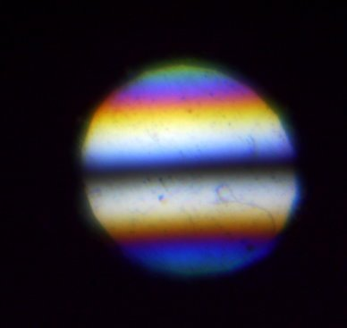
Condenser Prism Fringes_40pc00001.jpg (9.35 KiB) Viewed 4846 times
Objective Prism:
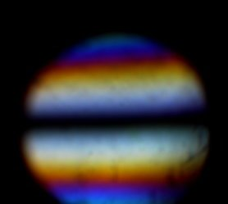
Objective Prism Fringes_30pc00001.jpg (5.65 KiB) Viewed 4846 times
Not great photos but good enough to show the fringe patterns with zeroth order approximately in the centre.
I'll be very pleased if I can get this thing to work! If I can, I'll endeavour to physically shorten the setup which I think should be possible. As it is, even if it does work, it's a bit impractical.
The game's afoot! More to follow!
Louise
A Nikon CF plan 20x; A Swift 380T; A DIY infinity corrected focus rail system with a 40x/0.65 Olympus Plan, a 10x/0.30 Amscope Plan Fluor, and a 20x/0.75 Nikon Plan Apo
Top
Quote
Post
Scarodactyl
Posts: 2040
Joined: Sat Mar 03, 2018 9:09 pm

Re: DIC Question

#228 by Scarodactyl » Sun Aug 22, 2021 4:44 pm
Wow, that looks great! I'll look forward to seeing how it progresses from.here.
Top
Quote
Post
LouiseScot
Posts: 1001
Joined: Tue Jul 07, 2020 1:51 pm
Location: Scotland

Re: DIC Question

#229 by LouiseScot » Sun Aug 22, 2021 5:07 pm
Scarodactyl wrote: ↑
Sun Aug 22, 2021 4:44 pm
Wow, that looks great! I'll look forward to seeing how it progresses from.here.
Hiya - thanks for the encouragement! I've had a quick go at trying to image a mounted diatom strew but the results were a bit blurry... My cheap, Chinese 60x plan achro isn't great and some of the other optics need improving. It's not a proper microscope - it's components and bits put together on some v-section. There isn't a proper stage - just a 3d printed slide holder with micrometer adjustment so focusing is tricky. I think I'll spend some time improving the 'condenser' and better aligning the optics. Will keep me busy!
Here is a crop of part of the strew
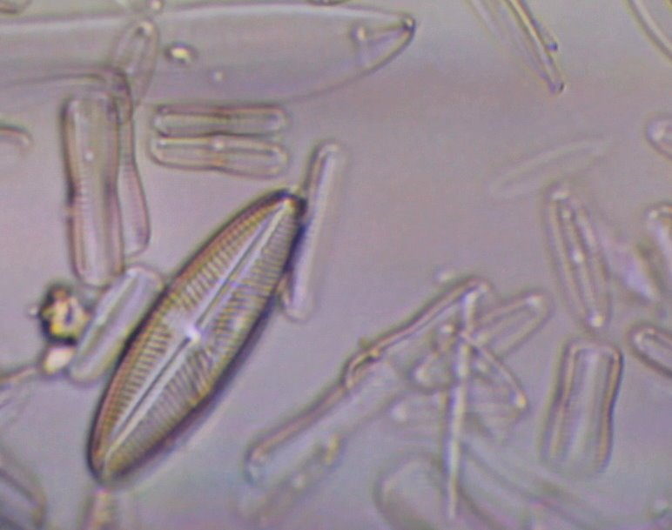
IMG_0008_crop.jpg (55.38 KiB) Viewed 4825 times
At least I can see some things through my contraption
Louise
A Nikon CF plan 20x; A Swift 380T; A DIY infinity corrected focus rail system with a 40x/0.65 Olympus Plan, a 10x/0.30 Amscope Plan Fluor, and a 20x/0.75 Nikon Plan Apo
Top
Quote
Post
PeteM
Posts: 2306
Joined: Tue Dec 06, 2016 6:22 am
Location: N. California

Re: DIC Question

#230 by PeteM » Sun Aug 22, 2021 6:50 pm
Thought it worth a mention that a Nikon Optiphot DIC system showed up on the Ebay US site today. It's in Japan. With shipping and tax might it might end up around $3200 US for a buyer in the US or Europe? I can't vouch for the seller or the scope, but a quick glance suggests it's more or less complete. One would have to check that the DIC prisms are present - it could be there is just an upper slider and a phase contrast rather than universal condenser?
Recent comparable asking prices seem to be two to three thousand dollars more. And that's not including what looks like a complete and fairly pricey polarization setup.
This is the first Optiphot version and not quite as desirable as the Optiphot 2 with it's brighter lamp (100 watts vs. 50 watts) and the DIC slider set at a 45 degree angle. Some of the objectives are also an earlier Nikon plan achromat version to the later "CFN" versions with the three chromed knurls on the body. However, they're still pretty good. Both the first and second Optiphot models produce very good DIC in my experience.
I mention it because the cost of a new DIC slider and three condenser prisms might well be about as much.
Last edited by PeteM on Sun Aug 22, 2021 7:04 pm, edited 1 time in total.
Top
Quote
Post
LouiseScot
Posts: 1001
Joined: Tue Jul 07, 2020 1:51 pm
Location: Scotland

Re: DIC Question

#231 by LouiseScot » Sun Aug 22, 2021 7:03 pm
PeteM wrote: ↑
Sun Aug 22, 2021 6:50 pm
Thought it worth a mention that a Nikon Optiphot DIC system showed up on the Ebay US site today. It's in Japan. With shipping and tax might it might end up around $3200 US for a buyer in the US or Europe? I can't vouch for the seller or the scope, but a quick glance suggests it's more or less complete. Recent comparable asking prices seem to be two to three thousand dollars more.
This is the first Optiphot version and not quite as desirable as the Optiphot 2 with it's brighter lamp (100 watts vs. 50 watts) and the DIC slider set at a 45 degree angle. Some of the objectives are also an earlier Nikon plan achromat version to the later "CFN" versions with the three chromed knurls on the body. However, they're still pretty good.
I mention it because the cost of a new DIC slider and three condenser prisms might well be about as much.
Thanks but the point of this (now very long) thread is to build my own! I've looked at buying a Nikon N2 prism but really only if I need to, and in order to help me get the Sanderson prisms working.
Louise
A Nikon CF plan 20x; A Swift 380T; A DIY infinity corrected focus rail system with a 40x/0.65 Olympus Plan, a 10x/0.30 Amscope Plan Fluor, and a 20x/0.75 Nikon Plan Apo
Top
Quote
Post
jmp
Posts: 66
Joined: Sun Feb 16, 2020 2:07 am
Location: Texas

Re: DIC Question

#232 by jmp » Mon Aug 23, 2021 2:55 pm
LouiseScot wrote: ↑
Sun Aug 22, 2021 12:21 pm
All that is needed is to place a piece of correctly oriented, unstrained polycarbonate in front of the condenser prism (between the condenser prism and the condenser lens) and the fringe patterns are shifted to allow proper adjustment. Such a simple answer to what seemed an intractable problem before! It's amazing how helpful a break from a problem can be.
So now, using a 60x objective I can adjust the fringe patterns to pretty much match Rathi's and other published images of prism fringes for a 60x setup. What I need to do though is build a setup/holder that will easily let me make fine adjustments to the prism positions and fringe spacing. However, first I'll have to see whether I can now actually achieve DIC - or not!
Hi Louise, glad to hear that you've been able to solve this problem. That too is how I was able to replicate the symmetric interference patterns from Rathi's paper: I stacked 2 prisms between the polarizers, small adjustments of the bending force on one of them led to noticeable changes in the fringe pattern (here and here). I was not able to obtain a symmetric fringe pattern with a dark band in the middle using a single prism because significantly more bending force led to small shifts of the pattern towards the center. Hans also showed the same trend here, an asymmetric fringe pattern from a single prism, and a symmetric pattern from stacked prisms under a lower bending force.
You now have 2 prisms before the condenser in order to have a symmetric interference pattern. From the fringe patterns of the Nomarski prisms in objective sliders shown here I assume that 2 prisms would be needed at the back focal plane (again, for a symmetric interference pattern). Am I right in assuming that a total of 4 prisms would be needed for a Sanderson-DIC setup: two at the condenser level and two at the back focal plane of the objective?
Top
Quote
Post
LouiseScot
Posts: 1001
Joined: Tue Jul 07, 2020 1:51 pm
Location: Scotland

Re: DIC Question

#233 by LouiseScot » Mon Aug 23, 2021 4:19 pm
jmp wrote: ↑
Mon Aug 23, 2021 2:55 pm
LouiseScot wrote: ↑
Sun Aug 22, 2021 12:21 pm
All that is needed is to place a piece of correctly oriented, unstrained polycarbonate in front of the condenser prism (between the condenser prism and the condenser lens) and the fringe patterns are shifted to allow proper adjustment. Such a simple answer to what seemed an intractable problem before! It's amazing how helpful a break from a problem can be.
So now, using a 60x objective I can adjust the fringe patterns to pretty much match Rathi's and other published images of prism fringes for a 60x setup. What I need to do though is build a setup/holder that will easily let me make fine adjustments to the prism positions and fringe spacing. However, first I'll have to see whether I can now actually achieve DIC - or not!
Hi Louise, glad to hear that you've been able to solve this problem. That too is how I was able to replicate the symmetric interference patterns from Rathi's paper: I stacked 2 prisms between the polarizers, small adjustments of the bending force on one of them led to noticeable changes in the fringe pattern (here and here). I was not able to obtain a symmetric fringe pattern with a dark band in the middle using a single prism because significantly more bending force led to small shifts of the pattern towards the center. Hans also showed the same trend here, an asymmetric fringe pattern from a single prism, and a symmetric pattern from stacked prisms under a lower bending force.
You now have 2 prisms before the condenser in order to have a symmetric interference pattern. From the fringe patterns of the Nomarski prisms in objective sliders shown here I assume that 2 prisms would be needed at the back focal plane (again, for a symmetric interference pattern). Am I right in assuming that a total of 4 prisms would be needed for a Sanderson-DIC setup: two at the condenser level and two at the back focal plane of the objective?
Hi Jmp
I wish I'd known before... I've actually changed it a bit now. I just have one piece of polycarbonate before the objective prism. It's just a spare piece of polycarbonate. It has to be oriented correctly. When in place, it allows me to look down the tube and adjust both the condenser and objective prism fringes (at different focal planes). With the condenser prism removed I can see the objective prism fringes using the dslr+lens. I think I just used a mirror and lens to see the condenser fringes. Aligning the two sets of fringes can be a bit tricky. I think that when in situ the fringes are not exactly the same as when looking at each prism with cross polarisers and extra polycarbonete piece outside of the optical train. Anyway, I'm actually working on the other optics now - I need to fit a proper condenser! Hopefully, that will give me better images. I'm still not certain if I've actually achieved DIC but I think I'm getting there... There are still a number of things I'm not sure about.
Louise
A Nikon CF plan 20x; A Swift 380T; A DIY infinity corrected focus rail system with a 40x/0.65 Olympus Plan, a 10x/0.30 Amscope Plan Fluor, and a 20x/0.75 Nikon Plan Apo
Top
Quote
Post
microb
Posts: 722
Joined: Wed Mar 27, 2019 6:39 am

Re: DIC Question

#234 by microb » Mon Aug 23, 2021 4:46 pm
I'd like to try a set-up like this. If either of you have models for frames with I guess two layers of polycarbonate. Let me know. I'm setting up a CNC for aluminum and can use this as a test case for parts.
Thanks,
Ted
Top
Quote
Post
LouiseScot
Posts: 1001
Joined: Tue Jul 07, 2020 1:51 pm
Location: Scotland

Re: DIC Question

#235 by LouiseScot » Mon Aug 23, 2021 5:00 pm
microb wrote: ↑
Mon Aug 23, 2021 4:46 pm
I'd like to try a set-up like this. If either of you have models for frames with I guess two layers of polycarbonate. Let me know. I'm setting up a CNC for aluminum and can use this as a test case for parts.
Thanks,
Ted
I'm currently just using the open frames as per Rathi. It might be worth waiting a bit until someone definitely has it working...
Louise
A Nikon CF plan 20x; A Swift 380T; A DIY infinity corrected focus rail system with a 40x/0.65 Olympus Plan, a 10x/0.30 Amscope Plan Fluor, and a 20x/0.75 Nikon Plan Apo
Top
Quote
Post
LouiseScot
Posts: 1001
Joined: Tue Jul 07, 2020 1:51 pm
Location: Scotland

Re: DIC Question

#236 by LouiseScot » Mon Aug 23, 2021 5:10 pm
LouiseScot wrote: ↑
Mon Aug 23, 2021 5:00 pm
microb wrote: ↑
Mon Aug 23, 2021 4:46 pm
I'd like to try a set-up like this. If either of you have models for frames with I guess two layers of polycarbonate. Let me know. I'm setting up a CNC for aluminum and can use this as a test case for parts.
Thanks,
Ted
I'm currently just using the open frames as per Rathi. It might be worth waiting a bit until someone definitely has it working...
Louise
Here is a link to the Rathi paper:
https://www.quekett.org/wp-content/uplo ... prisms.pdf
A Nikon CF plan 20x; A Swift 380T; A DIY infinity corrected focus rail system with a 40x/0.65 Olympus Plan, a 10x/0.30 Amscope Plan Fluor, and a 20x/0.75 Nikon Plan Apo
Top
Quote
Post
microb
Posts: 722
Joined: Wed Mar 27, 2019 6:39 am

Re: DIC Question

#237 by microb » Mon Aug 23, 2021 7:27 pm
LouiseScot wrote: ↑
Mon Aug 23, 2021 5:10 pm
LouiseScot wrote: ↑
Mon Aug 23, 2021 5:00 pm
microb wrote: ↑
Mon Aug 23, 2021 4:46 pm
I'd like to try a set-up like this. If either of you have models for frames with I guess two layers of polycarbonate. Let me know. I'm setting up a CNC for aluminum and can use this as a test case for parts.
Thanks,
Ted
I'm currently just using the open frames as per Rathi. It might be worth waiting a bit until someone definitely has it working...
Louise
Here is a link to the Rathi paper:
https://www.quekett.org/wp-content/uplo ... prisms.pdf
I had seen the paper. But it seemed that some extra work was needed to get it working.
Top
Quote
Post
LouiseScot
Posts: 1001
Joined: Tue Jul 07, 2020 1:51 pm
Location: Scotland

Re: DIC Question

#238 by LouiseScot » Mon Aug 23, 2021 7:48 pm
microb wrote: ↑
Mon Aug 23, 2021 7:27 pm
LouiseScot wrote: ↑
Mon Aug 23, 2021 5:10 pm
LouiseScot wrote: ↑
Mon Aug 23, 2021 5:00 pm
I'm currently just using the open frames as per Rathi. It might be worth waiting a bit until someone definitely has it working...
Louise
Here is a link to the Rathi paper:
https://www.quekett.org/wp-content/uplo ... prisms.pdf
I had seen the paper. But it seemed that some extra work was needed to get it working.
I'm still working on it! But, as I say, I'm using the Rathi open frame design. I'm kindof doing it all on an optical prototyping system based on aluminium extrusion. You have to be able to place the prism holders in the right places i.e. within/very close to the condenser, and at the extended objective position as if it was a Wollaston-type prism. It's fairly clear from Rathi's paper.
Louise
A Nikon CF plan 20x; A Swift 380T; A DIY infinity corrected focus rail system with a 40x/0.65 Olympus Plan, a 10x/0.30 Amscope Plan Fluor, and a 20x/0.75 Nikon Plan Apo
Top
Quote
Post
LouiseScot
Posts: 1001
Joined: Tue Jul 07, 2020 1:51 pm
Location: Scotland

Re: DIC Question

#239 by LouiseScot » Tue Aug 24, 2021 9:00 am
LouiseScot wrote: ↑
Mon Aug 23, 2021 4:19 pm
jmp wrote: ↑
Mon Aug 23, 2021 2:55 pm
LouiseScot wrote: ↑
Sun Aug 22, 2021 12:21 pm
All that is needed is to place a piece of correctly oriented, unstrained polycarbonate in front of the condenser prism (between the condenser prism and the condenser lens) and the fringe patterns are shifted to allow proper adjustment. Such a simple answer to what seemed an intractable problem before! It's amazing how helpful a break from a problem can be.
So now, using a 60x objective I can adjust the fringe patterns to pretty much match Rathi's and other published images of prism fringes for a 60x setup. What I need to do though is build a setup/holder that will easily let me make fine adjustments to the prism positions and fringe spacing. However, first I'll have to see whether I can now actually achieve DIC - or not!
Hi Louise, glad to hear that you've been able to solve this problem. That too is how I was able to replicate the symmetric interference patterns from Rathi's paper: I stacked 2 prisms between the polarizers, small adjustments of the bending force on one of them led to noticeable changes in the fringe pattern (here and here). I was not able to obtain a symmetric fringe pattern with a dark band in the middle using a single prism because significantly more bending force led to small shifts of the pattern towards the center. Hans also showed the same trend here, an asymmetric fringe pattern from a single prism, and a symmetric pattern from stacked prisms under a lower bending force.
You now have 2 prisms before the condenser in order to have a symmetric interference pattern. From the fringe patterns of the Nomarski prisms in objective sliders shown here I assume that 2 prisms would be needed at the back focal plane (again, for a symmetric interference pattern). Am I right in assuming that a total of 4 prisms would be needed for a Sanderson-DIC setup: two at the condenser level and two at the back focal plane of the objective?
Hi Jmp
I wish I'd known before... I've actually changed it a bit now. I just have one piece of polycarbonate before the objective prism. It's just a spare piece of polycarbonate. It has to be oriented correctly. When in place, it allows me to look down the tube and adjust both the condenser and objective prism fringes (at different focal planes). With the condenser prism removed I can see the objective prism fringes using the dslr+lens. I think I just used a mirror and lens to see the condenser fringes. Aligning the two sets of fringes can be a bit tricky. I think that when in situ the fringes are not exactly the same as when looking at each prism with cross polarisers and extra polycarbonete piece outside of the optical train. Anyway, I'm actually working on the other optics now - I need to fit a proper condenser! Hopefully, that will give me better images. I'm still not certain if I've actually achieved DIC but I think I'm getting there... There are still a number of things I'm not sure about.
Louise
Actually, thinking about it again, and more logically, then it must need the extra polycarbonate piece with the condenser prism as there's no point in only shifting the fringes after the specimen... I'll check it out later and confirm
Louise
A Nikon CF plan 20x; A Swift 380T; A DIY infinity corrected focus rail system with a 40x/0.65 Olympus Plan, a 10x/0.30 Amscope Plan Fluor, and a 20x/0.75 Nikon Plan Apo
Top
Quote
Post
jmp
Posts: 66
Joined: Sun Feb 16, 2020 2:07 am
Location: Texas

Re: DIC Question

#240 by jmp » Tue Aug 24, 2021 2:48 pm
Yes, it be good to know if that's the case. I've postponed work on this project for several reasons, one being that I need to re-design the prism sliders. My current 3D printed sliders did work for some tests, but they deform even when a small bending force is applied to the prism... and then don't 'slide' into the microscope. I might need to try a different filament (perhaps one of the carbon reinforced ones) or be creative with the use metal to craft a frame, without a milling machine (which shouldn't be as hard as it might sound). Of course, it would be good to know if I should re-design each slider to hold one or two prisms before going any furthe
Quote
Post

Re: DIC Question

#241 by LouiseScot » Tue Aug 24, 2021 3:51 pm
jmp wrote: ↑
Tue Aug 24, 2021 2:48 pm
Yes, it be good to know if that's the case. I've postponed work on this project for several reasons, one being that I need to re-design the prism sliders. My current 3D printed sliders did work for some tests, but they deform even when a small bending force is applied to the prism... and then don't 'slide' into the microscope. I might need to try a different filament (perhaps one of the carbon reinforced ones) or be creative with the use metal to craft a frame, without a milling machine (which shouldn't be as hard as it might sound). Of course, it would be good to know if I should re-design each slider to hold one or two prisms before going any further.
Hi again
Are you trying to do it with like normal prism sliders? I think that would be difficult - which is why Rathi used the open frame design. They created the smaller condenser prism to fit inside their actual Olympus condenser. I've tried using a smaller frame for the condenser prism but the fringes in the much smaller prism didn't seem right. I'll have another look when I can. Also, putting in a proper condenser, though sensible, seems to mess everything up. So I'll have to have another look at that also. Using an extra piece of polycarbonate before the condenser prism does seem to work ok . Similarly with the objective prism. I was trying to figure out whether it made a difference as to whether the extra polycarbonate went before or after the objective prism. At the moment, I've supposed it should be the same as the condenser prism and go before.
Here is a crop of some diatoms with the prisms and extra polycarbonate arranged as above:
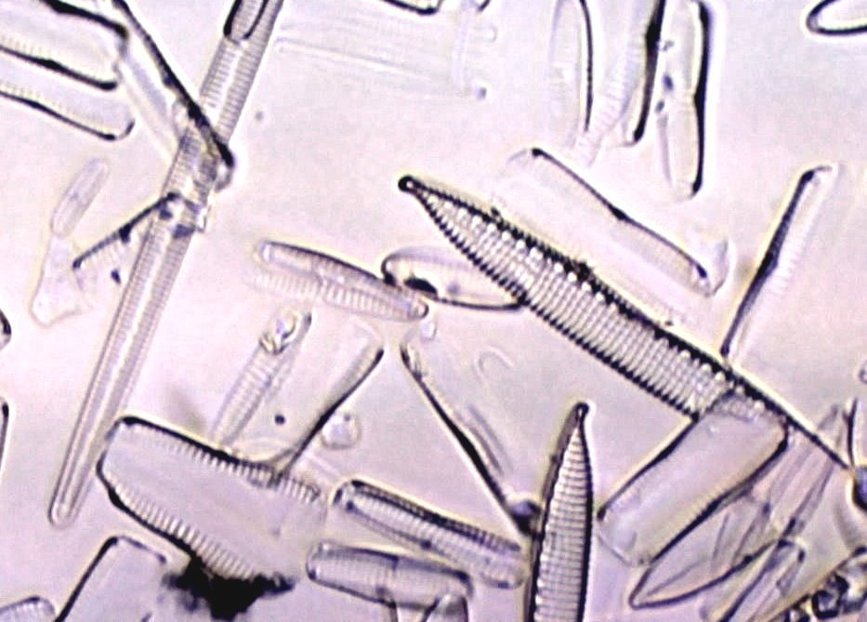
Both_15mmCond_Crop_Adj2_016.jpg (114.76 KiB) Viewed 2689 times
There is some background hue - probably left over from the fringing. Illumination is from a white LED. The fringes from each of the prisms seem to largely cancel each other out. I'll try again to get the proper condenser working.
Louise
A Nikon CF plan 20x; A Swift 380T; A DIY infinity corrected focus rail system with a 40x/0.65 Olympus Plan, a 10x/0.30 Amscope Plan Fluor, and a 20x/0.75 Nikon Plan Apo
Top
Quote
Post
jmp
Posts: 66
Joined: Sun Feb 16, 2020 2:07 am
Location: Texas

Re: DIC Question

#242 by jmp » Wed Aug 25, 2021 2:59 pm
LouiseScot wrote: ↑
Tue Aug 24, 2021 3:51 pm
Are you trying to do it with like normal prism sliders? I think that would be difficult - which is why Rathi used the open frame design.
The sliders for this microscope are relatively large. The smallest one is l=80mm by w=30mm, with the constraint being on the width. Two stacked polycarbonate prisms, covering the entire exit pupil of the objective, will fit there and it should be possible to adjust the bending force if the frame is made of metal (aluminum should be enough, though perhaps brass would be better).
LouiseScot wrote: ↑
Tue Aug 24, 2021 3:51 pm
The fringes from each of the prisms seem to largely cancel each other out.
I noticed this when I did some tests with single prism sliders. When I inserted only one slider the (asymmetric) interference pattern was visible at the back focal plane of the objective. Once I got both sliders in, with the prisms aligned on the same axis, I didn't see any interference pattern, but if the sliders (and prisms) were at 45deg the interference pattern looked like a crosshatch!
Top
Quote
Post
LouiseScot
Posts: 1001
Joined: Tue Jul 07, 2020 1:51 pm
Location: Scotland

Re: DIC Question

#243 by LouiseScot » Wed Aug 25, 2021 3:44 pm
jmp wrote: ↑
Wed Aug 25, 2021 2:59 pm
LouiseScot wrote: ↑
Tue Aug 24, 2021 3:51 pm
Are you trying to do it with like normal prism sliders? I think that would be difficult - which is why Rathi used the open frame design.
The sliders for this microscope are relatively large. The smallest one is l=80mm by w=30mm, with the constraint being on the width. Two stacked polycarbonate prisms, covering the entire exit pupil of the objective, will fit there and it should be possible to adjust the bending force if the frame is made of metal (aluminum should be enough, though perhaps brass would be better).
LouiseScot wrote: ↑
Tue Aug 24, 2021 3:51 pm
The fringes from each of the prisms seem to largely cancel each other out.
I noticed this when I did some tests with single prism sliders. When I inserted only one slider the (asymmetric) interference pattern was visible at the back focal plane of the objective. Once I got both sliders in, with the prisms aligned on the same axis, I didn't see any interference pattern, but if the sliders (and prisms) were at 45deg the interference pattern looked like a crosshatch!
But aren't objective prism sliders usually designed for Nomarski prisms? The Sanderson prisms are more like Wollaston prisms which I think need special objectives? Unless maybe a low magnification objective is used and which has its back focal plane outside of the objective casing. The condenser prisms, however, can be Wollaston type. I think if I had a scope with spaces for prism sliders I might just buy Nomarski objective prisms. You might still get away with a Sanderson Prism in the condenser if you can get one to fit
I've been trying to get things to work with an actual condenser but it seems to mess things up when using the prisms. Rathi's diagram shows a 15mm spacing between the condenser lens and the condenser prism but I can't do that with a standard condenser. I'll have to try and disassemble the condenser to take the lenses out and then 3D print a new holder. Even then it could be very tight. I'd really like to see exactly how a DIC condenser is put together...
Louise
A Nikon CF plan 20x; A Swift 380T; A DIY infinity corrected focus rail system with a 40x/0.65 Olympus Plan, a 10x/0.30 Amscope Plan Fluor, and a 20x/0.75 Nikon Plan Apo
Top
Quote
Post
Scarodactyl
Posts: 2040
Joined: Sat Mar 03, 2018 9:09 pm

Re: DIC Question

#244 by Scarodactyl » Wed Aug 25, 2021 3:51 pm
I wonder if a sanderson prism in condenser + an epi DIC top would make for a good combination.
Top
Quote
Post
LouiseScot
Posts: 1001
Joined: Tue Jul 07, 2020 1:51 pm
Location: Scotland

Re: DIC Question

#245 by LouiseScot » Wed Aug 25, 2021 3:55 pm
Scarodactyl wrote: ↑
Wed Aug 25, 2021 3:51 pm
I wonder if a sanderson prism in condenser + an epi DIC top would make for a good combination.
I've no idea - but if you have a DIC condenser you could give it a go!
Louise
A Nikon CF plan 20x; A Swift 380T; A DIY infinity corrected focus rail system with a 40x/0.65 Olympus Plan, a 10x/0.30 Amscope Plan Fluor, and a 20x/0.75 Nikon Plan Apo
Top
Quote
Post
LouiseScot
Posts: 1001
Joined: Tue Jul 07, 2020 1:51 pm
Location: Scotland

Re: DIC Question

#246 by LouiseScot » Wed Sep 15, 2021 3:54 pm
Just a quick update. Well not much to say actually as I've been busy with other things... So no further DIC progress. I ordered some lenses from Surplus Shed a few weeks ago. They are a bit slow with shipping and I'll have to wait for them to make their way through UK customs and post. I might get a bill for customs charges. Still, it shouldn't be too long before I'm back on it - again!
Louise
A Nikon CF plan 20x; A Swift 380T; A DIY infinity corrected focus rail system with a 40x/0.65 Olympus Plan, a 10x/0.30 Amscope Plan Fluor, and a 20x/0.75 Nikon Plan Apo
Top
Quote
Post
dolmadis
Posts: 36
Joined: Mon Jan 08, 2018 6:06 pm

Re: DIC Question

#247 by dolmadis » Thu Nov 11, 2021 5:09 pm
Hi
Been reading this and the other threads on evolving Sanderson Prisms.
Looking at figure 2b on the Rathi paper has anyone delved into or speculated upon the description which cites that the bending moment is modulated by two set screws (the condenser prism) ?
Where were the two set screws placed relative to the smaller polycarbonate beam which is mounted within the circular frame?
Where should they be placed if that has not been disclosed or deduced to achieve the effect that contributors here have re-produced in the open frame?
Thanks, John
Top
Quote
Post
LouiseScot
Posts: 1001
Joined: Tue Jul 07, 2020 1:51 pm
Location: Scotland

Re: DIC Question

#248 by LouiseScot » Thu Nov 11, 2021 8:33 pm
dolmadis wrote: ↑
Thu Nov 11, 2021 5:09 pm
Hi
Been reading this and the other threads on evolving Sanderson Prisms.
Looking at figure 2b on the Rathi paper has anyone delved into or speculated upon the description which cites that the bending moment is modulated by two set screws (the condenser prism) ?
Where were the two set screws placed relative to the smaller polycarbonate beam which is mounted within the circular frame?
Where should they be placed if that has not been disclosed or deduced to achieve the effect that contributors here have re-produced in the open frame?
Thanks, John
Hiya
My current condenser prism has been fabricated roughly in proportion to Rathi's open frame design. Fortunately, I'm not constrained to using an existing condenser. The exact spacing between set screws / supports isn't critical - just has to be symmetrical. I'm just finalising my condenser/ prism version but I'm using a Nikon DIC objective nosepiece with the small Sanderson prism for the condenser. I hope to post an update before too long
Louise
A Nikon CF plan 20x; A Swift 380T; A DIY infinity corrected focus rail system with a 40x/0.65 Olympus Plan, a 10x/0.30 Amscope Plan Fluor, and a 20x/0.75 Nikon Plan Apo
Top
Quote
Post
dolmadis
Posts: 36
Joined: Mon Jan 08, 2018 6:06 pm

Re: DIC Question

#249 by dolmadis » Thu Nov 11, 2021 8:42 pm
Hi Louise
Thanks for sharing your understanding which you have amassed so far.
I assume that the Rathi condenser prism is a rectangular prism?
It would be useful if a condenser prism could be fashioned from a disc of polycarbonate but I would imagine that it has to be in the form of a beam?
Best, John
Top
Quote
Post
LouiseScot
Posts: 1001
Joined: Tue Jul 07, 2020 1:51 pm
Location: Scotland

Re: DIC Question

#250 by LouiseScot » Thu Nov 11, 2021 9:28 pm
dolmadis wrote: ↑
Thu Nov 11, 2021 8:42 pm
Hi Louise
Thanks for sharing your understanding which you have amassed so far.
I assume that the Rathi condenser prism is a rectangular prism?
It would be useful if a condenser prism could be fashioned from a disc of polycarbonate but I would imagine that it has to be in the form of a beam?
Best, John
Hi
Yeah, it needs to be rectangular. I cut my current one from a small piece (A5, think) of 2mm clear polycarbonate. It's cheap and the small pieces are easy to get via Ebay. I sawed a section that's 39mm x 14mm for the condenser prism. You need to cut a second piece which sits to one side of (in front or behind) the stressed prism. The second piece has to be cut from the A5 sheet at right angles to the original piece, and it functions as a waveplate.
Here's a quick pic:
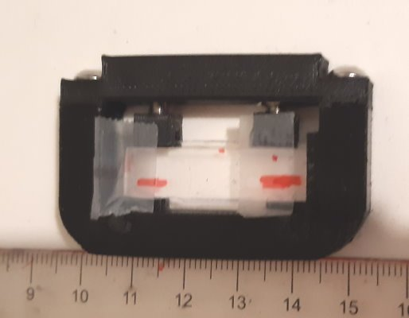
DIC_prism_small.jpg (18.43 KiB) Viewed 2263 times
The 'extra' piece is just being held in place by some tape. I've used M4 grub screws for the 'set screws'.
Louise
A Nikon CF plan 20x; A Swift 380T; A DIY infinity corrected focus rail system with a 40x/0.65 Olympus Plan, a 10x/0.30 Amscope Plan Fluor, and a 20x/0.75 Nikon Plan Apo
Top
Quote
Post
dolmadis
Posts: 36
Joined: Mon Jan 08, 2018 6:06 pm

Re: DIC Question

#251 by dolmadis » Thu Nov 11, 2021 9:55 pm
Many thanks for the demonstration in response to the naive question I posed. Very helpful.
Looking forward to seeing the results of your experimentation with the DIC nosepiece.
Best, John
Top
Quote
Post
amphicyon
Posts: 21
Joined: Fri Dec 03, 2021 9:46 am

Re: DIC Question

#252 by amphicyon » Fri Dec 03, 2021 10:02 am
Hello
I am writing here for the first time, although I have been reading for a long time.
I am also a amateur microscopist, from Ukraine (so forgive me for my english).
You don't need a fully symmetric DIC system, one prism is enough. In condenser you need to insert a SLIT diaphragm in aperture plate. In the cut of which you need to place a strip of prism the same color. And you get a real DIC.
I use this method on my Carl Zeiss Jenaval scope with one dic prism from metallurgical scope.
Top
Quote
Post
viktor j nilsson
Posts: 659
Joined: Thu Aug 23, 2018 10:12 pm
Location: Lund, Sweden

Re: DIC Question

#253 by viktor j nilsson » Fri Dec 03, 2021 10:44 am
I'd love to see some pictures. That is the principle of Zeiss's recent plasDIC system, and PZO also provided a slit condenser for the same purpose. I haven't played around with it myself, but was under the impression that it is limited in color range and resolution (as you are not filling the objective aperture).
Top
Quote
Post
amphicyon
Posts: 21
Joined: Fri Dec 03, 2021 9:46 am

Re: DIC Question

#254 by amphicyon » Fri Dec 03, 2021 10:57 am
Yes, slit method does not full fill a aperture of objective and resolution is decrease. But not so hard. And color is fine.
I have a PZO DIC system also, but its condenser not compatible with Zeiss. I made slider in condenser from common microscope slide and blades of old safe razor.
Video from Zeiss with "slit condenser".
https://youtu.be/4FOW0dZOKLw
Top
Quote
Post
viktor j nilsson
Posts: 659
Joined: Thu Aug 23, 2018 10:12 pm
Location: Lund, Sweden

Re: DIC Question

#255 by viktor j nilsson » Fri Dec 03, 2021 2:07 pm
More colorful than I had expected, but the low resolution of the video really makes it hard to judge.
But I'm curious to test it myself, it's definitely an interesting technique that should get more attention as it's so easy to diy.
Top
Quote
Post
amphicyon
Posts: 21
Joined: Fri Dec 03, 2021 9:46 am

Re: DIC Question

#256 by amphicyon » Fri Dec 03, 2021 3:57 pm
Video really not sharp. Maybe this photo shows the quality better.
DIC Nikon 20x0.75 by Konstantin M, on Flickr
The field not solid because this i used Nikon Planapo 20x0.75 objective, wich not good work with my DIC prism.
Top
Quote
Post
tpruuden
Posts: 59
Joined: Mon Feb 22, 2021 7:44 pm

Re: DIC Question

#257 by tpruuden » Wed Dec 15, 2021 3:43 pm
dolmadis wrote: ↑
Thu Nov 11, 2021 8:42 pm
I assume that the Rathi condenser prism is a rectangular prism?
It would be useful if a condenser prism could be fashioned from a disc of polycarbonate but I would imagine that it has to be in the form of a beam?
The prism can be any arbitrary shape, as long one can create suitable stress gradient in the material (may not be easy). Additionally, there is some DIC even if the gradients are not fully overlapping for both prisms. The example image is of frameless, nearly square prism, I also experimented with D and other multifaceted shapes.
ATTACHMENTS
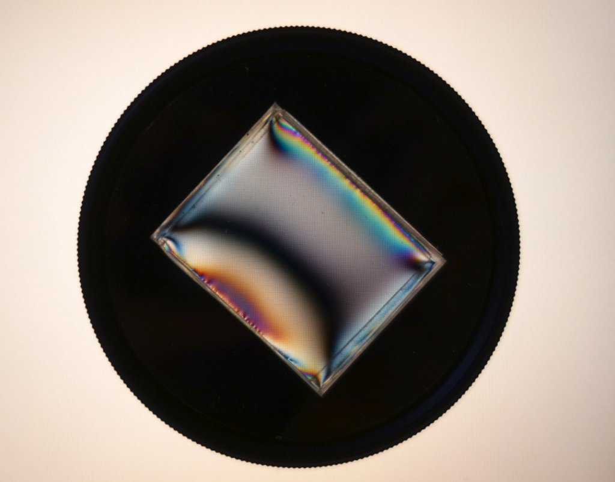
photo1639840464.jpeg (64.15 KiB) Viewed 1819 times
Top
Quote
Post
tpruuden
Posts: 59
Joined: Mon Feb 22, 2021 7:44 pm

Re: DIC Question

#258 by tpruuden » Sat Jan 01, 2022 6:49 pm
It may be interesting to use other types of shear gradients:
ATTACHMENTS
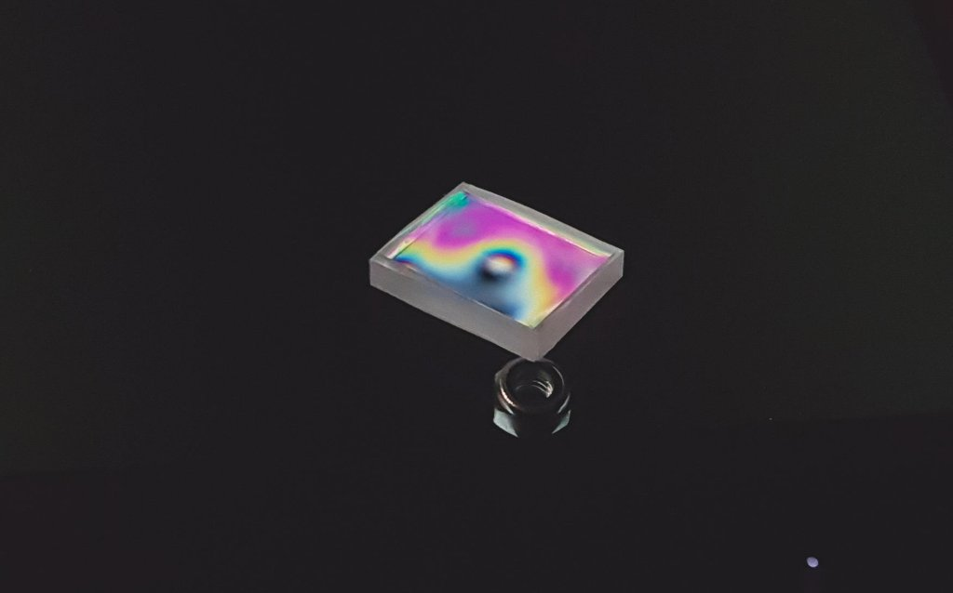
Circular gradient.jpg (27.73 KiB) Viewed 1708 times
Top
Quote
Post
Post Reply

