OK what about Zeiss standard DIC?
Quote
by waterbear »
Post
In my search for DIC info, I naturally came across old built-like-a-tank Zeiss scopes. I saw a few Zeiss condensers for sale with one arrow symbol or two arrows.
Anyone got a view on which system is best and ideas on objective compatibility/availability?
Maybe this is an option for transmitted light DIC on a budget (well maybe not a "budget" by the time I have all the parts anyway).
Leitz Orthoplan
Top
JohnyM
Posts: 463
Joined: Tue Dec 24, 2013 7:02 am
Quote
by JohnyM »
Post
Check out PZO DIC "UPI". One of most advanced and also cheapest DIC systems i know.
Old Zeiss (West) is notorious for delamination. I've bought few pieces of those systems in pristine condition that... still went bad after short (relative) time.
On the other hand Zeiss Jena is of excellent quality, but coarsly build in comparision to West.
Late infinite west optics, or infinite optics after merging is free of that problem.
Top
Ichthyophthirius
Posts: 1152
Joined: Thu Mar 07, 2013 5:24 am

Re: OK what about Zeiss standard DIC?
Quote
by Ichthyophthirius »
Post
waterbear wrote:I saw a few Zeiss condensers for sale with one arrow symbol or two arrows.
Surely not two arrows.
There are two main DIC systems for the 160 mm Zeiss West microscopes (INKO = Interferenzkontrast): http://www.photomacrography.net/forum/v ... 113#182113
1) INKO "old" with a condenser (single arrow) and one large objective-side prism (I, II or III) for all objectives. The objective-side prism is mounted in an intermediate tube (there are different versions, not all are compatible).
2) INKO "new" with a condenser (two options: normal NA 1.4 (46 52 85) and long distance NA 0.63 (46 52 73) mainly for inverted microscopes) and small objective-side prisms, one for each objective. An intermediate tube is also needed to mount the analyser slider. The "two arrows" "S" and "T" indicate the different condenser prism configurations for small and large Zeiss microscopes.
http://www.photomacrography.net/forum/v ... p?p=217306
INKO "old" is a bit cheaper as you need only one objective-side prism and mainly accommodates objectives 16:1, 40:1 and 100:1 (although a few off-label combinations also work).
INKO "new" is more flexible but the more exotic prism sliders can be very expensive. http://www.microscopeitaly.it/2009/11/3 ... -versione/
All suffer from delamination. This makes it difficult to find a setup in good conditions but on the other hand, prisms with small areas of delamination still work (especially if it is just the condenser) and can be a real bargain.
You need to be patient and wait for months and years until you got all the parts together for a good price!
Top
waterbear
Posts: 14
Joined: Tue Jan 08, 2019 5:29 am
Quote
by waterbear »
Post
thanks very much this forum is a wealth of information - I'm doing more research. It seems that there are some of the latter and possibly more desirable DIC sets available but if delamination is a problem then it's probably down to temperature and moisture changes in a short space of time. That certainly rules out shipping from overseas at this time of year anyway. I opened an objective from the USA the other day and it had condensation forming on it instantly it was almost frozen .
Leitz Orthoplan
Top
Ichthyophthirius
Posts: 1152
Joined: Thu Mar 07, 2013 5:24 am
Quote
by Ichthyophthirius »
Post
waterbear wrote:That certainly rules out shipping from overseas at this time of year anyway. I opened an objective from the USA the other day and it had condensation forming on it instantly it was almost frozen .
You're right, winter shipping is always problematic for these items! I wouldn't risk it this time of year.
Even in spring or autumn, it's wise to leave the package for 24h at room temperature before opening it. Delayed gratification
Top
viktor j nilsson
Posts: 419
Joined: Fri Mar 01, 2013 1:43 am
Location: Lund, Sweden
Quote
by viktor j nilsson »
Post
I am not really planning to shell out the dough needed to put together a DIC system, but I have been reading a lot of DIY DIC threads with great interest lately. (is that the first symptoms of DIC stepwise acquisition disorder?).
Anyway, now that JohnyM and others are listening, i have a question:
What are the parameters that determine whether two Nomarski prisms match 1) each other; and 2) a specific objective?
I've noted that there is a russian distributor that sells Nomarski prisms: http://opticsprovider.com/optics/nomarski-prism
I have no idea what they cost, but it made me curious to know if it's possible to put together a system from just the raw prisms. It seems like matching prisms from different makers and versions is hit and miss. But what if you start out with a new, matching set?
So: What parameters do you need to consider to put together a DIC system that works for a couple of different objectives, say a 20x PA and a 40x or 60x PA?
Top
waterbear
Posts: 14
Joined: Tue Jan 08, 2019 5:29 am
Quote
by waterbear »
Post
Good idea. Wouldn't it be great if we could all re-invigorate DIC for old scopes which were on the junk pile?
I'm guessing parameters would be relating to numerical aperture and focal ratio (steepness of the light cone emanating from the objective).
I imagine that is thickness and angle, and extinction amount seems to be constant in their specs.
They are saying 30 arc sec deviation so it appears to be quite a tolerant system. 1/4 wave in red light isn't too accurate either to be honest. I would expect that green light where the eye is most sensitive. 4 surfaces = one whole wave. That is not accurate by any means but it may be all that's required at these long focal ratios. Not sure maybe someone can comment?
They also say they offer housings, so perhaps they are used to making them to spec and may even already know the parameters from buying old delaminated zeiss prisms, and measuring the thickness and angles, so one just needs to describe the system to them? Or send them some junked components.
They offer Senarmon, which it appears is better than Nomarski or at least more convenient to use (I have been reading about it on the Nikon website). If they could offer that for Zeiss 160 and Leitz 170 TL systems I for one would jump at it. Even infinity, anything to avoid buying stuff which may or may not work on eBay
Leitz Orthoplan
Top

Pau
Site Admin
Posts: 5850
Joined: Wed Jan 20, 2010 8:57 am
Location: Valencia, Spain
Quote
by Pau »
Post
Mixing and matching DIC components is risky and full of uncertainty although in some cases it works. *
waterbear wrote:...
I'm guessing parameters would be relating to numerical aperture and focal ratio (steepness of the light cone emanating from the objective).
I imagine that is thickness and angle, and extinction amount seems to be constant in their specs.
...
AFAIK the amount of shear and the focal distance where the interference band is placed (Nomarski prisms have it located outside the prism) to match the objective rear focal plane are main parameters. Unfortunately makers do not disclose them and I lack the knowledge and tools to measure it.
Also the objective rear focal plane is not standardized and many objectives can't deliver DIC. With my system I can't get DIC with any phase objectives I've tested, for example, but I get decent DIC with some non phase Leitz NPL fluotar and Pl Fluotar (160), Zeiss Planapo and and Nikon CF Plan Apo, even with a highly mismatched Nikon CFI Plan Apo 20/0.75.
I agree with Johny about the PZO system: because it is highly regulable it can work well with many objectives not designed to work with it like Nikon CF and Leitz NPL fluotars
* see my hybrid setup at http://www.photomacrography.net/forum/v ... hp?t=15606
Pau
Top
abednego1995
Posts: 84
Joined: Tue Nov 01, 2016 11:53 pm
Quote
by abednego1995 »
Post
Well, the main parameters for making a Nomarski prism would be the apex angle (alpha) and the section angle (beta). Shear amount is dictated by the apex angle, and where the interference plane comes, by the crystal(mostly quartz) axis section angle.
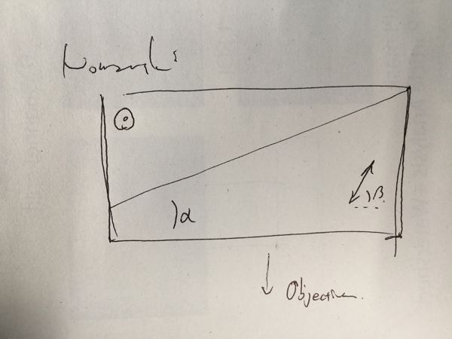
The most important equation your optics have to fulfill in DIC would probably be the function which describes "pupillar compensation"
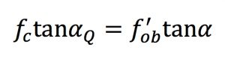
fc: condenser focal length
alphaQ: condenser prism wedge angle
fob: objective focal length
alpha: objective prism wedge angle
I'll skip other mathematical magic involved, but in systems where there is only one translating prism above the objective the only parameter easily changed would be alphaQ, with the condenser prism. This explains when only one prism is at the objective side, multiple prisms are required for the condenser (of course you still have to consider the aperture, but that is another story.) And when the shear amount is dictated by the NA of the objective (it must be under the resolution limit for obvious reasons), you get a quite tight design margin for the apex angle of the objective prism, typically 0.5-1 degrees from low to high NA.
What I'm guessing is, most Nomarski DIC prisms that are made for same magnifications and NA might have very similar apex angles with different section angles.
So, if you already have a DIC condenser and a few mismatching nomarski prisms sitting around, being careful to match the objective prism to the indicated magnification, and getting the prism interference plane to coincide with the BFP of your objective might suffice. i.e, if you can vary the position of the objective prism vertically, even in ill performing setups, there is a possibility of resurrecting your Frankenskop (again?).
Cheers,
John
Top
viktor j nilsson
Posts: 419
Joined: Fri Mar 01, 2013 1:43 am
Location: Lund, Sweden
Quote
by viktor j nilsson »
Post
Thank you! That mostly match my intuition about the parameters involved. It seems like you could get a lot of different Nomarski prisms to play well together if you were able to move them vertically.
Top
Pau
Site Admin
Posts: 5850
Joined: Wed Jan 20, 2010 8:57 am
Location: Valencia, Spain
Quote
by Pau »
Post
abednego1995 wrote:Well, the main parameters for making a Nomarski prism would be the apex angle (alpha) and the section angle (beta). Shear amount is dictated by the apex angle, and where the interference plane comes, by the crystal(mostly quartz) axis section angle.
....
fc: condenser focal length
alphaQ: condenser prism wedge angle
fob: objective focal length
alpha: objective prism wedge angle
...
What I'm guessing is, most Nomarski DIC prisms that are made for same magnifications and NA might have very similar apex angles with different section angles.
With beta angle and section angle, do you refer to the angle the optical planes of both sections of the same prism? Is it what determines the distance of the interference plane to the prism?
So, if you already have a DIC condenser and a few mismatching nomarski prisms sitting around, being careful to match the objective prism to the indicated magnification, and getting the prism interference plane to coincide with the BFP of your objective might suffice. i.e, if you can vary the position of the objective prism vertically, even in ill performing setups, there is a possibility of resurrecting your Frankenskop (again?).
I've tried it with different prisms for reflected DIC as objective prisms and none of them worked. I've also tried my Oly U-DICT at different positions trying to improve evenness without positive results (but getting negative ones ).
What I do as a routine with big effect is to move the condenser up and down, in fact with most of my objectives DIC is realized a bit outside the ideal Köhler position.
Pau
Top
abednego1995
Posts: 84
Joined: Tue Nov 01, 2016 11:53 pm
Quote
by abednego1995 »
Post
Yup, the beta angle and section angle are the same and they determine the distance of the interference plane to the prism.
I've tried it with different prisms for reflected DIC as objective prisms and none of them worked. I've also tried my Oly U-DICT at different positions trying to improve evenness without positive results (but getting negative ones Confused ).
What I do as a routine with big effect is to move the condenser up and down, in fact with most of my objectives DIC is realized a bit outside the ideal Köhler position.
I'm also trying dinking around with those reflected DIC prisms since they are cheaper compared with those for transmitted DIC. I think what you're getting by moving the condenser up and down, is shifting the image plane of the condenser aperture and by doing so, matching the plane with the interference plane of the mismatched objective prism. It will mess up Koehler, but you're probably getting DIC in that way. I'm currently thinking of making a bare mount for the objective, and placing a positioning mount for the objective prism. It'll look more like a optical bench setup, but who cares? It could be cheap:-)
Top
viktor j nilsson
Posts: 419
Joined: Fri Mar 01, 2013 1:43 am
Location: Lund, Sweden
Quote
by viktor j nilsson »
Post
Here's a few more question:
1) how is it possible for the first-generation Zeiss inko system to use a single objective prisms for all objectives? The more I think about it the weirder it seems. How would you design such a jack-of-all-trades prism?
2) is it really critical to place the objective prism exactly at the rear focal plane of the objective? It doesn't seem that way to me: some systems place the prisms immediately between the objective and the nose piece, and others (from the same maker) place them well above the objectives inside the nosepiece or inside an intermediate tube. Surely the location of the rear focal plane can't be that different among the objectives for those systems?
Top
viktor j nilsson
Posts: 419
Joined: Fri Mar 01, 2013 1:43 am
Location: Lund, Sweden
Quote
by viktor j nilsson »
Post
abednego1995 wrote:I'm also trying dinking around with those reflected DIC prisms since they are cheaper compared with those for transmitted DIC. [...]
I'm currently thinking of making a bare mount for the objective, and placing a positioning mount for the objective prism. It'll look more like a optical bench setup, but who cares? It could be cheap:-)
Love this idea! I actually put in an offer for some reflected DIC prisms just to have something to play with, if I can get DIC to work with one or two objectives that'd be awesome, but at least I'll learn something (hopefully).
Top
Ichthyophthirius
Posts: 1152
Joined: Thu Mar 07, 2013 5:24 am
Quote
by Ichthyophthirius »
Post
viktor j nilsson wrote:1) how is it possible for the first-generation Zeiss inko system to use a single objective prisms for all objectives? The more I think about it the weirder it seems. How would you design such a jack-of-all-trades prism?
2) is it really critical to place the objective prism exactly at the rear focal plane of the objective? It doesn't seem that way to me: some systems place the prisms immediately between the objective and the nose piece, and others (from the same maker) place them well above the objectives inside the nosepiece or inside an intermediate tube. Surely the location of the rear focal plane can't be that different among the objectives for those systems?
1) The single prism is designed to match the exit pupils of all 3 (4) objectives it was intended for, Plan 16, Plan 40 and Plan 100 (+ Plan 6,3). The objectives were re-designed for this; some older Plan 40s are incompatible.
Read more about the design here: https://www.microscopyu.com/pdfs/Allen_ ... 3-1969.pdf
There are then 3 (4) compensating prisms in the condenser to correct for all 3 (4) different magnifications.
Also, it's not a dated concept. Olympus and Leica are using single objective-side prisms. They have multiple condenser prisms to compensate. Zeiss and Nikon have multiple objective-side prisms and just a few (mostly 2) condenser prisms.
2) Some early interference contrast systems placed prisms directly in the back focal plane. The innovation of the Nomarski prism (over the Wollaston) was that the interference fringes are located outside the prism, so the prism could be placed outside the objective as well. Leitz was the only company that had prisms inside the objectives until the 1980s.
See here: http://olympus.magnet.fsu.edu/primer/ja ... index.html
Regards, Ichty

by Pau »
Post
viktor j nilsson wrote:Here's a few more question:
1) how is it possible for the first-generation Zeiss inko system to use a single objective prisms for all objectives? The more I think about it the weirder it seems. How would you design such a jack-of-all-trades prism?
2) is it really critical to place the objective prism exactly at the rear focal plane of the objective? It doesn't seem that way to me: some systems place the prisms immediately between the objective and the nose piece, and others (from the same maker) place them well above the objectives inside the nosepiece or inside an intermediate tube. Surely the location of the rear focal plane can't be that different among the objectives for those systems?
1- Using different condenser prisms for different magnification objectives. The goal in all cases is to match the interference band of both prisms at the rear focal plane of the objective. This is the original Nomarski design first implemented by Zeiss.
Zeiss moved to the individual objective prisms at the nosepiece design in their double arrow system but Olympus still uses the original design although with objective-dedicated changeable condenser prisms
2- In principle it is, although I think that you can place it a bit higher or lower if you still accomplish the condition of matching the interference band of both prisms at the same plane and close to the objective rear focal plane (I suppose that this is what I'm doing when I move a bit the condenser outside the Kölher position to obtain DIC in my hybrid setup)
It depends of the prisms design, the "section or beta angle" referred by abednego1995 is what determines the distance between the interference plane and the objective rear focal plane.
With a Wollaston prism this plane is placed inside the prism but the modified Wollaston prism by Nomarski places it outside the prism. I think that some Leitz DIC systems placed the prisms inside the objective for this reason (and so avoiding to pay Nomarski license fees)
Pau
Top
viktor j nilsson
Posts: 419
Joined: Fri Mar 01, 2013 1:43 am
Location: Lund, Sweden
Quote
by viktor j nilsson »
Post
Thanks, I think I understand a bit more now. I was confused because some places online claim to show Nomarski prisms but actually show Wollaston prisms located exactly at the rear focal plane. This one for example:
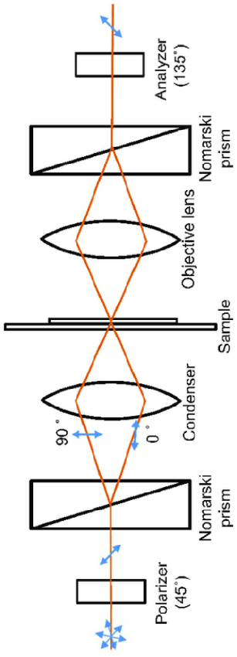
In this case, the objective-side prism must be located exactly at the rear focal plane. I had to look around a bit for an illustration that actually showed Nomarski prisms and found this:
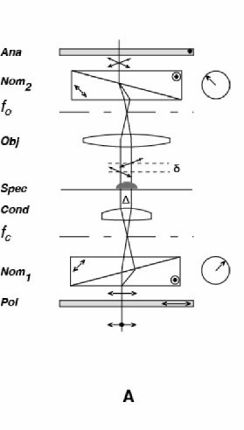
So when we have a Nomarski prism, it's the front interference plane of the objective-side prism that must coincide with the objective rear focal plane - not the prism itself. Correct?
Image sources:
https://www.researchgate.net/figure/Exp ... 190278/amp
http://microscopy.berkeley.edu/courses/ ... asdic.html
Top
viktor j nilsson
Posts: 419
Joined: Fri Mar 01, 2013 1:43 am
Location: Lund, Sweden
Quote
by viktor j nilsson »
Post
Ooops, the seller accepted my low-ball offer, so soon I'll have four Nikon epi-DIC Nomarski prisms to play with.
Top
abednego1995
Posts: 84
Joined: Tue Nov 01, 2016 11:53 pm
Quote
by abednego1995 »
Post
So when we have a Nomarski prism, it's the front interference plane of the objective-side prism that must coincide with the objective rear focal plane - not the prism itself. Correct?
Exactly.
I've had the same problems in the past with DIC schematics showing Wollaston prisms in a Nomarski setup. Another thing... The upper wedge must be thinner than the lower wedge in a Nomarski prism, but most drawings just have a straight line connecting the corners. Small but important difference.[/code]
Top

blekenbleu
Posts: 133
Joined: Sat May 10, 2008 5:37 pm
Location: U.S.
Contact:

Re: OK what about Zeiss standard DIC?
Quote
by blekenbleu »
Post
Nikon has reflected DIC prisms with label: "10.40.100x";
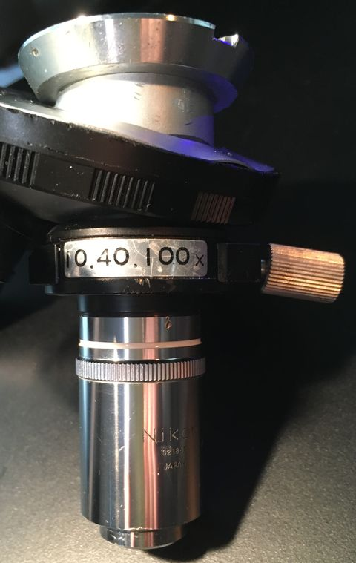
... does that suggest some trade-off e.g. between magnification and distance from back focal plane?
Metaphot, Optiphot 1, 66; AO 10, 120, and EPIStar 2571
https://blekenbleu.github.io/microscope
Contact blekenbleu
Top
Pau
Site Admin
Posts: 5850
Joined: Wed Jan 20, 2010 8:57 am
Location: Valencia, Spain

Re: OK what about Zeiss standard DIC?
Quote
by Pau »
Post
blekenbleu wrote: ↑
Sat Dec 10, 2022 9:31 am
Nikon has reflected DIC prisms with label: "10.40.100x";
... does that suggest some trade-off e.g. between magnification and distance from back focal plane?
Maybe, the Zeiss old InKo reflected (DIC) system uses the same prism for 4X and 8X objectives but not for higher magnifications.
Another approach is making the prism adjustable vertically like in some Reichert and Leica metallurgical models with only one prism for all objectives
Pau
Top
blekenbleu
Posts: 133
Joined: Sat May 10, 2008 5:37 pm
Location: U.S.
Contact:

Re: OK what about Zeiss standard DIC?
Quote
by blekenbleu »
Post
Elongated DIC sliders presumably have their interface between (quartz?) wedges change vertically when sliders move horizontally, so more universal but fussy to adjust among objectives.
I wonder whether Nikon objectives with DIC engraving were verified to both be strain-free as well as having precisely registered back focal planes to accommodate relatively fixed prisms.
Metaphot, Optiphot 1, 66; AO 10, 120, and EPIStar 2571
https://blekenbleu.github.io/microscope
Contact blekenbleu
Top
viktor j nilsson
Posts: 419
Joined: Fri Mar 01, 2013 1:43 am
Location: Lund, Sweden

Re: OK what about Zeiss standard DIC?
Quote
by viktor j nilsson »
Post
blekenbleu wrote: ↑
Sat Dec 10, 2022 10:21 am
I wonder whether Nikon objectives with DIC engraving were verified to both be strain-free as well as having precisely registered back focal planes to accommodate relatively fixed prisms.
A couple of years ago, when I bought the epi-DIC prisms discussed above, I made some experiments to learn more about this exact issue. I wanted to know the location of the interference fringe of each prism, so that I could know at least roughly where to place the prisms in my DIY DIC setup. I didn't know how to observe the location of the fringe directly, so I instead measures the location of the back focal plane of the objectives the prisms where designed for. I didn't have all the M plan DIC objectives, but I did have a regular M plan 10x, a Mplan 20x DIC, and a M plan 40x DIC.
To measure the location of the BFP, I used Paolo Pozzi's method described here: https://www.researchgate.net/post/Is_th ... ctive_lens
That is, shine a laser pointer through the front lens, and measure the diameter of the projected circle at different distances from the back of the objective, fit a regression and calculate where the diameter is expected to reach zero.
I'll post some screenshots of the data in another post, but the results were quite interesting. Here's some highlights:
M plan 10x: -1.36 mm
M plan 20x DIC: -4 mm
M plan 40x DIC: -1.13mm
CF Fluor 10x: +0.5mm
CF E plan 4x: roughly +15mm
Measurements are given as a distance from the back edge of the objective, not at the shoulder. So -1.36 means that the BFP is located inside the barrel, and +0.5 just outside of it.
This shows that the 10x and 40x M plans, that use the same DIC prisms, also have remarkably similar BFP locations. And the 20x M plan, that has a dedicated prism, has a BFP in a pretty different location. Furthermore, the 10x in particular appears to have been designed so that the BFP falls unusually far into the objective for a relatively low-magnification objective, while other 10x presumably have their BFPs at least some distance outside the objective barrel.
Personally, I don't think that the BFP locations differs between M plan objectives marked DIC and those lacking the DIC designation. But I do think that the 10x M plan was designed to have a BFP location that matched that of the 40x and 100x M plans.
Top
viktor j nilsson
Posts: 419
Joined: Fri Mar 01, 2013 1:43 am
Location: Lund, Sweden

Re: OK what about Zeiss standard DIC?
Quote
by viktor j nilsson »
Post
And here's the spreadsheet with raw data and regressions:
Plots show A~B, where A is diameter of illuminated circle and B is distance from rear of objective.
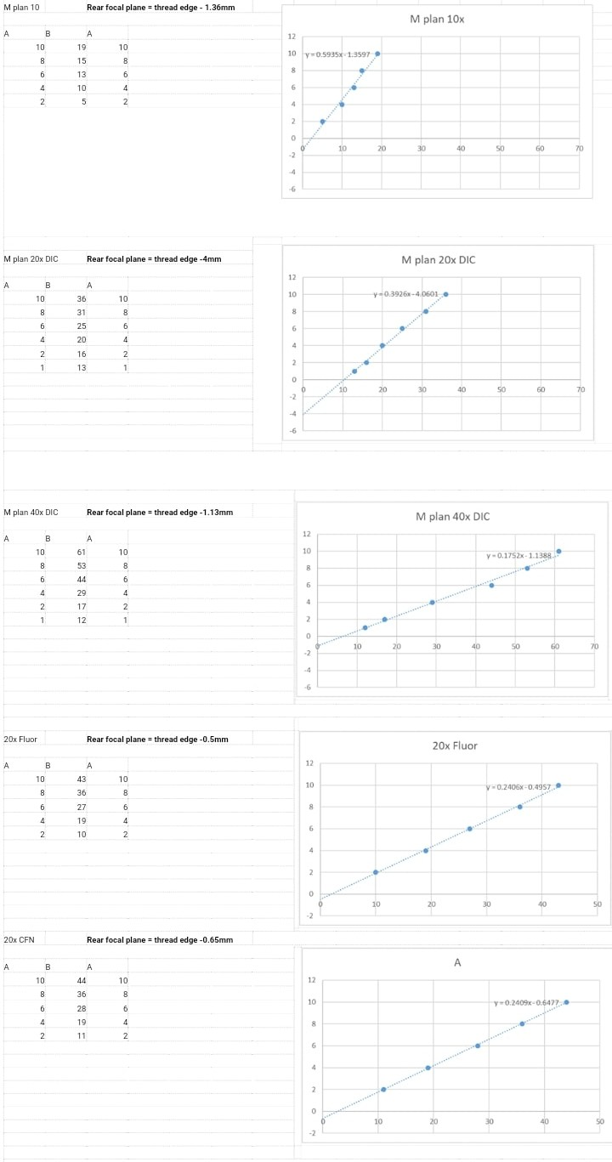
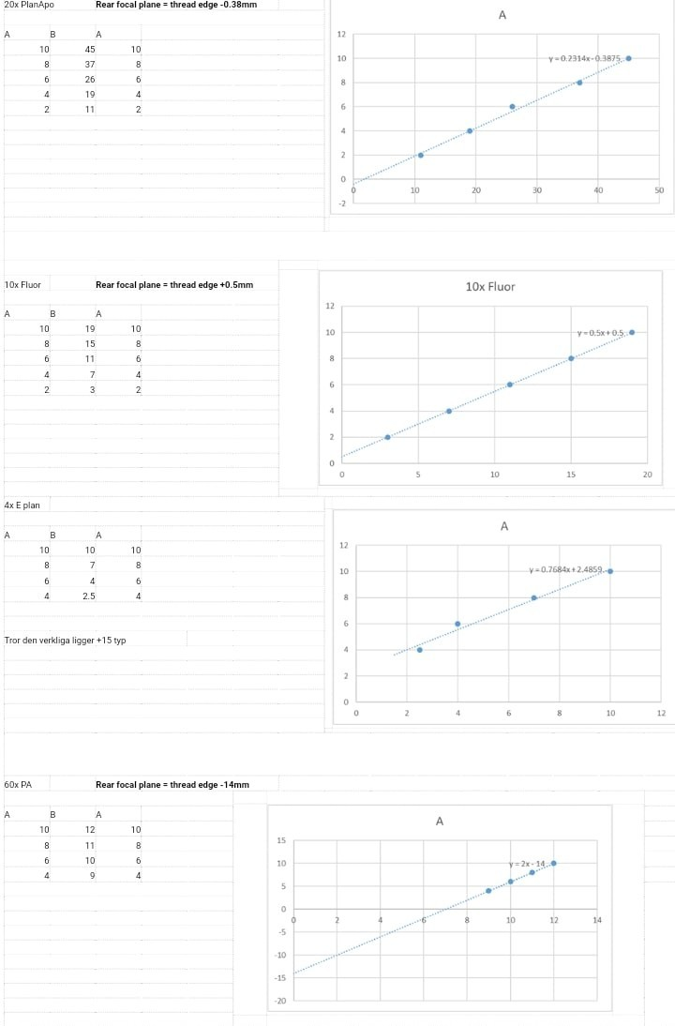
Top
viktor j nilsson
Posts: 419
Joined: Fri Mar 01, 2013 1:43 am
Location: Lund, Sweden

Re: OK what about Zeiss standard DIC?
Quote
by viktor j nilsson »
Post
Note that data for the 4x objective is nonsense, the laser pointer method don't work well with low magnification objectives with front lenses much larger than the beam diameter.
Top

rjlittlefield
Site Admin
Posts: 22920
Joined: Tue Aug 01, 2006 8:34 am
Location: Richland, Washington State, USA
Contact:

Re: OK what about Zeiss standard DIC?
Quote
by rjlittlefield »
Post
This process and data are very interesting to me. Thanks for the full description.
Data for the 4x objective does not strike me as nonsense. It also makes sense in terms of an optical design that places the rear principal plane far forward. You could check this possibility by pointing the objective at a distant scene and looking to see where it forms its image. If I understand correctly the measurement you made, then the image of the distant scene should form at the same place indicated by the laser measurement.
--Rik
Contact rjlittlefield
Top
viktor j nilsson
Posts: 419
Joined: Fri Mar 01, 2013 1:43 am
Location: Lund, Sweden

Re: OK what about Zeiss standard DIC?
Quote
by viktor j nilsson »
Post
Glad you found it interesting.
What data on the 4x do you refer to? The data in the graph, or the 15mm estimate? As I can recall, the 15mm estimate was based on pointing the objective at the sun and observing where the image was formed on a piece of paper. But the data in the graph suggests that the BFP is located 2.48mm behind the objective, which I interpreted as a spurious result caused by the fact that the laser pointer only filled a small central portion of the entrance pupil (is that the correct term?).
I just double-checked the E plan 4x, and when I aim it at two semi distant street lamps it forms a sharp image on a matte screen located ~15mm behind the objective.
Top
rjlittlefield
Site Admin
Posts: 22920
Joined: Tue Aug 01, 2006 8:34 am
Location: Richland, Washington State, USA
Contact:

Re: OK what about Zeiss standard DIC?
Quote
by rjlittlefield »
Post
I was looking at the good linearity of data in the graph.
Having heard the rest of the story, I agree that the data in the graph looks nonsense.
That shifts my curiosity to what caused the nonsense. An incoming parallel beam that fills the aperture will produce a wide-angle cone that comes to a small focus in back, which is how the image of your street lamps gets formed. An incoming parallel beam that does not fill the aperture will produce a narrower cone in the back, but barring insane aberrations it will come to a focus at the same distance. I just checked some of my own objectives and that's the way it worked with them. The narrowness and high intensity of the beam may make measuring its diameter difficult, but if there were a measurement problem then I would expect noisy data, which I did not see.
Having looked again at your data, I'm wondering if the laser beam was actually scattering off something inside the objective, like the edge of a lens element, and what you were measuring was a cone of light coming off the scattering point.
Do you have any ideas along those lines?
--Rik
Contact rjlittlefield
Top
Macro_Cosmos
Posts: 1423
Joined: Mon Jan 15, 2018 9:23 pm
Contact:

Re:
Quote
by Macro_Cosmos »
Post
Pau wrote: ↑
Tue Jan 29, 2019 6:31 am
Mixing and matching DIC components is risky and full of uncertainty although in some cases it works. *
waterbear wrote:...
I'm guessing parameters would be relating to numerical aperture and focal ratio (steepness of the light cone emanating from the objective).
I imagine that is thickness and angle, and extinction amount seems to be constant in their specs.
...
AFAIK the amount of shear and the focal distance where the interference band is placed (Nomarski prisms have it located outside the prism) to match the objective rear focal plane are main parameters. Unfortunately makers do not disclose them and I lack the knowledge and tools to measure it.
Also the objective rear focal plane is not standardized and many objectives can't deliver DIC. With my system I can't get DIC with any phase objectives I've tested, for example, but I get decent DIC with some non phase Leitz NPL fluotar and Pl Fluotar (160), Zeiss Planapo and and Nikon CF Plan Apo, even with a highly mismatched Nikon CFI Plan Apo 20/0.75.
I agree with Johny about the PZO system: because it is highly regulable it can work well with many objectives not designed to work with it like Nikon CF and Leitz NPL fluotars
* see my hybrid setup at viewtopic.php?t=15606
The shear angle of the normal type Olympus DIC slider prism (U-DICT, U-DICTS, WI-DICT) is 74μrad. Nikon's fitted nosepiece objective-specific prism is 76μrad and Zeiss is 71μrad.
A smaller shear angle and therefore shorter shear distance correspond to higher resolution, and vice versa for higher contrast. This is why Zeiss and Nikon's DIC "seems to have better resolution", it is not their "superior optics" but rather their vision of what an optimised DIC system looks like. There is nothing stopping Olympus and Leica from doing the same with matching prisms.
Assuming the normal DIC is being used.
Leica: higher contrast, common nosepiece slider with condenser prisms for specific objetives.
Nikon and Zeiss: contrast and resolution balanced, most people prefer the look of these two. Each objective has its own slider while condenser prisms are tailored for different NA.
Olympus: Between Leica and Nikon/Zeiss. Common nosepiece slider with condenser prisms for specific objectives. High contrast at lower magnifications while contrast and resolution is balanced at higher magnifications.
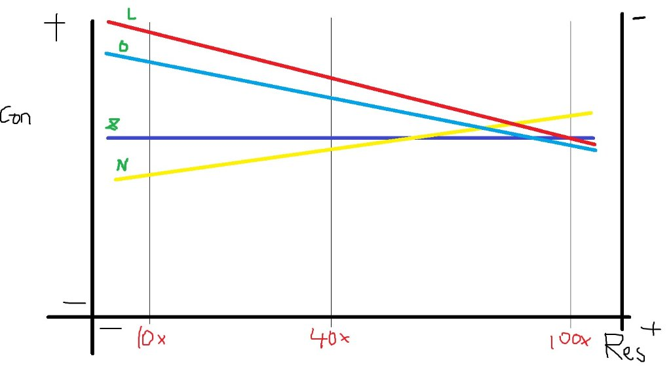
My post is here: https://www.microbehunter.com/microscop ... 27&t=15169
Measuring this number is rather tricky, hopefully, I settle down enough and build something to do that next year. If I get all the numbers accurately measured, mixing and matching prisms from different brands even could become a possibility.
My website
YouTube
Instagram for Microscopy
Contact Macro_Cosmos
Top
viktor j nilsson
Posts: 419
Joined: Fri Mar 01, 2013 1:43 am
Location: Lund, Sweden

Re: OK what about Zeiss standard DIC?
Quote
by viktor j nilsson »
Post
rjlittlefield wrote: ↑
Sat Dec 10, 2022 6:17 pm
Having looked again at your data, I'm wondering if the laser beam was actually scattering off something inside the objective, like the edge of a lens element, and what you were measuring was a cone of light coming off the scattering point.
Do you have any ideas along those lines?
--Rik
It was a couple of years ago, I don't remember exactly what the symptoms were I'm afraid. But I'd be happy to dig out my laser pointer and set up my optical bench again to try to see if I can figure it out. And by optical bench I mean a ruler, a caliper, and a couple of dabs of Blu-tack to hold things in place.

by Pau »
Post
viktor j nilsson wrote:Here's a few more question:
1) how is it possible for the first-generation Zeiss inko system to use a single objective prisms for all objectives? The more I think about it the weirder it seems. How would you design such a jack-of-all-trades prism?
2) is it really critical to place the objective prism exactly at the rear focal plane of the objective? It doesn't seem that way to me: some systems place the prisms immediately between the objective and the nose piece, and others (from the same maker) place them well above the objectives inside the nosepiece or inside an intermediate tube. Surely the location of the rear focal plane can't be that different among the objectives for those systems?
1- Using different condenser prisms for different magnification objectives. The goal in all cases is to match the interference band of both prisms at the rear focal plane of the objective. This is the original Nomarski design first implemented by Zeiss.
Zeiss moved to the individual objective prisms at the nosepiece design in their double arrow system but Olympus still uses the original design although with objective-dedicated changeable condenser prisms
2- In principle it is, although I think that you can place it a bit higher or lower if you still accomplish the condition of matching the interference band of both prisms at the same plane and close to the objective rear focal plane (I suppose that this is what I'm doing when I move a bit the condenser outside the Kölher position to obtain DIC in my hybrid setup)
It depends of the prisms design, the "section or beta angle" referred by abednego1995 is what determines the distance between the interference plane and the objective rear focal plane.
With a Wollaston prism this plane is placed inside the prism but the modified Wollaston prism by Nomarski places it outside the prism. I think that some Leitz DIC systems placed the prisms inside the objective for this reason (and so avoiding to pay Nomarski license fees)
Pau
Top
viktor j nilsson
Posts: 419
Joined: Fri Mar 01, 2013 1:43 am
Location: Lund, Sweden
Quote
by viktor j nilsson »
Post
Thanks, I think I understand a bit more now. I was confused because some places online claim to show Nomarski prisms but actually show Wollaston prisms located exactly at the rear focal plane. This one for example:
In this case, the objective-side prism must be located exactly at the rear focal plane. I had to look around a bit for an illustration that actually showed Nomarski prisms and found this:
So when we have a Nomarski prism, it's the front interference plane of the objective-side prism that must coincide with the objective rear focal plane - not the prism itself. Correct?
Image sources:
https://www.researchgate.net/figure/Exp ... 190278/amp
http://microscopy.berkeley.edu/courses/ ... asdic.html
Top
viktor j nilsson
Posts: 419
Joined: Fri Mar 01, 2013 1:43 am
Location: Lund, Sweden
Quote
by viktor j nilsson »
Post
Ooops, the seller accepted my low-ball offer, so soon I'll have four Nikon epi-DIC Nomarski prisms to play with.
Top
abednego1995
Posts: 84
Joined: Tue Nov 01, 2016 11:53 pm
Quote
by abednego1995 »
Post
So when we have a Nomarski prism, it's the front interference plane of the objective-side prism that must coincide with the objective rear focal plane - not the prism itself. Correct?
Exactly.
I've had the same problems in the past with DIC schematics showing Wollaston prisms in a Nomarski setup. Another thing... The upper wedge must be thinner than the lower wedge in a Nomarski prism, but most drawings just have a straight line connecting the corners. Small but important difference.[/code]
Top
blekenbleu
Posts: 133
Joined: Sat May 10, 2008 5:37 pm
Location: U.S.
Contact:

Re: OK what about Zeiss standard DIC?
Quote
by blekenbleu »
Post
Nikon has reflected DIC prisms with label: "10.40.100x";
... does that suggest some trade-off e.g. between magnification and distance from back focal plane?
Metaphot, Optiphot 1, 66; AO 10, 120, and EPIStar 2571
https://blekenbleu.github.io/microscope
Contact blekenbleu
Top
Pau
Site Admin
Posts: 5850
Joined: Wed Jan 20, 2010 8:57 am
Location: Valencia, Spain

Re: OK what about Zeiss standard DIC?
Quote
by Pau »
Post
blekenbleu wrote: ↑
Sat Dec 10, 2022 9:31 am
Nikon has reflected DIC prisms with label: "10.40.100x";
... does that suggest some trade-off e.g. between magnification and distance from back focal plane?
Maybe, the Zeiss old InKo reflected (DIC) system uses the same prism for 4X and 8X objectives but not for higher magnifications.
Another approach is making the prism adjustable vertically like in some Reichert and Leica metallurgical models with only one prism for all objectives
Pau
Top
blekenbleu
Posts: 133
Joined: Sat May 10, 2008 5:37 pm
Location: U.S.
Contact:

Re: OK what about Zeiss standard DIC?
Quote
by blekenbleu »
Post
Elongated DIC sliders presumably have their interface between (quartz?) wedges change vertically when sliders move horizontally, so more universal but fussy to adjust among objectives.
I wonder whether Nikon objectives with DIC engraving were verified to both be strain-free as well as having precisely registered back focal planes to accommodate relatively fixed prisms.
Metaphot, Optiphot 1, 66; AO 10, 120, and EPIStar 2571
https://blekenbleu.github.io/microscope
Contact blekenbleu
Top
viktor j nilsson
Posts: 419
Joined: Fri Mar 01, 2013 1:43 am
Location: Lund, Sweden

Re: OK what about Zeiss standard DIC?
Quote
by viktor j nilsson »
Post
blekenbleu wrote: ↑
Sat Dec 10, 2022 10:21 am
I wonder whether Nikon objectives with DIC engraving were verified to both be strain-free as well as having precisely registered back focal planes to accommodate relatively fixed prisms.
A couple of years ago, when I bought the epi-DIC prisms discussed above, I made some experiments to learn more about this exact issue. I wanted to know the location of the interference fringe of each prism, so that I could know at least roughly where to place the prisms in my DIY DIC setup. I didn't know how to observe the location of the fringe directly, so I instead measures the location of the back focal plane of the objectives the prisms where designed for. I didn't have all the M plan DIC objectives, but I did have a regular M plan 10x, a Mplan 20x DIC, and a M plan 40x DIC.
To measure the location of the BFP, I used Paolo Pozzi's method described here: https://www.researchgate.net/post/Is_th ... ctive_lens
That is, shine a laser pointer through the front lens, and measure the diameter of the projected circle at different distances from the back of the objective, fit a regression and calculate where the diameter is expected to reach zero.
I'll post some screenshots of the data in another post, but the results were quite interesting. Here's some highlights:
M plan 10x: -1.36 mm
M plan 20x DIC: -4 mm
M plan 40x DIC: -1.13mm
CF Fluor 10x: +0.5mm
CF E plan 4x: roughly +15mm
Measurements are given as a distance from the back edge of the objective, not at the shoulder. So -1.36 means that the BFP is located inside the barrel, and +0.5 just outside of it.
This shows that the 10x and 40x M plans, that use the same DIC prisms, also have remarkably similar BFP locations. And the 20x M plan, that has a dedicated prism, has a BFP in a pretty different location. Furthermore, the 10x in particular appears to have been designed so that the BFP falls unusually far into the objective for a relatively low-magnification objective, while other 10x presumably have their BFPs at least some distance outside the objective barrel.
Personally, I don't think that the BFP locations differs between M plan objectives marked DIC and those lacking the DIC designation. But I do think that the 10x M plan was designed to have a BFP location that matched that of the 40x and 100x M plans.
Top
viktor j nilsson
Posts: 419
Joined: Fri Mar 01, 2013 1:43 am
Location: Lund, Sweden

Re: OK what about Zeiss standard DIC?
Quote
by viktor j nilsson »
Post
And here's the spreadsheet with raw data and regressions:
Plots show A~B, where A is diameter of illuminated circle and B is distance from rear of objective.
Top
viktor j nilsson
Posts: 419
Joined: Fri Mar 01, 2013 1:43 am
Location: Lund, Sweden

Re: OK what about Zeiss standard DIC?
Quote
by viktor j nilsson »
Post
Note that data for the 4x objective is nonsense, the laser pointer method don't work well with low magnification objectives with front lenses much larger than the beam diameter.
Top
rjlittlefield
Site Admin
Posts: 22920
Joined: Tue Aug 01, 2006 8:34 am
Location: Richland, Washington State, USA
Contact:

Re: OK what about Zeiss standard DIC?
Quote
by rjlittlefield »
Post
This process and data are very interesting to me. Thanks for the full description.
Data for the 4x objective does not strike me as nonsense. It also makes sense in terms of an optical design that places the rear principal plane far forward. You could check this possibility by pointing the objective at a distant scene and looking to see where it forms its image. If I understand correctly the measurement you made, then the image of the distant scene should form at the same place indicated by the laser measurement.
--Rik
Contact rjlittlefield
Top
viktor j nilsson
Posts: 419
Joined: Fri Mar 01, 2013 1:43 am
Location: Lund, Sweden

Re: OK what about Zeiss standard DIC?
Quote
by viktor j nilsson »
Post
Glad you found it interesting.
What data on the 4x do you refer to? The data in the graph, or the 15mm estimate? As I can recall, the 15mm estimate was based on pointing the objective at the sun and observing where the image was formed on a piece of paper. But the data in the graph suggests that the BFP is located 2.48mm behind the objective, which I interpreted as a spurious result caused by the fact that the laser pointer only filled a small central portion of the entrance pupil (is that the correct term?).
I just double-checked the E plan 4x, and when I aim it at two semi distant street lamps it forms a sharp image on a matte screen located ~15mm behind the objective.
Top
rjlittlefield
Site Admin
Posts: 22920
Joined: Tue Aug 01, 2006 8:34 am
Location: Richland, Washington State, USA
Contact:

Re: OK what about Zeiss standard DIC?
Quote
by rjlittlefield »
Post
I was looking at the good linearity of data in the graph.
Having heard the rest of the story, I agree that the data in the graph looks nonsense.
That shifts my curiosity to what caused the nonsense. An incoming parallel beam that fills the aperture will produce a wide-angle cone that comes to a small focus in back, which is how the image of your street lamps gets formed. An incoming parallel beam that does not fill the aperture will produce a narrower cone in the back, but barring insane aberrations it will come to a focus at the same distance. I just checked some of my own objectives and that's the way it worked with them. The narrowness and high intensity of the beam may make measuring its diameter difficult, but if there were a measurement problem then I would expect noisy data, which I did not see.
Having looked again at your data, I'm wondering if the laser beam was actually scattering off something inside the objective, like the edge of a lens element, and what you were measuring was a cone of light coming off the scattering point.
Do you have any ideas along those lines?
--Rik
Contact rjlittlefield
Top
Macro_Cosmos
Posts: 1423
Joined: Mon Jan 15, 2018 9:23 pm
Contact:

Re:
Quote
by Macro_Cosmos »
Post
Pau wrote: ↑
Tue Jan 29, 2019 6:31 am
Mixing and matching DIC components is risky and full of uncertainty although in some cases it works. *
waterbear wrote:...
I'm guessing parameters would be relating to numerical aperture and focal ratio (steepness of the light cone emanating from the objective).
I imagine that is thickness and angle, and extinction amount seems to be constant in their specs.
...
AFAIK the amount of shear and the focal distance where the interference band is placed (Nomarski prisms have it located outside the prism) to match the objective rear focal plane are main parameters. Unfortunately makers do not disclose them and I lack the knowledge and tools to measure it.
Also the objective rear focal plane is not standardized and many objectives can't deliver DIC. With my system I can't get DIC with any phase objectives I've tested, for example, but I get decent DIC with some non phase Leitz NPL fluotar and Pl Fluotar (160), Zeiss Planapo and and Nikon CF Plan Apo, even with a highly mismatched Nikon CFI Plan Apo 20/0.75.
I agree with Johny about the PZO system: because it is highly regulable it can work well with many objectives not designed to work with it like Nikon CF and Leitz NPL fluotars
* see my hybrid setup at viewtopic.php?t=15606
The shear angle of the normal type Olympus DIC slider prism (U-DICT, U-DICTS, WI-DICT) is 74μrad. Nikon's fitted nosepiece objective-specific prism is 76μrad and Zeiss is 71μrad.
A smaller shear angle and therefore shorter shear distance correspond to higher resolution, and vice versa for higher contrast. This is why Zeiss and Nikon's DIC "seems to have better resolution", it is not their "superior optics" but rather their vision of what an optimised DIC system looks like. There is nothing stopping Olympus and Leica from doing the same with matching prisms.
Assuming the normal DIC is being used.
Leica: higher contrast, common nosepiece slider with condenser prisms for specific objetives.
Nikon and Zeiss: contrast and resolution balanced, most people prefer the look of these two. Each objective has its own slider while condenser prisms are tailored for different NA.
Olympus: Between Leica and Nikon/Zeiss. Common nosepiece slider with condenser prisms for specific objectives. High contrast at lower magnifications while contrast and resolution is balanced at higher magnifications.
My post is here: https://www.microbehunter.com/microscop ... 27&t=15169
Measuring this number is rather tricky, hopefully, I settle down enough and build something to do that next year. If I get all the numbers accurately measured, mixing and matching prisms from different brands even could become a possibility.
My website
YouTube
Instagram for Microscopy
Contact Macro_Cosmos
Top
viktor j nilsson
Posts: 419
Joined: Fri Mar 01, 2013 1:43 am
Location: Lund, Sweden

Re: OK what about Zeiss standard DIC?
Quote
by viktor j nilsson »
Post
rjlittlefield wrote: ↑
Sat Dec 10, 2022 6:17 pm
Having looked again at your data, I'm wondering if the laser beam was actually scattering off something inside the objective, like the edge of a lens element, and what you were measuring was a cone of light coming off the scattering point.
Do you have any ideas along those lines?
--Rik
It was a couple of years ago, I don't remember exactly what the symptoms were I'm afraid. But I'd be happy to dig out my laser pointer and set up my optical bench again to try to see if I can figure it out. And by optical bench I mean a ruler, a caliper, and a couple of dabs of Blu-tack to hold things in place.

