The OPCW Douma Leaks Part 4: The OPCW Investigation
February 11, 2020
By Bellingcat Investigation Team
Introduction
Over the last year, the OPCW has faced a series of leaks related to the Fact Finding Mission’s (FFM) investigation into the Douma chemical attack. The OPCW have now released their investigation into these leaks. These leaks appear to have originated from two former employees: Inspector A, who is Ian Henderson and Inspector B, a.k.a “Alex”, who is almost certainly Brendan Whelan.
In previous parts of this series we looked at the claims associated with Whelan and Henderson, and consulted chemists, toxicologist and chemical weapons experts. It became clear that Henderson and Whelan’s claims were flawed, overstated and at times actively misleading.
We also assessed what would be required for a “false flag” attack to have taken place in order to result in the the huge amount of evidence found related to this incident. Once available information is taken into account, it is clear that faking the Douma chemical attack would have been effectively impossible.
The OPCW investigation
In short, the OPCW’s investigation agrees with the key points that we identified using openly available information. These two employees not only had limited access to information related to the Douma investigation, but also actively misled people on issues, including their status and the work they were authorised to conduct.
Ian Henderson a.k.a Inspector A
The OPCW report makes it clear that Henderson was not a member of the FFM. He aided the FFM by collecting data at sites of interest, including processing the cylinders from the two locations. He was later assigned to conduct an inventory of information and assess what other information would be required for future studies. The OPCW investigation states he had no further official part in the FFM investigation. It is important to note that this means Henderson would not have had access to large amounts of information regarding the Douma attack, including further investigations conducted by the FFM.
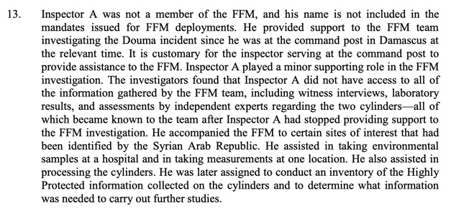
Henderson’s status was already possible to establish using both OPCW statements and internal documents leaked by WikiLeaks, specifically an email from Sebastien Braha, the Chief of Cabinet to the Director General of the OPCW. In this email Braha finds out that Henderson had produced an “engineering assessment” and asks why someone who was not a member of the FFM was carrying out this work.
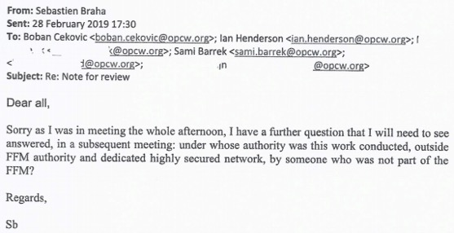
It is ironic that this email chain was leaked in an attempt to support the narrative of Whelan and Henderson, but resulted in a clear demonstration that Henderson was not regarded as being part of the FFM by the OPCW.
Despite not actually being part of the FFM, and despite being told specifically not to do so, Henderson decided to conduct his “engineering assessment” anyway. This not only involved misleading senior members of the OPCW, but also lying to the university which carried out his simulation. Henderson told this university they were being officially engaged by the OPCW. They were not. Indeed the OPCW even claims Henderson was on leave when this simulation was carried out.
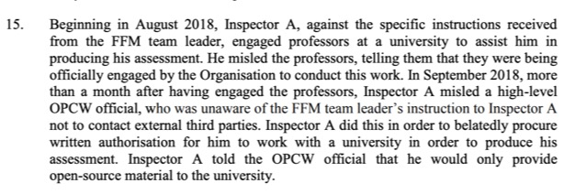
During this period, Henderson also improperly handled extremely sensitive classified information. As well as disclosing this information to external organisations without proper authorisation, he also requested that they email him using his personal Gmail address. Considering the sensitivity of this kind of information, Henderson’s actions in handling it appear to be extraordinarily reckless.
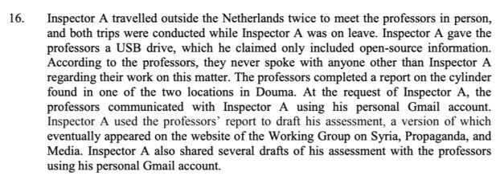
In short, the OPCW report confirms the key points of our reporting on Henderson: his “engineering assessment” was an unauthorised report carried out with incomplete information by a person who consistently misled in order to achieve what they personally wanted. Henderson himself acted in a cavalier attitude with incredibly sensitive information and deceived those around him, both inside the OPCW and at external organisations, to achieve his own goals.
Brendan Whelan a.k.a Inspector B
We have previously examined Whelan’s claims in detail. In short, they are flawed, hugely overstated and, at times, actively misleading. As with Henderson, the conclusions of the OPCW investigation on Whelan are very similar to ours.
The most important point of the OPCW investigation is that Whelan left the OPCW altogether in August of 2018. This was the month after the interim report was published. Whelan was not present for, nor had access to information relating to, the majority of the FFM investigation. Although we noted this as a possibility, the OPCW investigation confirms it.
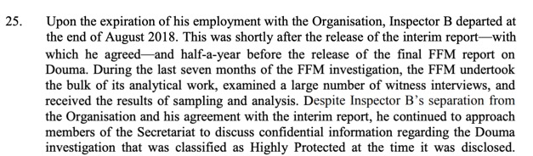
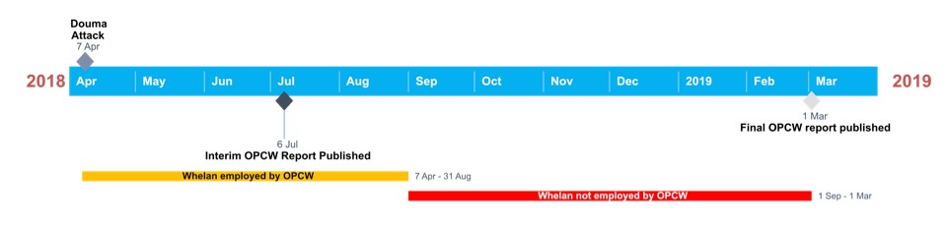
This is an absolutely vital piece of information that was not mentioned by any previous coverage of Whelan’s claims. By excluding this detail, organisations such as WikiLeaks, the Mail on Sunday and CounterPunch have potentially misled their readers about Whelan’s capacity to dispute the findings of the FFM.
The OPCW investigation also claims that Whelan confirmed in writing that he was satisfied with the Interim report that was eventually published. Although the OPCW does not provide any direct evidence of this, it is not entirely surprising. The only firm conclusion the published Interim report made about the Douma attack was that nerve agents were not used. As with all versions of the Interim report, it noted that further investigations were required.
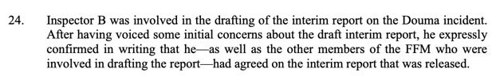
The OPCW’s conclusions about Henderson also reflect on Whelan too. Whelan clearly made misleading statements about Henderson’s status, possibly in an attempt to lend more weight to Henderson’s analysis. It seems possible that Whelan’s email of the 20th May 2019, which criticises the OPCW for kicking out Henderson and insists he was a member of the FFM, was written with the intention of leaking it later in support of Whelan’s own claims. As we now know, those claims were false.
Conclusion
Even using open sources, it was possible to demonstrate that the claims of a conspiracy at the OPCW were misleading. We have previously covered this with a series of articles looking at the claims made by Henderson and Whelan, consulting with chemists, chemical weapons experts and toxicologists.
The OPCW investigation supports these conclusions: Whelan and Henderson made claims unsupported by evidence, misled their colleagues and lied to external organisations, mishandled sensitive classified information and made misleading claims about the attack in Douma.
It is fitting that the last word on this subject should go to Mr Fernando Arias, the Director-General of the OPCW:
“Inspectors A and B are not whistle-blowers. They are individuals who could not accept that their views were not backed by evidence. When their views could not gain traction, they took matters into their own hands and breached their obligations to the Organisation. Their behaviour is even more egregious as they had manifestly incomplete information about the Douma investigation. Therefore, as could be expected, their conclusions are erroneous, uninformed, and wrong.”

Share this article:

Join the Bellingcat Mailing List:
Enter your email address to receive a weekly digest of Bellingcat posts, links to open source research articles, and more.

53 Comments
- « Older Comments

- SorryViennese - February 15, 2020
second typo correction (“at” instead of “a”)
correct is:
As logic clearly says, if one cylinder was not airdropped, there was at least one manual operation.
Reply
- Jeroen - February 15, 2020
So you think one cylinder was a genuine air attack being dropped by an Assad forces operated helicopter and some other “false flag” people timely spotted a second helicopter in the area, and thought it a great idea to place another cylinder somewhere near in that same area “manually” or even drop some 34 dead bodies they held already in the frig anyway for some days, to add some extra effects, to make things much worse?
Well know I understand why your scientifical career never really lifted off.
But thank you for sharing your interesting thoughts, much apreciated.
I strongly advice you to look for some conspiracy loving niches in the World Wide Web where they adore such things.
You missed something essential, people like BC for fact checking.
When you have finished your study about dropping camping gaz cylinders dropping 500 of them by small drones at different height and speeds and describing their behaviour and impact patterns you still have to proof your findings can be extrapolated to heavy chlorine cylinders dropped from helicopters. Love to read your articles about it in some real peer review journals, I will check for them in 2023 and later years.
Reply
  - SorryViennese - February 16, 2020
Dear Jeroen,
thank you for your swift response.
However, you did not address the central conclusion of my finding on the facts above:
The cylinder at Location 4 can not have been airdropped. In simplest language: It was not airdropped.
Your answer has to address and quote my findings specifically.
Your answer is just creating fog and distraction, it is not specific. Why are you doing it? Better to stay calm and accept a small defeat.
Please refrain from attacks ad hominum, at me.
KR, SV
Reply
    - Jeroen - February 16, 2020
Publishing any findings and ideas at an peer review journal will accelerate a scientifical career more than dropping some lines here every two weeks.
It would be great to find out that some “false flag” operation was carried out somewhere on this planet not particularly in Syria.
Bellingcat would love to prove the world that “false flag’s” were planned or. carried out.
It is important to do such.
For example when soldiers mask them selves take of their insigna on order, lie about it against journalists and illegally blokkade streets, buildings, enter them illegally with weapons, threatening other people.
A Buk System is illegicaly entering a neighbouring country to shoot down aircraft. And when a civilian plane is shot down the responsible authorities lie about it. Statements are made that it was a “neighbours” Sukhoi, or a “neighbours” Buk, “that did it”. Tests are done and aired to “proof” that a Sukhoi did it. And so on and on.
As you pretend to be so concerned about finding out what really happened you might adress some of your attention and time (here at BC) at the MH17 case.
Not only the families of Syrian people want to know who dropped cylinders killing their loved ones.
But you could really help to make Belingcat question more. Try to find some false flag operation still not covered with additional supporting proof in Syria that we can really work on. Were additional proof is possible to find, like just for example cellphone recordings of cylinders in ambulances we can geolocate, driving around, people lifting cylinders with cranes on roofs and so on and on. But you do not find about Douma, they are not there, because these cylinders were airdropped.
Your current examination is not very promising.
Person A states at BC comment section.
The earth is flat, do you agree?
Nobody answers
Then states nobody disagreed so all at BC comment section agree earth is flat! Nobody disagree, all agree?!
So next thesis.
Earth is not only flat but also cubic.
Wait two weeks.
Nobody openly disagree?
Oh then all agree.
So earth is cubic.
Now earth is cubic and larger and also heavier than the sun.
Everyone clearly can see that every day can not you?
Now do you all believe Newton was right?
Yes we do because nobody openly disagreed.
Look people person A claimes he just proofed the earth is a cubic and the sun is circling around the cubic.
I believe one round cylinder fell through the roof, the other just punctured a hole in it.
No cubics here.
Reply
      - SorryViennese - February 16, 2020
Dear Jeroen,
you again do not address my central argument presented . It is about facts. Your are trying to obfuscate, to create fog and distraction.
I repeat it now, that you can address it piece by piece, taken from my argument above:
This “airdorpped” cyclinder could only have fallen vertically after pentrating the roof (see interim report above, Figures 6 – 8). His next hit after the penetration hole, must have been vertically below that hole. However the cylinder was found in the bed, 3-5 meters away from that – hit the floor spot (“initial landing point”) (see Figure 9).
So dear Jeroen, I asked you to look at the figures of the official OPCWW report , especially figure 9 and comment that.
We have to speak about what every reader of this report, can see there in figure 9.
And the conclusion is inevitable, whatever fog and distraction you create in your answers.
The Location 4 cylinder was not airdropped.
Sorry your case is lost … ,
KR; SV
Reply
        - Servus - February 16, 2020
…read few entries above, I’ve made “kotleti” of your caricature of a technical text..
- Jeroen - February 16, 2020
First
Information presented by Henderson or adressed to him does not include open available details to check about the simulation or large amounts of the data associated with the simulation, where his conclusions were based upon.
Also the technical drawings in both versions of his leaked report are too low quality to read properly. This makes it very difficult to assess the simulation itself, if not rather impossible.
Secondly Henderson did not have all data collected by the FFM.
Thirdly most of use neither posses all data collected by FFM about the Douma case, neither posses other data collected at those locations by other actors.
Therefor one could theoretically formulate an endless number of hypotheses about what could have happened, what if’s, what about, and so on and on and on.
One might for example asume that a certain cylinder had zero horizontal speed, one might asume that a certain cylinder had no vertical speed, being only manually placed, just for example.
To me it seems rather unusal for a cylinder being dropped from a helicopter to have no forward speed, it normaly does, allthough vertical downwards speed would be of greater importance while impacting.
There would be no need for hoovering stationary over a certain spots, dropping two chlorine cylinders over living buildings, the effects on the population would not be different. But I could be wrong here, of course.
Well the point is here, we do not need most if not all of these hypotheses so much, they are rather useless, without proper data, without sufficient insider knowledge.
There was a fact finding mission to establish the facts about these Douma events. And they reported that the team analysed the available material and consulted independent experts in mechanical engineering, ballistics and metallurgy who utilised specialised computer modelling techniques to provide qualified and competent assessments of the trajectory and damage to the cylinders found at Locations 2 and 4.
Moreover they staed that the analyses indicated that the structural damage to the rebar-reinforced concrete terrace at Location 2 was caused by an impacting object with a geometrically symmetric shape and sufficient kinetic energy to cause the observed damage. The analyses indicate that the damage observed on the cylinder found on the roof-top terrace, the aperture, the balcony, the surrounding rooms, the rooms underneath and the structure above, is consistent with the creation of the aperture observed in the terrace by the cylinder found in that location.
And at Location 4, the results of the studies indicated that the shape of the aperture produced in the modulation matched the shape and damage observed by the team. The studies further indicated that, after passing through the ceiling and impacting the floor at lower speed, the cylinder continued an altered trajectory, until reaching the position in which it was found.
That is what the Douma FFM concluded and reported.
Everybody can read that (on page 4) in the final report.
Speculations about the possible and theoretical effects about dropping 22kg camping cooking gas cylinders on the office floor standing on one’s desk or chair,
do not add a drop to usefull knowledge about these chemical attacks.
Back to OPCW and credibility.
I prefer to believe that most if not all are competent, responsible and conscientiously working professionals with OPCW.
Until proven differently.
Reply
  - SorryViennese - February 17, 2020
Dear Jeroen,
Twice I asked you to look at the official interim report, and in that at Figure 9, which shows the bedroom and impossible trajectory very clearly: Thus the most important facts are presented. You decline to look at it, you obfuscate again in your lenghty answer.
You did not look at it, you did not comment it. Why? ….
Everybody else, please look at the official OPCW interim report, and the Figures and paragaphs describing the facts at Location 4, as I have mentioned several times above (see my posts 15th of Feb).
And jugde yourself, I do not ask for more.
KR, SV
Reply
- SorryViennese - February 17, 2020
Dear Servus,
you attack me personally above, try to offense me … and you write verbatim 2 sentences (see above)
…”…after passing through the ceiling and impacting the floor at lower speed, the cylinder continued an altered trajectory, until reaching the position in which it was found.” [quoted from the final OPCW report
´The trajectory [1] through the crater [2] can be seen at the fig 10, the cylinder continues [3] horizontally.´
[written by Servus, numbers in [] added by me
[my comment on that, a small sketch to illustrate this proposed trajectory by Servus:
1 airdrop
2 impact floor crater
3 continues horizontally
1
*
*
*
2__*_______
3 L >>>>>>>>>
Who, dear readers, has ever seen such a trajectory (**** L >>>>>> ) of a gas cylinder weighting perhaps around 100 kg …
KR, SV
Reply
  - SorryViennese - February 17, 2020
small correction
The sketch is distorted by the BC website, the * * * * line should be quite vertical above the hole (crater) and the vertical leg of the “L”
Reply
    - Servus - February 17, 2020
Dear Vienia,
finally a small progress, you start understanding that the cylinder fell flat, made a rectangular hole and continued horizontally. While you were falsely certain that it fell vertically . Do you agree to it at this stage ?
Take your time with the next piece of the trajectory, it took us just two week to get horizontally through the roof .
Reply
      - SorryViennese - February 17, 2020
Dear Servus
A fall is never flat. Galielo found this even before Newton. An apple or cylinder falls vertically.
You do not look at the figures, you do not answer all my crucial questions.
The airdrop to the ceiling of the bedroom can only have been nearly vertically. Assuming your proposed straight flight from the hole to bed, is not possible. As the only allowed drop direction from above is, in the opposite direction for a straight “flat” continuation to the bed, from the hole in the ceiling.
All other axes are blocked by untouched walls, above and below the ceiling of the bedroom. You never looked at the figures of location 4, I urged you, then it is easier to understand.
And then, after the floor/ceiling impact – crater – you name it, the slow speed leads to a vertical drop from the ceiling to the floor. That is presented in the diagram.
And the vertical drop is presented in Figure 11 in the offical final report, too, look it up.
So in summary, the only possible trajectory, which would need a jumping cylinder in the bedroom, is impossible. This simple fact, has to be obfuscated, by many words, distractions by commentators like you, that seems to be their job or mission.
However, ballistics is king in war and forensic. Sorry for that.
KR, SV
Reply
- SorryViennese - February 17, 2020
Dear Servus,
you address figure 10 (from the final OPCW report, publ. 1. March 2019).
I agree, it is about the moment of penetrating through the roof.
As diagramm, it is a speed / time diagramm.
I shows milli seconds on the x-axis, speed on the y axis.
It does not report on the movement within the room.
And the next Figure 11 is completely consistent with the Figure 9 from the interim report, I urged you and Jeroen several times to look at, and comment it already. So the Figure 9 reports the facts, as I stated several times before.
Or do you challenge now the final report of OPCW, as you tried with the figures in the interim report, quoted by me above ?
KR, SV
Reply
  - SorryViennese - February 17, 2020
small improvement, more precision, replace “movement” with “direction, or trajectory of the cylinder, ” above.
The sentence regarding diagramm in figure 10, should be
“It does not report on the direction, or trajectory of the cylinder within the room”
KR, SV
Reply
    - Servus - February 17, 2020
Dear Vienia ,
I will wait for a while until you correct your errors. You should still study my answers.
Reply
      - SorryViennese - February 17, 2020
Dear Servus,
I studied all your answers carefully. You can wait as long as you like.
The corrections/improvements were necessary to highlight your misunderstanding on the diagram of figure 10 (final report).
The precision, including the sketch, helps to clarify your errornous thinking on this diagramm.
There was no evidence presented, how such an “alternate” trajectory could have come about. What was the cause of your “horizontal” movement? Only God´s hand, deflecting the dropping cylinder, could have done this what you think happened.
The cylinder dropped straight from the floor to the ground. Even the final OPCW report says so.
And it was no “horizontal continuation” at all, as you claimed. That is your misunderstanding of the diagramm in fig.10., page 18 (see above).
The horizonatal part of the diagramm just reflects the calculated low speed of the cylinder´s straight drop from the floor. I hope you are able to acknowledge that.
KR SV
Reply
        - SorryViennese - February 17, 2020
meant the ceiling above:
.. cylinder dropped straight from the ceiling to the floor (of the bedroom). …
        - Servus - February 17, 2020
…tell me when you are ready with all corrections …
  - Servus - February 17, 2020
Dear Vienia,
we are making progress you look into documents now, I’m please with it.
“As diagramm, it is a speed / time diagramm.
I shows milli seconds on the x-axis, speed on the y axis.
It does not report on the movement within the room. ”
Yes, you are right, it’s a velocity/time diagram. But it has a hidden secret in it, …
actually two, the easy one is , why does velocity never go to 0? Is the cylinder still flying ? The second secret is more secret, it will take us easily two weeks, so, take your time.
Reply
    - SorryViennese - February 17, 2020
Dear Servus,
why did you try to mislead me then.
Of course i have studied figure 10, befor I even studied the interim reports figure 6-9 including text.
your secret
“velocity never go to 0”, as I answerd you above already, cylinder dropped vertically from the ceiling to the floor of the bedroom, no spikes, …. no jump in this “final report” – simulation diagramm I agree.
The just showed the 15,x milliseconds of their simulation around the time when the crater was formed by the assumed “airdrop” in the diagramm.
And I agree, and said it befor. Gently must have been the cylinder falling from the ceiling.. (see my comments as of 15. Feb.)
The diagramm has not further title, is was done to simulate the forces at the assumed penetration … see the line “Effective Plastic Strain” in the right upper corner
But note, the simulation diagramm has never a “bed ” as endpoint, this was was cleverly avoided by the final report makers.
And do not forget, your implied “flat” (horizontal?) direction from the ceiling hole to the bed is impossible (see above), the untouched wall situation does not allow this flight. . and the OPCW does not claim it ….it is your private thinking, do you need a proof for that?..
Alas, the cylinder, did not jump, did not fly flat in the bedroom, the trajectory is impossible, it was not airdropped…
The Bellingcat Investigation Team is an award winning group of volunteers and full time investigators who make up the core of the Bellingcat's investigative efforts.

