‘I saw things differently than men’: Elizabeth Becker on covering war in Cambodia
The Cambodian conflict of the 1970s was predominantly told through the male lens. But Elizabeth Becker, as one of the few women journalists reporting on the frontline, endeavoured to cast a light on the female experience of war
WRITTEN BY:
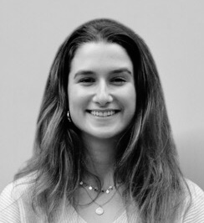
ALLEGRA MENDELSONFollow

MAY 5, 2021
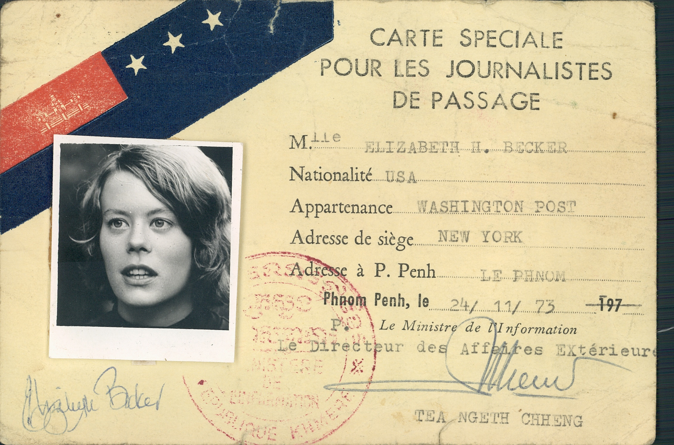
When journalist Elizabeth Becker returned to Phnom Penh in December 1978, she was struck by the silence of the once-bustling city.
For Becker, one of the only female reporters on the frontlines during the American-Vietnam war era, it was the stillness – the lack of children playing and the empty stalls at Central Market – that confirmed allegations of the crimes committed by the Khmer Rouge regime.
“I kept seeing evidence after evidence that they [the regime] were covering things up, that people were scared when we talked to them,” Becker told the Globe. “I had actually lived in the country. I knew what it was like to live there and this was not Cambodia.”
Becker’s reporting on the Cambodian civil war and its genocidal aftermath would become one of the most accredited accounts of the conflicts. Her work would offer both a record of the brutality, later used by the prosecution in the Khmer Rouge Tribunal, as well as an unprecedented gendered dimension – largely ignored by her male colleagues – to the devastation of wartime in Cambodia.
While her male colleagues often overlooked women in their reporting, considering them unimportant in the grand scheme of war, Becker saw the opportunity for impactful stories that could offer new insight into the conflict. As a woman, she also had greater access to local populations who were less fearful of female reporters.
“I was not as intimidating as the male correspondent. I did not look like a soldier, I didn’t look like anyone from the embassy because there were no women diplomats then either,” said Becker. “So when I went to interview people they didn’t look at me as a big American man.”
These experiences, along with her desire to showcase the stories of female journalists and their groundbreaking work, led Becker to pen her latest book, You Don’t Belong Here. In the book, published in February, she profiles Catherine Leroy, Kate Webb and Frances Fitzgerald, three influential female journalists of the American-Vietnam War era. These women offered invaluable, firsthand accounts of the violence and paved the way for other journalists, including Becker.
Yet, even drawing inspiration from their work, with so few women in the field, Becker still faced scepticism from her male counterparts.
Not long after she arrived, at the height of the civil war in 1972, fellow journalist Sylvana Foa was expelled in April 1973 for a report claiming the US Embassy was illegally directing pilots in the ongoing bombing campaign, leaving Becker as the only female correspondent in Cambodia – a status she would retain until the penultimate days of the war when the Khmer Rouge took Phnom Penh in 1975.
“There was a loneliness and an isolation that you didn’t have if you were a man. And the men did treat you differently, I know they will say now that it was all fine, but they don’t remember,” explained Becker.
“You were very aware that the men looked at you as a possible woman that they wanted to bed before they looked at you as a serious reporter.”
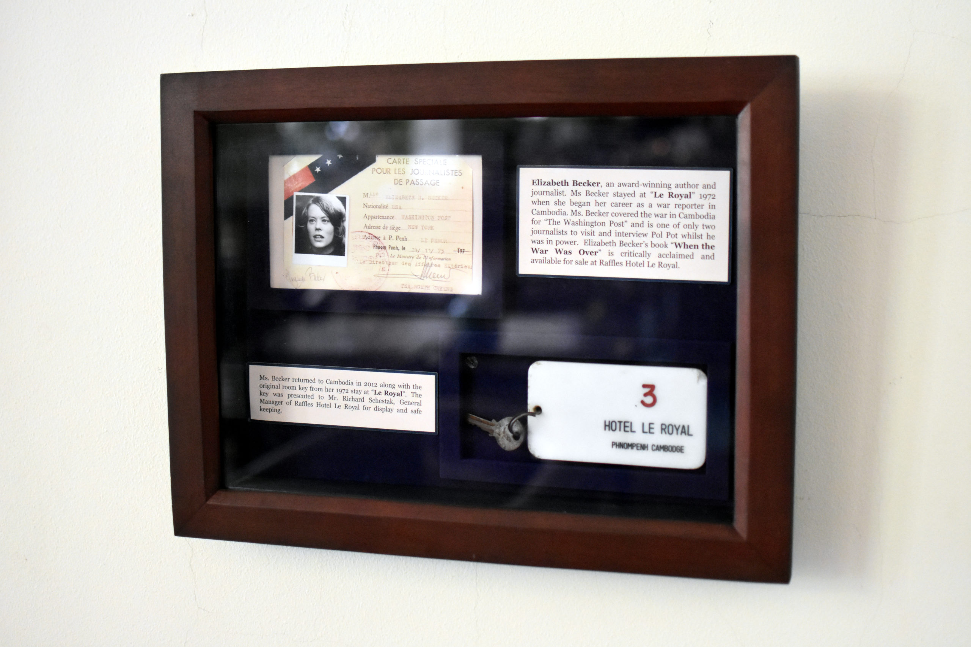

Becker returned to the US in 1974, after nearly two years on the frontlines. Eager to return to Cambodia, she spent four years pressing for a visa into the country to no avail.
However, by 1978, the Khmer Rouge was losing ground and the threat of Vietnamese occupation loomed large. In a last ditch effort to safeguard its power, the regime invited three foreigners into the country. Becker, who had been working for the Washington Post, was among them, joined by Richard Dudman, a reporter with the St Louis Post Dispatch, and Malcolm Caldwell, an academic known for being a defender of the regime.
“Why having a couple of journalists would prevent the Vietnamese from invading, I don’t know. It was fantasy land,” she said. “They were truly not all with it.”
The group was accompanied by security at all times, keeping them under what Becker described as “essentially house arrest” and monitoring their every step.
“We couldn’t move without them,” Becker recounted. “When they found out that I was leaving the guest house to go on my own throughout the city, they locked the guesthouse so that we couldn’t go out. There was no room for improvisation.”
It was quite clear it [the tour] was to hold off the Vietnamese invasion and have us come back [to the US] and send the message that the Vietnamese are the bad guys and the Khmer Rouge were the good guys
And yet, while Becker saw through the regime’s façade, for Dudman, who had never lived in Cambodia and knew only of American support for the Khmer Rouge, the choreographed tour had not aroused suspicion. He returned to the US claiming that no gross human rights violations had been committed.
“The one thing that may have been about gender that I didn’t think of then, was because it was so political everybody wanted to believe Dudman’s stories and not mine,” said Becker, adding that their two reports were so different that at the Khmer Rouge Tribunal in 2015, Dudman was called by the defence and Becker by the prosecution.
“Because the United States at the point did take the Khmer Rouge’s side, it was to the general advantage of the American position to accept Dudman’s.”
It was not until the film The Killing Fields was released six years later, which depicted the experiences of foreign journalists in Cambodia during the Khmer Rouge era, that the narrative began to change, lending greater credence to Becker’s work.
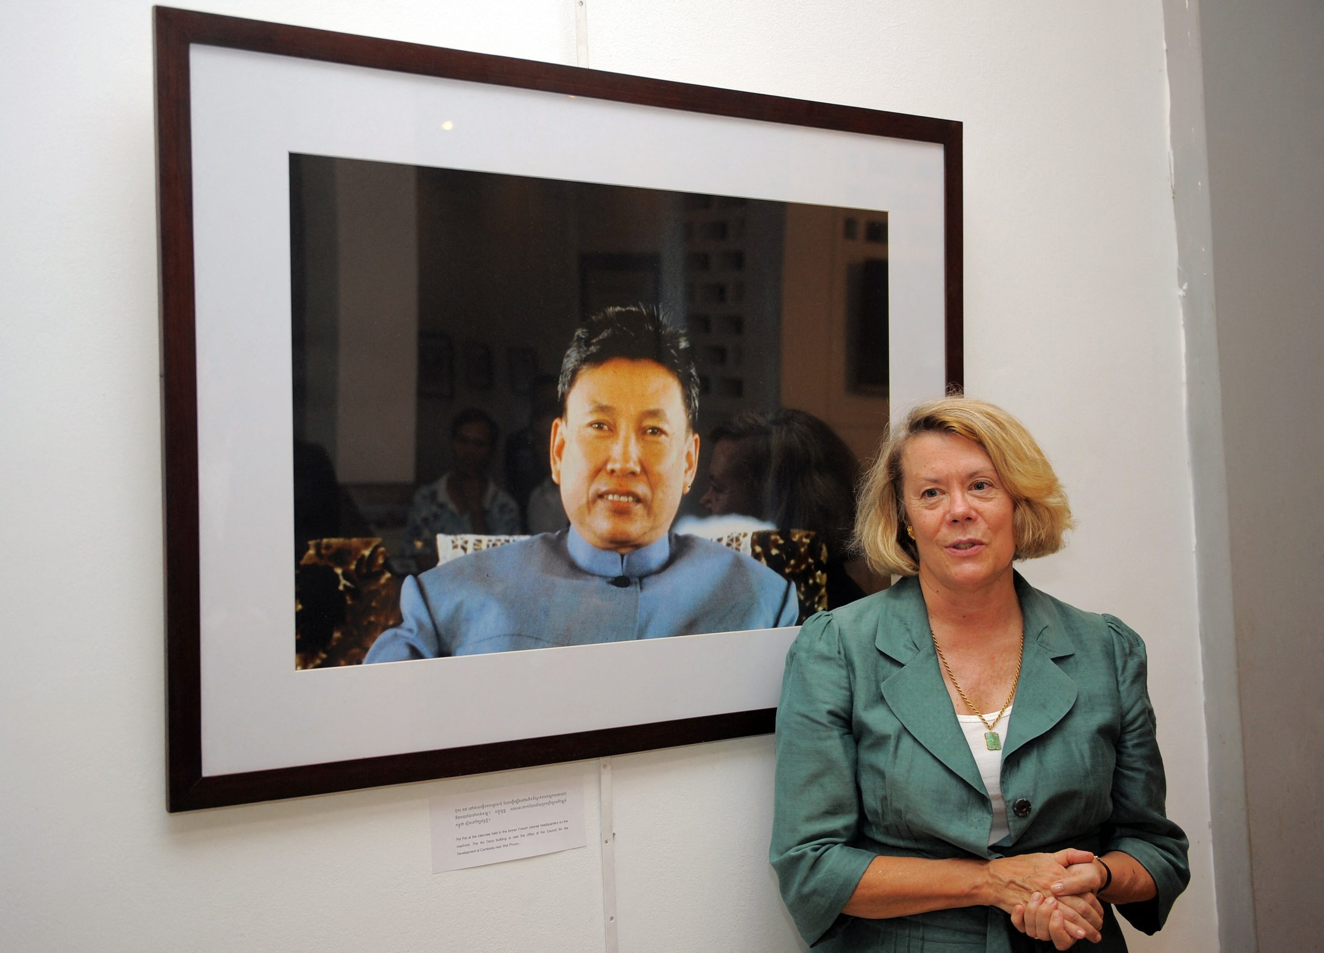 Washington Post correspondent Elizabeth Becker standing next to a photo of former Khmer Rouge leader Pol Pot during her photo exhibition at Bophana centre in Phnom Penh in February 2012. Photo: Tang Chhin Sothy
As part of the tour, Becker and Dudman were granted a sit-down interview with Pol Pot, becoming the only two journalists to speak with the tyrant face-to-face while the Khmer Rouge held power. Caldwell was also granted time with him, though separately.
Pol Pot spent the conversation speaking about the Vietnamese threat and their plan to invade Cambodia, confident that NATO and American forces would intervene and offer support to the regime should this happen.
“It was quite clear it [the tour] was to hold off the Vietnamese invasion and have us come back [to the US] and send the message that the Vietnamese are the bad guys and the Khmer Rouge were the good guys,” Becker explained.
Though the interviews with Pol Pot had been cordial, with Becker remembering Caldwell in particular as having been “delighted with his time with Cambodia’s leader”, she wrote in her book When the War was Over, someone had been upset with how the tour had unfolded.
The evening following their sit-downs with the Khmer Rouge leader, a heavily armed man entered the compound where the tour was being housed. He pointed a gun at Becker, who survived by hiding in a bathtub, but shot and killed Caldwell.
The reasons for the attack are unknown, though Becker assumes the assailant was sent by the regime to silence them, as an outsider would have been stopped by the horde of security assigned to shield the tour.
For all its inexplicable logic, the tour’s apparent aim of holding off an invasion and securing foreign support was a failure. Vietnamese forces invaded Cambodia only a day after the group left.
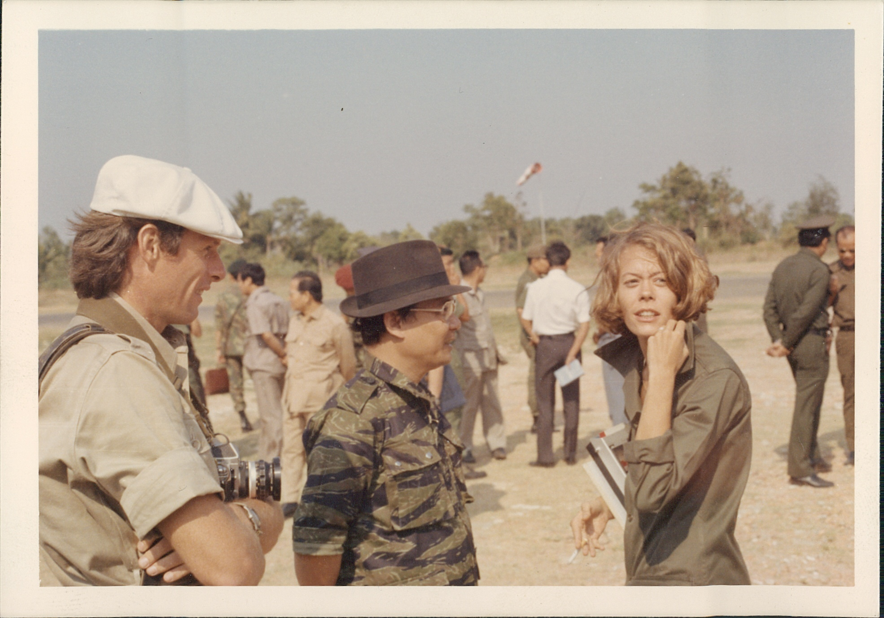

Nearly two years after the Vietnamese invasion, in 1980, members of the ousted communist movement made their only trip to the UN. During the visit, Becker once again deviated from her male colleagues by seeking out an interview with Ieng Thirith.
Thirith had been the minister of social welfare for the Khmer Rouge and, more notably, the only woman to hold a senior position in the communist administration. She was also the wife of the regime’s third-in-command, Ieng Sary, and was a key figure in the regime – yet one that, because of her gender, most male journalists had ignored.
“I saw things differently than men and I didn’t do it on purpose,” Becker recalled of the interview with Thirith. “I automatically wanted to know what the minister of social welfare thought the country looked at because what was the big issue then: The awful human rights conditions for the average Cambodian during the Khmer Rouge.”
While at the time Becker had no inclination the interview would be used outside of her reporting, when she was called to testify during the Khmer Rouge Tribunal, her conversation with Thirith proved an integral part of the prosecution’s case, adding to her reporting from the 1978 tour in shedding light on the inner-workings of the Khmer Rouge leadership and the atrocities its members had committed. Both Thirith and her husband Sary were arrested in 2007 after indictment by the tribunal but did not stand trial due to health reasons.
Becker’s inclusion of women’s stories would guide her once again in 1981 when she returned to Cambodia. On a quest to find women she may have known before the genocide, Becker visited Tuol Sleng, the former school used as Security Prison 21 (S-21) by the Khmer Rouge, and was drawn to a file on a former inmate named Hout Bophana.
While she had no political affiliations, Bophana had written love letters to her husband, Ly Sitha, recounting the torture she suffered while imprisoned. Her story was unique and powerful, yet mostly unknown until unearthed by Becker.
“I was the only person who had asked for it [the file] because the men never asked for the women’s files. It turned out to be the thickest file in Tuol Sleng,” said Becker.
Becker went on to profile Bophana in her book When The War Was Over, attracting the attention of filmmaker Rithy Panh, who produced a documentary spotlighting the torture and forced confessions inflicted upon inmates at S-21. The Bophana Center, an audiovisual institute in Phnom Penh, established by Panh in 2006, was named in her honour to protect and preserve stories of those who had been massacred by the regime.
Becker’s work centred the experiences of women like Bophana at a time when coverage often cast them aside or excluded them entirely. However, Becker wouldn’t describe it as novel or even deliberate – it was simply reporting the whole story.
“I did not erase women from my viewpoint. It was walking into a void more than pushing people aside.”

