Is Eric Weinberg Hollywood’s Most Prolific Predator?
Last month, police arrested the 'Scrubs' and 'Californication' writer-producer on 20 charges of sexual assault, including rape. Speaking publicly for the first time, his alleged victims share their stories and reveal how they came together to seek justice: "He’s taken everything he’s allowed to take from me."
BY SAMUEL BRASLOW
Plus Icon

Share this article on Facebook
Share this article on Twitter
Share this article on Email
Show additional share options
Editor’s note: This story contains detailed descriptions of alleged sexual assaults.
In February 2019, Gil Ramirez put out a query on Twitter on behalf of his friend, Avian Anderson. “Hey folks in the LA region: I have a friend that has been asked by a Eric Weinberg to take photos of her,” he tweeted. “Can you help me do a little research on him? Has anyone heard of him?”
Weinberg initially approached Anderson, then a 29-year-old storyboard artist, in the parking lot of a Ralphs in North Hollywood. The then-58-year-old introduced himself as a writer-producer for the hit show Scrubs, in addition to being an amateur photographer. She recalls that he asked if she modeled and would like to shoot with him.

Related Stories
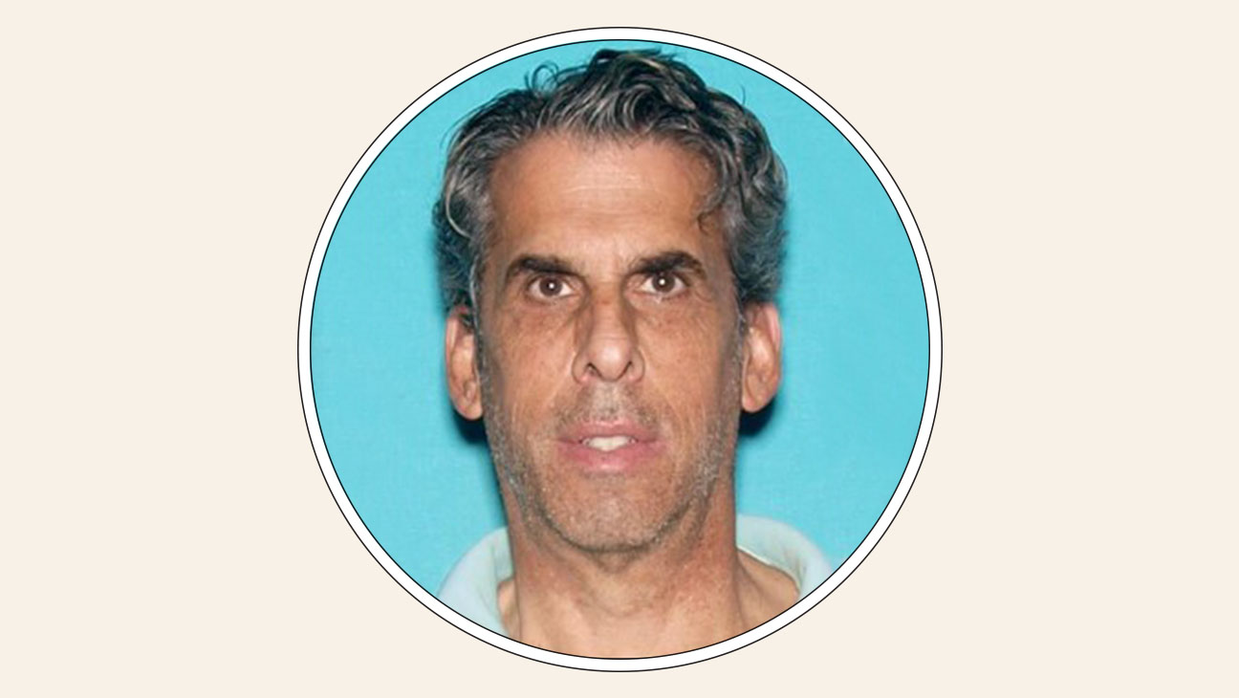
TV

'Scrubs' Writer Eric Weinberg Charged by Los Angeles District Attorney
GENERAL NEWS

Eric Weinberg, 'Scrubs' Writer Arrested for Sexual Assault, Has Court Date Postponed
“I think if you just look at it as an appreciation of the sculpture of your body, you’ll really love your photos. It’ll be empowering for sure,” he later texted her.
Over the next week and a half, Anderson did her due diligence. Weinberg explained that he didn’t have a public portfolio of his work because he didn’t want “TV execs finding my name next to photos of gorgeous models and actresses,” but he sent her examples of his photography. She looked into Weinberg’s work history online. She corresponded with him via text about the type of shoot they’d do, vetoing ideas she found too risqué or explicit. Weinberg had her speak with a model who vouched for him.
Ramirez’s Twitter post yielded no insight, and Anderson went to Weinberg’s Los Feliz home for the shoot. A stand-up comedian as well, she brought some silly props along with her, including a “realistic bird head.” “I told him exactly what I wanted and what I didn’t want,” she says. “But he had other things in mind.”
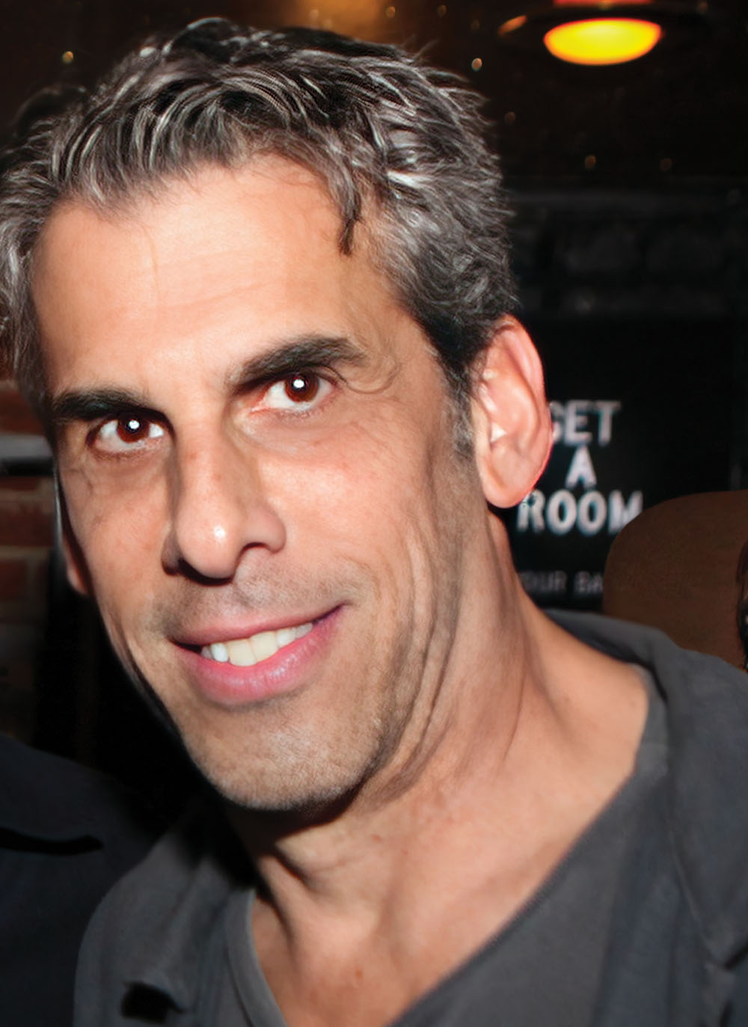
Eric Weinberg COURTESY OF SAMUEL BRASLOW
The shoot began, she says, in a room that appeared to belong to a child, where Weinberg instructed her to disrobe and pose on top of a bed. While photographing her on the bed, Weinberg began “adjusting” Anderson’s breasts, she says.
Anderson had communicated to Weinberg over text that her “main interest would be cool setups of costumes or lighting,” making clear that even for more “provocative” shots, she was not comfortable with any “bits show[ing],” according to texts reviewed by THR. She says she went along with Weinberg’s directions, never having done a photo shoot before, but began cracking jokes as she grew more uncomfortable with her level of nudity.
“Just shut the fuck up, Avian, quit making this a joke,” Anderson recalls Weinberg lashing out at her. “Why do you always have to fight?” (A few days later, Anderson would detail this encounter in a social media post.)
Weinberg led Anderson upstairs, where he positioned her in a hallway arching her back against a wall. She says he then photographed himself touching her genitals before telling her, “Just tell me when to stop.” She didn’t have time to react or respond before she felt him repeatedly insert his finger into her anus, she says.
Standing 5 feet compared with 6-foot-2 Weinberg and weighing only 98 pounds, Anderson says she went numb “like a dead fish.”
According to Anderson, Weinberg then brought her to his bedroom and performed oral sex on Anderson to give her genitals what he called a “glistening effect” for the photos. She says she told him then — and throughout the encounter — that she was asexual. In order to deflect Weinberg’s repeated suggestions of anal sex, she says, she performed oral sex on him.
At the conclusion of the alleged assault, she remembers Weinberg standing between her and the door as she dressed, thanking her for coming over and telling her another woman was on her way over for a shoot. “You’re not going to go to the police and tell everybody I raped you, right?” she says Weinberg asked. She assured him she wouldn’t.
It took her three days to muster the courage — three days of not bathing to preserve the dried semen on her body — before she went to the police and submitted to a rape kit examination. According to the police report, “Avian A. did not stop Weinberg at any time or state that she did not want him to touch or digitally penetrate her because she was afraid that he would become aggressive or stop her from leaving. She believed that if she allowed him to do what he wanted and stayed cordial with him, he would not become aggressive.” When she returned home and took a bath, seeing her nude body for the first time since the shoot, she vomited.
Anderson heard nothing from the LAPD in the weeks and months that followed. In that time, she describes how her mental health declined, along with her performance at work, and how she lost her dream job as an art director on an animated show.
And then Anderson learned about the Facebook group.

Avian Anderson: “I told him exactly what I wanted and didn’t want. But he had other things in mind.” PHOTOGRAPHY BY EMILY BERL
About a year after Anderson’s alleged assault, in January 2020, Claire Wilson, a 30-year-old artist in L.A., posted on a private Facebook group of women in Los Angeles: “I am reaching out to see if any other women have encountered this man Eric Weinberg. I met him over a dating app and although the evening began consensually, he later violated my consent multiple times and forced me to do things I didn’t want to. I want to know if anyone else has had any experiences with him. He’s a prominent screenwriter and producer and it makes me physically sick to think that he probably does this all the time.”
On Dec. 19, 2019, Wilson met Weinberg on OkCupid (he listed his age as 49, 10 years shy of the truth). They began sexting a day later, exchanging explicit messages and images. “I’m very sexually open but not going to jump into your bed without at least a conversation or two about other things,” she wrote him.
On Dec. 21, they met for drinks at a bar, then decamped to Weinberg’s house, but “only to hang out and talk,” she would later tell police. After they began kissing consensually, Wilson says Weinberg forced her to perform oral sex on him. He then pinned her on the ground, held her arms down and forced her to perform other sexual acts, she says.
“I said, ‘No, I don’t want to do that, get off of me,’ ” she says.
After the encounter, Wilson acknowledges that she continued to text with Weinberg in the hopes of clarifying the negative experience. “We want the people who hurt us to fix it,” she tells THR. Weinberg dodged accountability, however, and when he indicated that he would not be seeing her again, she posted to the Facebook group.
The initial post — and a follow-up Wilson shared on another private Facebook group where women offer nightlife safety tips and cautionary tales — prompted an outpouring of stories from those who said they or someone they knew also had been approached by Weinberg for photos. Many of those interactions, the women said, ended in sexual assault.
Within days, the post generated hundreds of comments, prompting Wilson to post in other similar women-only Facebook groups. The posts and the subsequent allegations they surfaced hinted at decades of similar claims of misconduct committed while Weinberg worked for some of the most popular TV shows on air, including Scrubs, Californication and Anger Management.
When Anderson first learned of the chorus of other accusations, she says she felt relieved — but also sickened. “I was hoping that I was just hypersensitive,” she says. “I was hoping I was just being hysterical.”
In interviews with THR, more than two dozen women allege Weinberg approached them in L.A.-area parking lots, in grocery stores, at cafes and on sidewalks, commenting on their appearance before listing his Hollywood credits and showing them examples of his photography, sometimes explicit images. THR spoke with women whose claims go as far back as 2000 and as far away as Portland, Oregon, and New York.
Some say Weinberg would pressure them during shoots into taking off clothing. He would exaggerate his authority in the industry and threaten to derail their nascent careers.
Multiple women describe Weinberg engaging in sexual activity without their consent, frequently photographing the acts as they took place.
Asked for comment on specific allegations, Weinberg’s divorce attorney Karen Silver offered the following statement: “As we have unfortunately seen these days, time and time again, a heavily litigated and acrimonious custody dispute has now given rise to strategically placed criminal allegations. These claims have previously been investigated and reviewed by both law enforcement and the Los Angeles family court and the results have continued to unveil a myriad of evidence, documentation and expert analysis that wholly undermine the narrative now being promulgated. Though Mr. Weinberg himself is precluded from commenting on any aspect of this litigation due to court orders, family law rules and in the best interests of his minor children, he will continue through counsel to cooperate in all aspects of this investigation and, if necessary, will address these allegations in the only forum that should matter — a public courtroom.”
Dating back to at least 2014, multiple women had taken their allegations to law enforcement, but they say that in most instances, police failed to follow up or adequately investigate. In at least two cases, police believed sufficient evidence existed to charge Weinberg, but the Los Angeles District Attorney’s Office, then under the leadership of Jackie Lacey, declined to prosecute. (Lacey did not comment.)
Still, even as their cases seemed to stall and other, more high-profile #MeToo reckonings were covered in the media, the women on the Facebook group continued to follow up with law enforcement, seek out additional victims and support one another. Finally, on July 14, 2022, more than two years after Wilson’s initial Facebook post, police arrested Weinberg on 20 charges of sexual assault, including rape. As he awaits arraignment, Weinberg remains free on $3.25 million in bail.
Speaking publicly for the first time, Weinberg’s accusers detail their encounters with him, the years of frustration and legal dead-ends, and the eventual support of those closest to him that led to the case against one of Hollywood’s most prolific alleged sexual criminals.
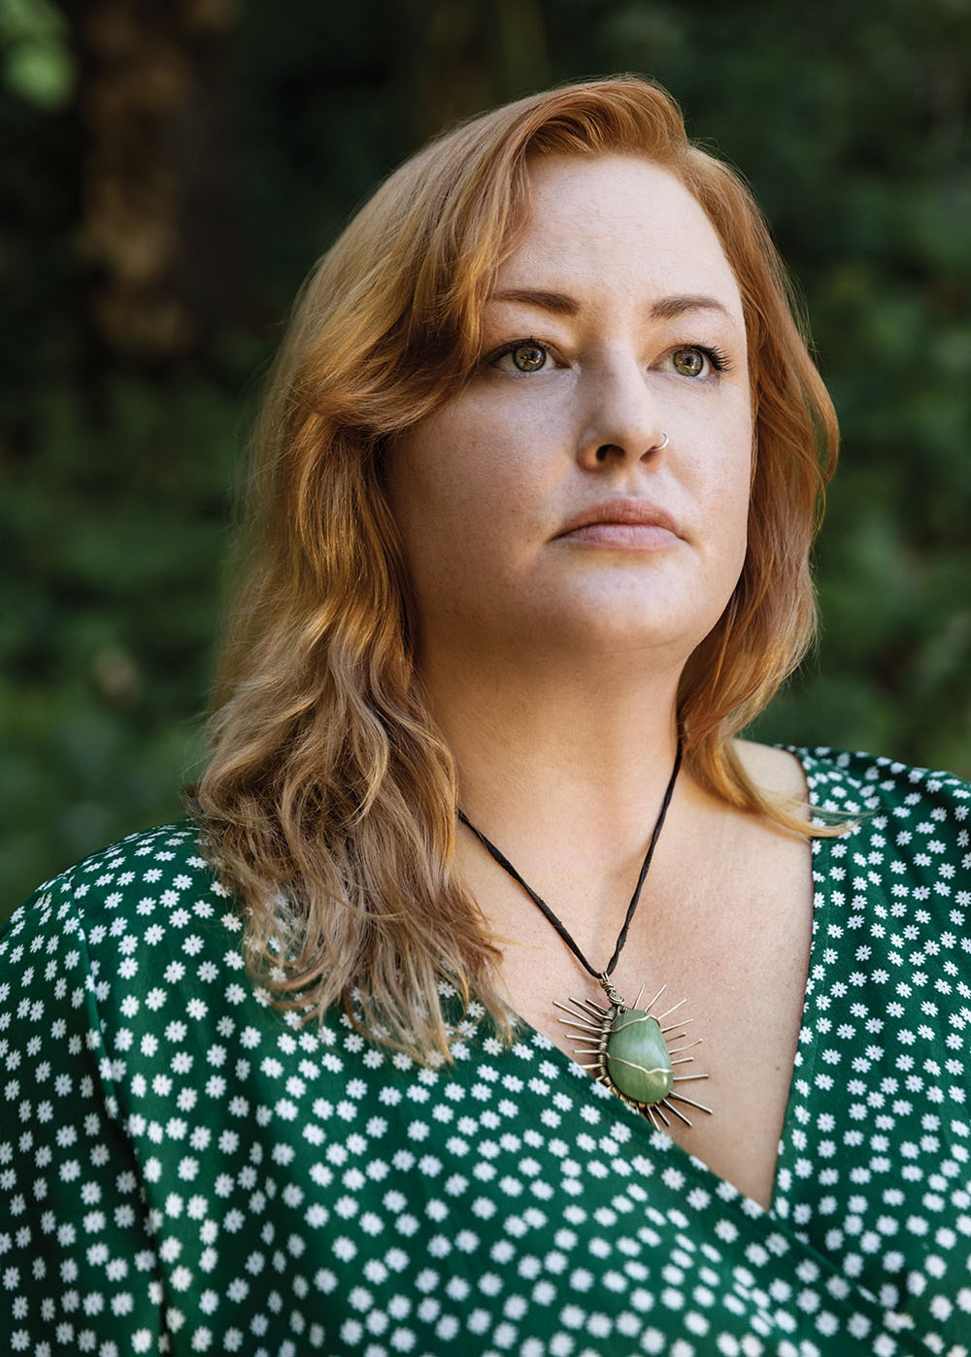
Claire Wilson: “We want the people who hurt us to fix it.” PHOTOGRAPHY BY EMILY BERL
***
Weinberg, now 61, took a circuitous route to TV writing. A graduate of the Wharton School of the University of Pennsylvania, he first worked in finance at investment bank Oppenheimer & Co. before netting his first writing credits in the mid-’90s.
He was a steady presence in writers rooms from the late 1990s until 2016. He worked on the hit NBC show Scrubs from 2002 to 2006, with credits on more than 100 episodes, and rose up to co-executive producer. He held the same position on Showtime’s Californication, starring David Duchovny, and FX’s Anger Management, headlined by Charlie Sheen.
After 2016, his trail of credits goes cold. To those closest to him, he would blame the work stoppage on #MeToo and shifting cultural attitudes, saying, “Nobody wants to hire an old white man.” But according to one producer who worked with Weinberg and spoke with THR on the condition of anonymity, he had become “unrecommendable.” Even without working, according to a partial judgment in his divorce, Weinberg’s monthly income is $45,794, likely a mix of residuals and investments.
Weinberg was still very much a working writer, however, when he approached then-18-year-old Catherine, an actress whose real name is being withheld and who spoke on the condition of anonymity out of concerns for her career.
It was 2014, two months after she had moved to Los Angeles to pursue acting. Catherine heard someone calling after her in the Studio City Ralphs parking lot. She says that Weinberg approached her, told her he wanted to photograph her and listed some credits. Catherine’s ears perked up at the mention of Scrubs, a favorite show of hers — she figured Weinberg could be a valuable connection in a new city.
After confirming Weinberg’s identity online, Catherine told him that he first had to talk with her mom before she could go through with the shoot. Weinberg and her mom had a “full conversation” in which her mom “expressed her concerns,” says Catherine. In response, she says Weinberg reassured her mom, telling her: “I have a daughter myself. I totally understand. I mean no harm to your daughter.” Catherine’s mother confirmed this conversation.
As a final precaution, Catherine brought a close friend, Celina Kimelman, then 20, with her to Weinberg’s house for the shoot.
Weinberg’s Los Feliz house and Tesla parked in front impressed Catherine, she recalls. He offered both her and her friend drinks, she says, which they declined. Weinberg told Kimelman to stay in his living room while the two photographed around the house.
She says that, citing better lighting, Weinberg brought her upstairs, where he “was pushing and pushing and pushing to be more sexual than I wanted to be.” She says he got an erection and began to rub his penis through his pants. She tried to laugh it off and continue with the shoot, she says.
“You look back on these moments, and even back when I was that age, I would always say, ‘I would never let this happen,'” Catherine says. “But then, when you’re in that position … I really did just freeze up and I didn’t want to make him uncomfortable.”
Weinberg posed her on his bed and pulled aside her clothing before penetrating her with his finger without her consent, she says. She remembers that, as her eyes began to well up with tears, Weinberg said she looked beautiful when she cried and “started taking pictures of me crying.”
They ended the shoot, but when they returned to the living room where Kimelman waited, Weinberg surprised them both by asking if she would like to take a turn modeling.
“He wouldn’t [abuse] two people,” Catherine recalls thinking. “I was the target.”
But, according to Kimelman, the same thing happened to her, almost beat for beat. After briefly and vaguely acknowledging that something strange had happened to both of them, the two friends would not talk about the experience for years.
In the months that followed, Catherine says she continued to correspond with Weinberg, who at one point dangled the possibility of an acting role on Anger Management.
In one exchange soon after the shoot, she says she reached out to him to tell him that what had happened that day was “totally not cool” and that she wanted to watch him delete the photos in front of her, arranging to meet him in the lobby of her apartment.
“I saw him delete the photos. I mean, he dragged them into his trash, but who fucking knows?” Catherine says.
Her doubts were justified.
A few months later, in April 2014, Weinberg emailed a batch of his photos to Kayra Raecke, a 22-year-old restaurant manager he met at Republic of Pie in North Hollywood, in an effort to persuade her to shoot with him. Among the images he sent to her, later obtained by THR, was a photo of Catherine with a tear sliding down her face.
Raecke agreed to model for him as long as she could remain clothed, she says. But during the shoot, she says Weinberg raped her.
“After I had said no so many times, he continued doing what he wanted anyway,” she says. “I didn’t know what else he was capable of, including violence. I thought there was a real possibility that I might die there.”
Afterward, she drove directly to Planned Parenthood.
“I think I was just raped,” she remembers telling the receptionist. Planned Parenthood provided her with emergency contraception, and then she went to police, who administered a rape kit. While at the trauma center, police had Raecke call Weinberg in an attempt to secure corroboration. She says Weinberg cried over the phone, repeatedly mentioning his children and trying to get off the line but not responding to her claims directly.
Raecke’s report triggered an investigation and Weinberg’s arrest. In June 2014, an LAPD detective submitted the case to the district attorney’s office, where Deputy District Attorney Teresa de Castro declined to prosecute, citing “insufficient evidence.”
“She claimed she did not consent. He claimed a consensual encounter. There is no corroboration for the victim’s allegations,” de Castro wrote in a charge evaluation worksheet. She did not respond to a request for comment.
However, Raecke was summoned back to the district attorney’s office in September 2014, when another woman came forward with claims of misconduct during a photo shoot. Again, the DA’s office declined to prosecute. Raecke was not informed of the status of the case until nearly two years later and only after she reached out to a detective on her own.
In one other instance, in 2016, law enforcement recommended charges against Weinberg to the district attorney’s office for an alleged nonconsensual sexual encounter with an unnamed woman that took place in 2014, again during a photo shoot at his home. According to a charge evaluation worksheet, Weinberg had “intercourse with her while she was laying on his bed” and she “orally copulated him” while he “photographed the encounter.”
The deputy district attorney in the case, current Superior Court Judge David Reinert, noted in the charge evaluation worksheet that Weinberg had “been investigated for the same conduct involving a separate victim” and characterized Weinberg’s conduct as “inappropriate.”
Still, he wrote, “because there is no evidence that the defendant used force, threats or intimidation to overcome the will of the victims, the case is declined for filing.”
In response to questions from THR, Reinert apologized that he could not recall the specific facts of the case. He did not respond to follow-up questions.

Kayra Raecke: “Had they done something eight years ago, nobody would be here.” PHOTOGRAPHY BY EMILY BERL
Azure Parsons, an actress who met Weinberg on the 2011 MTV show Death Valley, for which Weinberg was showrunner, tells THR that Weinberg sexually harassed her for the duration of the show’s one-season run. Years later, as she returned home from walking her dog in 2014, she says that a car pulled up next to her and a man began complimenting her curves and saying how he would love to photograph her. She turned and recognized Eric Weinberg, she says.
She screamed at him, “Are you fucking kidding me?” A “visibly angry” Weinberg got out of his car, “grabs my arm and tries to pull me into the car,” she says. She escaped from him and ran, calling her manager and then the police. She says the police did not follow up with her.
Parsons was left wondering whether Weinberg “looked me up and found where I lived” or if he “just does this so much” that he happened to approach her randomly, though she suspects “it’s the latter.”
Lending credence to her suspicion that it was a random repeat encounter, five other women who spoke with THR say that Weinberg approached them multiple times, sometimes years and sometimes just weeks apart, reintroducing himself. The women believe Weinberg did not recognize them.
In the weeks that followed, Parsons says she saw Weinberg park outside her home — and then again “in pretty much the same spot” years later, leading her to believe at this point he was now stalking her.
Parsons is not alone in accusing Weinberg of such behavior. Stephanie Nelson, who lives in Los Feliz, says that in 2017, Weinberg pulled up next to her in a gray sedan as she walked home one night. She estimates that she called police three times over the month as Weinberg continued to approach her around the neighborhood, one time appearing to follow her home.
In one such instance, on Oct. 22, 2017, Nelson began filming Weinberg after he rode up to her on a bicycle in Echo Park.
“You should stop harassing me and stop walking with me and stop following me — it’s fucking creepy, dude,” she says in the video. “You’ve done this three times in a month.”
After the encounters, she says, she stopped walking in her neighborhood for a year and a half.
***
After Wilson’s 2020 Facebook posts and the initial dizzying optimism of connecting with other alleged survivors and the hope that, together, the group of accusers could push law enforcement to take action, the cases again seemed to stall. They discovered that Weinberg had learned of the Facebook discussions about him from a member of the group who had violated its code of silence. One woman reported to Wilson seeing Weinberg on a dating app under an alias, while another member of the original Facebook group saw him at a bar with a young woman.
Though she continued to coordinate the group of accusers, Wilson left L.A. in 2020 for Tucson, Arizona. After the alleged assault, she lost a beloved job in art framing and fell into a depression, she says. Her apartment, mere blocks from Weinberg’s home, no longer felt safe.
In her Tucson living room in September 2020, surrounded by the cacti and succulents she now made a living from by selling them on Etsy, a Los Angeles number she didn’t recognize called her iPhone. A voice she didn’t recognize asked for Claire Wilson. The woman was Hilary Bidwell, Weinberg’s wife at the time.
“I was honestly thinking that she was calling me to confront me over something and accuse me of stalking or seducing her husband,” Wilson says.
“I found your Facebook posts,” Bidwell told her. “I want you to tell me everything that you know about my husband.”
“Are you sure? It’s a lot,” Wilson said.
Bidwell said yes. Wilson told her that she might want to take a seat. She proceeded to share what she and the other women had found.
Bidwell had met Weinberg around 1991 in Los Angeles at an acting class, according to interviews with Bidwell and court documents. Neither was enrolled in the class — Bidwell was visiting a friend and Weinberg was there to “get an actor’s perspective,” she says he told her. Weinberg had left Oppenheimer & Co. by then and was trying to break into television.
The two dated for about a decade before marrying in 2001. Hinting at what would unfold over the course of their marriage, one of their wedding guests joked in his toast that Weinberg had proposed to Bidwell by throwing the engagement ring from “the court-mandated 100 yards.”
At his best moments, Weinberg’s boyishness and penchant for banter could put Bidwell at ease and keep her laughing. But she also describes a pattern of aggression and boundary-pushing.
“He really has a way of making you feel safe,” she says to THR. “Until you’re not.”
Court records she filed in a custody battle describe a pattern of “impulsive, violent and high-risk behavior,” including an instance where Weinberg punched a wall in anger, breaking the wall and his finger, and repeated instances of holding Bidwell down and yelling at her. A friend of Bidwell’s called police in response to an incident in 2001, according to those filings, and Bidwell spent the night at a hotel.
In a declaration, Weinberg argued that Bidwell “is the one who has not worked through her intense anger toward me” and denied yelling at Bidwell or having anger issues. Nonetheless, he acknowledged enrolling in a “12-session anger management course.”
When reached for comment, their eldest son characterized his father’s behavior toward his mother as “certainly verbally abusive, beyond a doubt.”
A few years before they were married, Bidwell discovered a box of photographs of nude women in Weinberg’s garage. When she confronted him, he told her for the first time about his photography, she says, explaining that he took boudoir photos of the wives and girlfriends of his friends as favors for birthdays and anniversaries.
Bidwell and Weinberg had their first child a year into their marriage and their second in 2005. Bidwell worked part-time as a landscape designer and stayed home to raise their children, both boys, while Weinberg worked on shows like Politically Incorrect With Bill Maher and later Scrubs.
Then, in 2008, Bidwell discovered more photographs and sheets of paper in Weinberg’s golf bag with the handwritten names and numbers of hundreds of women, she says. The documents, reviewed by THR, frequently included apparent locations beside the women’s names, such as “Ralphs,” “library,” “gym” and “Glendale.”
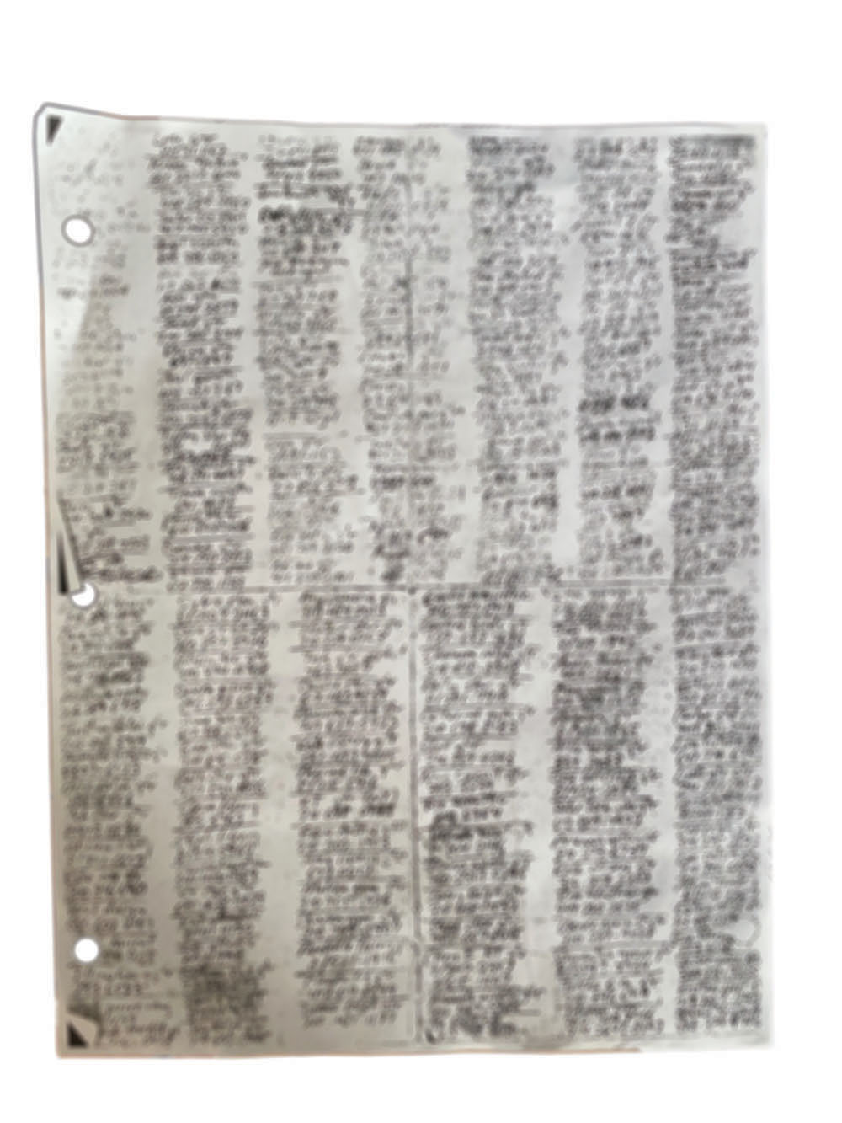
Handwritten pages listing hundreds of women’s names that Bidwell found in Weinberg’s golf bag in 2008.
In court filings, Weinberg claimed the lists were from when he moved to L.A. and did “headshot photography for income,” though he also said that he began treatment at the Sexual Rehabilitation Institute that summer.
In June 2008, Bidwell filed for divorce and asked Weinberg to move out, but the split did not last long. The two had their third child, a girl, in 2009. While Weinberg maintained a separate living situation, the two remained married. He spent a portion of each week cohabitating with Bidwell and taking care of their three children.
The relative peace of this arrangement was shattered in 2014, when Bidwell received a call from a bail bondsman. Weinberg had been arrested on suspicion of rape in connection to Raecke’s claims. He repeatedly denied the allegations to Bidwell, telling her that nothing sexual had happened with Raecke.
“I’ll say that again: On my mother’s life, I had no sexual contact with this person,” Weinberg wrote in an email to Bidwell.
At the same time, though, he told investigators that the two had had a “consensual sexual encounter,” according to the charge evaluation worksheet.
After returning from jail, he sat with Bidwell in their guest room speculating about what would look better to a jury, “a female or male lawyer,” Bidwell recalls. He went with the former, retaining onetime Harvey Weinstein attorney Blair Berk. He also paid for the services of a forensic computer company following the arrest, according to credit card records.
“That’s the last time he spent the night at the house,” Bidwell says.
In October 2015, she filed for divorce again, but when faced with accusing him of a sex addiction in the public record, she decided not to pursue, worried about the possible impact the claim could have on her children, she says. Instead, she opted for a kind of permanent separation.
But increasingly alarming accusations against her husband would continue to surface.
In 2017, Bidwell received a phone call from the mother of a 17-year-old girl who had met Weinberg online. The mother, who spoke to THR on the condition of anonymity, told Bidwell that Weinberg had invited her daughter over to his home for breakfast and then pulled her onto his couch and tried to unzip her sweater. She learned of the encounter after seeing an “inordinate” number of calls from an unknown number — Weinberg’s — to her daughter on her phone records, she says. She called the number, demanding he tell her “how the fuck you know my daughter.”
Weinberg acknowledged in custody filings that “I had breakfast with a girl I met on a dating app who lied about her age to me” but denied doing anything illegal or “inappropriate.”
The mother expresses skepticism that Weinberg would not have known that her daughter was a minor. “She looked like a little girl,” she says.
The final straw for Bidwell — the incident that led her to Wilson’s Facebook post — came in June 2019.
Weinberg approached a 16-year-old girl at a Starbucks a block from his son’s high school and asked to take photos of her, according to divorce filings and interviews with Weinberg’s eldest son and the girl, who spoke on the condition of anonymity.
The Starbucks was a regular haunt for the girl and her classmates, she says. As she had done countless times before, she says she sat at a table to work on chemistry homework, wearing her Jansport backpack with accompanying “stuffed animal, fluffy key chain,” sitting in front of a laptop covered in stickers from her favorite TV shows, like the animated children’s show Adventure Time.
“It’s so hard for me to just emphasize how clear it was that I was a high school student,” she says. “I was 16 and had these skinny, almost prepubescent long legs.”
Weinberg pulled up a chair, she says, complimenting her “athletic physique,” “length” and “amazing bone structure,” before asking if she had modeled. She said no and that she had no interest in doing so, she recalls. Nonetheless, she estimates Weinberg spent “a solid two minutes … going on about my body and face” and how they “would photograph so beautifully.”
“You strike me as someone who would be very comfortable with their body,” she recalls him saying. “He pulls out his camera roll and he proceeds to show me photos of many naked women.”
She was visibly nervous, she says, when Weinberg placed his hand on the small of her back and told her not to worry and that he was “a family man.” As he had done with many women before, he showed her a photo of his children. The girl recognized Weinberg’s eldest son. He sat next to her in ninth period.
She said nothing about the mutual connection to Weinberg. Feeling trapped, she gave Weinberg her number before pretending that a call from her boyfriend was a call from her father, she says. She fled to a corner of a nearby residential neighborhood and “just cried.”
Later, according to a screenshot obtained by THR, Weinberg texted her, “Let’s shoot some time. It’ll actually be fun and the photos will be beautiful.”
Word of the encounter soon reached Weinberg’s son through a mutual friend. He then told his mom. Bidwell and her son confronted Weinberg about the incident. Though he initially denied that the encounter ever took place — even swearing on his daughter’s life, they say — he would later claim in family court that he had only had a “brief, barely two-minute conversation in Starbucks” with his son’s classmate “whose age I didn’t know.” He denied engaging in “untoward or illegal conduct.”
Even as Weinberg denied the allegations, he agreed to spend two weeks at an intensive residential sex addiction rehabilitation program in Palm Desert, California, according to court records. But when he returned and took his children out for dinner, Weinberg appeared to hit on their server, their eldest son told Bidwell.
Bidwell hired a new attorney and filed for divorce in February 2020, and in September, she went onto Google and typed in the search terms “Eric Weinberg sexual assault.” This brought up the public Facebook post Wilson had made in August 2020 with her claims about her date with Weinberg.
Through Wilson, Bidwell learned that Weinberg had lied about not having sex with Raecke, a disclosure that she says severed the last of her trust in Weinberg’s assurances about his behavior.
After Bidwell made contact, Wilson, Anderson and Raecke all agreed to file sworn statements describing their claims of assault, telling THR that they worried about the safety of Weinberg’s daughter.
In addressing the rape allegations, Weinberg declared in court documents that he “exercised poor judgment and did not make the best decisions in the past with regard to third parties.” Elsewhere, he claimed to have taken “full responsibility for some lapses in judgment over the years.” Weinberg detailed extensive therapy, including the two stints at sex addiction clinics, and noted in a July 2020 declaration that he was at that very time running a Sex and Love Addicts Anonymous meeting.
(At one point after his encounter with Wilson, in a call reviewed by THR, Weinberg told her: “I’m not fucking Donald Trump, I’m not going to say that everything I say or do is perfect. I’m not perfect. I know that. I’m trying my very best. I’m trying my very best with every kind of therapy I can to make sure I make all the right decisions in life. I really, really am.”)
As the divorce proceedings crept along, the possibility of other accusations worried Bidwell. While Bidwell long had known of her husband’s prolific extramarital activity since the discovery of the phone numbers in 2008, she says she had understood Weinberg’s behavior in the context of a sex addiction, not alleged serial assault and rape. Now, aware of the other side of many stories, Bidwell says she felt a sense of obligation to identify other alleged survivors.
Unbeknownst to her divorce attorney (and against her recommendations), Bidwell reached out to a private investigation firm and gave them a broad mandate: Find other women with claims against Weinberg for a possible criminal investigation.
But even with the three sworn declarations and the incident involving the 16-year-old, the private investigators — who had seen their fair share of vindictive exes — were skeptical of Bidwell’s claims and broader suspicions about her husband. It wasn’t until Bidwell received a call in February 2021 from Cassidy Rouch that the private investigators began to take seriously the full potential scale of Weinberg’s actions.
Weinberg had reached out to Rouch in February 2019 after he saw her profile on Model Mayhem, a networking site for amateur models and photographers. He introduced himself in an email, saying he worked in television and had shot for agencies in L.A.
“I know you don’t do nudes, but if you’re okay with implied nude (nothing worn, nothing showing), I do think that photos where you can see the sculpture of your curves would be really beautiful,” Weinberg wrote her.
Rouch, who was 22 at the time and studying nursing, had opted to try her hand at modeling on the advice of a friend. She began texting with Weinberg about ideas for the shoot, she says. She expressed an openness to implied nudity but says she shut down the suggestion of anything more explicit.
Once inside Weinberg’s house on the day of the shoot, he almost immediately told her to “strip down,” she recalls. As she uncomfortably complied, she says that Weinberg groped her breasts “so hard I could see the white imprint of his hand on my skin.”
She pulled herself away and asked where she could change and reapply makeup.
“That’s when he led me to his daughter’s room,” she says, describing the drawings, trophies, small pink Converse shoes and stuffed animals she observed. “It reminded me of my room when I was a kid.”
In the bedroom, she says Weinberg offered her an alcoholic beverage, holding the cup to her mouth and spilling the contents on her body. After cleaning herself up, she says Weinberg instructed her to put on an oversized men’s button-down shirt. As he began to photograph her on his daughter’s bed, she says he began drawing attention to his erection while touching her under the pretense of positioning her. Then, he pushed her legs apart and “started touching me,” she says, taking photos as he repeatedly pushed two fingers into her vagina. She told him he was hurting her, and he stopped and apologized, she says.
The assault continued on his bed upstairs, where he continued to penetrate her with his fingers despite her objections and repeated statements of pain, she says.
“He just told me that I needed a man to take care of me and make me feel good,” she says. “So I told him again, ‘I don’t like what you’re doing.'”
Weinberg stopped, left the room briefly, then returned, she says, telling her that “he could prevent me from getting any kind of contracts for work for modeling.”
After the conclusion of the shoot, he checked in with her, she says, asking her, “Are you OK to drive? I’m a father and I have a daughter, and I want to make sure that you’re safe.”
Rouch says she experienced a period of dissociation in the following weeks and months. Weinberg would continue to text her, she says, and she would respond politely but no further.
Then, in December 2020, Rouch stumbled upon a TikTok video by actor Ester Jiron describing her own encounter with Weinberg in 2016. At a shoot at his home, Jiron says Weinberg began asking her invasive questions like whether her long-distance boyfriend allowed her to have sex with other people. She says she immediately stopped the shoot and left. She told her manager about the experience.
“Believe it or not, I actually know of this guy and his reputation,” her manager responded in an email, describing Weinberg as “a very powerful man in Hollywood.”
Soon after, Rouch phoned Weinberg and accused him of assaulting her. Weinberg threatened to involve lawyers and said their continued messages after the assault proved his innocence, she says. Rouch hung up on him midsentence and then called Bidwell, whose number she found online.
Rouch’s call came at a low point in Bidwell’s custody battle with Weinberg. For months, Bidwell sought to limit the amount of time their children spent with Weinberg and to require supervision, but twice already, the court had granted Weinberg more unsupervised time, including overnight visits.
As Bidwell sat in her office about to sign a custody agreement granting more time for her kids with Weinberg, her phone rang. Rouch, in a shaky voice still heated from her confrontation with Weinberg, blurted out, “I was sexually assaulted by your husband on your daughter’s bed and I don’t feel that she’s safe.”
Bidwell hung up and then called Rouch back, this time with one of the private investigators on the other line. She did not sign the custody stipulation.
Animated by a new sense of urgency, the investigators began opening up lines of communication with their contacts in law enforcement. They also reached out to David DeJute, a Los Angeles attorney at Michelman & Robinson and adjunct professor at the Pepperdine University School of Law who, in a prior role as an assistant U.S. attorney in the Department of Justice, defended then-President Barack Obama in one of the “birther” lawsuits challenging his citizenship.
DeJute immediately took an interest in the case, and by March 2022, a group of Weinberg’s accusers met in a conference room in his Westwood office, some in person, others over Zoom.
While DeJute still needed to present the case to his firm for representation in a possible civil case, he wanted to help advise the alleged survivors as things built toward a possible criminal case.
“You’ve been lied to,” DeJute said. “I think you’ve been lied to by Weinberg, I think the system has let you down. The very least that I can commit to is to be honest with each one of you.”
In that spirit, he cautioned the group that whatever legal avenue they went down, be it civil or criminal, each of them would face a unique indignity reserved for survivors of sexual violence seeking accountability through the justice system.
“This will not be an easy process,” DeJute told the women. “I’m not here to tell you what to do. I’m here to help, if I can, and to navigate the legal shoals and to see if we can get some rough kind of justice for you.”
“He’s taken everything that he’s allowed to take from me. There’s no more,” responded Raecke, whose case had appeared before the DA’s office in 2014 but was declined for prosecution.
For Raecke, seeing so many others whose alleged assaults took place after hers had a special kind of hurt. Addressing the group, she likened herself to Cassandra of Roman mythology who had the power of prophecy but not the power to make people believe her. “Had they done something eight years ago, nobody would be here,” she said.
By the end of the month, the private investigators began putting the women in touch with LAPD’s Special Assaults Section, which specializes in sexual crimes. From there, things moved far faster than anyone had anticipated, and by mid-April the detectives assigned to the case indicated that they hoped to arrest Weinberg by May or June.
This came as welcome news to all, but none more so than Bidwell. After Rouch filed a sworn declaration about her alleged assault — adding to the three others — Weinberg took an increasingly aggressive tack in family court. In an email to Bidwell, his attorney threatened monetary sanctions against her and the accusers “as a direct result of having to defend against Hilary’s baseless claims and accusations.”
May and June came and went with no arrest. Then, just as Bidwell and the women began worrying law enforcement would take no action, around noon on July 14, more than a dozen LAPD officers surprised Weinberg at his home in Los Feliz and arrested him. The officers, some in tactical gear, spent the next few hours executing a search warrant for evidence related to the alleged assaults.
In the aftermath of the arrest, with the news ricocheting across the internet, the detectives investigating the case experienced a deluge of tips and additional allegations against Weinberg, prompting them to request more resources from the LAPD.
“We have not scratched the surface,” says a detective involved in the case who was not authorized to speak publicly. “It is overwhelming the amount of new women that have come forward.”
The prosecutor in the case, Marlene Martinez, had to postpone Weinberg’s Aug. 12 arraignment, writing to one accuser that she needed more time to review “a large volume of documents, recordings, interviews, pictures, etc.”
After making bail, Weinberg told his two sons “that he wanted to bang his head against the wall and bleed out and that his life was over,” according to a declaration filed in court by his eldest son. Weinberg also told his children that he was being falsely accused by women who “were out to get him.” Meanwhile, the court revoked overnight visits for Weinberg with his children and now requires a monitor during visitation.
Convalescing at home from COVID, Wilson burst into tears when she learned of Weinberg’s arrest. While it would never heal the initial trauma she says she experienced, she voiced hope that it would ease the pain of the skepticism and disbelief she and others encountered afterward.
“People come up with a lot of reasons in their head about why something this horrible might not be true,” she says. “That victims are making it up because the system can’t possibly be that bad and somebody can’t possibly be that evil or stupid to keep doing it over and over again. It’s like, ‘No, all of those things are true. All of those things are true.'”
This story first appeared in the Sept. 6 issue of The Hollywood Reporter magazine. Click here to subscribe.
Do you know more about this story? Confidentially tip The Hollywood Reporter here.

