Does anyone feel their actual age, over the age of 30? I suppose I assumed we generally did not, that we were all milling around in various states of cognitive dissonance, waiting for a certainty that would never arrive.I thought about it and calculated that my internal compass stopped at 28. That was the answer I gave last Wednesday, and it still fits after exploring the edges of the statement ever since. It was at 28 that I planned in earnest to leave my law job and start traveling. I didn’t plan to keep traveling. My one year sabbatical was supposed to morph into real life once more, and into a law job potentially in the public sector instead of a private firm.
But as the story goes, not so much with the return to the law.
Frankly, up until that point, I did things a bit backward. I started law school just after my 19th birthday, I billed 90 weeks at a fast-paced firm, then moved to a slightly smaller one to work in advertising law. While I did play mini-putt in the hallway with paralegals while waiting for my proxy statements to turn, the level of billable hours certainly wasn’t what my most of my friends in their early twenties were doing. And as anyone in the billable business knows, the astronomical hours billed in my first year of lawyering meant far more actual hours in the office all told.
From the judicious billing in 6-minute units, I took a sabbatical to turn to what I loved most in the world: learning as much as possible every day. That my thirst to absorb (and eat!) turned into a business was extraordinary. That it sustained my travels financially and led me to develop a community of travellers and readers who supported my work was… well, very delightful. Very humbling. How did these smart, capable people become interested in my site? Reader meetups were a wondrous marvel. I didn’t know how they got there. I just felt grateful.
Long-term Legal Nomads fans know that I never quit my job as a lawyer because I burned out. I quit because I wanted to see the world, and let those memories inform my next steps as an attorney. That I had the privilege to do so was never lost on me. Taken together, that privilege plus my profound awe that I mistakenly stumbled into a passion that became a career, meant that most of my days took little for granted.
And then this leak happened.
When I look back, I feel a loss of innocence. How could I have known to also be grateful for the ability to tie my own shoes? To walk down the street without fear of someone bumping into me and reversing my fragile healing?
I wrote about being in pain since I got dengue fever, and along the edges of that pain I found a deeper appreciation for my work and my life. At the time, it felt that my world was narrowing beyond recognition for each. It took adjustment to recalibrate to gratitude.
With the perspective I have now, those years feel ethereal and free. That journey toward grace, and my earlier reacquaintance with food when I learned I was a celiac, both feel expansive in retrospect.
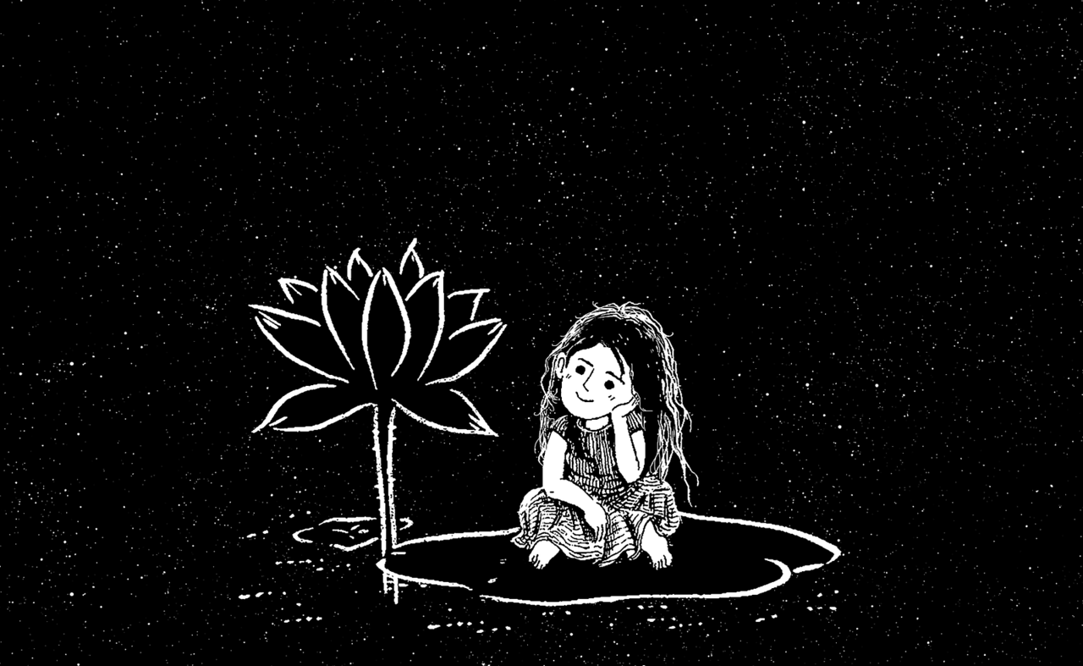
(c) CDD20 via Pixabay
***
One of my favourite short quotes is by Italian writer Carlo Levi, who noted that “the future has an ancient heart.” In a 2011 column on The Rumpus, Cheryl Strayed shared it and added that the quote beautifully summarizes her belief that who we become is born of who we most primitively are. Strayed’s reply was to a request for a graduation speech for writers, many of whom dreaded entering the real world.
I think it’s a useful sentiment for you to reflect upon now, sweet peas, at this moment when the future likely feels the opposite of ancient, when instead it feels like a Lamborghini that’s pulled up to the curb while every voice around demands you get in and drive.
I remembered this column when I began to write this post. Those times where the future felt roaring and new are curiously hard to grasp. With the weight of tragedy, I’m not alone in struggling to reconcile who I was with how my heart and soul has evolved.
The future may have an ancient heart, but my present does too.
In the two years since this spinal leak began, my inbox overflowed regularly with the rattled confusion that accompanies deep misfortune. And I write those people back using my thumbs and I say, “Yes – what we actually know in our hearts feels murky in the midst of unfathomable disorientation. Yes. I hear you. I’m sorry. I’m listening.”
How do you trust your heart when you can’t put on your own socks? How do you close your eyes and be you when “you” no longer exists in some fundamental way? The catastrophe led each of us to this mysterious place where nothing makes any sense always fails to provide the way out.
The cold truth is that life just isn’t fair. Depending on our childhoods, we learn that lesson early. Or, we learn it later. Eventually, we figure it out. How we deal with the stoic certainty of that unfairness as it churns through us dictates how well we survive.
In those two years, I’ve come to believe what many before me have said. That way out is through. The way out is remembering what we are outside the bounds of our wounds. In a society obsessed with doing, identity often ties to your accomplishments, not who you are. Fighting through all that “doing” to get to the “being” sometimes feels like a salmon trying to swim upstream.
My life today life is life itty bitty teeny tiny through no fault of my own. Many weeks I cannot go outside. I am not alone in this place; I have found others with similar, persistent CSF leaks and similar complications following treatment. Together we hold ourselves aloft in the ether.
As I’ve written before, getting through this is not about thinking positive for me. It’s about choosing what serves this journey best. Anger corrodes, and the last thing I need is more of that. It has taken a conscious shift to force myself past the borders of reasonable reaction, and into something open-hearted. To accept this twisted lot I’ve received, and then transform those fiery feelings into something lighter and more empowering.
A wisp of life is what I have, sure. But my work each day is to find joy in that wisp. Or put another way: I can’t change what happened now, but I can change the way I wake up each day. Moment to moment, I have had to pull out my most powerful emotion-microscope to find ways to feel gratitude despite how much I grieve.
I have many tools that have helped me calibrate that microscope, and I absolutely could not have done it alone. I also could not have dedicated so much brainpower and time to overcoming the mental aspect of this big life change without my family holding the weight of my physical care.
The “how to stay sane within tragedy” is a question I receive each day from readers. I hope to write about it when my health allows. It’s one of the most important questions we can ask, even in the absence of calamity.
Every day, the choice looms: do we dust ourselves off and try to find joy, or do we wallow in suffering? It’s a decision we all have to make. I used to think that optimizing for joy alone meant that we were neglecting the reasons for suffering. I equated the shift in thinking to burying my head in the sand. Through this experience, I see that even when we have good reason to wallow, it doesn’t help us endure or overcome.
My stakes feel particularly acute, since most of my days are spent to myself. I first had to accept the intrinsic unfairness. Slowly now, I can untangle the knots of my frustration and despair, and flatten out the thread until it looks sleek. Neat and tidy.
And then the next day, I start all over again.
***
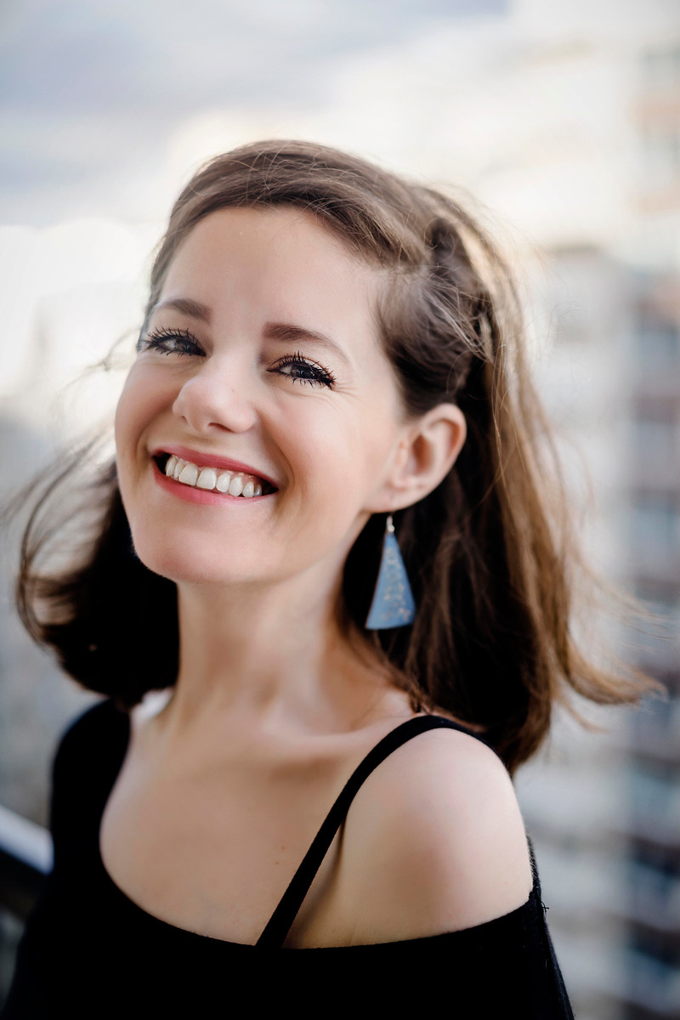
This picture was a generous gift from my friend Marie-Christine. A wedding photographer, she came over to shoot photos and make me feel glamorous for my 40th. I put on makeup for the first time in almost a year, went on the balcony, and MC did her thing.
A wise person once told me decades ago that it was smart never to compare my insides to someone else’s outsides. Few people wear their struggles on their sleeve or their face. We never know someone’s story, we can’t say what is weighing them down or lifting them up. We use our own beliefs, honed with however many years of bias, to make a judgement call about a stranger.
It doesn’t look like I spent 10 months in bed or that my brain is sinking into my spine, does it? There’s a reason they call it “invisible illness”. It’s one of 30 photos I’m set to receive, all taken last week. My smile and laughter are real. I had an excellent afternoon with a dear friend, even though I paid for being upright with some extra pain.
The afternoon was a reminder of what I’ve tried to remember as I pass through this extraordinary time. That each moment we get with someone we love, each second that we can find goodness and joy — that’s one moment we aren’t giving into what exists and can dredge us down.
***
“As my face changes, I will lose myself,” writes Chelsea G. Summers in a piece about the skincare industry. “The skin-deep existential crisis is this: Who am I when I don’t recognize myself in my own skin?”
As a woman, aging unfurls all sorts of whispered consequences. Peeking grey hair and wrinkles and yes, changing skin. These days, aging is somewhere in a storage space at the back of my mind. At forefront is instead the dearth of basics that I never thought I’d lack. Walking. Being able to tie my own shoes or cut my own toenails. Opening a heavy drawer. Cooking my own food. Laughing hard or coughing or sneezing without worrying about opening up a bigger leak in my spine.
It’s not been an easy few years. It’s been the hardest few years, harder than I ever thought I could sustain. I haven’t given up, and have surprised myself with the resilience I needed to power through. “I couldn’t do what you’re doing,” people tell me. Of course they could. We never know the depths of our own adaptability and strength until it’s deeply called into question.
My story is no exception, it’s just a story of extremes. Freedom to not-freedom, with the love of the world in between.
Learning as much as I could powered my life as a traveler, and it’s powering my life now. I’ve spent two years reading everything I could about neuroplasticity, immunology, and epigenetics. I’ve meditated more than is reasonable. Through force of imagination and curiosity, and with the help of many remarkable people, I’m no longer in the pit. Even though I don’t know when I’ll walk again without brain sag.
There are thousands and thousands of people who have shown me they care during this absurd time. I try to show up for other leakers in the same way, or for readers who are scared about their pain.
I dreaded my 40th for the last while because my plan was for years to summit a big mountain with my friends. But as the day approached, I made more peace with where I am. Is it where I wanted to be? Absolutely not. But the same lust for life that fuelled my too-young-to-be-lawyering years and my eating-all-of-the-soup years sustains me now.
Life changes in an instant, and I feel proud that I packed in more in my 40 years than many people get in a lifetime. For the last two years, I’ve had to live life from the inside-out, searching for answers that don’t exist. Trying to keep my brain afloat both literally and figuratively.
***
My actual birthday was as good as it could be given the circumstances. I woke up to a burst of love from around the globe from my family, community, and friends. Friends and my mum stopped in all day long in waves, to give me gentle hugs. My Montreal bestie, who you may remember from my post about how I officiated her wedding in Costa Rica, came over for sushi dinner and a beautiful cake.
The cake was specially by Kleine Shoppe. The owner, Katie, patiently took my short list of “ingredients that don’t cause a Jodi to go into anaphylaxis” and turned out one of the most beautiful cakes I’ve ever had the pleasure of eating.

To be clear, she chose the message not me. But it was both hilarious and delicious, and I saved some of it for future consumption.
I went to bed content on my 40th. Even without the foods I used to obsess over, I felt sated. And most of all, I felt deeply cared for.
Many of us have a hard time receiving love, and that’s been a lesson for me in the past two years. It’s hard not to feel unworthy – not of love generally, but the fierceness and care of so many who want to see me well. The natural awkwardness of that feeling is far eclipsed by the strength it gives me, and the humbling effect the support has.
I’ve always looked young, something that was a liability as a lawyer and a source of mirth as a traveler. But now, it feels particularly off-key. When I first arrived in New York as a summer associate I was 20. Amazed I was there at all, I would scrutinize people’s faces as they passed by. Who would I look like? Where would my life lead me in 20 years time? It’s always fascinating to remember the shape of those predictions in retrospect.
I look at my face and my face doesn’t look forty.
I look at my face and think, who cares how old my face looks?
In that 2011 Rumpus column, Strayed writes about the interstitial years between knowing your heart’s path and making it there, eventually.
The most terrible and beautiful and interesting things happen in a life. For some of you, those things have already happened. Whatever happens to you belongs to you. Make it yours. Feed it to yourself even if it feels impossible to swallow. Let it nurture you, because it will.
When I stare in the mirror, I see a weary but strong version of me that doesn’t jive with who I was, but is exactly who I am. Surprised and knowing all at once.
And in those quiet exhalations when the pain lessens for a blessed moment, I feel overwhelmed with pure love.
My soul in bloom and my ancient heart and my youthful face, all of it, braided together to help me feel whole.
-Jodi

How You Can Help
A lot of incredibly generous people have written to ask how to help during this time. I am not starting a Go Fund Me again, and unless things change I do not plan to.
However there are three easy ways to help.

1. Help by Donating to the CSF Leak Foundation
Help by making a donation to the CSF Spinal Leak foundation, a 501(c)(3) charitable organization that has advocated tremendously for the condition I’m currently working to overcome. They are a lean organization, with those involved also dealing with spinal leaks – so every dollar counts. I’ve started a fundraiser for 1 week, via the Legal Nomads page. If you’re on Facebook, you can make a donation here until the fundraiser ends on August 22nd.

2. Helping me personally (which many of you have asked for specifically!)
I’ve told friends and extended family that the best way to help me is an Amazon gift card. This allows me purchase ingredients for foods I can eat, like teff and tiger nut flour, without my parents having to go hunt for them. I also use Amazon for the items that help with the disabilities I face – grabber devices, coccyx pillows, and my fave! Lying down glasses. You can send a gift card to legalnomads-at-gmail.com if you’d like to contribute to me personally.

3. Help spread the word and raise awareness about CSF leaks
CSF Leaks are an under-diagnosed condition than can arise from a spinal tap, epidural, spinal surgery, epidural steroid injection, and even spontaneously.
If you’re in the USA, please see the CSF Spinal Leak foundation‘s page, including the research studies they have previously funded.
If you’re in Canada, there’s a new Canadian foundation that was started by leakers this year. Awareness of leaks is specially low in Canada, and doctors here told me that I was just “having migraines” – even though they went away when I laid down. The leak experts are predominantly in the USA, so hopefully with more awareness and doctor education this changes.
***
PS. It seems my internal age broadcasts externally just fine, because several people joked that I looked 28 before I published this post. Here are a few of the responses from my birthday pics on FB and Instagram:
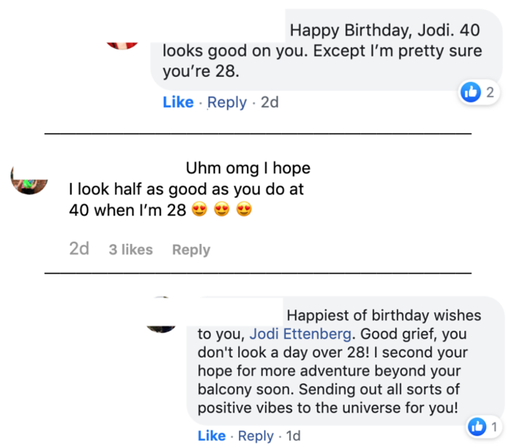
Best coincidence ever?
PPS. I had to end with a llama
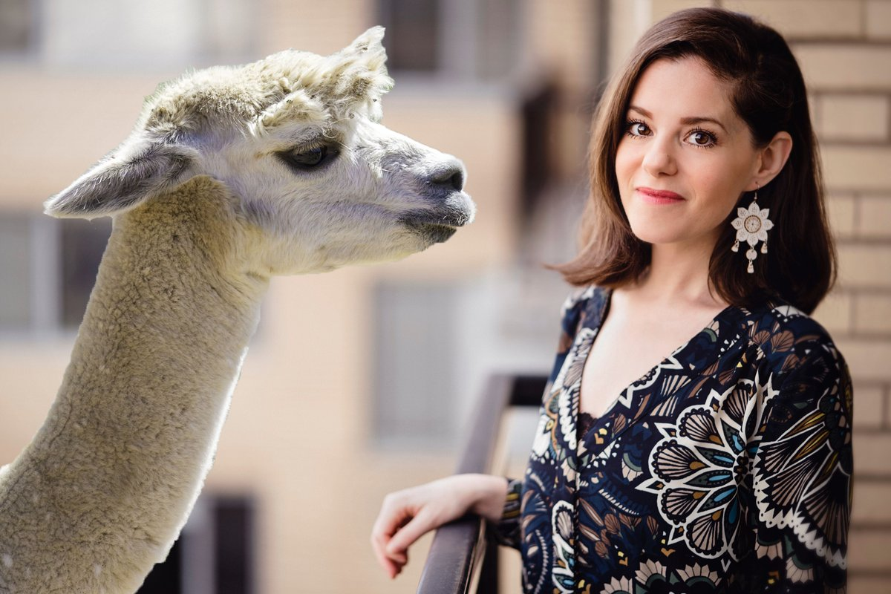
Another of MC’s photos from our birthday photoshoot last week, with bonus llama photoshopped in by my always-creative friend, Laurence.

ON TURNING 40 WITH AN ANCIENT HEART
BY JODI ETTENBERG40 COMMENTSFEAR AND ANXIETY, PERSONAL MUSINGS, WELLNESS
In February, I realized that I was no longer sleeping well. On the rare nights that I did rest, my tracker said I went into only 20 minutes of deep sleep a night total. Plus, the hours of light or REM sleep that I did have were punctuated with awful nightmares.
After a particularly rough stretch of ugly darkness, my friend Naomi asked to chat one night before bed. I slept soundly for the first time in months. In the morning, I couldn’t believe my eyes when I saw that I had one hour and fifteen minutes of deep sleep. In the shower, where all good ideas derive, I decided to ask for some help and see who would want to have a nighttime call with me to help me sleep better.
Worried it was too hokey, I texted my brother as my brain-check.
“Are you kidding!?” he exclaimed. “Everyone feels helpless in this mess. Give them something to do.”
He was right.
I put up a short sign-up sheet on my personal Facebook page on February 13th, and by the end of the day I had a call booked every single night, all the way until late May.
“Some species of trees spread root systems underground that interconnect the individual trunks and weave the individual trees into a more stable whole that can’t so easily be blown down in the wind,” wrote Rebecca Solnit in her essay A Short History of Silence. “Stories and conversations are like those roots.”
The nighttime calls were my root system that leant a beautiful intimacy to already existing friendships. Everyone who signed up already knew me fairly well. The combo of my present situation, plus the tenderness with which everyone tried to tiptoe around it, assured that the calls were truly wonderful.
I wanted to direct the conversation away from my explaining how I was doing. I wasn’t doing very well, and to repeat that night after night didn’t seem like an effective way to sleep better. So I decided to ask everyone two questions:
- When life takes something or someone important from you or delivers a big blow, how do you find hope and joy again?
- Does spirituality affect your ability to be resilient in life? (By this I meant lower-case “s” spirituality, general connectedness to all things / something greater, not necessarily Spirituality in a religious sense. For many who were religious, it was one and the same.)
The questions led to some beautiful discourse, a deep dive into wonder and the human experience. People felt comfortable sharing their own grief and losses, as well as how they picked themselves up again.
I listened, I shared, and I felt connected to the world in a way that I missed.
I slept well almost every night.
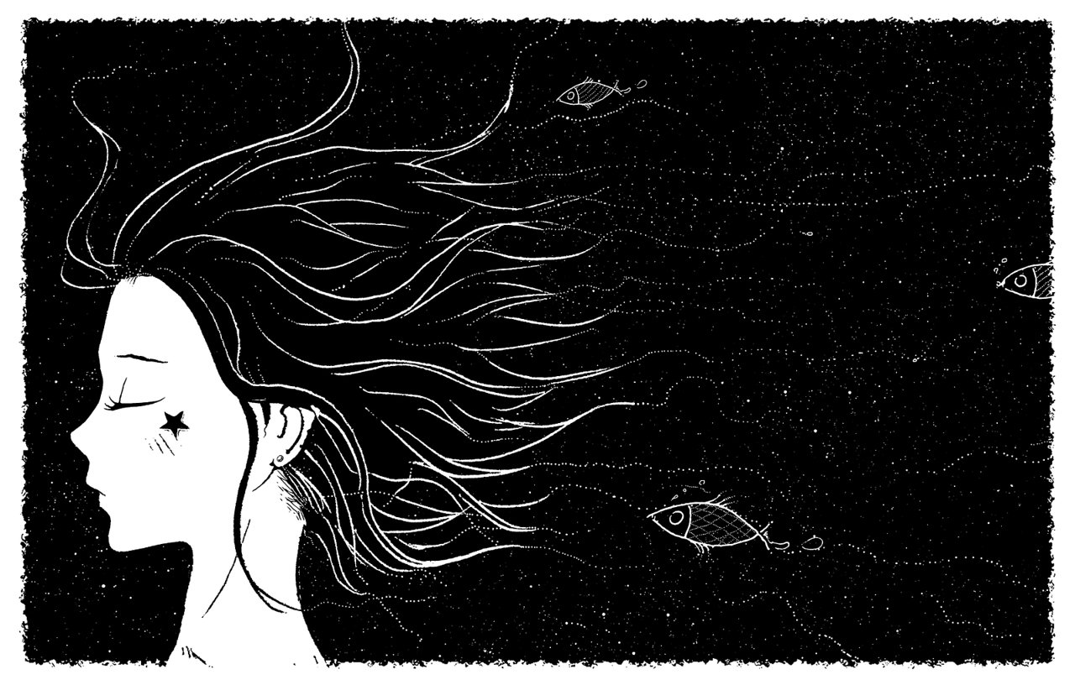
(c) CDD20 via Pixabay
***
The day before my 40th birthday, someone asked me how old I felt internally. I laughed, saying that we all felt younger than we were. But she meant an actual number. The question stemmed from an exchange she had with her friends, since none of them felt their age.

