Euro 2024 and German efficiency: Forget everything you thought you knew
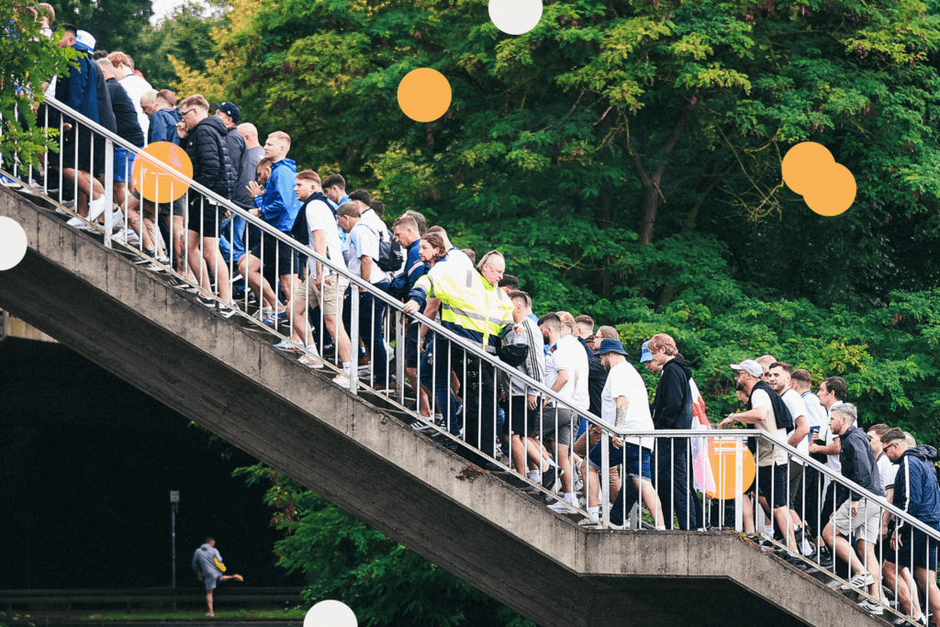
By Sebastian Stafford-Bloor
Jun 18, 2024

Follow live coverage of Turkey vs Portugal and Georgia vs Czech Republic at Euro 2024 today
Efficiency. Reliability. Functionality.
That’s what many people most associate with Germany, but so far at the 2024 European Championship, none of those cliches have been proven true. Tournament organisers have struggled with crowd control outside stadiums. Fans have endured miserable conditions on the way to and from games. Metro and rail services within the host cities have failed under the extra demand.

It is not what the rest of Europe expected to find.
On Friday night, Euro 2024 began in Munich. The city is used to serving big football crowds, with Bayern Munich selling out their 80,000-capacity Allianz Arena game after game, year after year.
The journey from the centre of town is usually simple enough, via a metro train (on the U-Bahn) that rattles north and delivers fans at Frottmaning station, which is a 10-minute walk from the stadium. For big games, it can get busy. But outside the ground, for Bundesliga and Champions League matches, everything works well enough and supporters find the areas they need.
On Friday night, it could not have been more different. The line that runs out of Munich and up to Frottmaning ground to a halt. Trains stopped at platforms and in tunnels for long periods and grew fuller. Munich has a warm climate, especially in June, and it was to the great credit of the Germany and Scotland supporters that, even though they were jammed up against each other, with no room to move, the mood stayed calm.
Outside the Allianz Arena — in scenes that have been repeated at other games played since — it was chaos. For Bayern games, fans are signposted towards certain entrances, depending on where in the stadium they are sitting. On Friday, the zoning failed, creating one big queue in front of the ground. Some were outside for hours.
On reaching the front of the line, many fans had no choice but to physically push through the crowds to find their entrance, much to the annoyance of others who misinterpreted what was happening, which resulted in a few fleeting flare-ups.
Organisation around Bundesliga games is generally excellent across the country. Many of the supporters in attendance, particularly the German fans, would also have had prior experience of Allianz Arena before and yet this was wildly different.
The first game of a major tournament often brings opening-night wrinkles and issues, but what happened in Munich was strange — and it was just the start.
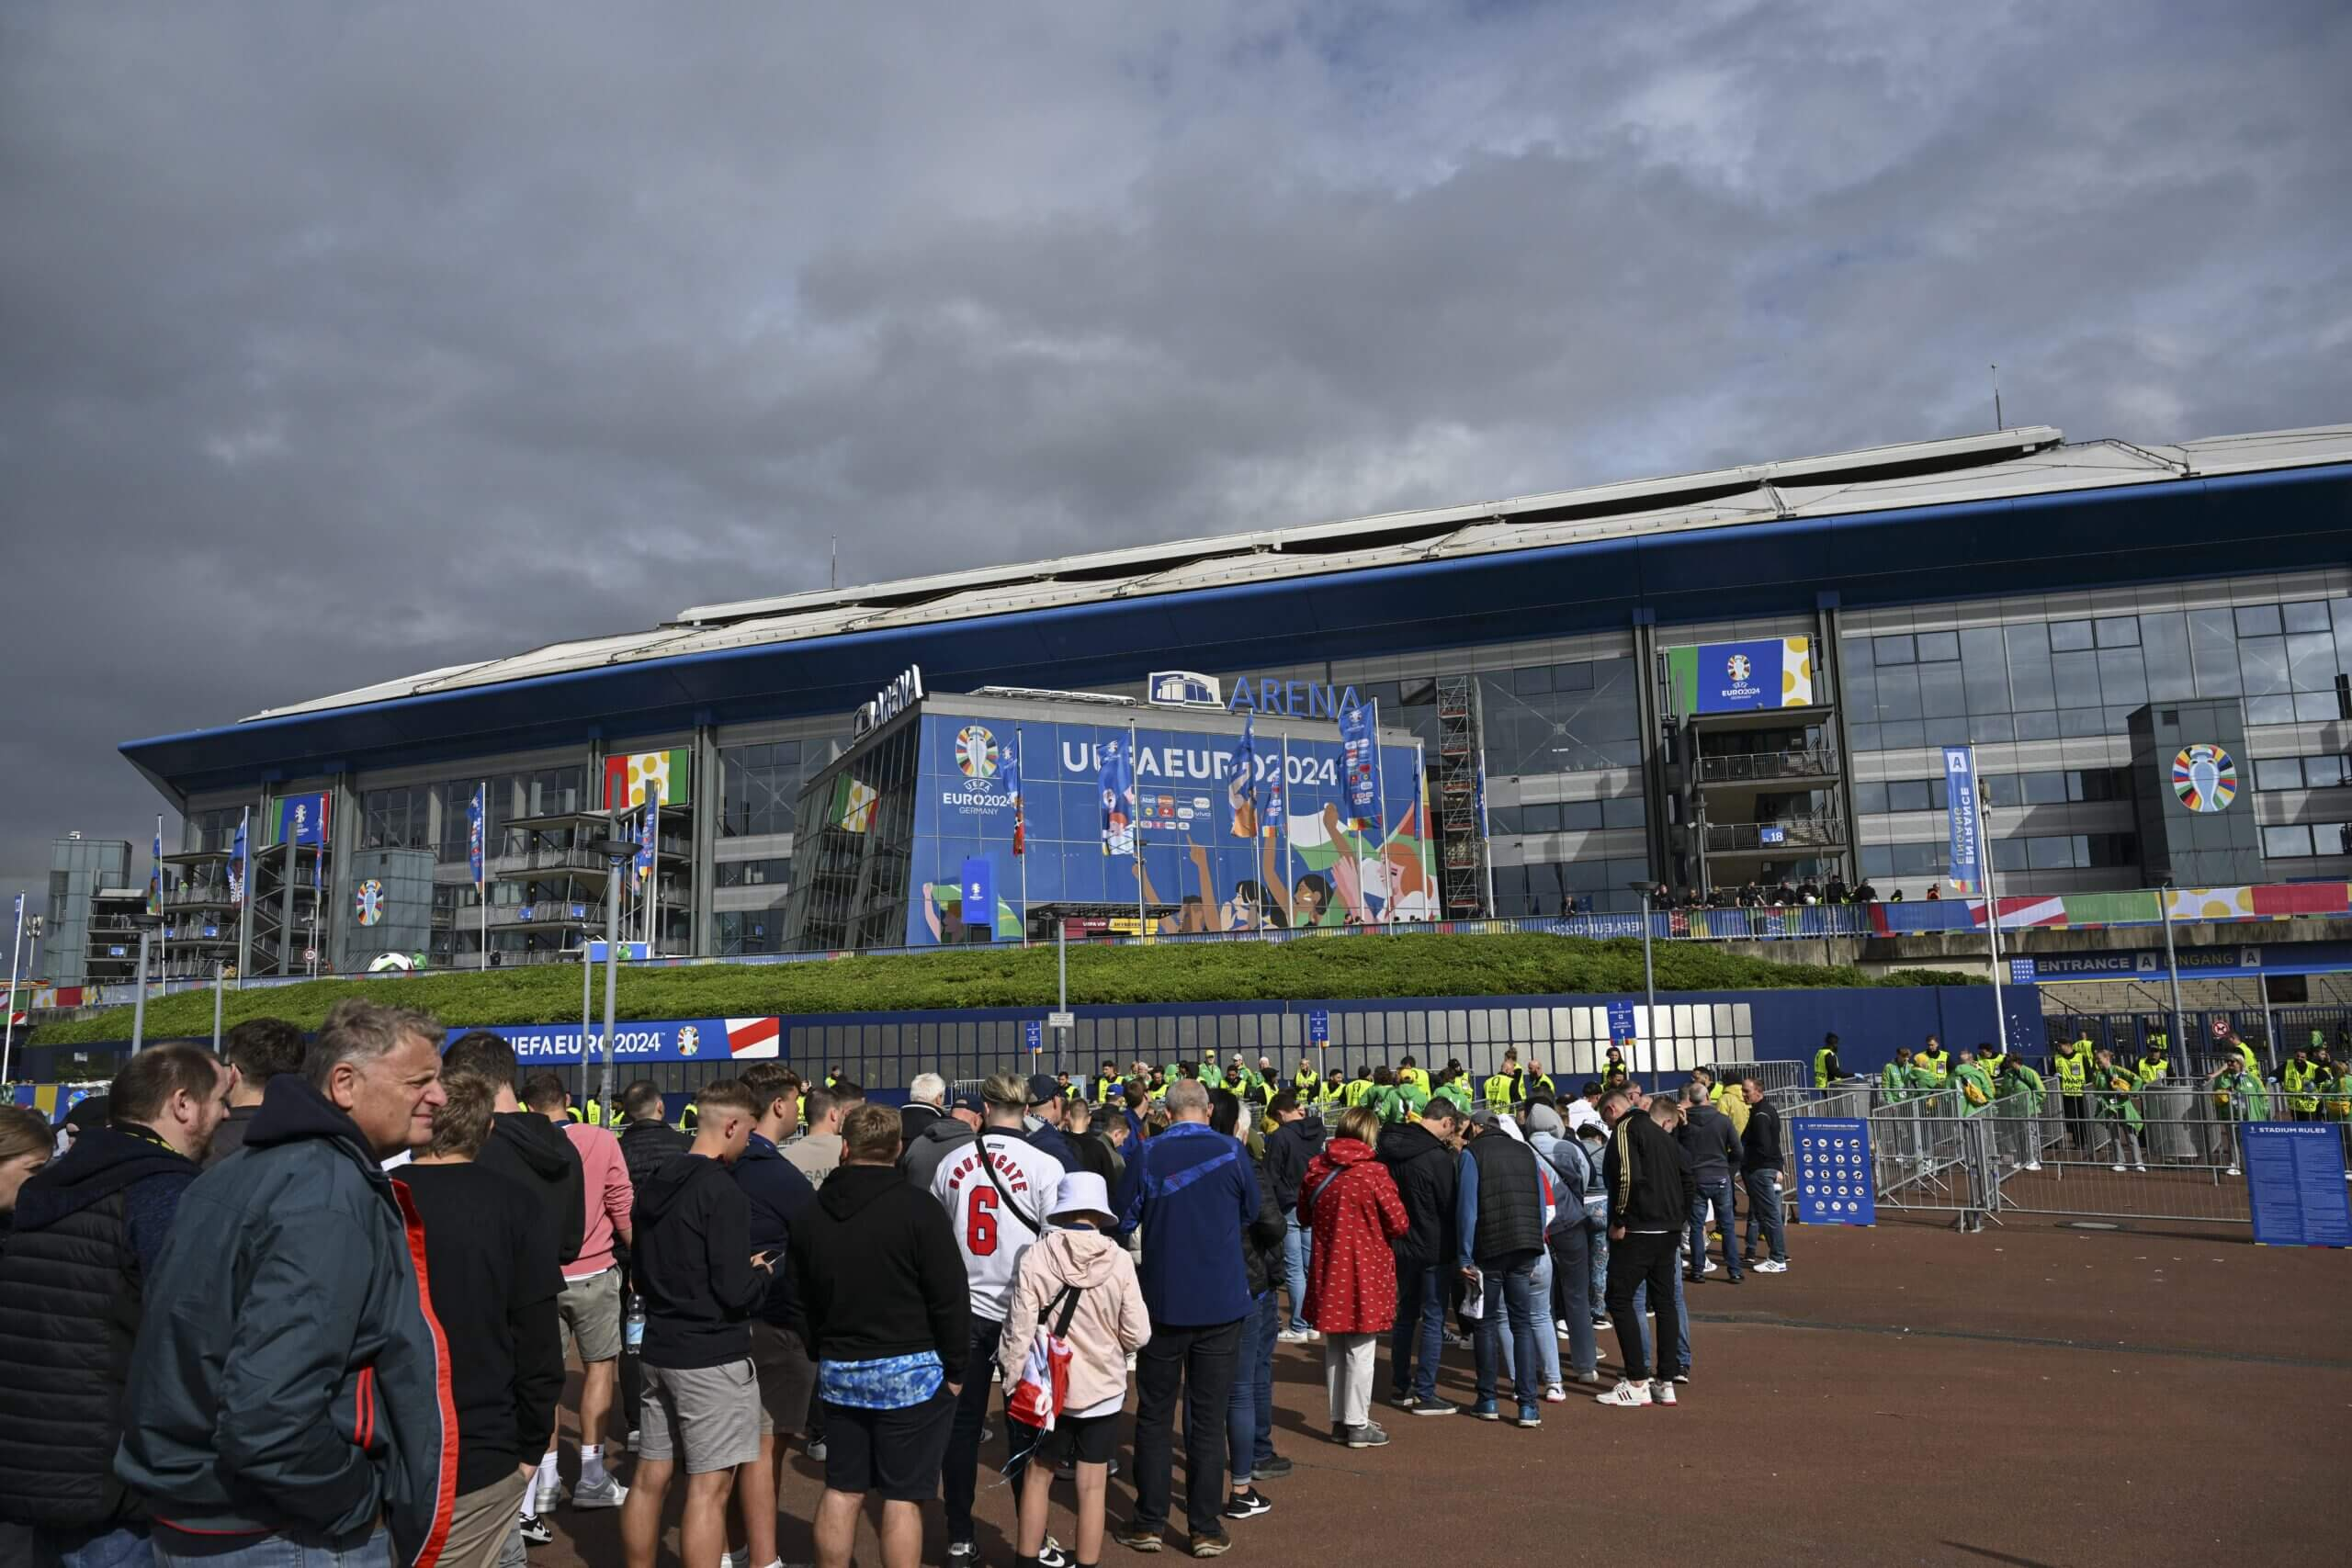
Fans queuing outside the ground on Sunday in Gelsenkirchen (Oguz Yeter/Anadolu via Getty Images)

On Sunday night, England played Serbia in Gelsenkirchen. Bad stories have emerged from before and after the game.
There was gridlock and congestion on the tram service from the station to Arena AufSchalke, the out-of-town stadium, to the extent that some fans chose to walk the entire way instead — about an hour and a half from the city’s central station. England’s 1-0 victory ended up being a sub-plot to stories of crying children, heavy rain and, in a lot of cases, confusion.

Steve Grant, an England fan who follows the team home and abroad, did take public transport to the ground and said overcrowding at the station was so “dangerous” that “if you were stood at the platform edge, you were using your entire body weight to stop yourself being pushed onto the track”. He said there were “no crowd control measures in place at all”.

GO DEEPER
England fan group criticises 'serious issues in Gelsenkirchen' over Euro 2024 game
After the game, there was more chaos. Another England fan, Alex, described scenes at the main train station as “absolute bedlam” even hours after the final whistle. He had decided to take public transport back, while another friend walked — arriving half an hour before him.
“I couldn’t believe how busy the main station was,” he said. “When we heard the platform announcement for our train, people ran at full pace to reach it — I can’t imagine what it would have been like to take children to the game. Then, when we got to the platform, there was no train. We eventually got back to Dusseldorf (in theory 30 minutes away by intercity train) after 2am.”
Rich Nelson was also in Gelsenkirchen on Sunday night with one of his friends, a wheelchair user.
“It was a right mess,” he said. “Trains were coming to different parts of the platform with no announcement, so you had hundreds of people running to squeeze on. Platforms were altered so Essen trains were coming through when announced as going to Dusseldorf and one train looked like one of the old slam-door British Rail ones.
“We somehow managed to squeeze on thanks to a few people moving and holding doors, but the train took an hour to get to Dusseldorf. The trains have been the poorest and least reliable part of the weekend for us. Not a single train, of the several we took, ran on time and despite us booking ramps (for the wheelchair), Deutsche Bahn staff weren’t interested in helping last night.”

Gelsenkirchen is one of the smallest Euro 2024 host cities. It is an industrial town which has relatively little nightlife or attraction to travelling supporters and fewer hotel rooms than most. It was inevitable that an enormous stress would be placed on its transport systems on the day of the game itself.

Deutsche Bahn (DB) is the company that runs Germany’s privately-operated, government-funded railway network. Once the gold standard of rail travel in Europe, today it is far from that peak and has been for some time.
While people from outside Germany have been aghast at the delays, those who live in the country are all too familiar with DB’s struggles. Trains are late. Trains do not turn up. Trains change destinations without warning. Connections are missed and people are left stranded.
Sit in a DB carriage when a delay is announced and pay attention to the glances that Germans exchange and how they roll their eyes; it has become a punchline and while some of the issues at Euro 2024 are a surprise, the endless delays and disruptions on the train network are not among them.
It is a complicated problem without an obvious remedy.
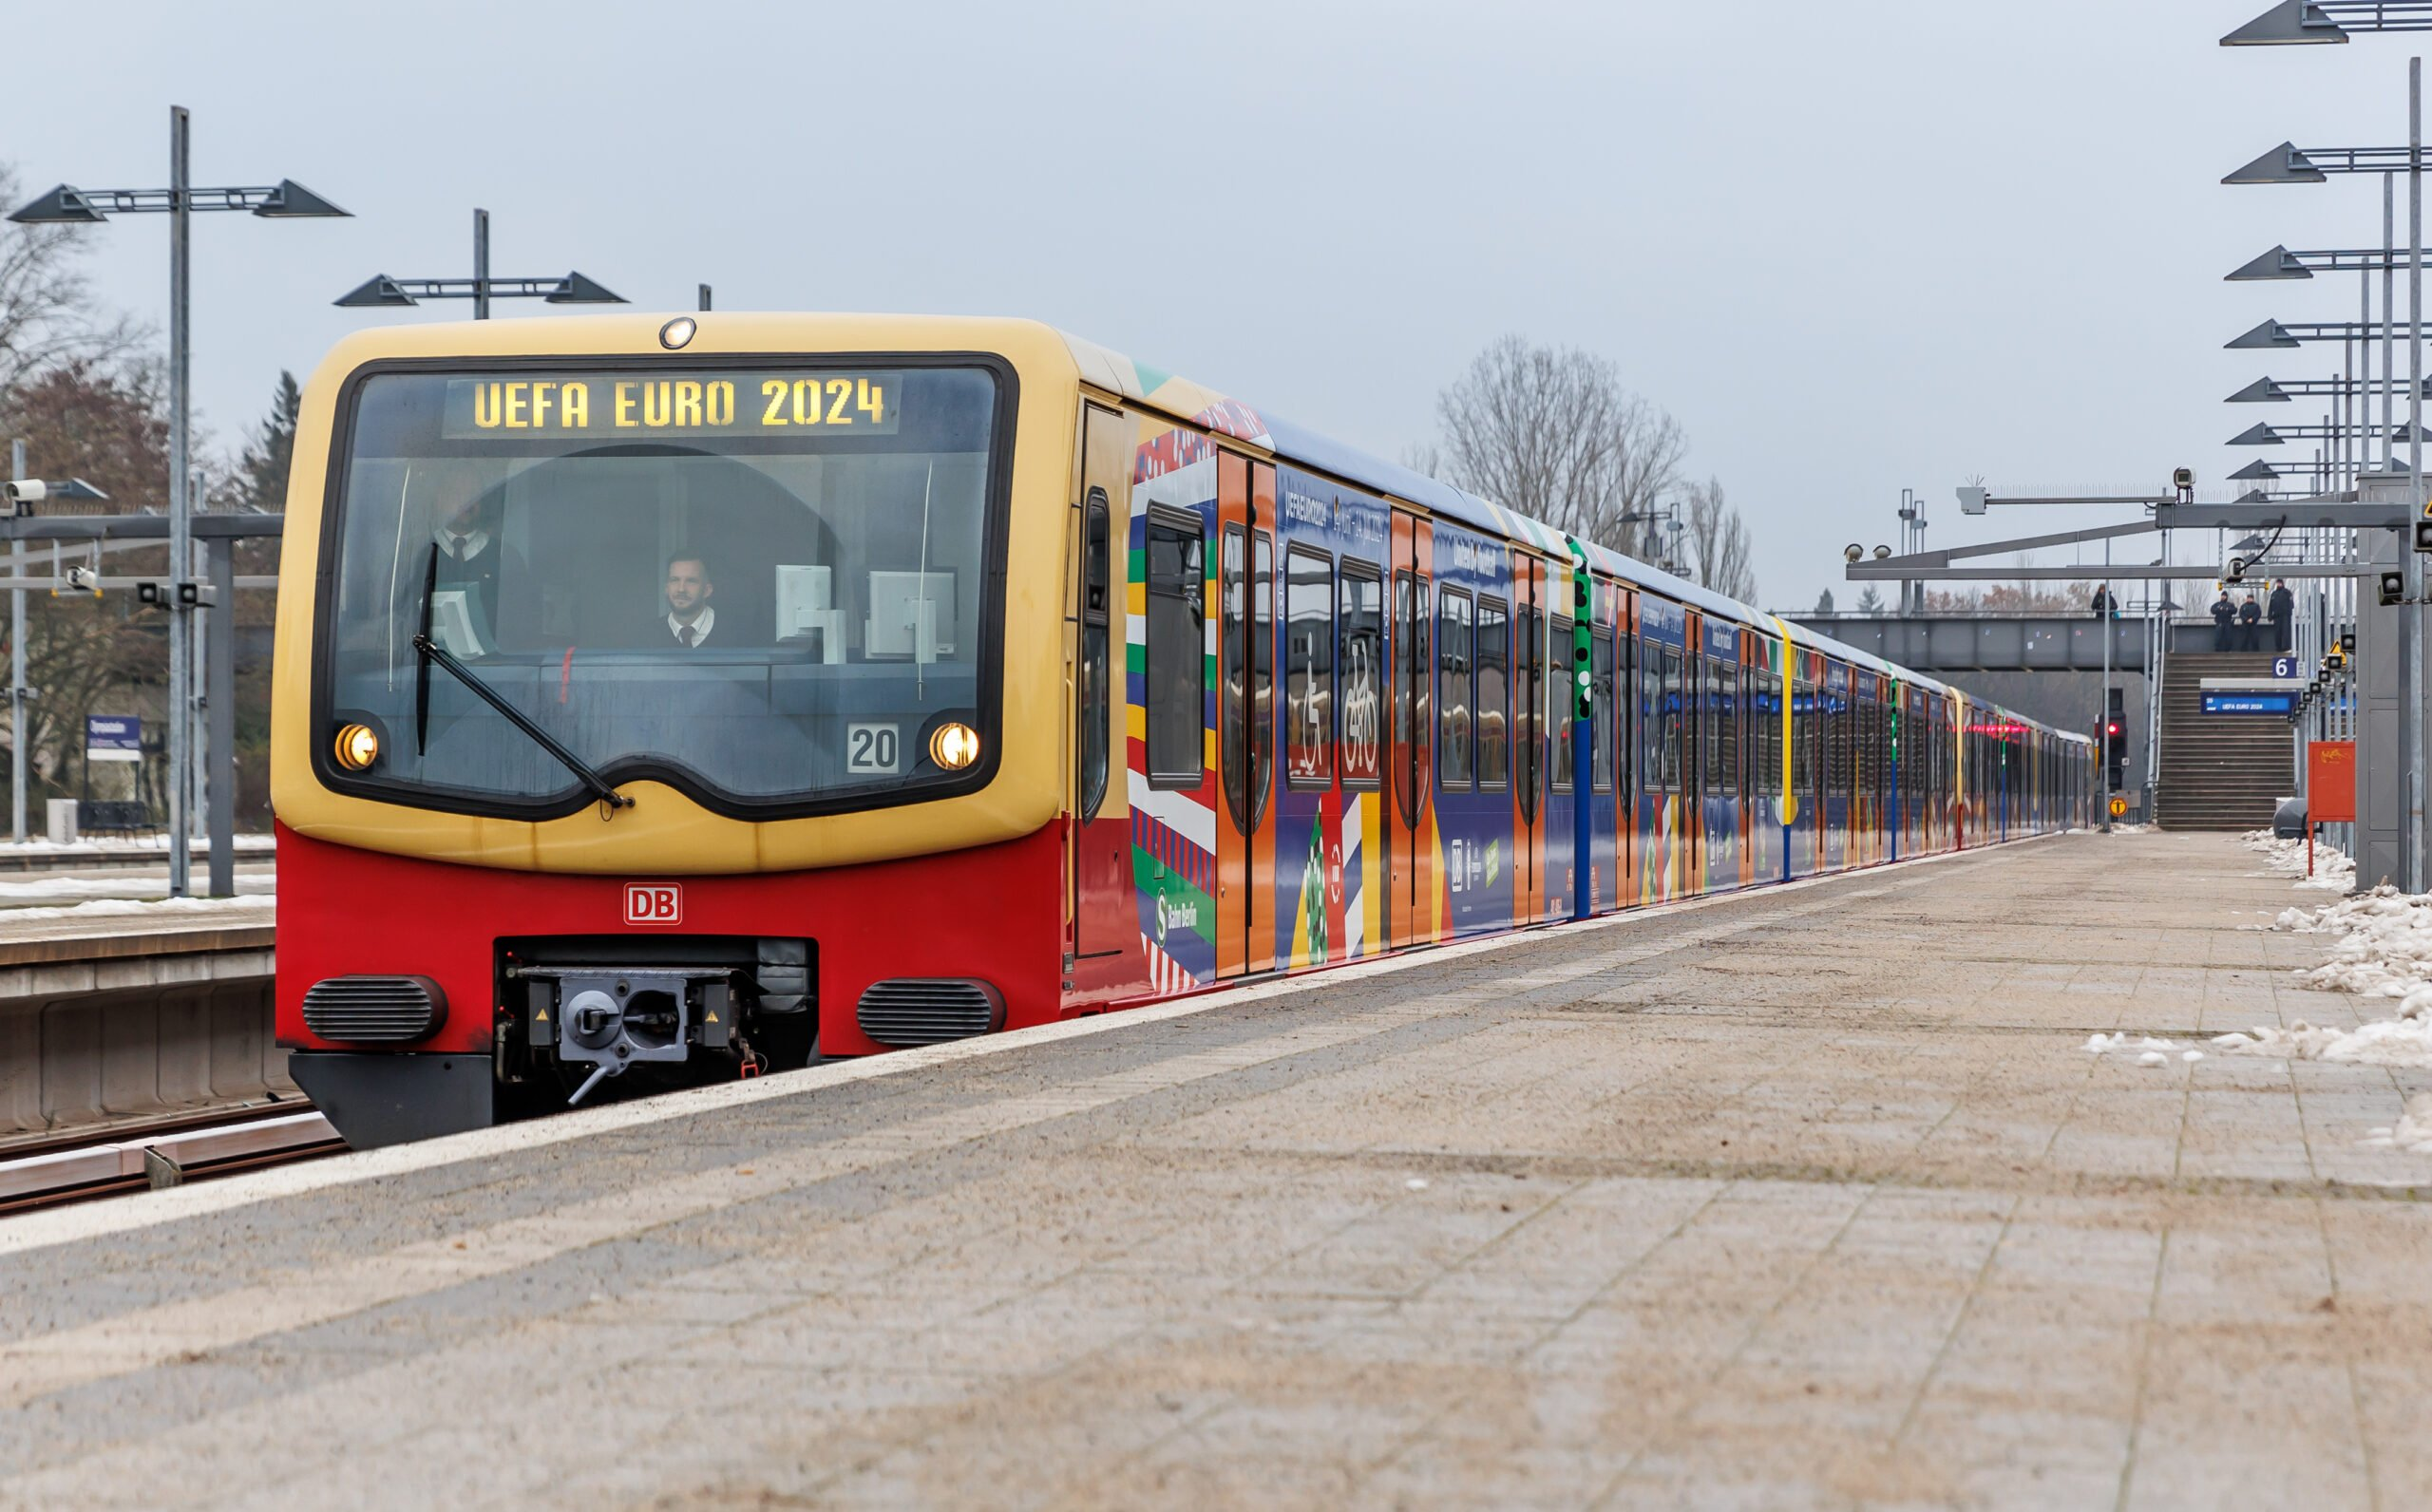
A train in Euro 2024 colours at Berlin’s Olympiastadion S-Bahn station (Andreas Gora/picture alliance via Getty Images)

The services that DB provides are enshrined within the German constitution. The federal government has a responsibility to maintain a service that serves the common good — referring both to its cost and its reliability.
Recent trends are alarming. In 2020, more than 80 per cent of trains arrived on time. In 2021, it was 75 per cent. By the summer of 2023, the punctuality rate had fallen below 60 per cent, beneath the 70 per cent target DB has publicly committed to.
One of the best-known statistics, certainly the one most repeated in German media, is that in 2022 more than 33 per cent of all long-distance trains arrived late to their destination (defined as at least six minutes late). It represented a 10-year low.
In response to a request for comment for this article, a DB spokesperson said the company was “doing everything we can to get soccer fans to their games on time and stress-free”.
They said the rail system was “at absolute full capacity right now” and DB was “essentially running every train we have”.

Sabrina Wendling of the Pro Rail Alliance, a non-profit interest group for the promotion and improvement of rail transport, says the problems we are seeing are a legacy of underfunding that goes back almost 30 years.
“What we are experiencing now is the heavy burden on a long-neglected railway — with growing traffic at the same time,” she says.
“Past governments have always practised a road-first policy, so that was where the majority of the state’s investments went. That has changed with the present government. But the need for investment is now so high that it will take years to improve the current state of the infrastructure.
“In addition, there is a significant lack of drivers almost everywhere in the country (not only for trains but also for buses and lorries). A lack of drivers often means a dissatisfying frequency of services. This gets very obvious when more people than usual use public transport.”
By DB’s own admission, their infrastructure is in poor condition. In a network status report published in March 2023, they described it as being “prone to failure”, referencing the number of signal boxes, switches and level crossings that were in inadequate condition.

GO DEEPER
Anxious Germany a nation in need of a summer fairy tale
The size of the network — in terms of track length — has also been shrinking over the past 30 years. At the same time, as Wendling describes, the number of services operating on it has been steadily increasing. The effect is more and more stress on a network that is suffering from a lack of investment. Since 1994, around half the switches on the network have been removed, which makes it harder for trains to pass one another, making it more important that everything runs on time and more impactful when it does not.
There are other inconveniences and antagonisms throughout the network. With over 200,000 members of staff, DB is one of Germany’s largest employers, but there are still shortages of personnel across the network. Station PA systems are a more minor nuisance. While information is almost always provided in German and English, the acoustics can be poor and the announcements can be difficult to hear. During times of stress, or when platform alterations are being read out, that is particularly difficult for people unfamiliar with the network.

A more macro problem is the sheer size of the company. A long-term conversation, which has no end in sight, relates to whether DB should be broken up to make it more manageable but also to introduce more competition to Germany’s rail services.
It’s certainly not difficult to see how a cycle of failure has developed or why it has been so dysfunctional during the current tournament. Ultimately, it is a problem that pre-dates Euro 2024 by decades and will continue for many years. While big investment projects are now underway, including building new lines and adding many more connections between major German cities, the result is a huge burden on the taxpayer and, ironically, more disruption as a result of the projects themselves.

Where does the tournament go from here?
There are still parts of it which are going well. The atmosphere in stadiums is good and the quality of the football itself has been excellent to this point. The Germans are wonderful hosts, too, and from Hamburg in the north to Munich in the far south, the country is full of food, drink, architecture and history that will make the experience of being at this European Championship a rich one.
Many of the volunteers, who are not being paid by UEFA, are clearly doing their best under trying circumstances and working extremely hard to help people. While there have been issues with crowding in the fan zones, too, a lot of thought has evidently gone into providing supporters with entertainment around the games. In Munich on Sunday, as chaos developed in the Ruhr Valley, people enjoyed watching the games on an array of vast screens, next to big lakes in the Olympiapark, with activities and live music to entertain children and families between matches.
But, for now, the bad stories are more prominent. Given how much of an effect they are currently having on the tournament, that might remain the case for some time.
Additional reporting: Dan Sheldon

