A Reporter at Large

From Aggressive Overtures to Sexual Assault: Harvey Weinstein’s Accusers Tell Their Stories

Multiple women share harrowing accounts of sexual assault and harassment by the film executive.
By Ronan Farrow
October 10, 2017
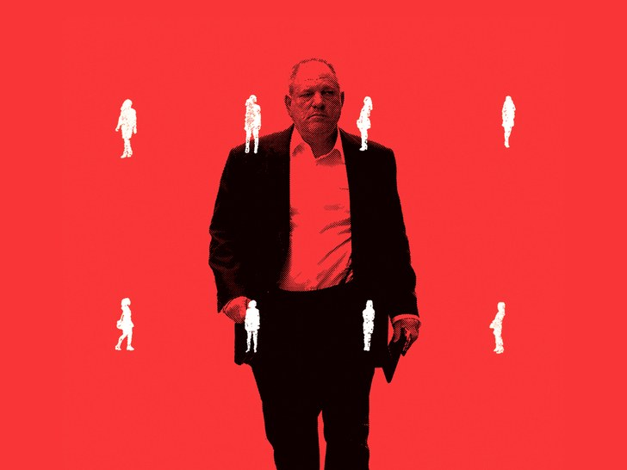
In the course of a ten-month investigation, thirteen women interviewed said that, between the nineteen-nineties and 2015, Weinstein sexually harassed or assaulted them.
Illustration by Oliver Munday; source photograph by Raymond Hall / GC Images via Getty
This story was first published on newyorker.com on October 10, 2017, at 10:47 a.m. The version below appears in the October 23, 2017, issue.

1.
Since the establishment of the first studios, a century ago, there have been few movie executives as dominant, or as domineering, as Harvey Weinstein. He co-founded the production-and-distribution companies Miramax and the Weinstein Company, helping to reinvent the model for independent films with movies including “Sex, Lies, and Videotape,” “The Crying Game,” “Pulp Fiction,” “The English Patient,” “Shakespeare in Love,” and “The King’s Speech.” Beyond Hollywood, he has exercised his influence as a prolific fund-raiser for Democratic Party candidates, including Barack Obama and Hillary Clinton. Weinstein combined a keen eye for promising scripts, directors, and actors with a bullying, even threatening, style of doing business, inspiring both fear and gratitude. His movies have earned more than three hundred Oscar nominations, and, at the annual awards ceremonies, he has been thanked more than almost anyone else in movie history, ranking just after Steven Spielberg and right before God.
For more than twenty years, Weinstein, who is now sixty-five, has also been trailed by rumors of sexual harassment and assault. His behavior has been an open secret to many in Hollywood and beyond, but previous attempts by many publications, including The New Yorker, to investigate and publish the story over the years fell short of the demands of journalistic evidence. Too few people were willing to speak, much less allow a reporter to use their names, and Weinstein and his associates used nondisclosure agreements, payoffs, and legal threats to suppress their accounts. Asia Argento, an Italian film actress and director, said that she did not speak out until now—Weinstein, she told me, forcibly performed oral sex on her—because she feared that Weinstein would “crush” her. “I know he has crushed a lot of people before,” Argento said. “That’s why this story—in my case, it’s twenty years old, some of them are older—has never come out.”
On October 5th, the New York Times, in a powerful report by Jodi Kantor and Megan Twohey, revealed multiple allegations of sexual harassment against Weinstein, an article that led to the resignation of four members of the Weinstein Company’s all-male board, and to Weinstein’s firing.
The story, however, is complex, and there is more to know and to understand. In the course of a ten-month investigation, I was told by thirteen women that, between the nineteen-nineties and 2015, Weinstein sexually harassed or assaulted them. Their allegations corroborate and overlap with the Times’s revelations, and also include far more serious claims.
Three of the women—among them Argento and a former aspiring actress named Lucia Evans—told me that Weinstein had raped them, forcibly performing or receiving oral sex or forcing vaginal sex. Four women said that they had experienced unwanted touching that could be classified as an assault. In an audio recording captured during a New York Police Department sting operation in 2015, Weinstein admits to groping a Filipina-Italian model named Ambra Battilana Gutierrez, describing it as behavior he is “used to.” Four of the women I interviewed cited encounters in which Weinstein exposed himself or masturbated in front of them.

Sixteen former and current executives and assistants at Weinstein’s companies told me that they witnessed or had knowledge of unwanted sexual advances and touching at events associated with Weinstein’s films and in the workplace. They and others described a pattern of professional meetings that were little more than thin pretexts for sexual advances on young actresses and models. All sixteen said that the behavior was widely known within both Miramax and the Weinstein Company. Messages sent by Irwin Reiter, a senior company executive, to Emily Nestor, one of the women who alleged that she was harassed, described the “mistreatment of women” as a serial problem that the Weinstein Company had been struggling with in recent years. Other employees described what was, in essence, a culture of complicity at Weinstein’s places of business, with numerous people throughout his companies fully aware of his behavior but either abetting it or looking the other way. Some employees said that they were enlisted in a subterfuge to make the victims feel safe. A female executive with the company described how Weinstein’s assistants and others served as a “honeypot”—they would initially join a meeting along with a woman Weinstein was interested in, but then Weinstein would dismiss them, leaving him alone with the woman. (On October 10th, the Weinstein Company’s board issued a statement, writing that “these allegations come as an utter surprise to the Board. Any suggestion that the Board had knowledge of this conduct is false.”)
Virtually all of the people I spoke with told me that they were frightened of retaliation. “If Harvey were to discover my identity, I’m worried that he could ruin my life,” one former employee told me. Many said that they had seen Weinstein’s associates confront and intimidate those who crossed him, and feared that they would be similarly targeted. Four actresses, including Mira Sorvino and Rosanna Arquette, told me they suspected that, after they rejected Weinstein’s advances or complained about them to company representatives, Weinstein had them removed from projects or dissuaded people from hiring them. Multiple sources said that Weinstein frequently bragged about planting items in media outlets about those who spoke against him; these sources feared similar retribution. Several pointed to Gutierrez’s case: after she went to the police, negative items discussing her sexual history and impugning her credibility began rapidly appearing in New York gossip pages. (In the taped conversation, part of which The New Yorker posted online, Weinstein asks Gutierrez to join him for “five minutes,” and warns, “Don’t ruin your friendship with me for five minutes.”)
Several former employees told me that they were speaking about Weinstein’s alleged behavior now because they hoped to protect women in the future. “This wasn’t a one-off. This wasn’t a period of time,” an executive who worked for Weinstein for many years told me. “This was ongoing predatory behavior toward women—whether they consented or not.”
It’s likely that the women who spoke to me have recently felt increasingly emboldened to talk about their experiences because of the way the world has changed regarding issues of sex and power. Their disclosures follow in the wake of stories alleging sexual misconduct by public figures, including Donald Trump, Bill O’Reilly, Roger Ailes, and Bill Cosby. In October, 2016, a month before the election, a tape emerged of Trump telling a celebrity-news reporter, “And when you’re a star, they let you do it. You can do anything. . . . Grab ’em by the pussy. You can do anything.” This past April, O’Reilly, a host at Fox News, was forced to resign after Fox was discovered to have paid five women millions of dollars in exchange for silence about their accusations of sexual harassment. Ailes, the former head of Fox News, resigned in July, 2016, after he was accused of sexual harassment. Cosby went on trial this summer, charged with drugging and sexually assaulting a woman. The trial ended with a hung jury.
In the Times piece, Weinstein made an initial effort at damage control by partly acknowledging what he had done, saying, “I appreciate the way I’ve behaved with colleagues in the past has caused a lot of pain, and I sincerely apologize for it.” In an interview with the New York Post, he said, “I’ve got to deal with my personality, I’ve got to work on my temper, I have got to dig deep. I know a lot of people would like me to go into a facility, and I may well just do that—I will go anywhere I can learn more about myself.” He went on, “In the past I used to compliment people, and some took it as me being sexual, I won’t do that again.” In his written statement to the Times, Weinstein claimed that he would “channel that anger” into a fight against the leadership of the National Rifle Association. He also said that it was not “coincidental” that he was organizing a foundation for women directors at the University of Southern California. “It will be named after my mom and I won’t disappoint her.” (U.S.C. has since rejected his funding pledge.)
Sallie Hofmeister, a spokesperson for Weinstein, issued a new statement in response to the allegations detailed here. It reads in full: “Any allegations of non-consensual sex are unequivocally denied by Mr. Weinstein. Mr. Weinstein has further confirmed that there were never any acts of retaliation against any women for refusing his advances. Mr. Weinstein obviously can’t speak to anonymous allegations, but with respect to any women who have made allegations on the record, Mr. Weinstein believes that all of these relationships were consensual. Mr. Weinstein has begun counseling, has listened to the community and is pursuing a better path. Mr. Weinstein is hoping that, if he makes enough progress, he will be given a second chance.”
While Weinstein and his representatives have said that the incidents were consensual, and were not widespread or severe, the women I spoke to tell a very different story.

2.
Lucia Stoller, now Lucia Evans, was approached by Weinstein at Cipriani Upstairs, a club in New York, in 2004, the summer before her senior year at Middlebury College. Evans, who is now a marketing consultant, wanted to be an actress, and although she had heard rumors about Weinstein she let him have her number. Weinstein began calling her late at night, or having an assistant call her, asking to meet. She declined, but said that she would do readings during the day for a casting executive. Before long, an assistant called to set up a daytime meeting at the Miramax office in Tribeca, first with Weinstein and then with a casting executive, who was a woman. “I was, like, Oh, a woman, great, I feel safe,” Evans said.
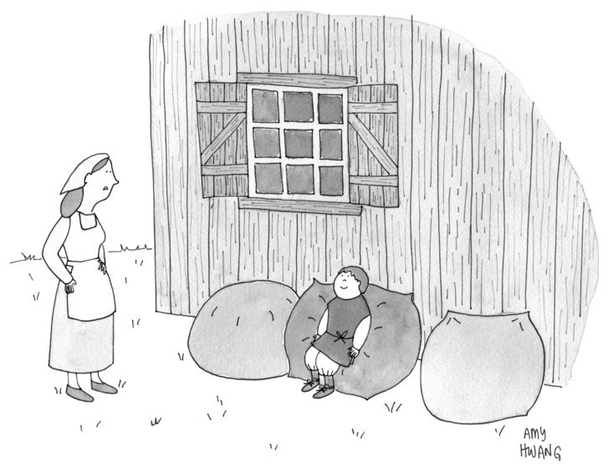
“You sold our cow for magical beanbags?”
When Evans arrived for the meeting, the building was full of people. She was led to an office with exercise equipment in it, and takeout boxes on the floor. Weinstein was there, alone. Evans said that she found him frightening. “The type of control he exerted—it was very real,” she told me. “Even just his presence was intimidating.”
In the meeting, Evans recalled, “he immediately was simultaneously flattering me and demeaning me and making me feel bad about myself.” Weinstein told her that she’d “be great in ‘Project Runway’ ”—the show, which Weinstein helped produce, premièred later that year—but only if she lost weight. He also told her about two scripts, a horror movie and a teen love story, and said one of his associates would discuss them with her.
“At that point, after that, is when he assaulted me,” Evans said. “He forced me to perform oral sex on him.” As she objected, Weinstein took his penis out of his pants and pulled her head down onto it. “I said, over and over, ‘I don’t want to do this, stop, don’t,’ ” she recalled. “I tried to get away, but maybe I didn’t try hard enough. I didn’t want to kick him or fight him.” In the end, she said, “he’s a big guy. He overpowered me.” She added, “I just sort of gave up. That’s the most horrible part of it, and that’s why he’s been able to do this for so long to so many women: people give up, and then they feel like it’s their fault.”
Weinstein appeared to find the encounter unremarkable. “It was like it was just another day for him,” Evans said. “It was no emotion.” Afterward, he acted as if nothing had happened. She wondered how Weinstein’s staff could not know what was going on.
Following the encounter, she met with the female casting executive, who sent her the scripts, and also came to one of her acting-class readings a few weeks later. (Evans does not believe that the executive was aware of Weinstein’s behavior.) Weinstein, Evans said, began calling her again late at night. She told me that the entire sequence of events had a routine quality. “It feels like a very streamlined process,” she said. “Female casting director, Harvey wants to meet. Everything was designed to make me feel comfortable before it happened. And then the shame in what happened was also designed to keep me quiet.”
Evans said that, after the incident, “I just put it in a part of my brain and closed the door.” She continued to blame herself for not fighting harder. “It was always my fault for not stopping him,” she said. “I had an eating problem for years. I was disgusted with myself. It’s funny, all these unrelated things I did to hurt myself because of this one thing.” Evans told friends some of what had happened, but felt largely unable to talk about it. “I ruined several really good relationships because of this. My schoolwork definitely suffered, and my roommates told me to go to a therapist because they thought I was going to kill myself.”
In the years that followed, Evans encountered Weinstein occasionally. Once, while she was walking her dog in Greenwich Village, she saw him getting into a car. “I very clearly saw him. I made eye contact,” she said. “I remember getting chills down my spine just looking at him. I was so horrified. I have nightmares about him to this day.”

3.
Asia Argento, who was born in Rome, played the role of a glamorous thief named Beatrice in the crime drama “B. Monkey,” which was released in the U.S. in 1999. The distributor was Miramax. In a series of long and often emotional interviews, Argento told me that Weinstein assaulted her while they were working together.
At the time, Argento was twenty-one and had twice won the Italian equivalent of the Oscar. Argento said that, in 1997, one of Weinstein’s producers invited her to what she understood to be a party thrown by Miramax at the Hôtel du Cap-Eden-Roc, on the French Riviera. Argento felt professionally obliged to attend. When the producer led her upstairs that evening, she said, there was no party, only a hotel room, empty but for Weinstein: “I’m, like, ‘Where is the fucking party?’ ” She recalled the producer telling her, “Oh, we got here too early,” before he left her alone with Weinstein. (The producer denies bringing Argento to the room that night.) At first, Weinstein was solicitous, praising her work. Then he left the room. When he returned, he was wearing a bathrobe and holding a bottle of lotion. “He asks me to give a massage. I was, like, ‘Look, man, I am no fucking fool,’ ” Argento told me. “But, looking back, I am a fucking fool. And I am still trying to come to grips with what happened.”
Argento said that, after she reluctantly agreed to give Weinstein a massage, he pulled her skirt up, forced her legs apart, and performed oral sex on her as she repeatedly told him to stop. Weinstein “terrified me, and he was so big,” she said. “It wouldn’t stop. It was a nightmare.”
At some point, she stopped saying no and feigned enjoyment, because she thought it was the only way the assault would end. “I was not willing,” she told me. “I said, ‘No, no, no.’ . . . It’s twisted. A big fat man wanting to eat you. It’s a scary fairy tale.” Argento, who insisted that she wanted to tell her story in all its complexity, said that she didn’t physically fight him off, something that has prompted years of guilt.
“The thing with being a victim is I felt responsible,” she said. “Because, if I were a strong woman, I would have kicked him in the balls and run away. But I didn’t. And so I felt responsible.” She described the incident as a “horrible trauma.” Decades later, she said, oral sex is still ruined for her. “I’ve been damaged,” she told me. “Just talking to you about it, my whole body is shaking.”
Argento recalled sitting on the bed after the incident, her clothes “in shambles,” her makeup smeared. She said that she told Weinstein, “I am not a whore,” and that he began laughing. He said he would put the phrase on a T-shirt. Afterward, Argento said, “He kept contacting me.” For a few months, Weinstein seemed obsessed, offering her expensive gifts.
What complicates the story, Argento readily allowed, is that she eventually yielded to Weinstein’s further advances and even grew close to him. Weinstein dined with her, and introduced her to his mother. Argento told me, “He made it sound like he was my friend and he really appreciated me.” She said that she had consensual sexual relations with him multiple times over the course of the next five years, though she described the encounters as one-sided and “onanistic.” The first occasion, several months after the alleged assault, came before the release of “B. Monkey.” “I felt I had to,” she said. “Because I had the movie coming out and I didn’t want to anger him.” She believed that Weinstein would ruin her career if she didn’t comply. Years later, when she was a single mother dealing with childcare, Weinstein offered to pay for a nanny. She said that she felt “obliged” to submit to his sexual advances.
Argento told me that she knew this contact would be used to attack the credibility of her allegation. In part, she said, the initial assault made her feel overpowered each time she encountered Weinstein, even years later. “Just his body, his presence, his face, bring me back to the little girl that I was when I was twenty-one,” she told me. “When I see him, it makes me feel little and stupid and weak.” She broke down as she struggled to explain. “After the rape, he won,” she said.
In 2000, Argento released “Scarlet Diva,” a movie that she wrote and directed. In the film, a heavyset producer corners Anna, the character played by Argento, in a hotel room, asks her for a massage, and tries to assault her. After the movie came out, women began approaching Argento, saying that they recognized Weinstein’s behavior in the portrayal. “People would ask me about him because of the scene in the movie,” she said. Some recounted similar details to her: meetings and professional events moved to hotel rooms, bathrobes and massage requests, and, in one other case, forced oral sex.
Weinstein, according to Argento, saw the film after it was released in the U.S., and apparently recognized himself. “Ha, ha, very funny,” Argento remembered him saying to her. But he also said that he was “sorry for whatever happened.” The movie’s most significant departure from the real-life incident, Argento told me, was how the hotel-room scene ended. “In the movie I wrote,” she said, “I ran away.”
Other women were too afraid to allow me to use their names, but their stories are uncannily similar to these allegations. One, a woman who worked with Weinstein, explained her reluctance to be identified. “He drags your name through the mud, and he’ll come after you hard with his legal team.”
Like others I spoke to, this woman said that Weinstein brought her to a hotel room under a professional pretext, changed into a bathrobe, and, she said, “forced himself on me sexually.” She told him no, repeatedly and clearly. Afterward, she experienced “horror, disbelief, and shame,” and considered going to the police. “I thought it would be a ‘he said, she said,’ and I thought about how impressive his legal team is, and I thought about how much I would lose, and I decided to just move forward,” she said. The woman continued to have professional contact with Weinstein after the alleged rape, and acknowledged that subsequent communications between them might suggest a normal working relationship. “I was in a vulnerable position and I needed my job,” she told me. “It just increases the shame and the guilt.”

4.
Mira Sorvino, who starred in several of Weinstein’s films, told me that he sexually harassed her and tried to pressure her into a physical relationship while they were working together. She said that, at the Toronto International Film Festival in September, 1995, she found herself in a hotel room with Weinstein, who produced the movie she was there to promote, “Mighty Aphrodite,” for which she later won an Academy Award. “He started massaging my shoulders, which made me very uncomfortable, and then tried to get more physical, sort of chasing me around,” she recalled. She scrambled for ways to ward him off, telling him that it was against her religion to date married men. (At the time, Weinstein was married to Eve Chilton, a former assistant.) Then she left the room.
A few weeks later, in New York City, her phone rang after midnight. It was Weinstein, saying that he had new marketing ideas for the film and asking to get together. Sorvino offered to meet him at an all-night diner, but he said he was coming over to her apartment and hung up. “I freaked out,” she told me. She called a friend and asked him to come over and pose as her boyfriend. The friend hadn’t arrived by the time Weinstein rang her doorbell. “Harvey had managed to bypass my doorman,” she said. “I opened the door terrified, brandishing my twenty-pound Chihuahua mix in front of me, as though that would do any good.” When she told Weinstein that her new boyfriend was on his way, he became dejected and left.
Sorvino said that she struggled for years with whether to come forward with her story, partly because she was aware that it was mild compared with the experiences of other women, including Sophie Dix, an actress she spoke to at the time. (Dix told me that she had locked herself in a hotel bathroom to escape Weinstein, and that he had masturbated in front of her. She said it was “a classic case” of “someone not understanding the word ‘no.’ . . . I must have said no a thousand times.”) The fact that Weinstein was so instrumental in Sorvino’s success also made her hesitate: “I have great respect for Harvey as an artist, and owe him and his brother a debt of gratitude for the early success in my career, including the Oscar.” She had professional contact with Weinstein for years after the incident, and remains a close friend of his brother and business partner, Bob Weinstein. (She never told Bob about his brother’s behavior.)
Sorvino said that she felt afraid and intimidated, and that the incidents had a significant impact on her. When she told a female employee at Miramax about the harassment, the woman’s reaction “was shock and horror that I had mentioned it.” Sorvino appeared in a few more of Weinstein’s films afterward, but felt that saying no to Weinstein and reporting the harassment had ultimately hurt her career. She said, “There may have been other factors, but I definitely felt iced out and that my rejection of Harvey had something to do with it.”

5.
In March, 2015, Ambra Battilana Gutierrez, who was once a finalist in the Miss Italy contest, met Harvey Weinstein at a reception for “New York Spring Spectacular,” a show that he was producing at Radio City Music Hall. Weinstein introduced himself to Gutierrez, who was twenty-two, remarking repeatedly that she looked like the actress Mila Kunis.
Following the event, Gutierrez’s modelling agency e-mailed her to say that Weinstein wanted to set up a business meeting as soon as possible. Gutierrez arrived at Weinstein’s office in Tribeca early the next evening with her modelling portfolio. In the office, she sat with Weinstein on a couch to review the portfolio, and he began staring at her breasts, asking if they were real. Gutierrez later told officers of the New York Police Department’s Special Victims Division that Weinstein then lunged at her, groping her breasts and attempting to put a hand up her skirt while she protested. He finally backed off and told her that his assistant would give her tickets to “Finding Neverland,” a Broadway musical that he was producing. He said he would meet her at the show that evening.
MORE FROM THIS ISSUE
October 23, 2017

Personal History
Hard Up in New York
By Jonathan Franzen

Books
Briefly Noted Book Reviews
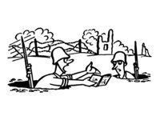
The Pictures
A Second Civil War in “Bushwick”
By Don Steinberg

Fiction
“Strangler Bob”
By Denis Johnson

Classical Music
Ruth Crawford Seeger’s Music Shines On
By Russell Platt

Annals of Technology
Welcoming Our New Robot Overlords
By Sheelah Kolhatkar
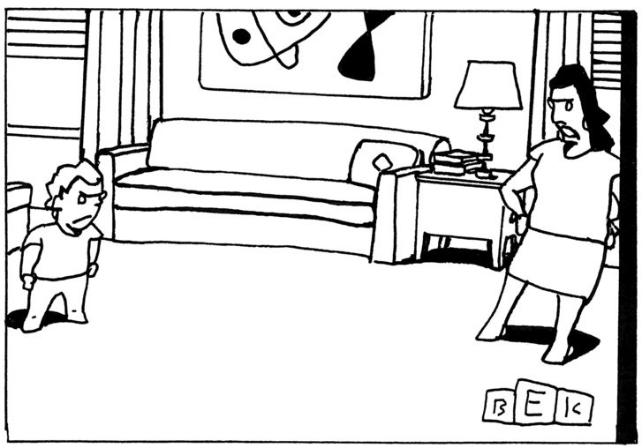
“When you’re President, then you can watch six hours of television a day.”
Instead of going to the show, Gutierrez went to the nearest police station and reported the assault. Weinstein telephoned her later that evening, annoyed that she had failed to appear at the show. She picked up the call while sitting with investigators from the Special Victims Division, who listened in and devised a plan: Gutierrez would agree to see the show the following day and then meet with Weinstein. She would wear a wire and attempt to extract a confession or an incriminating statement.
The next day, Gutierrez met Weinstein at the bar of the Tribeca Grand Hotel. A team of undercover officers helped guide her through the interaction. On the recording, which I have heard in full, Weinstein lists actresses whose careers he has helped and offers Gutierrez the services of a dialect coach. Then he presses her to join him in his hotel room while he showers. Gutierrez says no repeatedly; Weinstein persists, and after a while she accedes to his demand to go upstairs. But, standing in the hallway outside his room, she refuses to go farther. In an increasingly tense exchange, he presses her to enter. Gutierrez says, “I don’t want to,” “I want to leave,” and “I want to go downstairs.” She asks him directly why he groped her breasts the day before.
“Oh, please, I’m sorry, just come on in,” Weinstein says. “I’m used to that. Come on. Please.”
“You’re used to that?” Gutierrez asks, sounding incredulous.
“Yes,” Weinstein says. He adds, “I won’t do it again.”
After almost two minutes of back-and-forth in the hallway, Weinstein finally agrees to let her leave.
According to a law-enforcement source, Weinstein, if charged, would most likely have faced a count of sexual abuse in the third degree, a misdemeanor punishable by a maximum of three months in jail. But, as the police investigation proceeded and the allegation was widely reported, details about Gutierrez’s past began to appear in the tabloids. In 2010, as a young contestant in the Miss Italy beauty pageant, Gutierrez had attended one of Prime Minister Silvio Berlusconi’s infamous “Bunga Bunga” parties. She claimed that she had been unaware of the nature of the party before arriving, and she eventually became a witness in a bribery case against Berlusconi, which is still ongoing. Gossip outlets also reported that Gutierrez, as a teen-ager, had made an allegation of sexual assault against an older Italian businessman but later declined to coöperate with prosecutors.
Two sources close to the police investigation of Weinstein said that they had no reason to doubt Gutierrez’s account of the incident. One of them, a police source, said that the department had collected more than enough evidence to prosecute Weinstein. But the other said that Gutierrez’s statements about her past complicated the case for the office of the Manhattan District Attorney, Cyrus Vance, Jr. After two weeks of investigation, the D.A.’s office decided not to file charges. The office declined to comment on this story but pointed me to its statement at the time: “This case was taken seriously from the outset, with a thorough investigation conducted by our Sex Crimes Unit. After analyzing the available evidence, including multiple interviews with both parties, a criminal charge is not supported.”
“We had the evidence,” the police source involved in the operation told me. “It’s a case that made me angrier than I thought possible, and I have been on the force a long time.”
Gutierrez, when contacted for this story, said that she was unable to discuss the incident. Someone close to the matter told me that, after the D.A.’s office decided not to press charges, Gutierrez, facing Weinstein’s legal team, and in return for a payment, signed a highly restrictive nondisclosure agreement with Weinstein, including an affidavit stating that the acts he admits to in the recording never happened.
Weinstein’s use of such settlements was reported by the Times and confirmed to me by numerous people. A former employee with firsthand knowledge of two settlement negotiations that took place in London in the nineteen-nineties recalled, “It felt like David versus Goliath . . . the guy with all the money and the power flexing his muscle and quashing the allegations and getting rid of them.”

6.
The Times story disclosed a complaint to the Weinstein Company’s office of human resources, filed on behalf of a temporary front-desk assistant named Emily Nestor in December, 2014. Her own account of Weinstein’s conduct is being made public here for the first time. Nestor was twenty-five when she started the job and, after finishing law school and starting business school, was considering a career in the movie industry. On her first day in the position, Nestor said, two employees told her that she was Weinstein’s “type” physically. When Weinstein arrived at the office, he made comments about her appearance, referring to her as “the pretty girl.” He asked how old she was, and then sent all of his assistants out of the room and made her write down her telephone number.
Weinstein told her to meet him for drinks that night. Nestor invented an excuse. When he insisted, she suggested an early-morning coffee the next day, assuming that he wouldn’t accept. He did, and told her to meet him at the Peninsula hotel in Beverly Hills, where he was staying. Nestor said that she had talked with friends in the entertainment industry and employees in the company who had warned her about Weinstein’s reputation. “I dressed very frumpy,” she said.
Nestor told me that the meeting was “the most excruciating and uncomfortable hour of my life.” After Weinstein offered her career help, she said, he began to boast about his sexual liaisons with other women, including famous actresses. “He said, ‘You know, we could have a lot of fun,’ ” Nestor recalled. “ ‘I could put you in my London office, and you could work there and you could be my girlfriend.’ ” She declined. He asked to hold her hand; she said no. In Nestor’s account of the exchange, Weinstein said, “Oh, the girls always say no. You know, ‘No, no.’ And then they have a beer or two and then they’re throwing themselves at me.” In a tone that Nestor described as “very weirdly proud,” Weinstein added “that he’d never had to do anything like Bill Cosby.” She assumed that he meant he’d never drugged a woman. “It’s just a bizarre thing to be so proud of,” she said. “That you’ve never had to resort to doing that. It was just so far removed from reality and normal rules of consent.”
“Textbook sexual harassment” was how Nestor described Weinstein’s behavior to me. “It’s a pretty clear case of sexual harassment when your superior, the C.E.O., asks one of their inferiors, a temp, to have sex with them, essentially in exchange for mentorship.” She recalled refusing his advances at least a dozen times. “ ‘No’ did not mean ‘no’ to him,” she said. “I was very aware of how inappropriate it was. But I felt trapped.”
Throughout the breakfast, she said, Weinstein interrupted their conversation to yell into his cell phone, enraged over a spat that Amy Adams, a star in the Weinstein movie “Big Eyes,” was having in the press. Afterward, Weinstein told Nestor to keep an eye on the news cycle, which he promised would be spun in his favor. Later in the day, there were indeed negative news items about his opponents, and Weinstein stopped by Nestor’s desk to be sure that she’d seen them.
By that point, Nestor recalled, “I was very afraid of him. And I knew how well connected he was. And how if I pissed him off then I could never have a career in that industry.” Still, she told a friend about the incident, and he alerted the company’s office of human resources, which contacted her. (The friend did not respond to a request for comment.) Nestor had a conversation with company officials about the matter but didn’t pursue it further: the officials said that Weinstein would be informed of anything she told them, a practice not uncommon in businesses the size of the Weinstein Company. Several former Weinstein employees told me that the company’s human-resources department was utterly ineffective; one female executive described it as “a place where you went to when you didn’t want anything to get done. That was common knowledge across the board. Because everything funnelled back to Harvey.” She described the department’s typical response to allegations of misconduct as “This is his company. If you don’t like it, you can leave.”
Nestor told me that some people at the company did seem concerned. Irwin Reiter, a senior executive who had worked for Weinstein for almost three decades, sent her a series of messages via LinkedIn. “We view this very seriously and I personally am very sorry your first day was like this,” Reiter wrote. “Also if there are further unwanted advances, please let us know.” Last year, just before the Presidential election, he reached out again, writing, “All this Trump stuff made me think of you.” He described Nestor’s experience as part of Weinstein’s serial misconduct. “I’ve fought him about mistreatment of women 3 weeks before the incident with you. I even wrote him an email that got me labelled by him as sex police,” he wrote. “The fight I had with him about you was epic. I told him if you were my daughter he would have not made out so well.” (Reiter declined to comment for this article, but his lawyer, Debra Katz, confirmed the authenticity of the messages and said that Reiter had made diligent efforts to raise these issues, to no avail. Katz also noted that Reiter “is eager to coöperate fully with any outside investigation.”)
Though no assault occurred, and Nestor left after completing her temporary placement, she was profoundly affected by the experience. “I was definitely traumatized for a while, in terms of feeling so harassed and frightened,” she said. “It made me feel incredibly discouraged that this could be something that happens on a regular basis. I actually decided not to go into entertainment because of this incident.”

7.
Emma de Caunes, a French actress, met Weinstein in 2010, at a party at the Cannes Film Festival. A few months later, he asked her to a lunch meeting at the Hôtel Ritz, in Paris. In the meeting, Weinstein told de Caunes that he was going to be producing a movie with a prominent director, that he planned to shoot it in France, and that it had a strong female role. It was an adaptation of a book, he said, but he claimed he couldn’t remember the title. “But I’ll give it to you,” Weinstein said, according to de Caunes. “I have it in my room.”
De Caunes replied that she had to leave, since she was already running late for a TV show she was hosting—Eminem was appearing on the show that afternoon, and she hadn’t written her questions yet. Weinstein pleaded with her to retrieve the book with him, and finally she agreed. As they got to his room, she received a telephone call from one of her colleagues, and Weinstein disappeared into a bathroom, leaving the door open. She assumed that he was washing his hands.
“When I hung up the phone, I heard the shower go on in the bathroom,” she said. “I was, like, What the fuck, is he taking a shower?” Weinstein came out, naked and with an erection. “What are you doing?” she asked. Weinstein demanded that she lie on the bed and told her that many other women had done so before her.
“I was very petrified,” de Caunes said. “But I didn’t want to show him that I was petrified, because I could feel that the more I was freaking out, the more he was excited.” She added, “It was like a hunter with a wild animal. The fear turns him on.” De Caunes told Weinstein that she was leaving, and he panicked. “We haven’t done anything!” she remembered him saying. “It’s like being in a Walt Disney movie!”
De Caunes told me, “I looked at him and I said—it took all my courage, but I said, ‘I’ve always hated Walt Disney movies.’ And then I left. I slammed the door.” She was shaking on the stairs going down to the lobby. A director she was working with on the TV show confirmed that she arrived at the studio distraught and that she recounted what had happened. Weinstein called relentlessly over the next few hours, offering de Caunes gifts and repeating his assertion that nothing had happened.
De Caunes, who was in her early thirties at the time, was already an established actress, but she wondered what would happen to younger and more vulnerable women in the same situation. Over the years, she said, she’s heard similar accounts from friends. “I know that everybody—I mean everybody—in Hollywood knows that it’s happening,” de Caunes said. “He’s not even really hiding. I mean, the way he does it, so many people are involved and see what’s happening. But everyone’s too scared to say anything.”
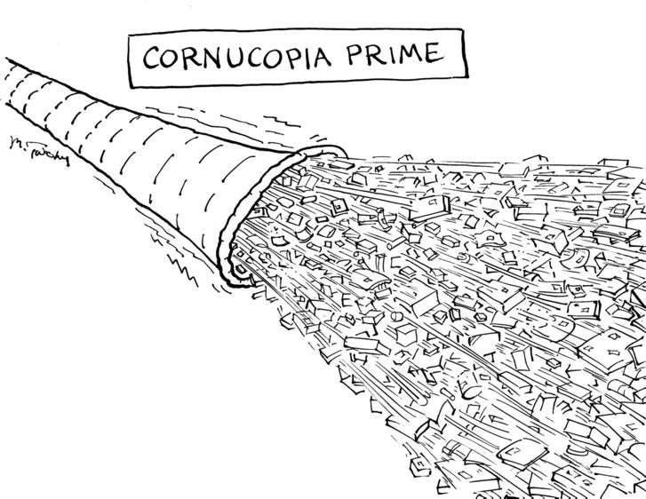

8.
One evening in the early nineties, the actress Rosanna Arquette was supposed to meet Weinstein for dinner at the Beverly Hills Hotel to pick up the script for a new film. At the hotel, Arquette was told to meet Weinstein upstairs, in his room.
Arquette recalled that, when she arrived at the room, Weinstein opened the door wearing a white bathrobe. He said that his neck was sore and that he needed a massage. She told him that she could recommend a good masseuse. “Then he grabbed my hand,” she said. He put it on his neck. When she yanked her hand away, Weinstein grabbed it again and pulled it toward his penis, which was visible and erect. “My heart was really racing. I was in a fight-or-flight moment,” she said. She told Weinstein, “I will never do that.”
Weinstein told her that she was making a huge mistake by rejecting him, and named an actress and a model who he claimed had given in to his sexual overtures and whose careers he said he had advanced as a result. Arquette said she responded, “I’ll never be that girl,” and left.
Arquette said that after she rejected Weinstein her career suffered. In one case, she believes, she lost a role because of it. “He made things very difficult for me for years,” she told me. She did appear in one subsequent Weinstein film—“Pulp Fiction.” Arquette believes that she only got that role because of its small size and Weinstein’s deference to the filmmaker, Quentin Tarantino. (Disputes later arose over her entitlement to payment out of the film’s proceeds.) Arquette said that her silence was the result of Weinstein’s power and reputation for vindictiveness. “He’s going to be working very hard to track people down and silence people,” she explained. “To hurt people. That’s what he does.”
There are other examples of Weinstein’s using the same modus operandi. Jessica Barth, an actress who met him at a Golden Globes party in January, 2011, told me that he invited her to a business meeting at the Peninsula. When she arrived, he asked her over the phone to go up to his room. Weinstein assured her it was “no big deal”—because of his high profile, he simply wanted privacy to “talk career stuff.” In the room, she found that Weinstein had ordered champagne and sushi.
Barth said that, in the conversation that followed, Weinstein alternated between offering to cast her in a film and demanding a naked massage in bed. “So, what would happen if, say, we’re having some champagne and I take my clothes off and you give me a massage?” she recalled him asking. “And I’m, like, ‘That’s not going to happen.’ ”
When she moved toward the door to leave, Weinstein lashed out, saying that she needed to lose weight “to compete with Mila Kunis,” and then, apparently in an effort to mollify her, promising a meeting with one of his female executives. “He gave me her number, and I walked out and I started bawling,” Barth told me. (Immediately after the incident, she spoke with two people; they confirmed to me that she had described her experience to them at the time.) Barth said that the promised meeting at Weinstein’s office seemed to be purely a formality. “I just knew it was bullshit,” she said. (The executive she met with did not respond to requests for comment.)

9.
Weinstein’s behavior deeply affected the day-to-day operations of his companies. Current and former employees described a pattern of meetings and strained complicity that closely matches the accounts of the many women I interviewed. The employees spoke on condition of anonymity because, they said, they feared for their careers in Hollywood and because of provisos in their work contracts.
“There was a large volume of these types of meetings that Harvey would have with aspiring actresses and models,” one female executive told me. “He would have them late at night, usually at hotel bars or in hotel rooms. And, in order to make these women feel more comfortable, he would ask a female executive or assistant to start those meetings with him.” She was repeatedly asked to join such meetings, she said, but she refused.
The executive said that she was especially disturbed by the involvement of other employees. “It almost felt like the executive or assistant was made to be a honeypot to lure these women in, to make them feel safe,” she said. “Then he would dismiss the executive or the assistant, and then these women were alone with him. And that did not feel like it was appropriate behavior or safe behavior.”
One former employee told me that she was frequently asked to join for the beginning of meetings that, she said, had in many cases already been moved from day to night and from hotel lobbies to hotel rooms. She said that Weinstein’s conduct in the meetings was brazen. During a meeting with a model, the former employee said, he turned to her and demanded, “Tell her how good of a boyfriend I am.” She said that when she refused to join one such meeting, Weinstein became enraged. Often, she was asked to keep track of the women, who, in keeping with a practice established by Weinstein’s assistants, were all filed under the same label in her phone: F.O.H., which stood for “Friend of Harvey.” She added that the pattern of meetings was nearly uninterrupted in her years of working for Weinstein. “I have to say, the behavior did stop for a little bit after the groping thing,” she told me, referring to Gutierrez’s allegation to the police. “But he couldn’t help himself. A few months later, he was back at it.”
Two staffers who facilitated these meetings said that they felt morally compromised by them. One male former staffer noted that many of the women seemed “not aware of the nature of those meetings” and “were definitely scared.” He told me that most of the encounters that he saw seemed consensual, but others gave him pause. He was especially troubled by his memory of one young woman: “You just feel terrible because you could tell this girl, very young, not from our country, was now in a room waiting for him to come up there in the middle of the day, and we were not to bother them.” He said that he was never asked to facilitate these meetings for men.
None of the former executives or assistants I spoke to quit because of the misconduct, but many expressed guilt and regret over not having said or done more. They talked about what they believed to be a culture of silence about sexual assault inside Miramax and the Weinstein Company and across the entertainment industry more broadly.

10.
Weinstein and his legal and public-relations teams have conducted a decades-long campaign to suppress these stories. In recent months, that campaign escalated. Weinstein and his associates began calling many of the women in this article. Weinstein asked Argento to meet with a private investigator and give testimony on his behalf. One actress who initially spoke to me on the record later asked that her allegation be removed from this piece. “I’m so sorry,” she wrote. “The legal angle is coming at me and I have no recourse.” Weinstein and his legal team have threatened to sue multiple media outlets, including the New York Times.
Several of the former executives and assistants in this story said that they had received calls from Weinstein in which he attempted to determine if they had talked to me or warned them not to. These employees continued to participate in the article partly because they felt that there was a growing culture of accountability, embodied in the relatively recent disclosures about high-profile men such as Cosby and Ailes. “I think a lot of us had thought—and hoped—over the years that it would come out sooner,” the former executive who was aware of the two legal settlements in London told me. “But I think now is the right time, in this current climate, for the truth.”
The female executive who declined inappropriate meetings told me that her lawyer advised her that she could be liable for hundreds of thousands of dollars in damages for violating the nondisclosure agreement attached to her employment contract. “I believe this is more important than keeping a confidentiality agreement,” she said. “The more of us that can confirm or validate for these women if this did happen, I think it’s really important for their justice to do that.” She continued, “I wish I could have done more. I wish I could have stopped it. And this is my way of doing that now.”
“He’s been systematically doing this for a very long time,” the former employee who had been made to act as a “honeypot” told me. She said that she often thinks of something Weinstein whispered—to himself, as far as she could tell—after one of his many shouting sprees at the office. It so unnerved her that she pulled out her phone and tapped it into a memo, word for word: “There are things I’ve done that nobody knows.” ♦
Published in the print edition of the October 23, 2017, issue.

- Ronan Farrow is a contributing writer to The New Yorker and the author of the forthcoming book “Catch and Kill: Lies, Spies, and a Conspiracy to Protect Predators.” His reporting for The New Yorker won the 2018 Pulitzer Prize for public service.
Read more »

