‘Motherhood on ice’: Exploring why women freeze their eggs
Anthropologist Marcia Inhorn discusses her new book examining why women freeze their eggs.
By Mike Cummings
may 9, 2023
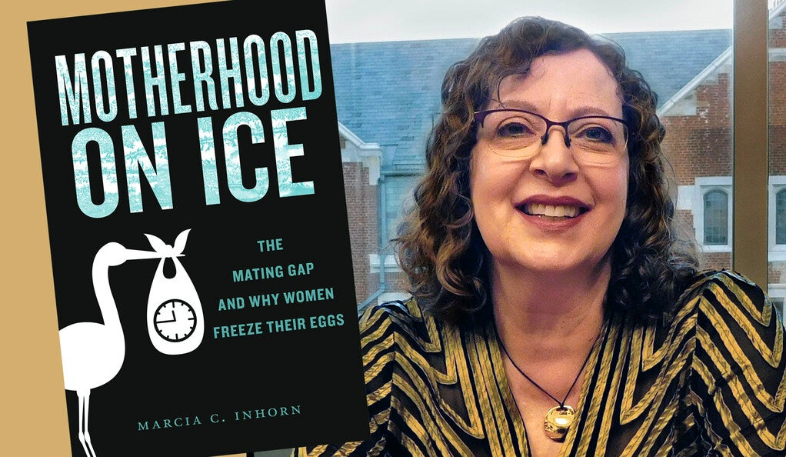
Marcia C. Inhorn
Oocyte vitrification, a method to flash-freeze human eggs so they can be stored for later use, emerged in the early 2000s. Initially, the technology was limited to women undergoing chemotherapy or experiencing medical conditions known to cause infertility.
In 2012, the American Society for Reproductive Medicine lifted the procedure’s experimental label, allowing women to freeze their eggs for non-medical reasons. By the end of 2019, more than 36,000 women in the United States used the increasingly popular technology to preserve their eggs and extend their fertility.
What drives them to this decision?
In a new book, “Motherhood on Ice: The Mating Gap and Why Women Freeze Their Eggs” (New York University Press), Yale anthropologist Marcia C. Inhorn explores the factors that motivate different individuals to freeze their eggs — including what she describes as a “mating gap” causing a shortage of partners for college-educated women — that run counter to popular assumptions.
Her narrative, drawn from interviews with 150 women who underwent the procedure, reveals the real-world complexities behind women’s choices.
In an interview with Yale News, Inhorn, the William K. Lanman Jr. Professor of Anthropology and International Affairs in Yale’s Faculty of Arts and Sciences, discusses what she found and how it runs counter to the conventional wisdom about egg freezing’s rising popularity. The interview is condensed and edited.

What inspired you to write this book?
Marcia C. Inhorn: Ever since egg freezing became available for reasons beyond medical conditions, there has been a lot of discussion about who is using this technology. The common assumption is that most women who freeze their eggs are twenty-somethings who want to delay childbirth in consideration of their career trajectories. They want to put motherhood on hold as they pursue their careers and egg freezing is a way of keeping their options open.
I thought this assumption was worth investigating. Perhaps there was an alternative hypothesis that we hadn’t been discussing. Thirty-six of the women I interviewed had frozen their eggs for medical reasons. The book focuses on the stories of the 114 women who froze their eggs for non-medical reasons.

What did you learn?
Inhorn: Overwhelmingly, the women who froze their eggs electively were in their thirties and motivated by partnership problems. Eighty-two percent of them were single and being single was why they froze their eggs. That’s my big finding and it runs against popular conceptions of the young professional woman who is so busy with her career that she wants to put off having kids.
The women I interviewed were at or near the [‘fertility cliff’]. They want to be mothers but feel that time is running out. The book humanizes the women who find themselves in this difficult situation.
marcia c. inhorn
These are well-educated and successful women who found themselves in the difficult situation of wanting partnership, pregnancy, and parenthood, but are unable to find a suitable reproductive partner. They are lacking what I call the “three Es” in potential partners: eligible, educated, and equal.
Women’s fertility starts to significantly decline at 37, which is called the “fertility cliff.” The women I interviewed were at or near the cliff. They want to be mothers but feel that time is running out. The book humanizes the women who find themselves in this difficult situation.

Why are so many educated and successful professional women struggling to find partners?
Inhorn: Some of the women I interviewed said they knew other women in the same situation as them. They believed that something must be happening demographically. They’re right. In big cities across the country, there are more college-educated women than men. It’s the underlying explanation for what I call the mating gap, which is driving the increasing popularity of egg freezing.
An economic journalist named Jon Birger published a book in 2015 called “Date-onomics” that informed my research. He used census data to analyze the educational disparities between men and women in the United States, which have been growing since the 1980s. Women are matriculating and graduating from four-year universities and colleges at a significantly higher rate than men. Simultaneously, men are sliding out of higher education. Birger calls this the “man deficit,” a massive undersupply of college-educated men and a significant oversupply of college-educated women.
I also looked at World Bank statistics, something called the Gender Parity Index, which looks at this education deficit between men and women. Women are outstripping and outperforming men in higher education in more than 60% of the world’s countries.

Are men simply reluctant to enter relationships with women who are more educated and successful than them?
Inhorn: That was among the issues the women discussed with me. They said that men feel intimidated being with someone who is better educated, more accomplished, or makes more money than they do. At the same time, successful women tend to want to find partners who are equally educated and accomplished. They often told me about their experiences with online dating and how men seemed to be intimidated by their success. Women said they knew they’d get nowhere if they disclosed that they had a Ph.D. on their online dating profile.
They mentioned other issues, too. The most prevalent being men’s general lack of readiness or willingness to marry and become fathers. A lot of men are single at heart. Women called them “Peter Pans” because of their reluctance to grow up. They might be educated and professionally successful — they may wine and dine you — but they have no intention of settling down. The book includes poignant stories of women who loved these men and wanted to be with them and have children, but the guys just couldn’t get there.
I should note that I don’t condemn men in this book. There is a chapter where I discuss the important role men play in the lives of women who decide to freeze their eggs. Fathers, brothers, male friends, sometimes even women’s ex-partners support them.

What is the process for having eggs frozen?
Inhorn: It is not an easy proposition. I have a full chapter on the logistical difficulty of doing it. Minimally, it costs about $10,000 to do one cycle of egg freezing, but it often ends up costing much more because of the hormonal medications needed. You need to self-inject hormonal medications, which is very trying, and the hormones are expensive. The cost can wind up being closer to $15,000 per cycle.
It’s not a solution to the mating gap, but egg freezing is a bridging technology to help women to buy a little time at the end of the reproductive lifespan.
marcia c. inhorn
The annual storage fees are anywhere between, say, $500 and $1,500 a year. And then if you wanted to go back and use your eggs — the second half of an IVF cycle — it costs on average $6,000 to do that. When all is said and done, you’re talking about a very expensive technology. About 90% of the women who I interviewed were able to cover the cost on their own, but the expense is exclusionary. It needs to be reduced or covered by health insurance because most women can’t afford it.

What role can egg freezing play in relation to the mating gap?
Inhorn: It’s not a solution to the mating gap, but egg freezing is a bridging technology to help women to buy a little time at the end of the reproductive lifespan. It can function as a sort of reproductive backstop. If you find yourself without a partner but really wanting to be a mom of your own bio-genetic children, then you should consider egg freezing if you have the money to do it. I’m not advocating egg freezing, but I am arguing it is a tool that one should consider, particularly for single women in their thirties who know they want to become mothers.
Unless the mating gap is corrected swiftly, and a lot more men start graduating college, the gap will continue growing. In anthropology we have these terms “hypergamy” and “hypogamy.” Hypergamy is marrying up. Hypogamy is marrying down. Traditionally women have engaged in hypergamy, marrying somebody slightly older, better educated, who maybe makes more money. Today, women who are highly educated and successful are facing a lack of potential male partners with similar levels of education or professional success. Perhaps they need to consider hypogamy. That doesn’t mean they should settle for someone below their standards. But if a person makes you happy and is kind to you, you can have a great relationship.
And similarly, men are going to have to overcome their intimidation of highly educated and successful women. They need to realize that it’s wonderful to be in a committed relationship with somebody who is well educated and successful.

