jsa-aerial/hanamiPublic
- Notifications
- Fork 10
- Star 317

- Code
- Issues5
- Pull requests2
- Actions
- Projects
- Security
- Insights

master

jsa-aerial/hanami
1 branch 0 tags
Go to file


Latest commit
jsa-aerial Merge pull request #20 from PEZ/bump-dev-dependencies
fd143d9
- 404 commits

Git stats
doc

Files
Type
Name
Latest commit message
Commit time
0.8.0 announcement
examples
Bump dev dependencies to use latest
resources
local default example pic
src
Make & and copyright processing better
CHANGELOG.md
Running changes
LICENSE
Create LICENSE
README.md
spelling and more formatting
project.clj
New version for changes

README.md

Hanami
Interactive arts and charts visualizations with Clojure(Script), Vega-lite, and Vega. Flower viewing 花見 (hanami)

Hanami is a Clojure(Script) library and framework for creating interactive visualization applications based in Vega-Lite (VGL) and/or Vega (VG) specifications. These specifications are declarative and completely specified by data (JSON maps). VGL compiles into the lower level grammar of VG which in turn compiles to a runtime format utilizting lower level runtime environments such as D3, HTML5 Canvas, and WebGL. In addition to VGL and VG, Hanami is built on top of Reagent and Re-Com.

Table of Contents
- Overview
- Installation
- Features
- Examples
  - Simple cars
  - Instrumented barchart
  - Contour plot using Vega template
  - Tree Layout using Vega template
- Templates, Substitution Keys and Transformations
  - Function values for substitution keys
  - Subtitution Key Functions
  - Template local defaults
  - Basic transformation rules
  - Meta data and the :USERDATA key
  - Example predefined templates
  - Example predefined substitution keys
  - Data Sources
    - File data source
  - Walk through example of transformation
- Application Construction
  - Library overview
  - Framework overview
    - framework topology graphic
  - Resource requirements
  - Header
  - Tabs
    - Basics
    - Configuration and behavior
    - Extension tabs
    - Incremental bodies
    - Wrapping functions
  - Sessions
  - Messages
    - Connection
    - Session group
    - Tab updates
    - User messages
  - Picture Frames
    - Empty Frames
  - Data Streaming
  - Client Only Apps
    - Basic client app requirements
      - Require resources
      - Application initialization
      - Landing page - index.html
      - Application start
    - Example Client Only Application
  - API
    - Templates and Substitution keys
    - Startup
      - Server start
      - Client start
    - Message system
      - send msg
      - user msg
    - Client core
      - Visualization
      - Tab system
      - Hanami main
    - Server core
- Example Transform 'Gallery'
  - Observed vs Binomial Model
  - Lowess smoothing of Tn-Seq fitness data
    - With Overview Detail
  - Interactive Cross plot Differential Gene Expression
toc

Overview
Hanami is a Clojure(Script) library and framework for creating interactive visualization applications based in Vega-Lite (VGL) and/or Vega (VG) specifications. These specifications are declarative and completely specified by data (JSON maps). VGL compiles into the lower level grammar of VG which in turn compiles to a runtime format utilizting lower level runtime environments such as D3, HTML5 Canvas, and WebGL.
In keeping with the central data oriented tenet, Hanami eschews the typical API approach for generating specifications in favor of using recursive transforms of parameterized templates. This is also in keeping with the data transformation focus in functional programming, which is espcially nice in Clojure(Script).
An important aspect of this approach is that parameterized templates can be used to build other such templates by being higher level substitutions. In addition templates can be composed and this is an important idiomatic use. Furthermore, templates may be merged, though typically this is after transformation. The overall result enables the construction of sharable libraries of templates providing reusable plots, charts, and entire visualizations. Generally these will be domain and/or task specific. Hanami itself provides only a small set of very generic templates, which have proven useful in constructing more domain/task specific end results.
Hence, templates are a means to abstract all manner of visualization aspects and requirements. In this sense they are similar to what Altair provides but without the complications and limitations of an OO class/method based approach.

Installation
To install, add the following to your project :dependencies:
[aerial.hanami "0.15.1"]

Features
- Parameterized templates with recursive transformations
  - Takes the place of the typical static procedural/functional API
  - Purely data driven - no objects, classes, inheritance, whatever
  - Completely open ended - users may define their own with their own defaults
  - More general in scope than an API while capable of arbitrary specific detail
- A tabbing system for named visulization groupings
  - Multiple simultaneous independent and dependent visulizations per grouping
  - Automatic grid layout
  - Option system for customization
- Enables specific application construction
  - Application level page header instrumentation (re-com enabled)
  - Application level external instrumentation of charts (re-com enabled)
  - Full hiccup/re-com "picture framing" capability for independent charts
  - Multiple simultaneous (named) applications
  - Multiple sessions per application
    - Shared named sessions
  - Application extensible messaging capability
  - Data streaming capable
    - Realtime chart/plot updates with data updates
- Uses light weight websocket messaging system

Examples
(ns hanami.examples
(:require [aerial.hanami.common :as hc]
[aerial.hanami.templates :as ht]
[aerial.hanami.core :as hmi]
...)
In all of the documentation, these namespaces are referred to by the shorthand provided in this require example.
- aerial.hanami.common == hc
- aerial.hanami.templates == ht
- aerial.hanami.core == hmi

Simple cars
As a first example let's compare a Hanami template with corresponding Altair code. This is a the typical scatter plot example from the Vega-Lite developers used in many tutorials and by others in various places. First, the Altair:
cars = data.cars()

alt.Chart(cars).mark_point().encode(
x='Horsepower',
y='Miles_per_Gallon',
color='Origin',
).interactive()
Hanami template version:
(hc/xform ht/point-chart
:UDATA "data/cars.json"
:X "Horsepower" :Y "Miles_per_Gallon" :COLOR "Origin")
Which, using the standard default substitution keys transforms to this Vega-Lite JSON specification:
{:data {:url "data/cars.json"},
:width 400,
:height 300,
:background "floralwhite",
:encoding
{:x {:field "Horsepower", :type "quantitative"},
:y {:field "Miles_per_Gallon", :type "quantitative"},
:color {:field "Origin", :type "nominal"},
:tooltip
[{:field "Horsepower", :type "quantitative"}
{:field "Miles_per_Gallon", :type "quantitative"}]}}
When rendered, both the Altair code and Hanami template, result in the following visualization, where the mouse is hovering over the point given by [132, 32.7]:
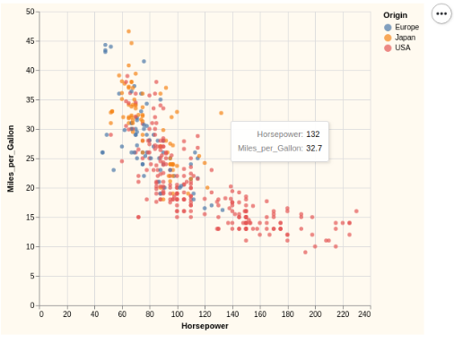

Instrumented barchart
Hanami visualizations may be instrumented with external active componets (react/reagent/re-com) to enable external transforms on them. An example of an instrumented chart:
(hc/xform ht/bar-chart
:USERDATA
(merge
(hc/get-default :USERDATA)
{:vid :bc1
:slider `[[gap :size "10px"] [label :label "Add Bar"]
[label :label ~minstr]
[slider
:model :m1
:min ~min, :max ~max, :step 1.0
:width "200px"
:on-change :oc1]
[label :label ~maxstr]
[input-text
:model :m1
:width "60px", :height "26px"
:on-change :oc2]]})
:HEIGHT 300, :WIDTH 350
:X "a" :XTYPE "ordinal" :XTITLE "Foo" :Y "b" :YTITLE "Bar"
:DATA data)
Which requires the active component implementing the instrument to be coded over on the client side. For this simple example, the test code on the client is a branch inside of a cond testing for the :slider key and value and then processing it:
(let [cljspec spec
udata (cljspec :usermeta)
default-frame {:top [], :bottom [],
:left [[box :size "0px" :child ""]],
:right [[box :size "0px" :child ""]]}]
(cond
...
(udata :slider)
(let [sval (rgt/atom "0.0")]
(printchan :SLIDER-INSTRUMENTOR)
(merge default-frame
{:top (xform-recom
(udata :slider)
:m1 sval
:oc1 #(do (bar-slider-fn tabid %)
(reset! sval (str %)))
:oc2 #(do (bar-slider-fn tabid (js/parseFloat %))
(reset! sval %)))}))
When this chart is rendered, it shows as (left, before slider move; right, after slider move)
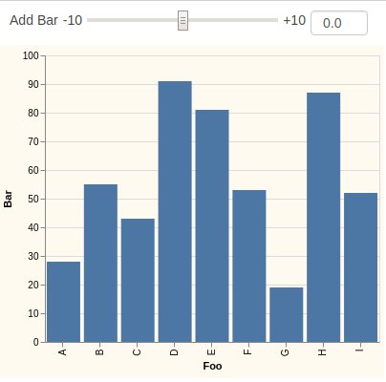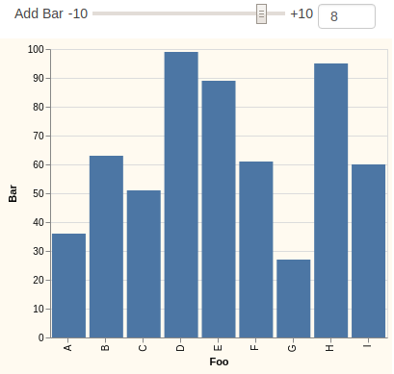

Contour plot using Vega template
An example using a Vega template for contour plotting. An important point to recognize here is that Vega specifications are also pure data, so the exact same recursive transformation works on Vega templates as Vega Lite templates:
(hc/xform
ht/contour-plot
:MODE "vega"
:HEIGHT 400, :WIDTH 500
:X "Horsepower", :XTITLE "Engine Horsepower"
:Y "Miles_per_Gallon" :YTITLE "Miles/Gallon"
:UDATA "data/cars.json"
:XFORM-EXPR #(let [d1 (% :X)
d2 (% :Y)]
(format "datum['%s'] != null && datum['%s'] !=null" d1 d2)))
This generates far too much to show here, as Vega is a much lower level formal specification language than Vega Lite. This renders as:
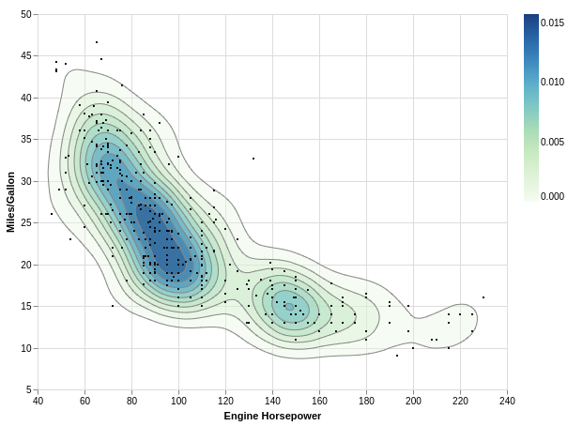

Tree Layout using Vega template
Another interesting Vega example uses the tree-layout template. Using this template for such layouts abstracts away a good deal of low level complexity. In this example a software system module dependency graph is rendered.
(hc/xform
ht/tree-layout
:MODE "vega"
:WIDTH 650, :HEIGHT 1600
:UDATA "data/flare.json"
:LINKSHAPE "line" :LAYOUT "cluster"
:CFIELD "depth")
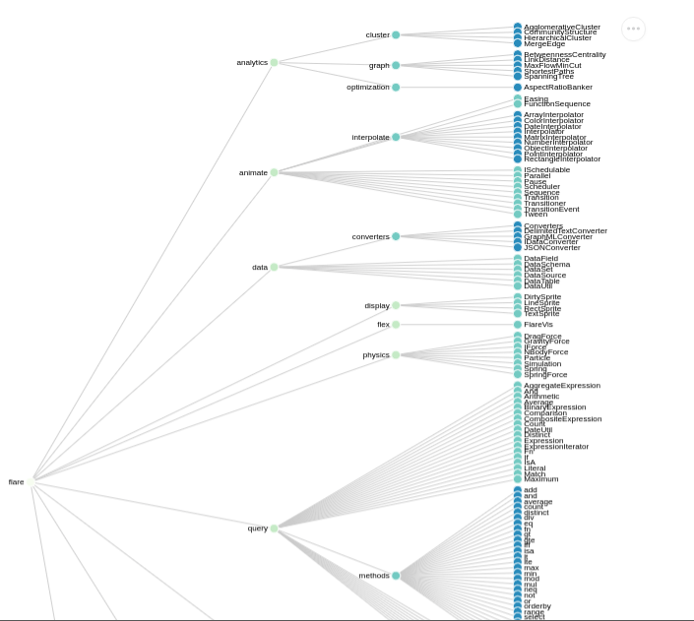
A number of other examples appear at the end of this README, along with their transformations and renderings.

Templates, Substitution Keys and Transformations
Templates are simply maps parameterized by substitution keys. Generally, templates will typically correspond to a legal VG or VGL specification or a legal subcomponent thereof. For example, a complete VGL specification (rendered as Clojure) is a legal template - even though it has no substitution keys. At the other extreme, templates can correspond to pieces of specifications or subcomponents. These will always have substitution keys - if they didn't there would be no point to them.
Substitution Keys can be considered or thought of in two ways. They are the keys in the substitution map(s) of the recursive transformer hc/xform. There is a default map hc/_defaults (which is an atom containing the map) with various default substitution keys and their corresponding default values. This map can be updated and xform can also be supplied a variadic list of substitution keys and their values for a given invocation.
The second way of thinking about substitution keys is that they are the starting values of keys in templates. So, they represent parameterized values of keys in templates.
As an example consider the following. In a template we have a field and value :field :X. The :X here is a substitution key - it will be replaced as the value of :field during transformation by its value in the current substitution map. In the default substitution map hc/_defaults :X has a value of "x", so the result will be :field "x".
A more complex example would be the field and value :encoding :ENCODING in the predefined subcomponent ht/view-base which lays out the structure of a Vega-Lite view. As before :ENCODING will be replaced during transformation by the value of :ENCODING in the substitution map. However, the default value of :ENCODING is the predefined subcomponent ht/xy-encoding. This value is a map describing the structure of a view's x-y encodings and contains many fields with their own substitution keys. So, to produce a final value, ht/xy-encoding is recursively transformed so that the final value of :encoding is a fully realized x-y encoding for the view being processed. ht/view-base has several other such fields and is itself recursively transformed in the context of the current substitution map. And its final value will be the base of a chart, such as a line chart (ht/line-chart) or area chart (ht/area-chart), or some new plot/chart/layout/etc of your own for some domain specific application.

Function values for substitution keys
A substitution key may have a function of one argument for its value: (fn[submap] ...). The submap parameter is the current substitution map in the transformation. This map contains the special key ::hc/spec whose value is the initial (input) specification as well as all current substitution keys and their current values. This is useful in cases where a substitution key's value should be computed from other values. For example, a typical (Saite does this by default) use case would be to compute the label (display name) of a tab from its id:
:TLBL #(-> :TID % name cljstr/capitalize)
This takes the tab's id, which here is a keyword, converts to a string and returns the capitalized version.

Subtitution Key Functions
A more general version of the function as value of a substitution key is provided by the hc/subkeyfns map and associated processing. The function hc/update-subkeyfns can be used to register a function for a subtitution key. This is a 'global' function - separate from any value given for the key. These functions take three arguments: (fn[submap, subkey, subval] ...).
Where the submap parameter is the current substitution map in the transformation; the subkey parameter is the substitution key for this function; and the subval parameter is the value of the substitution key.
These functions can be very useful in providing a further level of abstractions is template specifications. For example, it is very typical that a color specification is intended for the mark of a chart (line-chart, bar-chart, point-chart, etc). providing a simple string indicating the data element to facet with colors makes for a cleaner abstraction, but this needs to be converted to correct full form field and type element. Having a subkeyfn for the hc/color-key (default :COLOR) supports this sort of processing:
color-key
(fn[xkv subkey subval]
(if (string? subval)
(xform ht/default-mark-props (assoc xkv :MPFIELD subval))
subval))
There is a default set of such keys provided with this particular case being one of them. There are a few others, including one which implements the file data source capability for specifications.

Template local defaults
As of version 0.12.9 there is support for default parameterization per template (where 'template' here means any map whatsoever). A new transformation control key is introduced, :aerial.hanami.templates/defaults which can be used to supply a map, local to the template, containing default values of substitution keys. The substitution keys may be those specific only to the template or any other enclosing template, or for changing global defaults. The values are in effect for the duration of the template's processing, unless a more nested template has its own local defaults which override some of the outer's values. In all cases, the in line (point of call) user specified values to hc/xform take precedent over any template local defaults.
Local defaults can be a nice way to deliver new templates without any need to setup new substitution keys in the global registry or require users to add many key-value pairs to their call to hc/xform using the new templates. Addtionally they can automatically parameterize the underlying templates (those used in constructing a new template) to reflect the value of them required for the form of a new template. As an example, let's look at the following, which will show the construction of a new trend-chart for plotting base data along with a smoothed trend line for it.
;;; Base layer for trend-chart
(def trend-layer
(assoc ht/line-chart
:aerial.hanami.templates/defaults
{:X :data/x> :XTYPE :xtype>
:Y :data/y> :YTYPE :ytype>
:YSCALE {:zero false}
:DATA hc/RMV
:WIDTH :width> :HEIGHT :height>
:USERDATA hc/RMV}))
This gives the base form for what the two layers will look like. It is simply the base ht/line-chart parameterized to give the default value of each layer when transformed. The new trend chart will use :data/x> and :data/y> as the parameters for x and y data fields, along with corresponding parameters for the types of the fields :xtype> and :ytype>. Next we use this base layer template to create the trend-chart template:
;;; Trend chart - two layers. 1. base data, 2. loess trend line
;;; Parameters :data/x for x-axis data. :data/y> for y-axis data
;;; :xtype> and :ytype> for axis types, will default to :XTYPE :YTYPE
;;; :width>, will default to 700
;;; :height>, will default to :HEIGHT default
;;; :trend-color> for loess line, defaults to "firebrick"
(def trend-chart
(assoc ht/layer-chart
:description "A two layer plot of base data and its smoothed trend line given by loess transform"
:aerial.hanami.templates/defaults
{:LAYER [(hc/xform trend-layer)
(hc/xform
trend-layer
:TRANSFORM [{:loess :data/y> :on :data/x>}]
:MCOLOR :trend-color>)]
:trend-color> "firebrick"
:xtype> :XTYPE :ytype> :YTYPE
:width> 700
:height> (hc/get-defaults :HEIGHT)}))
Here we use the underlying templates of the predefined ht/layer-chart and the new trend-layer. The layer structure is given by the default for :LAYER as being the two transformed cases for trend-layer. The first layer transform just ensures the result has all the new parameters in place. The second also gives the loess transform and provides for a new trend-color for custom coloring the trend line, with a default of "firebrick". The width of the chart gets a new default of 700 while the height defaults to the global :HEIGHT default. The new :xtype> and :ytype> axis types get defaults of whatever the global :XTYPE and :YTYPE values are.
This can now be used in a highly simplified form such as the following:
(let [[cols data] (get-trend-data file)]
(hc/xform
trend-chart
:DATA (mapv #(zipmap cols %) data)
:data/x> :year :xtype> :temporal
:data/y> :C))
Resulting in this output:
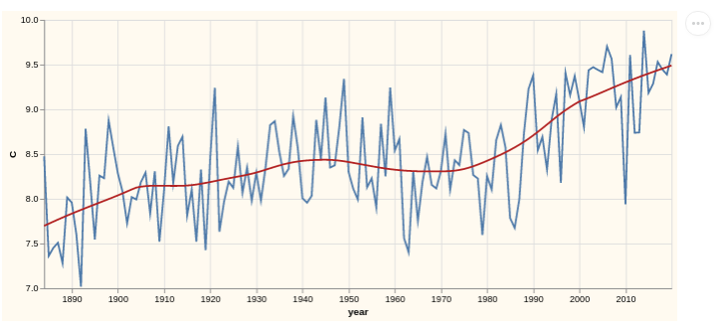

Basic transformation rules
There are some important rules that guide certain aspects of the recursive transformation process. These aspects are really only important in advanced template contruction, but if you find yourself in such circumstances, they are quite useful and helpful.
- Defaults for substitution keys are always overridden by values given for them in a call to hc/xform.
- Any field whose final value is the special hc/RMV value, will be removed from the corresponding specification or subcomponent thereof.
- Any field whose final value is an empty collection, will have this value replaced by hc/RMV and thus removed from its containing collection and specification. This is a very important transformation rule as it enables highly general substitution values. See for example such values as ht/data-options.
- While the simplest way to look at the transformation process is as a continuous transform until the last output is the same as the input, the actual processing is a preorder depth first walk and replacement. Typically, this implementation detail should not factor in to any template authoring, as they should be declarative in nature. However, there may be cases where this ordering can help in constructing proper substitution keys and values.

Meta data and the :USERDATA key
Vega and Vega-Lite support the inclusion of application specific meta data in specifications via the :usermeta top level key in a specification. To Vega and Vega-Lite, this key is completely transparent and is not used in any way by their processing. This affords applications using them to include application specific data, in particular, control data.
Hanami defaults the :usermeta field to the substitution key :USERDATA, which has a default value of RMV. So, by default, there is no application meta data. However, several aspects of Hanami's messaging system, session management, picture frames and tab system expect and make use of control data supplied via the :usermeta field and associated values for the :USERDATA substitution key. So, if you plan on using any of that, you will need to supply a value for this key - either as a default (via hc/update-defaults) or explicitly in a transform (hc/xform). Of course, if you have your own application specific meta/control data that needs to be supplied to clients, you can provide your own fields and values here.
Hanami understands the following 'special' fields:
- :tab - value is a map of fields (:id, :label, :opts) identifying and controlling tabs.
  - :id - value is an id for the tab. Typically a keyword
  - :label - value is the display name for the tab
  - :opts - value is a map of fields (:order, :eltsper, :size, and :wrapfn)
    - :order - value is either :row or :col for either row based grid layouts or column based grid layouts
    - :eltsper - value is an integer for the maximum number of row or col entries. For example a value of 2 would mean 2XN grids for rows and Nx2 grids for columns
    - :size - value is a flexbox size indicator. Best known values are "auto" for row based grids and "none" for column based grids
    - :wrapfn - value is a function which takes the hiccup element for the tab's body (fully structured grid layout) and must return a hiccup/re-com element. The intent is a user may wish to encase the grid body in extra ancillary support layout / active elements. See wrapping functions
- :opts - value is a map of fields controlling Vega/Vega-Lite options. This is not the [:tab :opts] path and value!
  - :export - value is a map of boolean value fields (:png, :svg). Setting these true will provide implicit saving options in the popup Vega-Embed options button (typically upper right circle with "..." content).
  - :scaleFactor - value is a number indicating how much to scale image when exporting png or svg.
  - :renderer - value is either "canvas" or "svg"
  - :mode - value is either "vega-lite" or "vega". Indicates whether the specification is a Vega spec or a Vega-Lite spec (that will be compiled to Vega before rendering). Hanami default values are in (hc/default-opts :vgl) which defaults to
{:export {:png true, :svg true}
:scaleFactor :SCALEFACTOR
:editor true
:source false
:renderer :RENDERER ; either "canvas" or "svg" - see defaults
:mode :MODE} ; either "vega-lite" or "vega" - see defaults
- :vid - value is an application specific identifier of the associated visualization (if any). This is used as the HTML id tag for the element directly containing the visualization. Useful when needing to dynamically manipulate the container and/or the visualization.
- :msgop - value is one of :register, :tabs, or some application specific operator. These messages are from the server to the client. :register is sent on client connection for registration purposes. :tabs is used to update tabs and their content, if tabs are used. User messages have application specific operators and are sent when your application deems they should be sent.
- :session-name - the name of session(s) which will receive the complete specification (either via a :tabs message or some user message).
As an example, Saite has an init function as part of its start up which sets the values of :USERDATA and subsequent defining substitution keys as:
:USERDATA
{:tab {:id :TID, :label :TLBL, :opts :TOPTS},
:frame {:fid :FID, :top :TOP, :bottom :BOTTOM, :left :LEFT, :right :RIGHT}
:opts :OPTS,
:vid :VID,
:msgop :MSGOP,
:session-name :SESSION-NAME}

:OPTS (hc/default-opts :vgl)
:SESSION-NAME "Exploring"
:TID :expl1
:TLBL #(-> :TID % name cljstr/capitalize)
:TOPTS (hc/default-opts :tab)
:MSGOP :tabs
Where hc/default-opts is:
{:vgl {:export {:png true, :svg true}
:scaleFactor :SCALEFACTOR
:editor true
:source false
:renderer :RENDERER ; either "canvas" or "svg" - see defaults
:mode :MODE} ; either "vega-lite" or "vega" - see defaults
:tab {:order :ORDER ; either :row or :col - see defaults
:eltsper :ELTSPER ; count of elements per row/col - see defaults
:size "auto"}}

Example predefined templates
Here are some examples as provided by the name space aerial.hanami.templates which is always referred to in documentation as ht/.
A number of 'fragments':
(def default-tooltip
[{:field :X :type :XTYPE}
{:field :Y :type :YTYPE}])

(def default-mark-props
{:field :MPFIELD :type :MPTYPE})

(def default-row
{:field :ROW :type :ROWTYPE})

(def data-options
{:values :VALDATA, :url :UDATA, :name :NDATA})

(def interval-scales
{:INAME
{:type "interval",
:bind "scales", ; <-- This gives zoom and pan
:translate
"[mousedown[event.shiftKey], window:mouseup] > window:mousemove!"
:encodings :ENCODINGS,
:zoom "wheel!",
:resolve :IRESOLVE}})

(def mark-base
{:type :MARK, :point :POINT,
:size :MSIZE, :color :MCOLOR,
:filled :MFILLED})
A couple 'subcomponents':
(def xy-encoding
{:x {:field :X
:type :XTYPE
:timeUnit :XUNIT
:axis :XAXIS
:scale :XSCALE
:aggregate :XAGG}
:y {:field :Y
:type :YTYPE
:timeUnit :YUNIT
:axis :YAXIS
:scale :YSCALE
:aggregate :YAGG}
:opacity :OPACITY
:row :ROWDEF
:column :COLDEF
:color :COLOR
:size :SIZE
:shape :SHAPE
:tooltip :TOOLTIP})

(def view-base
{:usermeta :USERDATA
:title :TITLE
:height :HEIGHT
:width :WIDTH
:background :BACKGROUND
:selection :SELECTION
:data data-options
:transform :TRANSFORM
:encoding :ENCODING})
And some charts.
;; Useful for empty picture frames
(def empty-chart
{:usermeta :USERDATA})

(def line-chart
(assoc view-base
:mark (merge mark-base {:type "line"})))

(def point-chart
(assoc view-base
:mark (merge mark-base {:type "circle"})))

(def grouped-bar-chart
{:usermeta :USERDATA
:title :TITLE
:height :HEIGHT
:width :WIDTH
:background :BACKGROUND
:selection :SELECTION
:data data-options

:mark "bar"
:encoding :ENCODING

:config {:bar {:binSpacing 0
:discreteBandSize 1
:continuousBandSize 1}
:view {:stroke "transparent"},
:axis {:domainWidth 1}}})

Example predefined substitution keys
All of these are taken from hc/_defaults They are chosen so as to indicate how some aspects of the above template examples get transformed.
:USERDATA RMV, :MODE "vega-lite", :RENDERER "canvas", :SCALEFACTOR 1
:TOP RMV, :BOTTOM RMV, :LEFT RMV, :RIGHT RMV
:BACKGROUND "floralwhite"
:OPACITY RMV

;; Note that removed things will get Vega/Vega-Lite defaults
:TITLE RMV, :TOFFSET RMV
:HEIGHT 300, :WIDTH 400, :DHEIGHT 60

;; get-data-vals is a function which handles :DATA and :FDATA
:VALDATA get-data-vals
:DATA RMV, :FDATA RMV, :SDATA RMV, :UDATA RMV, :NDATA RMV

;; Describes the x encoding in xy-encoding. Similar for y encoding
:X "x", :XTYPE, "quantitative", :XUNIT RMV
:XSCALE RMV, :XAXIS {:title :XTITLE, :grid :XGRID, :format :XFORMAT}
:XTITLE RMV, :XGRID RMV, :XFORMAT RMV

;; Aggregation transforms
:AGG RMV, :XAGG RMV, :YAGG RMV

;; Mark properties
:POINT RMV, :MSIZE RMV, :MCOLOR RMV, :MFILLED RMV
:MPTYPE "nominal", :SHAPE RMV, :SIZE RMV

;; Note that by default then :ROWDEF -> {:field :ROW :type :ROWTYPE} ->
;; {:field RMV, :type RMV} -> {} -> RMV. See transformation rules
;; Similar for :COLDEF
:ROWDEF ht/default-row :ROW RMV, :ROWTYPE RMV

:TOOLTIP ht/default-tooltip
:ENCODING ht/xy-encoding

:TRANSFORM RMV
:SELECTION RMV

Data Sources
Visualizations are based in and so require data to realize them. Specifications provide several means of declaring the source and processing of data to be used in a visualization. The underlying Vega and Vega-Lite systems provide for several of these by various means. Hanami currently directly supports three of these plus a fourth. The keys and expected values are given in this section.
- :DATA - expects an explicit vector of maps, each map defining the data fields and values
- :UDATA - expects a relative URL (for example "data/cars.json") or a fully qualified URL to a csv or json data file.
- :NDATA - expects a named Vega data channel.
These three are based directly on the underlying Vega and Vega-Lite options. The fourth, file data sources, is provided by Hanami.

File data source
:FDATA <filepath | [filepath, type-vector-or-map]]
The filepath is a full path for the OS and can denote a file with extensions clj, edn, json, or csv. These extensions indicate the file types - no other checking is done. For the clj, edn, and json the content must be a vector of maps, where each map is a record of data fields and their values. CSV files are converted to vectors of maps, each map built from the column names and a row's corresponding values.
For csv, a type-vec-or-map may be provided as the second value of a vector pair (tuple). This can be either a vector of type indicators in 1-1 correspondence with the column names of the csv file, or a map where each key is one of the column names and the value is a type indicator. Type indicators supported are (the strings): "string", "int", "float", and "double". In either case, the strings in a row associated with the type indicators are converted per the indicator. The default type indicator for the case of maps is "string", i.e., return the original string value.
Example:
(hc/xform my-plot-template
:FDATA ["/Data/RNAseq/Exp-xyz/Out/dge-xyz.csv" {"dge" "float"}])
This will create a vector of maps from the csv content, where the "dge" field in each map will have its value converted to a floating point number.

Walk through example of transformation
It's worth having a look at what happens with the simple car chart template example and its transformations. The value of ht/point-chart is:
(def point-chart
(assoc view-base
:mark (merge mark-base {:type "circle"})))
We have already seen (above) what view-base, data-options, and mark-base are, so we know that the starting value of point-chart is:
{:usermeta :USERDATA
:title :TITLE
:height :HEIGHT
:width :WIDTH
:background :BACKGROUND
:mark {:type "circle"
:point :POINT
:size :MSIZE
:color :MCOLOR
:filled :MFILLED},
:selection :SELECTION
:data {:values :VALDATA, :url :UDATA, :name :NDATA}
:transform :TRANSFORM
:encoding :ENCODING}
We already have seen what the default values of the substitution keys here are. In the transform, explicit values are given for :UDATA, :X, :Y, and :COLOR. We will see about :COLOR a bit later, but with the values for the first three, conceptually, we have a "first version":
{:height 300
:width 400
:background "floralwhite"
:mark {:type "circle"}
:data {:url "data/cars.json"}
:encoding {:x {:field "Horsepower"
:type "quantitative"
:axis {:title :XTITLE, :grid :XGRID, :format :XFORMAT}}
:y {:field "Miles_per_Gallon"
:type "quantitative"
:axis {:title :YTITLE, :grid :YGRID, :format :YFORMAT}}
:row {:field :ROW :type :ROWTYPE}
:column {:field :COLUMN :type :COLTYPE}
:color :COLOR
:tooltip [{:field "Horsepower" :type "quantitative"}
{:field "Miles_per_Gallon" :type "quantitative"}]}}
By the second rule of transformation, we also know that the :axis, :row, and :column fields will be replaced first by {} (since all of their fields default to RMV) and then by the third rule they will be removed. So, conceptually, the 'next' version is:
{:height 300, :width 400, :background "floralwhite"
:mark {:type "circle"}
:data {:url "data/cars.json"}
:encoding {:x {:field "Horsepower" :type "quantitative"}
:y {:field "Miles_per_Gallon" :type "quantitative"}
:color :COLOR
:tooltip [{:field "Horsepower" :type "quantitative"}
{:field "Miles_per_Gallon" :type "quantitative"}]}}
OK, :COLOR is all we have left. As shown in the section on substitution key functions Hanami has a default such function for the hc/color-key (default :COLOR). If the subval of the key is a string, then this function returns the value (xform ht/default-mark-props (assoc xkv :MPFIELD subval)). As we know from above, the value of ht/default-mark-props is {:field :MPFIELD :type :MPTYPE} and so the function here returns {:field "Origin" :type "nominal"}. So, the final value of the transformation is:
{:height 300, :width 400, :background "floralwhite"
:mark {:type "circle"}
:data {:url "data/cars.json"}
:encoding {:x {:field "Horsepower" :type "quantitative"}
:y {:field "Miles_per_Gallon" :type "quantitative"}
:color {:field "Origin" :type "nominal"}
:tooltip [{:field "Horsepower" :type "quantitative"}
{:field "Miles_per_Gallon" :type "quantitative"}]}}
The reason for caveat uses of 'conceptually' in the above description is the final rule of transformation. Which says that the actual transformation process is via a depth first walk and replacement. So, for example, :encoding would have only had its full final value, not any intermediate value(s).

Application Construction
Hanami is an visualization application developement enabler. It is a library with optional framework aspects provided for both server side (Clojure) and client side (ClojureScript) development. The client is most typically expected to be in the browser, but technically may not be.

Library overview
The library portion of Hanami centers on
- Templates, Substitution Keys and Transformations
- Simple, potent, clean messaging system
- Clean single point Reagent (React lifecycle) component for compiling, both Vega and Vega-Lite and rendering the result.
These bits are not opionated in how to go about developing a domain specific visualization application. There is no constraint on how page(s) are to be laid out, what sort of ancillary and support components should be used, what CSS is used, etc. You can use Hiccup or Re-Com or whatever to layout and structure your application. Nor is there any opinion about the structure of the server side. And while there are a set of defaults, there are no requirements or expectations about the form, makeup, or content of templates and substitution keys. You can replace, augment, or change any or all of the defaults.

Framework overview
The framework portion of Hanami is opinionated, though not too stringently. It consists of
- Client side application header as provided by a user supplied function of zero arguments, which is expected to return a hiccup/re-com value which lays out the page header of the application. This value can simply be empty if you don't want this.
- Named session groups. The default (client) header function directly supports this by providing an input text box to specify which session group is desired. Any session in a session group of name name will receive any messages sent to that group. This supports dynamic sharing.
- A tab system for automatically structuring both your application layout (each tab can be a page, chapter, subsection, etc) and the structure and content of each such component.
These combine to form the basic page layout from this 'framework perspective' as shown here:

framework topology graphic
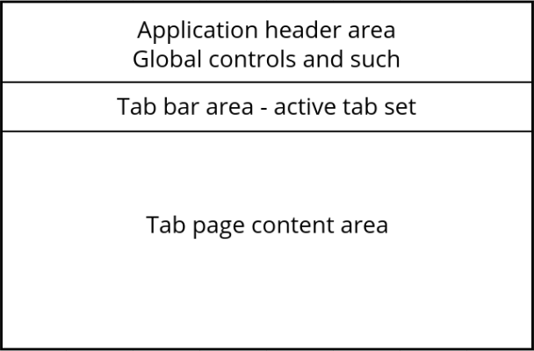
The header area is constructed by the :header-fn argument of the client start function. The tab bar is dynamically constructed via :tabs messages or by explict calls to the hmi/tabs client function. The content of each tab's body is also constructed dynamically via these same means. If the tab doesn't exist, it will be created and added to the tab bar at the time it's body is also rendered. Updates to a tab will simply update the existing tab's body.
As an example Saite makes use of the framework aspects of Hanami and here is an example page layout from a session in it.
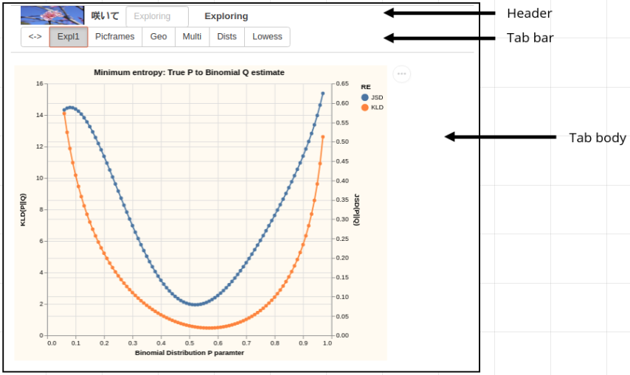

Resource requirements
The basic resource requirements are the various stylesheets, mostly in support of re-com, that are shown in the development 'landing page' index.html. When you create your own index.html landing page - or generate it dynamically - you will need to include these resources.
Also, as indicated in the development index.html, you will need to indicate where your final compiled JavaScript implementing your application will be and what it is called.
NOTE: If you will be running serverless, you will need to make sure that the resources and final javascript are located relative to where you load your landing page from or that all the links are absolute.

Header
The client side start function has a :header-fn parameter which is a function of a single parameter that should return the main application header area. The default function for this returns a header which supports multiple named session groups. This is one mechanism where by you can insert global controls, logos, application 'avatars', etc. Alternatively you may choose to have this return nothing and wait for the application initialization message, to perform the application setup. The latter may be more appealing if you compute a number of fields that support the contruction of a more sophisticated header.

Tabs
The tab system of Hanami is intended to be a fairly general purpose document structuring and layout capability for a variety of visualization applications. But that very fact means it has some level of 'opinion' on such layouts and so you may not want to use it if you need total general / manual layouts. But for the very large subset of cases where it fits nicely it can be very helpful. There is a set of functions and components of the client API for dealing with the tab system. If you use the standard framework main components, you will not have to use this API - it is all handled for you. The API is given in case you need / want to set up your own components which make use of it.

Basics
As depicted in the framework topology graphic, the tab system has a dedicated area for the tab bar. Tabs are dynamically added to the tab bar from left to right. They may also be deleted. Any selected tab will have its body displayed in the dedicated content area. If you use Hanami's standard framework, the main components will drive all tab actions and updates.

Configuration and behavior
To use tabs, the :usermeta field of specifications must contain the :tab key whose value must be a map. The keys and values of this map are detailed in the tab section of the USERDATA section of this documentation. The :id field is the primary key for identifying and manipulating a tab and its body. The :label field is for human readable naming of the tab. The :opts field details the auto layout format for the tab's body. It is worth noting that if the :eltsper field has a value of 1, the effect is to have the body layed out linearly from top to bottom in the order the specifications were given to the tab.
Tabs are added and updated via the update-tabs client core function. This function takes a vector of specifications and groups them by the tab id for each. Then for each such group,preprocesses the specifications (including instrumentation and frames) and places this information into the tab database. This database update triggers the Reagent components responsible for rendering any such changes.

Extension tabs
In addition to 'standard tabs', those described above, the tab system may be extended with 'extension tabs'. The defining characteristic of such tabs is that they have an extra field: [:opts :extfn]. The value of this field must be a Reagent form function. Typically it will be a form-2 and will implement the body of the tab. This functionality is seamlessly integrated with standard tabs and will be implicitly invoked when the tab is selected.
Extension tabs are intended to be built and added on the client side. add-tab can be used to manually add such tabs, and the :app-init user-msg is a convenient place to perform this action (as part of any other application initialization). NOTE in client only you can explicitly fire this message as part of on page load code start.

Incremental bodies
As of version 0.9.0, there is support for incrementally adding to a tab's content area, which is also known as it's body. Previously the only way to effect a change on a standard (non extention) tab's body was to perform a full update on it via update-tabs or more directly via vis-list. Both of these required the full list of specifications to be rendered. There are applications where this is simply too restrictive. You may want to simply insert a picture frame at a given point in a page. Or simply extend it, without needing to manage the entire sequence of specifications. There are now two new client core functions add-to-tab-body and remove-from-tab-body which can adjust the content of a tab at the granularity of picture frames.

Wrapping functions
As of version 0.9.0 there is now support for per tab user wrapping functions. This supports custom layout encompassing or encasing the tab's fully structured grid layout of the tab's sequence of specifications. Wrapping functions are configured by means of the :wrapfn key/value pair specifiable in the tab's options. This provides a level of customization that is in between fully custom extension tabs and standard tabs. Wrapping functions must accept one argument, gridhc, which is the fully computed hiccup for the grid layout of the tab, and return a hiccup/re-com element which includes the gridhc element somewhere inside it (directly or in some child). The result will then be rendered in the tab's content area.

Sessions
The server side start-server function has an :idfn parameter which is a parameterless function which returns session names for client connections. Upon a client connetion (initial websocket connect), the server will send a registration message to the client. Among other fields in the data sent will be a :session-name. This is the name of the session group the client has been placed in according to the idfn function.
It is possible for the client to "opt out" of this session group in favor of another - including a totally new one of it's own making - by sending a set session message to the server. This also implies that session groups need only contain one session.
As a simple example of how this can be done, the client start function's default header-fn function uses a two stage input area to support changing the server's default assigned session group to some other such group (including a new one if the input does not name an existing group):
(defn set-session-name [name]
(let [old-uid (get-adb [:main :uid])
name (if (= name "") (old-uid :name) name)]
(sp/setval [sp/ATOM :main :session-name sp/ATOM] name app-db)
(when (not= name (old-uid :name))
(update-adb [:main :uid :name] name)
(send-msg {:op :set-session-name
:data {:uid old-uid
:new-name name}}))))

(defn session-input []
(if (not= "" (sp/select-one [sp/ATOM :main :session-name sp/ATOM] app-db))
[:p]
[input-text
:model (get-adb [:main :session-name])
:on-change set-session-name
:placeholder (get-adb [:main :uid :name])
:width "100px"]))

(defn default-header-fn []
[h-box :gap "10px" :max-height "30px"
:children [[gap :size "5px"]
[:img {:src (get-adb [:main :logo])}]
[title
:level :level3
:label [:span.bold (get-adb [:main :title])]]
[session-input]
[gap :size "5px"]
[title
:level :level3
:label [:span.bold (get-adb [:main :uid :name])]]
[gap :size "30px"]]])
On connection the client's header contains a header with the default assigned session group name listed along side an input text box. The user can decide to change the assigned group, by typing in a new name. This will fire a set-session-name message to the server to reassign this session to the desired group.
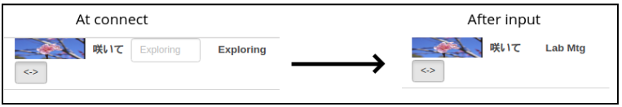
Any message sent from the server to a named session group, will result in all current session members getting the message. In particular, messages updating the visualizations and picture frame content of tab bodies, will be sent to all such session members. This is equally true for application specific messages sent via hmi/send-msg

Messages
There are a few builtin messages which are sent between the server and client. These are generally in support of the framework aspects of Hanami. In general, domain specific applications will have a set of their own messages. These can be sent via send-msg, available on both the client and server, and processed by user-msg, also available on both the client and server
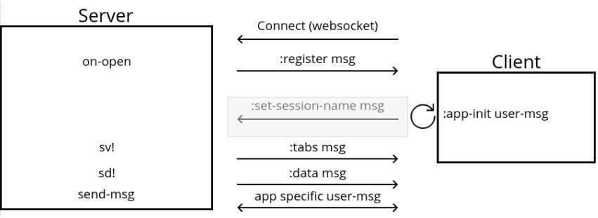
The messages listed in that graphic overview are roughly in the order they occur from top to bottom. Let's walk through them so that we know what happens as they occur.

Connection
Upon a client opening a connection, the server creates a session/app initialization data package, which is sent to the client via a :register message. This package is a map composed of two groups of data:
- A standard set of fields and values:
  - :uid a uid value {:uuid (hmi/uuid), :name (idfn)}
    - hmi/uuid generates string names from uuids
    - idfn is the start-server function's :idfn argument, which is expected to return the applications session group names.
  - :title, the start-server function's :title argument
  - :logo, the start-server function's :logo argument
  - :img, the start-server function's :img argument
  - :opts, the current hc/default-opts value
- A, possibly empty, set of user/application specific fields. These are determined by the start-server function's :connfn argument. This is a function of one parameter (fn [x] ...) where x is the map of standard fields and values. The expectation the function will compute new fields and values and add them to that set and return the total as a single initialization data map. The default function is identity.
The client side dispatches two calls upon reception of this message. Both are passed this final initialization data map. The first is hc/register which takes the standard fields and sets up the initial client side database. The second is the multimethod user-msg where the msg given is {:op :app-init :data init-data-map}. If your application implements this method for :app-init, it will be called and any application specific work can be done at that point.

Session group
As described in the section on sessions and session groups, the client may change the group its session belongs to (named by the idefn function of start-server) as described in the section on connections. This is achieved by sending the server a :set-session-name message, which has the form:
{:op :set-session-name
:data {:uid old-uid
:new-name name}}
Where
- old-uid is the uid the session currently has and wants shifted
- name is the name of the session group the client wants to move to.
Upon receipt of such a message, the server will update its database to reflect the change: the session's uuid will be moved to the requested group named by the :new-name field.

Tab updates
The :tabs message is the main way to update one or more tabs in a current sesion if you are using the tab system in a client / server setup. The simplest way to send these messages is via the server sv! function. Typically this will be from within a server side editor / IDE.
In client only applications, you can achieve the exact same effect by calling the client side 'mirror' function sv!.
As an example, the simple cars case listed in the opening examples was dispatched as:
(-> (hc/xform ht/point-chart
:UDATA "data/cars.json"
:X "Horsepower" :Y "Miles_per_Gallon" :COLOR "Origin")
hmi/sv!)

User messages
User, also know here as "application specific", messages are sent via the send-msg function. This function exists in both the client and server hmi name space. The entire point of these messages is to support extension messages that are specific to the needs of an application. All such messgaes will be caught by the receiving party and dispatched to the multimethod user-msg. There is one such message which is dispatched on the client side implicitly - the :app-init msg on client connection. This supports the any application specific client initialization processing.
Two examples of from Saite
The first is for the :app-init message.
(defmethod user-msg :app-init [msg]
(update-adb [:main :convert-chan] (async/chan))
(add-tab {:id :xvgl
:label "<->"
:opts {:extfn (tab<-> :NA)}}))
So, we add a Saite specific async channel to the database in support of conversions and popup renderings. Then we add the extension tab for the conversion / popup renderer capability.
The second (client / server is for messages specifically required by Saite to perform data conversion and transformation operations for the client.
;;; Client sends two versions of :read-clj msg to server.
;;; One for conversion and one for popup rendering
;;; The popup case
(let [...
msg {:op :read-clj
:data {:session-name nm
:render? true
:cljstg inspec}}
_ (send-msg msg)
...]
...
)

;;; Server user-msg method for this:
(defmethod hmi/user-msg :read-clj [msg]
(let [{:keys [session-name cljstg render?]} (msg :data)
clj (try
(let [clj (->> cljstg clojure.core/read-string)]
(swap! dbg (fn[m] (assoc m :clj clj)))
(->> clj xform-cljform eval final-xform))
(catch Exception e
{:error (format "Error %s" (or (.getMessage e) e))})
(catch Error e
{:error (format "Error %s" (or (.getMessage e) e))}))]
(swap! dbg (fn[m] (assoc m :xform-clj clj)))
(hmi/print-when [:pchan :umsg] :CLJ clj)
(hmi/send-msg session-name :clj-read (assoc clj :render? render?))))

;;; NOTE the send-msg to client with :cli-read

;;; Client user-msg method for this:
(defmethod user-msg :clj-read [msg]
(let [data (msg :data)
render? (data :render?)
clj (dissoc data :render?)
result (if render?
clj
(try (-> clj clj->js (js/JSON.stringify nil, 2))
(catch js/Error e (str e))))
ch (get-adb [:main :convert-chan])]
(go (async/>! ch result))))

Picture Frames
Picture frames are simply a way to automatically encase your visualizations with 'meta' level instrumentation and / or arbitrary annotations. They are composed of four individual parts corresponding to the top, bottom, left, and right quadrants. Picture frames (or simply frames) are specified in the usermeta data of a specification via the :frame key. By default Hanami uses the substitution key :USERDATA for this. So, the format is:
{...
:USERDATA {...
:frame {:fid ...
:top ...
:bottom ...
:left ...
:right ...}
...
}
}
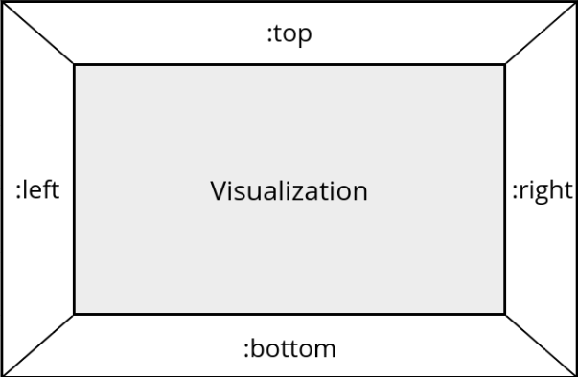
All of the quadrants are optional and :frame {} is legal, which by the third rule of transformation will result in its removal.
The value of :fid should be a globally unique id (keyword or string). If it is not specified the field will be removed and the frame will not have an id. This id will be used as the frame's DOM id as well as the corresponding spec's id. So, if it is not supplied the frame will not be accessible (in particular, it won't be accessible when using incremental bodies.
The value of a quadrant can be any legal mix of strings, hiccup, markdown (MD) and / or active components. Where 'legal' here means 'yields a legal DOM branch'. A great resource for active components, which Hanami provides as part of its package, is Re-Com. This is especially true if you are not a CSS/flex and / or component savant.
As of version 0.5.0, picture frames may be 'empty' in that they do not need to have an associated visualization. To make this a bit simpler, there is a new template for these cases ht/empty-chart.
As of version 0.9.0, markdown is directly available via the md active component, as such it is an extension to the hiccup used by Hanami (from Reagent). You would use this like / where you would use any other hiccup / re-com component. The form is [md <optional style map> <string of markdown>]. The string can include newlines. The style map is for things such as font-size, color, etc.
ASSIDE: LaTex is specifically not included in Hanami. This decision is based on three reasons: 1. Many (most?) applications do not need LaTex math rendering. 2. MathJax is the go to JS engine for this and is a heavy dependency that would not be used in these applications. 3) React (as of version 16+) has a 'bug' preventing proper running of engines like MathJax (and Google Translate and many many other such rendering engines). It is possible to get around issue 3. but it requires 'monkey patching' React. If you need LaTex, you should consider using Saite which is an application (built on Hanami) which does include MathJax, fixes 3., and is an application for general graphics and live document creation and sharing. Of course, if you are creating your own domain specific application and need LaTex for it, you will need to navigate issue 3. in your app. However, note that the md tag (see above markdown discussion) supports LaTex, so you can include it in your markdown (again, see Saite for examples).
You can specifiy frames from either the server or client side of your application. Working on the client side from within ClojureScript can make this more 'natural', as you are in the actual environment (browser/DOM) where things are running and rendering. However, specifying from the server side is fully supported, as long as Re-Com use is quoted (or more typical and useful, backquoted).
NOTE: if you are instrumenting your visualization (using active components - input box, dropdowns, selection lists, etc.) the functions updating the relevant model(s) of / for these components must be written over on the ClojureScript side (client). This is because, Hanami does not use a self hosted ClojureScript, but rather the cross compiled (with Google Closure) variant. Hence, you cannot, for example, write function code on the server side and have it eval'd on the client! (NOTE: this restriction may be lifted!)
Picture frames are fully automatic if you use the default tab system. If you use custom tabs and want to make use of frames, you should call hmi/vis-list on the client side (Cljs) for automatic rendering. If you are doing completely custom layouts, you will want to call hmi/frameit client function. As always, if you do not want to use any of this, you should 'manually' use the hmi/vgl reagent vega/vega-lite component.
A couple of examples. These are actually taken from Saite, which is an interactive, exploratory and ad-hoc visualization application written with Hanami. Worth noting is that Saite assumes an interactive REPL model of exploration on the server side, pushing visualizations to the client. Hence, the only active components that can be used are those that are self contained, like information buttons or modal panels.
(let [_ (hc/add-defaults
:NAME #(-> :SIDE % name cljstr/capitalize)
:STYLE hc/RMV)
frame-template {:frame
{:SIDE `[[gap :size :GAP]
[p {:style :STYLE}
"This is the " [:span.bold :NAME]
" 'board' of a picture "
[:span.italic.bold "frame."]]]}}
frame-top (hc/xform
frame-template :SIDE :top :GAP "10px")

frame-left (hc/xform
frame-template :SIDE :left :GAP "10px"
:STYLE {:width "100px" :min-width "50px"})
frame-right (merge-with merge
(hc/xform
frame-template :SIDE :right :GAP "2px"
:STYLE {:width "100px" :min-width "50px"})
(hc/xform
frame-template :SIDE :left :GAP "2px"
:STYLE {:width "100px" :min-width "50px"
:color "white"}))
frame-bot (hc/xform
frame-template :SIDE :bottom :GAP "10px")]
(->> (mapv #(hc/xform ht/point-chart
:HEIGHT 200 :WIDTH 250
:USERDATA (merge (hc/get-default :USERDATA) %)
:UDATA "data/cars.json"
:X "Horsepower" :Y "Miles_per_Gallon" :COLOR "Origin")
[frame-top frame-left frame-bot frame-right])
hmi/sv!))
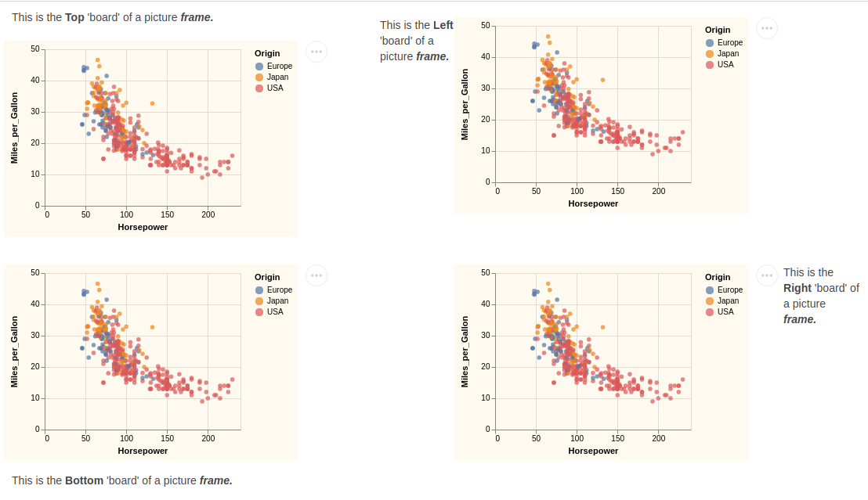
(let [text "Lorem ipsum dolor sit amet, consectetur adipiscing elit. Quod si ita est, sequitur id ipsum, quod te velle video, omnes semper beatos esse sapientes. Tamen a proposito, inquam, aberramus."
top `[[gap :size "150px"]
[p "An example showing a "
[:span.bold "picture "] [:span.italic.bold "frame"]
". This is the top 'board'"
[:br] ~text]]
left `[[gap :size "10px"]
[p {:style {:width "100px" :min-width "50px"}}
"Some text on the " [:span.bold "left:"] [:br] ~text]]
right `[[gap :size "2px"]
[p {:style {:width "200px" :min-width "50px"
:font-size "20px" :color "red"}}
"Some large text on the " [:span.bold "right:"] [:br]
~(.substring text 0 180)]]
bottom `[[gap :size "200px"]
[title :level :level3
:label [p {:style {:font-size "large"}}
"Some text on the "
[:span.bold "bottom"] [:br]
"With a cool info button "
[info-button
:position :right-center
:info
[:p "Check out Saite Visualizer!" [:br]
"Built with Hanami!" [:br]
[hyperlink-href
:label "Saite "
:href "https://github.com/jsa-aerial/saite"
:target "_blank"]]]]]]]
(->> [(hc/xform ht/point-chart
:TID :picframes
:TOP top :BOTTOM bottom :LEFT left :RIGHT right
:UDATA "data/cars.json"
:X "Horsepower" :Y "Miles_per_Gallon" :COLOR "Origin")]
hmi/sv!))
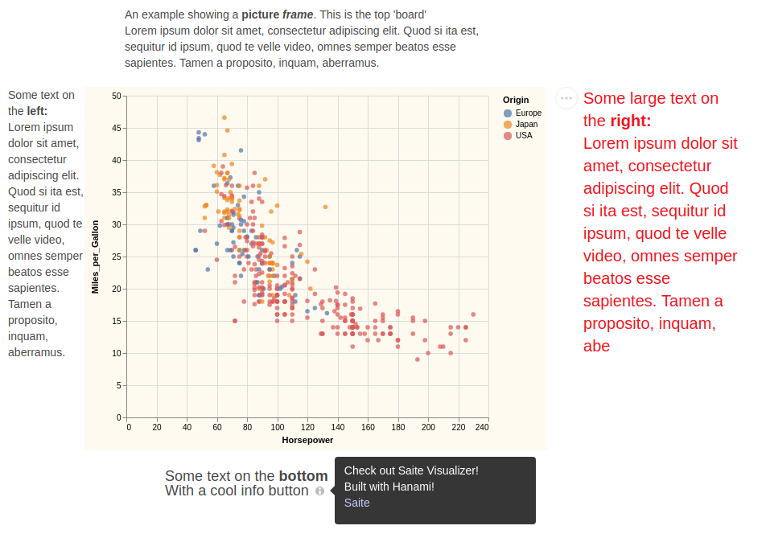

Empty Frames
As of version 0.5.0, picture frames can now be 'empty', i.e., they do not need an associated visualization. The basic layout is the same as for frames with visualizations:
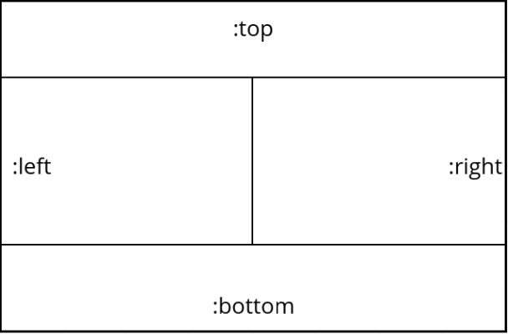
To make the use of these simpler (and easier) there is a new standard template ht/empty-chart which can be used to create them. Empty frames enable a more general document structure supporting paragraphs of html/'text oriented' material along side or in place of standard visualizations with or without frames. Here are a couple of examples showing the basic capability:
This example shows an empty frame with all 4 picture frame elements (areas) with various html/text information
(let [text "Lorem ipsum dolor sit amet, consectetur adipiscing elit. Quod si ita est, sequitur id ipsum, quod te velle video, omnes semper beatos esse sapientes. Tamen a proposito, inquam, aberramus."
top `[[gap :size "50px"]
[p {:style {:width "600px" :min-width "50px"}}
"An example empty picture frame showing all four areas."
" This is the " [:span.bold "top"] " area. "
~text ~text ~text]]
left `[[gap :size "50px"]
[p {:style {:width "300px" :min-width "50px"}}
"The " [:span.bold "left "] "area as a column of text. "
~text ~text ~text ~text]]
right `[[gap :size "70px"]
[p {:style {:width "300px" :min-width "50px"}}
"The " [:span.bold "right "] "area as a column of text. "
~text ~text ~text ~text]]
bottom `[[gap :size "50px"]
[v-box
:children
[[p {:style {:width "600px" :min-width "50px"}}
"The " [:span.bold "bottom "]
"area showing a variety of text. "
[:span.italic ~text] [:span.bold ~text]]
[p {:style {:width "400px" :min-width "50px"
:font-size "20px"}}
"some TeX: " "\\(f(x) = \\sqrt x\\)"]
[md {:style {:font-size "16px" :color "blue"}}
"#### Some Markup
* **Item 1** Lorem ipsum dolor sit amet, consectetur adipiscing elit.
* **Item 2** Lorem ipsum dolor sit amet, consectetur adipiscing elit. Quod si ita est, sequitur id ipsum, quod te velle video, omnes semper beatos esse sapientes. Tamen a proposito, inquam, aberramus."]
[p {:style {:width "600px" :min-width "50px"
:color "red"}}
~text]]]]]
(->> (hc/xform ht/empty-chart
:TID :picframes :TOP top :BOTTOM bottom :LEFT left :RIGHT right)
hmi/sv!))
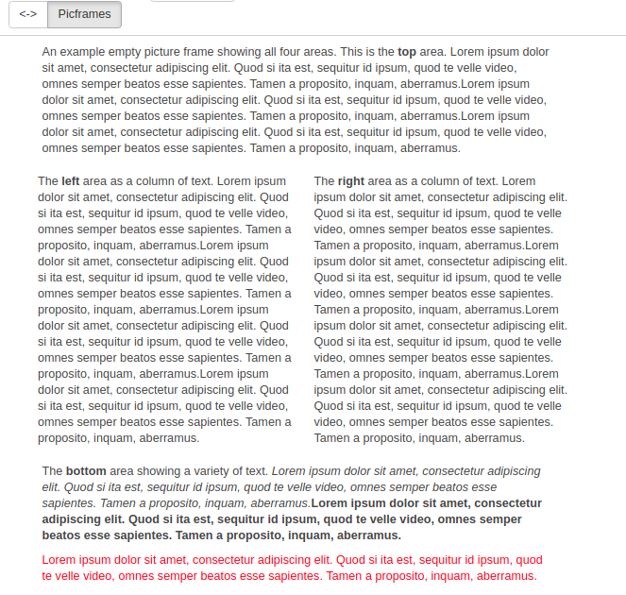
This next eample shows a tab/page with two picture frames. The left being a frame with an associated chart, while the one on the right shows how you can structure text in columns.
(let [text "Lorem ipsum dolor sit amet, consectetur adipiscing elit. Quod si ita est, sequitur id ipsum, quod te velle video, omnes semper beatos esse sapientes. Tamen a proposito, inquam, aberramus."
top `[[gap :size "50px"]
[p "Here's a 'typical' chart/plot filled picture frame."
"It only has the top area"
[:br] ~text]]
left `[[gap :size "20px"]
[p {:style {:width "200px" :min-width "50px"}}
"This is an empty frame with a " [:span.bold "left "]
"column of text" [:br] ~text ~text ~text ~text]]
right `[[gap :size "30px"]
[p {:style {:width "200px" :min-width "50px"}}
"And a " [:span.bold "right "]
"column of text"
[:br] ~text ~text ~text ~text]]]
(->> [(hc/xform ht/point-chart
:TID :picframes :UDATA "data/cars.json"
:TOP top
:X "Horsepower" :Y "Miles_per_Gallon" :COLOR "Origin")
(hc/xform ht/empty-chart
:TID :picframes
:LEFT left :RIGHT right)]
hmi/sv!))
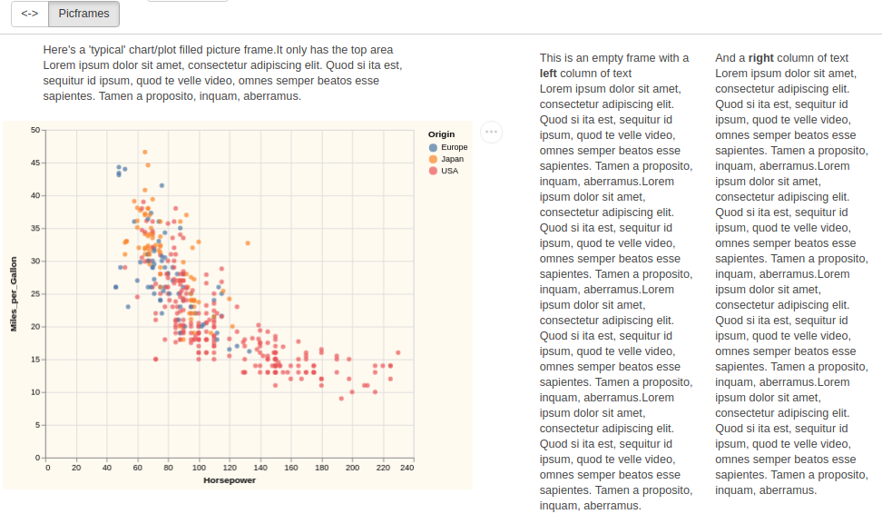

Data Streaming

Client Only Apps
While the most typical use case scenario involves clients and server working together, Hanami also enables the development of client only applications. In this case, the Clojure (server) side of the library (and framework aspects) is not used and all development is done on the client (typically browser) side.
In client only applications, there are no explicit messages, nor is the usual client side start function used. Application initialization is no longer implicit (via the server to client register message); you will need to explicitly code your own specific initialization.
As noted in resource requirements, you still need to create a landing page (index.html) with all the required resources and to have your directory structure setup for relative loading or use absolute URLs in the links.
When running client only applications, the full template system is available on the client side. Both the hc and ht namespaces may be required and their resources used. So, you can make full use of templates, substitution keys, and transformations. Further, all the default templates are available for use.

Basic client app requirements

Require resources
You need to require the basic Hanami resources in your name space definition
(ns clientex.core
(:require
...
[aerial.hanami.core
:as hmi
:refer [printchan user-msg
re-com-xref xform-recom
default-header-fn default-instrumentor-fn make-instrumentor
update-adb get-adb
init-tabs
hanami-main]]
[aerial.hanami.common :as hc :refer [RMV]]
[aerial.hanami.templates :as ht]
...))
The exact resources you refer will be up to how you typically do such referals. You may just use the :as hmi and reference all resources with hmi/.... If you want to use re-com capabilities, you will need to require those as well. For example, something like
[re-com.core
:as rcm
:refer [h-box v-box box gap line h-split v-split scroller
button row-button md-icon-button md-circle-icon-button info-button
input-text input-password input-textarea
label title p
single-dropdown
checkbox radio-button slider progress-bar throbber
horizontal-bar-tabs vertical-bar-tabs
modal-panel popover-content-wrapper popover-anchor-wrapper]]
But again, what you require and refer will be up to what you need for your application and how you want to structure it.

Application initialization
You will need to code your application setup and initialization functions. If you use the tab system you will need to call init-tabs as part of this. If you want to use hanami-main you will also need to setup the database to have the expected fields. The example client only app does this here

Landing page - index.html
The most typical way of getting the application loaded is via an explict index.html file which is correctly located in the directory resources/public of your application. The example application uses this index.html
Once you have your code compiled and located per the <script ...> tag in your index.html, you can simply use a browser to navigate to this file and your application will be active. If you want to have an interactive session(s) with the application you will need to run figwheel or an equivalent type of capability. The client only example app is set up to use figwheel (plus cljs-repl and piggyback)

Application start
Your code should have a final block which will start the application upon page load. Generally this will test for a specific DOM element upon which to render (via reagent) your main component. An example of this from the client only example is here. In this case the startup first sets several default substitution keys, then calls app-init which sets up the application. At this point you will be able to render visualizations just like from the server, using the same hc/xform transformer of templates, and hmi/sv!

Example Client Only Application
Hanami's github repository contains a client only example application. Found in the examples directory here. To run this you can simply change directory to the examples/ClientOnly directory. Then run lein repl. When repl is up and running, issue (use 'figwheel-sidecar.repl-api) and when ready issue (start-figwheel!). This will open a browser window and you will see:
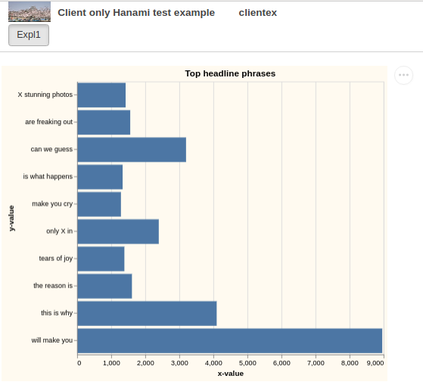
You can also, at this point, pull up the clientex.core.cljs in emacs, connect to the repl, and once connected issue (cljs-repl). Switch buffers to the clientex.core name space file, and evaluate the buffer. At this point you will be able to interactively transform and render other specifications (see the 'rich' comment for some other examples)

API
As noted, with respect to abstracting visualizations (ala' something like Altair) there isn't much of an API and no classes, objects, or methods are involved. Most of what API there is centers on application development and start up. This is split across the server and the client side.

Templates and Substitution keys
This applies across both the server and client - the facilities are available in both server and client. They are in aerial.hanami.common, in this documentation aka hc. NOTE this namespace, along with aerial.hanami.templates (aka ht), is available on both the client and server.
- (defn update-subkeyfns [k vfn & kvfns]): Updates the substitution key function map. k is a substitution key, vfn is either a function (fn [submap, subkey, subval] ...) or the special hc/RMV value. The latter case will remove any current key k and its value.
- (defn update-defaults [k v & kvs]): Updates the default substitution key map. k is a substitution key, v is some appropriate value including hc/RMV. To remove a key from the global register use the namespace key ::ht/RMV = :aerial.hanami.templates/RMV for v which will remove the key.
- (defn get-default [k]): Returns the current default value of substitution key k.
- (defn get-defaults [k & ks]): Returns the current default value of substitution key k or a vector of [k v] pairs if given two or more ks.
- (defn xform ([spec submap]) ([spec k v & kvs]) ([spec])): The template/specification transformation function. Generally, you will only call the second two arity signatures. The first is used for recursive transformation actions, so in the first signature, spec is generally the current value of a recursive transformation and submap the current state of the transformation.
In the second and third signatures, spec is a template. Recall legal templates may be already complete fully realized Vega or Vega-Lite specifications - this latter case is for what the third signature is intended. The second signature is what you will use in nearly all cases. k is a substitution key and v is the value it will have in the transformation. Hence you can override defaults and template local defaults and add specific keys for just a given transformation. Returns the fully transformed final value.
There are currently (as of V0.15.1) three transformation control keys. These keys affect the transformation process by changing the flow or state of the transformation.
  - :aerial.hanami.common/use-defaults? : if given as true (the default value) the global register is used as a starting set of default substitution keys and values. If false only the in line kvs and any template local defaults are used.
  - :aerial.hanami.common/rmv-empty? : If true, the default, follow the third rule of transformations. If false do not remove empty collections.
  - :aerial.hanami.templates/defaults : If a template (actually, any map) has this key defined, the value map for it is merged into the current state. This effects the behaivor of template local defaults

Startup
There are two main start functions. One each for the server and client.

Server start
(defn start-server
[port & {:keys [route-handler idfn title logo img connfn]
:or {route-handler (hanami-handler (hanami-routes))
idfn (partial gensym "hanami-")
connfn identity
title "花見 Hanami"
logo "logo.png"
img "Himeji_sakura.jpg"}}]
...)
- port the port on which to open the websocket messaging system
- :route-handler a function for handling http route requests. Hanami uses http-kit and this will be the function passed as the app argument to its run-server. Currently Hanami directly supports building routes via compojure, though supporting bidi is being considered. There are three ancillary functions to support users in creating their application routes.
  - (defn landing-page [request index-path] ...) The request argument is an http request map, but is not used. index-path is the resource path to your index.html landing page. Returns a Ring response map: (content-type {:status 200, :body (io/input-stream (io/resource index-path))}, "text/html")
  - (defn hanami-routes [& {:keys [landing-handler index-path] :or {landing-handler landing-page index-path "public/index.html"}}] ...) Creates a set of routes that uses (landing-handler request index-path) as the value of the get / route, and adds the necessary websocket routing to this and finally adds the default resources route (compojure.route/resources "/"). Returns the resulting function implementing the routes. Uses compojure.core/routes to create the 'rounting function'.
  - (defn hanami-handler [routes-fn & middle-ware-stack] ...) Takes a routing function routes-fn (as built by hanami-routes) and zero or more ring middle-ware wrapping functions. Returns the full wrapped site handler function.
- :idfn Function of zero paramters. The session group name generator for connections
- :connfn Function of one parameter (fn [x] ...) where x is the map of standard fields and values of a connection registration. Should compute any necessary application specific registration data. This data will be available to the :app-init method of user-msg multimethod.
- :title A application appropriate title. Can be used by the client start header-fn. The default header function of the client uses this to make a title in the application header area
- :logo A glyph/avatar for use in header function processing
- img An image resource. Again for use in application initialization as background or other such use.

Client start
(defn start [& {:keys [elem port header-fn instrumentor-fn frame-cb]
:or {header-fn default-header-fn
instrumentor-fn default-instrumentor-fn
frame-cb default-frame-cb
symxlate-cb identity}}]
...)
- :elem the DOM element on which the main Reagent component will be rendered. For example (js/document.querySelector "#app"). If using the framwork default, this will be the element on which hanami-main is rendered.
- :port the port to make websocket connection with. Generally as part of your page load start code, this port will be determined by :port js/location.port.
- :header-fn a parameterless function which is intended to perform layout of an application's header area
- :instrumentor-fn A function (fn[{:keys [tabid spec opts]}] ...) which is used to implement custom external instrumentation for visualizations. Instrumentation are active components and typically will be re-com components. See barchart example for an example. Also, CLJS aerial.hanami.core has a 'rich' comment which gives a couple full examples. The default-instrumentor-fn is a no-op.
- :frame-cb A function (fn ([]...) ([spec frame] ...)) which used to implement post processing of frames. The [] case is called on component update. The two arity case is called by frameit and passed the spec and frame map containing the frame elements that will be built into a single frame and :frameid whose value is the HTML id for the frame. It must passback a frame map, which can be the input or a new one with some adjustments. Generally this is used to set up post mounting processing (DOM mutation...) and the input is simply returned. The zero arity case is strictly intended for post mount processing. As an example, Saite uses this to render LaTex via MathJax.
- :symxlate-cb A function (fn ([sym] ...) which will be called during translation of symbols in hiccup/re-com vectors (typically from server, but could be client only as well). sym is a symbol in such a vector which does not exist in the default translation table. The return should be an application specific value (normally a function defined in the application) or sym if no such value exists for the application. The idea here is that users may add extra Reagent components which can then be used in picture frame construction. So, you can use the symbol as denoting a legal component and it will be replaced by the value returned by your symxlate-cb function. This will then be used during overall rendering.

Message system
This applies across both the server and client - the facilities are available in both server and client. They are in aerial.hanami.core, in this documentation aka hmi. NOTE this namespace, exists on both the client and server.

send msg
- Server: (defn send-msg ([to app-msg] ...) ([to op data] ...))
  - to is one of
    - string naming an existing session group
    - string naming an active Hanami uuid, a session uuid
    - an active client websocket object
  - app-msg is
    - an application specific message with form {:op opkey, :data data-value}
      - opkey is a msg specific operator
      - data-value is some arbitrary data - typically a map of fields
  - op is an opkey and data a data-value. This form is converted to a call (send-msg to {:op op, :data data})
- Client: (defn send-msg ([app-msg] ...) ([op data] ...))
  - app-msg is
    - an application specific message with form {:op opkey, :data data-value}
      - opkey is a msg specific operator
      - data-value is some arbitrary data - typically a map of fields
  - op is an opkey and data a data-value. This form is converted to a call (send-msg to {:op op, :data data})
In both cases, the receiving party will have their user-msg multimethod dispatched on the msg op key.

user msg
- Client and Server (defmulti user-msg :op) Multimethod for encoding application specific message envelopes (see Hanasu for general details). Specifically, calls with appropriate message arguments to send-msg on either the client or server will produce a dispatch in the corresponding party to this multimethod. Intent and purpose of these is to support domain semantics of specific applications. See for example, Saite.

Client core

Visualization
- (defn visualize [spec elem] ...): Function used by vgl reagent component to create Vega and Vega-Lite visualizations.
  - spec is a Vega or Vega-Lite specification as Clj/EDN which must have a :usermeta field with at least the opts field whose value must include at least the :mode.
  - elem is the DOM element into which the visualization will be inserted.
- (defn vgl [spec] ...): Reagent Form-3 which has life cycle methods for mounting, updating, and rendering a visualization.
  - spec is a Vega or Vega-Lite specification as Clj/EDN which must have a :usermeta field with at least the opts field whose value must include at least the :mode.
- (defn frameit [spec frame] ...): Embed visualization inside a picture frame.
  - spec is a Vega or Vega-Lite specification as Clj/EDN which must have a :usermeta field with at least the opts field whose value must include at least the :mode.
  - frame is the complete prebuilt picture frame with all 4 components: :top, :bottom, :left, and :right. One or more of these may be visually empty (for example, [] for :top and :bottom and [[box :size "0px" :child ""]] for :left and :right.
- (defn vis-list [tabid spec-frame-pairs opts] ...): Function for laying out tab bodies. Used for both standard and extension tabs Implicitly called by via reactive update events. May be manually called.

Tab system
- (defn get-tab-field ([tid] ...) ([tid field] ...)): For [tid] return entire tab value associated with tab id tid. For [tid field, return the field value associated with key field in tab value associated with tab id tid.
- (defn update-tab-field [tid field value] ...): Change (or add) the value of the key field in tab value associated with tab id tid to the value value.
- (defn get-cur-tab ([]...) ([field]...)): For [] return the tab value of the current tab. For [field], return the value of the key field in current tab.
- (defn set-cur-tab [tid] ...): Change the current tab to be that associated with tab id tid
- (defn update-cur-tab [field value] ...): Update the value of the key field to the value value in the current tab
- (defn add-tab [tabval] ...): Add a tab to the tab bar. tabval is a complete tab value:
{:label <tab label name>
:id <tab id>
:opts <full options - see hc/default-opts>
:specs <current set of specs for tab body>
:spec-frame-pairs <current set of (spec,frame) pairs rendered in body>
}
- (defn replace-tab [tid newdef] ...): Like add-tab, but replaces the tab value associated with tab id tid with newdef.
- (defn del-tab [tid] ...): Delete the tab associated with tab id tid. If this is the current tab, set current tab to the first remaining tab. If this deletes the only tab, remove tab bar.
- (defn add-to-tab-body [tid picframe & {:keys [at position opts] :or {at :end position :after opts {}}}] ...): Adds to tab id tid's body (content area) a new specification (with a defined picture frame) picframe at location at, either an existing frame id or special designator :end, positioned position (either :before or :after) relative to at. If opts is supplied it must be a map containing tab options which will override any existing options for the tab. The content area will properly reflect the grid layout for the tab. Note, if opts specifies a new grid layout, it will be used.
- (defn remove-from-tab-body [tid fid] ...): Removes the picture frame with frame id fid from the body (content area) of tab with id tid.
- (defn init-tabs [] ...): Initialize the tab system. This is called implcitly when using the client start, via the :register message. If you are building a client only application, and want to use the tab system, you need to call this as part of your initialization.
- (defn active-tabs [] ...): Reagent component that sets up the tab bar area. The content area will properly reflect the grid layout for the tab.
- (defn tabs [] ...): Reagent component for driving the tab system. This is called impicitly when using hanami main Reagent component. In particular, drives the update, rendering, and display of tab bodies. May be called manually or part of a different main component.
- (defn update-tabs [specs] ...): Function to update the set of tabs. This includes adding new tabs to the set. specs is a vector of specifications, each of which must have a :usermeta field with associated :tab key and value, which must contain an :id field (see USERDATA for details). The specifications in specs do not need to have the same tab given - they may indicate a mix of tabs. As such, update-tabs first groups the specifications by tab id, preprocesses the specs in each set and updates the tab database to reflect the changes. This database update triggers he Reagent components active-tabs and tabs to fire and render the changes. Typically, in server based applications, this function is implicitly called due to the reception of :tabs messages. For client only applications, this may be explicitly called, thus invoking the tab system machinery or more cleanly invoked by using the client side sv! which mirrors the server sv!.
- (defn sv! [specs] ...): Invokes update-tabs after ensuring specs is a vector of specifications (spec can be a single specification and it will be wrapped in a vector). Provided in order to keep client and server side tab updating the same in look and feel.

Hanami main
The main (top level) Reagent component for driving an application using the standard framework aspects
- (defn hanami-main [] ...): Top level Reagent component. Renders via reagent/render as part of standard registration. This component is the main driver for stanard framework usage. It assumes the standard framework structure and therefore also assumes that the app-db has been initialized according to the register function.
Creates a Re-Com v-box consisting of the framework header (using the value of calling the client start header function), tab bar area (via the active-tabs component, and tab body area (via the tabs component). Each is separated by a line.
If you are writing a client only application you could render this as part of your applications initialization if you want to use Hanami framework capabilities.

Server core
- (defn sv! [specs] ...): specs is a single specification (which will be wrapped in a vector before processing) or a vector of specifications, each of which must include :usermeta data with full tab data, where the msgop must be :tabs and the session-name must be appropriately set. Specifications must be fully transformed! Constructs a :tabs message and sends to client, which will add (or update) the bodies of the tabs to reflect the specifications given to them.

Example Transform 'Gallery'
A gallery of visualization examples exploiting the abstraction power of Hanami's templates and recursive transformations. This will likely keep growing as neat new things are built.
** If anyone has their own nice examples that they would like to pass along, please don't hesitate to submit a PR!!** Thanks!

Observed vs Binomial Model
Here is the same data (observed distribution vs binomial models) as row and column grouped (faceted) charts.
(hc/xform ht/grouped-bar-chart
:TITLE "Real distribution vs Binomials", :TOFFSET 10
:HEIGHT 80, :WIDTH 450
:DATA ...
:X "cnt" :XTYPE "ordinal" :XTITLE ""
:Y "y" :YTITLE "Probability"
:COLOR ht/default-color :CFIELD :ROW :CTYPE :ROWTYPE
:ROW "dist" :ROWTYPE "nominal")

(hc/xform ht/grouped-bar-chart
:TITLE "Real distribution vs Binomials", :TOFFSET 40
:WIDTH (-> 550 (/ 6) double Math/round (- 15))
:DATA ...
:X "dist" :XTYPE "nominal" :XTITLE ""
:Y "y" :YTITLE "Probability"
:COLOR ht/default-color
:COLUMN "cnt" :COLTYPE "ordinal")
Both of these transform into similar amounts of VGL output, but the first is somewhat more interesting. Note the :color mark propery value and the input for it in the above code.
{:title {:text "Real distribution vs Binomials", :offset 10},
:height 80,
:width 450,
:background "floralwhite",
:mark "bar",
:encoding
{:x {:field "cnt", :type "ordinal", :axis {:title ""}},
:y {:field "y", :type "quantitative", :axis {:title "Probability"}},
:row {:field "dist", :type "nominal"},
:color
{:field "dist",
:type "nominal",
:scale {:scheme {:name "greenblue", :extent [0.4 1]}}},
:tooltip
[{:field "cnt", :type "ordinal"}
{:field "y", :type "quantitative"}]},
:view {:stroke "transparent"},
:axis {:domainWidth 1}},
:data {:values ...}
:config
{:bar {:binSpacing 0, :discreteBandSize 1, :continuousBandSize 1}}
And the rendered visualizations are:
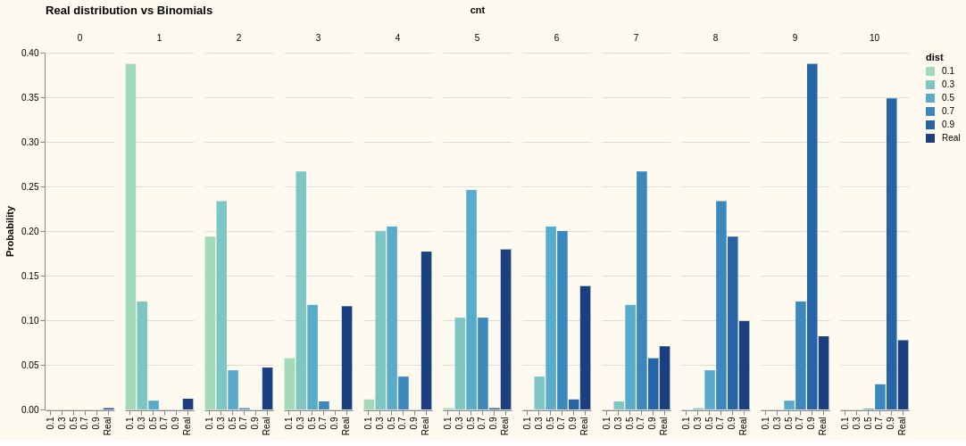
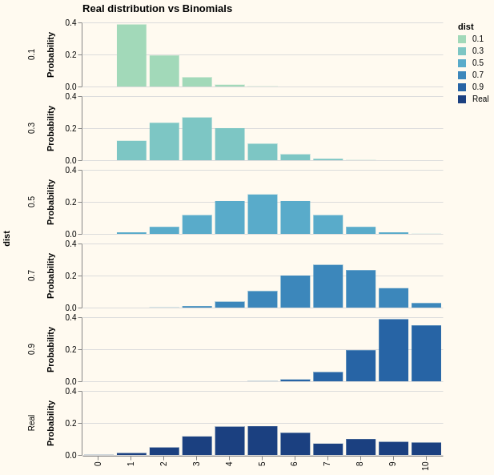
This is a nice example of how one visualization (the row grouping) can bring out the salient information so much better than another (the col grouping)

Lowess smoothing of Tn-Seq fitness data
The next is a visualization for an investigation into using lowess smoothing of Tn-Seq fitness data.
(hc/xform ht/layer-chart
:TITLE "Raw vs 1-4 lowess smoothing" :TOFFSET 5
:HEIGHT 500 :WIDTH 700
:DATA (concat base-xy lowess-1 lowess-2 lowess-3 lowess-4)
:LAYER (mapv #(hc/xform ht/gen-encode-layer
:MARK (if (= "NoL" %) "circle" "line")
:TRANSFORM [{:filter {:field "NM" :equal %}}]
:COLOR "NM"
:XTITLE "Position", :YTITLE "Count")
["NoL" "L1" "L2" "L3" "L4"]))
This one is interesting in that it combines some nice straight ahead Clojure data mapping with the template system. Here, we create five layers - but they are all different data sets and so VGL's repeat would not apply. But, Clojure's mapv combined with Hanami's xform does the trick. Of course, any number of layers could be so constructed.
{:title {:text "Raw vs 1-4 lowess smoothing", :offset 5},
:height 500,
:width 700,
:background "floralwhite",
:layer
[{:transform [{:filter {:field "NM", :equal "NoL"}}],
:mark "circle",
:encoding
{:x {:field "x", :type "quantitative", :axis {:title "Position"}},
:y {:field "y", :type "quantitative", :axis {:title "Count"}},
:color {:field "NM", :type "nominal"},
:tooltip
[{:field "x", :type "quantitative"}
{:field "y", :type "quantitative"}]}}
{:transform [{:filter {:field "NM", :equal "L1"}}],
:mark "line",
:encoding
{:x {:field "x", :type "quantitative", :axis {:title "Position"}},
:y {:field "y", :type "quantitative", :axis {:title "Count"}},
:color {:field "NM", :type "nominal"},
:tooltip
[{:field "x", :type "quantitative"}
{:field "y", :type "quantitative"}]}}
{:transform [{:filter {:field "NM", :equal "L2"}}],
:mark "line",
:encoding
{:x {:field "x", :type "quantitative", :axis {:title "Position"}},
:y {:field "y", :type "quantitative", :axis {:title "Count"}},
:color {:field "NM", :type "nominal"},
:tooltip
[{:field "x", :type "quantitative"}
{:field "y", :type "quantitative"}]}}
{:transform [{:filter {:field "NM", :equal "L3"}}],
:mark "line",
:encoding
{:x {:field "x", :type "quantitative", :axis {:title "Position"}},
:y {:field "y", :type "quantitative", :axis {:title "Count"}},
:color {:field "NM", :type "nominal"},
:tooltip
[{:field "x", :type "quantitative"}
{:field "y", :type "quantitative"}]}}
{:transform [{:filter {:field "NM", :equal "L4"}}],
:mark "line",
:encoding
{:x {:field "x", :type "quantitative", :axis {:title "Position"}},
:y {:field "y", :type "quantitative", :axis {:title "Count"}},
:color {:field "NM", :type "nominal"},
:tooltip
[{:field "x", :type "quantitative"}
{:field "y", :type "quantitative"}]}}],
:data {:values ...}
:config
{:bar {:binSpacing 1, :discreteBandSize 5, :continuousBandSize 5}}}
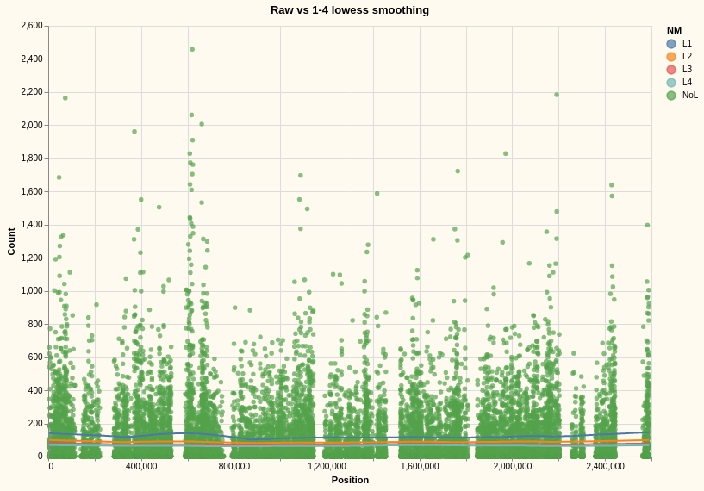

With Overview + Detail
We can do something more interesting here in this case, as we may want to get close ups of various sections of such a plot. Instead of looking at the entire genome, we can focus on chunks of it with selection brushes using an overlay+detail display:
(hc/xform ht/vconcat-chart
:TITLE "Raw vs 1-4 lowess smoothing" :TOFFSET 5
:DATA (concat base-xy lowess-1 lowess-2 lowess-3 lowess-4)
:VCONCAT [(hc/xform ht/layer-chart
:LAYER
(mapv #(hc/xform
ht/gen-encode-layer :WIDTH 1000
:MARK (if (= "NoL" %) "circle" "line")
:TRANSFORM [{:filter {:field "NM" :equal %}}]
:XSCALE {:domain {:selection "brush"}}
:COLOR "NM", :XTITLE "Position", :YTITLE "Count")
["NoL" "L1" "L2" "L3"]))
(hc/xform ht/gen-encode-layer
:MARK "circle"
:WIDTH 1000, :HEIGHT 60
:TRANSFORM [{:filter {:field "NM" :equal "NoL"}}]
:SELECTION {:brush {:type "interval", :encodings ["x"]}}
:COLOR "NM" :XTITLE "Position", :YTITLE "Count")])
Here are two snapshots of the resulting interactive visualization:
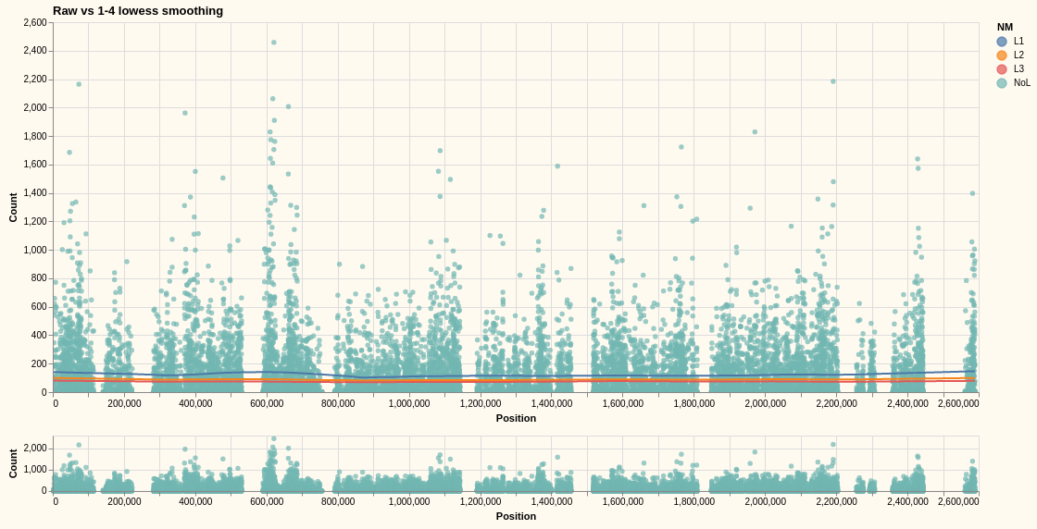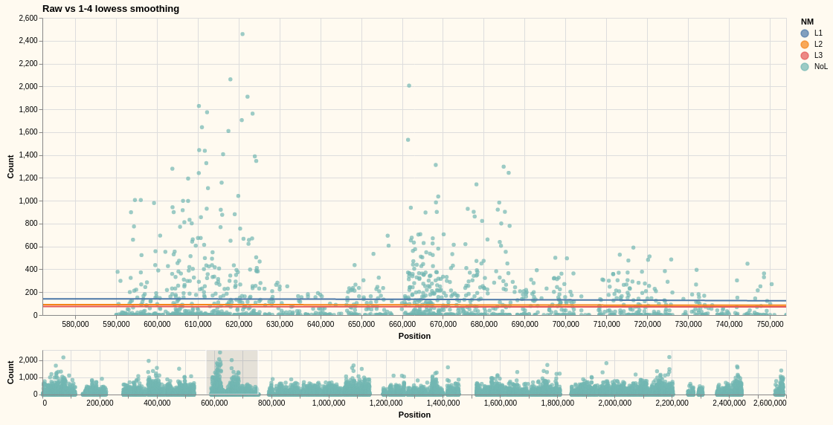

Interactive Cross plot Differential Gene Expression
And lastly a quite involved example from a real application for RNASeq Differential Gene Expression:
(let [data (->> DGE-data (filter #(-> "padj" % (<= 0.05))))
mdwn-brush (hc/xform ht/interval-brush-mdwn :MDWM-NAME "brush" :IRESOLVE "global")
color {:field "NM" :type "nominal" :scale {:range ["#e45756" "#54a24b" "#4c78a8"]}}
size {:condition {:selection {:not "brush"} :value 40} :value 400}
tooltip `[{:field "Gene", :type "nominal"} ~@ht/default-tooltip {:field "pvalue", :type "quantitative"}]]
(hc/xform
ht/hconcat-chart
:TITLE
"RNASeq Exp 180109_NS500751_0066 DGE for aT4-024V10min vs aT4-024V30min"
:TOFFSET 40
:DATA :data
:HCONCAT[(hc/xform
ht/point-chart
:TITLE "MA Plot"
:MSIZE 40
:SELECTION (merge (hc/xform ht/interval-scales :INAME "grid1")
mdwn-brush)
:X "baseMean", :Y "log2FoldChange"
:COLOR color, :SIZE size, :TOOLTIP tooltip)
(hc/xform
ht/point-chart
:TITLE "Volcano Plot"
:MSIZE 40
:SELECTION (merge (hc/xform ht/interval-scales :INAME "grid2")
mdwn-brush)
:X "log2FoldChange", :Y "-log10(pval)"
:COLOR color, :SIZE size :TOOLTIP tooltip)]))
Transforms to:
{:hconcat
[{:encoding
{:x {:field "baseMean", :type "quantitative"},
:y {:field "log2FoldChange", :type "quantitative"},
:color
{:field "NM",
:type "nominal",
:scale {:range ["#e45756" "#54a24b" "#4c78a8"]}},
:size
{:condition {:selection {:not "brush"}, :value 40}, :value 400},
:tooltip
[{:field "Gene", :type "Nominal"}
{:field "baseMean", :type "quantitative"}
{:field "log2FoldChange", :type "quantitative"}
{:field "pvalue", :type "quantitative"}]},
:mark {:type "circle", :size 40},
:width 450,
:background "floralwhite",
:title {:text "MA Plot"},
:selection
{"grid1"
{:type "interval",
:bind "scales",
:translate
"[mousedown[event.shiftKey], window:mouseup] > window:mousemove!",
:encodings ["x" "y"],
:zoom "wheel!",
:resolve "global"},
"brush"
{:type "interval",
:on
"[mousedown[!event.shiftKey], window:mouseup] > window:mousemove!",
:translate
"[mousedown[!event.shiftKey], window:mouseup] > window:mousemove",
:resolve "global",
:mark {:fill "#333", :fillOpacity 0.125, :stroke "white"}}},
:height 400}
{:encoding
{:x {:field "log2FoldChange", :type "quantitative"},
:y {:field "-log10(pval)", :type "quantitative"},
:color
{:field "NM",
:type "nominal",
:scale {:range ["#e45756" "#54a24b" "#4c78a8"]}},
:size
{:condition {:selection {:not "brush"}, :value 40}, :value 400},
:tooltip
[{:field "Gene", :type "Nominal"}
{:field "log2FoldChange", :type "quantitative"}
{:field "-log10(pval)", :type "quantitative"}
{:field "pvalue", :type "quantitative"}]},
:mark {:type "circle", :size 40},
:width 450,
:background "floralwhite",
:title {:text "Volcano Plot"},
:selection
{"grid2"
{:type "interval",
:bind "scales",
:translate
"[mousedown[event.shiftKey], window:mouseup] > window:mousemove!",
:encodings ["x" "y"],
:zoom "wheel!",
:resolve "global"},
"brush"
{:type "interval",
:on
"[mousedown[!event.shiftKey], window:mouseup] > window:mousemove!",
:translate
"[mousedown[!event.shiftKey], window:mouseup] > window:mousemove",
:resolve "global",
:mark {:fill "#333", :fillOpacity 0.125, :stroke "white"}}},
:height 400}],
:config
{:bar {:binSpacing 1, :discreteBandSize 5, :continuousBandSize 5}},
:width 450,
:background "floralwhite",
:title
{:text
"RNASeq Exp 180109_NS500751_0066 DGE for aT4-024V10min vs aT4-024V30min",
:offset 40},
:height 400,
:data {:values [... ]}}
Well, now that is quite a lot. When sent to a view, visualizes as follows. Note that this is a fully interactive visualization where each grid can be independently zoomed and panned and brush stroke highlighting in one view hightlights the covered points in the other view. Here the mouse is hovering over the upper left point in the volcano plot.


