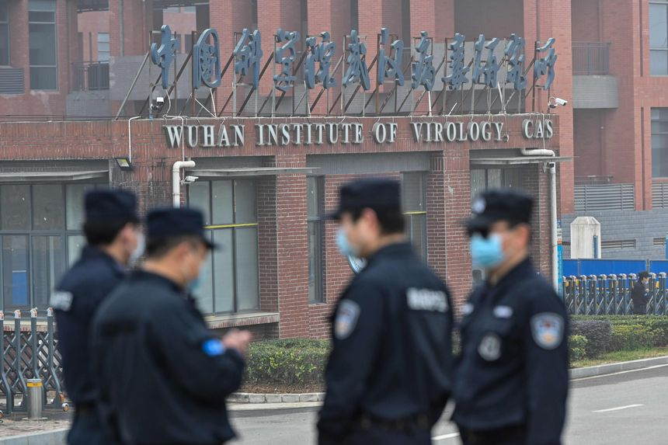
Common Sense Points to a Lab Leak
YOU MAY ALSO LIKE

WSJ Opinion: The Coronavirus 'Lab Leak' Origin Returns

WSJ Opinion: The Coronavirus 'Lab Leak' Origin Returns
Play video: WSJ Opinion: The Coronavirus 'Lab Leak' Origin Returns

Denials from authorities seemed political all along, and public trust will take a long time to recover.


By
Peggy Noonan

Security personnel stand guard outside the Wuhan Institute of Virology in Wuhan, China, Feb. 3, 2021.
PHOTO: HECTOR RETAMAL/AGENCE FRANCE-PRESSE/GETTY IMAGES

Government finagling and misdirecting, especially in crises, are destructive to the long-term public good. And in the end they’re always destructive to personal reputations.
The Journal last Sunday upended an old debate with a big exclusive: The Energy Department has told the White House it believes a lab leak was the most likely source of the Covid-19 pandemic. As reporters Michael R. Gordon and Warren P. Strobel noted, the department’s new stand is important because it results from new intelligence and because of the agency’s expertise—it oversees a network of labs. Two days later Christopher Wray, director of the Federal Bureau of Investigation, confirmed the FBI’s view that it was “most likely a potential lab incident . . . a potential leak from a Chinese government-controlled lab.”
News of the virus broke in January 2020, and almost from day one authorities seemed to steer the public away from the obvious. My own thinking was like that of most people: A new viral disease has broken out in Wuhan, China. It turns out China’s major viral laboratory is in . . . Wuhan. If the new virus has been found in the population just outside the lab, chances are good it escaped from it. It probably walked out on someone’s shoe.
Everything in your logic said this—common sense, Occam’s razor.

China denied it. The disease started with bats in caves, it was natural transmission, bats to humans. Or maybe it spread to humans at the crowded local wet market—raw foods, live animals, germs. You likely thought: That’s probably where it spread but not necessarily where it originated. You reserved judgment until the smoke clears.
But you respected your own thinking and it will have bothered you that month by month the highest scientific and medical authorities in the U.S. government seemed to be discouraging the conversation, or insistently directing it toward natural transmission. Anthony Fauci, we later found, dismissed the subject in internal emails a few months into the pandemic as a “shiny object that will go away.”
That was rather patronizing. People had a right to wonder and were wise to do so. The disease killed millions. It was a world-wide economic, societal and cultural disaster. Why it happened matters. Where and how it started matters. There could be another pandemic tomorrow. What steps must be taken to see that it doesn’t?
And there was a sense emanating from scientific and medical establishments that people who think it started in a Chinese lab think that only because they’re racist, they hate Asians, or because they’re conspiracists. At this you would have thought: No, buddy, I think it because I’m normal. Murphy’s Law. You have 1,000 safety protocols and one day you satisfy only 998 of them. That’s all you need for an accident.
And you likely thought something else: This isn’t politics to me, but I gather it’s politics to you. This began to poison things. Once lies and finagling walk out of the Lie and Finagle Lab, they contaminate everything.
Before the pandemic there had been U.S. State Department warnings of persistent concerns about safety procedures in China’s biological research labs. As Messrs. Gordon and Strobel report, the idea it escaped from a lab “has been fueled by U.S. intelligence that three researchers from the Wuhan Institute of Virology became sick enough in November 2019 that they sought hospital care.”
Why were so many others, not in the government but on social media and in the professions, so invested in the idea that the origin had nothing to do with a lab? Part of it was knee-jerk partisan thinking: Our political opposites think it happened in a Chinese lab because they’re xenophobic. Others were thinking diplomatically: Why increase tensions with China when there are already more than enough? Some were thinking practically: If China gets defensive, it’ll only withhold more data just when we need it most. Others appeared mysteriously uninterested in the lab-leak theory because, as we now know, there was something to hide: U.S. funding of the Wuhan lab. The National Institutes of Health admitted in October 2021 that it funded research on bat coronaviruses at the Wuhan Institute of Virology.
Some of that may have involved gain-of-function research, in which a pathogen is made more dangerous to develop future cures and treatments. At this point we should be admitting that it isn’t worth it. It’s tempting fate; it assumes constant perfection in obeying all safety protocols. That can’t be assumed with humans.
I suppose it should be noted here that the idea that China would deliberately weaponize and let loose the virus never passed any common-sense test. The Chinese government would develop a poison to deliberately sicken their own population, damage their own economy and ruin what remains of their international reputation in the hope it spreads beyond China and disrupts other nations too? Whatever Xi Jinping is, he’s not a fool. His government is one of ideologues and killers, not a suicide cult.
Dr. Fauci, who began the pandemic as a man of peerless professional stature, didn’t respond to the Energy Department report with an air of ingenuously embracing new data and opinion. He told the Boston Globe the report is interesting but we should “keep an open mind.” “We may never know” the origin of the outbreak. “I don’t see any data for a lab leak. That doesn’t mean it couldn’t have happened.” He noted, as he has in the past, that evolutionary virologists have in two peer-reviewed articles presented evidence that “rather strongly suggests it was a natural occurrence.”
The two most undermined words in the English language in the years since the pandemic are “peer reviewed.” Dr. Fauci struck me as a man who knows a few things about shiny objects himself.
We close with our usual advice to governments. They are full of people who don’t necessarily think honesty is the best policy but do think it’s a policy, one of many they might choose. They should always do so, but especially in crises they have to play it straight. What you don’t know, admit. No one knew, as the virus was breaking, its exact origin. China wouldn’t help.
Admit what you don’t know, make your best guesses, label them guesses, and don’t insist on your read, your version of reality.
There’s no safety in admitting what you don’t know. You’ll get clobbered. People want answers. “Why don’t they know?” “They probably do know and are afraid to say,” “I pay my taxes for this?”
But if you’re honest, the word of the government will not have been corrupted. And in time, with your undefended candor—“We don’t know but are trying hard to find out”—people will, almost perversely, come to see your good faith. They will see your discomfort. They will understand it is the discomfort of people trying to play it straight.
This is the Lincoln strategy: Forge ahead, be honest, let the entire country call you a loser for the first three years of your term, and in time, as you continue to operate within reality making sound decisions, and as things turn your way, as they will, it will get out there that you can be trusted.
Instead of the way it is now.

READ MORE DECLARATIONS
- Jimmy Carter’s ‘Malaise’ Speech Aged Well February 23, 2023
- America’s Longing for Authenticity February 16, 2023
- Biden’s Speech Was Trumpian February 9, 2023
By
Peggy Noonan

PRINT
TEXT
1,825

Security personnel stand guard outside the Wuhan Institute of Virology in Wuhan, China, Feb. 3, 2021.
PHOTO: HECTOR RETAMAL/AGENCE FRANCE-PRESSE/GETTY IMAGES

Listen to article
(7 minutes)
Length
Government finagling and misdirecting, especially in crises, are destructive to the long-term public good. And in the end they’re always destructive to personal reputations.
The Journal last Sunday upended an old debate with a big exclusive: The Energy Department has told the White House it believes a lab leak was the most likely source of the Covid-19 pandemic. As reporters Michael R. Gordon and Warren P. Strobel noted, the department’s new stand is important because it results from new intelligence and because of the agency’s expertise—it oversees a network of labs. Two days later Christopher Wray, director of the Federal Bureau of Investigation, confirmed the FBI’s view that it was “most likely a potential lab incident . . . a potential leak from a Chinese government-controlled lab.”
News of the virus broke in January 2020, and almost from day one authorities seemed to steer the public away from the obvious. My own thinking was like that of most people: A new viral disease has broken out in Wuhan, China. It turns out China’s major viral laboratory is in . . . Wuhan. If the new virus has been found in the population just outside the lab, chances are good it escaped from it. It probably walked out on someone’s shoe.
Everything in your logic said this—common sense, Occam’s razor.

China denied it. The disease started with bats in caves, it was natural transmission, bats to humans. Or maybe it spread to humans at the crowded local wet market—raw foods, live animals, germs. You likely thought: That’s probably where it spread but not necessarily where it originated. You reserved judgment until the smoke clears.

But you respected your own thinking and it will have bothered you that month by month the highest scientific and medical authorities in the U.S. government seemed to be discouraging the conversation, or insistently directing it toward natural transmission. Anthony Fauci, we later found, dismissed the subject in internal emails a few months into the pandemic as a “shiny object that will go away.”
That was rather patronizing. People had a right to wonder and were wise to do so. The disease killed millions. It was a world-wide economic, societal and cultural disaster. Why it happened matters. Where and how it started matters. There could be another pandemic tomorrow. What steps must be taken to see that it doesn’t?
And there was a sense emanating from scientific and medical establishments that people who think it started in a Chinese lab think that only because they’re racist, they hate Asians, or because they’re conspiracists. At this you would have thought: No, buddy, I think it because I’m normal. Murphy’s Law. You have 1,000 safety protocols and one day you satisfy only 998 of them. That’s all you need for an accident.
And you likely thought something else: This isn’t politics to me, but I gather it’s politics to you. This began to poison things. Once lies and finagling walk out of the Lie and Finagle Lab, they contaminate everything.
Before the pandemic there had been U.S. State Department warnings of persistent concerns about safety procedures in China’s biological research labs. As Messrs. Gordon and Strobel report, the idea it escaped from a lab “has been fueled by U.S. intelligence that three researchers from the Wuhan Institute of Virology became sick enough in November 2019 that they sought hospital care.”
Why were so many others, not in the government but on social media and in the professions, so invested in the idea that the origin had nothing to do with a lab? Part of it was knee-jerk partisan thinking: Our political opposites think it happened in a Chinese lab because they’re xenophobic. Others were thinking diplomatically: Why increase tensions with China when there are already more than enough? Some were thinking practically: If China gets defensive, it’ll only withhold more data just when we need it most. Others appeared mysteriously uninterested in the lab-leak theory because, as we now know, there was something to hide: U.S. funding of the Wuhan lab. The National Institutes of Health admitted in October 2021 that it funded research on bat coronaviruses at the Wuhan Institute of Virology.
Some of that may have involved gain-of-function research, in which a pathogen is made more dangerous to develop future cures and treatments. At this point we should be admitting that it isn’t worth it. It’s tempting fate; it assumes constant perfection in obeying all safety protocols. That can’t be assumed with humans.
I suppose it should be noted here that the idea that China would deliberately weaponize and let loose the virus never passed any common-sense test. The Chinese government would develop a poison to deliberately sicken their own population, damage their own economy and ruin what remains of their international reputation in the hope it spreads beyond China and disrupts other nations too? Whatever Xi Jinping is, he’s not a fool. His government is one of ideologues and killers, not a suicide cult.
Dr. Fauci, who began the pandemic as a man of peerless professional stature, didn’t respond to the Energy Department report with an air of ingenuously embracing new data and opinion. He told the Boston Globe the report is interesting but we should “keep an open mind.” “We may never know” the origin of the outbreak. “I don’t see any data for a lab leak. That doesn’t mean it couldn’t have happened.” He noted, as he has in the past, that evolutionary virologists have in two peer-reviewed articles presented evidence that “rather strongly suggests it was a natural occurrence.”
The two most undermined words in the English language in the years since the pandemic are “peer reviewed.” Dr. Fauci struck me as a man who knows a few things about shiny objects himself.

READ MORE DECLARATIONS
- Jimmy Carter’s ‘Malaise’ Speech Aged Well February 23, 2023
- America’s Longing for Authenticity February 16, 2023
- Biden’s Speech Was Trumpian February 9, 2023
We close with our usual advice to governments. They are full of people who don’t necessarily think honesty is the best policy but do think it’s a policy, one of many they might choose. They should always do so, but especially in crises they have to play it straight. What you don’t know, admit. No one knew, as the virus was breaking, its exact origin. China wouldn’t help.
Admit what you don’t know, make your best guesses, label them guesses, and don’t insist on your read, your version of reality.

There’s no safety in admitting what you don’t know. You’ll get clobbered. People want answers. “Why don’t they know?” “They probably do know and are afraid to say,” “I pay my taxes for this?”
But if you’re honest, the word of the government will not have been corrupted. And in time, with your undefended candor—“We don’t know but are trying hard to find out”—people will, almost perversely, come to see your good faith. They will see your discomfort. They will understand it is the discomfort of people trying to play it straight.
This is the Lincoln strategy: Forge ahead, be honest, let the entire country call you a loser for the first three years of your term, and in time, as you continue to operate within reality making sound decisions, and as things turn your way, as they will, it will get out there that you can be trusted.
Instead of the way it is now.

Copyright ©2022 Dow Jones & Company, Inc. All Rights Reserved. 87990cbe856818d5eddac44c7b1cdeb8
Appeared in the March 4, 2023, print edition.

HIDE CONVERSATION(1825)

