DeepSeek CEO Liang Wenfeng Interview (translated)
Hao Sheng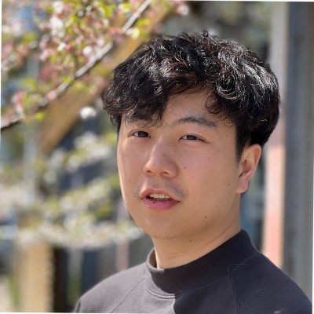

Hao Sheng

Building Chatsimple -- Human-Business Interface
Published Jan 27, 2025
+ Follow
[Author’s Note: The following article quotes and summarizes an interview originally published by 36Kr. For the full Chinese article, please visit 36Kr’s website. All credit goes to 36Kr for the original reporting and content.]
Below is an English translation of the interview, preserving its Q&A format and the speakers’ original meanings as closely as possible. The interviewer is referred to as “AnYong” and the founder of DeepSeek is Liang Wenfeng (梁文锋).

Interview

Q: Most Chinese companies want both the model and the application. Why is DeepSeek focusing solely on research for now?
Liang: Because we think the most important thing is to be part of this global wave of innovation. For many years, Chinese companies got used to letting others do the technical innovation while we brought it in and did the application work. But that’s not something we should take for granted. In this new wave, we’re not looking to make a quick profit; we want to get out in front of the technology and help drive the entire ecosystem forward.

Q: How was the first shot in the price war fired?
AnYong: After you released the DeepSeek V2 model, it quickly triggered a bloody price war among large-model providers. Some say you’re the “catfish” stirring up the industry.
Liang Wenfeng: We didn’t set out to be a catfish. It just happened by accident.

Q: Did you expect this outcome?
Liang: It was very unexpected. We had no idea that pricing would trigger such sensitivity. We were simply doing things at our own pace, then working out our costs to determine a fair price. Our principle is not to subsidize our service at a loss, but also not to charge exorbitant profits. The price is just slightly above our costs.

Q: Five days later, Zhipu AI followed suit, and then ByteDance, Alibaba, Baidu, Tencent, and other large players jumped in.
Liang: Zhipu AI only cut prices for an entry-level product. Their product that’s on par with ours is still quite expensive. ByteDance was the first to truly follow up. Their flagship model was brought down to our level, which then spurred the other big companies to slash their prices as well. Because the costs of running big-company models are much higher than ours, we didn’t expect anyone would actually lose money on purpose just to do this. But in the end, it turned into a typical “burn cash and subsidize” scenario from the internet era.

Q: From the outside, dropping prices often looks like a strategy to grab users, which is how internet-era price wars usually play out.
Liang: User acquisition wasn’t our main aim. On one hand, we lowered prices because the cost of our next-generation model structure had come down. On the other hand, we believe both APIs and AI should be affordable and accessible to everyone.

Q: Before this, most Chinese companies would directly copy the Llama structure to build applications. Why did you start by changing the model structure itself?
Liang: If your goal is purely to build an application, then reusing the Llama structure and quickly pushing out a product is a reasonable choice. But our goal is AGI, which means we need to develop new model structures that can achieve stronger capabilities on limited resources. That’s part of the fundamental research for scaling up to even larger models. Besides the model structure, we’ve done a lot of work on how to build datasets, how to make models more human-like, and so on. Those efforts are reflected in the models we’ve released. Also, from what we see, the Llama architecture is roughly two generations behind the cutting edge overseas in terms of training efficiency and inference cost.

Q: Where does that two-generation gap come from?
Liang: First, there’s a gap in training efficiency. We estimate that even the best domestic (Chinese) training is still about twice as inefficient compared to the best overseas in terms of both the model structure and training dynamics. Essentially, we need twice the compute power to reach the same performance. Then there’s another factor—data efficiency—where we likely also lag by a factor of two. That means we need double the data and double the compute just to match the same results. Put them together, and it could mean needing four times the resources overall. Our job is to keep narrowing these gaps.

Q: In the internet and mobile internet eras, the general perception was that the United States excels at technology innovation, while China is better at building applications.
Liang: We believe that as China’s economy continues to develop, we should gradually become a contributor rather than always being a free rider. In the last 30+ years of the IT wave, we didn’t genuinely participate in the core technological innovations. We got used to Moore’s Law “falling from the sky,” waiting 18 months for better hardware and software. People are now treating “Scaling Law” in the same way.
But in fact, these fundamental breakthroughs were generations in the making by a Western-led tech community, and we just weren’t part of that process, so we tended to ignore how it happened.

“The real gap isn’t a year or two; it’s the difference between originality and imitation.”

Q: Why did DeepSeek V2 surprise so many people in Silicon Valley?
Liang: Within the daily flow of innovation in the U.S., what we did is actually quite ordinary. They’re surprised because we’re a Chinese company stepping into their domain as an innovator, whereas most Chinese companies are used to simply following.

Q: In the Chinese context, though, it can look extravagant to put all your resources into pure research rather than commercialization. Large-model R&D is a high-investment undertaking, and not everyone has the capital to do it without a clear plan to monetize.
Liang: True, innovation isn’t cheap, and it’s understandable we used to rely on “borrowing” from others given China’s past conditions. But look at the size of our economy now, and the profits of big players like ByteDance or Tencent—they’re huge on the global stage. So money isn’t the real obstacle to innovation. What’s lacking is confidence and know-how in organizing high-density talent to innovate effectively.

Q: Why do Chinese companies—including those that aren’t short on money—still place rapid commercialization above everything else?
Liang: Because for the past 30 years, all we’ve emphasized is making money, and we tended to ignore innovation. But innovation isn’t purely commercial. It also stems from curiosity and creativity. We’ve been locked into this mentality by force of habit, but that’s just a phase.

Q: Still, you’re a commercial enterprise rather than a public research institute. You choose to innovate and then open-source it. How do you create a moat? For instance, the MLA architecture you launched in May could soon be copied by others, right?
Liang: In the face of disruptive technologies, a closed-source moat is short-lived. Even OpenAI, which is closed-source, can’t stop others from catching up. So we anchor our value in the team: as our people learn in this process, they accumulate know-how and form a culture and organization that can innovate. That’s our moat.
Open-sourcing and publishing papers doesn’t really cost us anything. For technical people, having others follow and adopt your work is a great sense of achievement. In essence, open source is a cultural act rather than a commercial one. Giving something away confers an additional honor. It also helps shape a company culture that’s attractive to talent.

Q: What’s your take on the market-first beliefs of investors like Zhu Xiaohu?
Liang: Zhu Xiaohu is consistent within his own framework, but it’s more fitting for companies looking for rapid returns. However, if you look at the most profitable U.S. companies, they are advanced tech companies built on long-term innovation.

Q: In big models, it’s hard to maintain an absolute edge based purely on technology. What bigger outcome are you betting on?
Liang: We think it’s impossible for Chinese AI to always remain in a follower’s position. People sometimes say that China is one or two years behind the U.S. in AI, but the real gap is originality vs. imitation. If that never changes, China will always trail. So some attempts to break ground are unavoidable.
NVIDIA’s lead wasn’t the result of just one company’s effort. It involved the entire Western tech community and industry. They saw the trend of the next generation of technology and had a roadmap in place. For China’s AI development, we also need such an ecosystem. Many domestic chip projects can’t get off the ground because there’s no supporting technology community—only second-hand information. Someone in China has to stand on the frontier of innovation.

“More funding doesn’t necessarily yield more innovation.”

Q: DeepSeek has a sort of early-OpenAI idealism about it, and you’re open-sourcing. Later on, will you choose to go closed-source? Both OpenAI and Mistral have switched from open to closed at various points.
Liang: We won’t go closed-source. We believe that first establishing a strong technology ecosystem is what truly matters.

Q: Do you have any fundraising plans? Some media reports mention that Huanfang (幻方) might spin off DeepSeek for an IPO. In Silicon Valley, AI startups often end up partnering or merging with major players.
Liang: In the short term, we have no plans to raise money. Our real bottleneck has never been funding; it’s the embargo on high-end chips.

Q: Some people argue that doing AGI is entirely different from doing quantitative finance. In quant, you can stay behind the scenes, but AGI might require a big push and alliances to expand resources.
Liang: More investment isn’t guaranteed to bring more innovation. Otherwise, the big tech companies would have scooped up all innovation already.

Q: You’re not developing applications now—do you lack the operational DNA to do so?
Liang: We believe the current period is about breakthroughs in technology, not an explosion in applications. Over the long run, we hope to build an ecosystem where the industry directly adopts our foundational models and research outputs. We’d be responsible for basic models and cutting-edge R&D, while other companies build B2B or B2C services on top of DeepSeek. If that complete industry chain takes shape, there’s no need for us to do the applications. Of course, if required, we have no problem building them, but R&D and innovation will always be our top priority.

Q: If a company wants an API, why pick DeepSeek over a tech giant?
Liang: The future is likely to be a world of specialized divisions of labor. Building a foundational model demands ongoing innovation. Big companies each have their own boundaries and may not be the best fit.

Q: But can technology alone create a real gap? You mentioned there’s no such thing as a permanent “technical secret.”
Liang: Technology has no true secrets, but rebuilding it still requires time and resources. In theory, there’s no technical secret to NVIDIA’s GPUs, but reassembling the people and knowledge to replicate them, and then catching up to the next generation, demands a lot of time. So there’s still a substantial moat in practice.

Recommended by LinkedIn
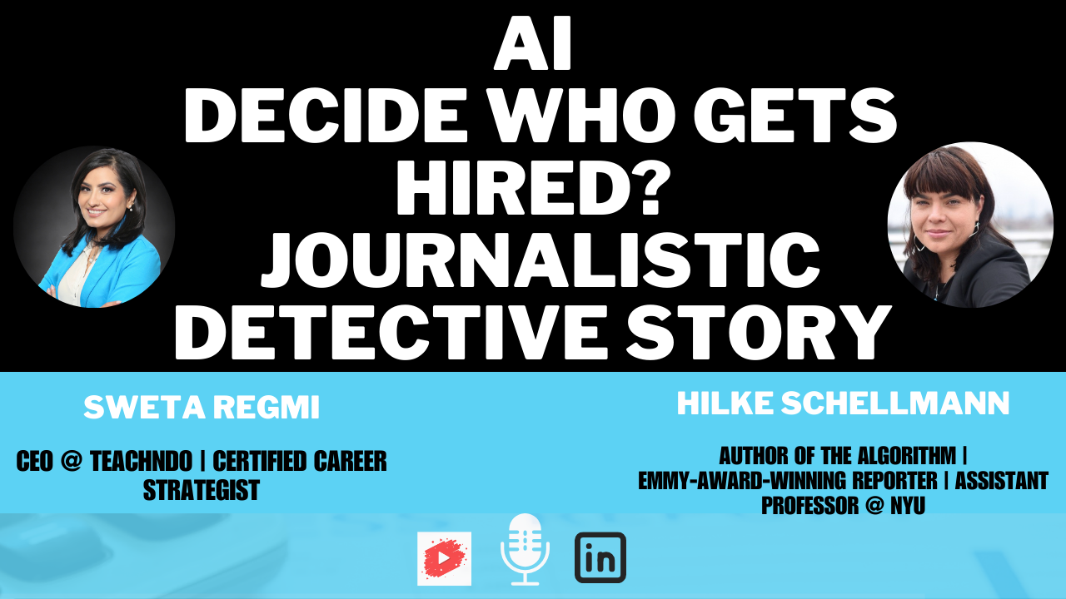
How AI Decides Who Gets Hired- Emmy award-winning…
Sweta Regmi 1 year ago

The Employment Edge #004 ChatGPT: Your Job Search Ally
Samantha B. 1 year ago

"Reverse Backstabbing"
Avi Z Liran, CSP, Author, Global Leadership EX Speaker 1 year ago

Q: After your price cut, ByteDance quickly matched, indicating they felt threatened. Do you see any new ways for startups to compete with large enterprises?
Liang: To be honest, we don’t really care much about it; we just did it along the way. Providing cloud services isn’t our main objective. Our goal is still AGI.
So far, I haven’t seen a “new” way, nor do I think big companies have a decisive advantage. They have existing user bases, but they also have cash-cow businesses that can become a burden if a disruptive shift happens.

Q: What do you think will happen with the other six large-model startups besides DeepSeek?
Liang: Two or three might survive. Right now, they’re all burning money. Those with a clear self-positioning and refined operations have a better chance. Some might transform drastically. Valuable assets won’t just vanish, but may reappear in a different form.

Q: Back at Huanfang (your previous venture), your stance on competition was described as “doing your own thing,” not paying much attention to comparisons with others. What’s your core view on competition?
Liang: I often think about whether a certain effort increases society’s overall efficiency, and whether you can find a place in the chain of division of labor that suits your strengths. As long as the endgame is higher social efficiency, it’s valid. There’s a lot of transient stuff in the middle—if you focus on it too much, you lose sight of the bigger picture.

“A group of young people doing ‘mysterious’ work.”

Q: Jack Clark (OpenAI’s former policy director and Anthropic co-founder) says that DeepSeek has hired “a group of enigmatically brilliant people.” Who exactly built DeepSeek V2?
Liang: There’s nothing particularly mysterious about them. They’re mostly fresh graduates from top universities, some PhD candidates in their fourth or fifth year who haven’t finished, plus a few who graduated just a few years ago.

Q: Many large-model companies strive to recruit overseas experts. Some believe the world’s top 50 AI minds aren’t employed by Chinese firms. Where does your team come from?
Liang: Nobody on the V2 model team was recruited from abroad; they’re all local. Maybe those top 50 experts aren’t here, but perhaps we can cultivate that level of talent ourselves.

Q: How did the MLA innovation come about? I heard the original idea came from a young researcher’s personal curiosity.
Liang: After observing some mainstream patterns in the evolution of Attention-based architectures, he had the sudden idea of designing an alternative. But it took a long path to go from “idea” to “implementation.” We assembled a team, and it took several months to make it work.

Q: That sort of spontaneous inspiration ties in with your fully innovation-driven structure. Back at Huanfang, you already used very little top-down management. But with AGI, which is so uncertain, have you added more direct management?
Liang: At DeepSeek, it’s still almost entirely bottom-up. We rarely assign tasks in advance; the division of labor emerges naturally. Everyone comes with unique experiences and their own ideas, so there’s no need to “push” them. If someone hits a snag, they’ll go grab others to talk it through. But once an idea shows real promise, of course we’ll coordinate resources from the top down.

Q: I’ve heard DeepSeek is very flexible in allocating GPUs and personnel.
Liang: There’s effectively no limit on how many GPU resources each person can request. If they have a good idea, they can use the training cluster freely without special approval. And because there are no hierarchical departments or layers, they can pull in anyone else who’s interested.

Q: This looser management style also means you’re good at finding people with strong intrinsic motivation. I’ve heard you spot them in unusual ways, so people who excel on nontraditional metrics can stand out.
Liang: Our single most important hiring criterion is genuine curiosity and passion. So we end up with people who have all sorts of intriguing backgrounds. They’re motivated far more by research than by money.

Q: The Transformer originated from Google’s AI Lab, and ChatGPT from OpenAI. How do you see the difference in innovation potential between a major company’s AI lab and a startup?
Liang: Google’s AI Lab, OpenAI, and even big Chinese tech AI labs all have real value. It’s somewhat a historical coincidence that OpenAI put out ChatGPT first.

Q: So is innovation also partly about serendipity? I noticed your office space has a row of meeting rooms with doors on both sides that people can open at will. Your colleagues say it’s designed to facilitate chance encounters. Transformer itself was famously born from people overhearing a conversation and joining in.
Liang: I believe the foundation of innovation is faith—faith that you can do it. Why is Silicon Valley so innovative? They dare to try. When ChatGPT first launched, the general sentiment in China—from investors to major tech firms—was that the gap was too big, so better to focus on applications. But innovation requires self-confidence. And that tends to be stronger in younger people.

Q: You aren’t raising funds or speaking publicly much, so your social profile is lower than many AI startups. How do you make sure DeepSeek is the first choice for top talent in large models?
Liang: Because we’re tackling the hardest problems. That’s the biggest magnet for top-tier talent—solving the toughest challenges. In China, top tech talent is sometimes undervalued because there aren’t enough hardcore innovation projects for them to shine. Since we’re tackling the hardest tasks, they want to join us.

Q: OpenAI’s latest event didn’t deliver GPT-5, and many people sense the technology curve is slowing down. There’s also rising skepticism about the “scaling law.” What’s your view?
Liang: We’re rather optimistic. Overall, the industry is progressing as expected. OpenAI isn’t some all-powerful entity that can always be out front.

Q: How long until AGI, in your view? Before releasing DeepSeek V2, you had code-generation and math models, and you switched from dense models to MoE. So what’s your roadmap?
Liang: It could be two years, five years, or ten years—but definitely within our lifetime. Even inside DeepSeek, we don’t have a single unified roadmap. But we do bet on three directions: (1) math and code, (2) multimodal, and (3) natural language itself. Math and code, like Go, form a closed and testable system that could reach high intelligence through self-learning. On the other hand, perhaps multi-modal learning from the real human world is also necessary for AGI. We keep an open mind.

Q: What do you see as the endgame for large models?
Liang: We’ll probably see specialized companies providing foundational models and services, and an extended chain of specialized roles. Others will build on top of them to serve the diverse needs of society.

“All the old ‘playbooks’ belong to the previous era.”

Q: Over the past year, China’s large-model startups have seen lots of changes. Wang Huiwen withdrew halfway, and new entrants have started to differentiate themselves.
Liang: Wang Huiwen bore all the losses personally so that others could walk away unscathed. It was tough on him personally, but best for everyone else—a very honorable move, which I respect a lot.

Q: Where do you spend most of your energy these days?
Liang: Mainly on researching the next generation of large models. There are still many unsolved problems.

Q: Other large-model startups want both technology and commercialization, since you can’t hold a tech lead forever, and they want to capitalize quickly. Is DeepSeek staying purely in model research because your model still isn’t strong enough for applications?
Liang: All those conventional methods belong to the previous generation, and they may not hold in the future. Trying to apply the internet-era business logic to AI’s future monetization is like comparing Pony Ma’s early startup phase to General Electric or Coca-Cola. It may be a futile exercise.

Q: Huanfang had a strong technological, innovative core and grew quite smoothly, which might explain your optimism?
Liang: Huanfang’s story strengthened our faith in technology-driven innovation, but it wasn’t all smooth sailing. We went through a long accumulation process. Outsiders only saw Huanfang after 2015, but we’d actually been doing it for 16 years by then.

Q: About original innovation: the economy is slowing, capital is cooling. Could that dampen original innovation?
Liang: I don’t think so. The restructuring of China’s industries requires hardcore technological breakthroughs. When people realize that making easy money was partly a matter of historical luck, they become more willing to roll up their sleeves and do real innovation.

Q: So you’re optimistic?
Liang: I’m from an 80s generation in a fifth-tier city in Guangdong. My father was a primary school teacher. In the 90s, there were tons of ways to make a quick buck in Guangdong, and many parents told him that studying was useless. But if you look back now, mindsets have changed drastically. Making quick money isn’t so easy anymore; you can’t even be sure there’s a taxi to drive. A single generation can change so much.

(End of Interview)
Like
Comment
Share
57634 Comments

Charles Chang
4d
Thanks for sharing Hao Sheng
Like
Reply
1 Reaction
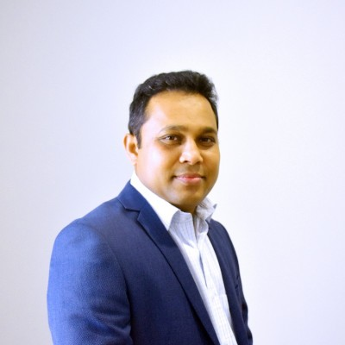
Janaka Dissanayake
4d
Liang Wenfeng’s vision for Deepseek highlights the transformative power of AI when combined with a strong ethical foundation. It’s refreshing to see leaders prioritizing not just innovation, but also the responsibility that comes with developing cutting-edge technologies. Deepseek’s focus on data quality and global collaboration is a reminder that the future of AI lies in balancing progress with purpose. Excited to see where this journey takes them!
Like
Reply
1 Reaction

Jatin Pawar
Ai for Impact | Master of Entrepreneurship and Innovation | Australian Awards Scholar | XR Dev
5d
This is pure gold. Thanks for sharing Hao I love this para the most "Liang: Within the daily flow of innovation in the U.S., what we did is actually quite ordinary. They’re surprised because we’re a Chinese company stepping into their domain as an innovator, whereas most Chinese companies are used to simply following."
Like
Reply
1 Reaction
Victor Gaspar
Chief Sales Officer
5d
Thanks for sharing!
Like
Reply
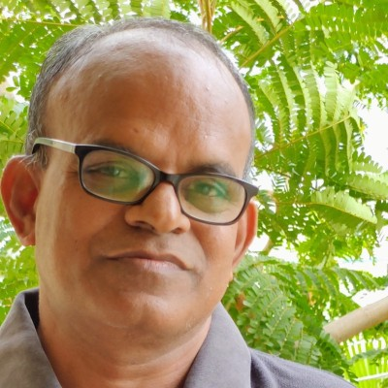
Baskar Perumal
SME IPO | Startup Fundraising | Author | Building Startup Ecosystem & Beyond
5d
Holding disruptive technologies, a privilege of a closed group. Thanks Hao Sheng for enabling everyone to cross the moat!

