How Love Changes Your Brain
In her new book, Stephanie Cacioppo, a neuroscientist, delves into romance, loss and human connection as she writes of her love story with her husband.
- Give this article
- 148
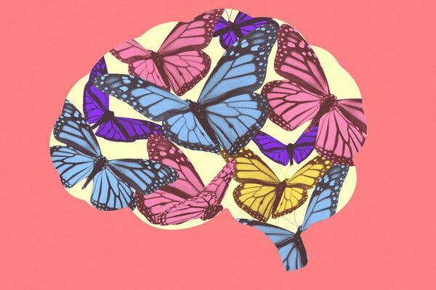
Yang Kim
Credit...
By Hope Reese
Leer en español

Can we do without love? For many years, the neuroscientist Stephanie Ortigue believed that the answer was yes. Even though she researched the science of human connections, Dr. Ortigue — an only child and, in her 20s and 30s, contentedly single — couldn’t completely grasp its importance in her own life.
“I told myself that being unattached made me a more objective researcher: I could investigate love without being under its spell,” she writes in her new book, “Wired for Love: A Neuroscientist’s Journey Through Romance, Loss and the Essence of Human Connection.”
But then, in 2011, at age 37, she met John Cacioppo at a neuroscience conference in Shanghai. Dr. Cacioppo, who popularized the concept that prolonged loneliness can be as toxic to health as smoking, intrigued her. The two scientists fell hard for each other and married. She took his last name and they soon became colleagues at the University of Chicago’s Pritzker School of Medicine (where she now directs the Brain Dynamics Laboratory) — forming a team at home and in the lab.
“Wired for Love” is the neurobiological story of how love rewires the brain. It’s also a personal love story — one that took a sad turn when John died of cancer in March 2018. Here, Dr. Cacioppo discusses what exactly love does to the brain, how to fight loneliness and how love is, literally, a product of the imagination.
Questions and answers have been edited and condensed for clarity.
You went from being happily single, to coupled, to then losing your husband. How did meeting him bring your research on love to life?

When we first met, we spoke for three hours, but I couldn’t feel time go by. I felt euphoria — from the rush of dopamine. I blushed — a sign of adrenaline. We became closer, physically, and started imitating each other. This was from the activation of mirror neurons, a network of brain cells that are activated when you move or feel something, and when you see another person moving. When you have a strong connection with someone, the mirror neuron system is boosted.
We quickly became “we.” When John was sick, I went to his radiation treatments. We shared a hospital bed. We were always together.
What exactly happens to the brain when we are in love?
When we’re falling in love with someone, the first thing we notice is how good it feels. It’s because the brain releases feel-good neurotransmitters that boost our mood. When we find love, it is like biological fireworks. Our heart rate is elevated, our levels of the so-called love hormone oxytocin are rising, which makes us feel connected. Our levels of the hormone and neurotransmitter norepinephrine are spiking, which makes us lose track of time; our levels of adrenaline rise, which expands the capillaries in our cheeks and makes us flush.
Meanwhile, our levels of serotonin, a key hormone in regulating appetite and intrusive anxious thoughts, fall down. So when we are in love we might find ourselves eating irregularly or fixating on small details, worrying about sending “the perfect text,” “saying the perfect words” and then replaying the text or the phone call over and over again in our head.
Then, when we start feeling a deep sense of calm and contentment with our partner, brain areas are activated that trigger not just basic emotions, but also more complex cognitive functions. This can lead to several positive results, like pain suppression, more compassion, better memory and greater creativity. Romantic love feels like a superpower that makes the brain thrive.
Is love necessary for survival?
Love is a biological necessity, just like water or exercise or food. My research has convinced me that a healthy love life — which could include your beloved partner, your closest circle of friends, your family and even your favorite sports team — is as essential to a person’s well-being as a good diet.
Love — in the holistic, expansive way I am now conceiving of the term — is the opposite of loneliness. When we look at the absence of positive and healthy relationships, we see a cascade of physical and mental disadvantages — from depression to high blood pressure to diabetes to sleep fragmentation.
If you don’t feel that you have a meaningful relationship, it’s as if you are socially thirsty, and your brain sends a signal to tell you that you need to help your social body. Some of the same alarms activated when people are thirsty are activated when people feel socially disconnected from others. The key is not to suppress these feelings. They are meant to help us survive; we are meant to do something about it.
But isn’t there still a stigma in admitting that we’re lonely?
No one feels guilty when they are thirsty, right? So no one should feel guilty when they are lonely.
There is a paradox in loneliness; we want to approach others, but the lonely mind has been lonely for so long that it detects more threats — inaccurately, of course — and makes you want to withdraw rather than approach others.
What advice do you have for those who struggle to find love or connect with others?
Love doesn’t have to be with a living person. If you are really in love with life, with your passion, with your hobby, it can also be a buffer against loneliness.
How can we help those we care about but who are isolated?
For years, people have thought that to help people who are lonely, you have to put them together. But the worst thing you can do for a lonely person is try to help them without asking them for help in return — a concept based on mutual aid and protection. Instead, we need to help them have a new sense of worth. We can ask them for their advice. Being shown respect, being depended upon, being made to understand your own importance — all these things can give a lonely person a sense of worth and belonging that decreases feelings of isolation.
Does long-distance love, love after a breakup or love for someone who has died affect the brain similarly?
Yes, you can stay connected with others even if you are physically alone in a room.
Close your eyes right now and think about the person you love the most. Now, think about the last time you made them laugh out loud. Does that bring a smile to your face? We store these positive memories in our mind, and we can access them any time. We have the remote control.

ADVERTISEMENT
Continue reading the main story

