Do I need another objective?

#1 by Free2Fish » Fri Mar 22, 2024 8:26 pm
I've got a Nikon Eclipse E400 microscope set up for DIC and I enjoy exploring the microscopic world, wherever that will take me. What I enjoy most is taking pictures of the various protists, both plant-like and animal-like. The objectives I use the most are:
Nikon CFI Plan Fluor 40X/0.75
Nikon CFI Plan 50X/0.90 oil
Nikon CFI Plan Apo 100X/1.40 oil
I have the C-CU universal condenser with the dry .90 NA lens and the proper prisms for the 40X and 100X. The 50X works OK with the 40X prism.
Lets get the obvious out of the way, of course I need another objective.
So I'd like to tap into the collective wisdom of this forum to get some ideas about what it should be. There is also the issue of cost, I don't want to empty my bank account in the pursuit of excellence.
I've been thinking about a 60X Plan Fluor dry but haven't seen much in the way of prisms.
Harry
Top
Quote
Post
zzffnn
Posts: 3199
Joined: Sat Jun 20, 2015 3:57 am
Location: Houston, Texas, USA
Contact:

Re: Do I need another objective?

#2 by zzffnn » Fri Mar 22, 2024 10:27 pm
Harry, I cannot speak for you, but I would be quite satisfied with what you already have there.
If I have to get one, I may get a water immersion 60x -100x objective, which I believe is made by BestScope for Nikon CFI series, member apochronaut may be able to tell you which one to get. Big brand modern infinity water objectives would cost easily $1000, if not several thousands. You 100x oil NA 1.4 is not that easy to work with water samples, though your 50x 0.9 oil should work quite well water samples.
Or you may get a 100x NA 1.25 oil objective that matches the prism, if you use that magnification quite a bit (I personally do, though everyone is different).
For lower magnifications at 20x objective and less, I personally prefer (easily implemented) DIY oblique and darkfield, over DIC. So I would not care to have DIC there. Maybe add a 20x, if you have to add one, but I would personally add a water 100x first; though again I cannot speak for your needs and preferences.
A 60x dry objective would not be easy to use with water samples, but you may be able to get used to it.
Top
Contact zzffnn
Quote
Post
Scarodactyl
Posts: 2773
Joined: Sat Mar 03, 2018 9:09 pm

Re: Do I need another objective?

#3 by Scarodactyl » Fri Mar 22, 2024 10:42 pm
First things first, get a cheap 20x/0.75 apo. Make sure it is the labeled one. It's an incredible objective and absurdly cheap because they were widely used in gene sequencers. The 20x fluor slider works pretty well with it.
Edit: currently the price is a bit higher, the last glut was a while back. Keep an eye out though, even at 3-400 it is a steal but they often go lower.
Top
Quote
Post
apochronaut
Posts: 6268
Joined: Fri May 15, 2015 12:15 am

Re: Do I need another objective?

#4 by apochronaut » Sat Mar 23, 2024 1:19 am
An option is always a pair of 12.5X or 15X eyepieces. Both , if designed as proper extensions of the system you have, will provide quality imaging and a larger image circle at any given magnification than a 10X eyepiece will provide, as long as the N.A. of the objective is high enough. Drop the decimal point in the N.A. , and if the N.A. is then more than 1.5X that of the magnification of the objective, you are good to go with 15X eyepieces. Yours are definitely high enough except perhaps the 100X but once you have the eyepieces, see what happens. I use 1.40 N.A. apochromats at 1500X all the time and the resolution loss is minimal with an apo. Not the case with an achro. There are good neutral , surgical 12.5X eyepieces available that will work with the Nikon infinity optics but I don't think Nikon ever made any for their E series microscopes.
Pros.
Not expensive compared to a single highly colour corrected objective.
They work with any objective, so one pair can provide intermediate magnifications for as many objectives as they are fully compatible with.
They provide quality imaging characteristic of the objective, if the N.A. of the objective X 100 is greater than 1.5X the magnification of the objective.
They provide more working distance at any given magnification than when a 10X eyepiece is used.
They usually provide a wider field of view than a 10X eyepiece in the same family provides at any given magnification. Typically 20% more is common.
Sometimes unbranded or those of other brands will work as well. Verification of that fom a trusted source is required.
Cons.
Slightly less eye relief at any given magnification than a 10X eyepiece provides.
They work best with highly colour corrected objectives and those of higher N.A.
Sometimes hard to find the right ones.
Sometimes a slight loss of contrast when compared to the same magnification obtained with 10X eyepieces.
Sometimes hard to find. Not all mfg. have made them for any given objective family.
With certain objectives that have sub par performance anyway, there will be a drop in resolution.
Top
Quote
Post
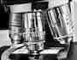RafaelML
Posts: 21
Joined: Mon May 30, 2016 5:25 am
Location: Málaga -Spain-
Contact:

Re: Do I need another objective?

#5 by RafaelML » Sat Mar 23, 2024 7:13 am
Nikon didn't design a prism for PlanFluor 60x.
My experience with 60X Plan Fluor dry and its prism: I use PF/PA 100 oil or PA 60x oil, and it works and the results are great.
But to observe protists I think the best is 60x Plan Apo WI, but i''s difficult to find it at a suitable price.
ATTACHMENTS
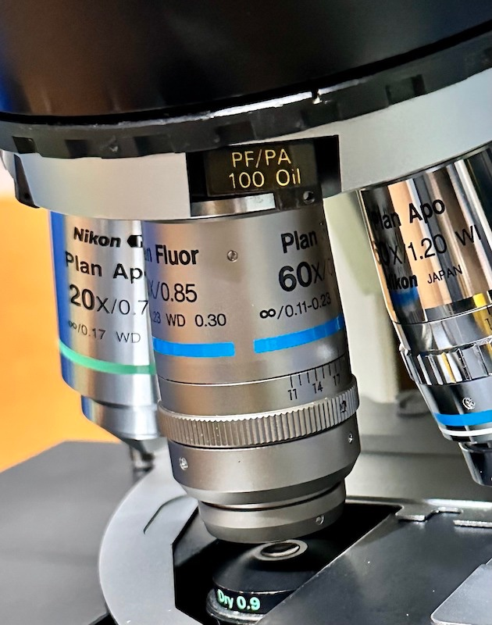
Plan fluor 60x .jpg (156.38 KiB) Viewed 935 times
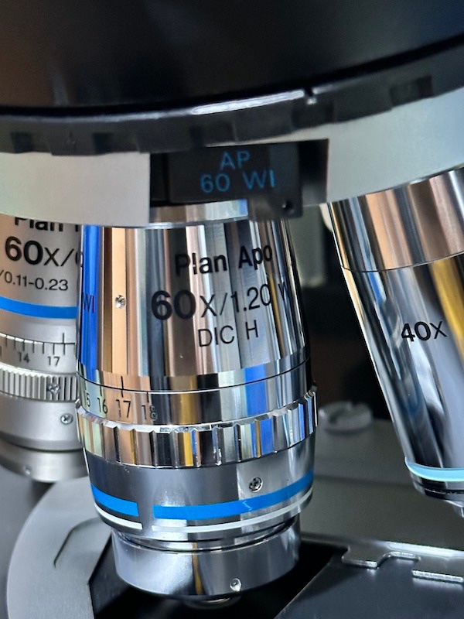
Plan apo 60x wi.jpg (146.46 KiB) Viewed 935 times
Nikon E600 and E400 Motic SMZ-168TL
Canon EOS 80D
https://twitter.com/rmartinledo
Top
Contact RafaelML
Quote
Post
Free2Fish
Posts: 65
Joined: Wed Feb 06, 2019 11:38 pm
Location: La Salle, Manitoba, Canada
Contact:

Re: Do I need another objective?

#6 by Free2Fish » Sat Mar 23, 2024 10:28 am
Thanks so much for the suggestions and information, this is exactly what I was looking for. You’ve given me much to ponder!
I should also have mentioned I’ve got a 20X 0.50 plan Fluor, 10X 0.30 plan flour and a 4X 0.10 plan finder objective, along with the slider prisms for the 10X and 20X. I’m quite satisfied with these objectives and see little need to augment what I have.
Zzffnn, I’m definitely happy with what I have and would likely be content exploring water droplets for many years with the equipment I have. I must say though there is high appeal to your suggestion of water immersion objectives. I had looked at them before but the high price scared me away. An affordable DIC WI option, say under or around $1000, would certainly be attractive since it would eliminate many of the problems of using oil objectives with wet mounts. I have been able to overcome some of these challenges but that may be better explained in a different thread.
Scarodactyl, I understand there may be a significant improvement in resolution in moving from the 20X plan Fluor to the plan apo but it is an objective I seldom spend much time with unless I’m viewing a larger specimen. Right now at least, I’m drawn to the smaller specimens.
apochronaut, I have considered 15X eyepieces and will continue to think about getting a pair should I find them for a reasonable cost. Thanks for the thorough presentation of pros and cons.
RaphaelML, it’s interesting you mention the PF/PA 100 oil slider prism works well with the plan Fluor 60X dry. I had read elsewhere that combination produced noticeable banding. I wonder if there is enough variability in these prisms to produce these different results. The fact that you get good results certainly puts the 60X dry plan Fluor or plan apo back into consideration for me.
I would like to thank everyone who responded again…some great information and thoughtful opinions here. I suspect a dry or WI 60X and/or some 15X eyepieces are in my future.
Harry
Top
Contact Free2Fish
Quote
Post
zzffnn
Posts: 3199
Joined: Sat Jun 20, 2015 3:57 am
Location: Houston, Texas, USA
Contact:

Re: Do I need another objective?

#7 by zzffnn » Sun Mar 24, 2024 4:27 am
Harry, you may ask Apochronaut about suitable WI objectives. I think the maker is BestScope (CFI60 standard?). It would obviously be a mismatch for your system, but if you can return it with minimal loss, then it may he appealing.
Another way is to find an authentic Nikon WI from your local university surplus sales / auctions. But your chance of finding the right objectives are not high; such search is not fun either.
Top
Contact zzffnn
Quote
Post
PeteM
Posts: 2981
Joined: Tue Dec 06, 2016 6:22 am
Location: N. California

Re: Do I need another objective?

#8 by PeteM » Sun Mar 24, 2024 4:41 pm
I can share a bit of personal experience with Nikon DIC prisms and the 60x Pl Fluor dry objective. This is the 0.85 n.a. version with 0.30 working distance and a .11 to .23 correction collar.
Both the PF60A and PA/PF100 prisms yield a banded background on my first-generation (E600, since ported to an 80i) system with L-M-H prisms in the condenser. There's a good DIC effect in the central area, but too uneven a background IMO.
I've also had some success with four other turret-side prisms: FL 40W, FL 60W, PF ELWD 40, and PF40 prisms. The PF40 gives DIC with the H condenser prism, but soft banding. The PF ELWD 40x gives a usable DIC effect on the M and H prisms, but not properly dark. The FL 40W is good on the M condenser prism, but not fully dark. It's OK-ish on the H prism. The FL 60W provides a pretty even and dark DIC on the H prism and is sort of OK on the M prism. The PF ELWD 40x gives a usable DIC effect on M and H condenser prisms. None of these (six total) prisms are what I'd consider ideal, but all could be usable with the right specimen (ideally one of tissue, so banding isn't seen so prominently). Note also, that these are visual observations. Banding will likely look worse in photos with clear backgrounds. A nice high-contrast effect with the wrong prism might have too great a DIC shear (by using lower-resolution prisms) and obscure some details.
I've heard (from Stephen, on this site) that the PF ELWD 60x is about as good as it gets for this objective and expect to have one fairly soon.
As others have suggested, I don't think the short working distance and fussy cover slip corrections of the Nikon 60x dry objective make it all that good for viewing protists under a cover slip.
I've just put one of those Bestscope NIS60 objectives (200mm reference tube, 60mm parfocal) 100x water immersion objectives on order - but with as much as a 30- 60 day delay per Alibaba. It has a 1.1 numerical aperture and should be good for peering a bit deeper under a cover slip. However, it's just a plan achro and might disappoint. I'll also have to see if there is a Nikon DIC prism that matches up reasonably well.
Some months from now I can likely update this.
Top
Quote
Post
apochronaut
Posts: 6268
Joined: Fri May 15, 2015 12:15 am

Re: Do I need another objective?

#9 by apochronaut » Sun Mar 24, 2024 5:57 pm
I could have sold you one cheaper and had it there in 10 days, Pete.
Top
Quote
Post
Free2Fish
Posts: 65
Joined: Wed Feb 06, 2019 11:38 pm
Location: La Salle, Manitoba, Canada
Contact:

Re: Do I need another objective?

#10 by Free2Fish » Sun Mar 24, 2024 6:34 pm
ZZffnn, it looks like the only immersion objective available from BestScope is a 100X and that magnification is not a present priority, although to may have later appeal. And yes, I watch local government and university surplus sale sites but have never found anything that was useful to me.
Pete, thanks for that information, it certainly adds to the particulars provided in this thread. I'll be very interested in your opinion of the immersion objective once you've had a chance to get it wet.
As an aside, I had decided yesterday to buy a Nikon CFI plan fluor 60X dry that I had been watching for some time but it had already sold a short time earlier. Still trying to figure out if that was bad or fortuitous timing.
Harry
Top
Contact Free2Fish
Quote
Post
PeteM
Posts: 2981
Joined: Tue Dec 06, 2016 6:22 am
Location: N. California

Re: Do I need another objective?

#11 by PeteM » Sun Mar 24, 2024 7:04 pm
Harry, Can you share your experience with the 50x Plan oil 0.90 an objective? The minus, for protists under a cover slip, is the oil immersion atop the cover slip. Perhaps there's a simple way to fix the slip in place. The pluses are likely the .30 or so working distance, a decent DIC prism match, the relatively high numerical aperture, and also the ability to do darkfield.
Top
Quote
Post
PeteM
Posts: 2981
Joined: Tue Dec 06, 2016 6:22 am
Location: N. California

Re: Do I need another objective?

#12 by PeteM » Sun Mar 24, 2024 7:06 pm
apochronaut wrote: ↑
Sun Mar 24, 2024 5:57 pm
I could have sold you one cheaper and had it there in 10 days, Pete.
Dang. Should have asked if you had spares.
Top
Quote
Post
Free2Fish
Posts: 65
Joined: Wed Feb 06, 2019 11:38 pm
Location: La Salle, Manitoba, Canada
Contact:

Re: Do I need another objective?

#13 by Free2Fish » Sun Mar 24, 2024 7:34 pm
PeteM wrote: ↑
Sun Mar 24, 2024 7:04 pm
Harry, Can you share your experience with the 50x Plan oil 0.90 an objective? The minus, for protists under a cover slip, is the oil immersion atop the cover slip. Perhaps there's a simple way to fix the slip in place. The pluses are likely the .30 or so working distance, a decent DIC prism match, the relatively high numerical aperture, and also the ability to do darkfield.
The resolution seems very close to what I'm getting with my plan apo 100X although that doesn't seem right. I'll have to do some strict testing to see how these two objectives compare. I took some photos today with both but deleted all the originals so a comparison is not in the works for today. I wasn't very happy with the 100X photos but it was the best I could do.
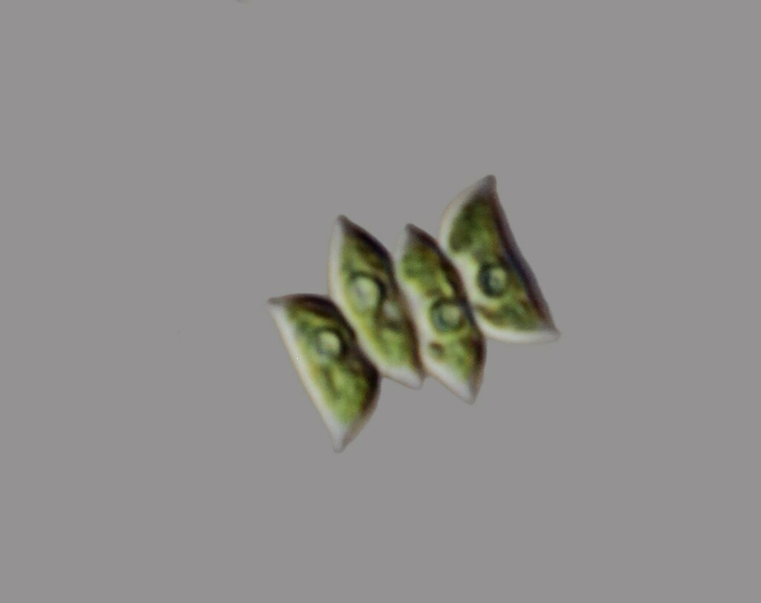
Cover slips can be fixed in place with plasticene at the 4 corners but there is still movement of the specimen during focusing with the 100X, less so with the 50X. Another pain, and it applies to both objectives, is the inability to work close to the edge of the cover slip. I've only tried DF with the 50X on a couple of ciliates and it worked well. It's something I hope to explore more later. Anyway, water immersion would help with some of these issues and I look forward to your results.
Perhaps apochronaut can chime in with some comments on the immersion objectives available from BestScope?
Harry
Top
Contact Free2Fish
Quote
Post
Scarodactyl
Posts: 2773
Joined: Sat Mar 03, 2018 9:09 pm

Re: Do I need another objective?

#14 by Scarodactyl » Sun Mar 24, 2024 8:29 pm
Using my planapo 60x/1.40 on my e800 was a bit disappointing since it has a dry condenser which throttles resolution. The oil condenser is very rare, I have never seen one for sale. I get better results using it with epi illumination/epi DIC on my other scope since it acts as its own high na oil condenser.
Last edited by Scarodactyl on Mon Mar 25, 2024 1:28 am, edited 1 time in total.
Top
Quote
Post
Free2Fish
Posts: 65
Joined: Wed Feb 06, 2019 11:38 pm
Location: La Salle, Manitoba, Canada
Contact:

Re: Do I need another objective?

#15 by Free2Fish » Sun Mar 24, 2024 9:45 pm
Thanks, I needed that. Still the math and objective properties suggest otherwise.
Harry
Top
Contact Free2Fish
Quote
Post
PeteM
Posts: 2981
Joined: Tue Dec 06, 2016 6:22 am
Location: N. California

Re: Do I need another objective?

#16 by PeteM » Sun Mar 24, 2024 11:18 pm
FWIW, I do like my 60x oil version with the 1.40 na and a dry condenser - but that is usually with tissue samples, not protists under a cover slip.
Top
Quote
Post
apochronaut
Posts: 6268
Joined: Fri May 15, 2015 12:15 am

Re: Do I need another objective?

#17 by apochronaut » Mon Mar 25, 2024 12:04 am
Free2Fish wrote: ↑
Sun Mar 24, 2024 7:34 pm
Perhaps apochronaut can chime in with some comments on the immersion objectives available from BestScope?
Harry
My involvement with Bestscope is limited. I had some involvement with them in 2017 and 18, almost purchasing a BS-2081, which is a Chjnese version of the E 200 but can be tricked out more. I did help a member buy one and he also bought some accessories from Radical because they sell the same stand with a wider array of optics. They at one time listed 3 or 4 M25 water immersion objectives but when ai tried to buy one, it was out of stock. I suspect that each of the objectives that they list(ed) can be had if you order enough of them. They claim the fancy optics are Japanese and likely made by Seiwa. A number of the designs overlap with Bestscopes offerings. The PlanF for instance has iterations made in China and India. When I wss dealing with Bestscope , they had just issued the 20X planapo. Now they have a set.
I decided to build up my AO/Reichert Diastar instead of invest in a BS-2081, which was a good idea. I now have a more complete 18 objective system, including glycerin immersion, a full set of planapos, highly colour corrected phase. I did however buy into 3 types of water immersion objectives from Bestscope ; a 100X 1.15 180mm Olympus format, a 100X 1.10 200 mm R.M.S. NIS format and a 100X 1.10 200mm M25 NIS format. All are planachros. My gut feeling was that the pruces in China were going to spiral up. Stuff was just too cheap in 2018.Some of it has gone up 300% since then. I also did buy a microscope. A BS-3090 planapo zoom stereo , which is a superb instrument and has completely changed my microscopy. 100X with quality in stereo us something to behold.
The 100X water immersion objectives are interesting and I could see one being exciting if you were working with a 100X oil 1.25 planachro a lot and found oil costly and annoying. I don't. The imaging is typical of a plan achromat with some characteristic ca bordering structures. The Olympus version gives primarily canary yellow border ca and the Nikon version pinkish. The two, apparently come from different factories but otherwise the resolution is about the same with each. Planarity will be dependant on what eyepieces one uses. The resolution is about what one would expect from an average good quality 1.25 oil immersion planachro imaging but less than a really good one, even with aqueous samples. One aspect of them and I find it with all water immersion objectives, is really just the nature of water : surface tension and easy contamination. They are more difficult to use than oil immersion and with carefull preparation I find that imaging using a fine 1.3 or 1.4 N.A. condenser and a 1.40 N.A.oil objective rarely doesn't meet my standards, even with aqueous samples, which I do a lot of.
The 45mm parfocal R.M.S. NIS one fits in with my Reichert system well and with thicker or hastily prepared samples, it is a go to objective but with glycerin immersion right at hand and with an iris diaphragm so I can use DF, I find I use it more. I have experimented with dropping in an N.A. restricter to fo DF and it works. The one I use is a better DF objective, than a BF objective and I do not know how it would fare for DIC. The M25 60mm parfocal objective appears to be the same optically ad the R.M.S. 45mm parfocal objective
Last edited by apochronaut on Mon Mar 25, 2024 1:11 am, edited 1 time in total.
Top
Quote
Post
PeteM
Posts: 2981
Joined: Tue Dec 06, 2016 6:22 am
Location: N. California

Re: Do I need another objective?

#18 by PeteM » Mon Mar 25, 2024 12:17 am
Phil, did you basically use a stop at the backside of the Bestscope water immersion objective for darkfield - maybe cut it down to around .90 na?
Top
Quote
Post
apochronaut
Posts: 6268
Joined: Fri May 15, 2015 12:15 am

Re: Do I need another objective?

#19 by apochronaut » Mon Mar 25, 2024 2:00 am
It is essentially a funnel stop but there is no funnel because the back lens is pretty flush with the top of the objective barrel, so it is flat. I found a rear diaphragm from a euchered objective that had a hole just a little smaller and sticking it on the existing diaphragm worked. Temporary and needs refinement.I don't know what the N.A. is but you are right , it is probably about .90, maybe a little more. That was for the 45mm parfocal R.M.S. objective but the optics in the 60mm parfocal objective seem the same, so the back lens is recessed in the barrel. Someone like yourself with machine tools could make a custom rear restricting diaphragm or funnel stop.
The first one I ever saw like that was for the very early Bausch & Lomb 100X 1.25 Flat Field Achromat, which they made for the later Dynazoom Flat Field into the early Balplan years, up to about 1972 or so. They never made a 100X Flat Field Achromat with an iris diaphragm. In the catalogue, it lists a part # for a funnel stop but because the back lens comes pretty close to the top of the barrel, it is just a replacement rear diaphragm with a smaller aperture.
Reichert Austria objectives are nice because the rear diaphragms all have the same thread. I removed the rear diaphragm from a broken 100X 1.25 planachro and put it into a 63X 1.0 .The smaller aperture by a hair, gave the 63X enough of an N.A. drop to allow DF to happen. Something to consider if trying to lower high N.A.s in lieu of having an iris equipped objective.
Top
Quote
Post
PeteM
Posts: 2981
Joined: Tue Dec 06, 2016 6:22 am
Location: N. California

Re: Do I need another objective?

#20 by PeteM » Mon Mar 25, 2024 2:26 am
Thanks, Phil.
Top
Quote
Post
Macro_Cosmos
Posts: 109
Joined: Mon Jul 19, 2021 2:20 am
Location: 192.0.0.1
Contact:

Re: Do I need another objective?

#21 by Macro_Cosmos » Mon Mar 25, 2024 4:32 am
I will add one of those $120 PlanApo 20x objectives, the ones with branding.
Also hunt for a 10x cheap fluorite and 4x achromatic to use as finders.
My website
YouTube
Instagram for Microscopy
Top
Contact Macro_Cosmos
Quote
Post
Free2Fish
Posts: 65
Joined: Wed Feb 06, 2019 11:38 pm
Location: La Salle, Manitoba, Canada
Contact:

Re: Do I need another objective?

#22 by Free2Fish » Mon Mar 25, 2024 2:29 pm
Thanks for all that info on the water immersion objectives, Phil. I was somewhat surprised you found them more difficult to use than oil. I would have assumed the opposite but on reflection it makes sense. Sounds like a 1.40 oil condenser would fit some of my needs well although they don’t appear to be common. Easily found and cheap for my Zeiss Universal but unavailable for the Nikon. I wonder why?
I’ll echo your comments about your stereoscope; I’ve spent a number of sessions watching cladocerans, worms and even larger ciliates at 45X. I can only imagine how spectacular the view would be at 100X.
Harry
Top
Contact Free2Fish
Quote
Post
Free2Fish
Posts: 65
Joined: Wed Feb 06, 2019 11:38 pm
Location: La Salle, Manitoba, Canada
Contact:

Re: Do I need another objective?

#23 by Free2Fish » Mon Mar 25, 2024 6:32 pm
RafaelML wrote: ↑
Sat Mar 23, 2024 7:13 am
But to observe protists I think the best is 60x Plan Apo WI, but i''s difficult to find it at a suitable price.
So for protist photography would you suggest the water immersion 60X followed by the 60X oil? Or does a 60X dry fit in there somewhere?
Are you using the 0.90 NA condenser with these lenses?
Thanks, Harry
Top
Contact Free2Fish
Quote
Post
apochronaut
Posts: 6268
Joined: Fri May 15, 2015 12:15 am

Re: Do I need another objective?

#24 by apochronaut » Mon Mar 25, 2024 9:27 pm
There was a bit of a condenser revolution, possibly after your Universal was minted? Either there was a paper presented at a conference or something akin about how a high percentage of users don't oil their condensers or wider field planarity became mainstream. Probably some of both. After a certain point in time, companies 1 by 1, issued high N.A. dry achromat aplanats . I am most familiar with AO. They trotted one out about 1967 or so. In the last incarnation of their wares, they didn't even offer an Abbe condenser, just a dry achromat aplanat, oil abbe aspheric or oil achromat aplanat. You would have better luck finding an Easter ham in Iran than the 1.40 achromat aplanat.
In the past your superior option to a 1.25 oil abbe was a high N.A. oil achromat and there is such a difference that anyone choosing the more highly corrected optics would have wasted them on a crappy condenser.
I suspect that after the dry achromats came along and performed so well and were sufficiently inexpensive, that more than some 1.4 N.A. objective users accepted a small resolution loss given their convenience and economy.
The difference in resolution between a .90 or .95 achromat aplanat corrected for air and a 1.4 achromat aplanat corrected for oil, both used with a 1.40 objective is surprisingy small. With all other factors being equal with the condensers ; colour correction, spherical correction etc., you only lose about 1 nanometer of theoretical resolution for every .01 N.A., so that 1/2 N.A. differential only results in about 1/20 of a micron resolution loss. You go from just above the theoretical limit at approx. 220nm with a 1.40 condenser in green light to 265 nm. with a .90 condenser. It isn't the same with a 1.25 abbe condenser, even oiled, because of it's lack of correction and poor N.A. off axis . An abbe aspheric or abbe aplanat are different again but cannot achieve their relatively fine performance levels which rival those of an achromat aplanat without immersion.
Top
Quote
Post
Free2Fish
Posts: 65
Joined: Wed Feb 06, 2019 11:38 pm
Location: La Salle, Manitoba, Canada
Contact:

Re: Do I need another objective?

#25 by Free2Fish » Tue Mar 26, 2024 12:11 pm
An interesting bit of history and some numbers I had never encountered before. The difference between condensers seems almost trivial.
I’ve wondered about the formula that suggests that when condenser NA is lower than Objective NA the result is an average of the two. Intuition suggests that NA should revert to the lower of the two.
Does anyone know if there is a mathematical basis for the averaged formula?
I suspect that averaging formula is an educated guess and that system NA will be difficult to predict. Light is very unruly and reflection, refraction and diffusion are all in play between the condenser and objective. Isn’t that what makes DF possible?
It would be so much easier if Nikon would send over a few objectives and prisms for me to try out. 
Harry
Top
Contact Free2Fish
Quote
Post
apochronaut
Posts: 6268
Joined: Fri May 15, 2015 12:15 am

Re: Do I need another objective?

#26 by apochronaut » Tue Mar 26, 2024 12:41 pm
Look up the Rayleigh Criterion for microscopes.
Top
Quote
Post
Free2Fish
Posts: 65
Joined: Wed Feb 06, 2019 11:38 pm
Location: La Salle, Manitoba, Canada
Contact:

Re: Do I need another objective?

#27 by Free2Fish » Tue Mar 26, 2024 2:43 pm
I'm wondering about the effects of condenser NA vs objective NA, not absolute resolution limits. Anyway, thanks for all your input and I guess whether I get another objective is now up to me.
And thanks to all the others who contributed to my better understanding of what I need.
Harry
Top
Contact Free2Fish
Quote
Post
Scarodactyl
Posts: 2773
Joined: Sat Mar 03, 2018 9:09 pm

Re: Do I need another objective?

#28 by Scarodactyl » Tue Mar 26, 2024 8:30 pm
Just saying this may be worth a bid https://www.ebay.com/itm/276399144621
Top
Quote
Post
Free2Fish
Posts: 65
Joined: Wed Feb 06, 2019 11:38 pm
Location: La Salle, Manitoba, Canada
Contact:

Re: Do I need another objective?

#29 by Free2Fish » Tue Mar 26, 2024 8:46 pm
And then I’d need another objective prism. So not really a priority for now, although admittedly it is a nice objective.
I’m thinking about this but wonder if it’s worth it with a 0.90 dry condenser.
https://www.ebay.ca/itm/225227198534?it ... R8jzh8jPYw
Top
Contact Free2Fish
Quote
Post
PeteM
Posts: 2981
Joined: Tue Dec 06, 2016 6:22 am
Location: N. California

Re: Do I need another objective?

#30 by PeteM » Tue Mar 26, 2024 9:47 pm
Harry, The 60x Plan Apo oil 1.40 objective is wonderful for thin, often stained, and stationary specimens. While lower magnification than the 100x Plan Apo oil, it has the same theoretical resolution and (if memory serves) can peer a tiny fraction (something like .02mm is typical) further below a cover slip. However, it would be hard (IMO) to justify $1200 to get a tiny part of a live protist, in slightly deeper focus, for some fleeting part of a second. The money might be better spent on something like a mirrorless camera that can capture every bit of resolution you already have, while eliminating vibration and the like.
Quote
Post

