Nikon DIC condensers and prisms

#1 by PeteM » Sat Oct 27, 2018 3:02 am
I've been trying the blind squirrel approach to DIC -- trying various combinations and finding some that work (e.g. "even a blind squirrel finds an acorn now and then")
I've seen four or five of these condensers pop up now and then (without selling) on Ebay:
https://www.ebay.com/itm/NIKON-UNIVERSA ... 7675.l2557
They're apparently meant for the Nikon Optiphot and normally require a top sliding prism that much more rarely shows up. My question is if anyone knows how these are set up? I was able to borrow one (just the condenser with 20-40-100x prisms) to experiment a bit with and it doesn't seem to work like either the Olympus or PZO DIC condensers, which will work (often with color fringing, though) with a prism above the objective -- and the usual crossed polarizers placed below the DIC condenser and above the objective prism.
My limited understanding is that Nikon might use de Senarmont DIC?
Does anyone know how these are set up? If there's a way to retrofit a prism above the objectives (I have an Olympus U-DICT, but it doesn't seem to work) and make use of this condenser, might be worth buying one.
Top
Quote
Post
abednego1995
Posts: 136
Joined: Thu Dec 15, 2016 6:32 am

Re: Nikon DIC condensers and prisms

#2 by abednego1995 » Sat Oct 27, 2018 9:45 am
Hi Pete.
The condenser in your link is for the 2nd generation of DIC out of 3 intended for the Optiphot/Optiphot-2 series. The 1st and 2nd are with single translating Nomarski prism above the objectives, and the 3rd is a Senarmont type set-up with dedicated prisms for each objective.
The thing with these, you have to check the polarization angles for the polarizer and analyzer. The 1st and 2nd generation kit pol/an directions are in a X configration, whereas after the 3rd generation and into CFI, they shifted to a + configuration. Mixing up prisms and polarizers intended for either system won't work. Plus the shearing amount of the prisms don't particularly match between different companies so you're stuck again.
But if... you are willing to live without the maximum NA out of your objectives, and just want the contrast enhancement there is a way to use only the objective side prism.
(see the excerpt from Maksmylian Pluta's Advanced Light Microscopy)
https://www.photomacrography.net/forum/ ... microscopy
Cheers,
John
Top
Quote
Post
PeteM
Posts: 2730
Joined: Tue Dec 06, 2016 6:22 am
Location: N. California

Re: Nikon DIC condensers and prisms

#3 by PeteM » Sat Oct 27, 2018 6:49 pm
Thanks, John. Pretty sure I had the polarizer and analyzer in an "X" (as well as other attempts). Could be that I didn't have a prism above the objectives that matched well enough to get any effect.
Would you happen to know the prism orientation inside that Nikon Universal condenser (v1 or v2) when it's indexed in place under an objective??
Top
Quote
Post
abednego1995
Posts: 136
Joined: Thu Dec 15, 2016 6:32 am

Re: Nikon DIC condensers and prisms

#4 by abednego1995 » Sun Oct 28, 2018 3:09 pm
My bad, Pete. My memory seems to be lapsing! The polarization axes are in the × configuration only for the gen1 kit. The prism shear axes are shifted 45 degrees between the crossed polarizers like \ in the case for the gen2 kit. I've took some quick pictures. Hope it helps.
John
ATTACHMENTS
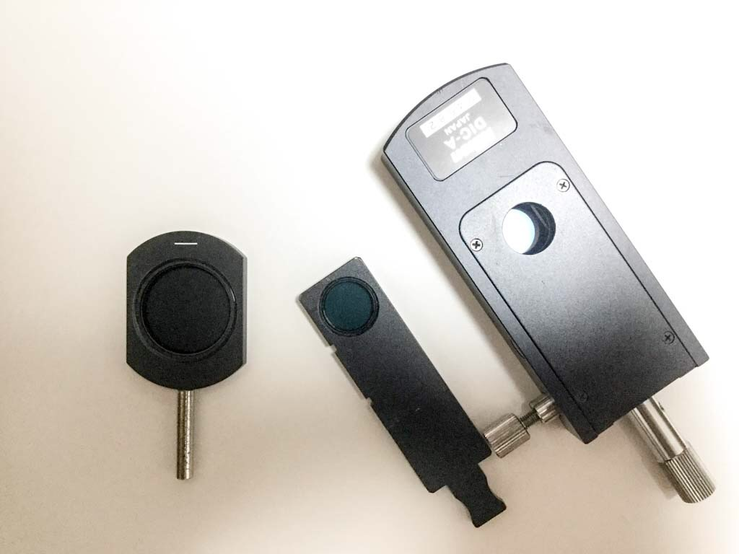
27830C1B-0097-45A1-917D-F141613ADC40.jpeg (82.49 KiB) Viewed 4433 times
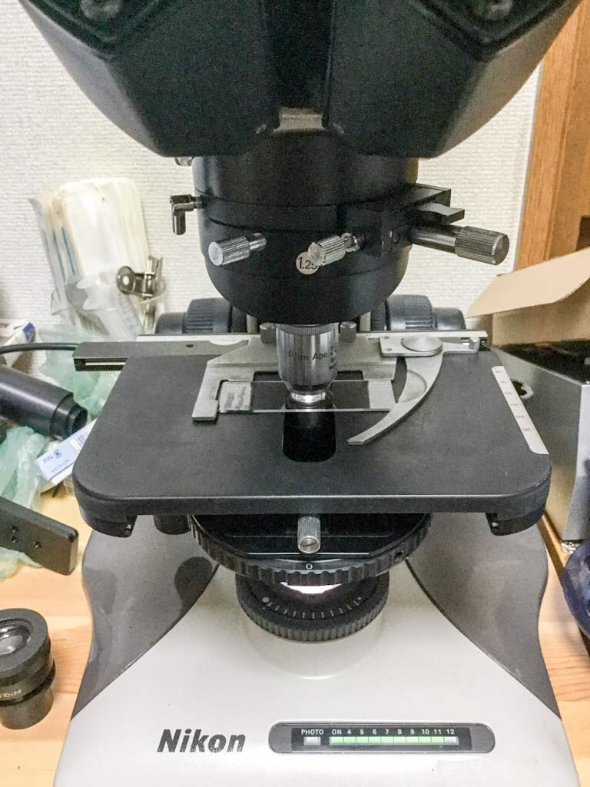
C187E20D-86C8-4B1A-81B7-92ACC1E97032.jpeg (173.49 KiB) Viewed 4433 times
Top
Quote
Post
PeteM
Posts: 2730
Joined: Tue Dec 06, 2016 6:22 am
Location: N. California

Re: Nikon DIC condensers and prisms

#5 by PeteM » Sun Oct 28, 2018 4:22 pm
Thanks very much, John.
I think this will give me a better chance of finding a prism that will work up top.
Looks like the condenser I've been playing with is a Gen 1, since the polarizer (otherwise the same as yours) that slides below the condenser is marked for an "X" configuration. Judging from that, I'm assuming the prisms in my condenser are East-West (or North-South?) and that the upper prism should also be aligned the same way?
How have you been satisfied with our setup? Could be someday I'll stumble across the proper Gen 1 Nikon prism and housing.
Top
Quote
Post
abednego1995
Posts: 136
Joined: Thu Dec 15, 2016 6:32 am

Re: Nikon DIC condensers and prisms

#6 by abednego1995 » Mon Oct 29, 2018 12:49 am
I think I'm getting to what went wrong in your case... I've attached some photos of a gen1 kit I used to have (I sold it for upgrading to gen2)
If the condenser you had had a NA of 1.40, it was intended for the gen2. The gen1 only has NA of 1.35. However, the polarizer plate underneath has the same
dimentions for both generations with different axes, so you might have had a polarizer mixup.
I've actually shifted to the CFI60 de Senarmont type of DIC, since I use fluorescence time to time. But I still keep this legacy DIC for my Optiphot2 since my
best objectives are NCF finite versions, and moreover you don't need to buy expensive prisms for each objective! I doubt you can tell between images from each
version if you find a clean unit. (of course de Senarmont is easier to calculate retardation, and offers a flatter background but for me the older version is adequate)
BTW, there's a boxed gen1 unit on sale for a while on the bay... not cheap, but complete.
https://www.ebay.com/itm/Nikon-Optiphot ... :rk:1:pf:0
ATTACHMENTS
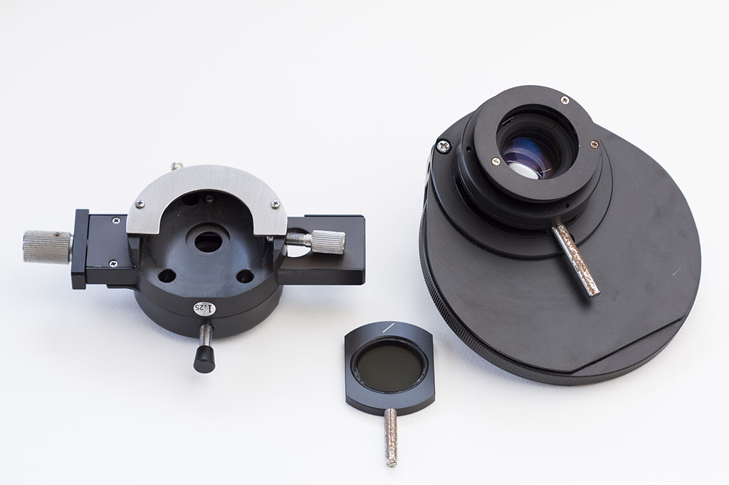
DSC_2399.jpg (83.31 KiB) Viewed 4410 times
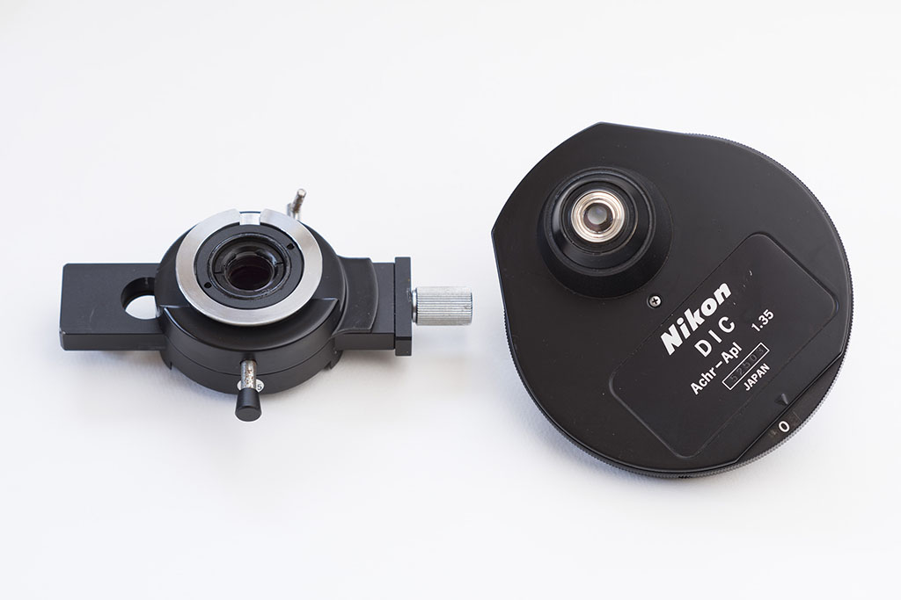
DSC_2397.jpg (79.54 KiB) Viewed 4410 times
Top
Quote
Post
PeteM
Posts: 2730
Joined: Tue Dec 06, 2016 6:22 am
Location: N. California

Re: Nikon DIC condensers and prisms

#7 by PeteM » Tue Oct 30, 2018 12:53 am
Thanks, John.
Looks like I've been playing around with a Version 1 DIC condenser.
I have gotten some very good DIC effects using Nikon Epi prisms up top and home-made DIC sliders just below the condenser iris. And others on some Olympus BHS finite, BX, and Motic and Accu-Scope microsocpes (both with Olympus infinity corrections) using a variety of prisms and home-made intermediate and condenser fittings.
Even after properly aligning (thanks) the Nikon turret-type DIC condenser, there's only a weak effect. Probably need that proper Nikon slider up top to work with that condenser.
I did see the Ebay listing. To the extent I have a mission in the past year's work, it has been to introduce kids to the notion of understanding how things work at small scale. Hard for me to justify $2500, when I could buy and fix up 20 or so microscopes for kids for that same $2500. So far I've fixed up and donated about eighty scopes. I plan to stop at 100 and am shifting to developing "single image science lessons." Cool things with a bit of a science lesson that kids (and parents, peers, mentors) can do in under half an hour.
Still, really want to be able to take cool pictures for those lessons -- all the better to get kids interested. So, I'll likely continue to waste some time on cheaper workarounds.
Appreciate your help!
Quote
Post

