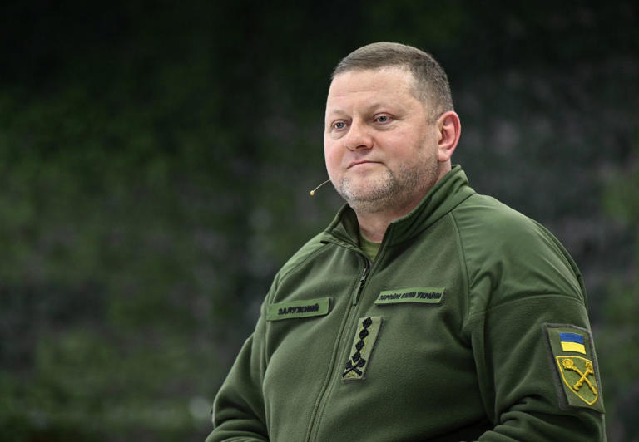
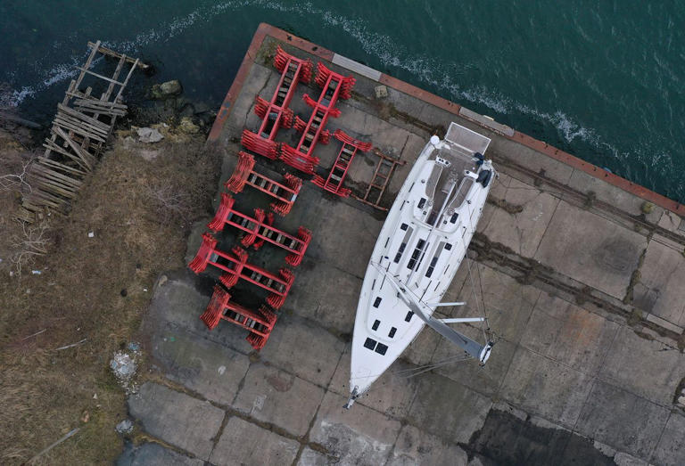
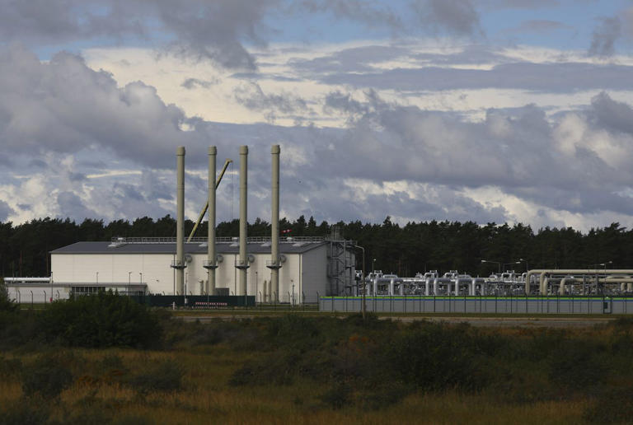
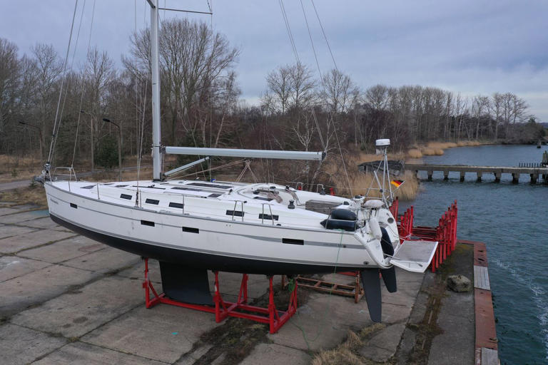
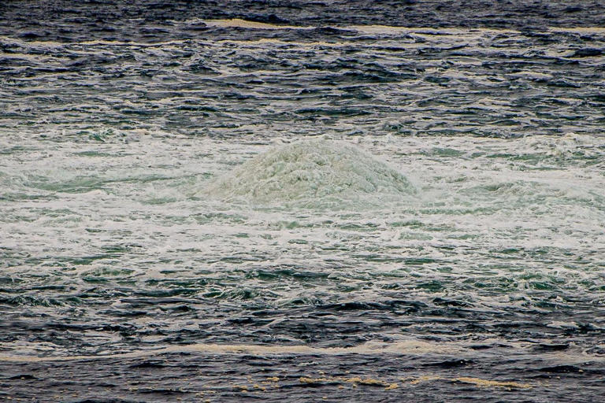
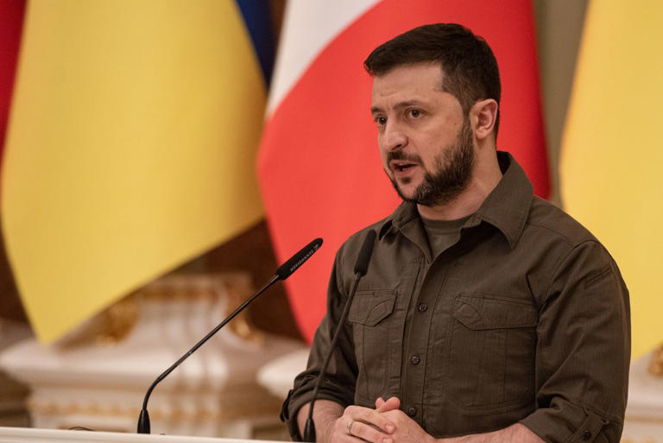
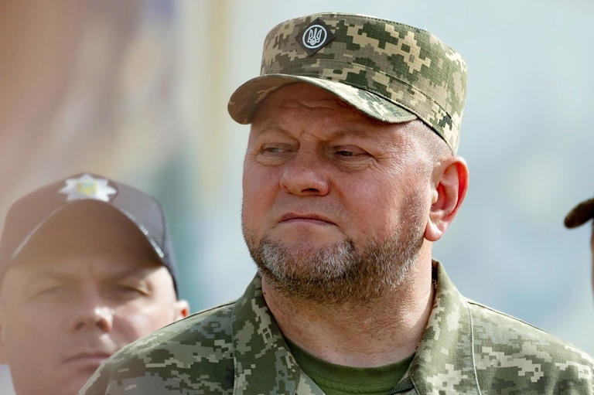
A Drunken Evening, a Rented Yacht: The Real Story of the Nord Stream Pipeline Sabotage
Story by Bojan Pancevski
• 3d • 11 min read
class="article-body" style="font-size: 17px; text-align: start; line-height: 26px; margin: 0px; max-height: 100%; overflow-y: hidden;"
It was the kind of outlandish scheme that might bubble up in a bar around closing time.
In May of 2022, a handful of senior Ukrainian military officers and businessmen had gathered to toast their country’s remarkable success in halting the Russian invasion. Buoyed by alcohol and patriotic fervor, somebody suggested a radical next step: destroying Nord Stream.
After all, the twin natural-gas pipelines that carried Russian gas to Europe were providing billions to the Kremlin war machine. What better way to make Vladimir Putin pay for his aggression?
Just over four months later, in the small hours of Sept. 26, Scandinavian seismologists picked up signals indicating an underwater earthquake or volcanic eruption hundreds of miles away, near the Danish island of Bornholm. They were caused by three powerful explosions and the largest-ever recorded release of natural gas, equivalent to the annual CO2 emissions of Denmark.
One of the most audacious acts of sabotage in modern history, the operation worsened an energy crisis in Europe—an assault on critical infrastructure that could be considered an act of war under international law. Theories swirled about who was responsible. Was it the CIA? Could Putin himself have set the plan in motion?
Now, for the first time, the outlines of the real story can be told. The Ukrainian operation cost around $300,000, according to people who participated in it. It involved a small rented yacht with a six-member crew, including trained civilian divers. One was a woman, whose presence helped create the illusion they were a group of friends on a pleasure cruise.
“I always laugh when I read media speculation about some huge operation involving secret services, submarines, drones and satellites,” one officer who was involved in the plot said. “The whole thing was born out of a night of heavy boozing and the iron determination of a handful of people who had the guts to risk their lives for their country.”
Ukrainian President Volodymyr Zelensky initially approved the plan, according to one officer who participated and three people familiar with it. But later, when the CIA learned of it and asked the Ukrainian president to pull the plug, he ordered a halt, those people said.
Zelensky’s commander in chief, Valeriy Zaluzhniy, who was leading the effort, nonetheless forged ahead.
A Drunken Evening, a Rented Yacht: The Real Story of the Nord Stream Pipeline Sabotage© Ukrainian Presidential Press Office/Associated Press
The Journal spoke to four senior Ukrainian defense and security officials who either participated in or had direct knowledge of the plot. All of them said the pipelines were a legitimate target in Ukraine’s war of defense against Russia.
Portions of their account were corroborated by a nearly two-year German police investigation into the attack, which has obtained evidence including email, mobile and satellite phones communications, as well as fingerprints and DNA samples from the alleged sabotage team. The Germany inquiry hasn’t directly linked President Zelensky to the clandestine operation.
Gen. Zaluzhniy, now Ukraine’s ambassador to the United Kingdom, said in a text exchange that he knows nothing of any such operation and that any suggestion to the contrary is a “mere provocation.” Ukraine’s armed forces, he added, weren’t authorized to conduct overseas missions, and he therefore wouldn’t have been involved.
A senior official of the main Ukrainian intelligence service, SBU, denied his government had anything to do with the sabotage, and said that Zelensky in particular “did not approve the implementation of any such actions on the territory of third countries and did not issue relevant orders.”
Putin has publicly blamed the U.S. for the attacks. A senior Russian diplomat in Berlin echoed that claim, and said the German investigation findings were “fairy tales worthy of the Brothers Grimm.”
In June, Germany’s federal prosecutor quietly issued the first arrest warrant in the case for a Ukrainian professional diving instructor for his alleged involvement in the sabotage. The German investigation is now focusing on Zaluzhniy and his aides, people familiar with the probe say, although they have no evidence that could be presented in court.
The findings could upend relations between Kyiv and Berlin, which has provided much of the financing and military equipment to Ukraine, second only to the U.S. Some German political leaders may have been willing to overlook evidence pointing to Ukraine for fear of undermining domestic support for the war effort. But German police are politically independent and their investigation took on a life of its own as they pursued one lead after another.
“An attack of this scale is a sufficient reason to trigger the collective defense clause of NATO, but our critical infrastructure was blown up by a country that we support with massive weapons shipments and billions in cash,” said a senior German official familiar with the probe.
Following the May 2022 pact between the businessmen and the military officers, it was agreed that the former would finance and help execute the project, because the army had no funds and was increasingly relying on foreign financing as it pushed back against the onslaught of its gargantuan neighbor. A sitting general with experience in special operations would oversee the mission, which one participant described as a “public-private partnership.” He would report directly to the head of Ukraine’s armed forces, the four-star Gen. Zaluzhniy.
A Drunken Evening, a Rented Yacht: The Real Story of the Nord Stream Pipeline Sabotage© Alexey Furman/Getty Images
Within days, Zelensky approved the plan, according to the four people familiar with the plot. All arrangements were made verbally, leaving no paper trail.
But the next month, the Dutch military intelligence agency MIVD learned of the plot and warned the CIA, according to several people familiar with the Dutch report. U.S. officials then promptly informed Germany, according to U.S. and German officials.
The CIA warned Zelensky’s office to stop the operation, U.S. officials said. The Ukrainian president then ordered Zalyzhniy to halt it, according to Ukrainian officers and officials familiar with the conversation as well as Western intelligence officials. But the general ignored the order, and his team modified the original plan, these people said.
The general tasked with commanding the operation enlisted some of Ukraine’s top special-operations officers with experience in orchestrating high-risk clandestine missions against Russia to help coordinate the attack.
One of them was Roman Chervinsky, a decorated colonel who previously served in Ukraine’s main security and intelligence service, the SBU.
Chervinsky is currently on trial in Ukraine for unrelated charges. In July, he was released on bail after over a year in detention. Reached after his release, he declined to comment on the Nord Stream case, saying he wasn’t authorized to speak about it.
A Drunken Evening, a Rented Yacht: The Real Story of the Nord Stream Pipeline Sabotage© DANISH DEFENCE/AFP/Getty Images
In a subsequent broadcast interview, he said that the sabotage had two positive effects for Ukraine: It helped loosen Russia’s grip on the European countries supporting Kyiv, and it left Moscow with only one main avenue for channeling gas to Europe, pipelines traversing Ukraine. Despite the war, Ukraine collects lucrative transit fees for Russian oil and gas estimated to be worth hundreds of millions of dollars a year.
Chervinsky and the sabotage team initially studied an older, elaborate plan to blow up the pipeline drafted by Ukrainian intelligence and Western experts after Russia first invaded Ukraine in 2014, according to people familiar with the plot.
After dismissing that idea due its cost and complexity, the planners settled on using a small sailing boat and a team of six—a mix of seasoned active duty soldiers and civilians with maritime expertise—to blow up the 700-mile-long pipelines that sat more than 260 feet below the sea’s surface.
In September 2022, the plotters rented a 50-foot leisure yacht called Andromeda in Germany’s Baltic port town of Rostock. The boat was leased with the help of a Polish travel agency that was set up by Ukrainian intelligence as a cover for financial transactions nearly a decade ago, according to Ukrainian officers and people familiar with the German investigation.
One crew member, a military officer on active duty who was fighting in the war, was a seasoned skipper, and four were experienced deep-sea divers, people familiar with the German investigation said. The crew included civilians, one of whom was a woman in her 30s who had trained privately as a diver. She was handpicked for her skills but also to lend more plausibility to the crew’s disguise as friends on holiday, according to one person familiar with the planning.
A Drunken Evening, a Rented Yacht: The Real Story of the Nord Stream Pipeline Sabotage© Sean Gallup/Getty Images
The skipper took a short leave from his unit, which had been fighting on the front in the southeast of Ukraine, and his commander was kept in the dark, according to two Ukrainians familiar with the plot.
Ukraine has a long history of training top civilian and military divers. A naval base on the Crimean Peninsula in the past trained deep-sea divers for the purposes of sabotage and demining. It also kept combat dolphins trained to attack enemy divers and blow up ships, according to two senior Ukrainian officers. The base was taken over by Russia after it occupied Crimea, and some of its staff moved elsewhere in Ukraine.
Armed only with diving equipment, satellite navigation, a portable sonar and open-source maps of the seabed charting the position of the pipelines, the crew set out. The four divers worked in pairs, according to people familiar with the German investigation. Operating in pitch-dark, icy waters, they handled a powerful explosive known as HMX that was wired to timer-controlled detonators. A small amount of the light explosive would be sufficient to rip open the high-pressure pipes.
Spending 20 minutes at that depth requires around three hours of decompression, and the person must then refrain from diving for at least 24 hours or risk serious injury.
Inclement weather forced the crew to make an unplanned stop in the Swedish port of Sandhamn. One diver accidentally dropped an explosive device to the bottom of the sea. The crew briefly discussed whether to abort the operation due to the bad weather but the storm soon subsided, two people familiar with the operation said.
Witnesses on other yachts moored in Sandhamn noted that the Andromeda was the only boat with a small Ukrainian flag hoisted on its mast.
A Drunken Evening, a Rented Yacht: The Real Story of the Nord Stream Pipeline Sabotage© FABRIZIO BENSCH/REUTERS
In the wake of the attack, which took out three of the four conduits forming the pipelines, energy prices surged. Germany and other nations scrambled to nationalize energy companies that handled Russian gas but collapsed after the pipelines were destroyed. Even today Germany is paying around $1 million a day alone to lease floating terminals for liquefied natural gas or LNG, which only partly replaced the Russian gas flows channeled by Nord Stream.
Germany, Denmark, Sweden and the U.S., among others, sent out warships, divers, underwater drones and aircraft to investigate the area around the gas leaks.
Zelensky took Zaluzhniy to task, but the general shrugged off his criticism, according to three people familiar with the exchange. Zaluzhniy told Zelensky that the sabotage team, once dispatched, went incommunicado and couldn’t be called off because any contact with them could compromise the operation.
“He was told it’s like a torpedo—once you fire it at the enemy, you can’t pull it back again, it just keeps going until it goes ‘boom,’ ” a senior officer familiar with the conversation said.
Days after the attack, in October 2022, Germany’s foreign secret service received a second tipoff about the Ukrainian plot from the CIA, which again passed on a report by the Dutch military intelligence agency MIVD. It offered a detailed account of the attack, including the type of boat used and the possible route taken by the crew, according to German and Dutch officials.
The Netherlands built deep intelligence-gathering capacity in Ukraine and Russia after Russian-backed paramilitaries downed a Malaysia Airlines flight originating from Amsterdam over eastern Ukraine, two Dutch officials said.
Due to rules governing the sharing of classified intelligence, German police investigating the case weren’t allowed to see the Dutch report that linked Zaluzhniy and the Ukrainian military to the attack, but they were made aware of it by intelligence officials.
German investigators questioned dozens of potential witnesses, scanned the bottom of the sea around the blasts and sifted through masses of data including digital communication, travel records and financial transactions.
A Drunken Evening, a Rented Yacht: The Real Story of the Nord Stream Pipeline Sabotage© Sean Gallup/Getty Images
They had one lucky break. In rushing to leave Germany, the sabotage crew neglected to wash the Andromeda, allowing German detectives to find traces of explosives, fingerprints and DNA samples of the crew.
Investigators later identified their mobile phone numbers and their Iridium satellite phone. That data allowed them to reconstruct the entire journey of the boat, which moored in Germany, Denmark, Sweden and Poland. U.S. authorities sought a court order to obtain from Google the emails a Ukrainian businessman used to lease the boat, and handed them over to the Germans. That Ukrainian businessman had contacted a number of boat rental firms in Sweden as well as in Germany, starting from mid-May 2022.
Investigators then analyzed all mobile phone traffic in the areas where the boat was located, trawling through thousands of connections to distill the relevant data.
At one point they were startled to find out that thousands of German mobile phones were active in the tiny Swedish port of Sandhamn, which was nearly empty at the time the boat was sheltering there from a storm.
It later emerged that a vast cruise ship belonging to a tourist operator passed by and the phones of German passengers briefly linked up with the local cellular mast.
They struggled at one point to secure the cooperation of Polish authorities despite the fact that the saboteurs used Poland partly as a logistical base and stopped in the Polish port of Kolobrzeg.
A port official suspicious of the yacht’s crew alerted police. Poland’s border guard checked the identification of the crew, who produced passports from European Union members. They were allowed to continue sailing north, where they laid the rest of the mines, people familiar with the investigation say.
The entire port was covered by extensive video surveillance, they found. However, despite a history of close cooperation between Warsaw and Berlin in police matters, Polish officials initially refused to hand over the CCTV footage of the port. This year, they told their German colleagues that the footage had been routinely destroyed shortly after the Andromeda departed.
The Polish internal security agency ABW told the Journal that no such footage exists.
By November 2022, German investigators believed Ukrainians were behind the explosion.
Earlier this year, Zelensky ousted Zaluzhniy from his military post, saying a shakeup was needed to reboot the war effort. Zaluzhniy, who has been viewed domestically as a potential political rival, was later appointed Ukraine’s ambassador to the U.K., a position that grants him immunity from prosecution.
In June, German officials issued a confidential arrest warrant for a Ukrainian citizen who the Germans believe was one of the crew members. According to people familiar with the investigation, a van driving the Ukrainian sabotage team from Poland into Germany in 2022 was snapped by a German speed camera, and the man, a diving instructor living with his family near Warsaw, was in the photo.
Authorities in Poland didn’t act on the warrant. The instructor is believed to have since returned to Ukraine. Poland’s failure to arrest him is a major blow to the German probe, because he and other suspects have now been tipped off and will avoid travelling outside Ukraine, people familiar with the investigation said. Ukraine doesn’t extradite its own citizens.
A Drunken Evening, a Rented Yacht: The Real Story of the Nord Stream Pipeline Sabotage© genya savilov/AFP/Getty Images
Ukrainian officials who participated in or are familiar with the plot believe it would be impossible to put any of the commanding officers on trial, because no evidence exists beyond conversations among top officials who were, at least initially, all in agreement about wanting to blow up the pipelines.
“None of them will testify, lest they incriminate themselves,” one former officer said.
Drew Hinshaw contributed to this article.
Write to Bojan Pancevski at bojan.pancevski@wsj.com

