Skip to main content


Use OpenStreetMap maps
Feature Requests
web android-app ios-app under-review 50 votes
Log In

50

Use OpenStreetMap maps
Feature Requests
webandroid-appios-appunder-review50 votes

Apr 2019
62 / 76
May 2022
Jan 18

16 days later

5 months later

4 months later

3 months later

10 months later

23 days later

21 days later

13 days later

8 days later

13 days later

2 months later

1 month later

hkmoths

1
yixianshuiesuan
Sep '21
This banning of Google related stuff in China impacts heavily on iNat users there - I’ve been told that all the iNat elements otherwise work fine, but no map. Kind of limits the functionality of a species’ distribution. I would welcome a shift to a viable mapping alternative for iNat users in China - we would likely see many new users as a result. I agree with @kueda that having OSM as a base map option for areas where Google is blocked would probably be a viable option, bandwidth issues and traffic issues permitting.
2 Replies
redpandacat

The situation doesn’t seem to be the same for the android app and the website.
For the website: I find that in the mainland images as well as maps don’t load or load extremely slowly unless you jump the wall. Identify mode doesn’t seem to load any content and my personal feed is very slow but does eventually load (or is that just a cached version?). Other page elements seem to load. The GPS map alignment point seems valid though I usually enter location info manually anyway.
I have shown the app to local naturalists and they love the look of it but most mainlanders won’t be able to easily use it. I do support OSM or similar being added as that would certainly remove a barrier for app use. In terms of the website it seems that there could still be a barrier if the image loading issue is related to google hosting.
castieler

I use iNat with Tor Browser and it loads most of the time, although sometimes I need to change the circuit. Chinese users could also use it.
redpandacat
hkmoths
Sep '21
The situation doesn’t seem to be the same for the android app and the website.
For the website: I find that in the mainland images as well as maps don’t load or load extremely slowly unless you jump the wall. Identify mode doesn’t seem to load any content and my personal feed is very slow but does eventually load (or is that just a cached version?). Other page elements seem to load. The GPS map alignment point seems valid though I usually enter location info manually anyway.
I have shown the app to local naturalists and they love the look of it but most mainlanders won’t be able to easily use it. I do support OSM or similar being added as that would certainly remove a barrier for app use. In terms of the website it seems that there could still be a barrier if the image loading issue is related to google hosting.
castieler
hkmoths
Sep '21
I use iNat with Tor Browser and it loads most of the time, although sometimes I need to change the circuit. Chinese users could also use it.
6 months later
vitor_jorge

Mar '22
Any update?
1 Reply
tiwaneiNaturalist Staff

vitor_jorge
Mar '22
No, there isn’t.
redpandacat
Apr '22
Fair enough, it’s not a small thing to do and it must be balanced against many other priorities.
Not complaining just wanted to add how things have changed here in recent months. I would say (personally) the situation here is getting more difficult. Often every few hours maps are unavailable (and sometimes other resources). With patience I can work around it but when time is tight it turns from an annoyance to a hindrance.
On the uploading observations side I’ve found pinning locations is helpful for commonly visited locations.
14 days later
earthknight

Apr '22
I would support it as a layer option, but I would not support a complete move over to OSM.
The satellite imagery what I use almost exclusively, and OSM doesn’t have that as an option. That in and ofitself is a complete deal killer for me.
The second issue I have with OSM is that while the information may be more accurate (not always, I’ve found that construction firms will sometimes place their planned projects into OSM long before they even have permission to break ground in an attempt to pre-justify the construction), I find the interface very ugly and extremely ‘busy’, which would make seeing pins and such messy.
The biggest issue is the lack of satellite imagery on OSM though. That’s absolutely vital to have, especially in the kinds of places I work where specific landforms and trees are the main way to identify a location.
Because of that lack I find OSM maps to be far less accurate than any system that uses a reasonably detailed satellite image.
1 Reply
earthknight
hedaja
Apr '22
No satellite imagery. Complete deal killer for me.
1 Reply
felix-insects

I agree.
fluffyinca

Apr '22
 earthknight:
The satellite imagery what I use almost exclusively
Same! I can’t imagine how difficult it would be to manually add a location to an observation without the landmarks visible on a satellite map. I know nothing about OSM, so I was neutral on this suggestion until now, but if the change would remove the satellite imagery I thoroughly oppose it.
felix-insects
earthknight
Apr '22
I agree.
rgvhf

Apr '22
Me too, in the field I use topographic maps(on a tablet, not real paper anymore), with some imagery, but on iNat its satellite imagery, 98% of the time for me, especially as many of my observations are in ‘nowhere land’ (large patches of green), on google street maps.
I don’t use google ‘terrain’.
I would use OSM, if it where an option, but not on a regular basis.
Different story if I was in China, though.
25 days later
nrg800

May '22
As someone who has spent a lot of time both personally and professionally looking at GIS and web-hosting options, I think in general the use of Google Maps is better for some reasons I’ll lay out below, but that it cannot hurt to show a simple leaflet OSM map for users with a Chinese IP address.
but in general
Pros of Google Maps
- Satellite imagery. I think this is a must, especially for locating in detail the location of a sighting that may not have GPS data attached to it. If I’m marking the location of a sighting in any detail at all (and imo what sets iNat apart from other citizen science project is the spatial resolution of its data), satellite imagery is key.
- More consistent mapping. There are some areas of the planet where OSM is notably better, some areas where it is notably worse, but Google has by and large managed to maintain a map that has acceptable detail globally. OSM is improving every day but it still has large gaps in its coverage in many countries.
- Localisation. One of the big problem with using OSM’s standard map for iNaturalist is that its map labels are in the local language. This is great if you’re from areas that speak a language other than english, but for people browsing a map who can’t read Thai, the labels aren’t very helpful in Thailand - which is especially relevant considering the number of people who upload travel observations.
- Inclusion of a geocoding API. This allows users to search for locations in picking an observation’s location, and to get text names for the coordinates they have included. Google’s geocoding and reverse geocoding is far more robust than any popular alternatives. OSM’s is very rigid requiring a direct match to its database, whereas Google will return results for a much larger variety of inputs. Any third-party geocoding API will also be expensive for the number of requests I expect it gets per day.
Cons of Google Maps:
- It’s expensive. It’s damn expensive. Most users of Google Maps have moved away since they hiked their API rates a few years ago. If iNaturalist gets access for free though that negates this con (and in a way seems like a bad deal to not take up the offer of free access).
- Blocked in China. Here there’s no wriggle room, and because of some pretty bonkers laws, even if a user in China has access to a VPN to use Google Maps, the road overlays are offset by a random but significant distance. It’s a bit weird to me that OSM doesn’t adhere to this law, but isn’t blocked, while Google does and is blocked. But that’s just how it is.
Pros of Open Street Map:
- In many areas OSM is more detailed, especially in the mapping of footpaths and bush tracks and similar places often used by nature enthusiasts.
- It allows users to add in data and improve the quality of their local maps.
- Open source, completely free.
- Easy Leaflet integration for adding other new features, compared to being restrained by the Google embedded maps structure (for example this feature request would be far easier to incorporate in a leaflet infrastructure than a google one https://forum.inaturalist.org/t/indicate-overlapping-observations-for-map-pins/18406/6 1)
- A larger variety of layer styles available.
Cons of OSM:
- No localisation options, you’re either stuck with the local script always being used or never being used.
Third party platforms
- Nope. Don’t. They will cost so much without much additional benefit. Mapbox gets very expensive very fast for tile mapping services. Unless you rebuild a vector-based mapping platform Mapbox will be prohibitively expensive. Same with MapTiler. Any platform that provides satellite imagery will also cost a lot for the scale that iNaturalist needs.
Overall, I think Google is the easiest, best, most consistent and cheapest (since it’s free) option available. There would be no harm in allowing users to switch to an OSM-style leaflet map, but that would require a rebuilding of the mapping code to make it leaflet based and not Google based, and this probably isn’t worth it for the slight increase in map data that OSM provides in some regions. However it may be worth it to allow users in China to map without it being blocked, and in that case it might be quite easy to allow that option for users globally.
Hope this is a helpful overview for some people!
Cheers,
Nathan.
2 Replies
Marina_GorbunovaАктивный пользователь

nrg800
May '22
There’re more cons of Google, e.g. it shows so many places with wrong names, I was really surprised how wrong it is in that, the best map here is Yandex non-satellite which shows both correct names and all the roads/paths as they are and not how Google does it – randomly.
1 Reply
hedaja

nrg800
May '22
Since GoogleMaps provides free service to iNaturalist, I wouldn’t mind keeping it.
Having OSM as an additional layer to choose from would be nice though.
Getting OSM tiles in the Google Maps API V3 seems to be possible.
See https://wiki.openstreetmap.org/wiki/Google_Maps_Example 4
The part that would need some work would be integrating it so it’s just an additional layer and doesn’t completely replace the Google Maps Layers
1 Reply
2 months later
jokkomarat

1
Jul '22
no google map on huawei phones
huawei uses petal maps
may any map would work just not google because of sanctions
fix this with GSpace app which emulates google services on a non google phone
how ever this is an anoying fix … and inat should be international useable … that means what ever just not google
the GSpace App to fix Inatuaralist on Huawei is here:
https://www.pixelstech.net/article/1627807970-Install-and-use-GSpace-to-install-apps-from-Google-Play-on-Huawei-Harmony-OS
25 days later
aparyany

kueda
Aug '22
No I would prefer a style with contours
ahospers

Marina_Gorbunova
Aug '22
Is Yandex also good in reverse image searching ?
1 Reply
Marina_GorbunovaАктивный пользователь
ahospers
Aug '22
I only use it for maps and things like traffic, taxi, public transport, but not browser (though for sure need to start using it instead of Google), so can’t say, the option is there as far as I remember.
jason_miller
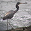
Aug '22
Very late to this discussion and not sure what I am about to say will even be any help, but here are just a few experiences I have with switching between Google Maps and various OSM maps
- The Geocaching app c:geo (only available for Android) gives the user several options for maps - live maps via Google, Google Sat View, OSM and a few others - but also an option to use various offline maps (OSM maps that are available via third-party websites such as Mapsforge). Those maps are typically downloaded at the level of State, Province, or Country (deepening on size). See https://manual.cgeo.org/en/offlinemaps 1. Having a similar option in the app might skirt some of the issues related to who will host the map data or traffic issues. If a user want to use OSM maps, they would need to download the OSM maps to their device. Another advantage is that it is available without data (remote locations).
- anyone that want to easily compare the maps between OSM (standard), Topo (OSM??), Gogole Maps and Sat View, visit https://flopp.net/ 1 pick a location and toggle between the various map options.
1 Reply
ahospers
jason_miller
Aug '22
* Inclusion of a geocoding API. This allows users to search for locations in picking an observation’s location, and to get text names for the coordinates they have included. Google’s geocoding and reverse geocoding is far more robust than any popular alternatives. OSM’s is very rigid requiring a direct match to its database, whereas Google will return results for a much larger variety of inputs. Any third-party geocoding API will also be expensive for the number of requests I expect it gets per day.
Where is the GeoCoding api used ? Because thisone take a lot of clicks and zoom compared to others which are much much faster. You mention the biggest place in the neighboorhood and it goes/opens there (Bangkok, Melbourne, Java, Djakarta, Bali)
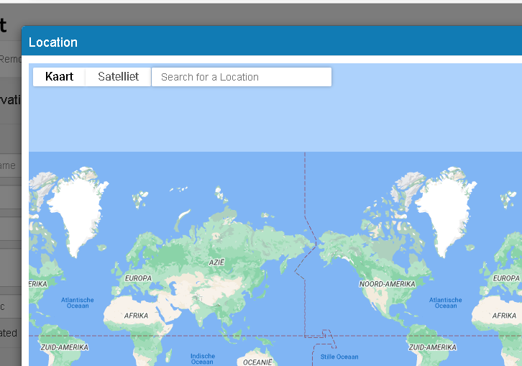
13 days later
image726×509 48.4 KB
olrett

hedaja
Aug '22
I have Huawei devices, one of a newer kind, where I cannot visualize maps in the iNat app (uploads work, but without geo references, those have to be added subsequently via the website) and one older device where Google maps still work.
Apart from iNat, I have been using the OSM+ app for many years, and there is satellite imagery which can be turned on and off. Most often I just use contours in the walking profile, but switching to satellite/hybrid view is a no-brainer. The nice thing is, OSM+ works on both old and new Huawei devices. And it is way more accurate than Google maps this side of the Atlantic.
5 months later
bryannamar

Jan 9
With the Overture Maps foundation ran by the Linux foundation and its going to be using OSM map data maybe they would be open to a similar free option to Google, or mapbox or someone. OSM just offers so much more detail for natural areas then gmaps does and it would be very nice to have it in inat.
OSM
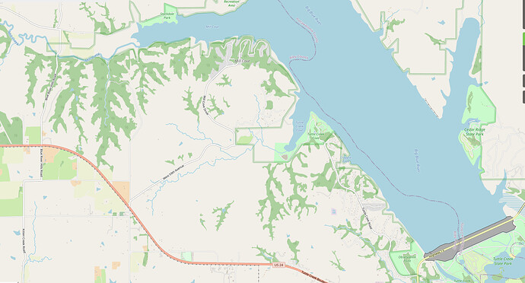
gmaps
image1621×875 283 KB
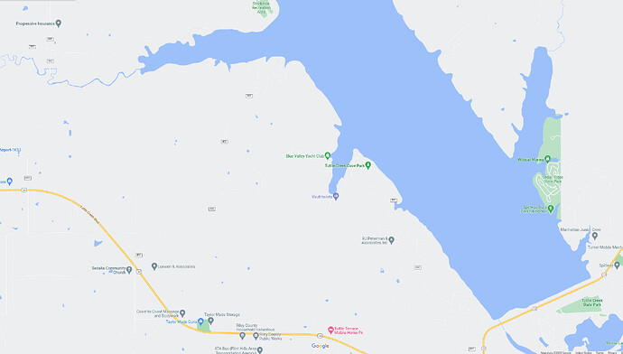
OSM
image2245×1278 246 KB
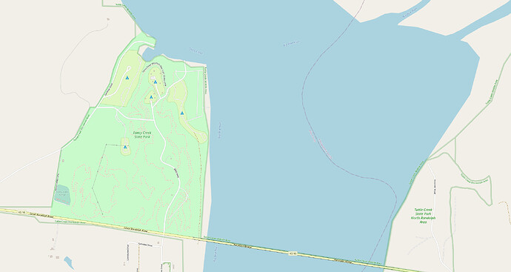
gmaps
image2233×1188 259 KB
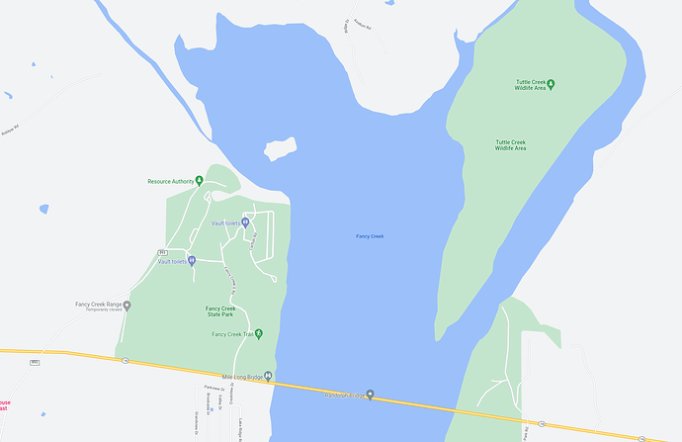
osm
image1744×1130 148 KB
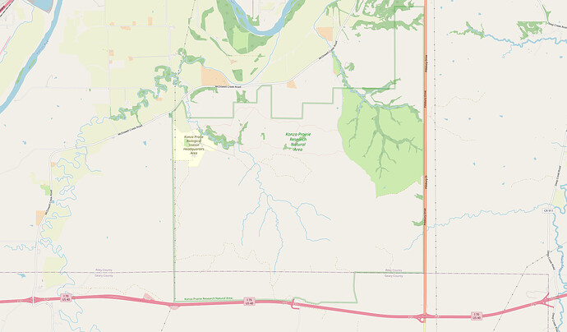
gmaps
image2003×1174 298 KB
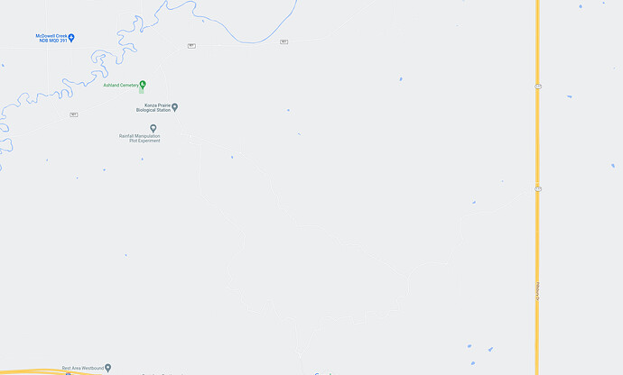
This one is less drastic because gmaps is slowly improving in like big national sites, but OSM has details of what is owned by the TNC in their preserve vs the state ran wildlife area
image2006×1210 107 KB
OSM
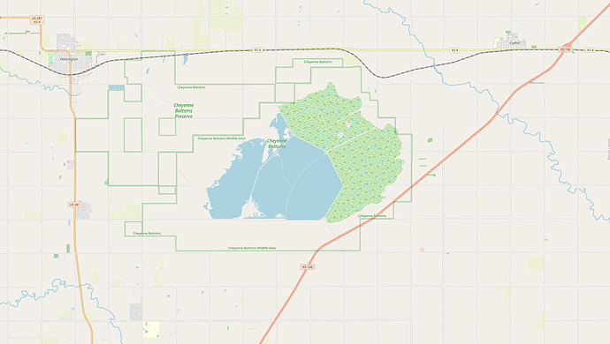
gmaps
image1949×1102 312 KB
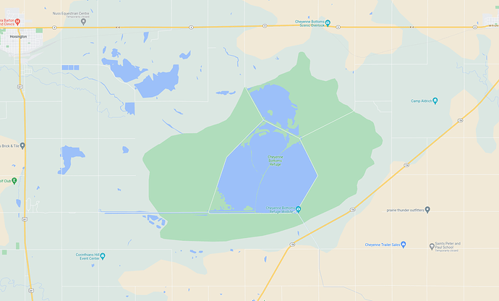
Here we have a state park and trails through a preserve
OSM
image2006×1210 274 KB
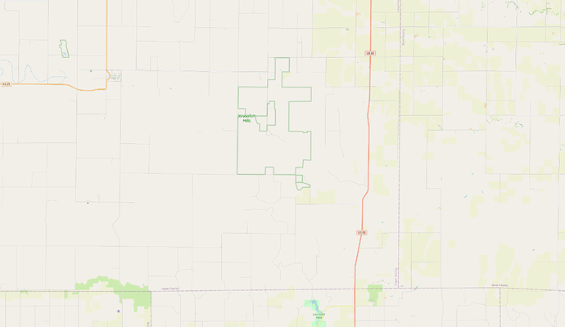
gmaps
image2078×1205 232 KB
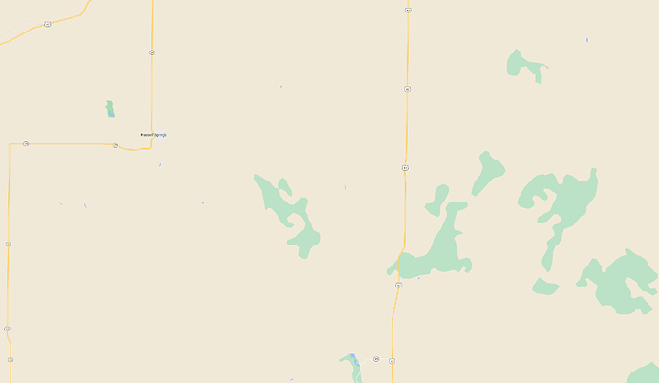
cicko

image2102×1223 81.9 KB
3
Jan 13
+1 for OpenStreetMap. The GMaps coverage in most remote areas I’ve been to is horrible. Often, the places are mapped outright wrong, kilometres from the actual location. There’s more private businesses than natural features on the maps. Nothing against businesses but that’s not what I’m after when hiking or taking photos of wildlife.
The use of the satellite imagery is somewhat murky. If I’m at a new location, the satellite image does not tell me much. The names, streams, map markers like tables, caves, peaks, etc. do.
I’d rather mark at least one GPS location and confirm later on the desktop. My usual plant locations are mostly in a circle with a ~30km diameter, so the precise location is not that important.
OSM editors, however, (including Vespucci, the mobile one) do have a choice of dozens of satellite imagery providers, including aerial photography.
I like the ability to improve the map if I can, at the same time. Which I often do. In that regard, I find inaturalist complimentary - mapping the wildlife.
The policies and prices obviously change, so I’ll add the link to Mapbox pricing below. Simply because I saw it in quite a few apps and Web sites.
https://www.mapbox.com/pricing/#maps 1
As for the localisation, OSM should have more, not less, localisation options, for all I know. This could be a feature of the apps that use offline maps, perhaps.
Recently, the privacy concerns have become more important. In that respect, we should all understand that Google is getting their fair share in return for a “free” service. It may not cost money but it is not free.
Clearly, the more mapping options the better.
My experience in the last 20 years of hiking with OsmAnd has been such that I have not even opened Google Maps in a browser in years. The mobile app I haven’t had for even longer.
pisum

kueda
Jan 16
when i was looking at the overpass turbo site 2, i noticed that they allow users to set their own custom tile set and opacity via settings. i wonder if something like that could be done for a “custom” basemap layer in iNat? this would allow folks to specify whatever (raster) tiles they prefer to use.
not sure if that’s friendly for tile providers, since enough folks hitting a particular provider might still overwhelm them, and folks might not attribute them correctly or use the tiles with proper licenses, but i thought the general concept was interesting for its flexibility.
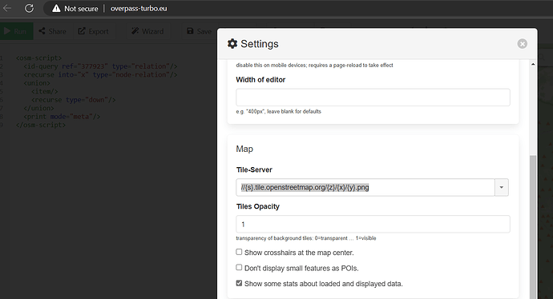
1 Reply
image1382×750 52.5 KB
- Visualize ecoregions as map background
kuedaiNaturalist Staff

Jan 18
 pisum:
allow users to set their own custom tile set and opacity via settings. i wonder if something like that could be done for a “custom” basemap layer in iNat?
The most minimal intervention I can think of is something along these lines, because it addresses the issue of OSM providing better data than Google in some places, but it does not address the issue of operating completely independently from Google for people in China or people who don’t want to constantly send their IP address to Google. The software to display map data from any source still comes from Google, as in every time you load an observation detail page, you’re loading Google Maps software from Google to show that map, even if the map data comes from an OSM server via a custom overlay or custom basemap.
It would be nice to rebuild our mapping system to use Leaflet (like overpass turbo does) or some other open source mapping system, but then we can’t show Google data, because you’re only allowed to show Google map tiles with Google software (yes, I realize many people do this anyway, but that’s a violation of Google’s terms, particularly 3.2.2 (d) and (e)).
Which leaves us with the unpleasant alternative of maintaining two separate mapping systems, one with Google map tiles and one without.
1 Reply
pisum
kueda
Jan 18
right. i wasn’t suggesting this would fix the China-Google problem. (that seems to be something that realistically needs to be handled politically.) i was just thinking about your question of which set of OSM tiles folks liked. if you were keeping the Google mapping framework but offering folks outside the Great Firewall a third basemap option that is non-Google, then you wouldn’t need folks to decide upfront which version of OSM tiles works best for the greatest number of people. you could just pick one as the default, and folks who want to use a different set could just override that default with whichever set they preferred.

Reply

Suggested Topics

Topic | Replies | Views | Activity
Add Projects filter to Collection Projects, and Places filter to Umbrella Projects.  Feature Requests | 1 | 111 | Feb 3
Package metadata with csv on observations/export  Feature Requests  github-issue-made | 6 | 334 | 4d
Make Annotations correctable, not just marked “Disagree”  Feature Requests  under-review | 13 | 688 | Aug '22
Add interpolating-coordinates to GUI for observations without location  Feature Requests | 5 | 2.3k | Dec '22
Improve (or remove) process for adding cascading conservation status  Feature Requests  webunder-review | 1 | 757 | 9d

Want to read more? Browse other topics in Feature Requests or view latest topics.

iNaturalist.org · Community Guidelines · Terms of Service · Privacy Policy

