The effect of nut consumption (tree nuts and peanuts) on the gut microbiota of humans: a systematic review
Published online by Cambridge University Press: 27 July 2020
Emily Fitzgerald,
Kelly Lambert,
Jordan Stanford and
Elizabeth P. Neale
Show author details

- Article
- Figures
- Supplementary materials
- Metrics
Save PDF
Share
CiteRights & Permissions
[Opens in a new window]

Abstract

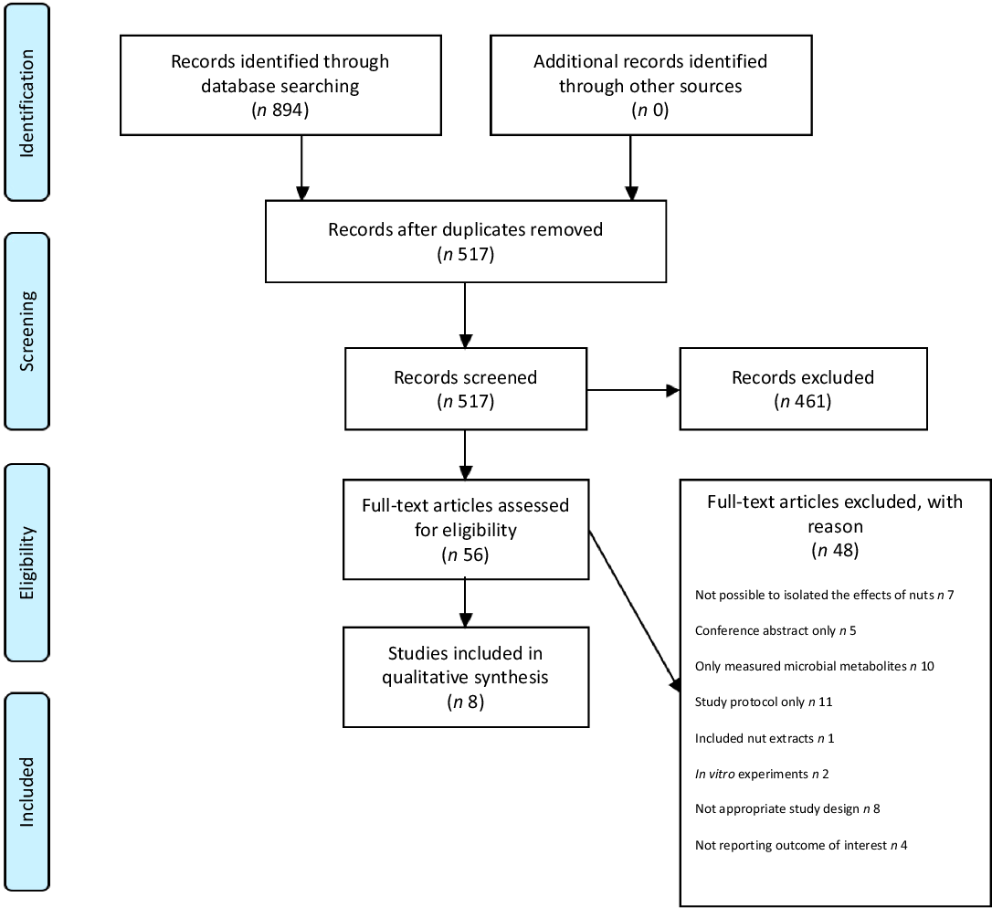
There is increasing evidence linking the gut microbiota to various aspects of human health. Nuts are a food rich in prebiotic fibre and polyphenols, food components which have been shown to have beneficial effects on the gut microbiota. This systematic review aimed to synthesise the evidence regarding the effect of nut consumption on the human gut microbiota. A systematic search of the databases MEDLINE, PubMed, Cochrane CENTRAL and CINAHL was performed until 28 November 2019. Eligible studies were those that investigated the effects of nut consumption in humans (aged over 3 years old), utilising next-generation sequencing technology. Primary outcome measures were between-group differences in α- and β-diversity metrics and gut microbial composition. A total of eight studies were included in the review. Included studies assessed the effects of either almonds, walnuts, hazelnuts or pistachios on the gut microbiota. Overall, nut consumption had a modest impact on gut microbiota diversity, with two studies reporting a significant shift in α-diversity and four reporting a significant shift in β-diversity. Walnuts, in particular, appeared to more frequently explain shifts in β-diversity, which may be a result of their unique nutritional composition. Some shifts in bacterial composition (including an increase in genera capable of producing SCFA: Clostridium, Roseburia, Lachnospira and Dialister) were reported following the consumption of nuts. Nut intake may yield a modulatory effect on the gut microbiota; however, results were inconsistent across studies, which may be explained by variations in trial design, methodological limitations and inter-individual microbiota.

Keywords
NutsGut microbiomeGut microbiotaPrebioticsSystematic reviewsDNA sequencing

Type
Systematic Review and Meta-Analysis
Information
British Journal of Nutrition , Volume 125 , Issue 5 , 14 March 2021 , pp. 508 - 520
DOI: https://doi.org/10.1017/S0007114520002925
[Opens in a new window]
Copyright
© The Author(s), 2020. Published by Cambridge University Press on behalf of The Nutrition Society
The gut microbiome is a rapidly expanding area of human research(1). While often used interchangeably(2), the term gut ‘microbiome’ refers to all of the microbial genes that reside inside the gastrointestinal tract, while the microbes themselves are collectively known as the ‘microbiota’. Being a complex and metabolically active ecosystem, these microbes generally maintain a symbiotic relationship with the host and participate in a number of beneficial functions within the body. These include the synthesis of vitamins(3), regulating the immune system(4) and production of SCFA, which are a key energy source for colonic epithelial cells(5). Interestingly, several health conditions have been linked with alterations in the gut microbiota populations, including type 2 diabetes(6,7) , obesity(8,9) and inflammatory bowel disease(10); however, it is unclear if this dysbiosis is a cause or consequence of the disease(11).
Reference Cani
Reference Knight, Callewaert and Marotz
Reference LeBlanc, Milani and de Giori
Reference Chu and Mazmanian
Reference Ramakrishna
Reference Larsen, Vogensen and van den Berg
Reference Qin, Li and Cai
Reference Ley, Turnbaugh and Klein
Reference Turnbaugh, Hamady and Yatsunenko
Reference Morgan, Tickle and Sokol
Reference Fischbach
Relatively recent advancements in techniques used to characterise the composition of the microbiota have provided a greater understanding of host–gut microbiota metabolic interactions and its subsequent effect on human physiology. Since 2005, advancements in microbial determination methods, in particular high-throughput sequencing techniques, have vastly improved the understanding of the gut microbiota, by allowing a more comprehensive investigation of phylogenetic composition and quantification(12). Examples of this technology include the next-generation sequencing of the 16s rRNA gene or its amplicons, which are based on sequence divergences of the small subunit rRNA(13).
Reference Fraher, O’Toole and Quigley
Reference Allaband, McDonald and Vazquez-Baeza
Given the potential impact of the gut microbiome on human health and disease, there is a need to identify foods which may support a healthy microbiome. Previous research has shown that prebiotic fibres are a key substrate facilitating change in the microbiome(14). In humans, prebiotic fibre escapes digestion in the small intestine and instead passes into the colon where it is used as a substrate by the microbes. Here, it stimulates the growth of specific organisms leading to the production of different metabolites, including the SCFA butyrate, which confers health benefits to the host(15).
Reference So, Whelan and Rossi
Reference Holscher
Nut consumption is associated with many positive health benefits(16). Both epidemiological studies and clinical trials have linked frequent nut consumption to a reduced risk of developing type 2 diabetes(17) and CHD(18), as well as a reduction in cardiovascular risk factors such as hypertension(19) and the promotion of a more beneficial lipid profile(20). Nuts are nutrient dense and contain high amounts of plant-based protein, unsaturated fatty acids, vitamins, minerals and other phytochemicals(21). Nuts have the second highest fibre content of all foods per 100 g, behind cereals(22). Nuts are also a food source rich in polymerised polyphenols(23), resistant starch(24) and NSP(25), which appear to have a prebiotic effect. Additionally, walnuts are particularly high in n-3 fatty acids, with preliminary research classifying these fatty acids as prebiotics(26). While the health benefits of nuts may in part be due to their unique nutritional composition, the exact mechanism by which nuts exert this range of beneficial health effects remains unclear. Previous trials have examined the specific microbial shifts that occur with nut consumption(27–34); however, due to inconsistency of study findings, there is a need to evaluate the evidence base. The present systematic review aimed to synthesise the existing evidence regarding the effect of nut consumption (tree nuts and peanuts) on the gut microbiota of humans. We hypothesise that due to the array of prebiotic compounds, supplementation of the diet with nuts promotes the proliferation of beneficial microbial species, leading to favourable changes in the gut microbiota.
Reference Ros
Reference Viguiliouk, Kendall and Blanco Mejia
Reference Kris-Etherton, Hu and Ros
Reference Mohammadifard, Salehi-Abargouei and Salas-Salvado
Reference Griel and Kris-Etherton
Reference Brufau, Boatella and Rafecas
Reference Marlett
Reference Lamuel-Raventos and Onge
Reference Fuentes-Zaragoza, Sánchez-Zapata and Sendra
Reference Sargautiene, Nakurte and Nikolajeva
Reference Costantini, Molinari and Farinon
Reference Holscher, Guetterman and Swanson
Reference Ukhanova, Wang and Baer

Methods
This systematic review was reported according to the guidelines of the Preferred Reporting Items for Systematic Reviews and Meta-Analysis statement(35). The review protocol was prospectively registered in PROSPERO (International Prospective Register of Systematic Reviews) protocol no. CRD42019127318.
Reference Moher, Liberati and Tetzlaff

Literature search
A systematic search of the electronic databases MEDLINE (EBSCO), PubMed, Cochrane CENTRAL and CINAHL (EBSCO) was performed until 28 November 2019, using a combination of MeSH and individual search terms. No date or language restriction was applied in the search strategy. In conjunction with searching the electronic databases, additional hand searching of the reference lists of relevant articles was also performed. An example search strategy is presented in online Supplementary Data 1.

Study selection
All search results were exported from the electronic databases into the reference management software ENDNOTE (X9; Thomson Reuters), and duplicates were then removed. Eligible studies were identified by two review authors (EF and EN) who screened articles independently based on title and abstract. Full texts were then retrieved, and the eligibility criteria were applied to the full-text articles. Discrepancies were resolved by consensus or consultation with a third party (KL).
Studies were included if they met all of the following criteria: (1) human studies involving participants aged more than 3 years old. This broad age range was used due to findings showing that the gut microbiota of children resembles that of an adult after 3 years of age(36); (2) nuts were administered in their whole form or minimally processed to still contain all components of the whole nut (e.g. nut butters, roasted, ground or chopped nuts); (3) consumption of nuts was compared with no consumption of nuts or a lower quantity of nuts; (4) study design was in the form of randomised or non-randomised experiments, cross-sectional or cohort studies and (5) outcomes were measured using next-generation DNA sequencing technologies, including both targeted amplicon sequencing and shotgun metagenomics. Studies were restricted to those that used these methods as they provide the most comprehensive analysis of the microbiota, enabling taxonomic quantification and identification. Additionally, limiting to these methods provided a means of promoting homogeneity between study results, considering the range of microbiota characterisation techniques available and the subsequent differences in reporting of outcome measurements(12).
Reference Yatsunenko, Rey and Manary
Reference Fraher, O’Toole and Quigley
In addition to the inclusion criteria outlined above, the following exclusion criteria were applied: (1) in vitro experiments and animal studies due to the limited applicability of these results to the human microbiota, (2) experiments where nut intake could not be isolated from other interventions (e.g. other dietary interventions) and (3) studies which only measured changes in the microbiota-related metabolites. In addition, studies which included both nuts in their whole form and isolated nut components (such as oils or extracts) were only included if data from nuts in their whole form could be differentiated.

Outcome measures
Primary outcome measures were between-group differences in α- and β-diversities, as well as statistically significant differences in the taxonomic composition and microbial abundances at specific taxonomic levels (phylum, class, order, family, genus or ‘operational taxonomic units’ (OTU). α-Diversity is a measure of within-sample (or community) diversity, taking into account the richness and/or evenness of the microbes present(37). β-Diversity is a measure of microbial dissimilarity between samples or sites, describing how many taxa are shared between samples(38).
Reference Lozupone and Knight
Reference Morgan and Huttenhower

Data extraction and quality assessment
A tabular summary was developed for the data extraction process, which included the population, study design and duration, nut type format and dosage, method of microbiota determination and results. Only significant findings (P < 0·05) from each study reporting changes in microbial composition following nut intake were recorded. The quality of included studies was assessed using the Quality Criteria Checklist and Risk of Bias Assessment Tool by the Academy of Nutrition and Dietetics(39).

Results

Summary of included studies
Searches of the electronic databases returned 894 articles, of which fifty-six were evaluated after removal of duplicates and screening of records. A final eight studies met the eligibility criteria and were included in the present review. The above study selection process is summarised in the Preferred Reporting Items for Systematic Reviews and Meta-Analysis 2009 Flow Diagram (Fig. 1) with the included studies summarised in Table 1 and described below. For all studies, significant shifts (P < 0·05) in microbial composition following nut intake are summarised in Table 2.

Fig. 1. Preferred Reporting Items for Systematic Reviews and Meta-Analyses (PRISMA) flow diagram of study selection.
Table 1. Characteristics of included trials examining the effect of nut consumption on the gut microbiota
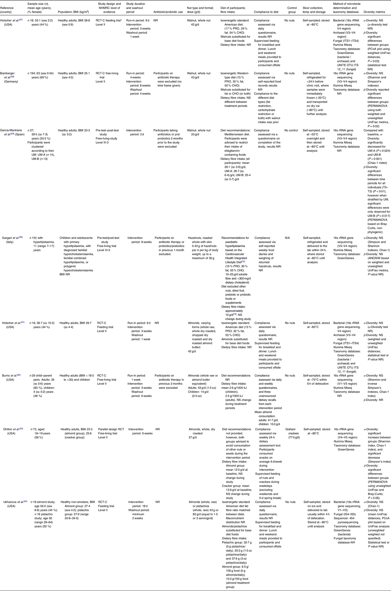
RCT-C, randomised controlled trial (cross-over); NHMRC, National Health and Medical Research Council; NR, not reported; PRO, protein; CHO, carbohydrate; OTU, operational taxonomic unit; PCoA, principal coordinate analysis; RCT, randomised controlled trial; UM, urolithin metabotype.
* ‘Feeding trial’ as described above relates to trials in which 100 % of all food consumed during the study duration is provided to participants.
† This study also used fifteen age-matched normolipidaemic controls which were not included in the analysis.
Table 2. Significant shifts in the gut microbial composition following nut intake

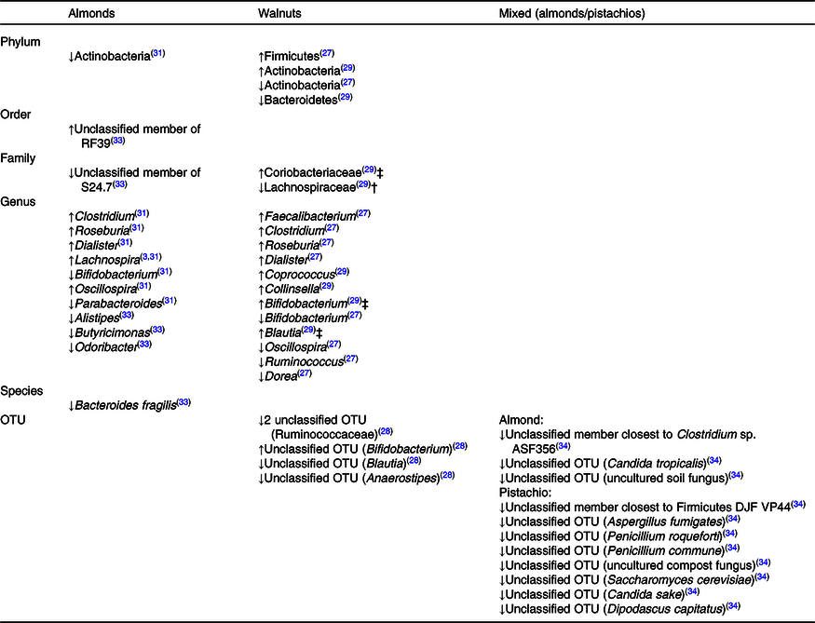
↓, Reported decrease in abundance/relative abundance; ↑, reported increase in abundance/relative abundance; OTU, operational taxonomic unit.
† Results for UM-A only.
‡ Results for UM-B only.
Five of the eight studies were randomised controlled cross-over trials(27,28,31,32,34) with the population group being healthy adults, one of which also included healthy children(32). All of these studies utilised a washout period, ranging from 1 to 6 weeks, in between treatment periods. The remaining three studies consisted of a parallel design randomised controlled trial(33) and two pre-test/post-test studies(29,30) . Studies were predominantly published in the USA(27,31–34) (n 5/8), with one being published in Germany(28), one in Italy(30) and one in Spain(29). Sample sizes ranged from n 15 to 194, with the proportion of female participants in each study ranging from 28 to 83 %. Feeding periods within studies ranged from 3 d to 8 weeks, with overall study length ranging from 3 d up to 24 weeks. Three studies examined the effect of whole walnut consumption on the gut microbiota(27–29), one study utilised whole roasted hazelnuts(30), three studies(31–33) investigated almonds in varying forms of the whole nut and one study utilised both whole almonds or pistachios(34). Nut dose in adult participants varied from approximately one serving (33 g/d) up to two servings daily (84 g), with the dosage being adapted for children. In most studies, the rationale for nut dosage was due to this serving size (42 or 43 g, or 1·5 oz) being consistent with the US Food and Drug Administration qualified health claim for nuts and CVD(40).
Reference Holscher, Guetterman and Swanson
Reference Bamberger, Rossmeier and Lechner
Reference Holscher, Taylor and Swanson
Reference Burns, Zitt and Rowe
Reference Ukhanova, Wang and Baer
Reference Burns, Zitt and Rowe
Reference Dhillon, Li and Ortiz
Reference Garcia-Mantrana, Calatayud and Romo-Vaquero
Reference Gargari, Deon and Taverniti
Reference Holscher, Guetterman and Swanson
Reference Holscher, Taylor and Swanson
Reference Ukhanova, Wang and Baer
Reference Bamberger, Rossmeier and Lechner
Reference Gargari, Deon and Taverniti
Reference Garcia-Mantrana, Calatayud and Romo-Vaquero
Reference Holscher, Guetterman and Swanson
Reference Garcia-Mantrana, Calatayud and Romo-Vaquero
Reference Gargari, Deon and Taverniti
Reference Holscher, Taylor and Swanson
Reference Dhillon, Li and Ortiz
Reference Ukhanova, Wang and Baer
Reference Taylor
All eligible studies assessed the gut microbiota using high-throughput sequencing technology, with all studies sequencing the 16s rRNA gene to determine bacterial composition. Seven studies used the Illumina Miseq(27–33), whereas one used 454-based pyrosequencing platform(34). In addition, three studies reported on microbial communities other than bacteria with one study also sequencing fungal DNA(34) (using primers directed against the IS4 and IS5 inter-spacer regions), and two studies sequencing both fungal (ITS1–ITS4) and archaeal (16s rRNA gene using 349f/806r primers) DNA(27,31) . All studies measured α-diversity using one or a combination of indices (Simpson’s index, Shannon index, Chao-1 index, Faith’s phylogenic diversity or observed OTU). Reported measures of β-diversity used across included studies were the UniFrac and Bray-Curtis distance metrics.
Reference Holscher, Guetterman and Swanson
Reference Dhillon, Li and Ortiz
Reference Ukhanova, Wang and Baer
Reference Ukhanova, Wang and Baer
Reference Holscher, Guetterman and Swanson
Reference Holscher, Taylor and Swanson
Using the Academy of Nutrition and Dietetics Evidence Analysis Manual Quality Criteria Checklist, six of the eight studies were deemed to be of positive quality(27,28,30,31,33,34) with the remaining two studies(29,32) found to be of neutral quality (online Supplementary Data 2).
Reference Holscher, Guetterman and Swanson
Reference Bamberger, Rossmeier and Lechner
Reference Gargari, Deon and Taverniti
Reference Holscher, Taylor and Swanson
Reference Dhillon, Li and Ortiz
Reference Ukhanova, Wang and Baer
Reference Garcia-Mantrana, Calatayud and Romo-Vaquero
Reference Burns, Zitt and Rowe

Microbiota diversity metrics and bacterial composition, by nut type

Walnuts
Following consumption of 42 g of walnuts per d for 3 weeks, Holscher et al.(27) found no significant shifts in α-diversity, a measure of within-sample diversity; however, bacterial communities were significantly affected by walnut consumption when β-diversity, a measure of microbial dissimilarity between samples was analysed, as evidenced by a weighted principal coordinate analysis of UniFrac distances (P = 0·03). No significant differences in fungal or archaeal abundances were found following walnut intake. A significant decrease in the relative abundance of Actinobacteria was observed, with the relative abundance of Firmicutes significantly increasing. At the genus level, an increased relative abundance of the genera Faecalibacterium, Clostridium, Roseburia (Clostridium clusters XIVa and IV) and Dialister (49–160 % higher relative abundance) was found, whereas the relative abundances of the genera Ruminococcus, Dorea, Oscillospira and Bifidobacterium were significantly decreased (16–38 % lower relative abundance).
Reference Holscher, Guetterman and Swanson
Utilising 43 g of walnuts per d over an 8-week period, Bamberger et al. (28) reported a significant shift in β-diversity only. Using the generalised UniFrac distance metric and the PERMANOVA statistical test, significant dissimilarity of approximately 5 % between the walnut and control groups (P = 0·02) was found. No significant differences in predominant phyla or the Firmicutes:Bacteroidetes ratio were observed. Significant shifts in the relative abundance could be seen in four OTUs, which are clusters of similar sequences used to categorise bacteria, of the phyla Firmicutes and one OTU of the phyla Actinobacteria, which decreased. A significant increase was found in two unclassified OTUs from the Ruminococcaceae family (P < 0·02), as well as an increase in an OTU from the Bifidobacterium genus (P < 0·02). A significant decrease was found in the relative abundance of two OTUs, Anaerostipes (P < 0·01) and Blautia (P = 0·04) from the Lachnospiraceae family.
Reference Bamberger, Rossmeier and Lechner
Garcia-Mantrana et al.(29) examined the effects of 33 g walnuts per d for 3 d on the gut microbiota, reporting results considering all participants, as well as according to the urolithin metabotype (UM) of participants, a measure of how ellagitannins metabolise to urolithins via the gut microbiota. According to their urinary urolithin concentrations, participants were classified as either UM-A (characterised by the production of urolithin-A), UM-B (characterised by the production of urolithin-B) or UM-0, whereby no urolithins were produced. Local diversity (Chao-1 index) significantly decreased for both UMs after walnut consumption and a redundancy analysis of all individuals revealed that bacterial communities were significantly affected by walnut intake (P = 0·001). However, when results were reported according to UM, these shifts were only significant for UM-B (P = 0·017), suggesting that UM-B was likely a driver of overall significance. Considering the microbial composition, walnut intake significantly decreased the relative abundance of Bacteroidetes, while increasing the abundance of Actinobacteria. Participants classed as UM-A exhibited a significant decrease in the Lachnospiraceae family, as well as a significant increase in the genera Coprococcus and Collinsela. Participants classed as UM-B exhibited a significant increase in the Coriobacteriaceae family, as well as significant increases in the genera Coprococcus, Collinsella, Bifidobacterium and Blautia.
Reference Garcia-Mantrana, Calatayud and Romo-Vaquero

Almonds
Dhillon et al.(33) examined the effects of 57 g roasted almonds intake on the gut microbiota over 6 weeks, with graham crackers being given to the control group. When considering α-diversity, almond feeding resulted in significant increases in the Chao-1 index, observed OTUs and Shannon index, while the Simpson’s index was significantly decreased. Similarly, significant differences in β-diversity between treatment groups were identified according to unweighted UniFrac distance and Bray-Curtis dissimilarity metrics. A significant increase was found in bacteria belonging to the RF39 order, as well as a significant decrease in bacteria belonging to the S24.7 family. At the genus level, a significant decrease in Alistipes, Butyricimonas and Odoribacter was observed, with a significant increase in the genera Lachnospira. At the species level, a 48 % decreased relative abundance of Bacteroides fragilis was reported.
Reference Dhillon, Li and Ortiz
Holscher et al.(31) utilised 42 g of almonds per d in varying forms over five 3-week diet periods (whole, raw, whole dry roasted, chopped, dry roasted and dry roasted almond butter), finding no significant shifts in microbial diversity measures. Further, no significant differences in fungal or archaeal abundances were found. Using pooled data, there were no significant differences in the Firmicutes:Bacteroidetes ratio; however, a significant decrease in the relative abundance of Actinobacteria was observed. Additionally, results revealed an increased relative abundance of the genera Roseburia, Clostridium, Dialister and Lachnospira. A decreased relative abundance of Parabacteroides and Bifidobacterium was also observed. When differentiating results by the impact of almond processing, it was found that chopped almonds increased the relative abundance of Lachnospira, Roseburia and Oscillospira, whole roasted almonds increased the relative abundance of Lachnospira and whole raw almonds increased the relative abundance of Dialister, with no difference between almond butter and controls.
Reference Holscher, Taylor and Swanson
Using both adult and children subjects, Burns et al.(32) used almonds (an option of whole raw almonds or almond butter equivalent) over two 3-week diet periods, with adults consuming 43 g/d and children 14 g/d. The present study found no significant change in microbial diversity or significant shifts at the phylum level. However, significant differences in the prevalence of unclassified bacterial signatures at the genus and species level were reported.
Reference Burns, Zitt and Rowe

Hazelnuts
Gargari et al.(30) investigated the effects of nut consumption on the microbiota over an 8-week period in both children and adults, using 0·43 g of hazelnuts per d per kg of body weight, up to a maximum of 30 g of hazelnuts per d. This was the only study to find no statistically significant differences in microbial diversity or composition of the gut microbiota.
Reference Gargari, Deon and Taverniti

Mixed intervention (almonds + pistachios)
Using a randomised, cross-over design, Ukhanova et al. (34) investigated the effects of both almond and pistachio consumption on the gut microbiota, utilising 0, 43 or 85 g/d (equal to 0, 1·5 or 3 serves) for three 18-d feeding periods. While no significant changes in α- or β-diversities were reported, the study did report the pistachio-consuming group to have a greater mean UniFrac distance (unspecified if weighted or unweighted metric used) compared with the almond-consuming group. This suggests that pistachios may have had a greater impact on the overall gut microbiota composition compared with almonds. While many OTUs were affected by nut consumption, only two were significantly decreased: one unspecified OTU closest to the Firmicutes bacterium DJF VP44 and the other unspecified OTU closest to Clostridium sp. ASF 356. Nut consumption did not significantly affect the proportion of the most dominant OTUs. As the present study also sequenced fungal DNA, it was found that while no fungal OTU was significantly increased, various fungal OTUs decreased in proportion (P < 0·01) with nut consumption.
Reference Ukhanova, Wang and Baer

Discussion
To our knowledge, this is the first study to systematically explore the overall microbiota-related changes related to nut consumption. This review establishes that while the evidence base is small, intake of nuts in the diet can exert a modulatory effect on the gut microbiota; however, the exact effects were inconclusive across studies.
Microbial diversity has been shown to be a key predictor of gut health, as greater diversity often equates to greater resilience of the community to recover from or adjust to disturbances(41). On the contrary, a loss of species diversity and an imbalance in the gut’s microbial community, or ‘dysbiosis’, has commonly been found in several disease states(9,42) . The present systematic review found that nut intake may have a modest effect on the diversity of the gut microbiota, with two(29,33) of the eight total studies reporting a significant change in α-diversity (one showing a decrease in diversity(29)), and four(27–29,33) reporting a significant change in β-diversity. The lack of effect on α-diversity found in this review is similar to the results of another systematic review on dietary fibre(14), where short-term feeding studies of dietary fibre in various forms did not increase α-diversity. Furthermore, these findings are also comparable to other dietary intervention studies using whole grains(43,44) . Interestingly, one study(29) included in this review observed a decrease in α-diversity following a 3-d walnut feeding intervention, a result comparable to findings from a short-term dietary intervention advising increased fibre intake(45). The researchers suggested this temporary reduction in diversity may be due to the rapid dietary change causing disruption to the microbial composition, termed the ‘shock effect’. However, these results are in contrast to previous observational studies that explore the relationship between overall dietary pattern and gut microbiota diversity. For example, adherence to the Mediterranean diet has been associated with increased gastrointestinal bacterial α-diversity(46,47) , a finding of particular relevance given that nuts are a key component of this dietary pattern. Given that it has been shown that diet-induced shifts in the gut microbiota occur within 3–4 d after a change in diet(48), the discrepancies observed between the short-term interventional trials included in this review and previous observational studies which assess habitual diets are unlikely due to the study duration alone. Rather, the discrepancies might also be explained by the synergistic effect of an overall healthy dietary pattern, which appears to be a greater determinant of gastrointestinal health than just foods or nutrients in isolation.
Reference Heiman and Greenway
Reference Turnbaugh, Hamady and Yatsunenko
Reference Frank, St Amand and Feldman
Reference Garcia-Mantrana, Calatayud and Romo-Vaquero
Reference Dhillon, Li and Ortiz
Reference Garcia-Mantrana, Calatayud and Romo-Vaquero
Reference Holscher, Guetterman and Swanson
Reference Garcia-Mantrana, Calatayud and Romo-Vaquero
Reference Dhillon, Li and Ortiz
Reference So, Whelan and Rossi
Reference Vuholm, Nielsen and Iversen
Reference Vanegas, Meydani and Barnett
Reference Garcia-Mantrana, Calatayud and Romo-Vaquero
Reference Klimenko, Tyakht and Popenko
Reference Garcia-Mantrana, Selma-Royo and Alcantara
Reference De Filippis, Pellegrini and Vannini
Reference Walker, Ince and Duncan
Given the variation in the composition of different nut types, consideration of study results by nut type was warranted. Different nut types offer unique nutritional profiles, with altered ratios of fibre, proteins, fat, micronutrients and other bioactive molecules including polyphenols. Of all the nuts investigated in the review, walnuts appeared to more frequently explain variations in the overall gut microbial composition between study participants, with all three of the walnut studies reporting a significant shift in relevant β-diversity metrics. While it is difficult to draw conclusions from this due to the small sample size, the unique nutritional composition of walnuts as a potential modulator of the gut microbiota should be considered and further explored in larger interventional trials. For example, walnuts have a particularly high ellagitannin (a type of polyphenol, the basic structure being ellagic acid) content compared with other nuts(49). It has been shown that gastrointestinal bacteria can metabolise ellagic acid to produce urolithins, which can have beneficial vascular and anti-inflammatory effects(50,51) , although studies supporting the role of ellagitannins as a prebiotic are inconclusive(52,53) . Further, it has been shown that different UMs can affect the metabolism and bioactivity of polyphenols, as demonstrated by Garcia-Mantrana et al.(29). Walnuts are also particularly rich in the n-3 essential fatty acid α-linolenic acid(54). Preliminary research on n-3 supplementation in humans has found these fatty acids to exert significant effects on gut microbial composition, with the authors concluding n-3 PUFA may be classified as prebiotics(26). It should be acknowledged that much of this research was performed using EPA and DHA, which may be synthesised, albeit often inefficiently, from α-linolenic acid (55). As a result, the extent to which α-linolenic acid acts as a possible modulator of the gut microbiota remains still unclear.
Reference Abe, Lajolo and Genovese
Reference Larrosa, Garcia-Conesa and Espin
Reference Papoutsi, Kassi and Chinou
Reference Li, Summanen and Komoriya
Reference Puupponen-Pimiä, Seppänen-Laakso and Kankainen
Reference Garcia-Mantrana, Calatayud and Romo-Vaquero
Reference Maguire, O’Sullivan and Galvin
Reference Costantini, Molinari and Farinon
Reference Burdge and Calder
In the present review, alterations in the gut microbiota profile were reported across a range of different phylogenic categories, although a lack of consistency across studies was observed. Nevertheless, some interesting patterns were observed relating to Bifidobacterium spp. and the SCFA butyrate, which warrants further discussion. Members of the genus Bifidobacterium are normal inhabitants of the human gastrointestinal tract and have demonstrated positive health benefits(56), largely due to their production of acetate, which has anti-inflammatory effects and is used by cross-feeding species as a co-substrate for the production of butyrate(57). Additionally, research has shown that the loss of Bifidobacterium species in the gastrointestinal tract has been associated with poor bowel outcomes(58). Given that previous research has found an increased abundance of Bifidobacterium with increased fibre(14) and polyphenol(59,60) intake, the addition of nuts to the diet may have been expected to produce a bifidogenic effect; however, this effect was inconsistent. Rather, two studies(27,31) reported a decreased abundance of Bifidobacterium, one(29) reported a significant increase in Bifidobacterium for UM-B (when stratified by UM), and one(28) found an increase in one OTU from the Bifidobacterium genus. The possible detrimental impact of walnut consumption on Bifidobacterium may be explained by inhibition of Bifidobacterium animalis spp. lactis in the presence of ellagic acid. However, this finding is not universal to the Bifidobacterium genus and appears to be species-specific(61). Further, this hypothesis would not explain the findings of Holscher et al.(31), which observed a decreased abundance of Bifidobacterium following almond consumption. One significant gap in the evidence base which may help explain these findings is the use of more sophisticated multi-omic methods (e.g. shotgun sequencing and metabolomics), a crucial step in explaining both the functional potential of the microbiota and the types of metabolites these microbes can produce.
Reference O’Callaghan and van Sinderen
Reference Belenguer, Duncan and Calder
Reference Grimm, Westermann and Riedel
Reference So, Whelan and Rossi
Reference Jin, Touyama and Hisada
Reference Vendrame, Guglielmetti and Riso
Reference Holscher, Guetterman and Swanson
Reference Holscher, Taylor and Swanson
Reference Garcia-Mantrana, Calatayud and Romo-Vaquero
Reference Bamberger, Rossmeier and Lechner
Reference Bialonska, Kasimsetty and Schrader
Reference Holscher, Taylor and Swanson
Findings of the present review are in contrast to the results of a recent review by So et al. (14), which found that prebiotic fibre supplementation consumption increased Bifidobacterium species. Interestingly, subgroup analysis which separated the effects of isolated fibres from whole foods found that whole-food intervention of mostly grains and cereals had no effect on Bifidobacterium abundances(14). However, the impact of whole foods v. isolated food components on Bifidobacterium populations is not consistent across studies. Mandalari et al.(62) highlighted the likely importance of using whole-food interventions over isolated fibres, demonstrating that when almonds were consumed with all constituent parts present (in comparison with almonds with the lipid content removed), a significant increase in the abundance of Bifidobacterium was observed. Taken together, these results suggest a lack of consistency for the effects of whole foods on the gut microbiota, highlighting the need for further research exploring the comparative effect of whole foods and food constituents.
Reference So, Whelan and Rossi
Reference So, Whelan and Rossi
Reference Mandalari, Nueno-Palop and Bisignano
The SCFA butyrate is mainly produced by members of the Firmicutes family including Roseburia spp. Lachnospira spp. and Faecalibacterium prausnitzii, which belong to the clostridium clusters XIVa and IV(63). Butyrate is a major source of energy for the colonic epithelial cells and has many well-documented health effects, including the inhibition of colonic carcinogenesis and acting as an anti-inflammatory agent(64). The present review found two studies(27,31) to report a significantly increased abundance of Clostridium and Roseburia, another two studies(31,33) to report a significantly increased abundance of Lachnospira and one study(34) to report a significant increase in an OTU closest to Clostridium sp. ASF-356. Studies in vitro have found that finely ground almonds increase concentrations of butyrate(62) and that Roseburia may be a major contributor to the butyrate-producing capacity of the gastrointestinal tract(65). As an increased abundance of specific butyrate-producing species was observed in the included trials listed above, it may be inferred that this potentially resulted in a butyrogenic effect, although further research utilising metabolomic analysis is required to confirm this. In contrast to these findings, one study(27) included in the review did report finding no difference in the predicted number of bacterial butanoate metabolism genes following walnut consumption, potentially explained by a proportionate decrease in other butyrate-producing species during the feeding period. Indeed, considering changes in the microbiota as a whole may be a better indicator of the overall metabolomic capacity of the microbiota, rather than focusing on the isolated microbial shift in individual taxa.
Reference Louis and Flint
Reference Canani, Costanzo and Leone
Reference Holscher, Guetterman and Swanson
Reference Holscher, Taylor and Swanson
Reference Holscher, Taylor and Swanson
Reference Dhillon, Li and Ortiz
Reference Ukhanova, Wang and Baer
Reference Mandalari, Nueno-Palop and Bisignano
Reference Pryde, Duncan and Hold
Reference Holscher, Guetterman and Swanson
In addition to bacteria, the present review also summarised the overall effects of nut intake on fungal and archaeal populations, providing a more comprehensive picture of the human gut microbiota. While it has previously been reported that diet-induced shifts can modulate the populations of these microbes(66), the review found no significant changes to the diversity or the relative abundance of archaea, with only one study(34) to report a decrease in various fungal OTUs following nut intake. The small sample size of the review may account for the differences observed in these results, as only one study sequenced fungal DNA(34) and two studies sequenced both fungal and archaeal DNA(27,31) . Further research in this area is needed in order to form a more comprehensive understanding of fungal and archaeal activity with nut intake.
Reference Hoffmann, Dollive and Grunberg
Reference Ukhanova, Wang and Baer
Reference Ukhanova, Wang and Baer
Reference Holscher, Guetterman and Swanson
Reference Holscher, Taylor and Swanson
While exploring shifts in the microbiota according to nut type was the main focus of the review, other commonalities between studies were also investigated to identify patterns in results. One study characteristic of interest was the feeding method utilised. For example, three(27,31,34) of the eight studies were classified as complete feeding trials, whereby all food provided to participants was controlled (as opposed to free-living trials where nuts were often administered alongside general dietary recommendations). Interestingly, while shifts in microbial diversity were negligible (only one of the three studies reported a change in β-diversity), shifts in bacterial composition were notable. In particular, two studies(27,31) reported an increase in Clostridium, Roseburia and Dialister, all of which are known to be capable of producing SCFA(67,68) . In both studies, a run-in period of 9 d was used to allow for the adaptation of the participant’s gut microbiota following the change in habitual diet, increasing the likelihood of these changes being attributable to nut intake. While the small sample size limits the broader interpretation of these findings, these results highlight the importance of controlling for participants’ background diet as a significant variable.
Reference Holscher, Guetterman and Swanson
Reference Holscher, Taylor and Swanson
Reference Ukhanova, Wang and Baer
Reference Holscher, Guetterman and Swanson
Reference Holscher, Taylor and Swanson
Reference Guo, Zhang and Ma
Reference Koh, De Vadder and Kovatcheva-Datchary
This review followed a robust methodology, including prospective registration of the review protocol and duplicate screening and inclusion of articles. Additionally, the review only included trials employing next-generation sequencing technology, to ensure the most comprehensive analysis of the microbiota reflecting current analytical techniques, and a means of promoting homogeneity between results. The implementation of this exclusion criteria did mean that the evidence base for analysis was smaller, as trials utilising other microbial determination techniques were excluded (such as bacterial culturing and fluorescence in situ hybridisation). As a limitation, the systematic search was restricted to scientific databases, which may have meant that unpublished studies were not detected. Further, the present review did not assess the metabolomic capacity of the gut microbiota including the measurement of SCFA, meaning interpretation of results is limited due to the challenge of connecting microbial shifts to metabolic pathway activity and health outcomes(69). The high level of heterogeneity between studies should also be acknowledged, including the collection and processing of biological samples, sequencing platform and computational pipelines used. Also, papers differed in their statistical analysis and reporting of gut microbial data, including the presentation of findings for different diversity metrics or only at certain taxonomic levels. Well-designed interventional trials with larger sample sizes, reproducible methods and reporting of results are still needed to exemplify the exact effect of nuts on the gut microbiota.
Reference Bunesova, Vlkova and Rada
Despite the small number of studies in this review, a large variation in results was observed. This may be due to the intrinsically complex nature of microbiome research, with marked differences in the inter-individual variation of subject’s gut microbiota previously observed(48). Despite strategies to decrease this variation such as the use of cross-over study designs and excluding participants with gastrointestinal disease or those on recent antibiotic therapy, large variations in the composition and function of individual’s microbiota remain. Previous research has indicated that an individual’s response to any dietary intervention is largely dependent upon their established gut microbiota(70). Given these findings, and the knowledge that a patient’s habitual diet and food diversity is a major determinant of their gut microbiota(71), a more rigorous screening and selection process including pre-intervention dietary analysis may be warranted in an attempt to reduce the inter-microbial differences of individual’s microbiota at baseline. In addition, several limitations in the design of several included studies may have impacted results – for example, a lack of reporting of baseline nut consumption. Therefore, robust study designs which take into account an individual’s baseline dietary intake, as well as considering inter-individual gut microbiota differences are required.
Reference Walker, Ince and Duncan
Reference Martinez, Lattimer and Hubach
Reference De Filippo, Cavalieri and Di Paola

Conclusion
This review suggests that nut intake has the potential to yield a modest effect on the gut microbiota, although the exact effects are inconsistent across studies. Compared with other nut types, walnuts appeared to be the strongest driver of overall gut microbial composition (β-diversity), which may be explained by their unique nutritional composition. Walnuts are rich in polyphenols and n-3 fatty acids, both of which have been found to have prebiotic properties. Overall, it appears gut microbial composition is more affected by nut intake during short-term feeding trials than overall microbial diversity, although the small sample size of this review limits interpretation. Further, whether these compositional changes translate into tangible health outcomes remains to be investigated, ideally with the use of more sophisticated multi-omic methods, such as metagenomic and metabolomic technology to evaluate the overall functional capacity of the microbiota. Inconsistencies associated with trial design and methodology, as well as inter-individual microbiota variances and the vast number of potential confounding variables present in this field of research further complicate interpretation of the results. Future trials aiming to explore the influence of nut intake on the gut microbiota must carefully consider study design, ideally incorporating complete feeding methods with a single food or nutrient modification. Additionally, an assessment of habitual dietary pattern and baseline microbiota composition is recommended in order to minimise the inter-individual composition of the gut microbiota.

Acknowledgements
No financial support for this research was received.
E. F., E. P. N. designed the study; E. F., E. P. N. conducted study screening, application of eligibility criteria and data extraction, with guidance from K. L. and J. S.; E. F. drafted the manuscript; E. F., E. P. N. and K. L., J. S. provided critical review of the manuscript.
E. F., K. L. and J. S. declare they have no competing interests. E. P. N. has previously received funding or hold current grants from Nuts for Life, the International Nut and Dried Fruit Council, and the California Walnut Commission.

Supplementary material
For supplementary materials referred to in this article, please visit https://doi.org/10.1017/S0007114520002925

References
1
Cani, PD (2018) Human gut microbiome: hopes, threats and promises. Gut 67, 1716–1725.CrossRefGoogle ScholarPubMed
2
Knight, R, Callewaert, C, Marotz, C, et al. (2017) The microbiome and human biology. Annu Rev Genomics Hum Genet 18, 65–86.CrossRefGoogle ScholarPubMed
3
LeBlanc, JG, Milani, C, de Giori, GS, et al. (2013) Bacteria as vitamin suppliers to their host: a gut microbiota perspective. Curr Opin Biotechnol 24, 160–168.CrossRefGoogle ScholarPubMed
4
Chu, H & Mazmanian, SK (2013) Innate immune recognition of the microbiota promotes host–microbial symbiosis. Nat Immunol 14, 668–675.CrossRefGoogle ScholarPubMed
5
Ramakrishna, BS (2013) Role of the gut microbiota in human nutrition and metabolism. J Gastroenterol Hepatol 28, Suppl. 4, 9–17.CrossRefGoogle ScholarPubMed
6
Larsen, N, Vogensen, FK, van den Berg, FW, et al. (2010) Gut microbiota in human adults with type 2 diabetes differs from non-diabetic adults. PLoS ONE 5, e9085.CrossRefGoogle ScholarPubMed
7
Qin, J, Li, Y, Cai, Z, et al. (2012) A metagenome-wide association study of gut microbiota in type 2 diabetes. Nature 490, 55–60.CrossRefGoogle ScholarPubMed
8
Ley, RE, Turnbaugh, PJ, Klein, S, et al. (2006) Microbial ecology: human gut microbes associated with obesity. Nature 444, 1022–1023.CrossRefGoogle ScholarPubMed
9
Turnbaugh, PJ, Hamady, M, Yatsunenko, T, et al. (2009) A core gut microbiome in obese and lean twins. Nature 457, 480–484.CrossRefGoogle ScholarPubMed
10
Morgan, XC, Tickle, TL, Sokol, H, et al. (2012) Dysfunction of the intestinal microbiome in inflammatory bowel disease and treatment. Genome Biol 13, R79.CrossRefGoogle ScholarPubMed
11
Fischbach, MA (2018) Microbiome: focus on causation and mechanism. Cell 174, 785–790.CrossRefGoogle ScholarPubMed
12
Fraher, MH, O’Toole, PW & Quigley, EM (2012) Techniques used to characterise the gut microbiota: a guide for the clinician. Nat Rev Gastroenterol Hepatol 9, 312–322.CrossRefGoogle Scholar
13
Allaband, C, McDonald, D, Vazquez-Baeza, Y, et al. (2019) Microbiome 101: studying, analyzing, and interpreting gut microbiome data for clinicians. Clin Gastroenterol Hepatol 17, 218–230.CrossRefGoogle ScholarPubMed
14
So, D, Whelan, K, Rossi, M, et al. (2018) Dietary fiber intervention on gut microbiota composition in healthy adults: a systematic review and meta-analysis. Am J Clin Nutr 107, 965–983.CrossRefGoogle ScholarPubMed
15
Holscher, HD (2017) Dietary fiber and prebiotics and the gastrointestinal microbiota. Gut Microbes 8, 172–184.CrossRefGoogle ScholarPubMed
16
Ros, E (2010) Health benefits of nut consumption. Nutrients 2, 652–682.CrossRefGoogle ScholarPubMed
17
Viguiliouk, E, Kendall, CW, Blanco Mejia, S, et al. (2014) Effect of tree nuts on glycemic control in diabetes: a systematic review and meta-analysis of randomised controlled dietary trials. PLOS ONE 9, e103376.CrossRefGoogle Scholar
18
Kris-Etherton, PM, Hu, FB, Ros, E, et al. (2008) The role of tree nuts and peanuts in the prevention of coronary heart disease: multiple potential mechanisms. J Nutr 138, 1746s–1751s.CrossRefGoogle ScholarPubMed
19
Mohammadifard, N, Salehi-Abargouei, A, Salas-Salvado, J, et al. (2015) The effect of tree nut, peanut, and soy nut consumption on blood pressure: a systematic review and meta-analysis of randomised controlled clinical trials. Am J Clin Nutr 101, 966–982.CrossRefGoogle Scholar
20
Griel, AE & Kris-Etherton, PM (2006) Tree nuts and the lipid profile: a review of clinical studies. Br J Nutr 96, Suppl. 2, S68–78.CrossRefGoogle ScholarPubMed
21
Brufau, G, Boatella, J & Rafecas, M (2006) Nuts: source of energy and macronutrients. Br J Nutr 96, Suppl. 2, S24–28.CrossRefGoogle ScholarPubMed
22
Marlett, JA (1992) Content and composition of dietary fiber in 117 frequently consumed foods. J Am Diet Assoc 92, 175–186.Google ScholarPubMed
23
Lamuel-Raventos, RM & Onge, MS (2017) Prebiotic nut compounds and human microbiota. Crit Rev Food Sci Nutr 57, 3154–3163.CrossRefGoogle ScholarPubMed
24
Fuentes-Zaragoza, E, Sánchez-Zapata, E, Sendra, E, et al. (2011) Resistant starch as prebiotic: a review. Starch - Stärke 63, 406–415.CrossRefGoogle Scholar
25
Sargautiene, V, Nakurte, I & Nikolajeva, V (2018) Broad prebiotic potential of non-starch polysaccharides from oats (Avena sativa L.): an in vitro study. Pol J Microbiol 67, 307–313.CrossRefGoogle Scholar
26
Costantini, L, Molinari, R, Farinon, B, et al. (2017) Impact of omega-3 fatty acids on the gut microbiota. Int J Mol Sci 18, 2645.CrossRefGoogle ScholarPubMed
27
Holscher, HD, Guetterman, HM, Swanson, KS, et al. (2018) Walnut consumption alters the gastrointestinal microbiota, microbially derived secondary bile acids, and health markers in healthy adults: a randomized controlled trial. J Nutr 148, 861–867.CrossRefGoogle ScholarPubMed
28
Bamberger, C, Rossmeier, A, Lechner, K, et al. (2018) A walnut-enriched diet affects gut microbiome in healthy Caucasian subjects: a randomised, controlled trial. Nutrients 10, 244.CrossRefGoogle Scholar
29
Garcia-Mantrana, I, Calatayud, M, Romo-Vaquero, M, et al. (2019) Urolithin metabotypes can determine the modulation of gut microbiota in healthy individuals by tracking walnuts consumption over three days. Nutrients 11, 2483.CrossRefGoogle ScholarPubMed
30
Gargari, G, Deon, V, Taverniti, V, et al. (2018) Evidence of dysbiosis in the intestinal microbial ecosystem of children and adolescents with primary hyperlipidemia and the potential role of regular hazelnut intake. FEMS Microbiol Ecol 94, 5.CrossRefGoogle ScholarPubMed
31
Holscher, HD, Taylor, AM, Swanson, KS, et al. (2018) Almond consumption and processing affects the composition of the gastrointestinal microbiota of healthy adult men and women: a randomized controlled trial. Nutrients 10, 126.CrossRefGoogle ScholarPubMed
32
Burns, AM, Zitt, MA, Rowe, CC, et al. (2016) Diet quality improves for parents and children when almonds are incorporated into their daily diet: a randomised, cross-over study. Nutr Res 36, 80–89.CrossRefGoogle Scholar
33
Dhillon, J, Li, Z & Ortiz, RM (2019) Almond snacking for 8 wk increases alpha-diversity of the gastrointestinal microbiome and decreases Bacteroides fragilis abundance compared with an isocaloric snack in college freshmen. Curr Dev Nutr 3, nzz079.CrossRefGoogle Scholar
34
Ukhanova, M, Wang, X, Baer, DJ, et al. (2014) Effects of almond and pistachio consumption on gut microbiota composition in a randomised cross-over human feeding study. Br J Nutr 111, 2146–2152.CrossRefGoogle Scholar
35
Moher, D, Liberati, A, Tetzlaff, J, et al. (2009) Preferred reporting items for systematic reviews and meta-analyses: the PRISMA statement. PLoS Med 6, e1000097.CrossRefGoogle ScholarPubMed
36
Yatsunenko, T, Rey, FE, Manary, MJ, et al. (2012) Human gut microbiome viewed across age and geography. Nature 486, 222–227.CrossRefGoogle ScholarPubMed
37
Lozupone, CA & Knight, R (2008) Species divergence and the measurement of microbial diversity. FEMS Microbiol Rev 32, 557–578.CrossRefGoogle ScholarPubMed
38
Morgan, XC & Huttenhower, C (2012) Chapter 12: human microbiome analysis. PLoS Comput Biol 8, e1002808.CrossRefGoogle ScholarPubMed
39
AD Association (2008) Evidence Analysis Manual: Steps in the ADA Evidence Analysis Process. Chicago, IL: Scientific Affairs and Research.Google Scholar
40
Taylor, CL (2003) Qualified Health Claims: Letter of Enforcement Discretion - Nuts and Coronary Heart Disease (Docket No 02P-0505). U.S. Food & Drug Administration. http://www.fda.gov/Food/IngredientsPackagingLabeling/LabelingNutrition/ucm072926.htm (accessed October 2019).Google Scholar
41
Heiman, ML & Greenway, FL (2016) A healthy gastrointestinal microbiome is dependent on dietary diversity. Mol Metab 5, 317–320.CrossRefGoogle ScholarPubMed
42
Frank, DN, St Amand, AL, Feldman, RA, et al. (2007) Molecular-phylogenetic characterisation of microbial community imbalances in human inflammatory bowel diseases. Proc Natl Acad Sci U S A 104, 13780–13785.CrossRefGoogle Scholar
43
Vuholm, S, Nielsen, DS, Iversen, KN, et al. (2017) Whole-grain rye and wheat affect some markers of gut health without altering the fecal microbiota in healthy overweight adults: a 6-week randomised trial. J Nutr 147, 2067–2075.Google Scholar
44
Vanegas, SM, Meydani, M, Barnett, JB, et al. (2017) Substituting whole grains for refined grains in a 6-wk randomised trial has a modest effect on gut microbiota and immune and inflammatory markers of healthy adults. Am J Clin Nutr 105, 635–650.CrossRefGoogle Scholar
45
Klimenko, NS, Tyakht, AV, Popenko, AS, et al. (2018) Microbiome responses to an uncontrolled short-term diet intervention in the frame of the citizen science project. Nutrients 10, 576.CrossRefGoogle Scholar
46
Garcia-Mantrana, I, Selma-Royo, M, Alcantara, C, et al. (2018) Shifts on gut microbiota associated to Mediterranean diet adherence and specific dietary intakes on general adult population. Front Microbiol 9, 890.CrossRefGoogle ScholarPubMed
47
De Filippis, F, Pellegrini, N, Vannini, L, et al. (2016) High-level adherence to a Mediterranean diet beneficially impacts the gut microbiota and associated metabolome. Gut 65, 1812–1821.CrossRefGoogle ScholarPubMed
48
Walker, AW, Ince, J, Duncan, SH, et al. (2011) Dominant and diet-responsive groups of bacteria within the human colonic microbiota. ISME J 5, 220–230.CrossRefGoogle ScholarPubMed
49
Abe, LT, Lajolo, FM & Genovese, MI (2010) Comparison of phenol content and antioxidant capacity of nuts. Food Sci Technol 30, 254–259.CrossRefGoogle Scholar
50
Larrosa, M, Garcia-Conesa, MT, Espin, JC, et al. (2010) Ellagitannins, ellagic acid and vascular health. Mol Aspects Med 31, 513–539.CrossRefGoogle ScholarPubMed
51
Papoutsi, Z, Kassi, E, Chinou, I, et al. (2008) Walnut extract (Juglans regia L.) and its component ellagic acid exhibit anti-inflammatory activity in human aorta endothelial cells and osteoblastic activity in the cell line KS483. Br J Nutr 99, 715–722.CrossRefGoogle ScholarPubMed
52
Li, Z, Summanen, PH, Komoriya, T, et al. (2015) Pomegranate ellagitannins stimulate growth of gut bacteria in vitro: implications for prebiotic and metabolic effects. Anaerobe 34, 164–168.CrossRefGoogle ScholarPubMed
53
Puupponen-Pimiä, R, Seppänen-Laakso, T, Kankainen, M, et al. (2013) Effects of ellagitannin-rich berries on blood lipids, gut microbiota, and urolithin production in human subjects with symptoms of metabolic syndrome. Mol Nutr Food Res 57, 2258–2263.CrossRefGoogle ScholarPubMed
54
Maguire, LS, O’Sullivan, SM, Galvin, K, et al. (2004) Fatty acid profile, tocopherol, squalene and phytosterol content of walnuts, almonds, peanuts, hazelnuts and the macadamia nut. Int J Food Sci Nutr 55, 171–178.CrossRefGoogle ScholarPubMed
55
Burdge, GC & Calder, PC (2005) Conversion of alpha-linolenic acid to longer-chain polyunsaturated fatty acids in human adults. Reprod Nutr Dev 45, 581–597.CrossRefGoogle ScholarPubMed
56
O’Callaghan, A & van Sinderen, D (2016) Bifidobacteria and their role as members of the human gut microbiota. Front Microbiol 7, 925–925.Google ScholarPubMed
57
Belenguer, A, Duncan, SH, Calder, AG, et al. (2006) Two routes of metabolic cross-feeding between Bifidobacterium adolescentis and butyrate-producing anaerobes from the human gut. Appl Environ Microbiol 72, 3593–3599.CrossRefGoogle ScholarPubMed
58
Grimm, V, Westermann, C & Riedel, CU (2014) Bifidobacteria–host interactions – an update on colonisation factors. Biomed Res Int 2014, 960826.CrossRefGoogle ScholarPubMed
59
Jin, JS, Touyama, M, Hisada, T, et al. (2012) Effects of green tea consumption on human fecal microbiota with special reference to Bifidobacterium species. Microbiol Immunol 56, 729–739.CrossRefGoogle ScholarPubMed
60
Vendrame, S, Guglielmetti, S, Riso, P, et al. (2011) Six-week consumption of a wild blueberry powder drink increases bifidobacteria in the human gut. J Agric Food Chem 59, 12815–12820.CrossRefGoogle ScholarPubMed
61
Bialonska, D, Kasimsetty, SG, Schrader, KK, et al. (2009) The effect of pomegranate (Punica granatum L.) byproducts and ellagitannins on the growth of human gut bacteria. J Agric Food Chem 57, 8344–8349.CrossRefGoogle ScholarPubMed
62
Mandalari, G, Nueno-Palop, C, Bisignano, G, et al. (2008) Potential prebiotic properties of almond (Amygdalus communis L.) seeds. Appl Environ Microbiol 74, 4264–4270.CrossRefGoogle ScholarPubMed
63
Louis, P & Flint, HJ (2009) Diversity, metabolism and microbial ecology of butyrate-producing bacteria from the human large intestine. FEMS Microbiol Lett 294, 1–8.CrossRefGoogle ScholarPubMed
64
Canani, RB, Costanzo, MD, Leone, L, et al. (2011) Potential beneficial effects of butyrate in intestinal and extraintestinal diseases. World J Gastroenterol 17, 1519–1528.CrossRefGoogle ScholarPubMed
65
Pryde, SE, Duncan, SH, Hold, GL, et al. (2002) The microbiology of butyrate formation in the human colon. FEMS Microbiol Lett 217, 133–139.CrossRefGoogle ScholarPubMed
66
Hoffmann, C, Dollive, S, Grunberg, S, et al. (2013) Archaea and fungi of the human gut microbiome: correlations with diet and bacterial residents. PLOS ONE 8, e66019.CrossRefGoogle ScholarPubMed
67
Guo, P, Zhang, K, Ma, X, et al. (2020) Clostridium species as probiotics: potentials and challenges. J Anim Sci Biotechnol 11, 24.CrossRefGoogle ScholarPubMed
68
Koh, A, De Vadder, F, Kovatcheva-Datchary, P, et al. (2016) From dietary fiber to host physiology: short-chain fatty acids as key bacterial metabolites. Cell 165, 1332–1345.CrossRefGoogle ScholarPubMed
69
Bunesova, V, Vlkova, E, Rada, V, et al. (2014) Bifidobacteria from the gastrointestinal tract of animals: differences and similarities. Benef Microbes 5, 377–388.CrossRefGoogle ScholarPubMed
70
Martinez, I, Lattimer, JM, Hubach, KL, et al. (2013) Gut microbiome composition is linked to whole grain-induced immunological improvements. ISME J 7, 269–280.CrossRefGoogle ScholarPubMed
71
De Filippo, C, Cavalieri, D, Di Paola, M et al. (2010) Impact of diet in shaping gut microbiota revealed by a comparative study in children from Europe and rural Africa. Proc Natl Acad Sci U S A 107, 14691–14696.CrossRefGoogle ScholarPubMed
72
Expert Panel on Integrated Guidelines for Cardiovascular Health and Risk Reduction in Children and Adolescents (2011) Expert Panel on Integrated Guidelines for Cardiovascular Health, Risk Reduction in Children and Adolescents: summary report. Pediatrics 128, Suppl. 5, S213–S256.CrossRefGoogle Scholar
73
Deon, V, Del Bo, C, Guaraldi, F, et al. (2018) Effect of hazelnut on serum lipid profile and fatty acid composition of erythrocyte phospholipids in children and adolescents with primary hyperlipidemia: a randomised controlled trial. Clin Nutr 37, 1193–1201.CrossRefGoogle Scholar

