Programmable Matter with Free and High-Resolution Transfiguration and Locomotion
Kerem Kaya, Alexander Kravberg, Claudia Scarpellini, Emre Iseri, Danica Kragic, Wouter van der Wijngaart
First published: 24 December 2023

https://doi.org/10.1002/adfm.202307105
SECTIONS
PDF
TOOLS

SHARE

Abstract
“hot flow in the cold changes shape in a dead world comes matter to life”
Programmable matter that allows free shape transfiguration and locomotion on command promises ubiquitous access to objects or functions of interest. Current approaches for the autonomous reshaping of solid objects (smart materials, soft actuators, modular robotics) are limited in spatial resolution and shape. Solid-liquid phase change pumping as a mechanism for the contactless transfiguring and locomotion of solid objects is introduced. Thin objects are deformed into any intended shape with sub-millimeter resolution and the ability to freely change their topology is demonstrated, including adding or removing holes, splitting and merging. The unique locomotion of objects through millimeter-sized constrictions narrower than their body size is demonstrated, followed by restoring the original shape. This approach opens up avenues for developing autonomous programmable matter with free shape transfiguration.

1 Introduction
Programmable matter refers to materials that can be programmed to change their physical properties, shape, or function on demand.[1] “Programmable matter intends to enable the instant creation of complex objects and their transfiguration on command. If such magical morphable matter were cheap and effective, it would allow us to send and download copies of objects as easily as we do digital documents. We could duplicate an object and then reshape it to our whims.”[2] However, achieving the full potential of programmable matter is a complex challenge that necessitates a comprehensive understanding of its key functional characteristics and the engineering of advanced material systems and deformation mechanisms. To introduce current programmable matter approaches, we begin by defining some of the essential functional characteristics of transfiguration (meaning shape-changing) and review some of the current deformation mechanisms and material systems (Figure 1).
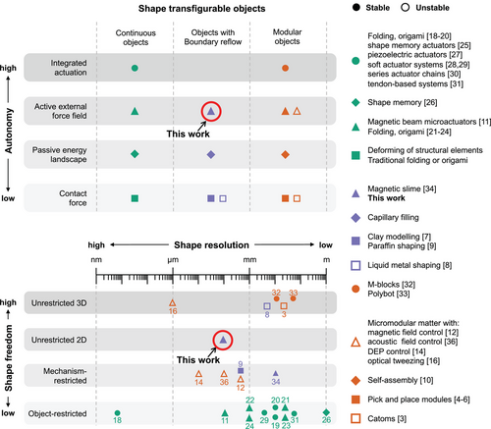
Figure 1
Open in figure viewerPowerPoint
Material systems and deformation mechanisms for shape transfiguration and their shape freedom and resolution. Shape resolution is the smallest feature size that can be programmably controlled. Shape freedom is quantified in four categories: “Unrestricted 3D” means unrestricted freedom to create shapes in three dimensions (3D), “Unrestricted 2D” means unrestricted freedom to create shapes in two dimensions (2D), “Object-restricted” means that the deformation of the objects is limited by the number and position of deformation zones machined in the object, “Mechanism-restricted” means that the material configurations are limited by the object-external deformation mechanism.
Four important characteristics of transfiguration are: shape freedom, i.e., the ability to assume shapes or forms without restriction; resolution, i.e., the smallest feature size that can be programmed; stability, i.e., the ability to maintain a shape without continuous energy supply, and; autonomy, i.e., the ability for an object to control its own shape.
Mechanisms for deforming transfigurable objects include - in order of increasing potential for autonomous operation: external contact forces on the object boundary;[3-9] contactless interaction with a passive energy landscape (self-organization);[10] contactless interaction with an actively controlled external force field (magnetic,[11-13] dielectrophoretic,[14] acoustic,[15] photonic),[16, 17] and; integrated actuation mechanisms (folding/origami,[18-24] shape memory,[25, 26] piezoelectric,[27] soft actuators,[28, 29] series actuator chains,[30] tendon-based,[31] gyroscopic,[32] and electromagnetic).[33] Integrated actuation mechanisms are essential to creating programmable matters with full autonomy, while contactless external force fields allow for contactless operation within the range of the field.
Transfigurable material systems can be divided into three categories: continuous (non-modular) objects,[11, 18-31] modular objects,[3-6, 10, 12, 14-17, 32, 33] and objects allowing reflow of their boundary.[7-9, 13, 34] Continuous objects can be transfigured by elastic deformation or internal mechanical systems but are limited in shape freedom by either the yield strength of the material or the number and position of deformation zones machined in the object. To transform objects into free shapes necessitates rearranging the objects' constituent parts. Objects with boundary reflow (locally) liquefy to assume a new shape. Modular objects rely on rearranging individual modules. An unstable subcategory of modular objects are conglomerates of modules/particles that are not bonded.[14-16, 35-38]
Stable material systems that allow high autonomy in transfiguration have been limited in either shape resolution or shape freedom. This study introduces a novel approach, solid–liquid phase change pumping, to overcome existing challenges in programmable matter. Our methodology uniquely offers stability, full shape freedom in two dimensions, sub-millimetre resolution, and the potential for elevated levels of autonomy in material transfiguration.

2 Results and Discussion

2.1 Liquid–Solid Phase Change Pumping for Transfiguration
We here introduce the transfiguring and locomotion of solid objects based on the repeated local melting and microfluidic manipulation of object substance using a novel pumping mechanism: solid–liquid phase change pumping (Figure 2; Figure S8, Supporting Information).

Figure 2
Open in figure viewerPowerPoint
I). Photographs of a flat object (blue) during transfiguration and locomotion through a narrow constriction (black lines) (scale bars are 1 mm). n indicates the number of solid-liquid phase change pumping cycles to reach the particular shape and position. II) Schematic of the experimental setup. Objects of phase change material are placed on a Peltier-cooled XY-stage (dark orange). A laser spot (red) locally melts (dark blue) the solid (light blue) object, while a camera (pink) records the object's shape. The insets show cross-sectional schematics of an anchored and a floating object. III) Subsequent steps of a phase change pumping cycle. Starting with a solid object of a substance with negative density change when melting (i), a hot spot (red dot) melts the boundary of the object at an entry point of choice such that molten substance (dark blue) flows outside the original object boundary (ii). Moving the hot spot (red arrow) with speed v (red arrow) towards the object interior (iii) results in diffusive heat transport cooling the liquid downstream of the hot spot below the freezing point. The molten section, encapsulated in a solid surrounding, exhibits a melting front and a freezing front, where local volume expansion at the melting front and volume contraction at the freezing front create a mass transport (white arrow) from melting to freezing front. When the melting front reaches another object boundary (iv), the hot spot is removed, whereupon the liquid region solidifies while shrinking. The result is a transfigured shape that differs from the initial shape by an outflow at the entry point and an indentation at the exit point (v).
Phase change pumping has been studied for liquid pumping using the density change associated with the liquid-gas transition.[39] This study investigates the potential of using the volume change during the solid–liquid transition for solid pumping. By melting part of an object with a hot spot, such as a laser spot, a liquid zone is created within the material. The movement of the hot spot inside the object generates a melting front, where the laser heats the material above its melting point, and a freezing front, where heat loss to the surroundings cools the material below its freezing point. Most materials decrease in density during melting and increase during freezing, resulting in material flow through the liquid zone from the melting front to the freezing front. We define a “pumping cycle” as moving a hot spot from one boundary point (entry) of the object to another (exit). This operation results in net matter transport from the exit to the entry, leading to a change in the object's shape. Concatenating multiple pumping cycles enables the reshaping of the object from an initial shape to any desired target shape while preserving the material volume.

2.2 Experimental Setup
We created thin objects of phase change material (paraffin, fatty acid), with approximate height h = 185 µm and lateral size 1 cm, and placed them on a computer-controlled XY stage with Peltier cooling. The objects were either anchored between two glass substrates or floating in a glycerol medium. A 450 nm wavelength laser created a hot spot in the object, while the XY stage controlled the relative position of the hot spot in the material. A camera imaged the object from the top. All hardware was coupled to a computer control system, and image processing was used to determine the object's shape and position.

2.3 Pump Performance
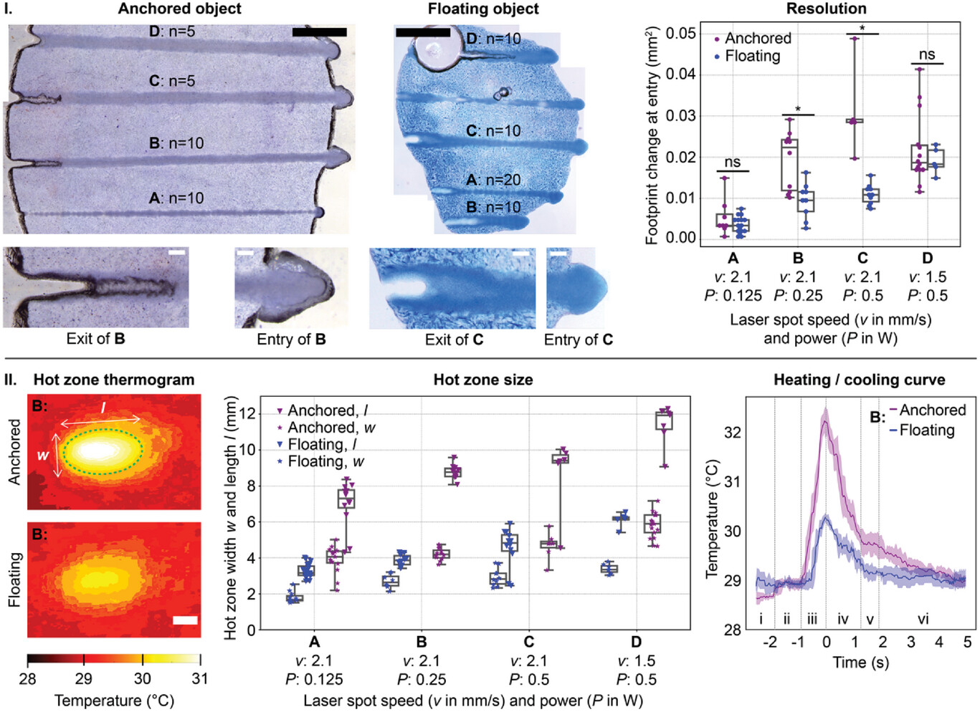
We performed solid–liquid phase change pumping for objects of paraffin (RT42; Figure 3) and fatty acid (eutectic lauric-myristic mixture; Figure S10, Supporting Information). For objects of paraffin, we evaluated hot spot speeds, v, of 1.5 and 2.1 mm s−1. We measured the average amount of material transported in one pumping cycle (resolution, expressed in change of footprint) to be between 0.0043 and 0.031 mm2 for anchored objects and between 0.0034 and 0.019 mm2 for floating objects (Figure 3I). The related pump rates (transfiguration speeds) were in the range 0.009 – 0.07 mm2.s−1 for anchored objects and 0.007 – 0.03 mm2.s−1 for floating objects. At low laser power (P = 0.125 W), anchored and floating objects were transformed with a similar high resolution, approximately 0.0038 mm2, and with a similar transfiguration speed, approximately 0.008 mm2.s−1. Increasing the laser power increased the transfiguration speed but lowered the resolution. For laser power P = 0.25 or 0.5 W, anchored objects were transfigured faster than floating objects.

Figure 3
Open in figure viewerPowerPoint
I) High-resolution solid-liquid phase change pumping of anchored and floating objects: stitched images from a stereo microscope of an anchored (left) and floating (middle) object after n consecutive sets of pump cycles with varying speeds, v, and power, P, of the laser spot, and the measured change in footprint area at the entry points between consecutive pump cycles (scale bars are 1 mm). The insets show a close-up of an entry and exit point (scale bars are 100 µm). Characters A-D link the different speed and power settings with the measured resolution. II) Size and temperature of the molten region during pumping: The infrared images show a typical example of the top surface temperature of the glass plates covering an anchored and floating object during pumping with laser spot speed v = 2.1 mm.s−1 and power P = 0.25 W (scale bar is 1 mm). The green ellipse indicates the closest-ellipse-fit with the 30 °C isotherm, with width, w, and length, l. The hot zone size graph shows the width and length of the 30 °C isotherm for varying speeds, v, and power, P, of the laser spot. The heating/cooling graph shows the mean (line) temperature and standard deviation (shaded zone) at a fixed position during the passing of a laser spot on an anchored (purple) and floating (blue) object with speed v = 2.1 mm.s−1 and power P = 0.25 W (n = 10; measurements were time shifted to have the maximum temperature at t = 0 s). The six zones in the heating/cooling graph indicate, for the anchored object specifically: i) heating of the solid, ii) melting, iii) heating of the liquid, peak, iv) cooling of the liquid, v) freezing and vi) cooling of the solid. Box plots indicate median, minimum, maximum, 25% and 75%. * indicates significance at p < 0.05. ns means not significant (p > 0.2).
We evaluated the temperature and heat flux close to the hot spot by thermal imaging of the top surface of the glass substrate immediately above the object (Figure 3 II). The glass temperature was notably higher for anchored objects than for floating objects. A hot zone is clearly visible on the glass surface, which provides a proxy for the size of the molten zone in the object underneath. This hot zone, which assumes an elliptical shape characterized by length l and width w, has a size that is proportional to the laser power. The heating/cooling graph, which tracks temperature at a fixed material position during a laser spot passage, could be segmented into six distinct time periods: i) solid heating, ii) melting (evidenced by a temperature plateau), iii) liquid heating leading to peak temperature, iv) liquid cooling, v) freezing (again evidenced by a temperature plateau), and vi) solid cooling.

2.4 Object Transfiguration and Locomotion
We transfigured objects from their current shape to a goal shape by employing consecutive pumping cycles, each moving a small amount of material from an object boundary point (exit) to another (entry).
We thus transfigured discs to form the characters “K”, “T” and “H” (Figure 4; Movie S1, Supporting Information). We further split and merged objects and generated and removed holes in objects (Figure 5; Movie S2, Supporting Information). To demonstrate the unique capabilities of our approach, we moved an initially centimeter-wide object through a millimetre-sized constriction, then reconstructed the original shape (Figure 2; Figure S11 and Movie S3, Supporting Information).
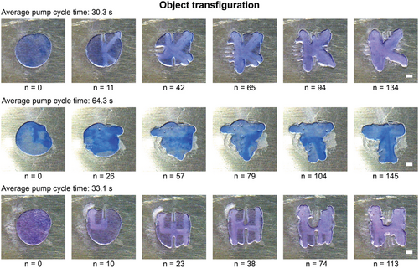
Figure 4
Open in figure viewerPowerPoint
Shape transfiguration to a desired target shape. The rows show subsequent Video frames of forming the characters “K”, “T”, and “H” using solid–liquid phase change pumping cycles. n indicates the number of pump cycles. “Average pump cycle time” indicates the average time per pump cycle for each character. Scale bars are 1 mm.
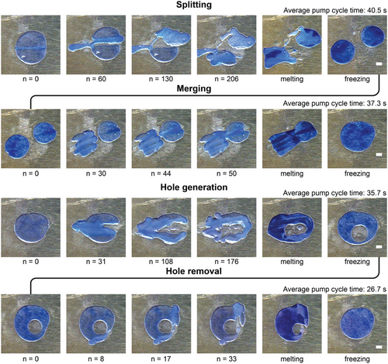
Figure 5
Open in figure viewerPowerPoint
Phase change pumping allows the operations of object splitting, object merging, hole generation, and hole removal and provides, through their combination, full topological freedom. The four rows show video frames of the four operations on anchored objects. n indicates the number of pump cycles. “Average pump cycle time” indicates the average time per pump cycle for each operation. Scale bars are 1 mm.

2.5 Automated Operation
We further automated the selection of subsequent pump cycles and performed shape-changing from a given shape to a target shape without user interference (Figure 6; Movie S4, Supporting Information).

Figure 6
Open in figure viewerPowerPoint
I) Automated shape transfiguration of uncomplicated shapes in uncomplicated environments. Top view photographs of object shape changing by automated laser sequences without user interference. A square target shape (red) is fed to the system. The computer automated shape detection, pumping path determination and pump cycle execution. The video frames show subsequent object shapes after n pump cycles. II) In silico physical modelling of solid-liquid phase change pumping to enable training data generation for AI-controlled shape-changing. Top view photographs (top row) and model simulations (second row) after n subsequent pump cycles between the same entry and exit point. The pump cycles had an average duration of 31.1 s. Scale bar is 1 mm.
In a naive first implementation, we selected the preferred entry and exit points for every pumping cycle as follows. The exit point was the object boundary point most distant from the goal shape. The entry point was the object boundary point closest to the goal shape boundary point with the largest distance from the object. Each associated pump cycle thus reduced the difference between the current and target object shape, and a series of pump cycles converge the object shape to the target shape.[40] Such “naive” approach fits well for transfiguration and locomotion in an unobstructed space and was easily automated (Figure 6I).
In the quest to optimize programmable matter, particularly in minimizing the number of actions required to achieve target shapes and effectively handle real-world interactions in complex environments, traditional methods fall short. Given the intricate dynamics and unpredictable variables at play, a deterministic approach alone is insufficient. Therefore, we envision a neural network-based approach, capitalizing on machine learning's capability to discern patterns, adapt, and provide solutions that conventional strategies cannot. Such an approach is not a mere addition but a pivotal advancement to ensure efficiency, adaptability, and precision in our methodology. To generate the required training datasets, we developed a simplified in silico physical model that can realistically and quickly simulate phase change pumping by modelling the underlying phenomena (Figure 6 II).[41] Our model successfully demonstrates object transfiguration by phase change pumping with the same number of pump cycles. We envision the implementation of existing algorithms, such as DPI-net,[42] using our model's efficient and concise formulation to create more efficient shape transfiguration strategies. Further details on our model are provided in the Supporting Information.

2.6 Discussion
In this study, we demonstrated the potential of solid–liquid phase change pumping for programmable object transfiguration and locomotion. Solid–liquid phase change pumping can be employed for any material with a difference in density between the solid and liquid phase, as long as a sufficiently high local heat addition and removal are possible. Materials that decrease density when melting (most materials) will portray mass transport in a direction opposite to the hot spot movement. Materials that increase density when melting (e.g., water ice) would be transported in the same direction as the hot spot movement. However, the selection of materials presents challenges due to varying physical properties. For instance, metals, with surfaces that reflect laser beams, pose difficulties in achieving localized heating. Furthermore, materials possessing high heat conductivity can inadvertently spread the applied heat, compromising the precision of the heating and cooling process. Another significant consideration is the behavior of materials during melt-and-freeze cycles. Materials undergoing changes like crystal structure alterations, segregation in alloys, or mixtures, molecular weight shifts in polymers, oxidation, or other phase transformations may induce limitations and alterations to strength, durability, chemical resistance, optical, and other relevant material properties. Given these challenges, future research might focus on identifying or engineering materials optimized for phase change pumping or developing advanced techniques for controlled localized heating and cooling. This method's potential remains vast, and we believe that addressing its limitations can pave the way for more efficient and diverse applications.
By concatenating pumping cycles, we uniquely achieved the controlled free-shape transfiguration of solid objects with a sub-millimetre resolution and without mechanical interaction with the object. Concatenating hole creation or removal and object splitting or merging allows full topological freedom in transfiguring between 2D shapes of constant volume. We further demonstrated the locomotion of objects via stepwise material transport and uniquely demonstrated moving objects through constrictions much smaller than their size, followed by reconstituting into a target shape of choice.
By utilizing both a laser spot and positioning hardware, we achieved precise localized heat application across all regions of the objects. The spatial resolution in our approach depends on three parameters: the software, through the shape convergence requirement in the pump sequence control algorithm; the hardware, through the precision of the camera, size of the laser spot, and precision of the XY translation, and; inherent limitations in solid-liquid phase change pumping. We demonstrated moving as little as 0.043 mm2 of material. During object transfiguration, the resolution of the demonstrated characters “K”, “T”, and “H” was constrained by the algorithm, where shape resolution was traded against the speed of convergence. The material volume pumped in a single cycle equals αVm, where Vm is the volume of the molten zone, ρs is the solid material density, ρl is the liquid material density, and the volume expansion coefficient. We thus expect that materials with a lower expansion coefficient α allow higher resolution. Vm is determined by the ratio of the heat supplied at the hot spot and the cooling flux to the surroundings, and the minimum molten volume is ultimately only limited by the precision with which heating and cooling can be tuned. Given that the algorithm's convergence criteria and the volume of the liquefied material can be freely optimized, the placement precision of the liquefied material in our methodology is ultimately governed by the hardware's accuracy.
The object transfiguration and locomotion are driven by phase change actuation, which boasts among the highest work densities among actuators.[43] We can, therefore, expect our approach to be suited for various challenging environments, including mechanical interferences or challenges posed by gravity.
The energy required for phase change pumping scales with ΔHfus/α, where ΔHfus is the latent heat of fusion. Materials with low ΔHfus/α and low-temperature hysteresis during phase transition are thus preferred for rapid transfiguration with limited energy consumption. For this reason, paraffins and fatty acids were identified as primary demonstrator materials (Figure S9, Supporting Information).
The speed of transfiguration is limited by the maximum heat flux available for heating or cooling, which, in our setup, was the cooling flux. Comparing the anchored and floating objects, we observed less heat flux to the air above the objects for the floating objects. We hypothesize that the floating object is cooled through the surrounding liquid glycerol, causing the volume of the molten zone to be lower than that in the anchored objects for the same laser conditions. A lower liquid volume would also explain the lower transfiguration rate for floating objects than anchored ones.
The mechanical properties of our solid objects surpass those of gels[34] or liquids[44] in terms of stiffness and strength and do not depend on the interaction between modules in modular materials.[12, 32, 33]
Compared to state-of-the-art stable transfiguration approaches, ours uniquely combines sub-millimetre resolution and high freedom in shape (Figure 1). DNA origami[18] provides higher resolution but is strongly limited in shape freedom, whereas M-blocks[32] and Polybots[33] allow shape freedom in 3D but are limited in resolution by their module size.

2.7 Outlook
Finally, to realize fully programmable matter, i.e., “programmable matter [that] enables the instant creation of complex objects and their transfiguration on command”[2] requires not only high resolution and free shape changing but also full autonomy and operation in three dimensions. To allow phase change pumping in 3D requires controlling the hot spot in 3D. We suggest that future efforts could focus on two-photon absorption[45] to fit such a purpose. Realising autonomous operation would necessitate integrating the material control system, including actuators (directional laser), sensors for proprioception and environment observation (cameras), processor and energy supply (battery), within the object boundary. We speculate that this could be accomplished by constructing a shell of shape-changing material around the central control system. We, therefore, argue that phase change pumping provides a unique path toward a programmable material with full freedom in shape and autonomy. The unparalleled potential for full topological shape freedom and the ability to move objects without direct contact can offer transformative solutions for several application areas. Particularly, our approach potentially enables limitless on-the-fly object or tool creation without introducing additional materials. Applications where such capabilities are of specific interest include challenging environments, such as space exploration, deep underground excavations, and deep-sea operations, or automated adaptation of living spaces, redefining modern living experiences. For instance, in public spaces, one could imagine plazas or squares seamlessly altering their layouts to accommodate fluctuating crowd sizes or events, revolutionizing urban design, and communal experiences. Furthermore, the freedom in shape control could enable dynamic optimization of vehicle shapes, optimizing aerodynamics or fuel efficiency based on real-time conditions.

3 Conclusion
In conclusion, this study introduces a novel approach to shaping programmable materials through solid–liquid phase change pumping. By harnessing the volume change during the solid–liquid transition, we demonstrated the contactless transfiguring and locomotion of solid objects with sub-mm resolution and full topological freedom in 2D shapes. The method can reshape objects into any desired form, pass them through constrictions narrower than their body size, and reconstitute them into any target shape. The combined shape freedom and high spatial resolution of this approach surpass those of existing techniques, opening up new possibilities for developing autonomous programmable matter. Further advancements, such as 3D operation and full autonomy, could be realized by incorporating novel techniques and integrating control systems within the object boundary.

4 Experimental Section

Experimental Control System
The control system was built by using the frame of a RepRap 3D printer (Creality 3D CP-01, China) that runs on Marlin firmware and could be controlled using GCODE commands (Figure 7). This hardware contained a laser and an XYZ stage. The continuous mode laser had a 450 nm wavelength and a power of 0.5 W. The user interface allowed power setting with a pulse width modulation of 1000 Hz. The laser had a spot size of 400 µm2. The XYZ stage controller had a travel speed of 200 mm.s−1 and a single step distance of 100 µm. A USB microscope (Vimicro USB 2.0, China) and a thermal camera (FLIR C5, Sweden) was attached to the laser unit to detect the visual outline and temperature profile of the object. The microscope and thermal camera were connected to the same computer. The bed heater of the RepRap printer was replaced with a custom-built and computer-controlled Peltier thermoelectric element (RS Pro, China). A custom graphical user interface was developed based on MATLAB AppDesigner (MATLAB R2021b) to control the system.

Figure 7
Open in figure viewerPowerPoint
Photographs of the Experimental setup. Left: A thin paraffin object between two glass slides. Scale bar is 5 mm. Right: The control system, including an XY-stage, laser, USB microscope camera, thermal camera and Peltier element. The object is placed on top of the Peltier element.

Transfigurable Objects
Transfigurable objects were built from both commercially available phase change material (PCM) (Rubitherm RT42, Germany) and fatty acid eutectic of Lauric-Myristic acid (LA-MA, 63.66%:36.34%).
For the fatty acid eutectic of Lauric-Myristic acid, Lauric acid (Merck, Germany), and Myristic acid (Merck, Germany) were added to a glass container in a 63.66%:36.34% weight ratio. The components were heated in an oven at 80° C for 2.5 h. Next, the ingredients were mixed in an ultrasonic generator at 50° C for 12 min. Next, the sample was degassed to remove bubbles at the molten state.
For commercially available PCM, Sudan Blue II (Merck, Germany) was added to the PCM in a glass vial at 0.5% w/w at room temperature. The components were heated and mixed at 80° C for 1 h on a hotplate with a magnetic stirrer and thereafter allowed to solidify. The colour increased the contrast of the PCM during imaging.
To fabricate anchored objects, 18 mg of the mixture between two microscope slide coverslips (VWR® Micro Cover Glasses were sandwiched, Thickness #1.5, 0.17 mm, Germany), utilizing 185 µm thick double-sided adhesive tape (64620, Tesa, Germany) as a spacer. Subsequently, the sandwich structure was subjected to heating and cooling cycles to melt and freeze the PCM mixture, or Lauric-Myristic fatty acid eutectic while gently pressing from the sides of the glass. Upon fabrication, the object manifested as a disc-shaped entity with a height h = 185 µm and diameter d = 6 mm.
To fabricate floating objects, first two microscope slide coverslips (VWR Micro Cover Glasses, Thickness #1.5, 0.17 mm, Germany) were pretreated with a thin layer of glycerol (Merck, Germany). Subsequently, 18 mg of the mixture was embedded into a glycerol bath. Double-sided adhesive tape (64620, Tesa, Germany) was utilized with a consistent thickness of 185 µm to construct the glycerol bath within the structure. Following this, the sandwich structure was subjected, comprised of glycerol and PCM mixture, to heating and cooling processes to melt and freeze the PCM mixture, while gently pressing the sides of the glass. After fabrication, the object thus formed was a floating, disc-shaped entity with a diameter d = 6 mm.
The sandwich structures were placed on a Peltier element to control the surrounding temperature. The temperature-controlled sandwich structure was placed on a computer-controlled XY stage.

System Calibration
After placing the object in the control system, an initial calibration sequence to correct the lens and angle distortion of the microscope was performed. Thereafter, the image coordinate frame was synchronized with machine GCODE coordinates by automatically detecting the laser dot on the sample by subtracting two images. After correct calibration and initialization, the system was ready for operation.

Shape Changing Without Topology Changing
To demonstrate shape change with the same topology, it started with a disc-shaped object and designed a target shape with the same topology. The object's shape was manually altered using consecutive laser passes.

Splitting and Merging Objects
To demonstrate splitting of an object, a splitting line was defined and consecutive laser passages along and away from this line were performed, thus removing material from the splitting line region. After all material was removed from the splitting line, two separate objects remained. These two objects were moved away from each other, each at a time. A short global heat pulse could potentially melt both objects to form smaller discs.
To demonstrate the merging of objects, two objects were initially used. A merging region was defined. Consecutive laser passages to move material from both objects toward the merging region was performed. When material from one object was transported against the other objects, the objects form a single object. Optionally, a short global heat pulse could remelt the object to form a disc.

Adding and Removing Holes from Objects
To generate a hole in an object, the process started with moving material such that a “tunnel” was formed from the boundary toward the center of the object. Material across the entry region of the tunnel was moved such that the tunnel mouth was closed, leaving a cavity inside the material.
To remove a hole from an object, a tunnel from the object's outer boundary to the inner cavity was created. Once the tunnel reaches the cavity, the object topology changes and the hole was removed. Optionally, a short global heat pulse could remelt the object to form a disc without a hole.

Automated Shape Changing
A pixel-based distance comparison algorithm based on Hausdorff distances to automate subsequent laser passes without user interference was incorporated. A target shape (red square in Figure 6) was specified. Before each pumping cycle, the object image (blue) was converted to a grey scale and binarized with automatic greyscale thresholding. In the black-and-white image, the outer boundary of the largest object was selected. The algorithm determined the entry and exit points on this object boundary using the “naive” method described in the main text, using a modified version[40] of the image-based Hausdorff distance algorithm[46] for this purpose.

Video Generation
The videos were made by concatenating photographs of the object after every pump cycle.

Acknowledgements
This work was sponsored by the Swedish Government through the Strategic Research Agenda Digital Futures and by the Swedish Research Council through grant 2020-05214.

Conflict of Interest
The authors declare no conflict of interest.

