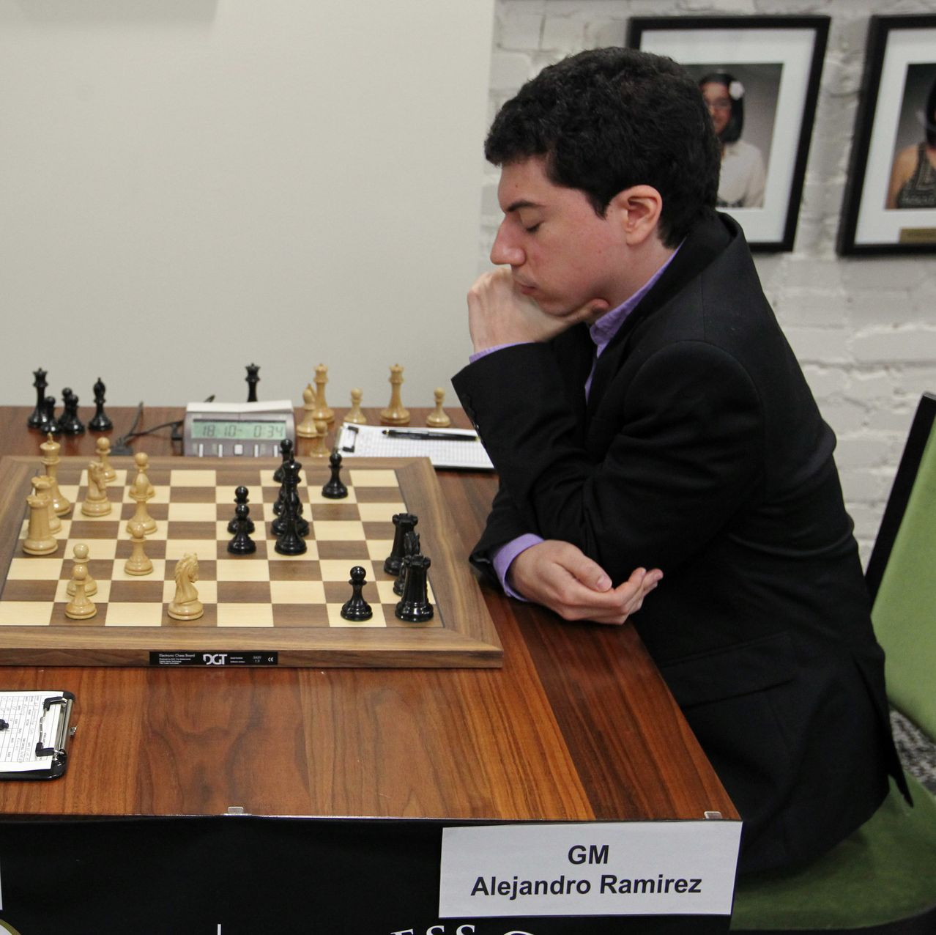
Alejandro Ramirez during the U.S. Chess Championship in 2014. Bill Greenblatt/UPI/Shutterstock

How Sexual Assault Allegations Against a U.S. Chess Grandmaster Went Unaddressed for Years

Numerous women have accused elite player and coach Alejandro Ramirez of misconduct. Two bodies that run chess in the U.S. allegedly knew of accusations for several years.
By

Andrew Beaton and
Joshua Robinson
When former U.S. women’s chess champion Jennifer Shahade alleged on social media last month that she had been sexually assaulted by a prominent grandmaster named Alejandro Ramirez, she had no idea it would set off a broad wave of additional allegations.
Ms. Shahade says she was sexually assaulted twice by Mr. Ramirez, one of the most recognizable faces in American chess over the past two decades. Her allegations and others in recent years were reported to top chess bodies, including the U.S. Chess Federation and the powerful St. Louis Chess Club, which failed to act or effectively investigate when first learning of them, according to interviews and documents reviewed by The Wall Street Journal.
Then, over the course of a few days after her tweet, messages poured in. Ten other women from the chess community reached out to Ms. Shahade to say they had also been assaulted or harassed by him, according to texts and direct messages the Journal reviewed.
The allegations represent a stunning turn for Mr. Ramirez, a 34-year-old who was once the second-youngest grandmaster in the world and the first from Central America to earn the title. Mr. Ramirez, who was born in Costa Rica, switched to representing the U.S. in international competition in 2011. In addition to playing at an elite level, he has helped coach a world championship contender, mentored younger players and built a profile as a go-to commentator for marquee events.
In interviews, eight women accused Mr. Ramirez of wrongdoing, saying that he used his status in chess to put himself in positions of influence and make repeated unwanted sexual advances toward them since 2011. Mr. Ramirez, they said, became physically aggressive as he forcibly kissed and groped them without their consent. Three were under the age of 18 at the time of the alleged incidents, including one who said Mr. Ramirez supplied her with vodka before he coerced her into performing oral sex.
On Monday, two days after being presented with a detailed list of the allegations against him by the Journal, Mr. Ramirez issued a press release through his attorney saying that he had resigned from his roles at the St. Louis Chess Club and as coach of the St. Louis University chess team because the investigations now being run by U.S. Chess and the club had become a “negative distraction.”
“Superimposing today’s mores on erroneous recitals of acts of yesteryear is a recipe for disaster for both the accused and the accuser,” Mr. Ramirez’s attorney, Albert Watkins, said.
Mr. Watkins didn’t comment on the specific allegations, saying he had been directed to respect the confidentiality of the investigative undertakings. “In this era of introspection and sensitivity to all matters ‘Me Too’ related, Mr. Ramirez remains very supportive of those who seek to raise issues of concern about anyone,” Mr. Watkins wrote in an email to the Journal.
Allegations about Mr. Ramirez’s conduct have been known to top chess bodies—including the U.S. Chess Federation and the St. Louis Chess Club, the global hub for the game backed by billionaire Rex Sinquefield—for several years.
A lawyer for the St. Louis Chess Club wrote in a 2021 letter that it was aware of Ms. Shahade’s allegation in 2020. In 2021, the club and U.S. Chess were informed of allegations against Mr. Ramirez, including the abuse of a 15-year-old, according to interviews and documents reviewed by The Journal. Mr. Ramirez was nonetheless tapped to coach the U.S. women’s team at the World Chess Olympiad in Chennai, India, in 2022.
Mr. Ramirez is now being investigated by the U.S. Chess Federation and the St. Louis Chess Club, where he was a prominent figure as a resident grandmaster and commentator. He was previously removed from coaching St. Louis University’s chess team on Feb. 16, the school said, the day after Ms. Shahade’s tweet. That’s also when Mr. Ramirez was taken off the Athletes’ Commission of FIDE, chess’s world governing body. FIDE said it made the decision following Shahade’s social-media post, pending the probe from U.S. Chess.
“The University takes matters of sexual harassment and misconduct very seriously and has robust policies and procedures in place to respond to any report it receives,” St. Louis University said in a statement.
The powerful organizations that oversee the game continued to place Mr. Ramirez in roles that often involved working closely with women, often under the age of 18, even after first learning about allegations about him.
“I was concerned that there was a clear and present danger that he could have interactions with girls and women,” Ms. Shahade said of her decision to go public.
There are indications that chess powers knew of Mr. Ramirez’s alleged behavior earlier than 2020. Another woman, who was underage at the time of her alleged incident around eight years ago, said that she was warned as early as 2016 by St. Louis Chess Club officials not to be alone with Mr. Ramirez after a party. A player’s mother, who is also involved in the sport, said she alerted the top U.S. Chess official to Mr. Ramirez’s behavior in 2017. The mother added that she was also present in 2017 when top executives at St. Louis Chess Club joked about Mr. Ramirez’s interest in young women.
St. Louis Chess Club didn’t respond to specific questions about its knowledge of the allegations. After the Journal’s inquiries, the club said in a statement that it accepted Mr. Ramirez’s resignation on Monday and that it has no further comment on this employment matter. Mr. Ramirez was the club’s highest-paid employee in 2018 and 2019, the most recent years for which the club’s full tax returns were available through the Internal Revenue Service.
The U.S. Chess Federation referred back to a statement dated Feb. 15 in which it said it was “aware that one of its employees has made serious allegations about a member of the chess community” and had opened an investigation, without naming Mr. Ramirez. The federation didn’t respond to the specific allegations that some of its employees had been aware of Mr. Ramirez’s behavior.

Jennifer Shahade is a former U.S. women’s chess champion.
Photo: Hannah Yoon for The Wall Street Journal
Ms. Shahade, a 42-year-old women’s grandmaster, said she was sexually assaulted by Mr. Ramirez twice. In the more recent of the two incidents, in 2014, she said they were at a small gathering in a large house in St. Louis when, at a moment when no one else was around, he “slammed” her against the wall and forcibly kissed her.
Ms. Shahade said she confronted Mr. Ramirez in October 2020 when he was set to serve as a commentator with her on the U.S. junior girls championship. After telling the club, she said they told her to call him and deal with the matter. A message reviewed by The Journal shows she contacted him the day of the opening ceremony, when he was included among the planned commentators.
Ms. Shahade said that, during a phone call, Mr. Ramirez immediately agreed to step down from the commentary role that October. She also said he later called back and apologized for his behavior with her, while alluding to other things that he regretted. Videos of the event show he didn’t serve as a commentator at the tournament and was replaced by another grandmaster.
In 2020, Ms. Shahade said she also spoke with U.S. Chess officials about Mr. Ramirez’s alleged behavior. Ms. Shahade has served as the woman’s program director for U.S. Chess since 2018.
In 2021, Greg Shahade, Ms. Shahade’s brother and a high-level player who organizes chess events, contacted St. Louis Chess Club and U.S. Chess to inform them of Mr. Ramirez’s alleged behavior, according to emails reviewed by the Journal. The email to the club included allegations involving girls as young as 15.
Two months later, a letter came back from a lawyer representing the club, acknowledging that it had heard about the allegations in October 2020. The letter said they weren’t aware of any inappropriate conduct by Mr. Ramirez. It further said that the club wasn’t the proper party to review and investigate the matters he raised.
In September of 2022, Mr. Ramirez played a featured role in a different scandal that rocked the world of elite chess—when he conducted the explosive post-match interviews with players during a tournament in St. Louis when teenage grandmaster Hans Moke Niemann faced cheating allegations. That month, Ms. Shahade and another player said they submitted complaints to the club and U.S. Chess about their allegations. The players said they had initial interviews with lawyers from the bodies, but didn’t hear back afterward. Ms. Shahade said she only heard back again after her tweet.
Neither body publicly addressed the allegations until Ms. Shahade’s post in February. In December, three months after the complaints, Mr. Ramirez was seen in photos on social media with women from the St. Louis University chess team in Mexico. The team was founded in 2016 as a partnership between the school and the St. Louis Chess Club.
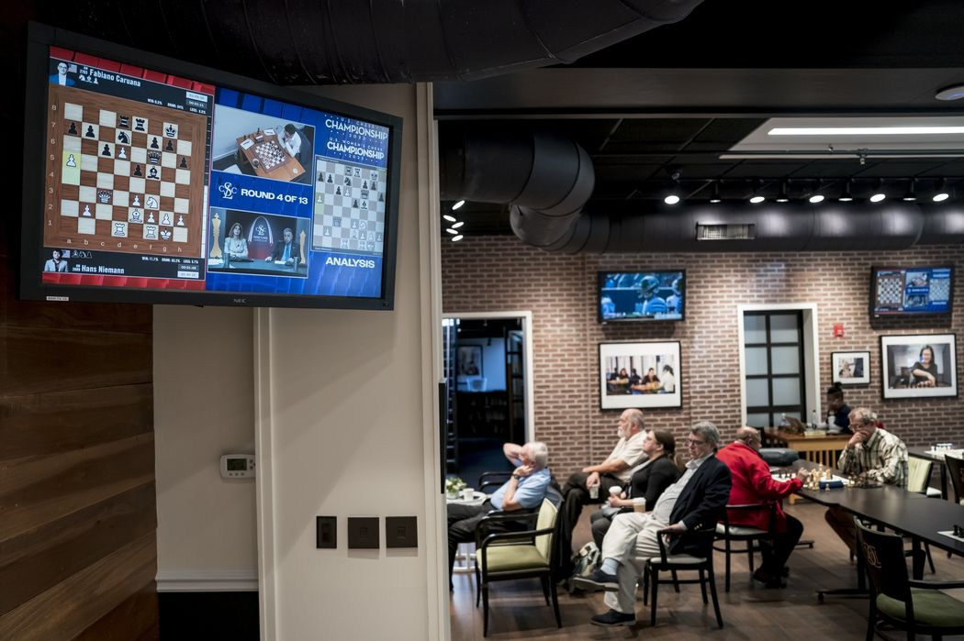
People play chess and watch the U.S. Chess Championship as it is broadcast on television screens at the Saint Louis Chess Club in St. Louis.
Photo: Whitney Curtis for The Wall Street Journal
Over the course of those years, Mr. Ramirez’s alleged behavior became an increasingly open secret, people in the game said, and caused some in the community to distance themselves from him. Chess.com, the popular platform for the game that also hosts events, hasn’t had a working relationship with Mr. Ramirez to write and play on the website since 2013, the company said, but internally agreed to not reconsider him for future work after first hearing allegations against him in 2019.
Ms. Shahade’s experience with Mr. Ramirez echoed the behavior described by others, who described similar situations involving force, unwanted advances, and often alcohol. Claire Grothe, who worked as a program manager at the World Chess Hall of Fame in St. Louis, said she met Mr. Ramirez at a 2014 reception organized by St. Louis Chess Club, which then spilled into an after-party at a nearby Italian bar. Ms. Grothe said she found herself in conversation with him toward the back by the restroom. That’s when she says that Mr. Ramirez grabbed her by the arm, pulled her into the restroom and pushed her up against a wall, where he forcibly kissed her and reached into her halter-neck dress to grope her breast. Ms. Grothe said she was able to push him off and leave.
The next day, Ms. Grothe was shocked when Mr. Ramirez appeared at her desk at the Hall of Fame. He asked her out on a date.
“I was horrified at that point,” Ms. Grothe says. She added that she told him that she was at work and he went away and that the incident led her to leave the Chess Hall of Fame later that year.
It was difficult for other players in Ramirez’s orbit to avoid him. Younger players say that they had respect for him as a coach and noticed when such a well-connected grandmaster took an interest in them.
Mr. Ramirez was 23 in 2011 when a then 15-year-old player says she encountered him at a chess camp where he was an instructor. One night, she said, he asked if she could bring toothpaste to his room. Once there, he shoved her against a counter and began forcibly kissing her even as she tried to turn her head away, she said.
In subsequent messages to the girl reviewed by the Journal, Mr. Ramirez wrote that he “tricked” her by asking for toothpaste. In their messages he wrote about the kiss, wanting to undress her and marrying her. He also made a reference to researching the age of consent in her home state.
She said Mr. Ramirez assaulted her again when they were at tournaments over the following year, including one instance in which people were hanging out in a hotel room and everyone left but them. That’s when she said he got on top of her, pinned her to the bed and started kissing, groping and attempting to undress her before she could escape. A sibling of hers said that she shared the incidents contemporaneously.
Two women also said Mr. Ramirez exploited shared living conditions, such as hotel rooms, saying they awoke in the middle of the night to Mr. Ramirez groping them. One of them said that it occurred multiple times, including once in a house operated by St. Louis Chess Club.
Another player says she was 16 when she traveled to a tournament with the U.S. Chess team, where Mr. Ramirez was one of the coaches. He was around 26 at the time.
On the night of the closing ceremony, Mr. Ramirez invited her and at least one other underage girl to his hotel room for celebratory drinks before the party, the woman said. Mr. Ramirez allegedly provided them with vodka and encouraged them to drink. Later that night, after the party, Mr. Ramirez led the 16-year-old back to his room, she said, and undressed her on his bed while she was visibly drunk. At that point, she added, he attempted to have sex with her, but she refused. He then initiated oral sex, when she says she wasn’t in a position to consent to.
In subsequent years, she heard chatter that she hadn’t been the only one on the receiving end of his unwanted advances.
“There was talk of him being a bit sleazy, messaging very young girls,” she said. She also warned other players never to hang out with him one-on-one, because he was “a slimy person.”
When the woman, no longer a competitive chess player, read Ms. Shahade’s post last month, she messaged her within five minutes.
Write to Andrew Beaton at andrew.beaton@wsj.com and Joshua Robinson at Joshua.Robinson@wsj.com

