My $2.6 Billion Ecosystem Fail: an RJMetrics Post Mortem
SHARE THIS


By Bob Moore

Most Read

Partnerships 101: ISVs, VARs, SIs, MSPs, and the Glue that Holds them Together
By Olivia Ramirez

SaaS Reseller Partnerships: What They Are & How They Work
By Jasmine Jenkins

The Most Common Partnership KPIs (According to Company Size and Maturity)
By Olivia Ramirez

Everything You Ever Wanted to Know About Channel Partnerships
By Jasmine Jenkins

8 Times Sales Reps Won the Deal by Co-Selling With Partners
By Olivia Ramirez

Latest Resources

There’s been no handbook for partnerships. Until now.

Our magnum opus: a 104-page actionable guide to becoming an indispensable partnership professional. Including:
- Insights from Zapier, HubSpot, Vidyard, Okta, and many many more.
- Perspectives on the unspoken aspects of partnerships (hint: failure and conflict are totally normal)
- Step-by-step guides for industry-leading co-marketing, co-selling, lead swapping, and enablement.
Avoid a decade-plus of trial and error. Learn from the best and get the PDF for free.
Email*

First Name*

Last Name*

Job Title*

Company Name*

By clicking "Submit" you agree to the terms outlined in Crossbeam's Privacy Policy.

- Partnership Insights

This June, a headline flashed across my phone and I knew one of my most serious business missteps had finally been finalized: Google had purchased Looker for $2.6 Billion.
Before founding Crossbeam, I was the co-founder of RJMetrics and Looker was one of our main competitors in the business intelligence space. They had a great product and their team was first-class. Even so, I was disappointed at the outcome: We had all of those things plus a four-year head start.
And yet, we ultimately sold RJMetrics to Magento in a modest transaction that was orders of magnitude away from the $2.6 Billion windfall earned by Looker. What was the difference between our companies?
You could point to a hundred things, but if you dig deeply enough one core product decision is at the root of most of them: Looker placed itself at the center of a massive ecosystem, while RJMetrics operated as a silo. They made other products more valuable, and we were where your data went to die. What felt like a strategic advantage — we were a one-stop shop, the only thing you would need—ended up being our downfall.
I learned a hard lesson: your place in an ecosystem of tech partners is just as important, if not moreso, than the quality of your product itself. Marc Andreesen was right when he quipped that “software is eating the world.” But in today’s marketplace, ecosystems are eating software.
I’ll never make that mistake again.
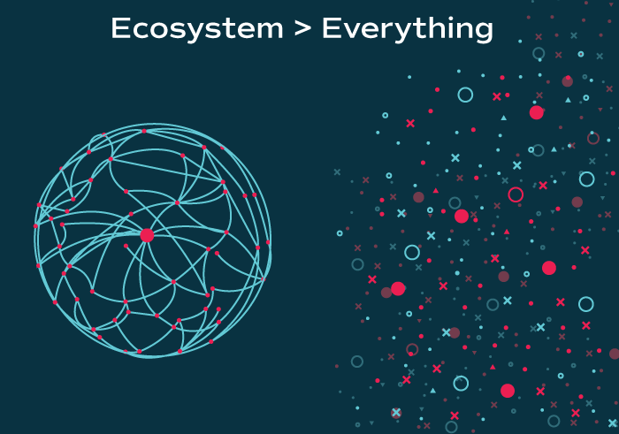

Your SaaS Product is Not a Platform (And That’s OK).
If you’re reading this, chances are you work for a tech company. When you’re asked about your product what do you say? If the word “platform” isn’t in your answer, you’re in the minority.
The “platform” metaphor is meant to convey that a product is a wide, horizontal offering on which other people can build their own products and offerings. We ascribe to the Bill Gates definition: “A platform is when the economic value of everybody that uses it, exceeds the value of the company that creates it. Then it’s a platform.”
Salesforce and AWS are true platforms. Entrepreneurs have taken to calling their products “platforms” just because they have APIs that allow data to pass in and out. As APIs become more like table stakes, every product sounds like a platform. But this is not the case. It can’t be platforms all the way down, after all.
At RJMetrics we were among the worst of these offenders. Do any of these sound familiar?
- We were a “terminal” when we should have been a “hub.” This cut off potentially the largest growth lever of all for SaaS companies: ecosystem growth effects. Ironic, given we were trying to be the “command center” for a business.
- By partnering with no one, we competed with everyone. Innovation in the market created tailwinds for our competitors and tech debt for us. When Amazon Redshift was released, for example, we gained competition that made our data warehouse look slow but gave Looker an easy way of having best-in-class warehousing.
- We were a jack of all trades. When your tool does one thing very well, it lessens the chance you’ll be outdone by competition. But when you’re a jack of all trades, it’s easier to get beat on any one of your features. And when one of your features falls behind, it’s easy to make the case that you have to go.

The Big Pivot: $60 million in 28 months
We made this realization a bit too late, and in 2015 we started breaking apart our stack so we could interconnect with other platforms. RJMetrics was sold in 2016 and we spun out the data pipeline part of our product as part of the deal. We rebranded it as “Stitch” and my RJMetrics co-founder Jake Stein became its CEO.
Stitch was all ecosystem, no glory. Most of the people who benefit from Stitch don’t know it exists. We pulled in data from the SaaS tools and databases you wanted and deposited it into a data warehouse of your choice, quickly and accurately.
We weren’t a dead end. We made everyone better in a giant ecosystem with SaaS tools on one side and data warehousing platforms on the other. In 28 months and with 25% of the headcount, Stitch grew as large as RJMetrics did after eight years and we were acquired by Talend in November 2018.
The market had given us a revelation: The Era of Ecosystems has arrived.

Welcome to the Era of the Ecosystem
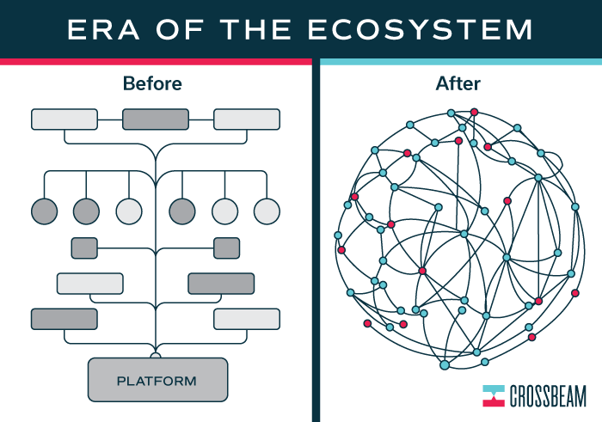
We realized that to be a player in your ecosystem, four things need to be true:
- You have more than one partner. Two’s a partnership. Three’s an ecosystem. Not a big one, but an auspicious beginning. These connections end up forging a network graph of products, interconnected with each other but having no “top” or “bottom.”
- You and your partners share data bi-directionally. Your service both offers and receives value from other applications. That usually means you are partnering with other services to integrate them into yours while making an API available for others to do the same, creating a positive feedback loop. You allow the behavior and preferences of the customer to determine the flow of data, not any possible customer lock-in. Remember: Be a “hub” not a terminal.
- Your partnerships team is not in a silo. Your ecosystem needs to be nurtured to survive. It’s easy to relegate your tech partner program as a cost center or the exclusive domain of your product team. Don’t. Partnerships are about growth. Done well, they create value for your customers that will map back to more leads, better conversion, higher annual contract value (ACV), and stronger retention. These are go-to-market benefits and your partner team and strategy should be built to drive these outcomes.
- You start with one core feature and rely on APIs. Get good at one thing. For any additional feature sets, rely on integrations or, later in your journey, acquisitions. And even when you do add new features don’t use some proprietary backend, make sure they “talk” via a public API.
Where and how you sit in this ecosystem is one of the most important levers for increasing your company’s value. The ecosystem is our modern “flywheel.” A healthy ecosystem helps all participants, as I send users to you while you send users to me.
Smart companies are quickly realizing this and capitalizing. As a result, you’re seeing ecosystems everywhere.
- Looker successfully leveraging its ecosystem while focusing on a finite set of features led it to become best-in-class, even better than Google—which is why the search giant was the eventual buyer.
- The maturity of the API Economy has reached a boiling point, with more than 20,000 public APIs on the web underpinning the apps we use every day.
- Zoom and Slack, two of the largest recent tech IPOs, are hyperconnected “supernodes” that integrate seamlessly with countless other SaaS platforms — including each other.
- HelloSign went from a fax company to being acquired by Dropbox on the strength of its integrations and relentless focus on a specific feature set.
- dotCloud became Docker after it noticed its Docker product had become the “center of a vibrant ecosystem that is driving a significant change in how software is written, built, and deployed.”
- Salesforce, the most valuable SaaS company in the world, boasts an AppExchange ecosystem which includes more than 5,000 partner offerings, a huge portion of which sync data bidirectionally with Salesforce.
The innovators of the 2010s considered themselves platforms and hoped the world would flock to build on top of their offerings. The ones who stayed relevant and came out on top had the foresight to embrace the ecosystem approach and let data flow in order to create value for customers. In the 2020s, every company — including those enormous incumbents — view themselves as a player in a greater ecosystem of partners.
You will never be able to move as fast as the entire ecosystem. Trust me, I’ve tried. How companies participate in tech ecosystems are the most powerful lever of growth and value creation in modern software.
Don’t let the opportunity pass you by.

