Up Close and Personal With the Rolling Stones

“Can the Stones still cut it? Are they slipping, is this the beginning of the end? Yes, they can, no they aren’t, and no, the end isn’t in sight. The Stones are in their prime.”

by KAREN DURBIN
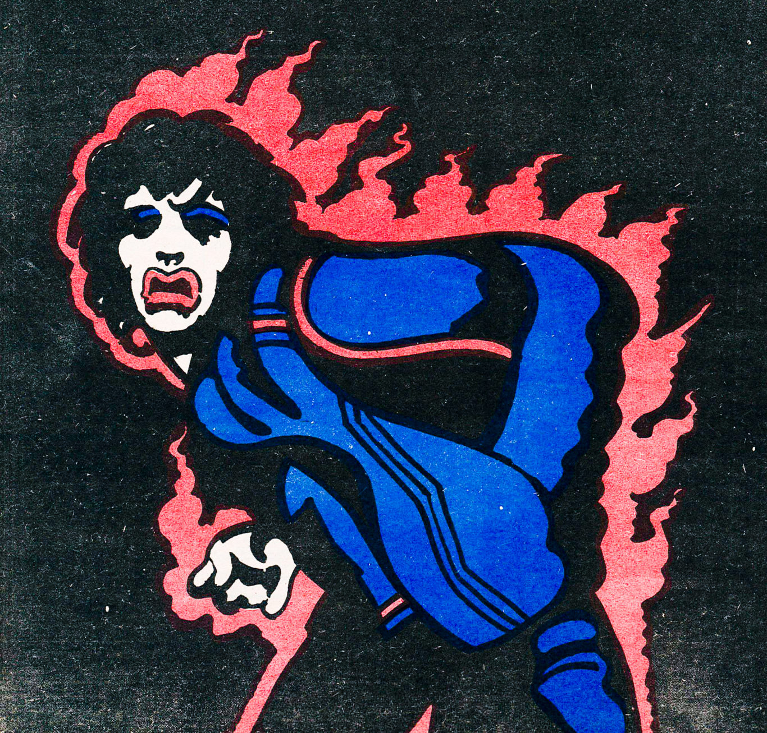
Can the Stones Still Cut It?
June 23, 1975
Two a.m. in a motel room in Wisconsin. The room is thick with dope and cigarette smoke. Peaple of various sexes crowd the room, among them the Stones. No one looks healthy. Keith Richard, as usual, looks moribund, wasted, and vaguely dangerous. He is wearing a toothy-looking earring in one ear and incredibly expensive, incredibly scuffed snakeskin boots. People are drinking whiskey and wine, snorting coke through rolled up five-pound notes. and, occasionally, popping amyl nitrate. One big fat bearded man in jeans and shitkicker boots sneaks up behind a heavily made-up young woman and pops an amyl nitrate capsule under her nose. Her eyes roll back and she almost keels 0ver. Then she pulls herself together and looks ecstatic. I am not ecstatic. I am not even slightly at ease. If someone pops one of those things under my nose, I know I’ll fall down in a hideous, gibbering fit. l feel the way I did on the first night of sixth grade dancing class back in Loveland, Ohio, where I was the only girl in anklets instead of stockings and Buddy Borger didn’t dance with me once. The coke I’ve snorted has intensified this feeling. The dope is decorating it. Mick Jagger is across the room, looking bored and small and unobtrusive. I would like to go over and talk to him, after all, I am a reporter and he is The Stone. I can’t do it. Every time I start to, my knees dissolve, as they have been dissolving, on and off, in his behalf for the past 10 years.
Finally, I give up the whole misguided adventure and slink off to my room, where I can read a murder mystery and try to feel less ridiculous. I am doing this, unsuccessfully, when I hear a light tap at my door.
“Come in,” I say. The door opens, and it is Mick. He has a bottle of wine in his hand, and he looks tired and friendly.
“Hi,” he says, “would you like to talk?”

RELATED
- MUSIC
The Magnificent Rolling Stones
by THE VOICE ARCHIVES
***
A fantasy, of course. It ran through my head on a repeating loop for two weeks, from the moment I got the assignment to cover the first week of the current Stones tour of North America until May 31, when I checked in at the Royal Orleans Hotel in New Orleans, thereby entering the world of a Stones tour.

It’s tight, self-enclosed, and intense; you’re pulled into it like an astronaut into a black hole. Swoop! and you’re in another world, within the larger universe but essentially sealed off from it, with the Stones as its gravitational center and everyone else revolving around them in a continually shifting hierarchy. There’s no room, or time, for fantasy in that world; you’re too busy finding your feet. And besides, the fantasy was wrong, as I had expected it would be.
After dropping my bags in the furnished closet that constitutes a single room at the Royal Orleans, I went with another reporter, John Rockwell of the Times, to the Stones’ floor to pick up a press kit. (The Stones’ touring party —upwards of 50 people — is large enough that they can commandeer a floor of every hotel they stay at.) While we were there, talking with Paul Wasserman and Suzi Oxley, the tour press people, Jagger walked in. He looked haggard and homely, with a mouth too large for his face, which at that moment seemed deeply lined, and a head too big for his body. He is small — all the Stones are, and they look slightly miniature, like 18th-century men. But to say he’s unobtrusive is too definite.

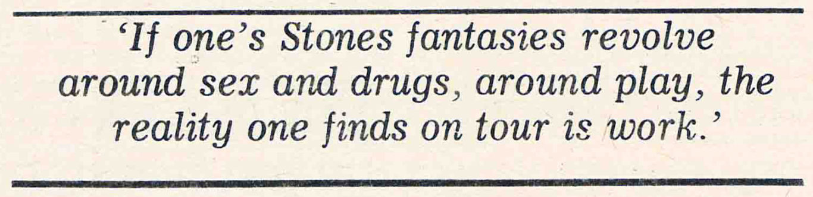
He is less unobtrusive than visually elusive. The parts don’t quite fit together; the subtle disproportion confuses the eye. And he turns on and off more than any other person I’ve seen. The difference between on and off is the difference between a lit stage set and a darkened one.
And with Jagger, on and off isn’t simply the difference between the onstage persona and the offstage person. The onstage persona is always on: however many different characters or moods Jagger might convey on stage — sexual, clownish, menacing, he shuffles them like a deck of cards — each is distinct and readable. But the offstage person is not consistently off, and the face of the person flickers continually with the masks of the personae. Charm gives way to boredom, boredom to irony, irony to humor, with no apparent sequential logic, and in between are moments of pure blankness, when there is no expression at all on the face. Perhaps these are moments of privacy for an extremely public person; if so, they work. Because at such moments the observer is left with nothing to look at but that confusing disproportion, and so you tend not to register him at all. Jagger is probably one of the most widely photographed people in the world, and yet if he wants to — and assuming there aren’t hordes of forewarned groupies behind every potted palm — he can pass through a hotel lobby virtually unremarked.
When Jagger came into the room that Saturday, he was a small, tired offstage performer asking his PR people a question. Then Paul introduced him to the reporters present, and the air zinged a little with that “oh, a star” tension that arises whenever any of the Stones is being introduced to someone. Jagger seemed to come into focus; he straightened and smiled and shook John Rockwell’s hand in an attitude of formal courtesy. When he turned and did the same with me, I saw that above the smile his eyes were like blind walls. It was interesting, even eerie, but not the sort of thing to dissolve the knees of any but the most determined sexual fantasist.
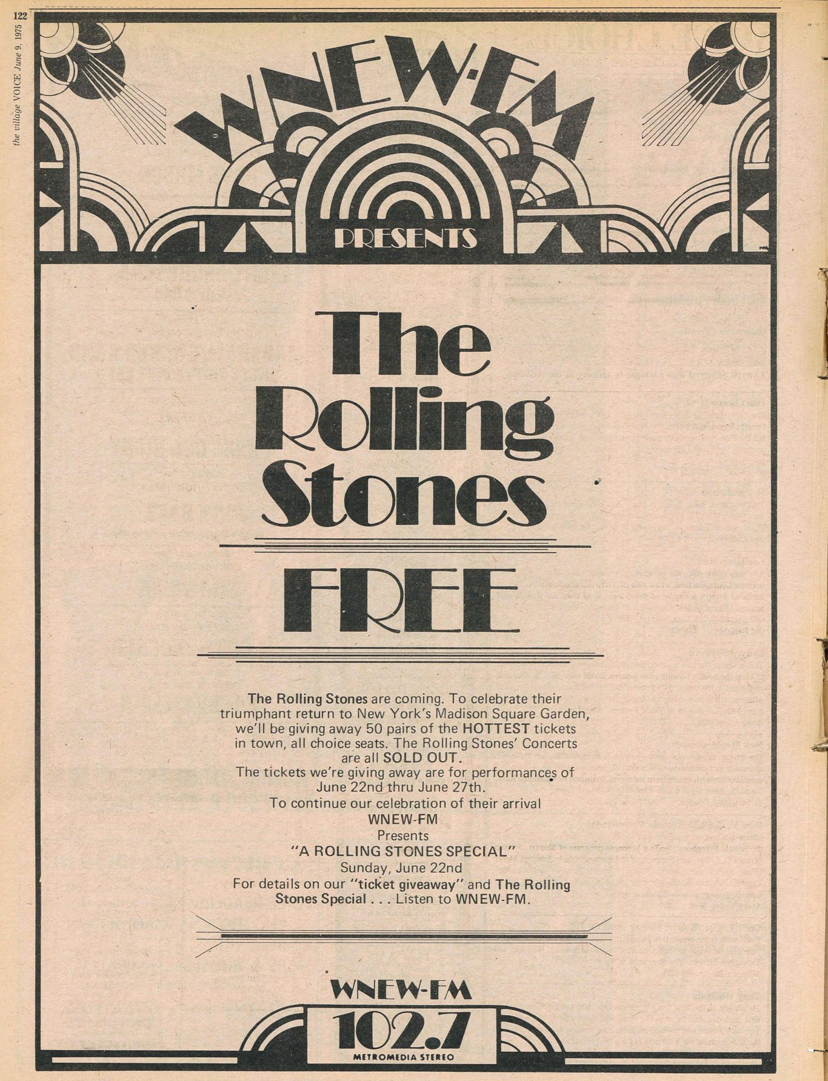
If one’s fantasies of Stones’ life revolve around sex and drugs, around play, the reality one finds on tour is work. This was particularly true during the first week of the tour, when the band was still pulling the show together. In the course of that first week, between June 1 and June 6, the Stones did five shows, two at Louisiana State University’s Assembly Center in Baton Rouge (the Stones commuted back and forth from the hotel in New Orleans by air-conditioned camper), another two in the Convention Center in San Antonio, and an outdoor show at the 60,000-seat Arrowhead stadium on the outskirts at Kansas City. The night before the first concert, there was a midnight to dawn technical rehearsal at Louisiana State with the full band — the four Stones, Ron Wood of the Faces filling the space left by guitarist Mick Taylor, Billy Preston on keyboard, and 22-year-old Ollie E. Brown, who usually plays with Stevie Wonder, assisting on percussion.
After most of the shows that week, the Stones continued to work, listening to tapes of the night’s performance, singling out rough spots, rearranging the song order to minimize guitar changes, and trying to find solutions to their most persistent problem in large halls, which is simply hearing each other. The night before the outdoor show in Kansas City, they held another rehearsal to incorporate fresh material — including a new song by Keith Richard called “Be Sure the One You Need.”

These are the longest sets the Stones have ever done, running a little over two hours and containing between 22 and 24 songs. The oldest is “Get Off My Cloud,” which segues out of “Ain’t Too Proud to Beg” — a typically paradoxical Stones juxtaposition — and the show concludes with a bombardment of rockers. All week long, you could see the show evolving on stage through the individual concerts, its parts knitting together into something organic and alive.
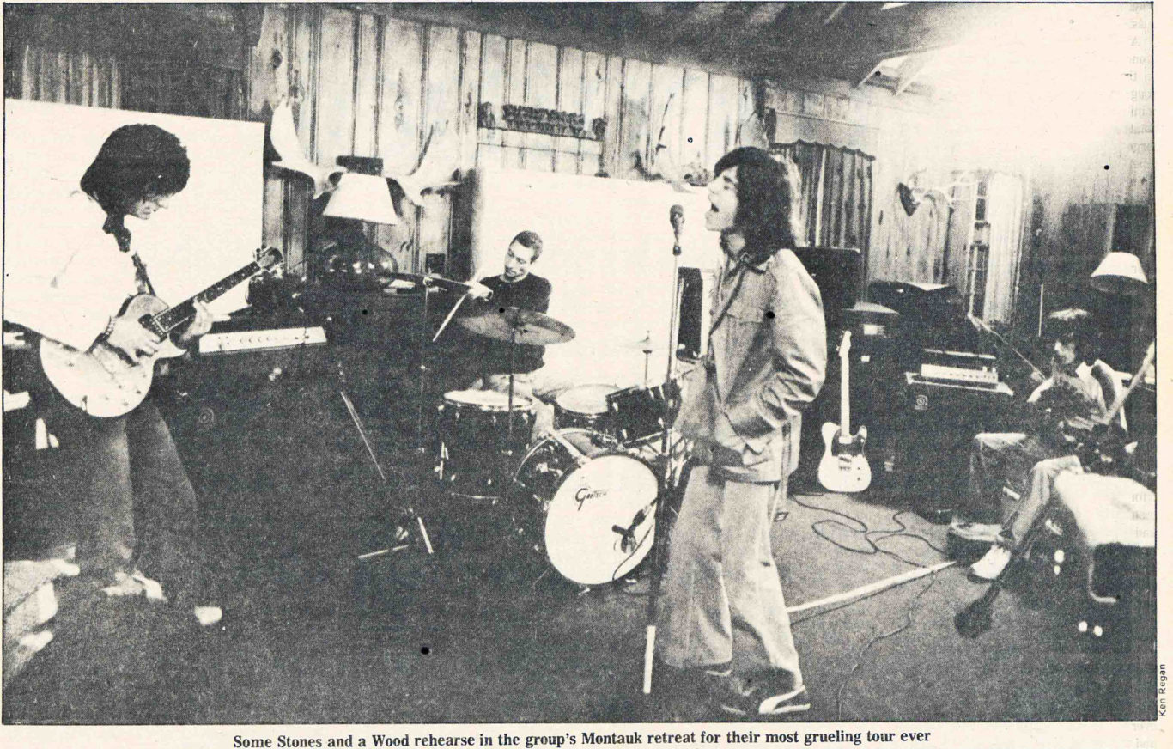
Not that any show was bad or any crowd disappointed, but the first concert had an air of labor about it. You could see the continual effort behind the music on the part of every member of the band; the seams were visible, and the show only really flew — that moment when the music seems to take over the musicians and send them as well as you spinning off into some musical outer space — during the last half-dozen numbers. At the next performance that evening, the show took off much sooner, less than halfway through and on a number that isn’t even hard rock, a version of “You Gotta Move” sung by Keith, Ron, Billy, and Mick. And two days later, with the first show in San Antonio, everything jelled. The band seemed loose and high by the second number (“All Down the Line”). Mick used every available inch of the huge, starflower-shaped stage, Keith grinned frequently (Garbo laughs!), and Ronnie Wood skittered around in circles like a speedy six-year-old. Even Bill Wyman, ordinarily a solemn man on stage, was seen to smile.
After the show, back at the hotel, everyone was exhilarated. It was evident that a tension had eased. And no wonder. Because that first San Antonio performance answered the uncomfortable questions that hang over this tour more than any other: Can the Stones still cut it? Are they slipping, is this the beginning of the end? Yes, they can, no they aren’t, and no, the end isn’t in sight. That show was one of the best rock shows I’ve ever seen, all two hours and 15 minutes of it, and the ones that followed were just as good. The Stones are in their prime.

RELATED
- FROM THE ARCHIVES
Lester Bangs: The Rolling Stones’ Nostradamus
by THE VOICE ARCHIVES
***
My favorite souvenir of the tour is a yellow armband, a cheap piece of ribbon with three words on it. The armbands were a source of both pleasure and paranoia. They first came to my attention Sunday evening after the first show. A room had been set aside at the LSU Assembly Center for the press to use. There were a lot of us there. I don’t think any Stones tour has been as heavily covered as this one is turning out to be, with anywhere from a half-dozen to two dozen radio, television, and print journalists following the tour at any given point.

Some of us were feeling a little out of sorts. It looked as if we were going to have to spend the time between shows — a matter of some hours — stuck in the press room. A hospitality room, where there was food and an opportunity to talk to the band and where we had been permitted to spend some time the night before, during the rehearsal, was off limits to the press. Or was it? Because as I was glumly considering the sadly empty state of my stomach and my notebook, Frank Conroy of the Times Magazine wandered by wearing some kind of yellow ribbon around his arm. Worse, he was drinking a beer. Then, Geraldo Rivera showed up, also wearing a yellow armband and eating a plate of food.
Paranoia, envy, and panic mingled in my brain. My worst suspicions were confirmed. Not all reporters were being kept away from the Stones, just some. Like me. I strained forward to read the words on Geraldo’s ribbon. Something about access. Access to rockstars? My god, I thought, that’s laying it on the line. Then he turned, and the words became clearly visible. In large gold letters, they said: NO ACCESS BACKSTAGE.
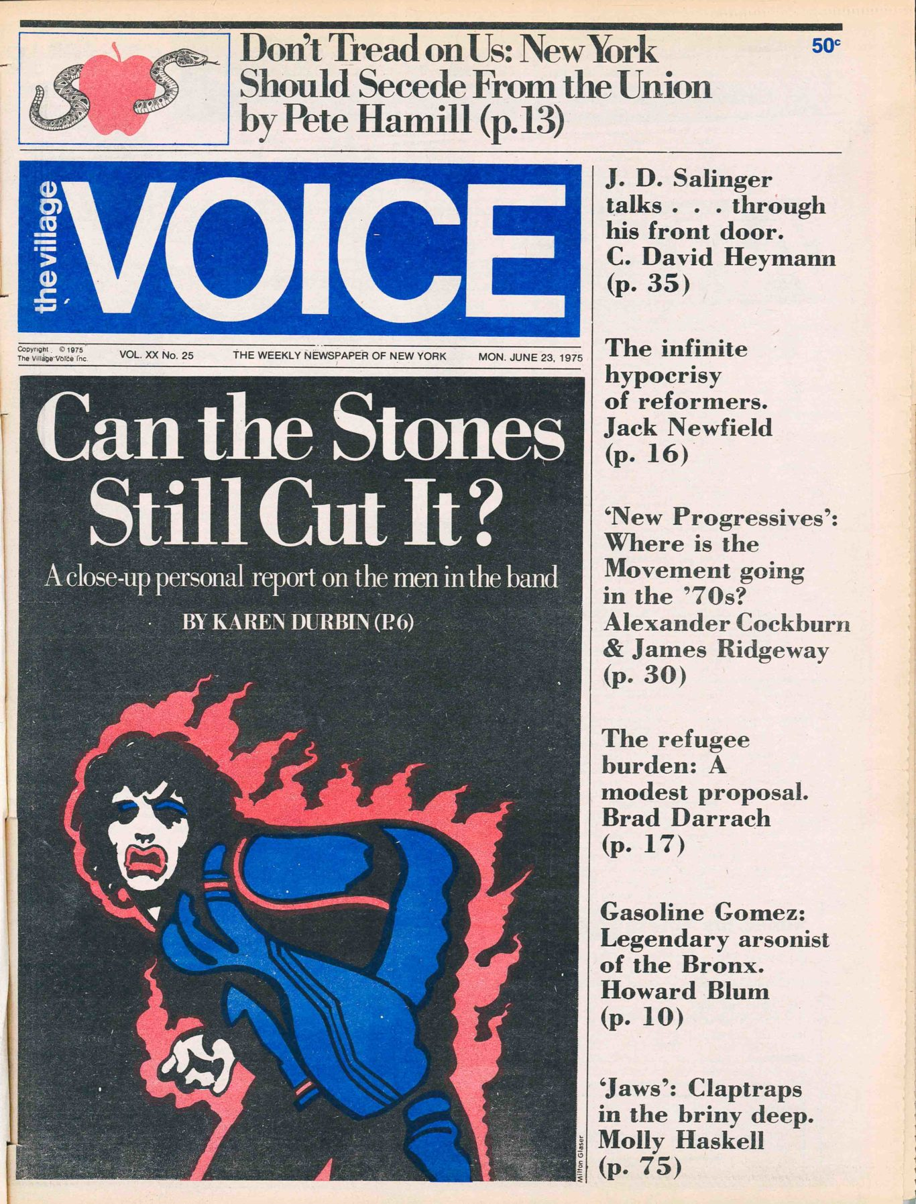
Access is a word I’ve never had much occasion to use; it belongs, however, in any reporter’s lexicon of a Stones tour, right next to Hierarchy and Paranoia. Access means access to the Stones, the pinnacle of the tour hierarchy. And worrying about that access is a reporter’s own special brand of paranoia on a Stones tour. I got an armband eventually, along with some of the other reporters. The armbands were primarily intended for photographers, and what they did was let you stand directly in front of the stage during the first two numbers, a joyous, ear-splitting experience. It is fitting that the only special badge of passage given to reporters on the tour was one that told you where you couldn’t go.
This kind of thing can make you feel slightly crazy, particularly if you’re a reporter who is a Stones fan. Even if you know that should the Stones prove horrible you will go home and say so, that doesn’t really quell the feelings of love, affection, and gratitude for pleasures past that are bobbing around embarrassingly in the back of your mind. While the Stones and the people around them are treating you gingerly, as if you might bite, you’re feeling like an overenthusiastic St. Bernard who’s about to roll all over the floor with unwonted, and unwanted, adoration.
The press was finally given access to the hospitality room that night. We were led in, over a period of a half-hour or so, in little groups of two and threes. It was a large collegiate recreation room. Bill Wyman, looking pretty and artificial in his stage makeup, played Ping-Pong with one of the touring party while Astrid Lundstrom, the striking blonde Swedish woman who has lived with him for the past eight years, looked on. Geraldo was over near the buffet talking to Bianca, who is tiny and exquisite and chic. “You look very beautiful tonight,” he said. “Thank you,” she said, in an incredibly husky voice.

In the center of the room, at a round table, sat Mick. He was wearing a T-shirt and jeans, and his eyes were almost completely obscured by the heavy black eye makeup he wore for the first two shows. (By San Antonio, Bianca had prevailed on him to change it to something lighter, which was smart; the black eyes were tacky, reminiscent of Alice Cooper, and they made him look blind and glaring on stage.) Sitting at the table with Mick were three British tabloid reporters and tour manager Peter Rudge; it was an informal press conference, and I sat in on it, resolving to be as un-St. Bernard-like as possible.
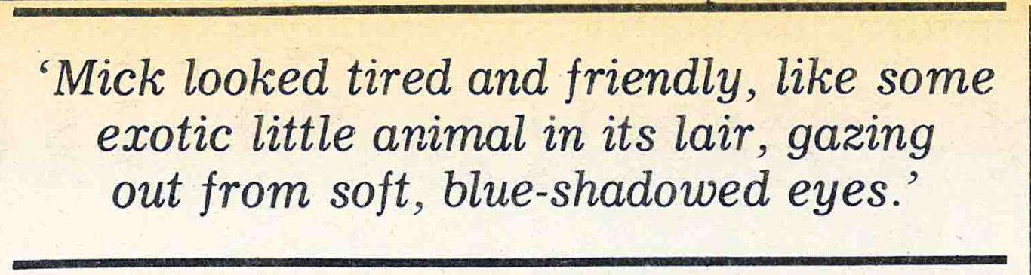
That, as it turned out, was easy. It was like a parody of the dumbest sort of pop star press conference, with everybody playing unnatural roles. Rudge, ordinarily a brusque man with the press, was alarmingly sweet — according to someone I spoke to later, because he’s going to be introducing a couple of his lesser groups into England in the fall and wants friendly coverage. The reporters, who had been sufficiently hard-assed and wisecracking back in the press room, now seemed afflicted with their own case of St. Bernardism. They were solemnly respectful, starting their questions with a ponderous, “Tell me, Mick…” and asking Jagger questions like did he feel that England was no longer a force in world politics? and what did he think should happen there? and what were his political views? Etc. ad dozium. He, in turn, distinguished himself by emitting such pearls as “I would like to see a social revolution (in England) but I dunno how you go about doin’ it.” He also said that he thought most people in England “have been enslaved by a stupid kind of materialism; they spend all their time watching telly.” As he said this, he gestured with his left hand, the third finger of which flickered with the light of a large, square diamond ring.
A moment later, one of the reporters asked, “Tell me, Mick, have you sung ‘Sympathy for the Devil’ since… then?”
Thus respectfully was the touchy subject of Altamont broached. “Sure, sure, hundreds of times,” said Mick, cheerfully lying. “We were going to do it tonight, we just forgot.” And into the small silence which followed this absurd statement, he suddenly sang, in a high, sweet falsetto: “Please allow me to introduce myself…” Just the first line, nothing more. But then you remember the line that follows. A man of wealth and taste indeed.

RELATED
- MUSIC
Beaten or Stoned? Was 1968 the Beginning of the End of the Sixties?
by R.C. BAKER
***
I see I am in danger of doing what reporters too often do — make Jagger seem like 90 per cent of the Stones. Theatrically, that’s true. He’s more than a singer, after all; he’s a performer and one who works at the level of spectacle, attempting to cast visual images large enough to reach people who may be sitting many hundreds of feet away from him.

But offstage, Jagger recedes, taking his place, along with Keith Richards, as first among equal Rolling Stones. Nowhere does this become so clear as on tour when you have a chance to watch the work behind the show. In one sense, the experience of that week was a process of watching the other members of the band emerge.
The first rehearsal evening at LSU was almost a capsulized version of the process. The rehearsal was supposed to begin around 9 p.m. It actually started three hours later because everyone thought Ronnie Wood was in someone else’s car, so a driver had to make the 90-minute run back to New Orleans to get him and bring him to Baton Rouge. Mick stayed backstage (no access rock stars); the half-dozen reporters present hung out in the hospitality room with various members of the tour and, as they came and went, the band.
Ollie Brown and Billy Preston came in, moved through the room looking like characters out of an Alvin Ailey ballet. They wear enormous Afros (Billy’s is a wig), and they are showy, dramatic-looking men. Ollie, who talked with frankly star-struck pleasure about being asked to join the tour, looked like a tough, flashy street dude, with his brightly studded jeans rolled up to show off high silver platform boots. Billy is older and more remote; playing Ping-Pong in slick, expensively tailored black trousers and yellow satin shirt, he might have been a rich young Harlem preacher on his day off.
Charlie Watts and Bill Wyman sat at a small round table in the middle of the room, and talked with reporters about the latest Stones album, Metamorphosis, and about the tour. The Stones are angry about the album, a collection of old, unreleased studio tracks put out without their cooperation by Allen Klein. “It’s nothing to do with us,” Charlie said, “the liaison was nil.” Bill called the album “just a load of junk, really” (in fact, it’s not that bad) and said that the Stones had put together their own album of unreleased material from the ’60s with songs dated and running consecutively from 1963 to 1968 — “so it’d have some historical interest, some sort of value for collectors” — but that Klein turned it down in favor of his own. “His isn’t as good, but he’ll make more money from it,” Bill said.
Bill Wyman seemed, in some ways, the most “normal” of the Stones. He was virtually free of that wary, slightly hostile tension that the Stones sometimes radiated around reporters, perhaps, in part, because the press tended to overlook him. Personally, this amused him. “‘Everybody says I’m so quiet, that I never talk. Know why I never talk? ’Cause nobody ever asks me anything.” Professionally, it isn’t quite so funny, although he was wry enough about it. “Take a movie like Ladies and Gentlemen, the Rolling Stones. That’s what it’s called, and yet, y’know, you’re in it for about 20 seconds. Gets to feel a bit weird, that. You begin to think, well, what the fuck’m I doin’ here?”
Talking to Wyman, that night at LSU and in a private interview at the end of the week with him and Astrid, I was struck by his openness. He expressed emotions — affection for Astrid, the pleasure they take in raising his 13-year-old son, who will travel with them for much of the tour — with the kind of unself-conscious frankness that is surprising in almost any man but especially one who is — however silently — a star.
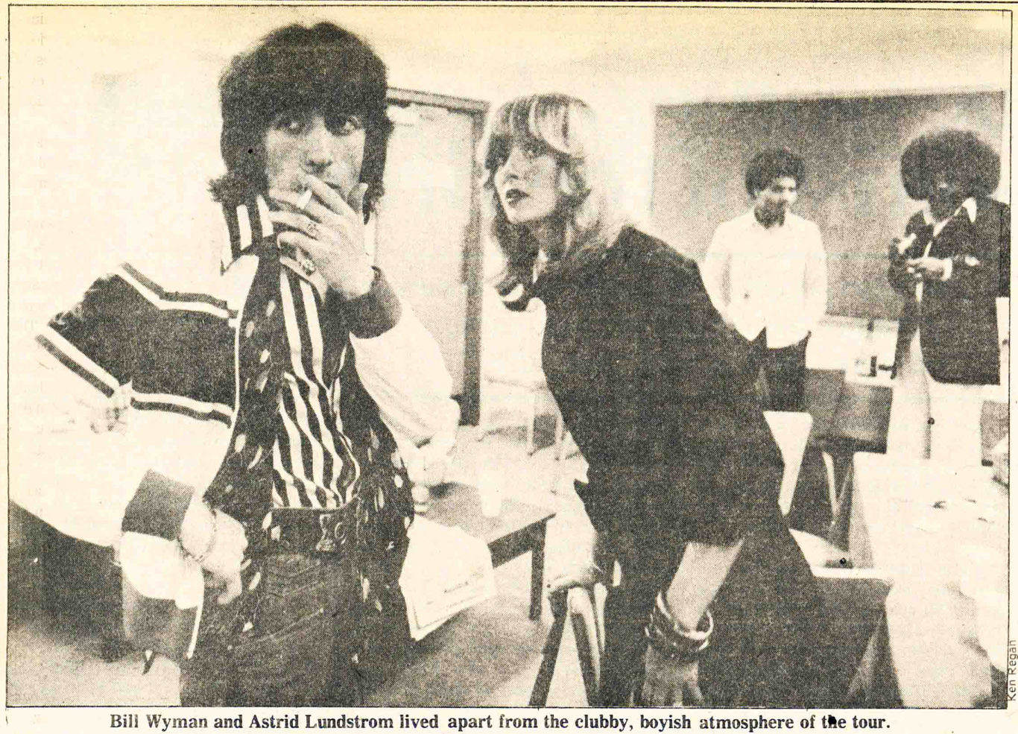
Musically, one associates Wyman and Watts, the oldest Stones; they provide the basic ground in which the Stones’ music is rooted. Offstage, that evening, they were like bad cop/good cop. Wyman was agreeable and talkative, inclined to a kind of mild humor; of all the Stones, he was the easiest to be around. Charlie, on the other hand, had the comic irascibility of a Dickens character. He has a reputation among the band for humor, and, he just now, he looks eccentric enough to be out of Dickens, amazingly thin, with a protuberant Adam’s apple and facial features sharpened by the fact that he has, for some reason, cut his hair so short that, with the small bald spot at the crown, it suggests nothing so much as a cross between a mad monk and someone who got out of Dartmoor Prison a week ago.
That night, as we talked about the design of the show — which was done by Robin Wagner in consultation with Mick and Charlie — he seemed to respond to half our questions with “Wottaya mean??!!” Then, having made it clear that the question was ridiculous, he would answer it. The last night I was on the tour, after doing the interview with Wyman, I ran into Charlie in the corridor and for once, he asked a question. He was looking at the remains of a room service buffet that Paul had provided for the press. “Wot’s this, then?” he asked, seeming interested. Assuming he was hungry, I pointed out a relatively unscathed avocado with crabmeat and suggested it was still edible. And sure enough… “Edible??!!” he howled, and then muttering something about how he certainly wasn’t goin’ to eat that ghastly stuff, he tromped off down the hall.

At one point during an informal interview with Charlie and Bill, Keith came blasting into the room with a small entourage, took one look at the reporters, and veered off to an upright piano standing against one wall and started pounding out a blues. It was like a metaphor for his whole relation to the world, to the press and to music. Throughout the week, I never once saw Keith alone; he was always with one or two people, often another musician like Billy or Ron Wood, and frequently a man named George Pappanjou. George remained a rather mysterious figure; he avoids the press even more assiduously than Keith does, looks rather like him, is said to be Hungarian, and was seen to keep Keith’s cigarettes lit and his glass filled; yet, when I asked one of the tour staff if George was Keith’s gofer — each star had somebody assigned to him in that capacity — she looked shocked and emphatically said no, George was Keith’s friend.
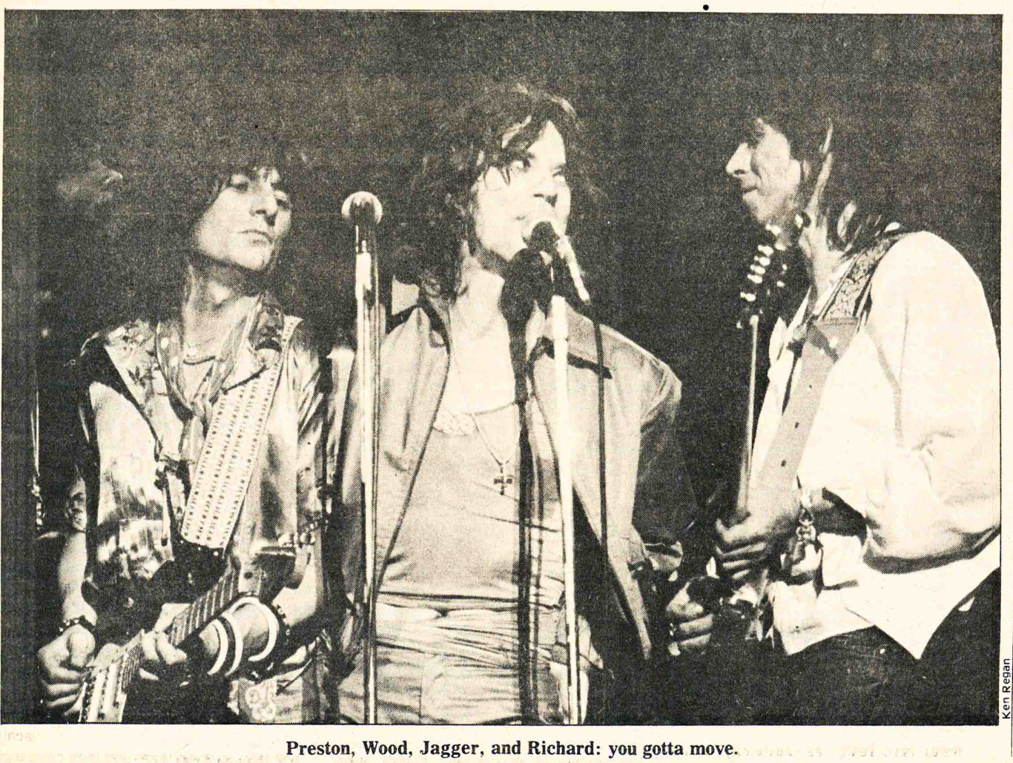
As for Keith blasting into rooms, well, he does. Offstage, Keith has the same intensity of presence as he does on, and so, of course, it stands out more. He’s amazing looking — all tatterdemalion satin jackets and flapping silk scarves, tight jeans, hollow cheeks, black artichoke hair, and huge iridescent eyes. He doesn’t look decadent; he looks vigorous and infernal, as if he just strode forth from the jaws of hell.
By the end of the week, it seemed odd that Keith could ever have been called decadent, with its connotations of decay and artifice and over-refinement; he seems utterly engaged in his work. The intensity of his involvement was evident onstage, where his role as the guiding force of the music was obvious. But the involvement was evident offstage as well. Night after night, sometimes after spending an hour or so going over tapes of the night’s performance, he would slip off, with Ronnie or another member of the band, to listen to music somewhere and possibly to jam. He lives hard, and God only knows what exotic substances he takes along the way (the only drugs I saw that week were Paul Wasserman’s tranquilizers and my own), but his life seems to revolve around music.
Keith isn’t really as unfriendly as he seems, but it was intimidating to talk to him in a way that it wasn’t with Jagger. Talking to Jagger feels appropriate; he interacts with his public. Talking to Keith you feel a little as though you are bothering a busy man.

RELATED
- MUSIC
When The Angels — and 400,000 others —said Goodbye to Brian Jones
by THE VOICE ARCHIVES
***
During the reporters’ group conversation with Charlie and Bill the night before the first concert, Frank Conroy told an unflattering anecdote about a woman he described as “one of those high-pressure girl reporters.” I know the woman he was talking about; she’s in her late thirties. Later in the same conversation Bill Wyman was talking about some studio work the Stones had done recently. Many of the songs don’t have names yet. “In the studio,” Bill said, “we call them any old thing, just to get a name on the box for convenience — ‘Dustbin Lid’ or whatever.” Then he described one song which was called “Vagina.” “It was ‘Cunt’ in the studio — not really, y’know, but because somebody had called somebody else a cunt, and so we used that. But then we didn’t want to write that, so we used ‘Vagina’ instead.”

Most of the time on the tour, I was just another reporter, neuter, doing my job while everyone else did theirs, but at moments like those, I felt self-consciously female, isolated and engulfed by an all-male world. The world of a Stones tour is very male. Out of a tour staff of 56, six were women. Of the half-dozen or so reporters following the tour that week, one was female — me. The result for a woman covering the tour is that you spend almost all your time with men; it’s a peculiar, alien sensation, as if you were visiting a planet where the female population had been decimated by an unnamed plague.
Of course, the plague does have a name — sexism. I had expected to encounter that, although not in quite the form it took in the Stones tour world. In the world that exists around the band, the sense you get is not the hey-honey-wanna-fuck mentality of an aggressively macho world where men are men and women are sex objects, but rather of a much younger sort of machismo, a world where boys are boys and this is their clubhouse so girls keep out.
It’s a world where it’s hard to imagine men and women simply being friends. Bill Wyman and Astrid Lundstrom were something of an exception to this; their relationship had a quality of friendship and mutual respect about it, and they seemed — and much of the time, literally were — somewhat apart from the clubby, boyish atmosphere that most frequently surrounded the rest of the band. But their relationship reflects some old-fashioned assumptions. When I asked Astrid if she had a separate profession of her own, she said no, although she had considered modeling or acting — and then Bill broke in, saying, “I wouldn’t let her; if she got involved with something like that, she mightn’t be able to come on tour.” It was a striking remark if only because except at that point in the conversation, Astrid seemed very much Bill’s equal.
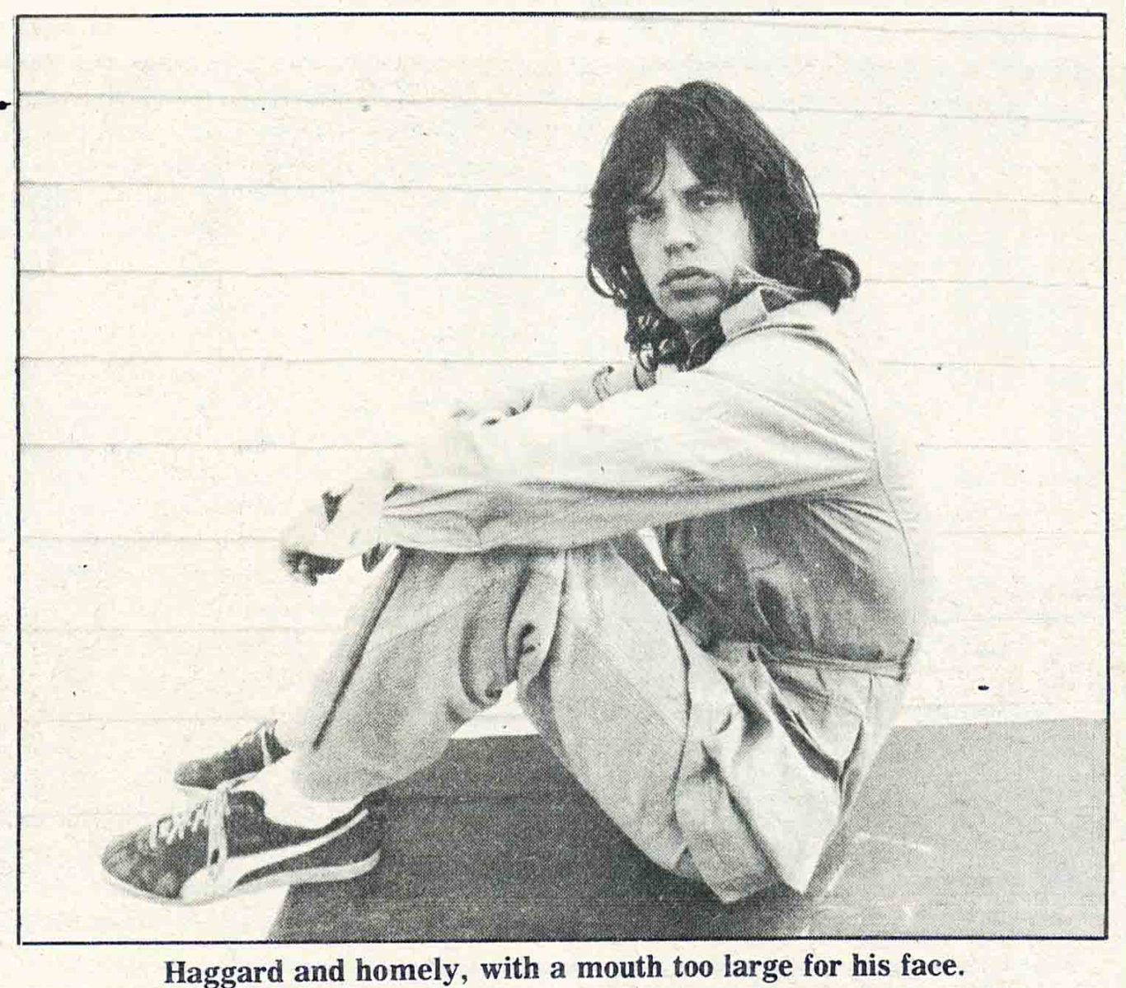
Feminism hasn’t made much more of an impact on the women who are part of the rock world than it has on the music itself, perhaps because that world is still so overwhelmingly dominated by men. I talked with some of the women on the tour about this, asking the most general sorts of questions about what it was like to work on the tour, and how did it compare with the rock world in general: They tended to confirm my impressions of the clubby, boyish atmosphere, but their reactions to the feminism implicit in such questions varied widely, from cautiously sympathetic interest to flickers of outright hostility. And every woman I spoke to at some point mentioned the groupies.
The hotels in San Antonio and Kansas City were besieged by groupies, not simply female fans, but female fans on the make. Some of their clothes were incredible, the stuff of pornographic fantasy — barely opaque dresses with no backs, no sides, and hardly any fronts; halters that didn’t halt much of anything; constrictingly tiny short shorts; even one brief, weird arrangement of black leather and industrial zippers. They crowded the lobby like fervid mendicants, stalked the halls like big game hunters, but to no end. They were held at bay by double ranks of security forces, in the lobby and on the Stones floor of each hotel, while the Stones themselves stayed safely out of reach.

There was a kind of comedy to that scene, but it had its depressing moments. In San Antonio, as I came out of my room, I met a girl standing by the elevator. She looked very young, with a fresh round country face, and she was wearing an awkwardly fitting black evening gown that looked as if it might have come from her mother’s closet. Noticing my notebook and tape recorder, she asked me rather desperately if I knew where the Stones’ rooms were. I said I didn’t, less out of loyalty to the tour than out of embarrassment for her. As I started to get on the elevator, she called after me, in a kind of shriek, “Can you get me an autograph?” “No, no,” I said, jumping on the elevator as the doors closed, and for a minute I hated rock music and stars and sex and men and women, and I wanted to be somewhere else entirely. Not that there was anywhere else to go; running from that girl, I was just running from part of myself.
Then I ran right back into it. My interview with Jagger was scheduled for the last night I was on the tour, following the Kansas City concert. It had been a long week. I was tired; he would be too. As I headed off for his room, I was prepared for blank-eyed ordinariness, even relieved at the prospect.
Mick was sitting in the middle of his bed. He was tousled, the bed was tousled, the room was softly lit, and lovely classical music played from a radio by the bed. He looked tired and friendly, like nothing so much as some exotic little animal in its lair, gazing out from soft, blue-shadowed eyes and smiling with lightly painted lips. I felt bewitched, and for a moment, dizzy, lustful half-thoughts collided inside my head.
Then the phone rang, the moment passed, and I pulled myself together and set up the tape recorder. It was, after all, not Arden Forest, but Room 521 of the Kansas City Royal Sheraton, a place where, among other things, a serious interview might be conducted — and almost was, until Ronnie Wood came in.
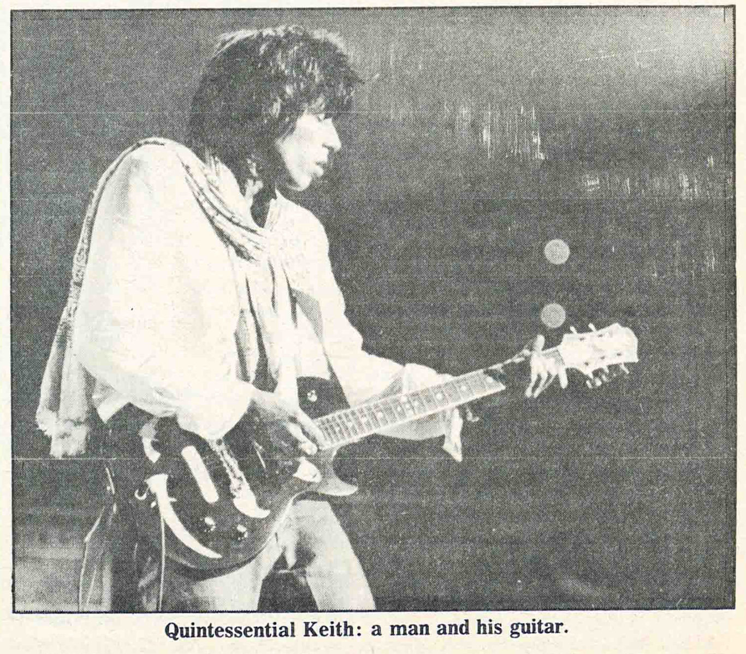
He entered just as I was asking Jagger if he’d done any solo work; Jagger said that he had been doing some work of his own and that, in fact, he’d done a lot of it with Ronnie. As he and Ronnie started talking, the whole tone of the interview shifted. When I’d been talking with Mick alone, the conversation had had a quality of professional seriousness about it. He was the serious artist-performer, talking about how performing a song changes it, making it diminish or expand, how the best ones always grow in performance, and how that was one of the things that made performing satisfying. But as he and Ronnie talked about their work together, they sounded like kids talking about their favorite hobby. It was lighthearted and funny and very young, a glimpse inside the clubhouse. Mick launched into a story about how if he’s got a song then he and Ronnie have got this studio with a drum machine and they go down there and they have a girl usually — he grins — and Ronnie says yeah, a girl engineer, and we lay down the basic track on guitars with the drum machine — and Mick says and we get the girl to run back the guitar track so we can sing the song — and I say, feeling somewhat confused but falling in with the general tone of things: Why a girl? Well, sometimes it’s Ronnie’s old lady ‘coz she’s there a lot (says Mick), or someone stayin’ with her y’know, keepin’ her company while we’re locked away downstairs (says Ronnie). And Mick explains: We need someone to do the machinery, just push the buttons, and we teach ’em that; they learn very easily. And sometimes they start comin’ jumpin’ out and playin’ the tambourine or somethin’ and y’say (he puts on a squawky Goon Show voice), “Git back to the controls, somebody has to play the guitar.”
There was more of this sort of thing, with much clowning around, and I found myself laughing even though the butt of all the jokes was girls-and-their-silly-ways. At one point Ronnie was talking about trying to explain to his girlfriend why it was a bother to have her along on tour; “You are a bother,” Mick interjected in a booming voice, “‘coz we don’t have more than one bathroom and your makeup is claustrophoberizing my fucking bath!!!” And then he toppled over on the bed, growling.

Funny machismo, but machismo just the same, and I asked Jagger if he thought the criticism of the Stones as macho was accurate. He said he thought the band was macho in a way, but the songs weren’t, or at least not since “Under My Thumb” and “Stupid Girl.” I had half-expected a sneer at the question itself; instead, he was polite enough until I brought up “Midnight Rambler.” “Midnight Rambler,” he said, wasn’t a macho song. Oh you mean it’s tongue-in-cheek? I asked, thinking of the Stones’ way with irony. But no, it wasn’t tongue-in-cheek, either, he said. it just wasn’t a macho song. I suggested that it might be a great song, but it played with images of rape and wasn’t really a song a woman could sing. And he got very sullen and said a woman could so sing it, and even when Ronnie and I started talking about something else, Mick went on muttering that it wasn’t a macho song, just wasn’t fucking macho, that’s all, wasn’t. Seeing as how we’d degenerated to the level of five-year-olds in a sandbox, I prepared to retreat to a friendlier line of questioning. Too late. No matter what I asked about anything, the answers came out in grudging monosyllables. So I put on my adult reporter face and said, “Well, thanks very much,” and he put on his polite adult performer face and said, “My pleasure, ” and there you have some irony.

RELATED
- MUSIC
Bob Dylan’s on Fire, Rolling Down the Road
by JERRY LEICHTLING
***
After the San Antonio concert, someone asked Keith about the Stones’ image as a band — did he think it had changed since the last American tour, and, if so, to what? Keith said he was sure it had changed, but that he had no idea what the band’s image on this tour would be, he’d be interested lo see. Then he talked about keeping the show fresh, with continual song changes throughout the tour. “It’s more work,” he said, “but it’s the only thing that keeps you from getting slick.”
If there’s an image for the Stones this time around, perhaps it is to be found in the extraordinary length of their shows, the effort going into them, and the amount of touring the band is planning to do. According to Bill Wyman, they hope to tour more or less steadily for the next year or so “in as much of the world as will have us” on a one-month-off, two-months-on schedule. If that’s true, it’s remarkable; the Stones haven’t worked together like that since the 1960s. The image of the Stones that I came away with at week’s end was simply that of a great working band, working hardest while they’re still at their best.
The Stones might act like kids sometimes, but they aren’t, and they know it. Bill Wyman, the oldest Stone, now refuses to give his age to the press. “I feel silly about that,” he said, when I asked him about it, “but… well, I’m afraid it might somehow hurt the band.” Jagger was asked so often on the tour about age that he began after a few days to brush the question aside a little wearily. “I can’t think more than a few years ahead,” he said at one point, sensibly enough. The same has to go for the whole group. Their future is the same as their working image, and both are identical to their music. Because it continually acknowledges the power struggles inherent in matters of love and politics, that music may not always please us. But it will have to do.

“Midnight Rambler” is macho. Worse, one of the onstage gimmicks the Stones are using for this tour is a huge white penis. It’s made of parachute silk and comes blowing up out of a trap in the stage while Jagger is singing “Starfucker.” He achieves some wit by punching and kicking the thing as it recedes into the trap, but mostly he rides it, and the gimmick seems sophomoric and second-rate, devoid of the multiple meanings that one has come to expect from the Stones. It’s dumb, and you expect the Stones to be smart.
But even if it were smart I would still wish it weren’t there. My politics make me want to believe that they give all their money to the revolution, that they didn’t really mean that part about the stupid girl, that in real life they refer to all females over the age of 12 as “women” and never fail to vote for the Equal Rights Amendment when they’re in town.
I have a perverse desire to make good guys of them. It’s perverse not because they’re bad guys — and I’m talking about them now not as people but as artists — but because they’re both good guys and bad, selfish and giving, arrogant and abjectly sad, joyous and continually aware of the limited life span of any joy. It’s their complexity, their capacity for paradox that makes them great, that makes the music resonate year after year in the mind. I have an impulse to clean them up, make them tidy and undisturbing. But it’s only the disturbing artists who are important, who fire our imaginations so that their art gives rise to our own.
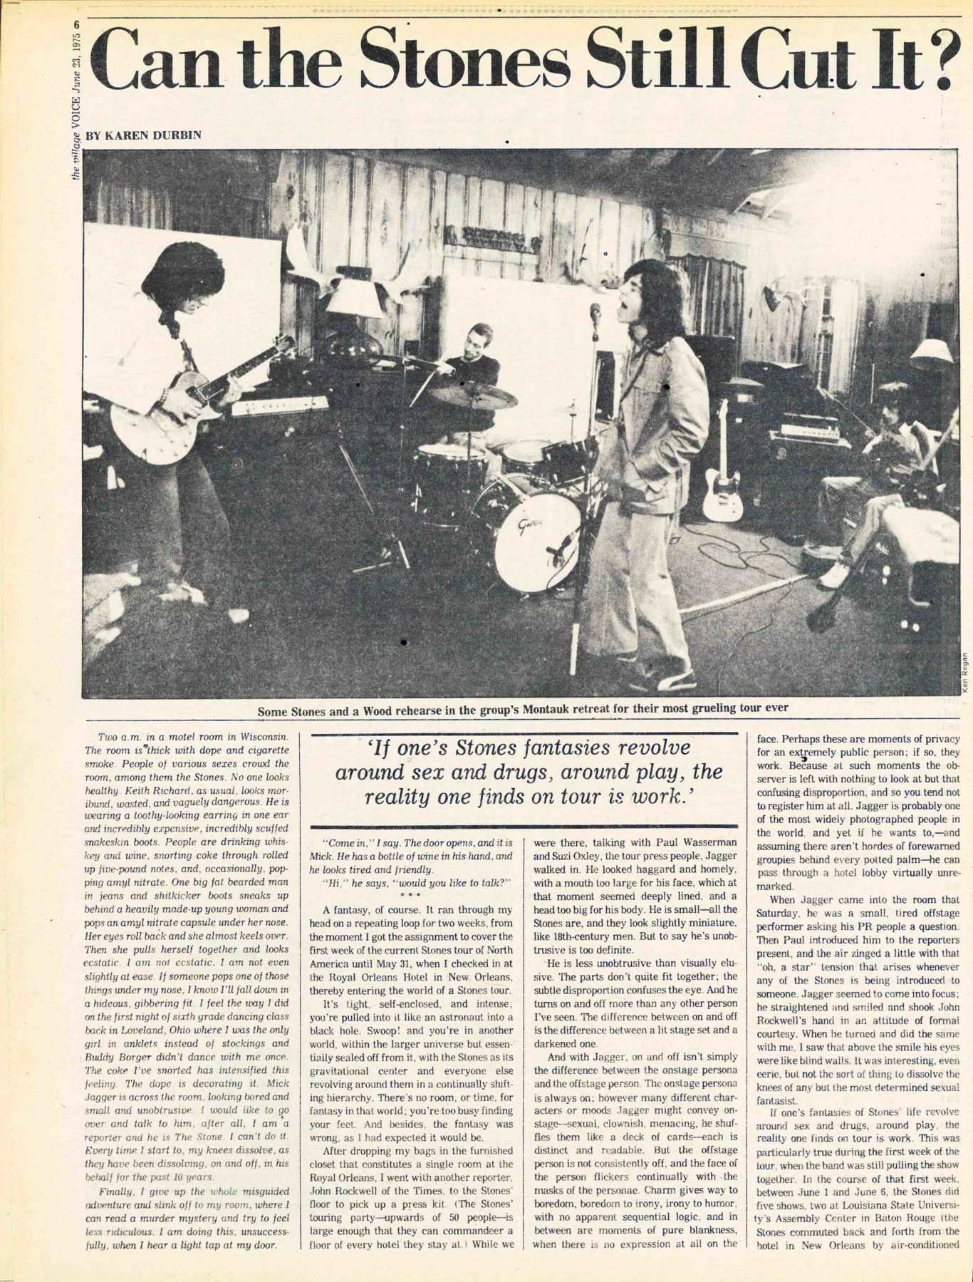
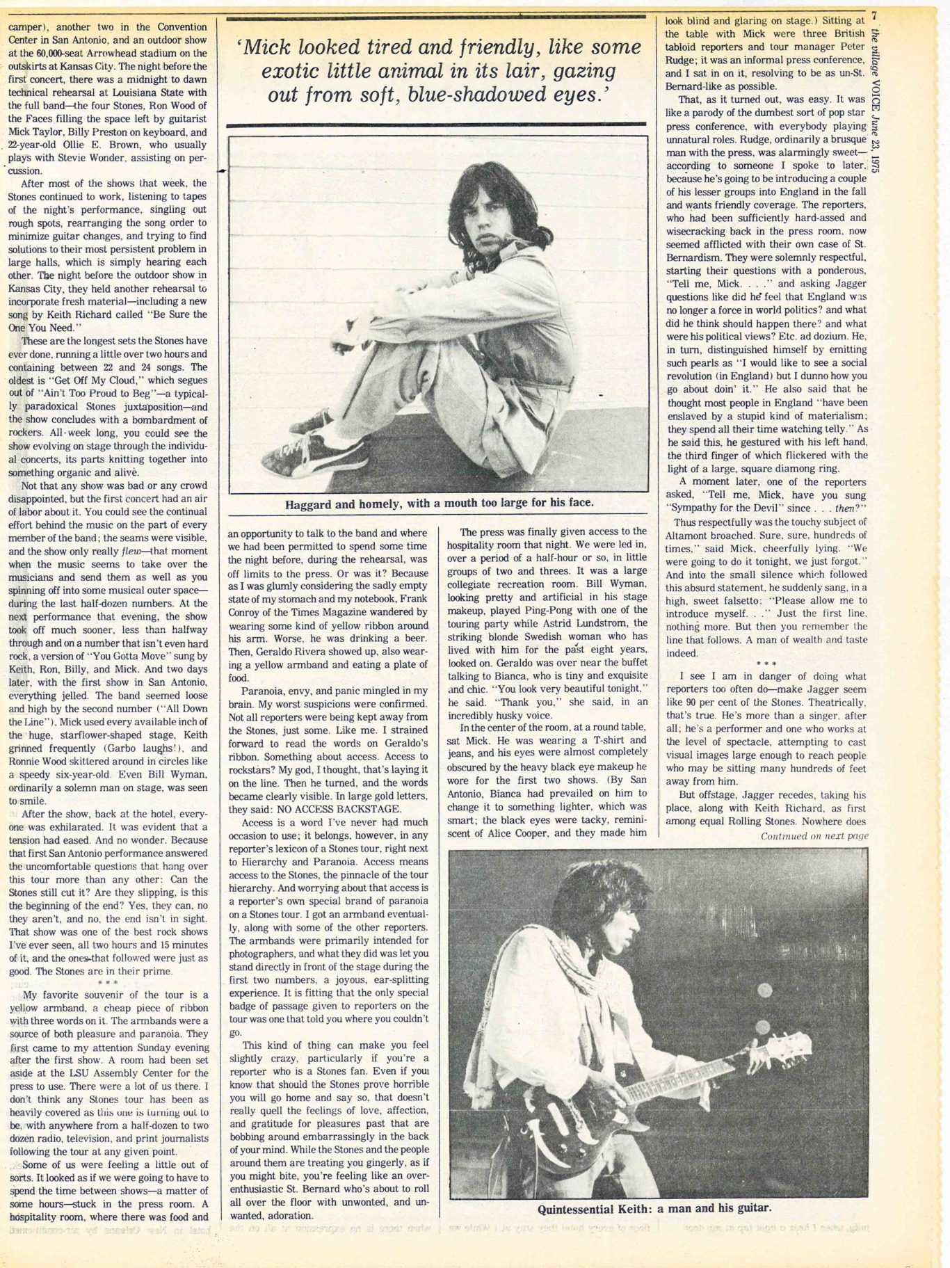
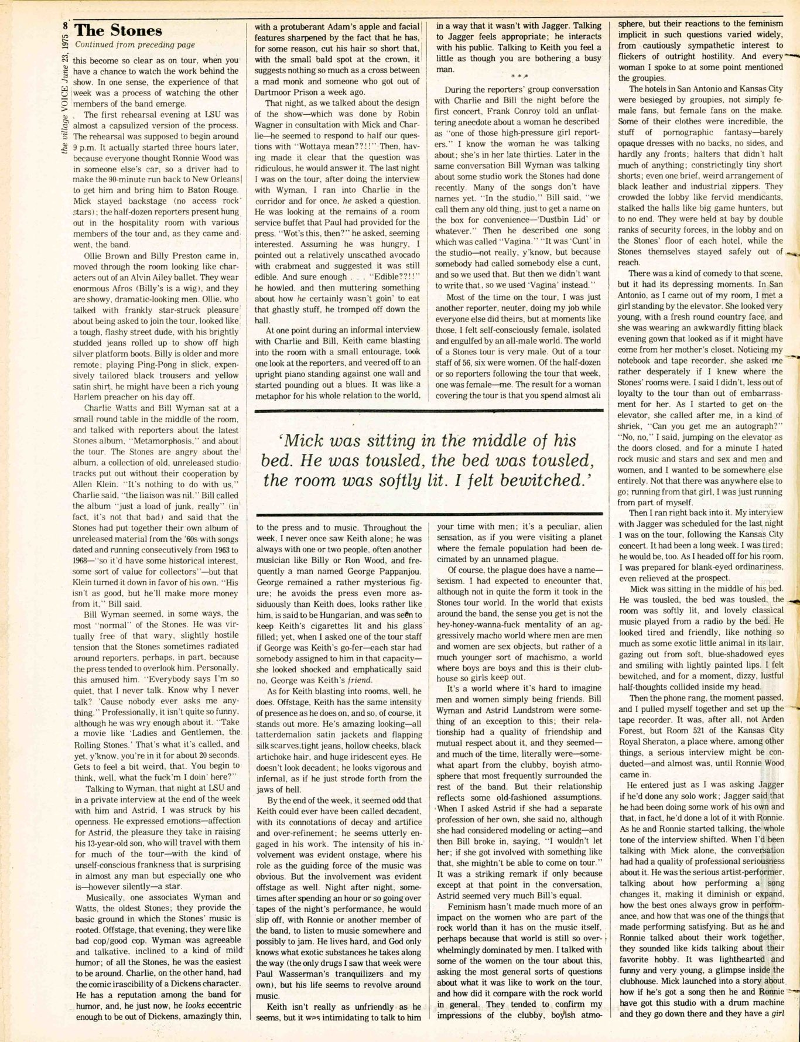
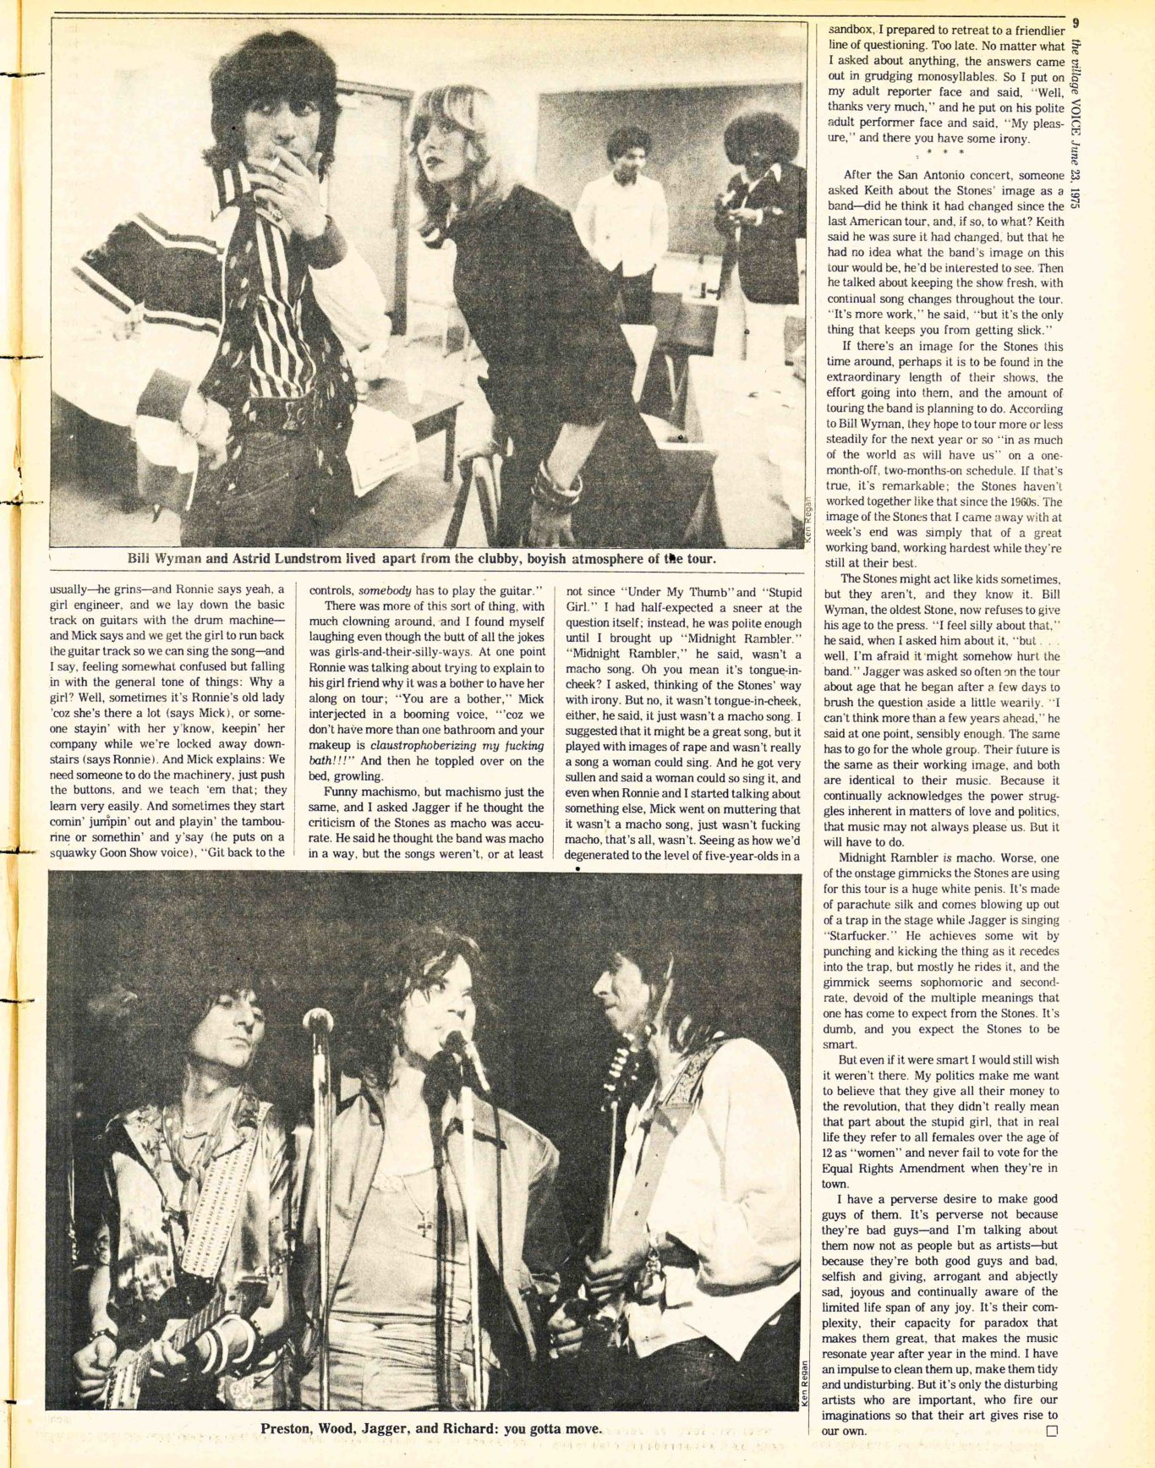
.
MORE:1970SKAREN DURBINKEITH RICHARDSMICK JAGGERROLLING STONES

