Bdelloid rotifers

An introduction to bdelloid rotifers and their study
Aydin Örstan  Germantown, Maryland, U.S.A. | Michael Plewka  Hattingen, NRW, Germany

Introduction
Bdelloid rotifers are microscopic aquatic animals. They are easily recognized by the pair of ciliated, eversible disks (corona) that most species have on their heads and by their characteristic creeping like an inchworm or a leech. Besides their interesting morphologies, bdelloids also boast unusual biological traits, including exclusively parthenogenetic reproduction and the ability to survive drying, that altogether make them unique among all animals. However, and despite also being quite common, bdelloids seem to be some of the least favourite subjects of microscopists.
Admittedly, bdelloids are difficult to study. The identification of almost all species requires that the animal be alive and fully extended with its corona – if it has one – unfolded. But live bdelloids are often very active and unruly and hence are difficult to follow under the microscope, especially at high magnifications necessary to examine taxonomically significant body parts. At the same time, even the slightest disturbance may cause them to contract their telescopic bodies into unidentifiable tight balls and remain so for frustratingly long periods. To make the matters worse, there are no readily available reagents that can be used to anaesthetize them and, until recently, there was no satisfactory method to preserve their bodies fully extended.
Needless to say, these challenges have been readily accepted and overcome by many microscopists over the years. Two pioneering rotiferologists of the early 20th century, James Murray (1865–1914) and David Bryce (1853–1934) were both amateur members of the Quekett Microscopical Club. The numbers of bdelloid species Murray and Bryce described add up to about 30% of the current total of about 400.
We hope that this brief guide will increase interest in these animals that certainly deserve more attention from microscopists.

Phylogeny of bdelloids
Bdelloid rotifers (Bdelloidea) along with monogonont (Monogononta) and seisonid (Seisonida) rotifers are in the phylum Rotifera. On a higher level of evolutionary classification, rotifers are in a group of mostly microscopic, aquatic animals known as the Gnathifera (Hejnol, 2015). The other members of the Gnathifera are the gnathostomulids, the micrognathozoans and the acanthocephalans. The phylum Gnathostomulida contains interstitial, worm-like creatures that live in the sea. The taxon Micrognathozoa consists of but one species that lives in freshwater streams on the islands near Greenland. The Acanthocephala, some species of which can be several tens of centimetres long, are internal parasites of vertebrates. They appear to be related more closely to the rotifers than to the other gnathiferans (Fontaneta & De Smet, 2015). All gnathiferans, except the acanthocephalans, possess a hard jaw-like organ. Among the gnathiferans, only the bdelloid rotifers have species that can survive drying as adults.

Anatomy of bdelloids
Most species are about 200 to 500 µm long. But a few, for example, Rotaria neptunia, can be longer than a millimetre (Fig. 1). The body of a bdelloid has been divided traditionally into five parts: head, neck, trunk, rump and foot (Donner, 1965; Iakovenko et al., 2015). Although there is no internal segmentation, the integument, especially around the foot, has well-defined transverse divisions that appear as joints (Fig. 2). The body is fully telescopic; a bdelloid can contract tightly into a shape resembling a microscopic lemon (Fig. 3). The integument of most species is transparent, but in some species the trunk accumulates a coat of debris that obscures the internal organs. Several species have on their bodies variously shaped spines, appendages or protuberances of unknown functions (Fig. 4).
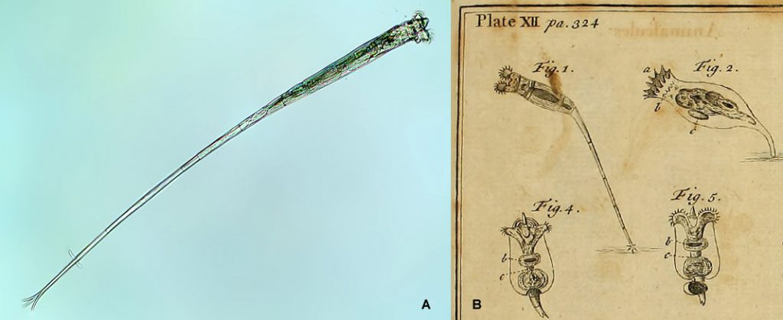Figure 1. A: Rotaria neptunia has an unusually long foot. The total length of some individuals may exceed 1 mm. B: Detail from a plate in Baker (1764) showing some of the rotifers he had observed. He described the rotifers in Fig. 1 as having “Tails enormously long”. They were probably R. neptunia, the first time this species was noted and drawn.
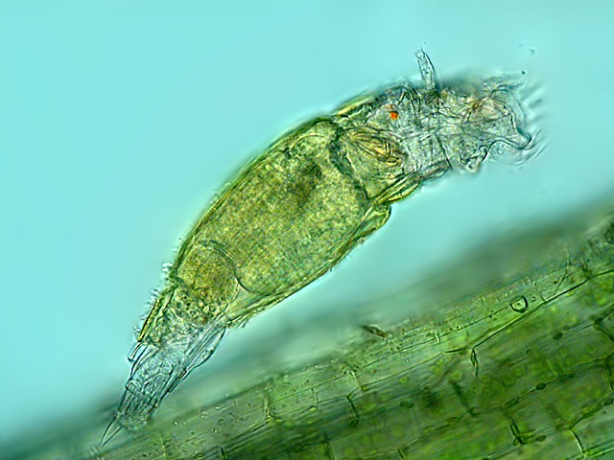Figure 2. Lateral view of a feeding Philodina citrina. The antenna on the head, one of the pair of red eye spots in the brain, the pseudo-joints of the integument covering the foot as well as one of the spurs are visible.
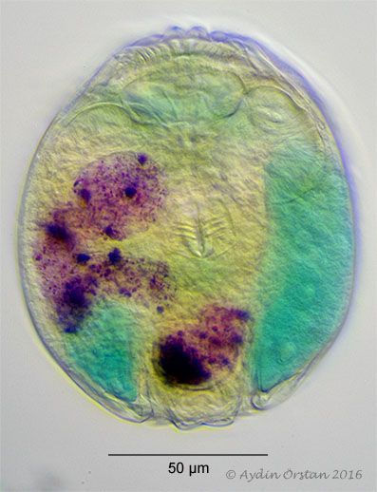Figure 3. A contracted Philodina vorax. Before it was killed and fixed with hot glutaraldehyde, the rotifer was fed carmine, the particles of which now mark the twisting lumen of its stomach. The trophi are almost at the centre and the two ciliated disks of the corona are above it. The vitellaria, on one each side, were dyed with methylene blue (oblique illumination).
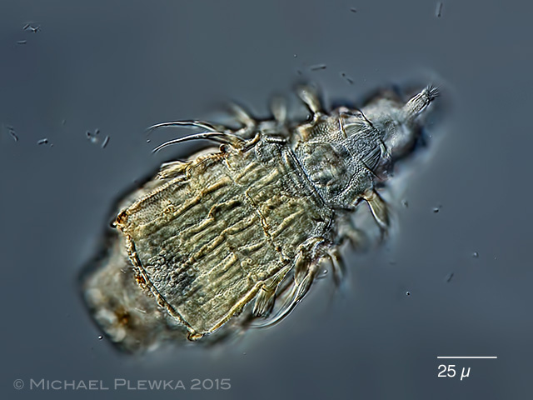Figure 4. Macrotrachela zickendrahtii whose papillose and corrugated integument also displays long spines and pedal-like appendages (differential interference contrast).
The species in the families Habrotrochidae and Philodinidae (which include the majority of the species) carry on their heads the characteristic corona consisting of two ciliated disks on pedicels (Fig. 5A). The mouth is a funnel-like ciliated structure below the corona on the ventral side of the head (Fig. 6). The corona and the mouth open only during swimming or stationary feeding. During creeping, the corona is withdrawn into the head, the mouth is closed, and a proboscis-like rostrum with a ciliated tip becomes the front end (Fig. 5B). The taxonomically significant upper lip is the dorsal area visible during feeding between the pedicels of the corona and the withdrawn rostrum (Fig. 7). In the family Adinetidae, there is no corona, the head is flattened and its ventral surface is ciliated (Fig. 8). On the dorsal surface of the heads of all species there is a dorsal antenna that varies in length (Fig. 2).
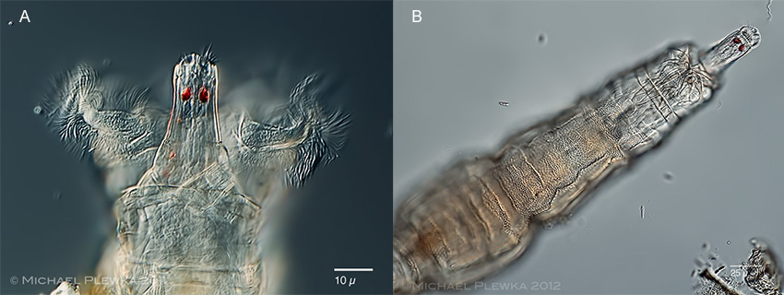Figure. 5. A: Rotaria tardigrada feeding. B: Same animal with its corona withdrawn and rostrum extended (differential interference contrast).
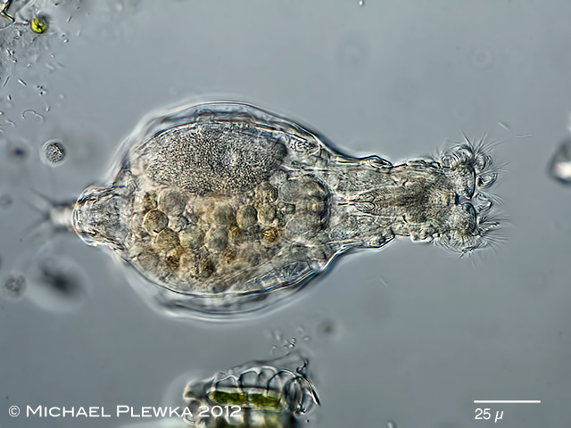Figure 6: Habrotrocha lata feeding. Focus was on the ventral side of the animal and shows the long ciliated mouth and the pellets in its stomach (differential interference contrast).
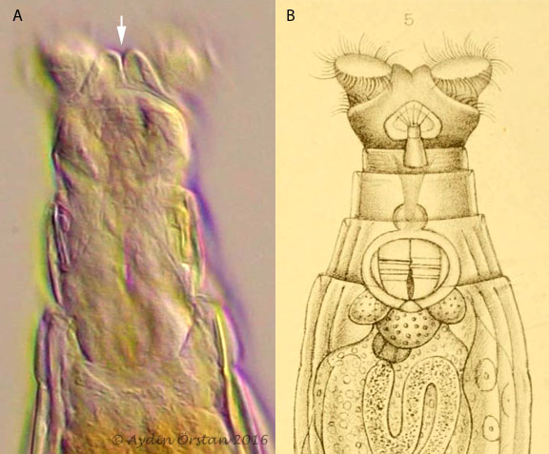Figure 7. A: A frame extracted from a high-resolution video of a feeding Macrotrachela habita (contrast-enhanced, unsharpened). The arrow marks the double-lobed upper lip (oblique illumination). B: The drawing of the species in David Bryce’s description from 1894.
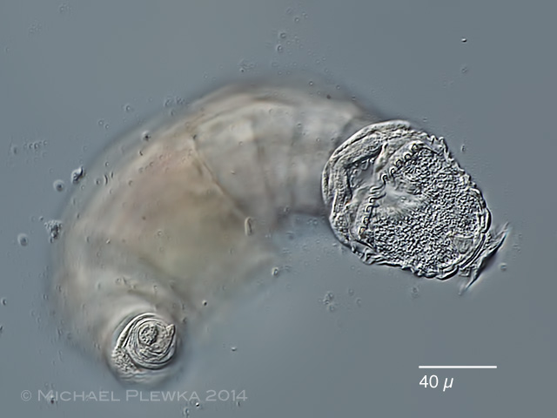Figure 8. The ventral side of the head of Adineta vaga. The U-shaped structures lined on each side of the posterior border of the flat ciliated field make up the rake organ and the broad V-shaped structure is the mouth. The rotifer was attached to the cover glass with its toes (differential interference contrast).
The jaws of bdelloids, known as the trophi, are easily noticed thanks to their almost incessant movement when a rotifer is feeding. The early microscopist Baker (1764) mistook the trophi for a heart and was confused when he observed that the “heart” sometimes suspended its motions as the trophi do when a bdelloid is creeping (in reality, because of their small size, there is no circulatory system in rotifers). The trophi consist of several pieces surrounded by muscles that are collectively known as the mastax. The upper surface of the trophi, about 10 to 35 µm long, is lined with numerous major and minor ridges functioning as teeth (Fig. 9). The opposing teeth alternate in position, which allows the two halves of the trophi to form a tight fit when closed (Fig. 9B). The number of major teeth on each half, usually expressed as n(1)/n(2), varies from one to ten depending on the species (Melone & Fontaneto, 2005) and is a useful taxonomic character. Adinetid species also have, in addition to their trophi, a “rake organ” consisting of tiny shovel-like teeth lined transversely on each side of their mouths (Fig. 8).
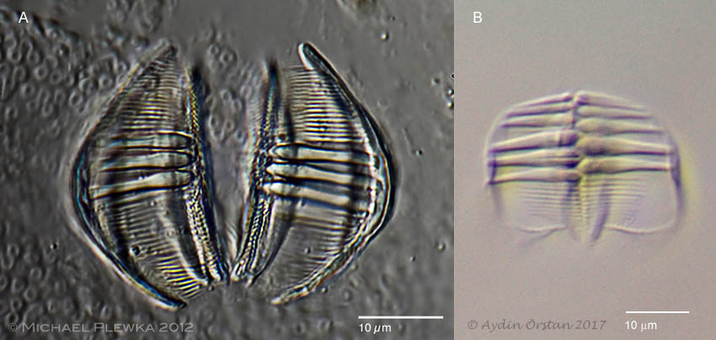Figure 9. A: Trophi of Dissotrocha macrostyla. Dental formula: 3/3 (differential interference contrast). B: Trophi of Abrochtha cf. sonneborni. Dental formula: 6/5 (oblique illumination).
Bdelloids, being bilaterally symmetric, have either paired organs placed more or less laterally or single medially placed organs. Located in the head dorsoanterior to the trophi is the relatively large brain (Fig. 10). Several additional bag-like organs in the head and the neck have traditionally been considered to be glands, although their exact functions are unknown. The most prominent of them, often almost as large as the brain, is placed transversely dorsal to the anterior end of the stomach. We call this the dorsotransverse gland (Fig. 10). The pair of eye spots, when present, are always under the integument either in the brain (Fig. 2) or in the rostrum (Fig. 5). The internalization of the eye spots, as opposed to being on the external surface, makes it unlikely that they can form images, but instead indicates that they either detect light or have a shading function.
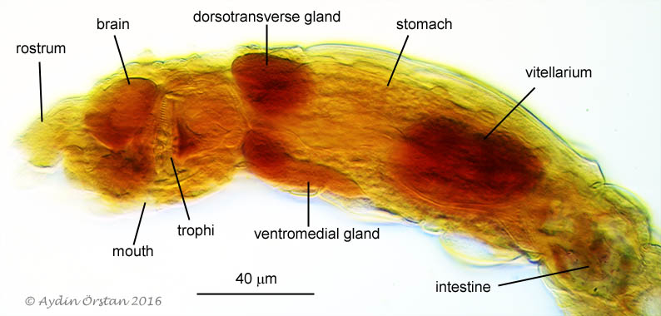Figure 10. The lateral view of a specimen of Abrochtha cf. sonneborni showing the major organs of the head and the trunk. The rotifer was killed with hot glutaraldehyde, stained with neutral red and mounted in glycerine jelly (image was processed to accentuate the colours; oblique illumination).
In the families Philodinidae, Philodinavidae and Adinetidae a lumen goes through the stomach, but is absent in the Habrotrochidae. The stomach runs into an intestine, which is followed by a contractile cloaca in the rump. The protonephridial system, responsible for excretion and osmotic regulation, consists of a tubule along each side of the body extending from the head into the cloaca. There are several elongated cells attached to the tubules. These are called “flame cells” because the movement of the bundles of cilia inside these cells makes them look like flickering flames. The movements of these cilia, visible at high magnifications, are sometimes the only indication of life in otherwise contracted and motionless bdelloids.
The trunk also contains a pair of vitellaria (yolk glands) each with an associated ovary. The latter, consisting of a number of small cells, are usually difficult to spot. One of the vitellaria is often larger than the other and is easily recognizable by the large nuclei it contains, which are eight in number in most species (Fig. 11). Some organs of bdelloids, including the integument and the vitellaria, are syncytial in which there are nuclei, but no cell membranes.
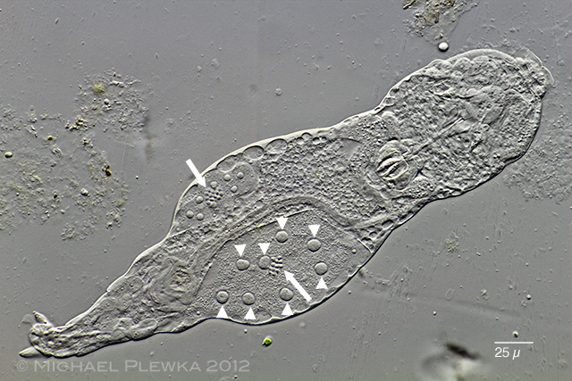Figure 11: A specimen of Adineta compressed under the cover glass. The large nuclei (arrow heads) of the two vitellaria as well as the ovaries (arrows) associated with each are visible (differential interference contrast).
In almost all species there is a pair of appendages called spurs on the penultimate pseudo-joint of the foot. The spurs seem to contribute to the attachment and the balancing of the foot. The foot ends with two to four toes or an adhesive plate. The number of toes and the morphology of the spurs are important taxonomic characters (Fig. 12).
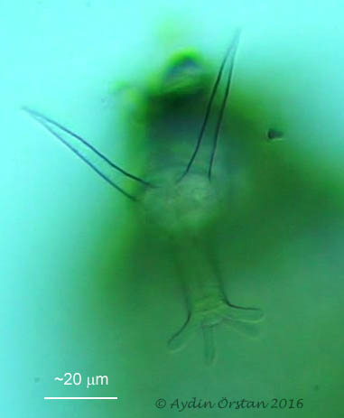Figure 12: A frame extracted from a high-resolution video of a Dissotrocha macrostyla that was creeping on the underside of a cover glass (contrast-enhanced, unsharpened). The long, blade-like spurs that give the species its specific name and the four toes at the end of the foot are visible (oblique illumination).

Reproduction
No male bdelloids have ever been observed and they are assumed not to exist. Females produce unfertilized eggs that develop into females. This process is called parthenogenesis. Bdelloids are the largest group of eukaryotes that reproduces exclusively by parthenogenesis.
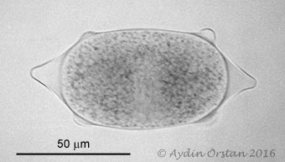Figure 13. The egg of Macrotrachela plicata
Most bdelloid species are oviparous. Eggs are about 50–100 µm long. The eggs of some species are covered with protuberances of various shapes (Fig. 13). There are also viviparous species that give birth to fully developed young. For example, all of the species in the genera Rotaria and Dissotrocha are viviparous. Rotifers carrying advanced embryos are easily recognized by the second set of trophi that will be visible in their trunks (Fig. 14). Sometimes, a viviparous rotifer may carry more than one embryo each at a different stage of development.
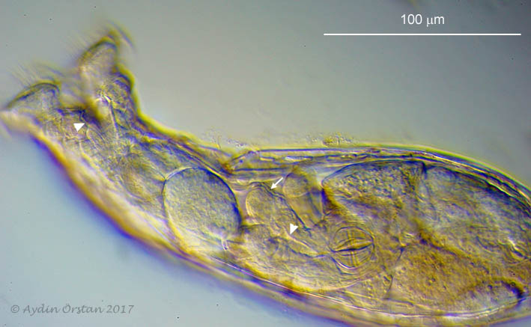Figure 14. A live Rotaria rotatoria with a fully developed embryo whose corona is open (arrow) and trophi are visible. The mouths of both the mother and the embryo are also visible (arrow heads). The embryo appears to be moving freely within the body cavity of its mother, but how it obtains nourishment is not clear (oblique illumination).

Habitats and drying survival
Bdelloids are ubiquitous in freshwater habitats where an overwhelming majority of the species lives. They may be found not only in rivers, lakes and ponds, but also in habitats that one may not think of associating with freshwaters. The latter include mosses and lichens growing on rocks, trees and on rooftops; rain puddles, rock pools, bird baths and even the tanks of sewage treatment plants. Most bdelloids are free living, but some species are epizoic on freshwater crustaceans and aquatic insect larvae. Several species in the genus Habrotrocha spend their lives inside the cases they build for themselves (Fig. 15).
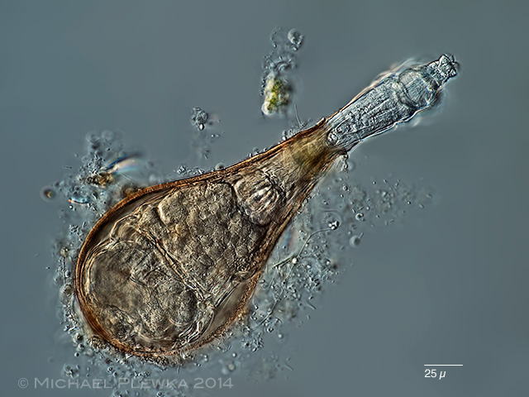Figure 15: Habrotrocha angusticollis in its rigid and uniquely shaped case that it has built for itself (differential interference contrast).
Bdelloids are much less common in brackish waters and the only one truly marine species, Zelinkiella synaptae, is epizoic on sea cucumbers. This puzzling jump from a widespread presence in freshwaters to the epizoic lifestyle of a single species in the sea leaves one all the more curious about the group’s evolutionary history.
If dry pieces of mosses, lichens, dry mud from recurring rain puddles or dry debris from bird baths and similar water receptacles are rehydrated with clean water, live bdelloids are usually obtained. Rehydration of dry mosses is indeed a time-honoured method of obtaining bdelloids and many new species have been described from such samples. The bird bath in the first author’s yard has been a steady source of Philodina roseola for many years. If the bath is allowed to dry out during rainless periods, enormous numbers of orange coloured dry bdelloids accumulate on bits of plant debris (Fig. 16). Upon placement in water, the majority of these rotifers revive. This is a simple demonstration that the bdelloid species that live in such ephemeral habitats can and necessarily survive drying.
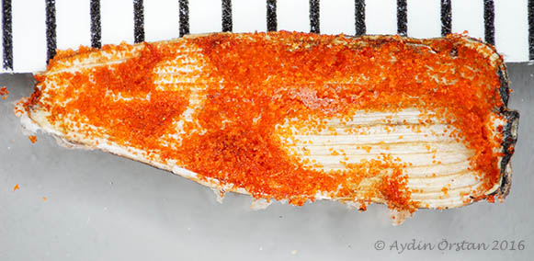Figure 16. When the bird bath in the first author’s yard was drying in the summer this shell of a sunflower seed served as a shelter for Philodina roseola and eventually accumulated a large number of dry, orange rotifers (ruler is in millimetres). Upon placement in water, the majority of these rotifers revived.
Dry bdelloids can withstand high temperatures: about 50% of desiccated individuals of Philodina roseola survived 10 minutes at 110°C and almost 2% survived 10 minutes at 130°C (Mertens et al., 2008). Bdelloids can also survive frozen for many months. One of the most common invertebrates in the meltwater ponds in Antarctica is the endemic Philodina gregaria that was discovered by James Murray during the British Antarctic Expedition of 1907–9 (Fig. 17). Murray (1910) noted that he could get large numbers of these rotifers in the winter by thawing ice containing plants from the lakes. In fact, already dry samples can be further dried and stored at temperatures below freezing for at least up to 18 months to yield live bdelloids upon rehydration (Örstan, 1998).
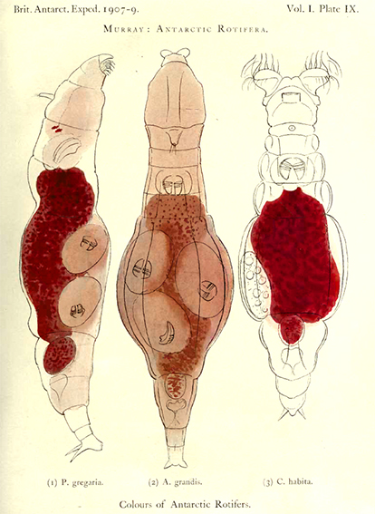Figure 17. Colour plate from James Murray’s 1910 report showing some of the bdelloid rotifers of Antarctica he studied during the British Antarctic Expedition of 1907–9. Murray thought the red colour of the animals’ stomachs was probably related to their food. Both Philodina gregaria and Adineta grandis are viviparous as indicated by the trophi of the multiple embryos they are carrying.
Bdelloids often share their habitats with tardigrades and nematodes, which owe their ability to survive drying at least partially to the accumulation of high concentrations of the carbohydrate trehalose in their tissues. Bdelloids, however, lack trehalose and how they achieve their drying tolerance is not known (Lapinski & Tunnacliffe, 2003). Once again, bdelloids are anything but ordinary.

How to study and identify bdelloids
Bdelloid species are notoriously difficult to identify. This is because species identification almost always requires the examination of minute morphological details of live and often unruly animals at high magnifications. A readily available anaesthetic effective for all species is not available. Some success has been reported with the anaesthetic bupivacaine, which may, however, be difficult to obtain by amateur microscopists. Moreover, until recently, there was no procedure to preserve the fully extended bodies of bdelloids without damage or distortion. Killing of bdelloids with boiling water – recommended in some publications – should be avoided, because hot water literally cooks the animals resulting in distorted and damaged bodies and coagulated internal organs. Instead, we advocate the use of hot glutaraldehyde (about 2.5%), which preserves bdelloids in a superior condition suitable for both identification purposes and anatomical studies (Fig. 10; Örstan, 2015).
One should also avoid the use of a glass pipette to transfer active bdelloids (unless a large number is being transferred), because often the animal remains attached to the inside of the pipette and is difficult to dislodge. Instead, a very fine and stiff probe (for example, a minuten pin with a flattened tip) mounted at the end of a suitably long handle may be used. Always have a second probe available to gently dislodge the rotifer should it stick to the first one. Certain types of plastic pipettes (for example, Eppendorf brand) may also be suitable as the bdelloids seem to have difficulty attaching to their surfaces. When there are many bdelloids in a sample, aliquots containing bdelloids may be successively divided and diluted on microscope slides to isolate individual specimens and to remove any interfering debris.
Species identification starts with a cursory examination of the overall morphology of a bdelloid under a stereomicroscope or at the low powers of a compound microscope and then continues in detail at a higher magnification, usually at 200× or 400×, and whenever convenient, with immersion objectives. First, one should look for any spines or appendages on the body. Most species don’t have such formations. Thus, their presence on a specimen brings one a step closer to an identification.
The observation of the shapes of the corona and the upper lip and the width of the corona (relative to the head) can be done only when a bdelloid is feeding. The morphology of the upper lip is an especially important taxonomic trait necessary for the identification of many species. Some individuals feed readily and for long periods under the cover glass, while others are frustratingly stubborn to open their coronas. When a rotifer is not feeding there isn’t much one can do other than wait patiently. Other taxonomically significant traits to note are the eye spots that may be on the brain (Philodina, Abrochtha, Dissotrocha, etc.) or on the rostrum (Rotaria, etc.) and the length of the antenna. The number of teeth on the trophi also need to be counted; this is done best in specimens slightly compressed under the cover glass. The length and the shape of the spurs should also be noted as they often are diagnostic.
Knowing the number of toes is often necessary to ascertain the genus of a specimen. The toes are best seen and counted, especially if they are short, when a bdelloid is creeping on the underside of a cover glass. Sometimes they attach to the cover glass on their own. Otherwise, one may place a specimen in a small drop of medium on a cover glass, wait for it to attach its toes to the glass, then quickly turn the cover glass upside down and place it on a support (such as an O-ring) just high enough to prevent the hanging drop from touching the slide. The toes can now be seen easily right underneath the cover glass as the bdelloid creeps upside down (Figs. 8 and 12).
Some species in the 3-toed genera Macrotrachela (Philodinidae) and Habrotrocha (Habrotrochidae) look alike and can be placed in the correct genus only by the examination of their stomachs for a lumen. The stomach contents of the species that have a lumen usually have a fine, granular appearance, while those of the species in the lumenless Habrotrochidae form large globules (pellets) (Fig. 6). These pellets retain their form for a short while outside the body (Donner, 1965: Fig. 1h), so if one happens to see a rotifer discharging waste this may help determine its familial association!
We have found it useful to record high-resolution, high-magnification videos of specimens. Scrutiny of such videos for salient morphological details, if necessary frame by frame, sometimes reveals details that one may have missed under the microscope (Fig. 7, Fig. 12).
The foundations of the current taxonomy of bdelloids dates back to Bryce’s (1910) paper in the Journal of the Quekett Microscopical Club. This century-old work is still informative to read. A more recent key to the genera was published in the Quekett Journal of Microscopy (Turner, 1999). Despite being more than 50 years old, Donner’s Ordnung Bdelloidea (1965) is the most complete identification guide for bdelloid species. Almost 40 new species have been described since 1965 and 18 of them within the last five years (for example, Iakovenko et al., 2015). Clearly, the work of the rotiferologist is not yet finished.

References
Baker H. 1764. Employment for the Microscope.
Bryce D. 1910. On a new classification of the bdelloid rotifera. Journal of the Quekett Microscopical Club, ser. 2, 11: 61–92.
Donner J. 1965. Ordnung Bdelloidea. Akademie-Verlag.
Fontaneto D, De Smet W. 2015. Rotifera in A. Schmidt-Rhaesa (ed.) Handbook of Zoology, Gastrotricha, Cycloneuralia and Gnathifera, 3: Gastrotricha and Gnathifera, pp. 217–300. De Gruyter.
Hejnol A. 2015. Gnathifera in A. Wanninger (ed.) Evolutionary Developmental Biology of Invertebrates 2: Lophotrochozoa (Spiralia). Springer.
Iakovenko NS, Smykla J, Convey P, Kašparová E, Kozeretska IA, Trokhymets V, Dykyy VI, Plewka M, Devetter M, Duriš Z, Janko K. 2015. Antarctic bdelloid rotifers: diversity, endemism and evolution. Hydrobiologia 761: 5–43.
Lapinski J, Tunnacliffe A. 2003. Anhydrobiosis without trehalose in bdelloid rotifers. FEBS Letters, 553: 387–390.
Melone G, Fontaneto D. 2005. Trophi structure in bdelloid rotifers. Hydrobiologia 546: 197–202.
Mertens J, Beladjal L, Alcantara A, Fougnies L, Van Der Straeten D, Clegg JS. 2008. Survival of dried eukaryotes (anhydrobiotes) after exposure to very high temperatures. Biological Journal of the Linnean Society 93: 15–22.
Murray J. 1910. Antarctic Rotifera. British Antarctic Expedition 1907–9, Reports on the Scientific Investigations 1: 41–65.
Örstan A. 1998. Factors affecting long-term survival of dry bdelloid rotifers: A preliminary study. Hydrobiologia 387/388: 327–331.
Örstan A. 2015. A method for the preservation of bdelloid rotifers for taxonomical and anatomical studies. Quekett Journal of Microscopy 42: 355–359.
Turner P. 1999. A simple generic key to bdelloid rotifers. Quekett Journal of Microscopy 38: 351–356.
This work (excluding Figure 1B, Figure 7B, Figure 17) is licensed under a Creative Commons Attribution-NonCommercial-NoDerivatives 4.0 International License.

