Zig vs Rust: A Comprehensive Comparison for Modern Developers

Priyanka Indrajeet
·
Follow
5 min read
·
Dec 30, 2023
2
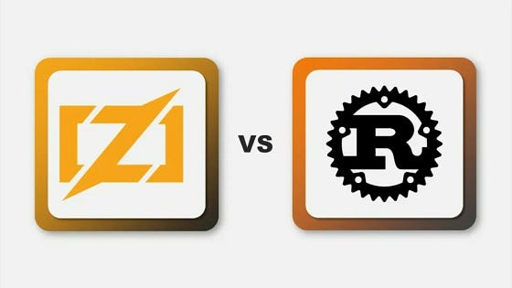
In the evolving landscape of systems programming, two languages stand out for their unique approaches and capabilities: Zig and Rust. Both offer compelling features but cater to different needs and preferences. This blog post delves into a detailed comparison of Zig and Rust, highlighting their strengths, use cases, and key differences.
Zig: Emphasizing Simplicity and Control
Simplicity and Readability: Zig’s straightforward syntax, reminiscent of C, prioritizes readability and ease of maintenance. Its design avoids hidden control flow and memory allocations, making the code transparent and easier to understand.
- Performance: Zig is designed to be highly performant and gives a lot of control over low-level details.
- Compile-Time Execution: Zig emphasis on compile-time execution, which reduces runtime overhead and optimizes performance.
- Control and Low-Level Capabilities: Ideal for systems programming, Zig shines in scenarios that demand direct management of system resources.
- Memory Safety: Zig approaches memory safety with compile-time checks and explicit error handling, relying on the programmer for manual memory management. Like Rust, C, and C++, Zig doesn’t use a garbage collector. To achieve memory safety like Rust, Zig comes with mechanisms that promote memory safety, such as:
- Strict compile-time checks
- Optional types to handle potentially null values
- Explicit error handling with Error type
- Enhanced memory allocation with built-in allocators
- Interoperability: Zig has excellent C interoperability and can directly use C libraries without needing a wrapper.
- Error Handling: Zig uses error types, error unions, and deferred statements for error handling.
- Community and Ecosystem: Being relatively new, Zig has a smaller but growing community and ecosystem.
- Metaprogramming capabilities: Zig’s compile-time metaprogramming improves code flexibility and productivity by reducing the need for boilerplate code and enabling code optimization
- Use Cases: Zig’s simplicity and direct C interoperability make it particularly advantageous for embedding in C projects or for low-level system programming where control and clarity are paramount. For example, it’s ideal for systems programming for building operating systems, device drivers, and embedded systems. It’s also useful in command-line tools for creating efficient and fast command-line interfaces, building system scripts, or optimizing existing tools for performance.
- Zig is known for its metaprogramming capabilities and focus on simplicity. A famous example is Bun, a runtime environment for JavaScript developed in Zig.
Rust: Safe, Concurrent, and High-Performance
- Memory Safety Without Garbage Collection: Rust’s ownership and borrowing rules ensure memory safety, eliminating the need for a garbage collector.
- Concurrency and Parallelism: Built-in support for safe and efficient multithreading makes Rust ideal for applications where concurrency is key.
- Compile Time: Rust’s safety measures may cause longer compile times than other languages. To prevent issues at runtime it examines the code during compile time.
- Interoperability: Rust depends on the Foreign Function Interface (FFI) and similar initiatives enable integration with C and C++.
- Community and ecosystem: Rust has a strong ecosystem of tools and libraries. Its package manager, Cargo, significantly simplifies dependency management and integration with external libraries.
- Error Handling: Rust’s Result and Option types add expressiveness to error handling, enhancing code reliability and readability.
- Cross-Platform Compatibility and Zero-Cost Abstraction: Rust promotes cross-platform development. Rust achieves zero-cost abstractions by compiling all code down to machine instructions, with no interpreter or garbage collector. This way, Rust ensures that any abstractions do not impose any additional runtime costs.
- Use Cases: Rust’s advanced concurrency features are effectively utilized in web servers and database systems, where managing multiple threads safely and efficiently is crucial. Its ownership model ensures thread safety, making it a strong choice for high-performance, concurrent applications like the Servo browser engine or the TiKV distributed key-value store.
- Though Rust, like any language, has its pros and cons, it remains a popular choice among developers. For the 8th year in a row, Rust has topped the chart as “the most desired and admired programming language” in the 2023 Stack Overflow developer survey, with more than 80% of respondents saying they want to use it again next year.
- In systems programming, Rust is useful for tasks like building operating systems, device drivers, and embedded systems.
- Both backend and frontend web developers also use Rust with popular frameworks like Rocket or Actix for backend development and WebAssembly or Tauri for frontend development.
- Rust is also used in networking and network services, like network protocols, proxies, load balancers, VPN software, and more.
Rust vs. Zig: Performance:
Objectively, between Rust and Zig, there is no better-performing language. Rust may outshine Zig in specific applications, while Zig may outperform Rust in others.
Let’s closely examine each performance with a comparison from the programming languages and compiler benchmarks:
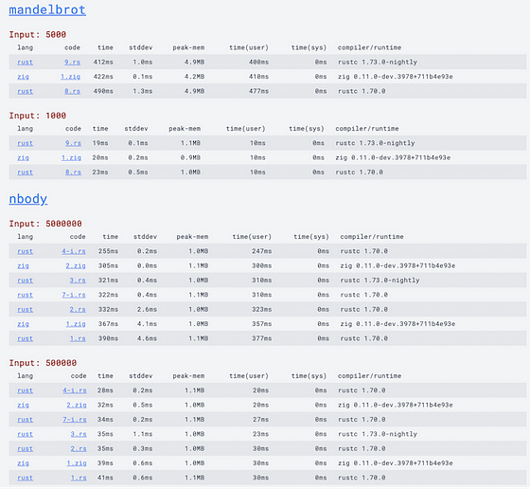
This benchmark project contains programs written in several programming languages that run simultaneously. The outcomes from their runs are then measured and presented in a tabular form for you to see how each programming language performs in the task.
In the image above, we have the mandelbrot and nbody programs, both written using Rust and Zig. The measurements in the comparison tables are arranged from more performant to less performant.
You’ll notice that in some cases Zig performs better than Rust, and in others, Rust performs better than Zig. Both are highly performant languages, so either option should serve you well in your projects.
Conclusion: Choosing the Right Tool for the Job
- Use Case Fit: If your project requires strong guarantees around memory safety and concurrency, Rust might be the better choice. For projects where C interoperability and simplicity are more important, Zig could be more suitable.
- Community and Support: Rust’s larger ecosystem might be a deciding factor for projects requiring a wide range of external libraries and community support.
- Learning Curve: Zig might be easier to grasp initially due to its C-like syntax, Rust’s learning curve might be justified by its robust safety features and concurrency support, depending on project requirements.
- Performance optimization: Zig and Rust are both known for their highly optimized code with manual memory management, direct CPU access, and compile-time evaluation.
- Low-level control: Both offer more control over system resources, making them ideal for low-level tasks and systems programming.
Ultimately, the choice between Zig and Rust should be based on the specific needs of your project, your team’s familiarity with the language, and the kind of support and libraries you require. Both languages are powerful tools in the realm of systems programming and can be the right choice in different scenarios. Rust has been around longer and thus might be considered more mature in terms of features and stability.

