Profiles
February 14 & 21, 2011 Issue

The Apostate
Paul Haggis vs. the Church of Scientology.
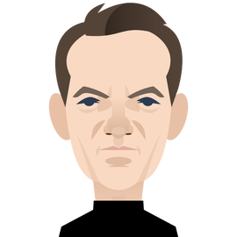
By Lawrence Wright

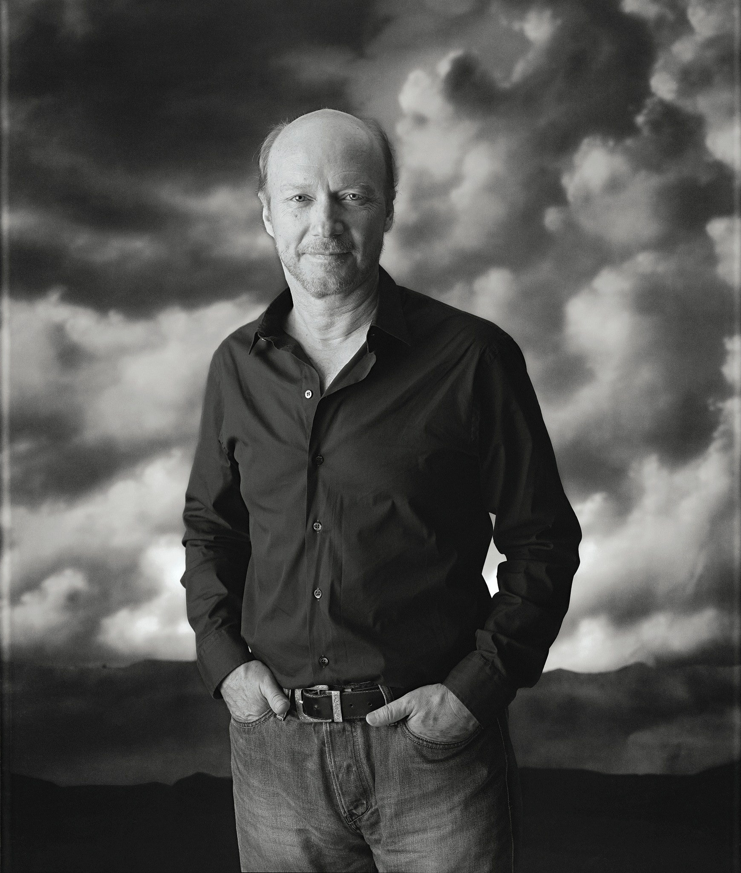
Asked how high he got in Scientology’s levels of study, Haggis said, “All the way to the top.”Photograph by Mary Ellen Mark
On August 19, 2009, Tommy Davis, the chief spokesperson for the Church of Scientology International, received a letter from the film director and screenwriter Paul Haggis. “For ten months now I have been writing to ask you to make a public statement denouncing the actions of the Church of Scientology of San Diego,” Haggis wrote. Before the 2008 elections, a staff member at Scientology’s San Diego church had signed its name to an online petition supporting Proposition 8, which asserted that the State of California should sanction marriage only “between a man and a woman.” The proposition passed. As Haggis saw it, the San Diego church’s “public sponsorship of Proposition 8, which succeeded in taking away the civil rights of gay and lesbian citizens of California—rights that were granted them by the Supreme Court of our state—is a stain on the integrity of our organization and a stain on us personally. Our public association with that hate-filled legislation shames us.” Haggis wrote, “Silence is consent, Tommy. I refuse to consent.” He concluded, “I hereby resign my membership in the Church of Scientology.”
Haggis was prominent in both Scientology and Hollywood, two communities that often converge. Although he is less famous than certain other Scientologists, such as Tom Cruise and John Travolta, he had been in the organization for nearly thirty-five years. Haggis wrote the screenplay for “Million Dollar Baby,” which won the Oscar for Best Picture in 2004, and he wrote and directed “Crash,” which won Best Picture the next year—the only time in Academy history that that has happened.
Davis, too, is part of Hollywood society; his mother is Anne Archer, who starred in “Fatal Attraction” and “Patriot Games,” among other films. Before becoming Scientology’s spokesperson, Davis was a senior vice-president of the church’s Celebrity Centre International network.
In previous correspondence with Davis, Haggis had demanded that the church publicly renounce Proposition 8. “I feel strongly about this for a number of reasons,” he wrote. “You and I both know there has been a hidden anti-gay sentiment in the church for a long time. I have been shocked on too many occasions to hear Scientologists make derogatory remarks about gay people, and then quote L.R.H. in their defense.” The initials stand for L. Ron Hubbard, the founder of Scientology, whose extensive writings and lectures form the church’s scripture. Haggis related a story about Katy, the youngest of three daughters from his first marriage, who lost the friendship of a fellow-Scientologist after revealing that she was gay. The friend began warning others, “Katy is ‘1.1.’ ” The number refers to a sliding Tone Scale of emotional states that Hubbard published in a 1951 book, “The Science of Survival.” A person classified “1.1” was, Hubbard said, “Covertly Hostile”—“the most dangerous and wicked level”—and he noted that people in this state engaged in such things as casual sex, sadism, and homosexual activity. Hubbard’s Tone Scale, Haggis wrote, equated “homosexuality with being a pervert.” (Such remarks don’t appear in recent editions of the book.)
In his resignation letter, Haggis explained to Davis that, for the first time, he had explored outside perspectives on Scientology. He had read a recent exposé in a Florida newspaper, the St. Petersburg Times, which reported, among other things, that senior executives in the church had been subjecting other Scientologists to physical violence. Haggis said that he felt “dumbstruck and horrified,” adding, “Tommy, if only a fraction of these accusations are true, we are talking about serious, indefensible human and civil-rights violations.”
Online, Haggis came across an appearance that Davis had made on CNN, in May, 2008. The anchor John Roberts asked Davis about the church’s policy of “disconnection,” in which members are encouraged to separate themselves from friends or family members who criticize Scientology. Davis responded, “There’s no such thing as disconnection as you’re characterizing it. And certainly we have to understand—”
“Well, what is disconnection?” Roberts interjected.
“Scientology is a new religion,” Davis continued. “The majority of Scientologists in the world, they’re first generation. So their family members aren’t going to be Scientologists. . . . So, certainly, someone who is a Scientologist is going to respect their family members’ beliefs—”
“Well, what is disconnection?” Roberts said again.
“—and we consider family to be a building block of any society, so anything that’s characterized as disconnection or this kind of thing, it’s just not true. There isn’t any such policy.”
In his resignation letter, Haggis said, “We all know this policy exists. I didn’t have to search for verification—I didn’t have to look any further than my own home.” Haggis reminded Davis that, a few years earlier, his wife had been ordered to disconnect from her parents “because of something absolutely trivial they supposedly did twenty-five years ago when they resigned from the church. . . . Although it caused her terrible personal pain, my wife broke off all contact with them.” Haggis continued, “To see you lie so easily, I am afraid I had to ask myself: what else are you lying about?”
Haggis forwarded his resignation to more than twenty Scientologist friends, including Anne Archer, John Travolta, and Sky Dayton, the founder of EarthLink. “I felt if I sent it to my friends they’d be as horrified as I was, and they’d ask questions as well,” he says. “That turned out to be largely not the case. They were horrified that I’d send a letter like that.”
VIDEO FROM THE NEW YORKER
“American Scar”: The Environmental Tragedy of the Border Wall

Tommy Davis told me, “People started calling me, saying, ‘What’s this letter Paul sent you?’ ” The resignation letter had not circulated widely, but if it became public it would likely cause problems for the church. The St. Petersburg Times exposé had inspired a fresh series of hostile reports on Scientology, which has long been portrayed in the media as a cult. And, given that some well-known Scientologist actors were rumored to be closeted homosexuals, Haggis’s letter raised awkward questions about the church’s attitude toward homosexuality. Most important, Haggis wasn’t an obscure dissident; he was a celebrity, and the church, from its inception, has depended on celebrities to lend it prestige. In the past, Haggis had defended the religion; in 1997, he wrote a letter of protest after a French court ruled that a Scientology official was culpable in the suicide of a man who fell into debt after paying for church courses. “If this decision carries it sets a terrible precedent, in which no priest or minister will ever feel comfortable offering help and advice to those whose souls are tortured,” Haggis wrote. To Haggis’s friends, his resignation from the Church of Scientology felt like a very public act of betrayal. They were surprised, angry, and confused. “ ‘Destroy the letter, resign quietly’—that’s what they all wanted,” Haggis says.
Last March, I met Haggis in New York. He was in the editing phase of his latest movie, “The Next Three Days,” a thriller starring Russell Crowe, in an office in SoHo. He sat next to a window with drawn shades, as his younger sister Jo Francis, the film’s editor, showed him a round of cuts. Haggis wore jeans and a black T-shirt. He is bald, with a trim blond beard, pale-blue eyes, and a nose that was broken in a schoolyard fight. He always has several projects going at once, and there was a barely contained feeling of frenzy. He glanced repeatedly at his watch.
Haggis, who is fifty-seven, was preparing for two events later that week: a preview screening in New York and a trip to Haiti. He began doing charitable work in Haiti well before the 2010 earthquake, and he has raised millions of dollars for that country. He told me that he was planning to buy ten acres of land in Port-au-Prince for a new school, which he hoped to have open in the fall. (In fact, the school—the first to offer free secondary education to children from the city’s slums—opened in October.) In Hollywood, he is renowned for his ability to solicit money. The actor Ben Stiller, who has accompanied Haggis to Haiti, recalls that Haggis once raised four and a half million dollars in two hours.
While watching the edits, Haggis fielded calls from a plastic surgeon who was planning to go on the trip, and from a priest in Haiti, Father Rick Frechette, whose organization is the main beneficiary of Haggis’s charity. “Father Rick is a lot like me—a cynical optimist,” Haggis told me. He also said of himself, “I’m a deeply broken person, and broken institutions fascinate me.”
Haggis’s producing partner, Michael Nozik, says, “Paul likes to be contrarian. If everyone is moving left, he’ll feel the need to move right.” The actor Josh Brolin, who appeared in Haggis’s film “In the Valley of Elah” (2007), told me that Haggis “does things in extremes.” Haggis is an outspoken promoter of social justice, in the manner of Hollywood activists like Sean Penn and George Clooney. The actress Maria Bello describes him as self-deprecating and sarcastic, but also deeply compassionate. She recalls being with him in Haiti shortly after the earthquake; he was standing in the bed of a pickup truck, “with a cigarette hanging out of his mouth and a big smile on his face, and absolutely no fear.” Though Haggis is passionate about his work, he can be cool toward those who are closest to him. Lauren Haggis, the second daughter from his first marriage, said that he never connected with his children. “He’s emotionally not there,” she says. “That’s funny, because his scripts are full of emotion.”
In the editing room, Haggis felt the need for a cigarette, so we walked outside. He is ashamed of this habit, especially given that, in 2003, while directing “Crash,” he had a heart attack. After Haggis had emergency surgery, his doctor told him that it would be four or five months before he could work again: “It would be too much strain on your heart.” He replied, “Let me ask you how much stress you think I might be under as I’m sitting at home while another director is finishing my fucking film!” The doctor relented, but demanded that a nurse be on the set to monitor Haggis’s vital signs. Since then, Haggis has tried repeatedly to quit smoking. He had stopped before shooting “The Next Three Days,” but Russell Crowe was smoking, and that did him in. “There’s always a good excuse,” he admitted. Before his heart attack, he said, “I thought I was invincible.” He added, “I still do.”
Haggis had not spoken publicly about his resignation from Scientology. As we stood in a chill wind on Sixth Avenue, he was obviously uncomfortable discussing it, but he is a storyteller, and he eventually launched into a narrative.
Haggis wasn’t proud of his early years. “I was a bad kid,” he said. “I didn’t kill anybody. Not that I didn’t try.” He was born in 1953, and grew up in London, Ontario, a manufacturing town midway between Toronto and Detroit. His father, Ted, had a construction company there, which specialized in pouring concrete. His mother, Mary, a Catholic, sent Paul and his two younger sisters, Kathy and Jo, to Mass on Sundays—until she spotted their priest driving an expensive car. “God wants me to have a Cadillac,” the priest explained. Mary responded, “Then God doesn’t want us in your church anymore.”
Haggis decided at an early age to be a writer, and he made his own comic books. But he was such a poor student that his parents sent him to a strict boarding school, where the students were assigned cadet drills. He preferred to sit in his room reading Ramparts, the radical magazine from America—the place he longed to be. He committed repeated infractions, but he learned to pick locks so that he could sneak into the prefect’s office and eliminate his demerits.
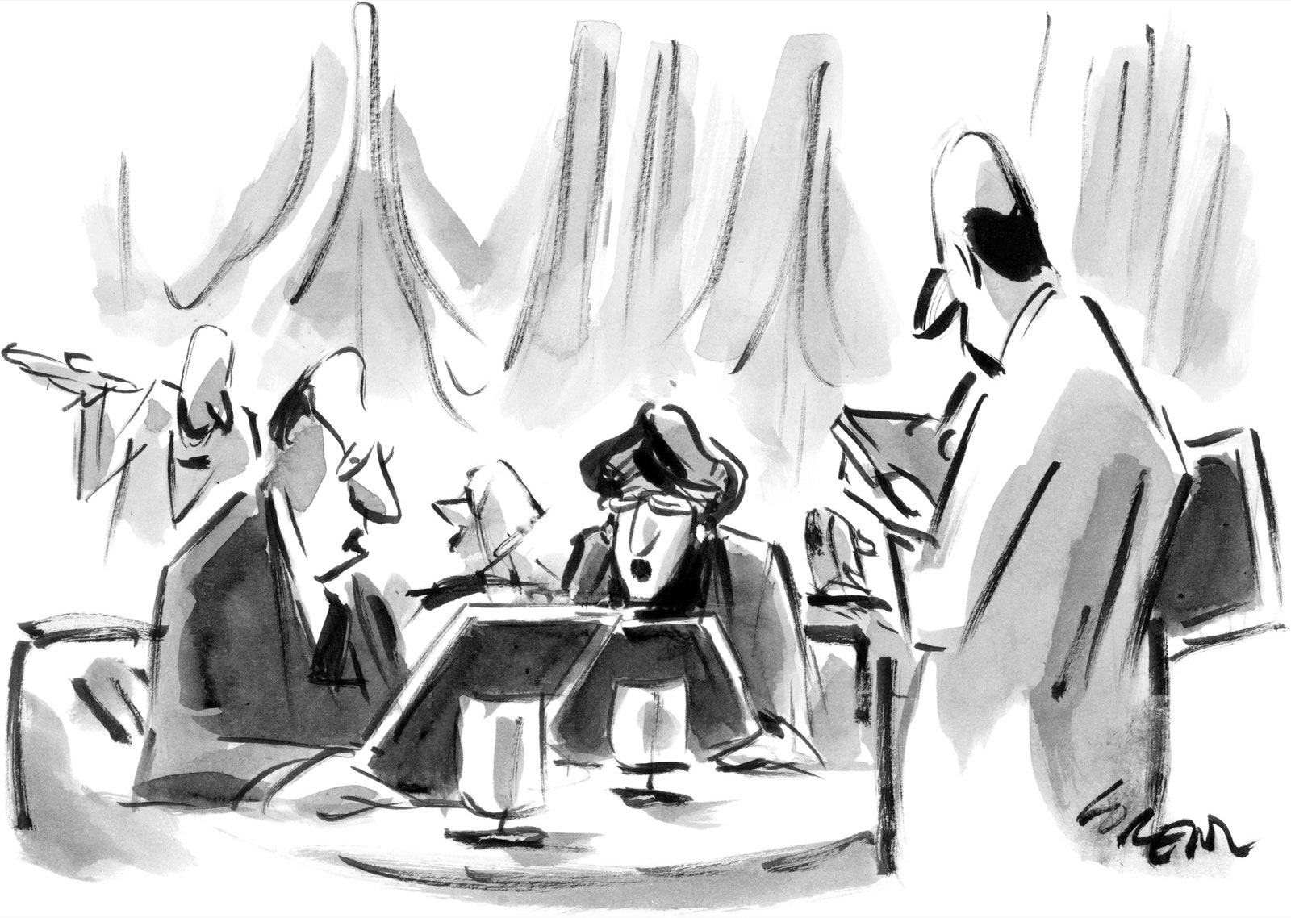
“We’ve got an early curtain, so you can skip reciting the Constitution between courses.”

After a year of this, his parents transferred him to a progressive boys’ school in Bracebridge, Ontario, where there was very little system to subvert. Haggis grew his curly blond hair to his shoulders. He discovered a mentor in his art teacher, Max Allen, who was politically radical and gay. Flouting Ontario’s strict censorship laws, Allen opened a theatre in Toronto that showed banned films; Haggis volunteered at the box office.
Haggis got caught forging a check, and he soon left school. He was drifting, hanging out with hippies and drug dealers. Two friends died from overdoses. “I had a gun pointed in my face a couple of times,” he recalls. He attended art school briefly, then quit; after taking some film classes at a community college, he dropped out of that as well. He began working in construction full time for his father. He also was the manager of a hundred-seat theatre that his father had created in an abandoned church. On Saturday nights, he set up a movie screen onstage, introducing himself and other film buffs to the works of Bergman, Hitchcock, and the French New Wave. He was so affected by Michelangelo Antonioni’s “Blow-Up” that in 1974 he decided to move to England, in order to become a fashion photographer, like the hero of the movie. That lasted less than a year.
Back in London, Ontario, he fell in love with Diane Gettas, a nurse, and they began sharing a one-bedroom apartment. He was starting to get his life together, but he was haunted by something that his grandfather had said to him on his deathbed. “He was a janitor in a bowling alley,” Haggis told me. “He had left England because of some scandal we don’t know about. He died when I was twelve or thirteen. He looked terrible. He turned to me and said, ‘I’ve wasted my life. Don’t waste yours.’ ”
One day in 1975, when he was twenty-two, Haggis was walking to a record store. When he arrived at the corner of Dundas and Waterloo Streets, a young man pressed a book into his hands. “You have a mind,” the man said. “This is the owner’s manual.” The man, whose name was Jim Logan, added, “Give me two dollars.” The book was “Dianetics: The Modern Science of Mental Health,” by L. Ron Hubbard, which was published in 1950. By the time Haggis began reading it, “Dianetics” had sold about two and a half million copies. Today, according to the church, that figure has reached more than twenty-one million.
Haggis opened the book and saw a page stamped with the words “Church of Scientology.”
“Take me there,” Haggis said to Logan.
Haggis had heard about Scientology a couple of months earlier, from a friend who had called it a cult. The thought that he might be entering a cult didn’t bother him. In fact, he said, “it drew my interest. I tend to run toward things I don’t understand.” When he arrived at the church’s headquarters, he recalled, “it didn’t look like a cult. Two guys in a small office above Woolworth’s.”
At the time, Haggis and Gettas were having arguments; the Scientologists told him that taking church courses would improve the relationship. “It was pitched to me as applied philosophy,” Haggis says. He and Gettas took a course together and, shortly afterward, became Hubbard Qualified Scientologists, one of the first levels in what the church calls the Bridge to Total Freedom.
The Church of Scientology says that its purpose is to transform individual lives and the world. “A civilization without insanity, without criminals and without war, where the able can prosper and honest beings can have rights, and where man is free to rise to greater heights, are the aims of Scientology,” Hubbard wrote. Scientology postulates that every person is a Thetan—an immortal spiritual being that lives through countless lifetimes. Scientologists believe that Hubbard discovered the fundamental truths of existence, and they revere him as “the source” of the religion. Hubbard’s writings offer a “technology” of spiritual advancement and self-betterment that provides “the means to attain true spiritual freedom and immortality.” A church publication declares, “Scientology works 100 percent of the time when it is properly applied to a person who sincerely desires to improve his life.” Proof of this efficacy, the church says, can be measured by the accomplishments of its adherents. “As Scientologists in all walks of life will attest, they have enjoyed greater success in their relationships, family life, jobs and professions. They take an active, vital role in life and leading roles in their communities. And participation in Scientology brings to many a broader social consciousness, manifested through meaningful contribution to charitable and social reform activities.”
In 1955, a year after the church’s founding, an affiliated publication urged Scientologists to cultivate celebrities: “It is obvious what would happen to Scientology if prime communicators benefitting from it would mention it.” At the end of the sixties, the church established its first Celebrity Centre, in Hollywood. (There are now satellites in Paris, Vienna, Düsseldorf, Munich, Florence, London, New York, Las Vegas, and Nashville.) Over the next decade, Scientology became a potent force in Hollywood. In many respects, Haggis was typical of the recruits from that era, at least among those in the entertainment business. Many of them were young and had quit school in order to follow their dreams, but they were also smart and ambitious. The actress Kirstie Alley, for example, left the University of Kansas in 1970, during her sophomore year, to get married. Scientology, she says, helped her lose her craving for cocaine. “Without Scientology, I would be dead,” she has said.
In 1975, the year that Haggis became a Scientologist, John Travolta, a high-school dropout, was making his first movie, “The Devil’s Rain,” in Durango, Mexico, when an actress on the set gave him a copy of “Dianetics.” “My career immediately took off,” he told a church publication. “Scientology put me into the big time.” The testimonials of such celebrities have attracted many curious seekers. In Variety, Scientology has advertised courses promising to help aspiring actors “make it in the industry.”
One of those actors, Josh Brolin, told me that, in a “moment of real desperation,” he visited the Celebrity Centre and received “auditing”—spiritual counselling. He quickly decided that Scientology wasn’t for him. But he still wonders what the religion does for celebrities like Cruise and Travolta: “Each has a good head on his shoulders, they make great business decisions, they seem to have wonderful families. Is that because they were helped by Scientology?” This is the question that makes celebrities so crucial to the religion. And, clearly, there must be something rewarding if such notable people lend their names to a belief system that is widely scorned.
Brolin says that he once witnessed John Travolta practicing Scientology. Brolin was at a dinner party in Los Angeles with Travolta and Marlon Brando. Brando arrived with a cut on his leg, and explained that he had injured himself while helping a stranded motorist on the Pacific Coast Highway. He was in pain. Travolta offered to help, saying that he had just reached a new level in Scientology. Travolta touched Brando’s leg and Brando closed his eyes. “I watched this process going on—it was very physical,” Brolin recalls. “I was thinking, This is really fucking bizarre! Then, after ten minutes, Brando opens his eyes and says, ‘That really helped. I actually feel different!’ ” (Travolta, through a lawyer, called this account “pure fabrication.”)
Many Hollywood actors were drawn into the church by a friend or by reading “Dianetics”; a surprising number of them, though, came through the Beverly Hills Playhouse. For decades, the resident acting coach there was Milton Katselas, and he taught hundreds of future stars, including Ted Danson, Michelle Pfeiffer, and George Clooney. “Most of Hollywood went through that class,” Anne Archer told me. In 1974, two years after her son Tommy Davis was born, she began studying with Katselas. She was a young mother in a dissolving marriage, coming off a television series (“Bob & Carol & Ted & Alice”) that had been cancelled after one season. Katselas had a transformative effect. She recalled discussions “about life, people, and behavior,” and said that Katselas “said some things in class that were really smart.” Some of the other students told her that Katselas was a Scientologist, so she began the Life Repair program at the Celebrity Centre. “I went two or three times a week, probably for a couple of weeks,” she said. “I remember walking out of the building and walking down the street toward my car and I felt like my feet were not touching the ground. And I said to myself, ‘My God, this is the happiest I’ve ever been in my entire life. I’ve finally found something that works.’ ” She added, “Life didn’t seem so hard anymore. I was back in the driver’s seat.”
Jim Gordon, a veteran police officer in Los Angeles, and also an aspiring actor, spent ten years at the Playhouse, starting in 1990. He told me that Scientology “recruited a ton of kids out of that school.” Like Scientology, the Playhouse presented a strict hierarchy of study; under Katselas’s tutelage, students graduated from one level to the next. As Gordon advanced within the Playhouse, he began recognizing many students from the roles they were getting in Hollywood. “You see a lot of people you know from TV,” Gordon says. He began feeling the pull of the church. “When you started off, they weren’t really pushing it, but as you progressed through the Playhouse’s levels Scientology became more of a focus,” he told me. After a few years, he joined. Like the courses at the Playhouse, Scientology offered actors a method that they could apply to both their lives and their careers.
Not long after Gordon became a Scientologist, he was asked to serve as an “ethics officer” at the Playhouse, monitoring the progress of other students and counselling those who were having trouble. He was good at pinpointing students who were struggling. “It’s almost like picking out the wounded chicks,” he says. He sometimes urged a student to meet with the senior ethics officer at the Playhouse, a Scientologist who often recommended courses at the Celebrity Centre. “My job was to keep the students active and make sure they were not being suppressed,” Gordon says. In the rhetoric of Scientology, “suppressive persons”—or S.P.s—block an individual’s spiritual progress. Implicitly, the message to the students was that success awaited them if only they could sweep away the impediments to stardom, including S.P.s. Katselas received a ten-per-cent commission from the church on the money contributed by his students.
Katselas died in 2008, and Scientology no longer has a connection with the Beverly Hills Playhouse. Anne Archer told me that the reputation of Katselas’s class as, in Gordon’s words, a “Scientology clearinghouse” is overblown. “His classes averaged about fifty or sixty people, and there would be maybe seven to ten people in it who would be Scientologists,” she says. But the list of Scientologists who have studied at the Playhouse is long—it includes Jenna Elfman, Giovanni Ribisi, and Jason Lee—and the many protégés Katselas left behind helped cement the relationship between Hollywood and the church.
Haggis and I travelled together to L.A., where he was presenting “The Next Three Days” to the studio. During the flight, I asked him how high he had gone in Scientology. “All the way to the top,” he said. Since the early eighties, he had been an Operating Thetan VII, which was the highest level available when he became affiliated with the church. (In 1988, a new level, O.T. VIII, was introduced to members; it required study at sea, and Haggis declined to pursue it.) He had made his ascent by buying “intensives”—bundled hours of auditing, at a discount rate. “It wasn’t so expensive back then,” he said.
David S. Touretzky, a computer-science professor at Carnegie Mellon University, has done extensive research on Scientology. (He is not a defector.) He estimates that the coursework alone now costs nearly three hundred thousand dollars, and, with the additional auditing and contributions expected of upper-level members, the cumulative cost of the coursework may exceed half a million dollars. (The church says that there are no fixed fees, adding, “Donations requested for ‘courses’ at Church of Scientology begin at $50 and could never possibly reach the amount suggested.”)
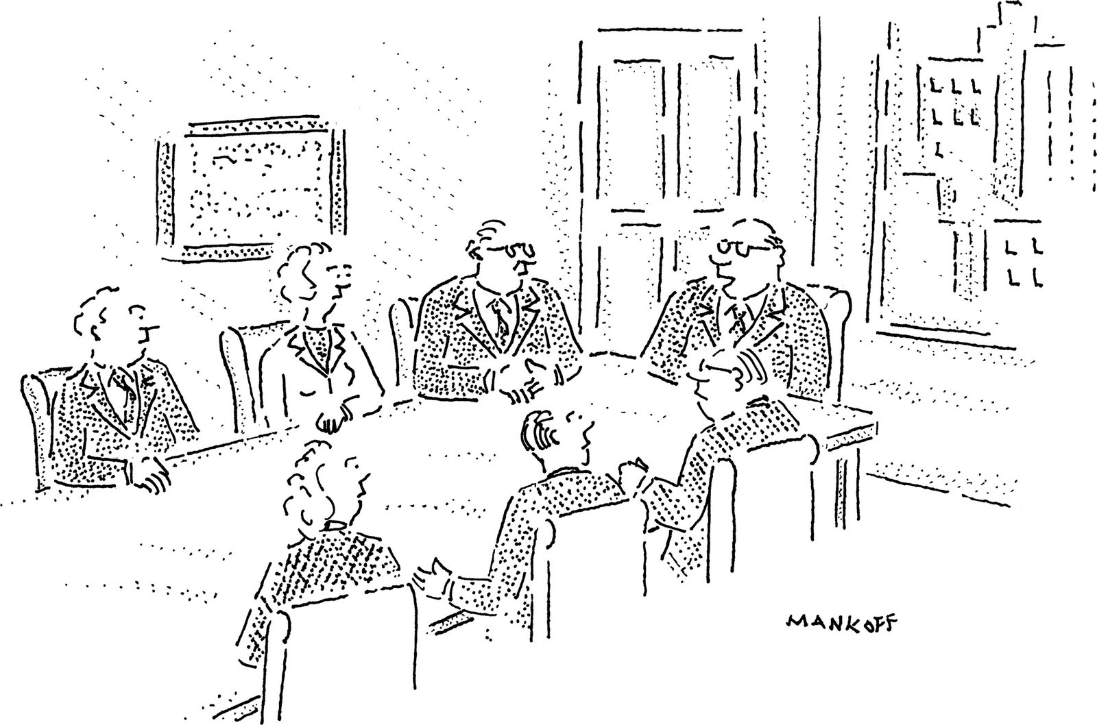
“Look, I’m for an orderly transfer of power, but all those who want me to resign immediately raise their shoe.”

I asked Haggis why he had aligned himself with a religion that so many have disparaged. “I identify with the underdog,” he said. “I have a perverse pride in being a member of a group that people shun.” For Haggis, who likes to see himself as a man of the people, his affiliation with Scientology felt like a way of standing with the marginalized and the oppressed. The church itself often hits this note, making frequent statements in support of human rights and religious freedom. Haggis’s experience in Scientology, though, was hardly egalitarian: he accepted the privileges of the Celebrity Centre, which offers notables a private entrance, a V.I.P. lounge, separate facilities for auditing, and other perks. Indeed, much of the appeal of Scientology is the overt élitism that it promotes among its members, especially celebrities. Haggis was struck by another paradox: “Here I was in this very structured organization, but I always thought of myself as a freethinker and an iconoclast.”
During our conversations, we spoke about some events that had stained the reputation of the church while he was a member. For example, there was the death of Lisa McPherson, a Scientologist who died after a mental breakdown, in 1995. She had rear-ended a car in Clearwater, Florida—where Scientology has its spiritual headquarters—and then stripped off her clothes and wandered naked down the street. She was taken to a hospital, but, in the company of several other Scientologists, she checked out, against doctors’ advice. (The church considers psychiatry an evil profession.) McPherson spent the next seventeen days being subjected to church remedies, such as doses of vitamins and attempts to feed her with a turkey baster. She became comatose, and she died of a pulmonary embolism before church members finally brought her to the hospital. The medical examiner in the case, Joan Wood, initially ruled that the cause of death was undetermined, but she told a reporter, “This is the most severe case of dehydration I’ve ever seen.” The State of Florida filed charges against the church. In February, 2000, under withering questioning from experts hired by the church, Wood declared that the death was “accidental.” The charges were dropped and Wood resigned.
Haggis said that, at the time, he had chosen not to learn the details of McPherson’s death. “I had such a lack of curiosity when I was inside,” Haggis said. “It’s stunning to me, because I’m such a curious person.” He said that he had been “somewhere between uninterested in looking and afraid of looking.” His life was comfortable, he liked his circle of friends, and he didn’t want to upset the balance. It was also easy to dismiss people who quit the church. As he put it, “There’s always disgruntled folks who say all sorts of things.” He was now ashamed of this willed myopia, which, he noted, clashed with what he understood to be the ethic of Scientology: “Hubbard says that there is a relationship between knowledge, responsibility, and control, and as soon as you know something you have a responsibility to act. And, if you don’t, shame on you.”
Since resigning, Haggis had been wondering why it took him so long to leave. In an e-mail exchange, I noted that higher-level Scientologists are supposed to be free of neuroses and allergies, and resistant to the common cold. “Dianetics” also promises heightened powers of intelligence and perception. Haggis had told me that he fell far short of this goal. “Did you feel it was your fault?” I asked. Haggis responded that, because the auditing took place over a number of years, it was easy to believe that he might actually be smarter and wiser because of it, just as that might be true after years of therapy. “It is all so subjective, how is one supposed to know?” he wrote. “How does it feel to be smarter today than you were two months ago? . . . But yes, I always felt false.”
He noted that a Scientologist hearing this would feel, with some justification, that he had misled his auditors about his progress. But, after hundreds of hours of auditing sessions, he said, “I remember feeling I just wanted it over. I felt it wasn’t working, and figured that could be my fault, but did not want the hours of ‘repair auditing’ that they would tell me I needed to fix it. So I just went along, to my shame. I did what was easy . . . without asking them, or myself, any hard questions.”
When Haggis first turned to Scientology, he considered himself an atheist. Scientology seemed to him less a religion than a set of useful principles for living. He mentioned the arc Triangle; “arc” stands for “Affinity, Reality, and Communication.” Affinity, in this formulation, means the emotional response that partners have toward each other; reality is the area of common agreement. Together, these contribute to the flow of communication. “The three parts together equal understanding,” Haggis said. “If you’re having a disagreement with someone, your affinity drops quickly. Your mutual reality is shattered. Your communication becomes more halted. You begin to talk over each other. There’s less and less understanding. But all you need to do is to raise one part of the triangle and you increase the others as well. I still use that.”
Some aspects of Scientology baffled him. He hadn’t been able to get through “Dianetics”: “I read about thirty pages. I thought it was impenetrable.” But much of the coursework gave him a feeling of accomplishment. He was soon commuting from London, Ontario, to Toronto to take more advanced courses, and, in 1976, he travelled to Los Angeles for the first time. He checked in at the old Chateau Élysée, on Franklin Avenue. Clark Gable and Katharine Hepburn had once stayed there, but when Haggis arrived it was a run-down church retreat called the Manor Hotel. (It has since been spectacularly renovated and turned into the flagship Celebrity Centre.) “I had a little apartment with a kitchen I could write in,” he recalls. “There was a feeling of camaraderie that was something I’d never experienced—all these atheists looking for something to believe in, and all these loners looking for a club to join.”
Recruits had a sense of boundless possibility. Mystical powers were forecast; out-of-body experiences were to be expected; fundamental secrets were to be revealed. Hubbard had boasted that Scientology had raised some people’s I.Q. one point for every hour of auditing. “Our most spectacular feat was raising a boy from 83 I.Q. to 212,” he told the Saturday Evening Post, in 1964.
At the Manor Hotel, Haggis went “Clear.” The concept comes from “Dianetics”; it is where you start if you want to ascend to the upper peaks of Scientology. A person who becomes Clear is “adaptable to and able to change his environment,” Hubbard writes. “His ethical and moral standards are high, his ability to seek and experience pleasure is great. His personality is heightened and he is creative and constructive.” Someone who is Clear is less susceptible to disease and is free of neuroses, compulsions, repressions, and psychosomatic illnesses. “The dianetic Clear is to a current normal individual as the current normal is to the severely insane.”
Going Clear “was not life-changing,” Haggis says. “It wasn’t, like, ‘Oh, my God, I can fly!’ ” At every level of advancement, he was encouraged to write a “success story” saying how effective his training had been. He had read many such stories by other Scientologists, and they felt “overly effusive, done in part to convince yourself, but also slanted toward giving somebody upstairs approval for you to go on to the next level.”
In 1977, Haggis returned to Canada to continue working for his father, who could see that his son was struggling. Ted Haggis asked him what he wanted to do with his life. Haggis said that he wanted to be a writer. His father recalls, “I said, ‘Well, there are only two places to do that, New York and Los Angeles. Pick one, and I’ll keep you on the payroll for a year.’ Paul said, ‘I think I’ll go to L.A., because it’s warmer.’ ”
Soon after this conversation, Haggis and Diane Gettas got married. Two months later, they loaded up his brown Camaro and drove to Los Angeles, where he got a job moving furniture. He and Diane lived in an apartment with her brother, Gregg, and three other people. In 1978, Diane gave birth to their first child, Alissa. Haggis was spending much of his time and money taking advanced courses and being audited, which involved the use of an electropsychometer, or E-Meter. The device, often compared in the press to a polygraph, measures the bodily changes in electrical resistance that occur when a person answers questions posed by an auditor. (“Thoughts have a small amount of mass,” the church contends in a statement. “These are the changes measured.”) In 1952, Hubbard said of the E-Meter, “It gives Man his first keen look into the heads and hearts of his fellows.” The Food and Drug Administration has compelled the church to declare that the instrument has no curative powers and is ineffective in diagnosing or treating disease.
During auditing, Haggis grasped a cylindrical electrode in each hand; when he first joined Scientology, the electrodes were empty soup cans. An imperceptible electrical charge ran from the meter through his body. The auditor asked systematic questions aimed at detecting sources of “spiritual distress.” Whenever Haggis gave an answer that prompted the E-Meter’s needle to jump, that subject became an area of concentration until the auditor was satisfied that Haggis was free of the emotional consequences of the troubling experience.
Haggis found the E-Meter surprisingly responsive. It seemed to gauge the kinds of thoughts he was having—whether they were angry or happy, or if he was hiding something. The auditor often probed for what Scientologists call “earlier similars.” Haggis explained, “If you’re having a fight with your girlfriend, the auditor will ask, ‘Can you remember an earlier time when something like this happened?’ And if you do then he’ll ask, ‘What about a time before that? And a time before that?’ ” Often, the process leads participants to recall past lives. The goal is to uncover and neutralize the emotional memories that are plaguing one’s behavior.
Although Haggis never believed in reincarnation, he says, “I did experience gains. I would feel relief from arguments I’d had with my dad, things I’d done as a teen-ager that I didn’t feel good about. I think I did, in some ways, become a better person. I did develop more empathy for others.” Then again, he admitted, “I tried to find ways to be a better husband, but I never really did. I was still the selfish bastard I always was.”
Haggis was moving furniture during the day and taking photographs for church yearbooks on the weekends. At night, he wrote scripts on spec. He met Skip Press, another young writer who was a Scientologist. Press had read one of Haggis’s scripts—an episode of “Welcome Back, Kotter” that he was trying to get to the show’s star, John Travolta. Haggis and Press started hanging out with other aspiring writers and directors who were involved with Scientology. “We would meet at a restaurant across from the Celebrity Centre called Two Dollar Bill’s,” Press recalls. Chick Corea and other musicians associated with the church played there. Haggis and a friend from this circle eventually got a job writing for cartoons, including “Scooby-Doo” and “Richie Rich.”
By now, Haggis had begun advancing through the upper levels of Scientology. The church defines an Operating Thetan as “one who can handle things without having to use a body or physical means.” An editorial in a 1959 issue of the Scientology magazine Ability notes that “neither Lord Buddha nor Jesus Christ were O.T.s, according to the evidence. They were just a shade above Clear.” According to several copies of church documents that have been leaked online, Hubbard’s handwritten instructions for the first level list thirteen mental exercises that attune practitioners to their relationship with others, such as “Note several large and several small male bodies until you have a cognition. Note it down.” In the second level, Scientologists engage in exercises and visualizations that explore oppositional forces:
Laughter comes from the rear half and calm from the front half simultaneously. Then they reverse. It gives one a sensation of total disagreement. The trick is to conceive of both at the same time. This tends to knock one out.
Haggis didn’t have a strong reaction to the material, but then he wasn’t expecting anything too profound. Everyone knew that the big revelations resided in level O.T. III.
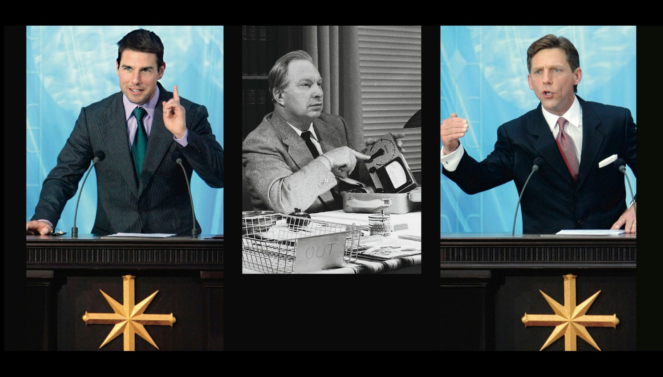
L. Ron Hubbard (center), Scientology’s founder; Tom Cruise (left), its most prominent celebrity adherent; and David Miscavige, its current head. right and left: PIERRE-PHILIPPE MARCOU / AFP / Getty; center: Chris Ware / Keystone Features / Getty
right and left: PIERRE-PHILIPPE MARCOU / AFP / Getty; center: Chris Ware / Keystone Features / Getty
Hubbard called this level the Wall of Fire. He said, “The material involved in this sector is so vicious, that it is carefully arranged to kill anyone if he discovers the exact truth of it. . . . I am very sure that I was the first one that ever did live through any attempt to attain that material.” The O.T. III candidate is expected to free himself from being overwhelmed by the disembodied, emotionally wounded spirits that have been implanted inside his body. Bruce Hines, a former high-level Scientology auditor who is now a research physicist at the University of Colorado, explained to me, “Most of the upper levels are involved in exorcising these spirits.”
“The process of induction is so long and slow that you really do convince yourself of the truth of some of these things that don’t make sense,” Haggis told me. Although he refused to specify the contents of O.T. materials, on the ground that it offended Scientologists, he said, “If they’d sprung this stuff on me when I first walked in the door, I just would have laughed and left right away.” But by the time Haggis approached the O.T. III material he’d already been through several years of auditing. His wife was deeply involved in the church, as was his sister Kathy. Moreover, his first writing jobs had come through Scientology connections. He was now entrenched in the community. Success stories in the Scientology magazine Advance! added an aura of reality to the church’s claims. Haggis admits, “I was looking forward to enhanced abilities.” Moreover, he had invested a lot of money in the program. The incentive to believe was high.
In the late seventies, the O.T. material was still quite secret. There was no Google, and Scientology’s confidential scriptures had not yet circulated, let alone been produced in court or parodied on “South Park.” “You were told that this information, if released, would cause serious damage to people,” Haggis told me.
Carrying an empty, locked briefcase, Haggis went to the Advanced Organization building in Los Angeles, where the material was held. A supervisor then handed him a folder, which Haggis put in the briefcase. He entered a study room, where he finally got to examine the secret document—a couple of pages, in Hubbard’s bold scrawl. After a few minutes, he returned to the supervisor.
“I don’t understand,” Haggis said.
“Do you know the words?” the supervisor asked.
“I know the words, I just don’t understand.”
“Go back and read it again,” the supervisor suggested.
Haggis did so. In a moment, he returned. “Is this a metaphor?” he asked the supervisor.
“No,” the supervisor responded. “It is what it is. Do the actions that are required.”
Maybe it’s an insanity test, Haggis thought—if you believe it, you’re automatically kicked out. “I sat with that for a while,” he says. But when he read it again he decided, “This is madness.”
The many discrepancies between L. Ron Hubbard’s legend and his life have overshadowed the fact that he was a fascinating man: an explorer, a best-selling author, and the founder of one of the few new religious movements of the twentieth century to have survived into the twenty-first. There are several unauthorized Hubbard biographies—most notably, Russell Miller’s “Bare-Faced Messiah,” Jon Atack’s “A Piece of Blue Sky,” and Bent Corydon’s “L. Ron Hubbard: Messiah or Madman?” All rely on stolen materials and the accounts of defectors, and the church claims that they present a false and fabricated picture of Hubbard’s life. For years, the church has had a contract with a biographer, Dan Sherman, to chronicle the founder’s life, but there is still no authorized book, and the church refused to let me talk to Sherman. (“He’s busy,” Davis told me.) The tug-of-war between Scientologists and anti-Scientologists over Hubbard’s legacy has created two swollen archetypes: the most important person who ever lived and the world’s greatest con man. Hubbard was certainly grandiose, but to label him merely a fraud is to ignore the complexity of his character.
Hubbard was born in Tilden, Nebraska, in 1911. His father, a naval officer, was often away, and Hubbard spent part of his childhood on his grandparents’ ranch, in Montana. When his father got posted to Guam, in 1927, Hubbard made two trips to see him. According to Hubbard, on the second trip he continued on to Asia, where he visited the Buddhist lamaseries in the Western Hills of China, “watching monks meditate for weeks on end.”
In 1933, Hubbard married Margaret Grubb, whom he called Polly; their first child, Lafayette, was born the following year. He visited Hollywood, and began getting work as a screenwriter, very much as Paul Haggis did some forty years later. Hubbard worked on serials for Columbia Pictures, including one called “The Secret of Treasure Island.” But much of his energy was devoted to publishing stories, often under pseudonyms, in pulp magazines such as Astounding Science Fiction.
During the Second World War, Hubbard served in the U.S. Navy, and he later wrote that he was gravely injured in battle: “Blinded with injured optic nerves and lame with physical injuries to hip and back at the end of World War II, I faced an almost nonexistent future. I was abandoned by family and friends as a supposedly hopeless cripple.” While languishing in a military hospital in Oakland, California, he said, he fully healed himself, using techniques that became the foundation of Scientology. “I had no one to help me; what I had to know I had to find out,” he wrote in an essay titled “My Philosophy.” “And it’s quite a trick studying when you cannot see.” In some editions of Hubbard’s book “The Fundamentals of Thought,” published in 1956, a note on the author says, “It is a matter of medical record that he has twice been pronounced dead.”
After the war, Hubbard’s marriage dissolved, and he moved to Pasadena, where he became the housemate of Jack Parsons, a rocket scientist who belonged to an occult society called the Ordo Templi Orientis. An atmosphere of hedonism pervaded the house; Parsons hosted gatherings involving “sex magick” rituals.
In a 1946 letter, Parsons described Hubbard: “He is a gentleman, red hair, green eyes, honest and intelligent.” Parsons then mentioned his wife’s sister, Betty Northrup, with whom he had been having an affair. “Although Betty and I are still friendly, she has transferred her sexual affections to Ron.” One day, Hubbard and Northrup ran off together. In the official Scientology literature, it is claimed that Hubbard was assigned by naval intelligence to infiltrate Parsons’s occult group. “Hubbard broke up black magic in America,” the church said in a statement.
Hubbard and Northrup ended up in Los Angeles. He continued writing for the pulps, but he had larger ambitions. He began codifying a system of self-betterment, and set up an office near the corner of La Brea and Sunset, where he tested his techniques on the actors, directors, and writers he encountered. He named his system Dianetics.
The book “Dianetics” appeared in May, 1950, and spent twenty-eight weeks on the New York Times best-seller list. Written in a bluff, quirky style and overrun with footnotes that do little to substantiate its findings, “Dianetics” purports to identify the source of self-destructive behavior—the “reactive mind,” a kind of data bank that is filled with traumatic memories called “engrams,” and that is the source of nightmares, insecurities, irrational fears, and psychosomatic illnesses. The object of Dianetics is to drain the engrams of their painful, damaging qualities and eliminate the reactive mind, leaving a person “Clear.”
Dianetics, Hubbard said, was a “precision science.” He offered his findings to the American Psychiatric Association and the American Medical Association but was spurned; he subsequently portrayed psychiatry and psychology as demonic competitors. He once wrote that if psychiatrists “had the power to torture and kill everyone they would do so.”
Scientists dismissed Hubbard’s book, but hundreds of Dianetics groups sprang up across the U.S. and abroad. The Church of Scientology was officially founded in Los Angeles in February, 1954, by several devoted followers of Hubbard’s work.
In 1966, Hubbard—who by then had met and married another woman, Mary Sue Whipp—set sail with a handful of Scientologists. The church says that being at sea provided a “distraction-free environment,” allowing Hubbard “to continue his research into the upper levels of spiritual awareness.” Within a year, he had acquired several oceangoing vessels. He staffed the ships with volunteers, many of them teen-agers, who called themselves the Sea Organization. Hubbard and his followers cruised the Mediterranean searching for loot he had stored in previous lifetimes. (The church denies this.) The defector Janis Grady, a former Sea Org member, told me, “I was on the bridge with him, sailing past Greek islands. There were crosses lining one island. He told me that under each cross is buried treasure.”
The Sea Org became the church’s equivalent of a religious order. The group now has six thousand members. They perform tasks such as counselling, maintaining the church’s vast property holdings, and publishing its official literature. Sea Org initiates—some of whom are children—sign contracts for up to a billion years of service. They get a small weekly stipend and receive free auditing and coursework. Sea Org members can marry, but they must agree not to raise children while in the organization.
As Scientology grew, it was increasingly attacked. In 1963, the Los Angeles Times called it a “pseudo-scientific cult.” The church attracted dozens of lawsuits, largely from ex-parishioners. In 1980, Hubbard disappeared from public view. Although there were rumors that he was dead, he was actually driving around the Pacific Northwest in a motor home. He returned to writing science fiction and produced a ten-volume work, “Mission Earth,” each volume of which was a best-seller. In 1983, he settled quietly on a horse farm in Creston, California.
Around that time, Paul Haggis received a message from the church about a film project. Hubbard had written a treatment for a script titled “Influencing the Planet” and, apparently, intended to direct it. The film was supposed to demonstrate the range of Hubbard’s efforts to improve civilization. With another Scientologist, Haggis completed a script, which he called “quite dreadful.” Hubbard sent him notes on the draft, but no film by that name was ever released.
In 1985, with Hubbard in seclusion, the church faced two of its most difficult court challenges. In Los Angeles, a former Sea Org member, Lawrence Wollersheim, sought twenty-five million dollars for “infliction of emotional injury.” He claimed that he had been kept for eighteen hours a day in the hold of a ship docked in Long Beach, and deprived of adequate sleep and food.
That October, the litigants filed O.T. III materials in court. Fifteen hundred Scientologists crowded into the courthouse, trying to block access to the documents. The church, which considers it sacrilegious for the uninitiated to read its confidential scriptures, got a restraining order, but the Los Angeles Times obtained a copy of the material and printed a summary. Suddenly, the secrets that had stunned Paul Haggis in a locked room were public knowledge.
“A major cause of mankind’s problems began 75 million years ago,” the Times wrote, when the planet Earth, then called Teegeeack, was part of a confederation of ninety planets under the leadership of a despotic ruler named Xenu. “Then, as now, the materials state, the chief problem was overpopulation.” Xenu decided “to take radical measures.” The documents explained that surplus beings were transported to volcanoes on Earth. “The documents state that H-bombs far more powerful than any in existence today were dropped on these volcanoes, destroying the people but freeing their spirits—called thetans—which attached themselves to one another in clusters.” Those spirits were “trapped in a compound of frozen alcohol and glycol,” then “implanted” with “the seed of aberrant behavior.” The Times account concluded, “When people die, these clusters attach to other humans and keep perpetuating themselves.”
The jury awarded Wollersheim thirty million dollars. (Eventually, an appellate court reduced the judgment to two and a half million.) The secret O.T. III documents remained sealed, but the Times’ report had already circulated widely, and the church was met with derision all over the world.
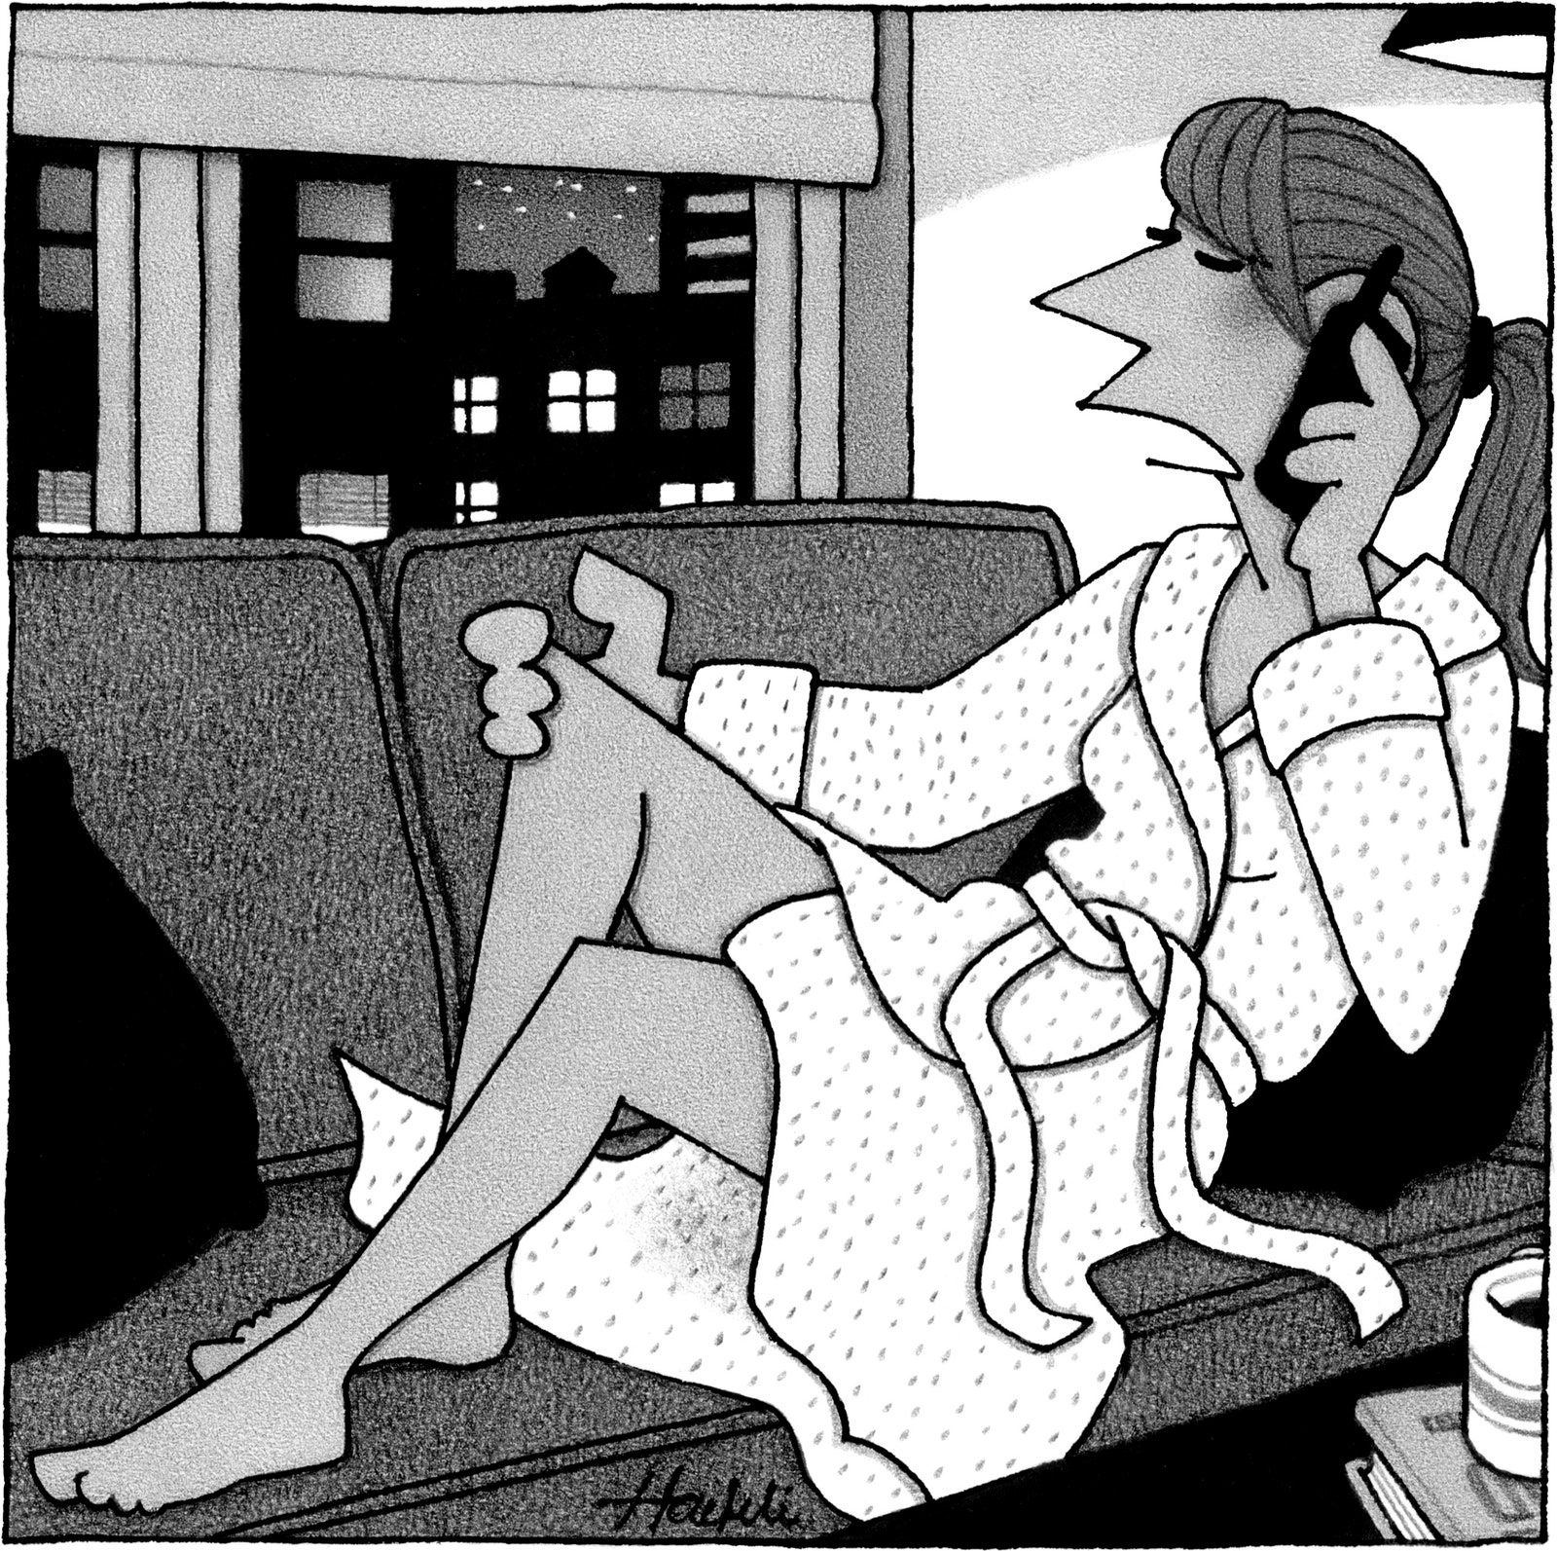
“As long as I’ve got my legs shaved, I might as well do something with them.”

The other court challenge in 1985 involved Julie Christofferson-Titchbourne, a defector who argued that the church had falsely claimed that Scientology would improve her intelligence, and even her eyesight. In a courtroom in Portland, she said that Hubbard had been portrayed to her as a nuclear physicist; in fact, he had failed to graduate from George Washington University. As for Hubbard’s claim that he had cured himself of grave injuries in the Second World War, the plaintiff’s evidence indicated that he had never been wounded in battle. Witnesses for the plaintiff testified that, in one six-month period in 1982, the church had transferred millions of dollars to Hubbard through a Liberian corporation. The church denied this, and said that Hubbard’s income was generated by his book sales.
The jury sided with Christofferson-Titchbourne, awarding her thirty-nine million dollars. Scientologists streamed into Portland to protest. They carried banners advocating religious freedom and sang “We Shall Overcome.” Scientology celebrities, including John Travolta, showed up; Chick Corea played a concert in a public park. Haggis, who was writing for the NBC series “The Facts of Life” at the time, came and was drafted to write speeches. “I wasn’t a celebrity—I was a lowly sitcom writer,” he says. He stayed for four days.
The judge declared a mistrial, saying that Christofferson-Titchbourne’s lawyers had presented prejudicial arguments. It was one of the greatest triumphs in Scientology’s history, and the church members who had gone to Portland felt an enduring sense of kinship. (A year and a half later, the church settled with Christofferson-Titchbourne for an undisclosed sum.)
In 1986, Hubbard died, of a stroke, in his motor home. He was seventy-four. Two weeks later, Scientologists gathered in the Hollywood Palladium for a special announcement. A young man, David Miscavige, stepped onto the stage. Short, trim, and muscular, with brown hair and sharp features, Miscavige announced to the assembled Scientologists that, for the past six years, Hubbard had been investigating new, higher O.T. levels. “He has now moved on to the next level,” Miscavige said. “It’s a level beyond anything any of us ever imagined. This level is, in fact, done in an exterior state. Meaning that it is done completely exterior from the body. Thus, at twenty-hundred hours, the twenty-fourth of January, A.D. 36”—that is, thirty-six years after the publication of “Dianetics”—“L. Ron Hubbard discarded the body he had used in this lifetime.” Miscavige began clapping, and led the crowd in an ovation, shouting, “Hip hip hooray!”
Miscavige was a Scientology prodigy from the Philadelphia area. He claimed that, growing up, he had been sickly, and struggled with bad asthma; Dianetics counselling had dramatically alleviated the symptoms. As he puts it, he “experienced a miracle.” He decided to devote his life to the religion. He had gone Clear by the age of fifteen, and the next year he dropped out of high school to join the Sea Org. He became an executive assistant to Hubbard, who gave him special tutoring in photography and cinematography. When Hubbard went into seclusion, in 1980, Miscavige was one of the few people who maintained close contact with him. With Hubbard’s death, the curtain rose on a man who was going to impose his personality on an organization facing its greatest test, the death of its charismatic founder. Miscavige was twenty-five years old.
In 1986, Haggis appeared on the cover of the Scientology magazine Celebrity. The accompanying article lauded his rising influence in Hollywood. He had escaped the cartoon ghetto after selling a script to “The Love Boat.” He had climbed the ladder of network television, writing movies of the week and children’s shows before settling into sitcoms. He worked on “Diff’rent Strokes” and “One Day at a Time,” then became the executive producer of “The Facts of Life.” The magazine noted, “He is one of the few writers in Hollywood who has major credits in all genres: comedy, suspense, human drama, animation.”
In the article, Haggis said of Scientology, “What excited me about the technology was that you could actually handle life, and your problems, and not have them handle you.” He added, “I also liked the motto, ‘Scientology makes the able more able.’ ” He credited the church for improving his relationship with Gettas. “Instead of fighting (we did a lot of that before Scientology philosophy) we now talk things out, listen to each other and apply Scientology technology to our problems.”
Haggis told Celebrity that he had recently gone through the Purification Rundown, a program intended to eliminate body toxins that form a “biochemical barrier to spiritual well-being.” For an average of three weeks, participants undergo a lengthy daily regimen combining sauna visits, exercise, and huge doses of vitamins, especially niacin. According to a forthcoming book, “Inside Scientology,” by the journalist Janet Reitman, the sauna sessions can last up to five hours a day. In the interview, Haggis recalled being skeptical—“My idea of doing good for my body was smoking low-tar cigarettes”—but said that the Purification Rundown “was wonderful.” He went on, “I really did feel more alert and more aware and more at ease—I wasn’t running in six directions to get something done, or bouncing off the walls when something went wrong.” Haggis mentioned that he had taken drugs when he was young. “Getting rid of all those residual toxins and medicines and drugs really had an effect,” he said. “After completing the rundown I drank a diet cola and suddenly could really taste it: every single chemical!” He recommended the Rundown to others, including his mother, who at the time was seriously ill. He also persuaded a young writer on his staff to take the course, in order to wean herself from various medications. “She could tell Scientology worked by the example I set,” Haggis told the magazine. “That made me feel very good.”
Privately, he told me, he remained troubled by the church’s theology, which struck him as “intergalactic spirituality.” He was grateful, however, to have an auditor who was “really smart, sweet, thoughtful. I could always go to talk to him.” The confessionals were helpful. “It just felt better to get things off my chest.” Even after his incredulous reaction to O.T. III, he continued to “move up” the Bridge. He saw so many intelligent people on the path, and expected that his concerns would be addressed in future levels. He told himself, “Maybe there is something, and I’m just missing it.” He felt unsettled by the lack of irony among many fellow-Scientologists—an inability to laugh at themselves, which seemed at odds with the character of Hubbard himself. When Haggis felt doubts about the religion, he recalled 16-mm. films he had seen of Hubbard’s lectures from the fifties and sixties. “He had this amazing buoyancy,” Haggis says. “He had a deadpan humor and this sense of himself that seemed to say, ‘Yes, I am fully aware that I might be mad, but I also might be on to something.’ ”
Haggis finally reached the top of the Operating Thetan pyramid. According to documents obtained by WikiLeaks, the activist group run by Julian Assange, the final exercise is: “Go out to a park, train station or other busy area. Practice placing an intention into individuals until you can successfully and easily place an intention into or on a Being and/or a body.”
Haggis expected that, as an O.T. VII, he would feel a sense of accomplishment, but he remained confused and unsatisfied. He thought that Hubbard was “brilliant in so many ways,” and that the failing must be his. At one point, he confided to a minister in the church that he didn’t think he should be a Scientologist. She told him, “There are all sorts of Scientologists,” just as there are all sorts of Jews and Christians, with varying levels of faith. The implication, Haggis said, was that he could “pick and choose” which tenets of Scientology to believe.
Haggis was a workaholic, and as his career took off he spent less and less time with his family. “He never got home till late at night or early in the morning,” his oldest daughter, Alissa, said. “All the time I ever spent with him was on the set.” Haggis frequently brought his daughters to work and assigned them odd jobs; Alissa earned her Directors Guild card when she was fifteen.
In 1987, Ed Zwick and Marshall Herskovitz, the creators of the new series “thirtysomething,” hired Haggis to write scripts. When I talked to them recently, Herskovitz recalled, “Paul walked in the door and said, ‘I love the fact that you guys are doing a show all about emotions. I don’t like talking about my emotions.’ ” In the show’s first season, one of Haggis’s scripts won an Emmy. Since he rarely discussed his religion, his bosses were surprised to learn of his affiliation. Herskovitz told me, “The thing about Paul is his particular sense of humor, which is ironic, self-deprecating—”
“And raw!” Zwick interjected.
“It’s not a sense of humor you often encounter among people who believe in Scientology,” Herskovitz continued. “His way of looking at life didn’t have that sort of straight-on, unambiguous, unambivalent view that so many Scientologists project.”
Observing Zwick and Herskovitz at work got Haggis interested in directing, and when the church asked him to make a thirty-second ad about Dianetics he seized the chance. He was determined to avoid the usual claim that Dianetics offered a triumphal march toward enlightenment. He shot a group of Scientologists talking about the practical ways that they had used Dianetics. “It was very naturalistic,” he recalls. Church authorities hated it. “They thought it looked like an A.A. meeting.” The spot never aired.
In 1992, he helped out on the pilot for “Walker, Texas Ranger,” a new series starring Chuck Norris. It ran for eight seasons and was broadcast in a hundred countries. Haggis was credited as a co-creator. “It was the most successful thing I ever did,” he says. “Two weeks of work. They never even used my script!”
With his growing accomplishments and wealth, Haggis became a bigger prize for the church. In 1988, Scientology sponsored a Dianetics car in the Indianapolis 500. David Miscavige was at the race. It was one of the few times that he and Haggis met. They sat near each other at a Scientology-sponsored dinner event before the race. “Paul takes no shit from anybody,” the organizer of the event recalled. Several times when Miscavige made some comment during the dinner, the organizer said, “Paul challenged him in a lighthearted way.” His tone was perceived as insufficiently deferential; afterward, Miscavige demanded to know why Haggis had been invited. (Miscavige declined requests to speak to me, and Tommy Davis says that Miscavige did not attend the event.) The organizer told me, “You have to understand: no one challenges David Miscavige.”
Haggis’s marriage had long been troubled, and he and his wife were entering a final state of estrangement. One day, Haggis flew to New York with a casting director who was also a Scientologist. They shared a kiss. Haggis felt bad about it, and confessed to it during an “ethics” session. He was given instruction on how to fix the problem. It didn’t work. He had a series of liaisons, each of which he confessed. Yet, perhaps because of his fame, he was not made to atone for what Scientologists call “out ethics” behavior.
Haggis and Gettas began a divorce battle that lasted nine years. Their three girls lived with Gettas, visiting Haggis occasionally. Gettas enrolled them in private schools that used Hubbard’s educational system, which is called Study Tech. It is one of the more grounded systems that he developed. There are three central elements. One is the use of clay, or other materials, to help make difficult concepts less abstract. Alissa explains, “If I’m learning the idea of how an atom looks, I’d make an atom out of clay.” A second concept is making sure that students don’t face “too steep a gradient,” in Hubbard’s words. “The schools are set up so that you don’t go on to the next level until you completely understand the material,” Alissa says. The third element is the frequent use of a dictionary to eliminate misunderstandings. “It’s really important to understand the words you’re using.”
Lauren, the middle sister, initially struggled in school. “I was illiterate until I was eleven,” she told me. Somehow, that fact escaped her parents. “I assume it was because of the divorce,” she says.
When the divorce became final, in 1997, Haggis and Gettas were ordered by the court to undergo psychological evaluations—a procedure abhorred by Scientologists. The court then determined that Haggis should have full custody of the children.
His daughters were resentful. They had lived their entire lives with their mother. “I didn’t even know why he wanted us,” Lauren says. “I didn’t really know him.”
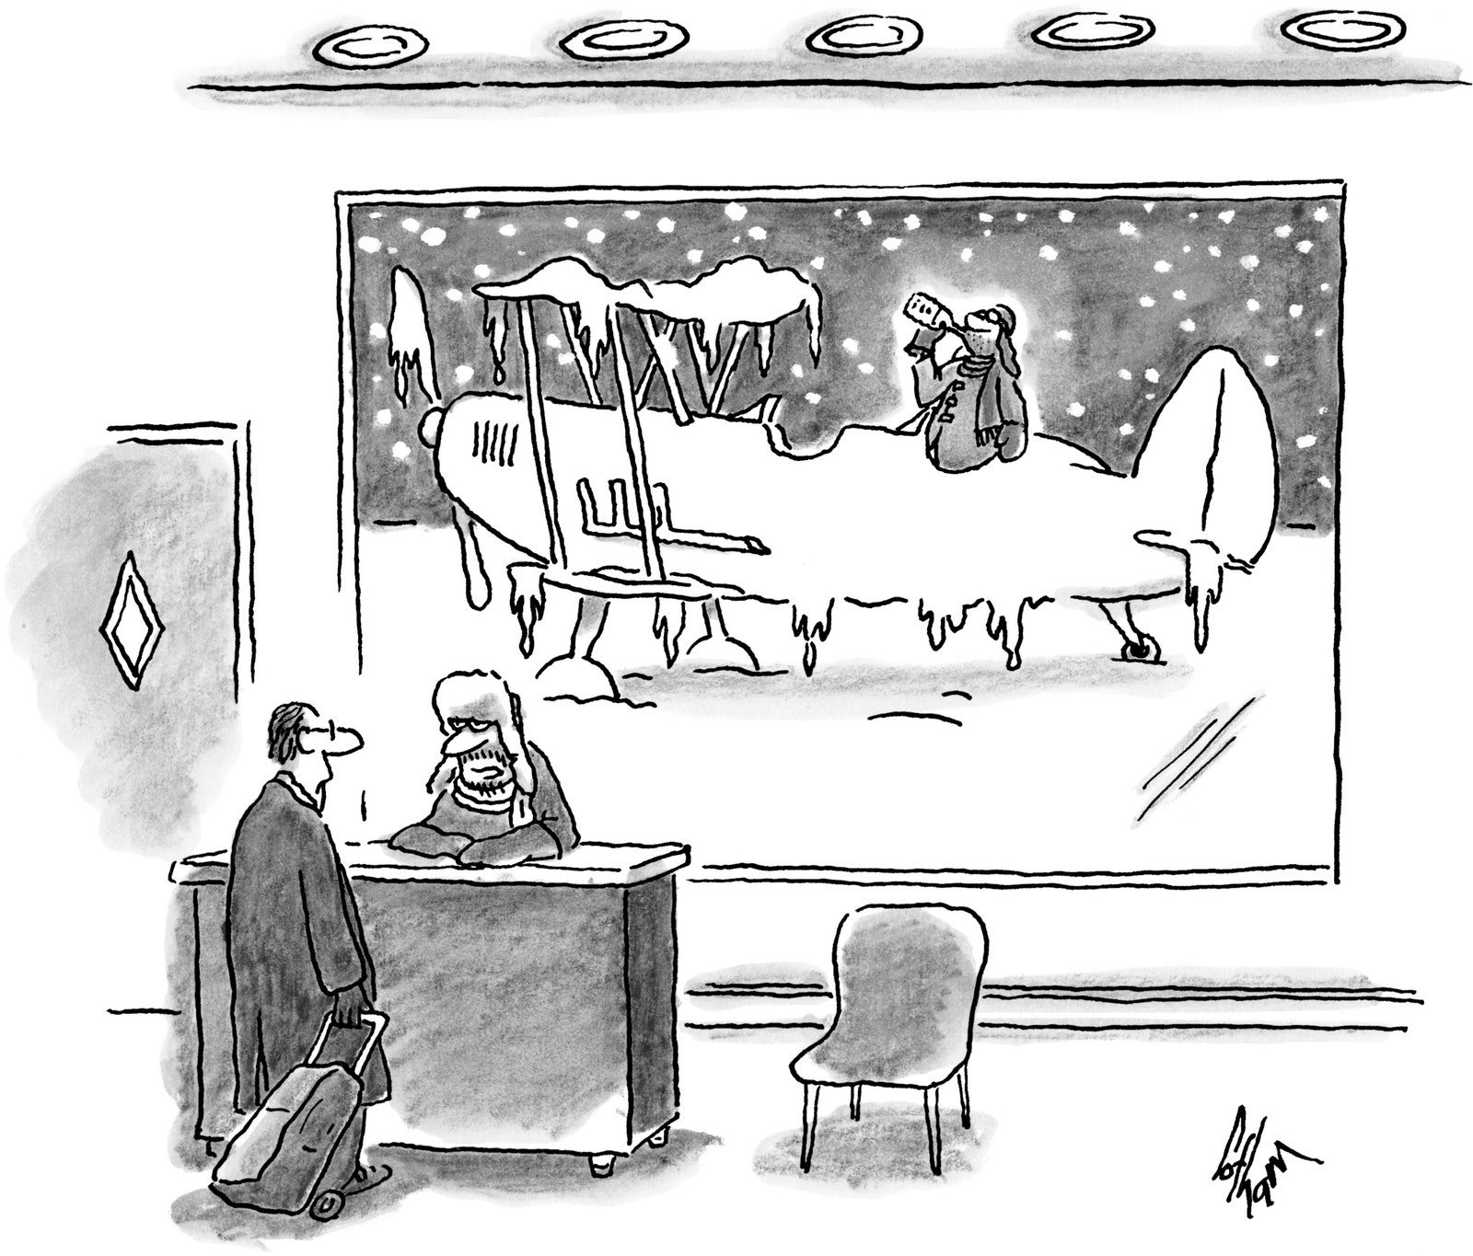
“Your pilot is still de-icing.”

Haggis put his daughters in an ordinary private school, but that lasted only six months. The girls weren’t entirely comfortable talking to people who weren’t Scientologists, and basic things like multiple-choice tests were unfamiliar. At a regular school, they felt like outsiders. “The first thing I noticed that I did, that others didn’t, is the Contact,” Alissa told me, referring to a procedure the church calls Contact Assist. “If you hurt yourself, the first thing I and other Scientology kids do is go quiet.” Scientology preaches that, if you touch the wound to the object that caused the injury and silently concentrate, the pain lessens and a sense of trauma fades.
The girls demanded to be sent to boarding school, so Haggis enrolled them at the Delphian School, in rural Oregon, which uses Hubbard’s Study Tech methods. The school, Lauren says, is “on top of a hill in the middle of nowhere.” She added, “I lived in a giant bubble. Everyone I knew was a Scientologist.”
For one course, she decided to write a paper about discrimination against various religions, including Scientology. “I wanted to see what the opposition was saying, so I went online,” she says. Another student turned her in to the school’s ethics committee. Information that doesn’t correspond to Scientology teachings is termed “entheta”—meaning confused or destructive thinking. Lauren agreed to stop doing research. “It was really easy not to look,” she says. By the time she graduated from high school, at the age of twenty, she had scarcely ever heard anyone speak ill of Scientology.
Alissa was a top student at Delphian, but she found herself moving away from the church. She still believed in some ideas promoted by Scientology, such as reincarnation, and she liked Hubbard’s educational techniques, but by the time she graduated she no longer defined herself as a Scientologist. Her reasoning was true to Hubbard’s philosophy. “A core concept in Scientology is: ‘Something isn’t true unless you find it true in your own life,’ ” she told me.
After starting boarding school, Alissa did not speak to her father for a number of years. She was angry about the divorce. Haggis mined the experience for the script of “Million Dollar Baby,” in which the lead character, played by Clint Eastwood, is haunted by his estrangement from his daughter.
“I’m very proud of Alissa for not talking to me,” Haggis told me, his eyes welling with tears. “Think what that takes.” It was the only time, in our many conversations, that he displayed such emotion.
Haggis and Alissa slowly resumed communication. When Alissa was in her early twenties, she accepted the fact that, like her sister Katy, she was gay. She recalls, “When I finally got the courage to come out to my dad, he said, ‘Oh, yeah, I knew that.’ ” Now, Alissa says, she and Haggis have a “working relationship.” As she puts it, “We do see each other for Thanksgiving and some meals.” Recently, Alissa, who is also a writer, has been collaborating on screenplays with her father. Haggis also gave her the role of a murderous drug addict in “The Next Three Days.”
In 1991, as his marriage to Gettas was crumbling, Haggis went to a Fourth of July party at the home of Scientologist friends. Deborah Rennard, who played J.R.’s alluring secretary on “Dallas,” was at the party. Rennard had grown up in a Scientology household and joined the church herself at the age of seventeen. In her early twenties, she studied acting at the Beverly Hills Playhouse and fell in love with Milton Katselas. They had recently broken up, after a six-year romance.
“When I first met Paul, he said he was having a ‘crisis of faith,’ ” Rennard told me. “He said he’d raced up to the top of the Bridge on faith, but he hadn’t gotten what he expected.” Haggis admitted to her, “I don’t believe I’m a spiritual being. I actually am what you see.” They became a couple, and married in June, 1997, immediately after Haggis’s divorce from Gettas became final. A son, James, was born the following year.
Rennard, concerned about her husband’s spiritual doubts, suggested that he do some more study. She was having breakthroughs that sometimes led her to discover past lives. “There were images, feelings, and thoughts that I suddenly realized, That’s not here. I’m not in my body, I’m in another place,” she told me. For instance, she might be examining what the church calls a “contra-survival” action—“like the time I clobbered Paul or threw something at him. And I’d look for an earlier similar. Suddenly, I’d realize I was doing something negative, and I’d be in England in the eighteen-hundreds. I’d see myself harming this person. It was a fleeting glimpse at what I was doing then.” Examining these moments helped the emotional charge dissipate. “Paul would say, ‘Don’t you think you’re making this up?’ ” She wondered if that mattered. “If it changed me for the better, who cares?” she says. “When you are working on a scene as an actor, something similar happens. You get connected to a feeling from who knows where.”
Haggis and Rennard shared a house in Santa Monica, which soon became a hub for progressive political fund-raisers. Haggis lent his name to nearly any cause that espoused peace and justice: the Earth Communications Office, the Hollywood Education and Literacy Project, the Center for the Advancement of Non-Violence. Despite his growing disillusionment with Scientology, he also raised a significant amount of money for it, and made sizable donations himself, appearing frequently on an honor roll of top contributors. The Church of Scientology had recently gained tax-exempt status as a religious institution, making donations, as well as the cost of auditing, tax-deductible. (Church members had lodged more than two thousand lawsuits against the Internal Revenue Service, ensnaring the agency in litigation. As part of the settlement, the church agreed to drop its legal campaign.)
Over the years, Haggis estimates, he spent more than a hundred thousand dollars on courses and auditing, and three hundred thousand dollars on various Scientology initiatives. Rennard says that she spent about a hundred and fifty thousand dollars on coursework. Haggis recalls that the demands for donations never seemed to stop. “They used friends and any kind of pressure they could apply,” he says. “I gave them money just to keep them from calling and hounding me.”
Adecade ago, Haggis moved into feature films. He co-wrote the scripts for the two most recent James Bond films, “Casino Royale” and “Quantum of Solace.” He claims that Scientology has not influenced his work—there are no evident references in his movies—but his scripts often do have an autobiographical element. “I’m not good at something unless it disturbs me,” he said. In “Million Dollar Baby,” he wrote about a boxing coach who pulls the plug on a paralyzed fighter. Haggis made a similar choice in real life with his best friend, who was brain dead from a staph infection. “They don’t die easily,” he said. “Even in a coma, he kicked and moaned for twelve hours.” Haggis likes to explore contradictions, making heroes into villains and vice versa, as with the racist cop in “Crash,” played by Matt Dillon, who molests a woman in one scene and saves her life in another. In “In the Valley of Elah,” Tommy Lee Jones plays a father trying to discover who murdered his son, a heroic soldier just returned from Iraq, only to learn that the sadism of the war had turned his son into a willing torturer.
In 2004, Haggis was rewriting “Flags of Our Fathers,” a drama about Iwo Jima, for Clint Eastwood to direct. (Haggis shared credit with William Broyles, Jr.) One day, Haggis and Eastwood visited the set of “War of the Worlds,” which Steven Spielberg was shooting with Tom Cruise. Haggis had met Cruise at a fund-raiser and, a second time, at the Celebrity Centre. Cruise says that he was introduced to the church in 1986 by his first wife, the actress Mimi Rogers. (Rogers denies this.) In 1992, he became the religion’s most famous member, telling Barbara Walters that Hubbard’s Study Tech methods had helped him overcome dyslexia. “He’s a major symbol of the church, and I think he takes that very seriously,” Haggis said.
Tommy Davis, at Cruise’s request, was allowed to erect a tent on the set of Spielberg’s “War of the Worlds,” where Scientology materials were distributed. That raised eyebrows in Hollywood. Haggis says that when he appeared on the set Spielberg pulled him aside. “It’s really remarkable to me that I’ve met all these Scientologists, and they seem like the nicest people,” Spielberg said. Haggis replied, “Yeah, we keep all the evil ones in a closet.” (Spielberg’s publicist says that Spielberg doesn’t recall the conversation.)
A few days later, Haggis says, he was summoned to the Celebrity Centre, where officials told him that Cruise was very upset. “It was a joke,” Haggis explained. Davis offers a different account. He says that Cruise mentioned the incident to him only “in passing,” but that he himself found the remark offensive. He confronted Haggis, who apologized profusely, asking that his contrition be relayed to “anyone who might have been offended.”
Davis has known Cruise since Davis was eighteen years old. They are close friends. The two men physically resemble each other, with long faces, strong jaws, and spiky haircuts. “I saw him hanging out with Tom Cruise after the Oscars,” Haggis recalls. “At the Vanity Fair party, they were let in the back door. They arrived on motorcycles, really cool ones, like Ducatis.” Cruise was also close to David Miscavige, and has said of him, “I have never met a more competent, a more intelligent, a more tolerant, a more compassionate being outside of what I have experienced from L.R.H. And I’ve met the leaders of leaders.”
In 2004, Cruise received a special Scientology award: the Freedom Medal of Valor. In a ceremony held in England, Miscavige called Cruise “the most dedicated Scientologist I know.” The ceremony was accompanied by a video interview with the star. Wearing a black turtleneck, and with the theme music from “Mission: Impossible” playing in the background, Cruise said, “Being a Scientologist, you look at someone and you know absolutely that you can help them. So, for me, it really is K.S.W.”—initials that stand for “Keeping Scientology Working.” He went on, “That policy to me has really gone—phist!” He made a vigorous gesture with his hand. “Boy! There’s a time I went through and I said, ‘You know what? When I read it, you know, I just went poo! This is it!’ ” Later, when the video was posted on YouTube and viewed by millions who had no idea what he was talking about, Cruise came across as unhinged. He did not dispel this notion when, in 2005, during an interview with Oprah Winfrey, he jumped up and down on a couch while declaring his love for the actress Katie Holmes. He and Holmes married in 2006, in Italy. David Miscavige was his best man.
Proposition 8, the California initiative against gay marriage, passed in November, 2008. Haggis learned from his daughter Lauren of the San Diego chapter’s endorsement of it. He immediately sent Davis several e-mails, demanding that the church take a public stand opposing the ban on gay marriage. “I am going to an anti Prop 8 rally in a couple of hours,” he wrote on November 11th, after the election. “When can we expect the public statement?” In a response, Davis proposed sending a letter to the San Diego press, saying that the church had been “erroneously listed among the supporters of Proposition 8.”
“ ‘Erroneous’ doesn’t cut it,” Haggis responded. In another note, he remarked, “The church may have had the luxury of not taking a position on this issue before, but after taking a position, even erroneously, it can no longer stand neutral.” He demanded that the church openly declare that it supports gay rights. “Anything less won’t do.”
Davis explained to Haggis that the church avoids taking overt political stands. He also felt that Haggis was exaggerating the impact of the San Diego endorsement. “It was one guy who somehow got it in his head it would be a neat idea and put Church of Scientology San Diego on the list,” Davis told me. “When I found out, I had it removed from the list.” Davis said that the individual who made the mistake—he didn’t divulge the name—had been “disciplined” for it. I asked what that meant. “He was sat down by a staff member of the local organization,” Davis explained. “He got sorted out.”
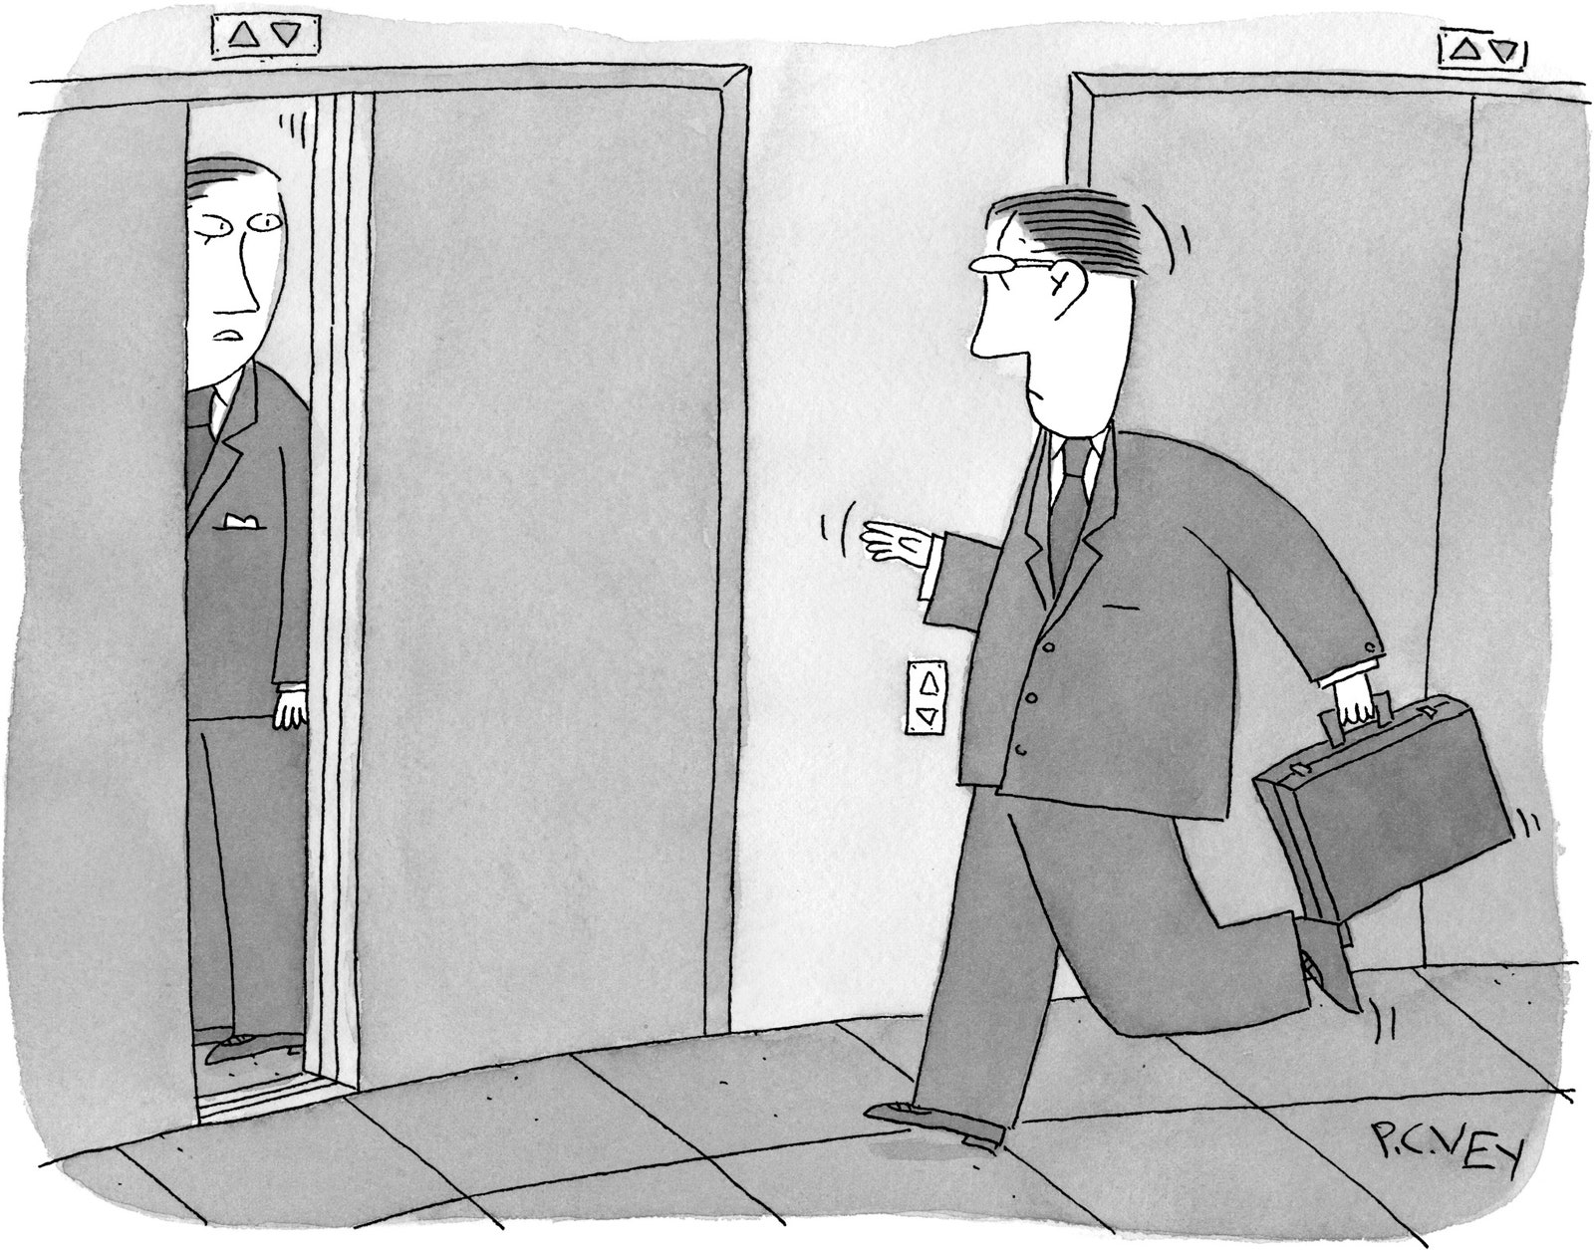
“Just let me know if you want me to make a valiant attempt at holding the doors.”

Davis told me that Haggis was mistaken about his daughter having been ostracized by Scientologists. Davis said that he had spoken to the friend who had allegedly abandoned Katy, and the friend had ended the relationship not because Katy was a lesbian but because Katy had lied about it. (Haggis, when informed of this account, laughed.)
As far as Davis was concerned, reprimanding the San Diego staff member was the end of the matter: “I said, ‘Paul, I’ve received no press inquiries. . . . If I were to make a statement on this, it would actually be more attention to the subject than if we leave it be.’ ”
Haggis refused to let the matter drop. “This is not a P.R. issue, it is a moral issue,” he wrote, in February, 2009. In the final note of this exchange, he conceded, “You were right: nothing happened—it didn’t flap—at least not very much. But I feel we shamed ourselves.”
Haggis sent this note six months before he resigned. Because he stopped complaining, Davis felt that the issue had been laid to rest. But, far from putting the matter behind him, Haggis began his investigation into the church. His inquiry, much of it conducted online, mirrored the actions of the lead character he was writing for “The Next Three Days”; the character, played by Russell Crowe, goes on the Internet to find a way to break his wife out of jail.
Haggis soon found on YouTube the video of Tommy Davis talking on CNN about disconnection. The practice of disconnection is not unique to Scientology. The Amish, for example, cut themselves off from apostates, including their own children; some Orthodox Jewish communities do the same. Rennard had disconnected from her parents twice. When she was a young child, her stepfather had got the family involved with Scientology. When she was in her twenties, and appearing on “Dallas,” her parents broke away from the church. Like many active members of Scientology, they had kept money in an account (in their case, twenty-five hundred dollars) for future courses they intended to take. Rennard’s mother took the money back. “That’s a huge deal for the church,” Rennard told me. She didn’t speak to her parents for several years, assuming that they had been declared Suppressive Persons.
In the early nineties, Rennard wrote to the International Justice Chief, the Scientology official in charge of such matters; she was informed that she could talk to her parents again. A decade later, however, she went to Clearwater, intending to take some upper-level courses, and was told that the previous ruling no longer applied. If she wanted to do more training, she had to confront her parents’ mistakes. The church recommended that she take a course called P.T.S./S.P., which stands for “Potential Trouble Source/Suppressive Persons.” “That course took a year,” Rennard told me. She petitioned officials at the Celebrity Centre in Los Angeles for help. “They put me on a program that took two years to complete,” she says. Still, nothing changed. If she failed to “handle” her parents, she would have to disconnect not only from them but also from everyone who spoke to them, including her siblings. “It was that, or else I had to give up being a Scientologist,” she says.
Rennard’s parents were among four hundred claimants in a lawsuit brought against Scientology by disaffected members in 1987; the case was thrown out of court the following year, for lack of evidence. To make amends, Rennard’s parents had to denounce the anti-Scientologist group and offer a “token” restitution. The church prescribes a seven-step course of rehabilitation, called A to E, for penitents seeking to get back into its good graces, which includes returning debts and making public declarations of error. Rennard told her parents that if they wanted to remain in contact with her they had to follow the church’s procedures. Her parents, worried that they would also be cut off from their grandson, agreed to perform community service. “They really wanted to work it out with me,” she says.
But the church wasn’t satisfied. Rennard was told that if she maintained contact with her parents she would be labelled a “Potential Trouble Source”—a designation that would alienate her from the Scientology community and render her ineligible for further training. “It was clearly laid out for me,” she says. A senior official counselled her to agree to have her parents formally branded as S.P.s. “Until then, they won’t turn around and recognize their responsibilities,” he said. “O.K., fine,” Rennard said. “Go ahead and declare them. Maybe it’ll get better.” She was granted permission to begin upper-level coursework in Clearwater.
In August, 2006, a notice was posted at the Celebrity Centre declaring Rennard’s parents Suppressive Persons, saying that they had associated with “squirrels,” which in Scientology refers to people who have dropped out of the church but continue to practice unauthorized auditing. A month later, Rennard’s parents sent her a letter: “We tried to do what you asked, Deborah. We worked the whole months of July & Aug. on A-E.” They explained that they had paid the church the twenty-five hundred dollars. After all that, they continued, a church adjudicator had told them to hand out three hundred copies of L. Ron Hubbard’s pamphlet “The Way to Happiness” to libraries; they had also been told to document the exchange with photographs. They had declined. “If this can’t be resolved, we will have to say Good-Bye to you & James will lose his Grand-Parents,” her mother wrote. “This is ridiculous.”
In April, 2007, Rennard’s parents sued for the right to visit their grandson. Rennard had to hire an attorney. Eventually, the church relented. She was summoned to a church mission in Santa Monica and shown a statement rescinding the ruling that her parents were S.P.s.
Tommy Davis sent me some policy statements that Hubbard had made about disconnection in 1965. “Anyone who rejects Scientology also rejects, knowingly or unknowingly, the protection and benefits of Scientology and the companionship of Scientologists,” Hubbard writes. In “Introduction to Scientology Ethics,” Hubbard defined disconnection as “a self-determined decision made by an individual that he is not going to be connected to another.”
Scientology defectors are full of tales of forcible family separations, which the church almost uniformly denies. Two former leaders in the church, Marty Rathbun and Mike Rinder, told me that families are sometimes broken apart. In their cases, their wives chose to stay in the church when they left. The wives, and the church, denounce Rathbun and Rinder as liars.
Afew days after sending the resignation letter to Tommy Davis, Haggis came home from work to find nine or ten of his Scientology friends standing in his front yard. He invited them in to talk. Anne Archer was there with Terry Jastrow, her husband, an actor turned producer and director. “Paul had been such an ally,” Archer told me. “It was pretty painful. Everyone wanted to see if there could be some kind of resolution.” Mark Isham, an Emmy-winning composer who has scored films for Haggis, came with his wife, Donna. Sky Dayton, the EarthLink founder, was there, along with several other friends and a church representative Haggis didn’t know. His friends could have served as an advertisement for Scientology—they were wealthy high achievers with solid marriages, who embraced the idea that the church had given them a sense of well-being and the skills to excel.
Scientologists are trained to believe in their persuasive powers and the need to keep a positive frame of mind. But the mood in the room was downbeat and his friends’ questions were full of reproach.
Jastrow asked Haggis, “Do you have any idea that what you might do might damage a lot of pretty wonderful people and your fellow-Scientologists?”
Haggis reminded the group that he had been with them at the 1985 “freedom march” in Portland. They all knew about his financial support of the church and the occasions when he had spoken out in its defense. Jastrow remembers Haggis saying, “I love Scientology.”
Archer had particular reason to feel aggrieved: Haggis’s letter had called her son a liar. “Paul was very sweet,” she says. “We didn’t talk about Tommy.” She understood that Haggis was upset about the way Proposition 8 had affected his gay daughters, but she didn’t think it was relevant to Scientology. “The church is not political,” she told me. “We all have tons of friends and relatives who are gay. . . . It’s not the church’s issue. I’ve introduced gay friends to Scientology.”
Isham was frustrated. “We weren’t breaking through to him,” he told me. Of all the friends present, Isham was the closest to Haggis. “We share a common artistic sensibility,” Isham said. When he visited Abbey Road Studios, in England, to record the score that he had written for “In the Valley of Elah,” Haggis went along with him. Haggis wanted him to compose the score for “The Next Three Days.” Now their friendship was at risk. Isham used Scientology to analyze the situation. In his view, Haggis’s emotions at that moment ranked 1.1 on the Tone Scale—the state that is sometimes called Covertly Hostile. By adopting a tone just above it—Anger—Isham hoped to blast Haggis out of the psychic place where he seemed to be lodged. “This was an intellectual decision,” Isham said. “I decided I would be angry.”
“Paul, I’m pissed off,” Isham told Haggis. “There’s better ways to do this. If you have a complaint, there’s a complaint line.” Anyone who genuinely wanted to change Scientology should stay within the organization, Isham argued, not quit; certainly, going public was not helpful.
Haggis listened patiently. A fundamental tenet of Scientology is that differing points of view must be fully heard and acknowledged. When his friends finished, however, Haggis had his own set of grievances.
He referred them to the exposé in the St. Petersburg Times that had so shaken him: “The Truth Rundown.” The first installment had appeared in June, 2009. Haggis had learned from reading it that several of the church’s top managers had defected in despair. Marty Rathbun had once been inspector general of the church’s Religious Technology Center, which holds the trademarks of Scientology and Dianetics, and exists to “protect the public from misapplication of the technology.” Rathbun had also overseen Scientology’s legal-defense strategy, and reported directly to Miscavige. Amy Scobee had been an executive in the Celebrity Centre network. Mike Rinder had been the church’s spokesperson, the job now held by Tommy Davis. One by one, they had disappeared from Scientology, and it had never occurred to Haggis to ask where they had gone.
The defectors told the newspaper that Miscavige was a serial abuser of his staff. “The issue wasn’t the physical pain of it,” Rinder said. “It’s the fact that the domination you’re getting—hit in the face, kicked—and you can’t do anything about it. If you did try, you’d be attacking the C.O.B.”—the chairman of the board. Tom De Vocht, a defector who had been a manager at the Clearwater spiritual center, told the paper that he, too, had been beaten by Miscavige; he said that from 2003 to 2005 he had witnessed Miscavige striking other staff members as many as a hundred times. Rathbun, Rinder, and De Vocht all admitted that they had engaged in physical violence themselves. “It had become the accepted way of doing things,” Rinder said. Amy Scobee said that nobody challenged the abuse because people were terrified of Miscavige. Their greatest fear was expulsion: “You don’t have any money. You don’t have job experience. You don’t have anything. And he could put you on the streets and ruin you.”
Assessing the truthfulness of such inflammatory statements—made by people who deserted the church or were expelled—was a challenge for the newspaper, which has maintained a special focus on Scientology. (Clearwater is twenty miles northwest of downtown St. Petersburg.) In 1998, six years before he defected, Rathbun told the paper that he had never seen Miscavige hit anyone. Now he said, “That was the biggest lie I ever told you.” The reporters behind “The Truth Rundown,” Joe Childs and Thomas Tobin, interviewed each defector separately and videotaped many of the sessions. “It added a measure of confidence,” Childs told me. “Their stories just tracked.”
Much of the alleged abuse took place at the Gold Base, a Scientology outpost in the desert near Hemet, a town eighty miles southeast of Los Angeles. Miscavige has an office there, and the site features, among other things, movie studios and production facilities for the church’s many publications. For decades, the base’s location was unknown even to many church insiders. Haggis visited the Gold Base only once, in the early eighties, when he was about to direct his Scientology commercial. The landscape, he said, suggested a spa, “beautiful and restful,” but he found the atmosphere sterile and scary. Surrounded by a security fence, the base houses about eight hundred Sea Org members, in quarters that the church likens to those “in a convent or seminary, albeit much more comfortable.”
According to a court declaration filed by Rathbun in July, Miscavige expected Scientology leaders to instill aggressive, even violent, discipline. Rathbun said that he was resistant, and that Miscavige grew frustrated with him, assigning him in 2004 to the Hole—a pair of double-wide trailers at the Gold Base. “There were between eighty and a hundred people sentenced to the Hole at that time,” Rathbun said, in the declaration. “We were required to do group confessions all day and all night.”
The church claims that such stories are false: “There is not, and never has been, any place of ‘confinement’ . . . nor is there anything in Church policy that would allow such confinement.”
According to Rathbun, Miscavige came to the Hole one evening and announced that everyone was going to play musical chairs. Only the last person standing would be allowed to stay on the base. He declared that people whose spouses “were not participants would have their marriages terminated.” The St. Petersburg Times noted that Miscavige played Queen’s “Bohemian Rhapsody” on a boom box as the church leaders fought over the chairs, punching each other and, in one case, ripping a chair apart.
Tom De Vocht, one of the participants, says that the event lasted until four in the morning: “It got more and more physical as the number of chairs went down.” Many of the participants had long been cut off from their families. They had no money, no credit cards, no telephones. According to De Vocht, many lacked a driver’s license or a passport. Few had any savings or employment prospects. As people fell out of the game, Miscavige had airplane reservations made for them. He said that buses were going to be leaving at six in the morning. The powerlessness of everyone else in the room was nakedly clear.
Tommy Davis told me that a musical-chairs episode did occur. He explained that Miscavige had been away from the Gold Base for some time, and when he returned he discovered that in his absence many jobs had been reassigned. The game was meant to demonstrate that even seemingly small changes can be disruptive to an organization—underscoring an “administrative policy of the church.” The rest of the defectors’ accounts, Davis told me, was “hoo-ha”: “Chairs being ripped apart, and people being threatened that they’re going to be sent to far-flung places in the world, plane tickets being purchased, and they’re going to force their spouses—and on and on and on. I mean, it’s just nuts!”
Jefferson Hawkins, a former Sea Org member and church executive who worked with Haggis on the rejected Dianetics ad campaign, told me that Miscavige had struck or beaten him on five occasions, the first time in 2002. “I had just written an infomercial,” he said. Miscavige summoned him to a meeting where a few dozen members were seated on one side of a table; Miscavige sat by himself on the other side. According to Hawkins, Miscavige began a tirade about the ad’s shortcomings. Hawkins recalls, “Without any warning, he jumped up onto the conference-room table and he launches himself at me. He knocks me back against a cubicle wall and starts battering my face.” The two men fell to the floor, Hawkins says, and their legs became entangled. “Let go of my legs!” Miscavige shouted. According to Hawkins, Miscavige then “stomped out of the room,” leaving Hawkins on the floor, shocked and bruised. The others did nothing to support him, he claims: “They were saying, ‘Get up! Get up!’ ”
I asked Hawkins why he hadn’t called the police. He reminded me that church members believe that Scientology holds the key to salvation: “Only by going through Scientology will you reach spiritual immortality. You can go from life to life to life without being cognizant of what is going on. If you don’t go through Scientology, you’re condemned to dying over and over again in ignorance and darkness, never knowing your true nature as a spirit. Nobody who is a believer wants to lose that.” Miscavige, Hawkins says, “holds the power of eternal life and death over you.”
Moreover, Scientologists are taught to handle internal conflicts within the church’s own justice system. Hawkins told me that if a Sea Org member sought outside help he would be punished, either by being declared a Suppressive Person or by being sent off to do manual labor, as Hawkins was made to do after Miscavige beat him. The church denies that Hawkins was mistreated, and notes that he has participated in protests organized by Anonymous, a “hacktivist” collective that has targeted Scientology. The group pugnaciously opposes censorship, and became hostile toward Scientology after the church invoked copyright claims in order to remove from the Internet the video of Tom Cruise extolling “K.S.W.” The church describes Anonymous as a “cyber-terrorist group”; last month, the F.B.I. raided the homes of three dozen members after Anonymous attacked the Web sites of corporations critical of WikiLeaks. (Two members of Anonymous have pleaded guilty to participating in a 2008 attack on a Scientology Web site.)
The church provided me with eleven statements from Scientologists, all of whom said that Miscavige had never been violent. One of them, Yael Lustgarten, said that she was present at the meeting with Hawkins and that the attack by Miscavige never happened. She claims that Hawkins made a mess of his presentation—“He smelled of body odor, he was unshaven, his voice tone was very low, and he could hardly be heard”—and was admonished to shape up. She says that Hawkins “wasn’t hit by anyone.” The defector Amy Scobee, however, says that she witnessed the attack—the two men had fallen into her cubicle. After the altercation, she says, “I gathered all the buttons from Jeff’s shirt and the change from his pockets and gave them back to him.”
The church characterizes Scobee, Rinder, Rathbun, Hawkins, De Vocht, Hines, and other defectors I spoke with as “discredited individuals,” who were demoted for incompetence or expelled for corruption; the defectors’ accounts are consistent only because they have “banded together to advance and support each other’s false ‘stories.’ ”
After reading the St. Petersburg Times series, Haggis tracked down Marty Rathbun, who was living on Corpus Christi Bay, in south Texas. Rathbun had been making ends meet by writing freelance articles for local newspapers and selling beer at a ballpark.
Haggis complained that Davis hadn’t been honest with him about Scientology’s policies. “I said, ‘That’s not Tommy, he has no say,’ ” Rathbun told me. “Miscavige is a total micromanager. I explained the whole culture.” He says that Haggis was shocked by the conversation. “The thing that was most troubling to Paul was that I literally had to escape,” Rathbun told me. (A few nights after the musical-chairs incident, he got on his motorcycle and waited until a gate was opened for someone else; he sped out and didn’t stop for thirty miles.) Haggis called several other former Scientologists he knew well. One of them said that he had escaped from the Gold Base by driving his car—an Alfa Romeo convertible that Haggis had sold him—through a wooden fence. The defector said that he had scars on his forehead from the incident. Still others had been expelled or declared Suppressive Persons. Haggis asked himself, “What kind of organization are we involved in where people just disappear?”
When Haggis began casting for “The Next Three Days,” in the summer of 2009, he asked Jason Beghe to read for the part of a cop. Beghe was a gravel-voiced character actor who had played Demi Moore’s love interest in “G.I. Jane.” In the late nineties, Haggis had worked with Beghe on a CBS series, “Family Law.” Like so many others, Beghe had come to the church through the Beverly Hills Playhouse. In old promotional materials for the church, he is quoted as saying that Scientology is “a rocket ride to spiritual freedom.”
Beghe told Haggis, “You should know that I’m no longer in Scientology. Actually, I’m one of its most outspoken critics. The church would be very unhappy if you hire me.”
Haggis responded, “Nobody tells me who I cast.” He looked at a lengthy video that Beghe had posted on the Internet, in which he denounces the church as “destructive and a ripoff.” Haggis thought that Beghe had “gone over the edge.” But he asked if they could talk.
The two men met at Patrick’s Roadhouse, a coffee shop on the beach in Pacific Palisades. Beghe was calmer than he had been in the video, which he called “a snapshot of me having been out only three months.” Even though Beghe had renounced the church, he continued to use Scientology methods when dealing with members and former members. “It’s almost like: ‘I can speak Chinese, I understand the culture,’ ” he explained to me. In several meetings with Haggis, he employed techniques based on what Hubbard labelled “Ethics Conditions.” These range from Confusion at the bottom and ascend through Treason, Enemy, Doubt, Liability, and Emergency, eventually leading to Power. “Each one of the conditions has a specific set of steps in a formula, and, once that formula is applied correctly, you will move up to the next-highest condition,” Beghe explained. “I assumed that Paul was in a condition of Doubt.”
Beghe joined Scientology in 1994. He told Haggis that, in the late nineties, he began having emotional problems, and the church recommended auditing and coursework. In retrospect, he felt that it had done no good. “I was paying money for them to fuck me up,” he said. “I spent about five or six hundred thousand dollars trying to get better, and I continued to get worse.” He says that when he finally decided to leave the church, in 2007, he told an official that the church was in a condition of Liability to him. Ordinarily, when a Scientologist does something wrong, especially something that might damage the image of the organization, he has to make amends, often in the form of a substantial contribution. But now the situation was reversed. Beghe recalls telling the official, “You guys don’t have any policies to make up the damage.” He eventually suggested to the official that the church buy property and lease it to him at a negligible rate; the church now characterizes this as an attempt at extortion.
Beghe was reluctant to use the word “brainwashing”—“whatever the fuck that is”—but he did feel that his mind had been somehow taken over. “You have all these thoughts, all these ways of looking at things, that are L. Ron Hubbard’s,” he explained. “You think you’re becoming more you, but within that is an implanted thing, which is You the Scientologist.”
Perhaps because Haggis had never been as much of a true believer as some members, he didn’t feel as deeply betrayed as Beghe did. “I didn’t feel that some worm had buried itself in my ear, and if you plucked it out you would find L. Ron Hubbard and his thought,” he told me. But, as he continued his investigation, he became increasingly disturbed. He read the church’s official rebuttal to the St. Petersburg Times series, in the Scientology magazine Freedom. It included an annotated transcript of conversations that had taken place between the reporters and representatives of the church, including Tommy Davis and his wife, Jessica Feshbach. In Freedom’s rendition of those conversations, the reporters’ sources were not named, perhaps to shield Scientologists from the shock of seeing familiar names publicly denouncing the organization. Rathbun was called “Kingpin” and Scobee “the Adulteress.”
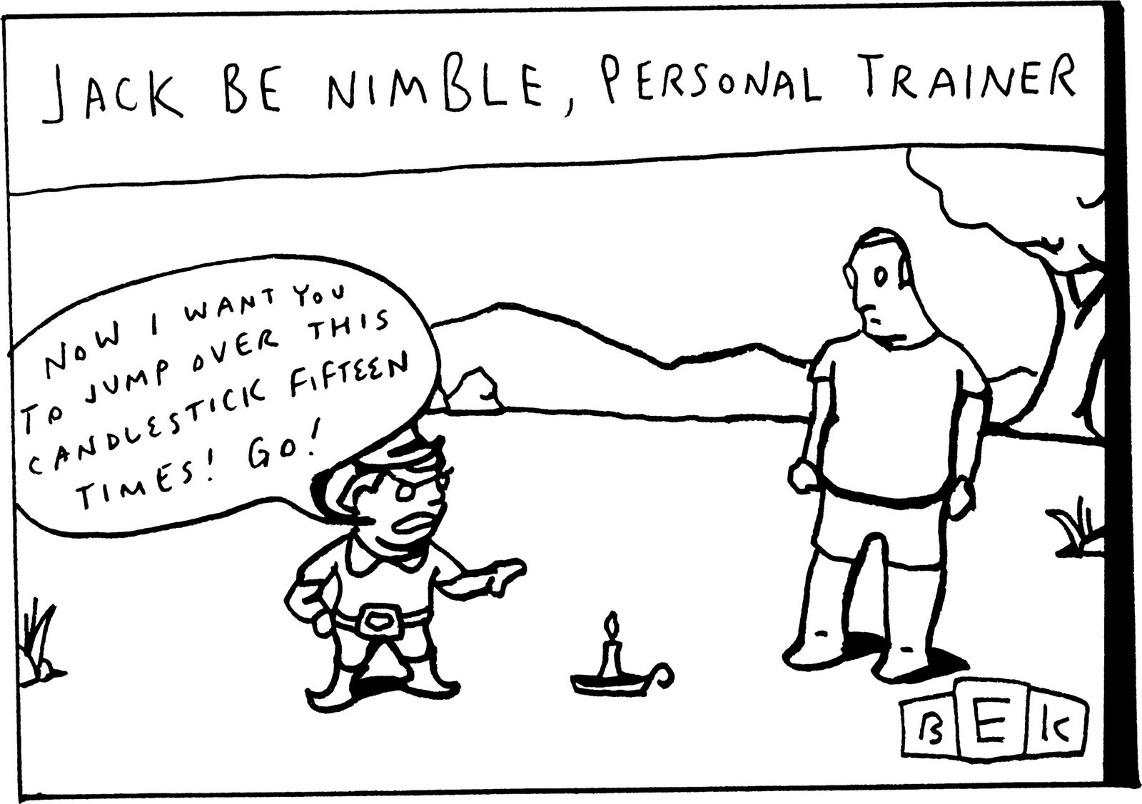

At one point in the transcribed conversations, Davis reminded the reporters that Scobee had been expelled from the church leadership because of an affair. The reporters responded that she had denied having sexual contact outside her marriage. “That’s a lie,” Davis told them. Feshbach, who had a stack of documents, elaborated: “She has a written admission [of] each one of her instances of extramarital indiscretion. . . . I believe there were five.” When Haggis read this in Freedom, he presumed that the church had obtained its information from the declarations that members sometimes provide after auditing. Such confessions are supposed to be confidential. (Scientology denies that it obtained the information this way, and Davis produced an affidavit, signed by Scobee, in which she admits to having liaisons. Scobee denies committing adultery, and says that she did not write the affidavit; she says that she signed it in the hope of leaving the church on good terms, so that she could stay in touch with relatives.)
In his letter to Davis, Haggis said that he was worried that the church might look through his files to smear him, too. “Luckily, I have never held myself up to be anyone’s role model,” he wrote.
At his house, Haggis finished telling his friends what he had learned. He suggested that they should at least examine the evidence. “I directed them to certain Web sites,” he said, mentioning Exscientologykids.com, which was created by three young women who grew up in Scientology and subsequently left. Many stories on the site are from men and women who joined the Sea Org before turning eighteen. One of them was Jenna Miscavige Hill, David Miscavige’s niece, who joined when she was twelve. For Hill and many others, formal education had stopped when they entered the Sea Org, leaving them especially ill-prepared, they say, for coping with life outside the church.
The stories Haggis found on the Internet of children drafted into the Sea Org appalled him. “They were ten years old, twelve years old, signing billion-year contracts—and their parents go along with this?” Haggis told me. “Scrubbing pots, manual labor—that so deeply touched me. My God, it horrified me!” The stories of the Sea Org children reminded Haggis of child slaves he had seen in Haiti.
Many Sea Org volunteers find themselves with no viable options for adulthood. If they try to leave, the church presents them with a “freeloader tab” for all the coursework and counselling they have received; the bill can amount to more than a hundred thousand dollars. Payment is required in order to leave in good standing. “Many of them actually pay it,” Haggis said. “They leave, they’re ashamed of what they’ve done, they’ve got no money, no job history, they’re lost, they just disappear.” In what seemed like a very unguarded comment, he said, “I would gladly take down the church for that one thing.”
The church says that it adheres to “all child labor laws,” and that minors can’t sign up without parental consent; the freeloader tabs are an “ecclesiastical matter” and are not enforced through litigation.
Haggis’s friends came away from the meeting with mixed feelings. “We all left no clearer than when we went in,” Archer said. Isham felt that there was still a possibility of getting Haggis “to behave himself.” He said that Haggis had agreed that “it wasn’t helping anyone” to continue distributing the letter, and had promised not to circulate it further. Unmentioned was the fact that this would be the last time most of them ever spoke to Haggis.
I asked Isham if he had taken Haggis’s advice and looked at the Web sites or the articles in the St. Petersburg Times. “I started to,” he said. “But it was like reading ‘Mein Kampf’ if you wanted to know something about the Jewish religion.”
In the days after the friends visited Haggis’s home, church officials and members came to his office, distracting his colleagues, particularly his producing partner, Michael Nozik, who is not a Scientologist. “Every day, for hours, he would have conversations with them,” Nozik told me. It was August, 2009, and shooting for “The Next Three Days” was set to start in Pittsburgh at the end of the month; the office desperately needed Haggis’s attention. “But he felt a need to go through the process fully,” Nozik says. “He wanted to give them a full hearing.”
“I listened to their point of view, but I didn’t change my mind,” Haggis says, noting that the Scientology officials “became more livid and irrational.” He added, “I applied more Scientology in those meetings than they did.”
Davis and other church officials told Haggis that Miscavige had not beaten his employees; his accusers, they said, had committed the violence. Supposing that was true, Haggis said, why hadn’t Miscavige stopped it? Haggis recalls that, at one meeting, he told Davis and five other officials, “If someone in my organization is beating people, I would sure know about it. You think I would put up with it? And I’m not that good a person.” Haggis noted that, if the rumors of Miscavige’s violent temper were true, it proved that everyone is fallible. “Look at Martin Luther King, Jr.,” he said, alluding to King’s sexual improprieties.
“How dare you compare Dave Miscavige with Martin Luther King!” one of the officials shouted. Haggis was shocked. “They thought that comparing Miscavige to Martin Luther King was debasing his character,” he says. “If they were trying to convince me that Scientology was not a cult, they did a very poor job of it.” (Davis says that King’s name never came up.)
In October, 2009, Marty Rathbun called Haggis and asked if he could publish the resignation letter on his blog. Rathbun had become an informal spokesperson for defectors who believed that the church had broken away from Hubbard’s original teachings. Haggis was in Pittsburgh, shooting his picture. “You’re a journalist, you don’t need my permission,” Haggis said, although he asked Rathbun to excise parts related to Katy’s homosexuality.
Haggis says that he didn’t think about the consequences of his decision: “I thought it would show up on a couple of Web sites. I’m a writer, I’m not Lindsay Lohan.” Rathbun got fifty-five thousand hits on his blog that afternoon. The next morning, the story was in newspapers around the world.
At the time Haggis was doing his research, the F.B.I. was conducting its own investigation. In December, 2009, Tricia Whitehill, a special agent from the Los Angeles office, flew to Florida to interview former members of the church in the F.B.I.’s office in downtown Clearwater, which happens to be directly across the street from Scientology’s spiritual headquarters. Tom De Vocht, who spoke with Whitehill, told me, “I understood that the investigation had been going on for quite a while.” He says Whitehill confided that she hadn’t told the local agents what the investigation was about, in case the office had been infiltrated. Amy Scobee spoke to the F.B.I. for two days. “They wanted a full download about the abuse,” she told me.
Whitehill and Valerie Venegas, the lead agent on the case, also interviewed former Sea Org members in California. One of them was Gary Morehead, who had been the head of security at the Gold Base; he left the church in 1996. In February, 2010, he spoke to Whitehill and told her that he had developed a “blow drill” to track down Sea Org members who left Gold Base. “We got wickedly good at it,” he says. In thirteen years, he estimates, he and his security team brought more than a hundred Sea Org members back to the base. When emotional, spiritual, or psychological pressure failed to work, Morehead says, physical force was sometimes used to bring escapees back. (The church says that blow drills do not exist.)
Whitehill and Venegas worked on a special task force devoted to human trafficking. The laws regarding trafficking were built largely around forced prostitution, but they also pertain to slave labor. Under federal law, slavery is defined, in part, by the use of coercion, torture, starvation, imprisonment, threats, and psychological abuse. The California penal code lists several indicators that someone may be a victim of human trafficking: signs of trauma or fatigue; being afraid or unable to talk, because of censorship by others or security measures that prevent communication with others; working in one place without the freedom to move about; owing a debt to one’s employer; and not having control over identification documents. Those conditions echo the testimony of many former Sea Org members who lived at the Gold Base.
Sea Org members who have “failed to fulfill their ecclesiastical responsibilities” may be sent to one of the church’s several Rehabilitation Project Force locations. Defectors describe them as punitive reëducation camps. In California, there is one in Los Angeles; until 2005, there was one near the Gold Base, at a place called Happy Valley. Bruce Hines, the defector turned research physicist, says that he was confined to R.P.F. for six years, first in L.A., then in Happy Valley. He recalls that the properties were heavily guarded and that anyone who tried to flee would be tracked down and subjected to further punishment. “In 1995, when I was put in R.P.F., there were twelve of us,” Hines said. “At the high point, in 2000, there were about a hundred and twenty of us.” Some members have been in R.P.F. for more than a decade, doing manual labor and extensive spiritual work. (Davis says that Sea Org members enter R.P.F. by their own choosing and can leave at any time; the manual labor maintains church facilities and instills “pride of accomplishment.”)
In 2009, two former Sea Org members, Claire and Marc Headley, filed lawsuits against the church. They had both joined as children. Claire became a member of the Sea Org at the age of sixteen, and was assigned to the Gold Base. She says she wasn’t allowed to tell anyone where she was going, not even her mother, who was made to sign over guardianship. (Claire’s mother, who is still in the church, has issued a sworn statement denying that she lost contact with her daughter.) The security apparatus at the Gold Base intimidated Claire. “Even though I had been in Scientology pretty much all my life, this was a whole new world,” she told me. She says she was rarely allowed even a telephone call to her mother. “Every last trace of my life, as I knew it, was thrown away,” she said. “It was like living in George Orwell’s ‘1984.’ ”
Claire met Marc Headley, also a teen-ager, soon after her arrival. “We had no ties to anyone not in Scientology,” Claire said. “It was a very closeted and controlled existence.” Marc says it was widely known around the base that he was one of the first people Tom Cruise audited. In Scientology, the auditor bears a significant responsibility for the progress of his subject. “If you audit somebody and that person leaves the organization, there’s only one person whose fault that is—the auditor,” Headley told me. (Cruise’s attorney says that Cruise doesn’t recall meeting Marc.) Claire and Marc fell in love, and married in 1992. She says that she was pressured by the church to have two abortions, because of a stipulation that Sea Org members can’t have children. The church denies that it pressures members to terminate pregnancies. Lucy James, a former Scientologist who had access to Sea Org personnel records, says that she knows of dozens of cases in which members were pressed to have abortions.
In 2005, Marc Headley says, he was punched by Miscavige during an argument. He and his wife quit. (The church calls Marc Headley dishonest, claiming that he kept seven hundred dollars in profits after being authorized to sell Scientology camera equipment; Headley says that shipping costs and other expenses account for the discrepancy.) In 2009, the Headleys filed their suits, which maintained that the working conditions at the Gold Base violated labor and human-trafficking laws. The church responded that the Headleys were ministers who had voluntarily submitted to the rigors of their calling, and that the First Amendment protected Scientology’s religious practices. The court agreed with this argument and dismissed the Headleys’ complaints, awarding the church forty thousand dollars in litigation costs. The court also indicated that the Headleys were technically free to leave the Gold Base. The Headleys have appealed the rulings.

“When is this sexual fantasy going to get interesting, Brad?”

Defectors also talked to the F.B.I. about Miscavige’s luxurious life style. The law prohibits the head of a tax-exempt organization from enjoying unusual perks or compensation; it’s called inurement. Tommy Davis refused to disclose how much money Miscavige earns, and the church isn’t required to do so, but Headley and other defectors suggest that Miscavige lives more like a Hollywood star than like the head of a religious organization—flying on chartered jets and wearing shoes custom-made in London. Claire Headley says that, when she was in Scientology, Miscavige had five stewards and two chefs at his disposal; he also had a large car collection, including a Saleen Mustang, similar to one owned by Cruise, and six motorcycles. (The church denies this characterization and “vigorously objects to the suggestion that Church funds inure to the private benefit of Mr. Miscavige.”)
Former Sea Org members report that Miscavige receives elaborate birthday and Christmas gifts from Scientology groups around the world. One year, he was given a Vyrus 985 C3 4V, a motorcycle with a retail price of seventy thousand dollars. “These gifts are tokens of love and respect for Mr. Miscavige,” Davis informed me.
By contrast, Sea Org members typically receive fifty dollars a week. Often, this stipend is docked for small infractions, such as failing to meet production quotas or skipping scripture-study sessions. According to Janela Webster, who was in the Sea Org for nineteen years before defecting, in 2006, it wasn’t unusual for a member to be paid as little as thirteen dollars a week.
I recently spoke with two sources in the F.B.I. who are close to the investigation. They assured me that the case remains open.
Last April, John Brousseau, who had been in the Sea Org for more than thirty years, left the Gold Base. He was unhappy with Miscavige, his former brother-in-law, whom he considered “detrimental to the goals of Scientology.” He drove across the country, to south Texas, to meet Marty Rathbun. “I was there a couple of nights,” he says. At five-thirty one morning, he was leaving the motel room where he was staying, to get coffee, when he heard footsteps behind him. It was Tommy Davis; he and nineteen church members had tracked Brousseau down. Brousseau locked himself in his room and called Rathbun, who alerted the police; Davis went home without Brousseau.
In a deposition given in July, Davis said no when asked if he had ever “followed a Sea Organization member that has blown”—fled the church. Under further questioning, he admitted that he and an entourage had flown to Texas in a jet chartered by Scientology, and had shown up outside Brousseau’s motel room at dawn. But he insisted that he was only trying “to see a friend of mine.” Davis now calls Brousseau “a liar.”
Brousseau says that his defection caused anxiety, in part because he had worked on a series of special projects for Tom Cruise. Brousseau maintained grounds and buildings at the Gold Base. He worked for fourteen months on the renovation of the Freewinds, the only ship left in Scientology’s fleet; he also says that he installed bars over the doors of the Hole, at the Gold Base, shortly after Rathbun escaped. (The church denies this.)
In 2005, Miscavige showed Cruise a Harley-Davidson motorcycle he owned. At Miscavige’s request, Brousseau had had the vehicle’s parts plated with brushed nickel and painted candy-apple red. Brousseau recalls, “Cruise asked me, ‘God, could you paint my bike like that?’ I looked at Miscavige, and Miscavige agreed.” Cruise brought in two motorcycles to be painted, a Triumph and a Honda Rune; the Honda had been given to him by Spielberg after the filming of “War of the Worlds.” “The Honda already had a custom paint job by the set designer,” Brousseau recalls. Each motorcycle had to be taken apart completely, and all the parts nickel-plated, before it was painted. (The church denies Brousseau’s account.)
Brousseau also says that he helped customize a Ford Excursion S.U.V. that Cruise owned, installing features such as handmade eucalyptus panelling. The customization job was presented to Tom Cruise as a gift from David Miscavige, he said. “I was getting paid fifty dollars a week,” he recalls. “And I’m supposed to be working for the betterment of mankind.” Several years ago, Brousseau says, he worked on the renovation of an airport hangar that Cruise maintains in Burbank. Sea Org members installed faux scaffolding, giant banners bearing the emblems of aircraft manufacturers, and a luxurious office that was fabricated at church facilities, then reassembled inside the hangar. Brousseau showed me dozens of photographs documenting his work for Cruise.
Both Cruise’s attorney and the church deny Brousseau’s account. Cruise’s attorney says that “the Church of Scientology has never expended any funds to the personal benefit of Mr. Cruise or provided him with free services.” Tommy Davis says that these projects were done by contractors, and that Brousseau acted merely as an adviser. He also says, “None of the Church staff involved were coerced in any way to assist Mr. Cruise. Church staff, and indeed Church members, hold Mr. Cruise in very high regard and are honored to assist him. Whatever small economic benefit Mr. Cruise may have received from the assistance of Church staff pales in comparison to the benefits the Church has received from Mr. Cruise’s many years of volunteer efforts for the Church.” Yet this assistance may have involved many hours of unpaid labor on the part of Sea Org members.
Miscavige’s official title is chairman of the board of the Religious Technology Center, but he dominates the entire organization. His word is absolute, and he imposes his will even on some of the people closest to him. According to Rinder and Brousseau, in June, 2006, while Miscavige was away from the Gold Base, his wife, Shelly, filled several job vacancies without her husband’s permission. Soon afterward, she disappeared. Her current status is unknown. Tommy Davis told me, “I definitely know where she is,” but he won’t disclose where that is.
The garden behind Anne Archer and Terry Jastrow’s house, in Brentwood, is filled with olive trees and hummingbirds. A fountain gurgles beside the swimming pool. When I visited, last May, Jastrow told me about the first time he met Archer, in Milton Katselas’s class. “I saw this girl sitting next to Milton,” Jastrow recalled. “I said, ‘Who is that?’ ” There was a cool wind blowing in from the Pacific, and Archer drew a shawl around her.
“We were friends for about a year and a half before we ever had our first date,” Archer said. They were married in 1978. “Our relationship really works,” Jastrow said. “We attribute that essentially a hundred per cent to applying Scientology.” The two spoke of the techniques that had helped them, such as never being critical of the other and never interrupting.
“This isn’t a creed,” Archer said. “These are basic natural laws of life.” She described Hubbard as “an engineer” who had codified human emotional states, in order to guide people to “feel a zest and a love for life.”
I asked them how the controversy surrounding Scientology had affected them. “It hasn’t touched me,” Archer said. “It’s not that I’m not aware of it.” She went on, “Scientology is growing. It’s in a hundred and sixty-five countries.”
“Translated into fifty languages!” Jastrow added. “It’s the fastest-growing religion.” He added, “Scientologists do more good things for more people in more places around the world than any other organization ever.” He continued, “When you study the historical perspective of new faiths, historically, they’ve all been—”
“Attacked,” Archer said. “Look what happened to the—”
“The Christians,” Jastrow said, simultaneously. “Think of the Mormons and the Christian Scientists.”
We talked about the church’s focus on celebrities. “Hubbard recognized that if you really want to inspire a culture to have peace and greatness and harmony among men, you need to respect and help the artist to prosper and flourish,” Archer said. “And if he’s particularly well known he needs a place where he can be comfortable. Celebrity Centres provide that.” She blamed the press for concentrating too much on Scientology celebrities. Journalists, she said, “don’t write about the hundreds of thousands of other Scientologists—”
“Millions!”
“Millions of other Scientologists. They only write about four friggin’ people!”
The church won’t release official membership figures, but it informally claims eight million members worldwide. Davis says that the figure comes from the number of people throughout the world who have donated to the church. “There is no process of conversion, there is no baptism,” Davis told me. It was a simple decision: “Either you are or you aren’t.” A survey of American religious affiliations, compiled in the Statistical Abstract of the United States, estimates that only twenty-five thousand Americans actually call themselves Scientologists. That’s less than half the number who identify themselves as Rastafarians.
Jastrow suggested that Scientology’s critics often had a vested interest. He pointed to psychiatrists, psychologists, doctors, drugmakers, pharmacies—“all those people who make a living and profit and pay their mortgages and pay their college educations and buy their cars, et cetera, et cetera, based on people not being well.” He cited a recent article in USA Today which noted that an alarmingly high number of soldiers in Iraq and Afghanistan had been hospitalized for mental illness. Drugs merely mask mental distress, he said, whereas “Scientology will solve the source of the problem.” The medical and pharmaceutical industries are “prime funders and sponsors of the media,” he said, and therefore might exert “influence on people telling the whole and true story about Scientology just because of the profit motive.”
Scientology has perpetuated Hubbard’s antagonism toward psychiatry. An organization that the church co-founded, the Citizens Commission on Human Rights, maintains a permanent exhibit in Los Angeles called “Psychiatry: An Industry of Death,” which argues that psychiatry contributed to the rise of Nazism and apartheid. The group is behind an effort “to help achieve legislative protections against abusive psychiatric treatment and drugging of children.” (Paul Haggis has hosted an event for the organization at his home. His defection from Scientology has not changed his view that “psychotropic drugs are overprescribed for children.”)
Jastrow, in his back yard, told me, “Scientology is going to be huge, and it’s going to help mankind right itself.” He asked me, “What else is there that we can hang our hopes on?”
“That’s improving the civilization,” Archer added.
“Is there some other religion on the horizon that’s gonna help mankind?” he said. “Just tell me where. If not Scientology, where?”
Archer and Jastrow found their way into Scientology in the mid-seventies, but Tommy Davis was reared in Archer’s original faith, Christian Science. He never met L. Ron Hubbard. He was thirteen years old on January 24, 1986, the day Hubbard died. Although Davis grew up amid money and celebrity, he impressed people with his modesty and his idealism. Like Paul Haggis, Davis was first drawn to the church because of romantic problems. In 1996, he told Details that, when he was seventeen, he was having trouble with a girlfriend, and went to his mother for advice. Archer suggested that he go to the Celebrity Centre. After taking the Personal Values and Integrity course, Davis became a Scientologist.
In 1990, Davis was accepted at Columbia University. But, according to the defector John Peeler—who was then the secretary to Karen Hollander, the president of the Celebrity Centre—pressure was put on Davis to join the Sea Org. Hollander, Peeler says, wanted Tommy to be her personal assistant. “Karen felt that because of who his parents were, and the fact that he already had close friendships with other celebrities, he’d be a good fit,” Peeler said. “Whenever celebrities came in, there would be Anne Archer’s son.” At first, Davis resisted. “He wanted to go to college,” Peeler said.
That fall, Davis entered Columbia. He attended for a semester, then dropped out and joined the Sea Org. “I always wanted to do something that helped people,” Davis explained to me. “I didn’t think the world needed another doctor or lawyer.” Archer and Jastrow say that they were surprised by Tommy’s decision. “We were hoping he’d get his college education,” Jastrow said.
Davis became fiercely committed to the Sea Org. He got a tattoo on one arm of its logo—two palm fronds embracing a star, supposedly the emblem of the Galactic Confederacy seventy-five million years ago. He began working at the Celebrity Centre, attending to young stars like Juliette Lewis, before taking on Tom Cruise. David Miscavige was impressed with Davis. Mike Rinder recalled, “Miscavige liked the fact that he was young and looked trendy and wore Armani suits.”
Paul Haggis remembers first meeting Davis at the Celebrity Centre in the early nineties. “He was a sweet and bright boy,” Haggis said.
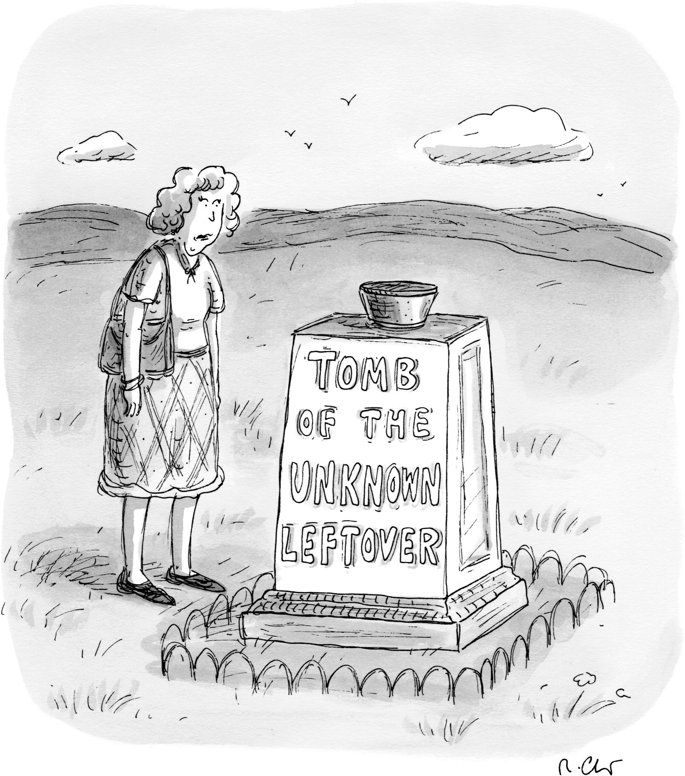

Davis’s rise within Scientology was not without difficulty. In 2005, Davis was sent to Clearwater to participate in something called the Estates Project Force. He was there at the same time as Donna Shannon, a veterinarian who had become an O.T. VII before joining the Sea Org. She had thought that she was attending a kind of boot camp for new Sea Org members, and was surprised to see veterans like Davis. She says that Davis, “a pretty nice guy,” was subjected to extensive hazing. “He complained about scrubbing a Dumpster with a toothbrush till late at night,” she recalls. “Then he’d be up at six to do our laundry.” Only later did Shannon learn that Davis was Anne Archer’s son.
Shannon and Davis worked together for a while in Clearwater, maintaining the grounds. “I was supposedly supervising him,” Shannon says. “I was told to make him work really hard.” At one point, Shannon says, Davis borrowed about a hundred dollars from her because he didn’t have money for food.
One day, according to Shannon, she and Davis were taking the bus to a work project. She asked why he was in the E.P.F.
“I got busted,” Davis told her. Using Scientology jargon, he said, “I fucked up on Tom Cruise’s lines”—meaning that he had botched a project that Cruise was involved in. “I just want to do my stuff and get back on post.”
Shannon recalled that, suddenly, “it was like a veil went over his eyes, and he goes, ‘I already said too much.’ ”
Several months later, Davis paid her back the money. (Davis says that he does not recall meeting Shannon, has never scrubbed a Dumpster, and has never had a need to borrow money.)
Davis ascended to his role as spokesman in 2007. He has since become known for his aggressive defenses of the church. In 2007, the BBC began reporting an investigative story about Scientology. From the start, the BBC crew, led by John Sweeney, was shadowed by a Scientology film crew. Davis travelled across the U.S. to disrupt Sweeney’s interviews with Scientology dissidents. The two men had a number of confrontations. In an incident captured on video in Florida, Sweeney suggests that Scientology is “a sadistic cult.” Davis responds, “For you to repeatedly refer to my faith in those terms is so derogatory, so offensive, and so bigoted. And the reason you kept repeating it is because you wanted to get a reaction like you’re getting right now. Well, buddy, you got it! Right here, right now, I’m angry! Real angry!” The two men had another encounter that left Sweeney screaming as Davis goaded him—an incident so raw that Sweeney apologized to his viewers.
Shortly afterward, in March, 2007, Davis mysteriously disappeared. He was under considerable stress. According to Mike Rinder, Davis had told Sweeney that he reported to Miscavige every day, and that angered Miscavige, who wanted to be seen as focussed on spiritual matters, not public relations. According to Rinder, Davis “blew.” A few days later, he surfaced in Las Vegas. Davis was sent to Clearwater, where he was “security-checked” by Jessica Feshbach, a church stalwart. A security check involves seeking to gain a confession with an E-Meter, in order to rout out subversion. It can function as a powerful form of thought control.
Davis claims that he never fled the church and was not in Las Vegas. He did go to Clearwater. “I went to Florida and worked there for a year and took some time off,” he told me. “I did a lot of study, a lot of auditing.” He and Feshbach subsequently got married.
When I first contacted Tommy Davis, last April, he expressed a reluctance to talk, saying that he had already spent a month responding to Paul Haggis. “It made little difference,” he said. “The last thing I’m interested in is dredging all this up again.” He kept putting me off, saying that he was too busy to get together, but he promised that we would meet when he was more available. In an e-mail, he said, “We should plan on spending at least a full day together as there is a lot I would want to show you.” We finally arranged to meet on Memorial Day weekend.
I flew to Los Angeles and waited for him to call. On Sunday at three o’clock, Davis appeared at my hotel, with Feshbach. We sat at a table on the patio. Davis has his mother’s sleepy eyes. His thick black hair was combed forward, with a lock falling boyishly onto his forehead. He wore a wheat-colored suit with a blue shirt. Feshbach, a slender, attractive woman, anxiously twirled her hair.
Davis now told me that he was “not willing to participate in, or contribute to, an article about Scientology through the lens of Paul Haggis.” I had come to Los Angeles specifically to talk to him, at a time he had chosen. I asked if he had been told not to talk to me. He said no.
Feshbach said that she had spoken to Mark Isham, whom I had interviewed the day before. “He talked to you about what are supposed to be our confidential scriptures.” Any discussion of the church’s secret doctrines was offensive, she said.
In my meeting with Isham, he asserted that Scientology was not a “faith-based religion.” I pointed out that, in Scientology’s upper levels, there was a cosmology that would have to be accepted on faith. Isham said that he wasn’t going to discuss the details of O.T. III. “In the wrong hands, it can hurt people,” he said.
“Everything I have to say about Paul, I’ve already said,” Davis told me. He agreed, however, to respond to written questions about the church.
In late September, Davis and Feshbach, along with four attorneys representing the church, travelled to Manhattan to meet with me and six staff members of The New Yorker. In response to nearly a thousand queries, the Scientology delegation handed over forty-eight binders of supporting material, stretching nearly seven linear feet.
Davis, early in his presentation, attacked the credibility of Scientology defectors, whom he calls “bitter apostates.” He said, “They make up stories.” He cited Bryan Wilson, an Oxford sociologist, who has argued that testimony from the disaffected should be treated skeptically, noting, “The apostate is generally in need of self-justification. He seeks to reconstruct his own past to excuse his former affiliations and to blame those who were formerly his closest associates.”
Davis spoke about Gerry Armstrong, a former Scientology archivist who copied, without permission, many of the church’s files on Hubbard, and who settled in a fraud suit against the church in 1986. Davis charged that Armstrong had forged many of the documents that he later disseminated in order to discredit the church’s founder. He also alleged that Armstrong had spread rumors of a 1967 letter in which Hubbard told his wife that he was “drinking lots of rum and popping pinks and grays” while researching the Operating Thetan material. Davis also noted that, in 1984, Armstrong had been captured on videotape telling a friend, “I can create documents with relative ease. You know, I did for a living.” Davis’s decision to cite this evidence was curious—though the quote cast doubt on Armstrong’s ethics, it also suggested that forging documents had once been part of a Scientologist’s job.
Davis passed around a photograph of Armstrong, which, he said, showed Armstrong “sitting naked” with a giant globe in his lap. “This was a photo that was in a newspaper article he did where he said that all people should give up money,” Davis said. “He’s not a very sane person.”
Armstrong told me that, in the photo, he is actually wearing running shorts under the globe. The article is about his attempt to create a movement for people to “abandon the use of currency.” He said that he received eight hundred thousand dollars in the 1986 settlement and had given most of the money away. (The settlement prohibited Armstrong from talking about Scientology, a prohibition that he has ignored, and the church has won two breach-of-contract suits against him, including a five-hundred-thousand-dollar judgment in 2004.)
Davis also displayed photographs of what he said were bruises sustained by Mike Rinder’s former wife in 2010, after Rinder physically assaulted her in a Florida parking lot. (Rinder denies committing any violence. A sheriff’s report supports this.) Davis also showed a mug shot of Marty Rathbun in a jailhouse jumpsuit, after being arrested in New Orleans last July for public drunkenness. “Getting arrested for being drunk on the intersection of Bourbon and Toulouse?” Davis cracked. “That’s like getting arrested for being a leper in a leper colony.” (Rathbun’s arrest has been expunged.) Claire and Marc Headley were “the most despicable people in the world”; Jeff Hawkins was “an inveterate liar.”
I asked how, if these people were so reprehensible, they had all arrived at such elevated positions in the church. “They weren’t like that when they were in those positions,” Davis responded. The defectors we were discussing had not only risen to positions of responsibility within the church; they had also ascended Scientology’s ladder of spiritual accomplishment. I suggested to Davis that Scientology didn’t seem to work if people at the highest levels of spiritual attainment were actually liars, adulterers, wife beaters, and embezzlers.
Scientology, Davis said, doesn’t pretend to be perfect, and it shouldn’t be judged on the misconduct of a few apostates. “I haven’t done things like that,” Davis said. “I haven’t suborned perjury, destroyed evidence, lied—contrary to what Paul Haggis says.” He spoke of his frustration with Haggis after his resignation: “If he was so troubled and shaken on the fundamentals of Scientology . . . then why the hell did he stick around for thirty-five years?” He continued, “Did he stay a closet Scientologist for some career-advancement purpose?” Davis shook his head in disgust. “I think he’s the most hypocritical person in the world.”
We discussed the allegations of abuse lodged against Miscavige. “The only people who will corroborate are their fellow-apostates,” Davis said. He produced affidavits from other Scientologists refuting the accusations, and noted that the tales about Miscavige always hinged on “inexplicable violent outbursts.” Davis said, “One would think that if such a thing occurred—which it most certainly did not—there’d have to be a reason.”
I had wondered about these stories as well. While Rinder and Rathbun were in the church, they had repeatedly claimed that allegations of abuse were baseless. Then, after Rinder defected, he said that Miscavige had beaten him fifty times. Rathbun has confessed that, in 1997, he ordered incriminating documents destroyed in the case of Lisa McPherson, the Scientologist who died of an embolism. If these men were capable of lying to protect the church, might they not also be capable of lying to destroy it? Davis later claimed that Rathbun is in fact trying to overthrow Scientology’s current leadership and take over the church. (Rathbun now makes his living by providing Hubbard-inspired counselling to other defectors, but he says that he has no desire to be part of a hierarchical organization. “Power corrupts,” he says.)
Twelve other defectors told me that they had been beaten by Miscavige, or had witnessed Miscavige beating other church staff members. Most of them, like John Peeler, noted that Miscavige’s demeanor changed “like the snap of a finger.” Others who never saw such violence spoke of their constant fear of the leader’s anger.
At the meeting, Davis brought up Jack Parsons’s black-magic society, which Hubbard had supposedly infiltrated. Davis said, “He was sent in there by Robert Heinlein”—the science-fiction writer—“who was running off-book intelligence operations for naval intelligence at the time.” Davis said, “A biography that just came out three weeks ago on Bob Heinlein actually confirmed it at a level that we’d never been able to before.” The book to which Davis was referring is the first volume of an authorized Heinlein biography, by William H. Patterson, Jr. There is no mention in the book of Heinlein’s sending Hubbard to break up the Parsons ring, on the part of naval intelligence or any other organization. Patterson says that he looked into the matter, at the suggestion of Scientologists, but found nothing.

“To answer your question, we may or may not be trying to have it both ways.”

Davis and I discussed an assertion that Marty Rathbun had made to me about the O.T. III creation story—the galactic revelations that Haggis had deemed “madness.” While Hubbard was in exile, Rathbun told me, he wrote a memo suggesting an experiment in which ascending Scientologists skipped the O.T. III level. Miscavige shelved the idea, Rathbun told me. Davis called Rathbun’s story “libellous.” He explained that the cornerstone of Scientology was the writings of L. Ron Hubbard. “Mr. Hubbard’s material must be and is applied precisely as written,” Davis said. “It’s never altered. It’s never changed. And there probably is no more heretical or more horrific transgression that you could have in the Scientology religion than to alter the technology.”
But hadn’t certain derogatory references to homosexuality found in some editions of Hubbard’s books been changed after his death?
Davis admitted that that was so, but he maintained that “the current editions are one-hundred-per-cent, absolutely fully verified as being according to what Mr. Hubbard wrote.” Davis said they were checked against Hubbard’s original dictation.
“The extent to which the references to homosexuality have changed are because of mistaken dictation?” I asked.
“No, because of the insertion, I guess, of somebody who was a bigot,” Davis replied.
“Somebody put the material in those—?”
“I can only imagine. . . . It wasn’t Mr. Hubbard,” Davis said, cutting me off.
“Who would’ve done it?”
“I have no idea.”
“Hmm.”
“I don’t think it really matters,” Davis said. “The point is that neither Mr. Hubbard nor the church has any opinion on the subject of anyone’s sexual orientation. . . .”
“Someone inserted words that were not his into literature that was propagated under his name, and that’s been corrected now?” I asked.
“Yeah, I can only assume that’s what happened,” Davis said.
After this exchange, I looked at some recent editions that the church had provided me with. On page 125 of “Dianetics,” a “sexual pervert” is defined as someone engaging in “homosexuality, lesbianism, sexual sadism, etc.” Apparently, the bigot’s handiwork was not fully excised.
At the meeting, Davis and I also discussed Hubbard’s war record. His voice filling with emotion, he said that, if it was true that Hubbard had not been injured, then “the injuries that he handled by the use of Dianetics procedures were never handled, because they were injuries that never existed; therefore, Dianetics is based on a lie; therefore, Scientology is based on a lie.” He concluded, “The fact of the matter is that Mr. Hubbard was a war hero.”
In the binders that Davis provided, there was a letter from the U.S. Naval Hospital in Oakland, dated December 1, 1945. The letter states that Hubbard had been hospitalized that year for a duodenal ulcer, but was “technically pronounced ‘fit for duty.’ ” This was the same period during which Hubbard claimed to have been blinded and lame. Davis had highlighted a passage: “Eyesight very poor, beginning with conjunctivitis actinic in 1942. Lame in right hip from service connected injury. Infection in bone. Not misconduct, all service connected.” Davis added later that, according to Robert Heinlein, Hubbard’s ankles had suffered a “drumhead-type injury”; this can result, Davis explained, “when the ship is torpedoed or bombed.”
Davis acknowledged that some of Hubbard’s medical records did not appear to corroborate Hubbard’s version of events. But Scientology had culled other records that did confirm Hubbard’s story, including documents from the National Archives in St. Louis. The man who did the research, Davis said, was “Mr. X.”
Davis explained, “Anyone who saw ‘J.F.K.’ remembers a scene on the Mall where Kevin Costner’s character goes and meets with a man named Mr. X, who’s played by Donald Sutherland.” In the film, Mr. X is an embittered intelligence agent who explains that the Kennedy assassination was actually a coup staged by the military-industrial complex. In real life, Davis said, Mr. X was Colonel Leroy Fletcher Prouty, who had worked in the Office of Special Operations. (Oliver Stone, who directed “J.F.K.,” says that Mr. X was a composite character, based in part on Prouty.) In the eighties, Prouty worked as a consultant for Scientology.
“We finally got so frustrated with this point of conflicting medical records that we took all of Mr. Hubbard’s records to Fletcher Prouty,” Davis told me. “He actually solved the conundrum for us.” According to Davis, Prouty explained to the church representatives that, because Hubbard had an “intelligence background,” his records were subjected to a process known as “sheep-dipping.” Davis explained that this was military parlance for “what gets done to a set of records for an intelligence officer. And, essentially, they create two sets.” He said, “Fletcher Prouty basically issued an affidavit saying L. Ron Hubbard’s records were sheep-dipped.” Prouty died in 2001.
Davis later sent me a copy of what he said was a document that confirmed Hubbard’s heroism: a “Notice of Separation from the U.S. Naval Service,” dated December 6, 1945. The document specifies medals won by Hubbard, including a Purple Heart with a Palm, implying that he was wounded in action twice. But John E. Bircher, the spokesman for the Military Order of the Purple Heart, wrote to me that the Navy uses gold and silver stars, “NOT a palm,” to indicate multiple wounds. Davis included a photograph of medals that Hubbard supposedly won. Two of the medals in the photograph weren’t even created until after Hubbard left active service.
After filing a request with the National Archives in St. Louis, The New Yorker obtained what archivists assured us were Hubbard’s complete military records—more than nine hundred pages. Nowhere in the file is there mention of Hubbard’s being wounded in battle or breaking his feet. X-rays taken of Hubbard’s right shoulder and hip showed calcium deposits, but there was no evidence of any bone or joint disease in his ankle.
There is a “Notice of Separation” in the records, but it is not the one that Davis sent me. The differences in the two documents are telling. The St. Louis document indicates that Hubbard earned four medals for service, but they reflect no distinction or valor. In the church document, his job preference after the service is listed as “Studio (screen writing)”; in the official record, it is “uncertain.” The church document indicates, falsely, that Hubbard completed four years of college, obtaining a degree in civil engineering. The official document correctly notes two years of college and no degree.
On the church document, the commanding officer who signed off on Hubbard’s separation was “Howard D. Thompson, Lt. Cmdr.” The file contains a letter, from 2000, to another researcher, who had written for more information about Thompson. An analyst with the National Archives responded that the records of commissioned naval officers at that time had been reviewed, and “there was no Howard D. Thompson listed.”
The church, after being informed of these discrepancies, said, “Our expert on military records has advised us that, in his considered opinion, there is nothing in the Thompson notice that would lead him to question its validity.” Eric Voelz, an archivist who has worked at the St. Louis archive for three decades, looked at the document and pronounced it a forgery.
Since leaving the church, Haggis has been in therapy, which he has found helpful. He’s learned how much he blames others for his problems, especially those who are closest to him. “I really wish I had found a good therapist when I was twenty-one,” he said. In Scientology, he always felt a subtle pressure to impress his auditor and then write up a glowing success story. Now, he said, “I’m not fooling myself that I’m a better man than I am.”
Recently, he and Rennard separated. They have moved to the same neighborhood in New York, so that they can share custody of their son. Rennard has also decided to leave the church. Both say that the divorce has nothing to do with their renunciation of Scientology.
On November 9th, “The Next Three Days” premièred at the Ziegfeld Theatre, in Manhattan. Movie stars lined up on the red carpet as photographers fired away. Jason Beghe, who plays a detective in the film, was there. He told me that he had taken in a young man, Daniel Montalvo, who had recently blown. He was placed in the Cadet Org, a junior version of the Sea Org, at age five, and joined the Sea Org at eleven. “He’s never seen television,” Beghe said. “He doesn’t even know who Robert Redford is.”
After the screening, everyone drifted over to the Oak Room of the Plaza Hotel. Haggis was in a corner receiving accolades from his friends when I found him. I asked him if he felt that he had finally left Scientology. “I feel much more myself, but there’s a sadness,” he admitted. “If you identify yourself with something for so long, and suddenly you think of yourself as not that thing, it leaves a bit of space.” He went on, “It’s not really the sense of a loss of community. Those people who walked away from me were never really my friends.” He understood how they felt about him, and why. “In Scientology, in the Ethics Conditions, as you go down from Normal through Doubt, then you get to Enemy, and, finally, near the bottom, there is Treason. What I did was a treasonous act.”
I once asked Haggis about the future of his relationship with Scientology. “These people have long memories,” he told me. “My bet is that, within two years, you’re going to read something about me in a scandal that looks like it has nothing to do with the church.” He thought for a moment, then said, “I was in a cult for thirty-four years. Everyone else could see it. I don’t know why I couldn’t.” ♦
February 14 & 21, 2011, issue.
Lawrence Wright has been a staff writer at The New Yorker since 1992. His most recent book is “The Plague Year.”

