Industry Report

Global Market Share Of Search Engines (2021 Report)
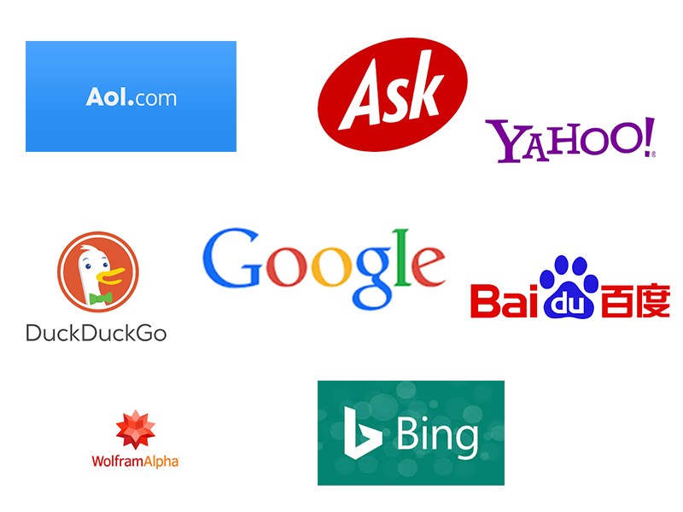
In today’s world, as we become more inclined towards the Internet, it has become easier to understand the logistics and methodology behind it. If you use computers or smartphones, you must be knowing about the search engine. It is the medium between your device/system and the Internet to provide you search results of your keywords.
Now when we use the term search engine, the first name to strike our mind is GOOGLE, but you’ll be amazed to know that apart from Google, many other search engines are offering their search engine services since the beginning of the Internet era. Sounds crazy!

Search engines like Yahoo!, Ask, AOL, Dogpile, Baidu, etc., are some of the names that have been offering search engine services along with Google. As per the statistics of the search engine market share of 2019, it is hard to believe how most of the search engines have been worn off.
Overview of Global Market Share Of Search Engines (2021 report) [show]

SEARCH ENGINE – KEY STATISTICS:
As more people consume video based content now, it has lead to generation of more video content, which results in more consumption, thereby creating a feedback loop. Currently, video content has a huge impact on all web traffic. Here is a look at what the numbers have to say:
- Around 93% of web traffics conducting through search engines.
- Google alone has processed over 2 trillion searches every year.
- Globally Google stands at 76% and 86% of search traffic via both desktop and mobile, respectively.
- Brazil has seen 96.2% of net search via Google, whereas India stays at 95.9%.
- By spending $1 on Google search and ads, it makes a profit of $8 to the company. That is 8 times the amount spent by the user.
- In 2018, Google was the most widely used search engine, and it had made a revenue of over $116 billion.
- Around 46% of Google searches are mainly for something local.
- 25% of all Google searches consist of top million keywords.
- 12.6% of Google clicks helps domains to become the top 100 domains.
- Marketers have combined the SEO and PPC ads and have seen 25% more clicks and attained 27% of higher profits.
- While Google continues to dominate and lead in the market of the search engine segment, sites like Bing, Baidu, and DuckDuckGo are still maintaining their presence and relevance.
- Having the search feature enabled on Amazon, Facebook, and Twitter, the growth of Google’s priorities has seen an increasing dominance in the market.
- Due to the programmed and widely used history of Google, Marketers are improving their CTR by using Google for business.
- Due to the usage in the global market, having a business on other sites or search engines can result in low traffic to your websites as the market rate drops every year.
- 63% of the users are most likely to click on the paid search links that are visible via search engines, thus creating the revenue for the search engines.
Let us jot down some amazing search engine sites and their reach in today’s time and understand the statistics in a better way by placing them in the order of most used to least used
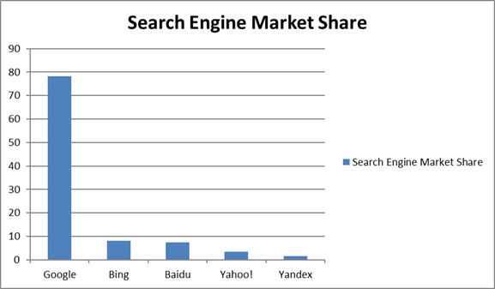
Google:
Market share of the Search engine – 78.23%
As we all know, Google to be the mostly-used search engine, one must believe that Google not only leads but dominates the market at the highest percentage of users. Introduced in 1996 with 20 years of hard work by Sergey Brin and Larry Page, the net worth of Google is about $300+ billion, and its parent company Alphabet’s net worth is about $900 billion. Google has not restricted itself as a search engine but has expanded its horizon by owning YouTube, introducing Gmail, and Google Drive. Ask, is the sixth-largest search engine, is now powered by Google.
Bing:
Market share of the Search engine – 8.04%
Presently, Bing is mostly visible when you buy a new device and don’t have any search engine installed. Internet Explorer majorly captures the market for Bing by redirecting any new user through their search results. The action of Bing is justifiable because Microsoft is the owner of Bing, and it promotes the same for Search Engine Optimisation on your device. Microsoft also brings you Windows live search and MSN search; however, they didn’t make it as wide as Bing at the market. Another interesting fact about Bing is, it powers Yahoo!, the 4th largest search engine, with 3.39% market share across all platforms as in October 2018.
Baidu:
Market share of the Search engine – 7.34%
Having a market share of 7.34% makes Baidu the third largest search engine worldwide. However, you will be surprised to know that Baidu holds a market of 74.73% in China, while Google holds a 2% market in China. Baidu is to china, what Google is to India or Brazil or any other country in the world. Found in 2000, Baidu has operations in Beijing, China’s capital, and is known to be one of the largest artificial intelligence and Internet service company regardless of its low influence outside China. Baidu is also referred to as the firewall of China because it restricts and eases the Internet for the citizens to ensure safe surfing.
Yahoo!:
Market share of the Search engine – 3.39%
If search engines were to be named down, Yahoo might be named right after Google due to its significance over the years. However, in the worldwide market search, this search engine is the fourth-largest internet engine which has been using by millions of users. Yahoo! means ‘Yet another hierarchical organized oracle,’ which also signifies the control and power of the Internet over humans. The company was established in 1994 but only propelled in 2000 at a valuation of $125 billion. Due to the downward trend and wrong strategies, Yahoo! mail is losing its ground to Gmail, Yahoo!’s Flickr almost lost to Instagram and Yahoo! Answers were taken over by Quora. Yahoo! search engine is also powered and redirected by Microsoft’s Bing.
Yandex: Market share of the Search engine – 1.53%
Yandex is one of the most successful and popularly using search engines in Russia, with a total market share of 55% of the search traffic, followed by Google. The search engine also has a significant stake and usage in Belarus, Ukraine, Uzbekistan, Turkey, and Kazakhstan. Having more than 70 services along with a cloud-based storage service, Yandex is providing similar functions as that of Google.
Following are the top 10 Search Engine and their market reach as per the statistics and reports of 2019
Who has the largest search engine market share, worldwide?
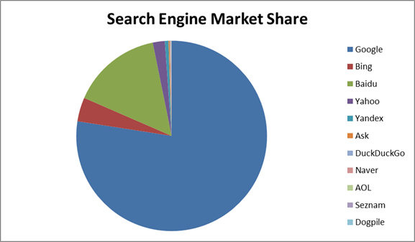
As per the Net Market Share, Google consolidates its position as the largest search engine giant in the world. Of course, Yahoo!, Bing, Baidu, and others are holding a reasonable audience rate; however, Google continues to lead and dominate the market like no other. As per the statistics of 2018 and 2019, Google has around 3.5 million users, and the numbers keep increasing each month for all services along with the search engine requirements.
Statistics of Google search Engine:
Ø 3.5 billion Google searches made every day.
Ø Every year Google sees a growth of 10% in the search medium.
Ø Almost every year, Google sees a new search of 16% – 20% that has never searched before.
Ø Almost 90% of desktop searched are via Google
Ø Along with keywords, product searches have also stood at 35% on Google
Ø Stores have located with the ‘Near me’ feature on Google for approximately 34% of that year.
Ø 60% of Google searches happen via a mobile device
What makes Google the best search engine globally?
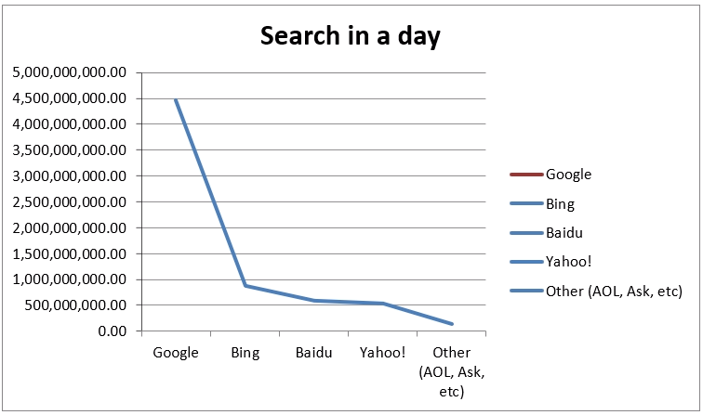
- The consolidation of search engine dominance of Google made them becoming more service-oriented, customer-friendly meeting most of the interface requirements. With all friendly features, they now handle around 3 billion pages a day.
- The primary reason for making Google as the best search engine is their aggressive approach to deliver high-quality results for each user.
- Ensuring the search results are well-curated and accurate, thus saving the time of the user.
- Another smart move by Google is the option for providing local search results within the proximity of the area, which manages to showcase new places and existing ones around, thus making Google the first point of contact for every search.
- The software team continuously works on the algorithm and AI of the search engine to change and adapt as per the latest requirement of the users.
- YouTube is another reason that has raised the chart for Google as a search engine as it provides and enables the users to have a video search option, thus making it easier to find the content by simply uploading the video.
- One can also search for content or personalities with the image as Google also offers Image Search Engine that works very much like the video search, thus saving the time of the user.
- If we can believe the forecasting, Google will take over the search engine parameter to another level by soon becoming the audio search engine, which will provide search results based on your audio identification.
- The other search engines remain active and shall use by a lesser number of people. However, if we look through the statistics of 4 years in a row, the picture is apparent where Google stands. Google has acquired more than 90% of the search engine market share as of today.
Other Search Engine Alternatives for users:
Apart from these search engines, the statistics also indicate that the users also using Amazon, Facebook, and Twitter as a search engine medium by directly using the product name or service name to find the nearest or reliable sources.
Amazon:
Though Google enjoys 90% of the search results by worldwide users, the statistics confirm that there had a flip between Amazon and Google between 2015 and 2018 wherein Google saw 54% of product-related searches and Amazon had 46% product related search. While in 2018, Amazon jumped to 54%, and Google fell to 46%. It might have happened because of the convenience of product-related checking directly on Amazon than having it checked through Google and later get routed to Amazon site anyway.
Facebook:
Despite the image of a social media platform for connectivity, Facebook has been widely using as a medium of search engine. It helped in locating products, people, companies, etc. It worked well in comparison to Google as it cuts down the search criteria by 37% since the users were more likely to search for personalities or individuals. Thus, dropping the ratio of Google by 12%, Facebook has been standing tall as one of the search engines which had not built to be one but ended up being one.
Twitter:
Having over 336 million active users monthly and 80% of active users accessing it via mobile devices, this microblog social media connection is also famous as a search engine. Be it for blogs, images, videos, or individuals, Twitter has been competing with Facebook in terms of replicating the search engine results. Business establishments show tremendous interest in these sites, since 95% of the population is available on either of the social media platforms, as the possibility of business conversions are very high.
Keynotes from the Global Market Search Engine statistics:
Ø As per the statistics, it is evident that Google is leading the search market, and other search engines like Baidu, Bing, and DuckDuckGo are yet to make their presence visible.
Ø Other platforms like Facebook, Amazon, and Twitter have also maintained its growth along with the growing dominance of Google by providing the search engine service for almost every product or individual
Ø The search section of Google has widely helped businesses and marketing companies to increase their CTRs and conversion rates.
Ø Ignoring other search engines may create a negative impact on business. It will be a reason for losing some customer base; however, they have justified sticking to top search engines by having discreet audience requirements and niche users for their selling purposes.
Conclusion:
While it is pretty evident with the statistics on how the search patterns and requirements of users are constantly changing, but the looming question is, should that have an impact on our everyday marketing activities?
It is agreed and proved as per the Net Share Market Statistics that Google enjoys the maximum number of users and the maximum number of searches every year. Though this may not hamper your marketing skills or marketing requirements, it may tie you to another element of how likely you may reach your desired audience, or justify ads per click for organic results.
Though the list of search engines and their statistics seem never-ending, there’s no denying that these search engines are the best way to grow your business.
Reference Links:
https://alphametic.com/global-search-engine-market-share
https://99firms.com/blog/search-engine-statistics/
https://gs.statcounter.com/search-engine-market-share
https://www.smartinsights.com/search-engine-marketing/search-engine-statistics/
https://www.wordstream.com/blog/ws/2019/02/07/google-search-statistics
https://www.seo.com/blog/23-search-engine-facts-and-stats-you-oughta-know/
https://www.investopedia.com/news/facebook-google-digital-ad-market-share-drops-amazon-climbs/
https://www.statista.com/topics/4213/google-apple-facebook-and-amazon-gafa/
https://www.searchenginewatch.com/2019/02/11/facebook-local-search-engine/
https://www.searchenginewatch.com/2019/08/01/amazon-google-market-share/
https://searchengineland.com/whos-really-winning-search-war-204651
https://www.webfx.com/blog/seo/2019-search-market-share/
https://medium.com/@SearchDecoder/global-search-engine-market-share-for-2018-in-the-top-15-gdp-nations-2cf65c11e5f5
https://www.oberlo.in/blog/top-search-engines-world

