Opinion
Serge Schmemann

It May Feel Like the 1960s, but It’s Worse
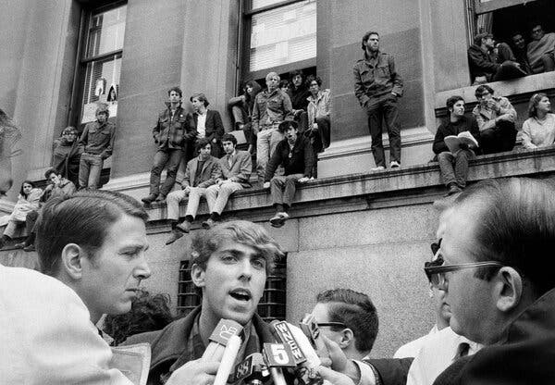
A student protest at Columbia University in New York in 1968.The Associated Press
Credit...
Listen to this article · 7:19 min Learn more
- Share full article
- 89

By Serge Schmemann
Mr. Schmemann, an Opinion writer, is a former Moscow bureau chief of The Times.
Many of us who lived through the 1960s are tempted to seek similarities between then and now. We see the acute polarization of the nation, the warring ideologies, the National Guard deployed against demonstrators, the presidents who abuse power, the sense of America losing its bearing. Whereas President Richard Nixon’s silent majority battled flower power and “commies,” President Trump’s MAGA assails wokeness and the radical left. Whereas students closed down campuses over Vietnam, students now — or at least a year ago — rose up over Gaza.
The list could go on. But it soon becomes evident that there are numerous differences. Some are obvious: the revolutionary advances over the past six decades in technology and communication, especially the prevalence of social media and smartphones, and the absence of a Cold War to clearly define global relationships and a draft to threaten young people with death in a distant jungle.
The demonstrations in Los Angeles against the federal hunt for immigrants are nowhere near the scale of the protests against the Vietnam War. The National Guard units that opened fire on students at Kent State University in May 1970 were called in by the Ohio governor after a few days of violent protest; those in Los Angeles were deployed by President Trump over the protests of the governor of California.
For me, though, the big difference is in the spirit of the times, the sense back then that change was possible and today that doors are being closed.
For all their passion and violence, the 1960s were an eruption of idealism, a youth-led rebellion against a misguided war and the racism and misogyny lurking in the placid suburbs and “Made in the U.S.A.” prosperity of the ’50s. There was a conviction in the songs, love-ins, protests and even mind-bending drugs that the world could be made better. “The Times They Are a-Changin’,” sang Bob Dylan in the hymn of that era, while John Lennon pictured its utopia: “Imagine there’s no countries / It isn’t hard to do / Nothing to kill or die for / And no religion, too.”
The student protests in the spring of 2024 against the carnage in Gaza, by contrast, never ignited a broader movement and petered out, mired in accusations of antisemitism and the humiliation of university leaders. The momentum was with Mr. Trump and his MAGA campaign, and its goal was, in effect, to reverse the gains of the ’60s — to undo civil rights, sexual tolerance, environmental protection, campus activism and all the other themes and values clustered under the banner of diversity, equity and inclusion.
Mr. Trump’s appeal to a large number of America is more complex than that, of course. D.E.I. sometimes deserved the criticism; people who voted for Mr. Trump had some valid grievances, and many of them do not necessarily support his angry, personal and often potentially illegal assaults on varying targets, including immigrants and Harvard. But the unmistakable message in “Make America Great Again” is that the forces of change unleashed in the ’60s are anti-American and needed to be expunged in order to restore the “real” America — one of Christian values, respectful students, public order and blinders on racial discrimination, inequality and other blemishes.
That rosy past may be just as illusory as “all the people livin’ life in peace,” as imagined by Mr. Lennon. But if dreams shape a generation, then those of almost half a million of my contemporaries (but not me, alas) who gathered for the legendary Woodstock rock festival in August 1969 for three days of peace and music are far more inspiring than a longing to return to Pleasantville.
Georgetown students in an on-campus protest in support of Palestinians, in Washington last year.Andrew Harnik/Getty Images
Image
Credit...
The search for parallels between then and now often includes the juxtaposition of Mr. Trump and Mr. Nixon, the president often relegated in popular memory — unfairly, I believe — to a symbol of what the ’60s rose up against. There are tempting similarities. Scandal followed Mr. Nixon throughout his career, as it has Mr. Trump. Both scrambled back to the forefront of politics — Mr. Nixon until he was felled by Watergate. (“He left. I don’t leave. A big difference,” is Mr. Trump’s take.) Both positioned themselves as victims of liberal elites and champions of a silent majority; both maintained an enemies list of people and institutions they wanted to punish.
Curiously, the two men even had more than a decade-long correspondence in the 1980s and early ’90s, when both were in New York, Mr. Nixon in retirement and Mr. Trump a real estate developer on the rise. Exhibited at Mr. Nixon’s presidential library, the letters include one in which Mr. Trump writes that he believes Mr. Nixon to be “one of this country’s great men”; in another, the older man commiserates about a “massive media attack” on the younger one’s business problems.
But the differences are far greater than the similarities. Mr. Nixon entered the fray only at the tail end of the ’60s — he was inaugurated in January 1969. His predecessors John F. Kennedy and Lyndon B. Johnson were far more responsible for the upheavals of that time. The idealism of “ask not what your country can do for you” and the Great Society was on their watch, as was the tragedy of the Vietnam War.
Mr. Trump, by contrast, defines what is happening today. The troubles of the country and world — whether the Gaza protests, the war in Ukraine or unchecked immigration — may predate his second term, but the way he has incorporated them into his broad assault on American institutions and values stamps this era with his brand.
Mr. Nixon never came close to anything of the sort. He was a lifelong politician, a skillful lawyer and a masterly player on the geopolitical chess board. I was fortunate to meet him in Moscow, when I was the Times bureau chief and he an elder statesman invited to address Russian students, and I remember how impressed I was by the depth and sophistication of his understanding of Russian history and politics. Tom Wicker, a Times columnist in the Nixon era, wrote in a study of the Nixon presidency that Watergate obscured “the achievements of a president who often responded to the pressures of his time with knowledge and skill and sometimes even with courage — qualities the American people apparently don’t find in most of their leaders today.”
The same cannot be said of Mr. Trump, a wheeler-dealer with seemingly little understanding of government and the Constitution who values instinct above expertise, doesn’t know shame or embarrassment, views foreign affairs as a zero-sum game in which America is the dunce, and values sycophancy over competence. The Trump era is still upon us, of course, so any comparison with eras past must be conditional.
Any search for lost time, whether the ’60s, ’50s or any other era, is of dubious value. Every age has its own array of peculiarities, conditions and fashions, and memory is too apt to idealize the good or expunge the bad to be a reliable judge. Maybe what I’ve written above is a good example of that. But if there is any value to identifying the disruptive actions of the Trump administration as the antithesis of the movement for change six decades ago, it is in asking which of the two really tried to make America great.
The Times is committed to publishing a diversity of letters to the editor. We’d like to hear what you think about this or any of our articles. Here are some tips. And here’s our email: letters@nytimes.com.
Follow the New York Times Opinion section on Facebook, Instagram, TikTok, Bluesky, WhatsApp and Threads.
Serge Schmemann joined The Times in 1980 and worked as the bureau chief in Moscow, Bonn and Jerusalem and at the United Nations. He was editorial page editor of The International Herald Tribune in Paris from 2003 to 2013.
A version of this article appears in print on , Section A, Page 18 of the New York edition with the headline: A Nation in Turmoil: 1968 and 2025. Order Reprints | Today’s Paper | Subscribe

