Squint

Squint is a light-weight dialect of ClojureScript with a compiler and standard library.
Squint is not intended as a full replacement for ClojureScript but as a tool to target JS when you need something more light-weight in terms of interop and bundle size. The most significant different with CLJS is that squint uses only built-in JS data structures. Squint's output is designed to work well with ES modules.
If you want to use squint, but with the normal ClojureScript standard library and data structures, check out cherry.
This project is a work in progress and may still undergo breaking changes.

Quickstart
Although it's early days, you're welcome to try out squint and submit issues.
$ mkdir squint-test && cd squint-test
$ npm init -y
$ npm install squint-cljs@latest
Create a .cljs file, e.g. example.cljs:
(ns example
(:require ["fs" :as fs]
["url" :refer [fileURLToPath]]))

(println (fs/existsSync (fileURLToPath js/import.meta.url)))

(defn foo [{:keys [a b c]}]
(+ a b c))

(println (foo {:a 1 :b 2 :c 3}))
Then compile and run (run does both):
$ npx squint run example.cljs
true
6
Run npx squint --help to see all command line options.

Why Squint
Squint lets you write CLJS syntax but emits small JS output, while still having parts of the CLJS standard library available (ported to mutable data structures, so with caveats). This may work especially well for projects e.g. that you'd like to deploy on CloudFlare workers, node scripts, Github actions, etc. that need the extra performance, startup time and/or small bundle size.

Talk

(slides)

Differences with ClojureScript
- The CLJS standard library is replaced with "squint-cljs/core.js", a smaller re-implemented subset
- Keywords are translated into strings
- Maps, sequences and vectors are represented as mutable objects and arrays
- Standard library functions never mutate arguments if the CLJS counterpart do not do so. Instead, shallow cloning is used to produce new values, a pattern that JS developers nowadays use all the time: const x = [...y];
- Most functions return arrays, objects or Symbol.iterator, not custom data structures
- Functions like map, filter, etc. produce lazy iterable values but their results are not cached. If side effects are used in combination with laziness, it's recommended to realize the lazy value using vec on function boundaries. You can detect re-usage of lazy values by calling warn-on-lazy-reusage!.
- Supports async/await:(def x (js-await y)). Async functions must be marked with ^:async: (defn ^:async foo []).
- assoc!, dissoc!, conj!, etc. perform in place mutation on objects
- assoc, dissoc, conj, etc. return a new shallow copy of objects
- println is a synonym for console.log
- pr-str and prn coerce values to a string using JSON.stringify (currently, this may change)
If you are looking for closer ClojureScript semantics, take a look at Cherry 🍒.

Articles
- Writing a Cloudflare worker with squint and bun
- Porting a CLJS project to squint

Projects using squint
- @nextjournal/clojure-mode
- static search index for Tumblr
- worlde

Advent of Code
Solve Advent of Code puzzles with squint here.

Seqs
Squint does not implement Clojure seqs. Instead it uses the JavaScript iteration protocols to work with collections. What this means in practice is the following:
- seq takes a collection and returns an Iterable of that collection, or nil if it's empty
- iterable takes a collection and returns an Iterable of that collection, even if it's empty
- seqable? can be used to check if you can call either one
Most collections are iterable already, so seq and iterable will simply return them; an exception are objects created via {:a 1}, where seq and iterable will return the result of Object.entries.
first, rest, map, reduce et al. call iterable on the collection before processing, and functions that typically return seqs instead return an array of the results.

Memory usage
With respect to memory usage:
- Lazy seqs in squint are built on generators. They do not cache their results, so every time they are consumed, they are re-calculated from scratch.
- Lazy seq function results hold on to their input, so if the input contains resources that should be garbage collected, it is recommended to limit their scope and convert their results to arrays when leaving the scope:
(js/global.gc)

(println (js/process.memoryUsage))

(defn doit []
(let [x [(-> (new Array 10000000)
(.fill 0)) :foo :bar]
;; Big array `x` is still being held on to by `y`:
y (rest x)]
(println (js/process.memoryUsage))
(vec y)))

(println (doit))

(js/global.gc)
;; Note that big array is garbage collected now:
(println (js/process.memoryUsage))
Run the above program with node --expose-gc ./node_cli mem.cljs

JSX
You can produce JSX syntax using the #jsx tag:
#jsx [:div "Hello"]
produces:
<div>Hello</div>
and outputs the .jsx extension automatically.
You can use Clojure expressions within #jsx expressions:
(let [x 1] #jsx [:div (inc x)])
Note that when using a Clojure expression, you escape the JSX context so when you need to return more JSX, use the #jsx once again:
(let [x 1]
#jsx [:div
(if (odd? x)
#jsx [:span "Odd"]
#jsx [:span "Even"])])
To pass props, you can use :&:
(let [props {:a 1}]
#jsx [App {:& props}])
See an example of an application using JSX here (source).
Play with JSX non the playground

HTML
Similar to JSX, squint allows you to produce HTML as strings using hiccup notation:
(def my-html #html [:div "Hello"])
will set the my-html variable to a string equal to <div>Hello</div>.
Using metadata you can modify the tag function, e.g. to use this together with lit-html:
(ns my-app
(:require ["lit" :as lit]))

#html ^lit/html [:div "Hello"]
This will produce:
lit/html`<div>Hello</div>`
See this playground example for a full example.

Async/await
Squint supports async/await:
(defn ^:async foo [] (js/Promise.resolve 10))

(def x (js-await (foo)))

(println x) ;;=> 10
Anonymous functions must have ^:async on the fn symbol or the function's name:
(^:async fn [] (js-await {}) 3)

Generator functions
Generator functions must be marked with ^:gen:
(defn ^:gen foo []
(js-yield 1)
(js-yield* [2 3])
(let [x (inc 3)]
(yield x)))

(vec (foo)) ;;=> [1 2 3 4]
Anonymous functions must have ^:gen on the argument vector:
(^:gen fn [] (js-yield 1) (js-yield 2))
See the playground for an example.

Arrow functions
If for some reason you need to emit arrow functions () => ... rather than function, you can use :=> metadata on the function expression, fn symbol or argument vector:
(fn ^:=> [] 1)

Defclass
See doc/defclass.md.

JS API
The JavaScript API exposes the compileString function:
import { compileString } from 'squint-cljs';

const f = eval(compileString("(fn [] 1)"
, {"context": "expr",
"elide-imports": true}
));

console.log(f()); // prints 1

REPL
Squint has a console repl which can be started with squint repl.

nREPL
A (currently immature!) nREPL implementation can be used on Node.js with:
squint nrepl-server :port 1888
Please try it out and file issues so it can be improved.

Emacs
You can use this together with inf-clojure in emacs as follows:
In a .cljs buffer, type M-x inf-clojure. Then enter the startup command npx squint repl (or bunx --bun repl) and select the clojure or babashka type REPL. REPL away!
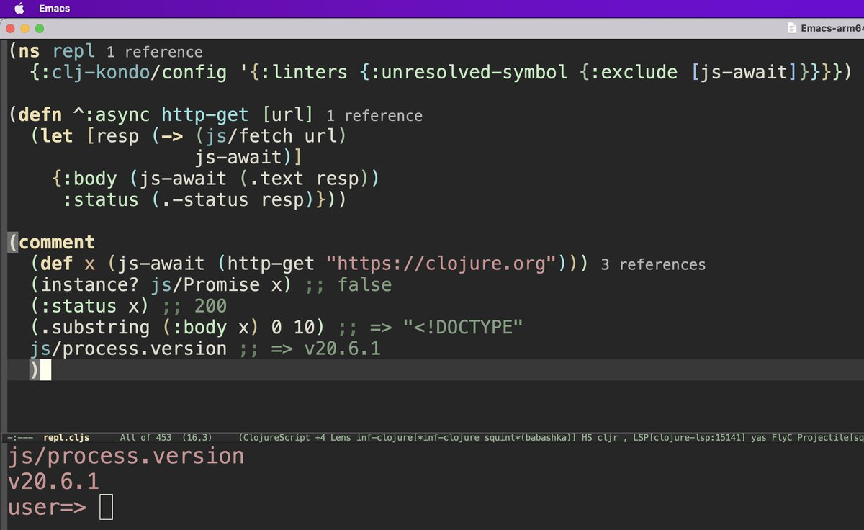

Truthiness
Squint respect CLJS truth semantics: only null, undefined and false are non-truthy, 0 and "" are truthy.

Macros
To load macros, add a squint.edn file in the root of your project with {:paths ["src-squint"]} that describes where to find your macro files. Macros are written in .cljs or .cljc files and are executed using SCI.
The following searches for a foo/macros.cljc file in the :paths described in squint.edn.
(ns foo (:require-macros [foo.macros :refer [my-macro]]))

(my-macro 1 2 3)

squint.edn
In squint.edn you can describe the following options:
- :paths: the source paths to search for files. At the moment, only .cljc and .cljs are supported.
- :extension: the preferred extension to output, which defaults to .mjs, but can be set to .jsx for React(-like) projects.
- :copy-resources: a set of keywords that represent file extensions of files that should be copied over from source paths. E.g. :css, :json. Strings may also be used which represent regexes which are processed through re-find.
See examples/vite-react for an example project which uses a squint.edn.

Watch
Run npx squint watch to watch the source directories described in squint.edn and they will be (re-)compiled whenever they change. See examples/vite-react for an example project which uses this.

Svelte
A svelte pre-processor for squint can be found here.

Vite
See examples/vite-react.

React Native (Expo)
See examples/expo-react-native.

Compile on a server, use in a browser
See examples/babashka/index.clj.

Playground
- Pinball
- Wordle
- React, preact
- TC39 Records and Tuples
- edn-data
- Immutable-js
- Loading a UMD module
- Vega-lite
- Vue.js
- Tic-tac-toe
- Date-fns
- VanJS
- Mithril
- Rough
- Immer, mutative
- MobX - another example using atoms
- SolidJS
- Web components
- Quill
- defmulti: multimethods in squint as a library

License
Squint is licensed under the EPL. See epl-v10.html in the root directory for more informati

