A New Hiroshi Sugimoto Sculpture in San Francisco Reaches for Infinity
His sliver of an artwork, “Point of Infinity,” marks the start of the city’s Treasure Island Art Program.
Hiroshi Sugimoto’s sculpture is meant to serve as an anchor — or beacon, given its height — for the area’s new public art program.Jessica Chou for The New York Times
Credit...
- Share full article
- 77
By Jori Finkel
Reporting from San Francisco

The San Francisco skyline has radically changed over the past two decades because of all the real estate development. It’s changing again now, but subtly, because of an artwork. The Japanese artist Hiroshi Sugimoto, famous for his slyly deceptive photography, has just planted a slender, 69-foot-tall stainless steel sculpture on a hilltop in Yerba Buena Island, meant to serve as an anchor — or beacon, given its height — for the area’s new public art program.
From some viewpoints it looks like the tip of a sewing needle poking out above the trees and cellular towers of this island in the San Francisco Bay. From others it seems an elegant high-tech cousin of the Transamerica Pyramid, the chunkier building across the bay. Because of its particular curved geometry, which tapers from a concrete base of 23 feet to a top that is less than one inch in diameter, the sculpture looks as if it’s growing infinitely smaller and taller as it reaches for Earth’s outer atmosphere.
The artist paradoxically calls his skyscraper “Point of Infinity,” and, even more than the beautiful sliver of mirror-finished stainless steel itself, he hopes to showcase that Zen koan-like notion. “The infinity point, where two curved lines are supposed to meet, only exists in the human mind; it’s a creation of human consciousness,” said Sugimoto, 75, who called the sculpture “beyond expectation” on Monday during his first visit to it on site. “I wished to make it reach all the way to infinity, but that’s technically impossible,” he added, laughing at himself, his habit even or especially when making gnomic pronouncements.
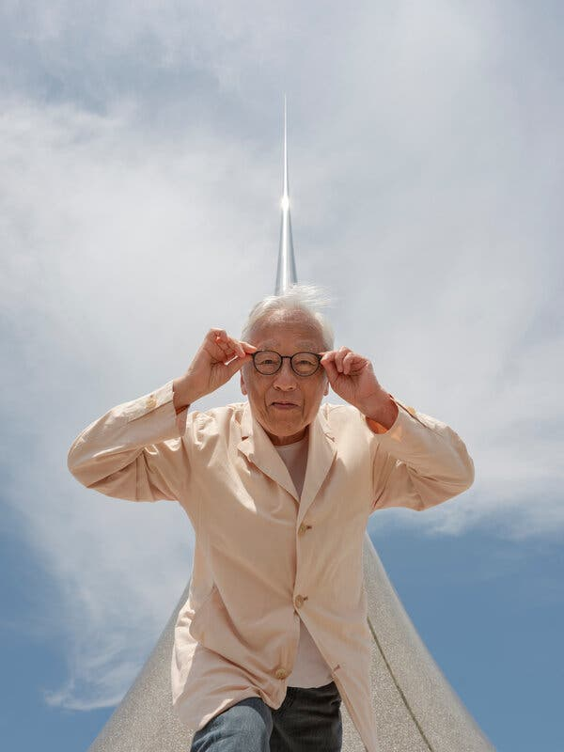
Image
“I wished to make it reach all the way to infinity, but that’s technically impossible,” said Sugimoto of his sculpture, laughing at himself.Jessica Chou for The New York Times
Credit...
The sculpture also serves a more practical or political purpose, marking Yerba Buena Island and the adjoining Treasure Island, a naval base from 1942 to 1997, as a new cultural destination. With a budget of $2 million, “Point of Infinity” is the first major artwork developed under the Treasure Island Art Program, run by the San Francisco Arts Commission and funded by a “one percent” program, which takes a cut of construction costs from new development on the islands.
The Treasure Island Development Authority plans to create 8,000 housing units, with 27 percent of them to be deemed affordable. Roughly 75 percent of the 400-acre site is designated as public space, making it “the city’s biggest allotment of public, open space since the creation of Golden Gate Park,” said Jill Manton, who directs the Treasure Island Art Program, describing parks, walkways and plazas where they can site public art.
She said the program’s overall budget for art could exceed $50 million “if everything progresses as planned” but acknowledged volatility in the real estate market. The three developers involved in the project also recently sued each other.
The art planning process has not been smooth either. Sugimoto’s work on the project began in 2017 after the city issued an open call for artists. By the end of that year, he was selected by a committee as one of seven finalists (out of a pool of 495 applicants) to develop proposals for three sites. Two finalists, Pae White and Antony Gormley, also made it to the next stage and revamped their plans, only to have them nixed in the end, Manton said, “over aesthetic concerns.” She recently enlisted Kehinde Wiley instead to submit a proposal for one of those sites, a major waterfront plaza.
From some vantage points the sculpture looks like an elegant, high-tech cousin to the chunkier Transamerica Pyramid across the bay.Jessica Chou for The New York Times
Image
Credit...
“With Antony and Pae, they were selected and asked to redesign. With Sugimoto, we wanted the sculpture exactly as proposed,” she said. “It’s so simple and elegant. It’s a very conceptual work but I think will appeal on many different levels, whether you know anything about art or not.”
As a photographer, Sugimoto came to prominence by making images that are both highly persuasive and strangely self-effacing. His rugged wildlife scenes capturing close-ups of polar bears or African antelope turn out to be dioramas he shot at the American Museum of Natural History. His pictures of brilliant white screens in ornate movie palaces actually come from photographing with one long exposure the entirety of a film as it plays. His photograph of Queen Elizabeth I, pure historical fiction, is really a portrait of her wax sculpture at Madame Tussauds.
With “Point of Infinity,” too, he says he’s interested in the play of presence and absence, or “the presence of immateriality” suggested by its hyperbolic geometry. He was immediately drawn to this geometry in 2003 when he saw a small, 19th-century mathematical model in a classroom at Tokyo University, designed to illustrate “a surface of revolution with a constant negative curvature,” also known as a pseudosphere.
He soon photographed that plaster model. But the surface was rough, its tip was broken, and he thought he could do better “using the very highest Japanese accuracy.” He has since made a handful of high-precision sculptures in different sizes, with the same formula, branching into sculpture around the same time he started an architectural practice. One recent hyperbolic form, “Sundial” in Tokyo, reaches nearly 40 feet.
“It’s so simple and elegant,” said the director of the Treasure Island Art Program. “It’s a very conceptual work but I think will appeal on many different levels, whether you know anything about art or not.”Jessica Chou for The New York Times
Image
Credit...
The largest of the group by far, “Point of Infinity,” is also a sundial in a sense, though without hour markings. Instead, Sugimoto will place a granite marker on the ground to align with the shadow cast by the artwork at solar noon on days of the spring and fall equinox. A ring of white gravel surrounds the sculpture to prevent it from becoming a skateboarding ramp.
For his part, Sugimoto sees “Point of Infinity” not as a sculpture but, nodding to Marcel Duchamp, as a readymade, because it’s based on a mathematical model. “It’s a found object, but price-wise it’s the same as a sculpture,” he said, laughing again.
He referred to the project’s costs frequently, describing spikes in fabrication and global shipping over the past four years. Built in 29 sections, “Point of Infinity” was fabricated by Sanwa Tajima in Japan and shipped in eight containers to Oakland. The San Francisco Arts Commission contributed an extra $350,000 in response to inflation, and the artist is absorbing other cost overruns himself.
There could be one other major expense left: altering the cement walls lining the small hilltop park, remnants from a water tank on site. Noticing how they cut into city views, Sugimoto this week requested that the Arts Commission shave the walls down by about a foot to 42 inches. Manton says they are looking into it but “there are code and safety concerns.”
Assuming that doesn’t cause delays, the park, currently considered a construction site, should officially open to the public sometime this fall. Variously called Tower Park and Yerba Buena Island Hilltop Park, it will be renamed Infinity Point Park.
Sugimoto said he’d like to return around then to photograph the sculpture. “I will come back with this huge 8 x 10 camera. It’s cheaper to do it by myself,” he said, flashing another smile, “rather than asking for a professional photographer.”
Hiroshi SugimotoJessica Chou for The New York Times
Image
Credit...
Jori Finkel is a reporter who covers art from Los Angeles. She is also the West Coast contributing editor for The Art Newspaper and author of “It Speaks to Me: Art that Inspires Artists.” More about Jori Finkel

