Asia

The Ultimate Visual Guide to Real Estate Portals in Thailand


by Edmund Keith

November 30, 2022

Share this Post:
LinkedIn
Share

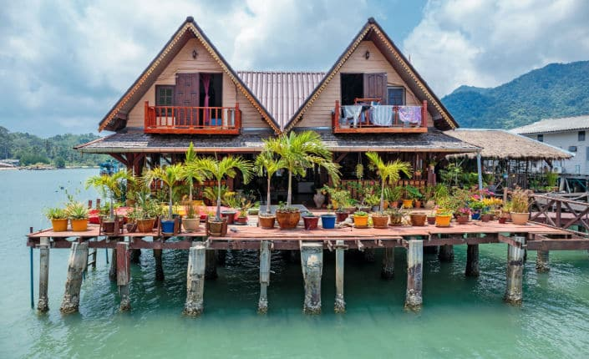
The real estate market in Thailand sees a lot of interest from foreign buyers. It is still a confusing and opaque market with legal and bureaucratic issues as well as issues around fake listings and trust.
Online Marketplaces collects data on real estate portals around the world and regularly speaks to the people that run them via interviews and at our industry conferences. We've put everything we know about real estate portals in Thailand together here for anyone trying to make sense of the landscape...

How many real estate portals are there in Thailand and who owns them?
Thailand's real estate market is unusual as it has a mixture of locally owned portal players, marketplaces run by ex-pats and a big foreign corporate at the top of the tree.
Agents typically earn 3-5% commission on sales and only transact a handful of properties per year, so there is huge value in being at the top of the lead funnel for portal websites.
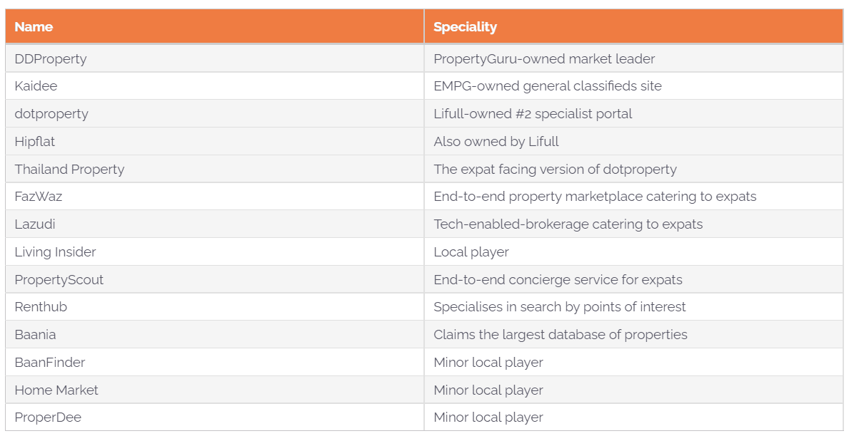

Which real estate portal in Thailand has the most traffic?
In terms of traffic, DDproperty is the clear leader. The portal is owned by Singapore-based regional powerhouse PropertyGuru which acquired DDproperty in 2011.
PropertyGuru added two smaller portals (Prakard.com and Thinkofliving.com) when it cut a deal to acquire regional assets from Australian portal market leader REA Group in May 2021. Prakard.com has since been redirected to DDproperty, boosting its traffic on the chart below.
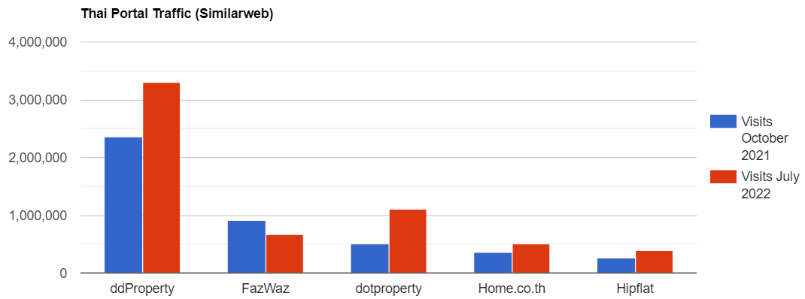

Which real estate portal in Thailand has the most listings and are fake listings a big problem?
In Thailand, property sales are not exclusive which means that the same house might get listed several times on portal sites through different agents. There is also the problem of agents looking to bait and switch unsuspecting home hunters by copying a listing which they don't actually have a mandate for to then drum up interest in their own listing.
Real estate portals in Thailand have been combatting the listing duplication issue in recent years though.
DDproperty had over 500k listings back in 2019 according to PropertyGuru's prospectus. The fact that the site had only around 54k sale listings and 87k rental listings when we looked in November 2022 probably says more about the work that the portal has done to cut down on fake listings than it does about the pandemic-affected market conditions.
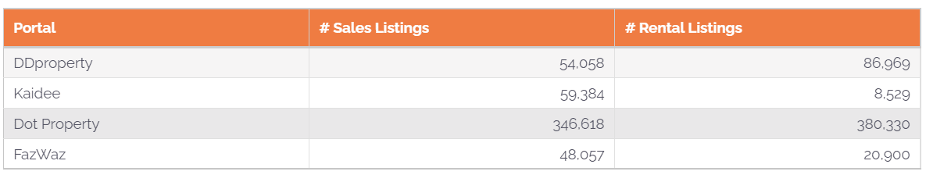

How do real estate portals in Thailand make money?
DDproperty makes its money mainly by charging Thai agents a subscription package to list on its website and app. It also makes money from developers by selling content marketing and banner advertising services as well as through the events and awards ceremonies it hosts in the country.
As a horizontal marketplace, Kaidee operates on a per-listing basis where both private users and professional agents are charged based on the number of listings they have on the platform.
Dot Property operates on a freemium / subscription basis. Users can list for free across all of the parent company, Lifull's network (Dot Property, Thailand Property and Hipflat) but then pay for premium exposure and extras.
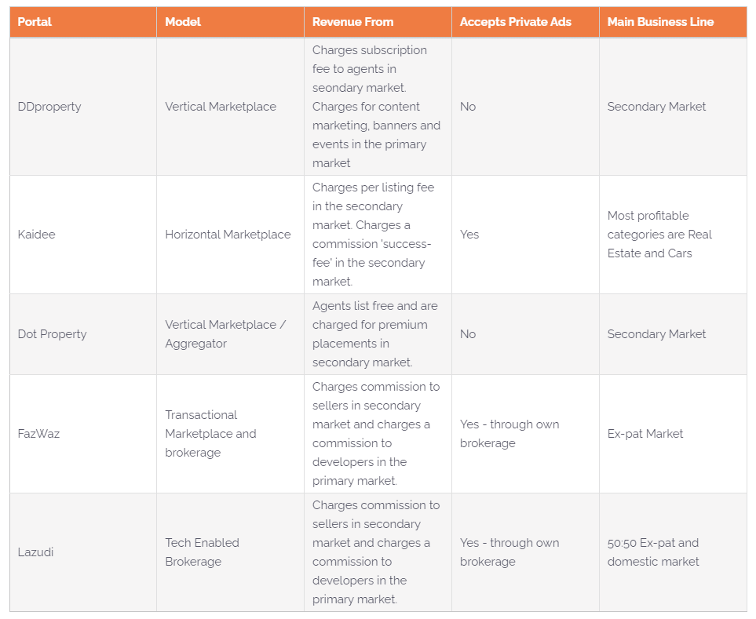
The lines between concierge service, brokerage and portal are a lot more blurred in Southeast Asia. With traditional pay-per-listing and subscription-based portal models persistently unprofitable in many markets in the region, many marketplaces have instead tried to earn a percentage of the sales commission.
The likes of FazWaz, PropertyScout and Lazudi have gone down this path. All three companies generate revenue through commission in one way or another with PropertyScout describing itself as a 'concierge service', Lazudi as a 'tech-enabled brokerage' and FazWaz as an 'end-to-end marketplace'.
Below, Lazudi co-founder Costa Savva tells us why his company monetises closer to the transaction than traditional portals.

What user-friendly features do real estate portals in Thailand have?
If we advocate for anything here at Online Marketplaces it's more user-friendly filters and features on real estate portals!
Back in 2021 we put out the first report of its kind that looked at some of these features on 650 real estate portal sites around the world. We found that portals in Thailand were a bit of a mixed bag. While market leader DDproperty scored pretty highly and FazWaz made it into our list of favourite portals, some of the others in the market have plenty of things to improve for their users.
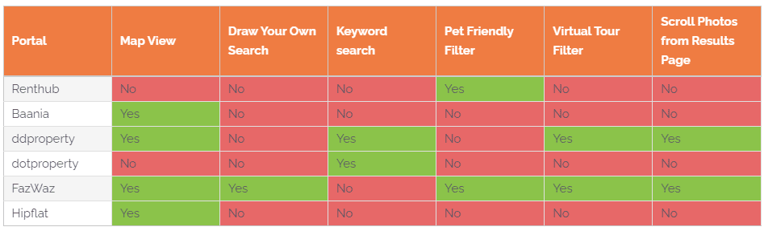
Thanks to our friends at virtual tour provider EyeSpy360 who we co-authored a report with earlier this year, we also know what percentage of listings on DDproperty have virtual tours.
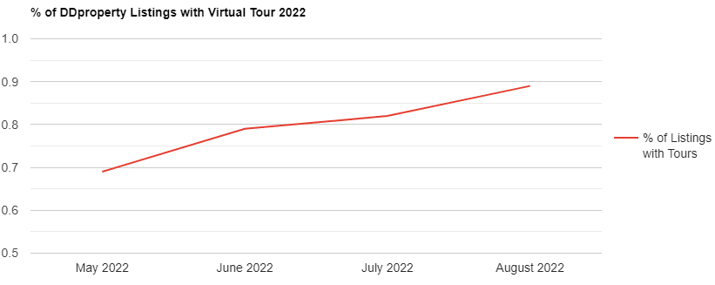
The percentage of listings with virtual tours on FazWaz when we checked in November 2022 was much higher at around 15% for sale listings.

What have real estate portals in Thailand been in the news for recently?
Our job at OnlineMarketplaces.com is to bring you all the news and views around the real estate portal industry. Here's what's real estate portal companies in Thailand have been hitting the headlines for recently...
DDproperty's owner PropertyGuru is a publicly traded entity with lofty ambitions. The company's operations in Thailand and Indonesia (which together constitute its 'Other Asia' segment) brought in a combined S$2.5 million in revenue in Q3 2022.
Despite its market leadership position in Thailand and #2 position in Indonesia however, PropertyGuru is still making a loss in the combined markets as it continues to invest in its products and wait for the developing markets to mature.
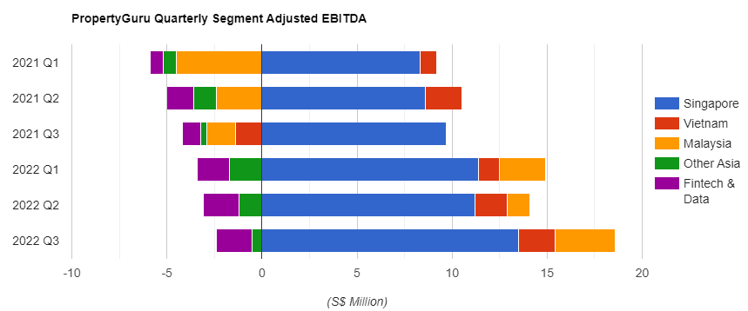
Kaidee recently announced that it would be ditching the transactional capabilities of its real estate segment to focus on turning a profit.
“Kaidee has been a beloved brand for Thais for over two decades, eventually becoming a modern-day technological representation of the bustling marketplace that is so central to Thai culture. We are now dedicating our complete focus to this central ethos, investing Kaidee’s considerable expertise and technical acumen to growing this tremendous platform further,” said CEO Mark Nosworthy.
Kaidee's parent company, Dubai-based EMPG recently raised $200 million in funding and announced its intention to eventually list on the stock market.
FazWaz has recently finished changing the news and content site Samui Times into a property marketplace with some 6,000 listings centred around the popular tourist destination of Koh Samui. In the summer of 2022, the company also launched its 'PopDeal' technology which generates and pre-screens leads for agents.
Lazudi meanwhile, has been working on expanding its business model to Dubai.

Read everything you need to know about the world of real estate portals, for free on Online Marketplaces.

by Edmund Keith

November 30, 2022
Since March 2020 Edmund's job has been to read about, write about, collect data on, analyse and generally know about real estate marketplaces and the companies that run them. Before that he worked at the aggregator Mitula Group (which became Lifull Connect) for five years.

