Upcycling Wood: Disused Materials Transformed Into Valuable And Useful Objects

Save this article

Save
Upcycling Wood: Disused Materials Transformed Into Valuable And Useful Objects
Save this picture!
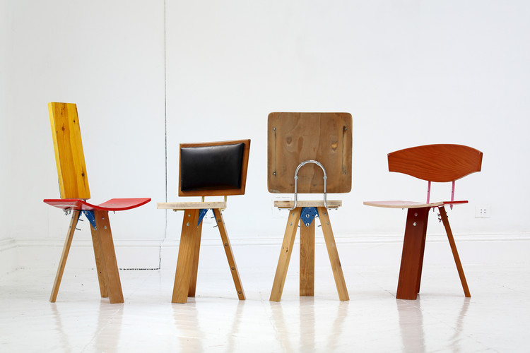
- Written by AD Editorial Team

The need to substantially reduce our impact on the planet must be translated into a significant change to our lifestyle and habits. One of these is to consume responsibly and consider that waste does not exist, but that all material can be transformed into something useful again following a circular ecological system.
In his book Upcycling Wood, Reutilización creativa de la madera, the architect and artist Bruno Sève writes and edits a non-exhaustive guide of the uses and possibilities of recovered wood, as a framework for responsible reuse; from small scale, such as furniture or artists' canvases, to medium scale, with its use in interiors and facades. This book seeks to raise awareness among professionals and citizens in general through analysis of the life cycle, examples of uses and finishing processes, leading to an ecological and responsible framework. The book is illustrated by numerous design and architecture teams who follow the guidelines of ecological design with reclaimed wood.
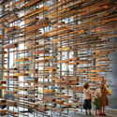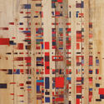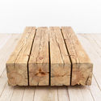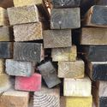+ 20
Save this picture!
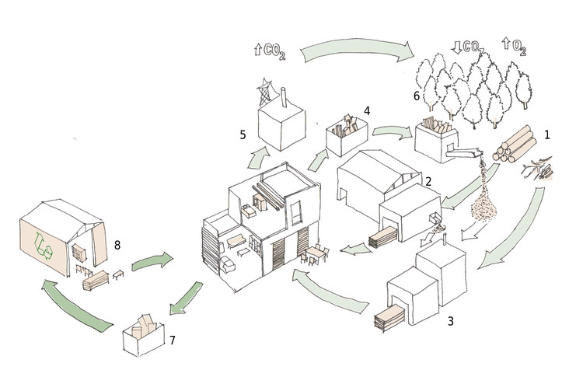
The book is structured in three parts: (1) A new life, (2) Upcycling, (3) Designers.

A new life: The present state of our natural wood resources
A critical diagnosis of our way of living, alternatives and possible solutions in design and production and analysis of the life cycle.
The twentieth century brought growth in technological advances unseen before, but that has left a questionable legacy to the incoming new generation. However, responsible consumption for sustainable purposes can change society little by little.
The word upcycling, or 'creative reuse', refers to the use of recyclable materials to create products that have a greater value than the original material had. The reuse of materials is a millenary practice and can be distinguished from modern recycling which requires some critical improvements. The logic of the reuse of objects, materials or spaces came above all from an economy of means, taking advantage of what already existed, such as ruins or directly available materials.
Save this picture!
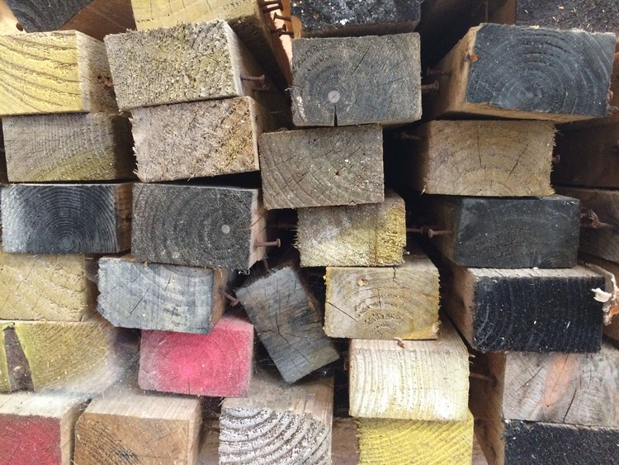
On the other hand, recycling is a much more modern technique that often needs a significant energy contribution to transform the waste. It is worth mentioning the multitude of problems generated by this process, especially when we talk about synthetic materials such as plastics.
Without denigrating the contribution of the twentieth century in terms of materials and modern recycling techniques, it is important to distinguish, first, between synthetic materials, with their disadvantages (BPA, toxicity to the human body, impact on the environment, pollution, etc), and natural materials such as wood, which are totally harmless to our health and the environment (if their felling process is properly managed). Secondly, we must differentiate between modern recycling on the one hand, and reuse on the other, whose process requires much lower energy expenditure.
Upcycling is a process that proposes creative reuse with an added value of waste to a higher quality product, such as, for example, the transformation of used wood into furniture, art pieces or architectural elements. The only way to achieve sustainable and responsible development is to closely examine our lifestyle. Luckily, the future in this sense is promising since many people, entities, associations, and practices already propose answers to these questions, which are mentioned in this book.
Save this picture!
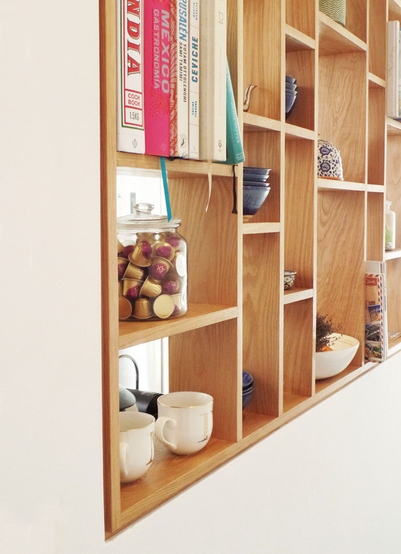

Upcycling: From material to biocompatible products
A guide for anyone wishing to undertake the process of a creative reuse project: from waste wood to ecological finishes, with case studies in Barcelona, the UK, and Mexico.
The author describes first what he calls ​'the creative reuse project​'. Because of the increase in industrialized products at a massive level, a new concept emerges in the design of products called post-industrial design, ecological design, cradle to cradle design (from cradle to cradle) or even postmodern design.
Ecological design is a logical reaction to mass consumption and brings several factors to the scene to make products biocompatible and durable, while recovering noble woods, durable assemblies and natural beautification techniques (paints).
Save this picture!
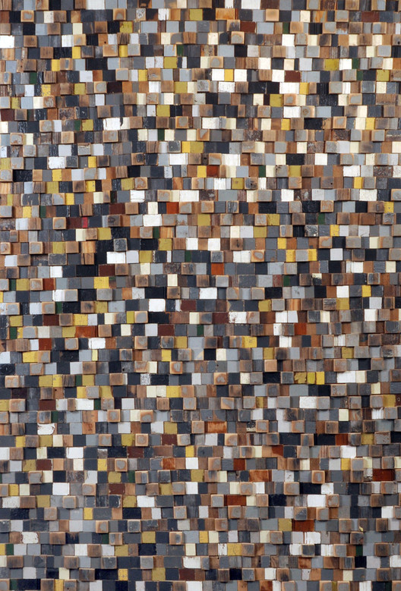
The upcycling project begins with recovered objects and materials, therefore, it is convenient to know the types of wood waste that we will find, mainly, the wood species and the pre-existing finishes. Then we have to know the processes of inspection or diagnosis, disassembly, preparation (pickling, brushing), specific treatments, and finishes according to ecological guidelines, that is, avoiding toxic products as much as possible, etc. These descriptions and tests are not intended to be an exhaustive guide, but to encourage interest in a holistic ecological process.
The product created for creative reuse must follow process guidelines to ensure a biocompatible cycle. Equally important as the material is the treatment it has received and the process that we are going to follow ourselves. The book explains aspects prior to the upcycling process such as the workshop the tools and products needed, valorization and recovery, ocular inspection and pathologies, and surface preparation and carpentry.
Save this picture!
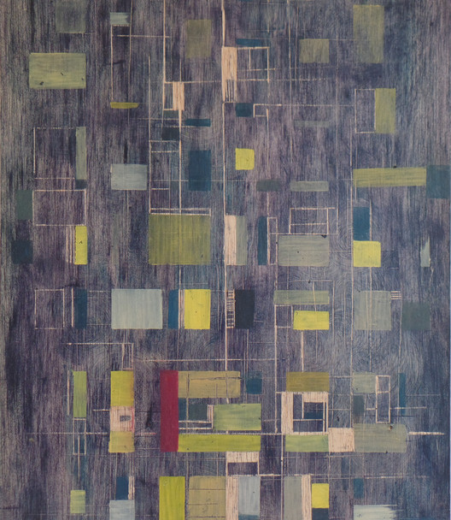
An interesting part is how the author and artists connect the natural paints and ecological finishes with artisanal methods that are still used in some regions of the world. The observation of artisanal methods is a source of possible colors, bio natural dyes, and represents a cultural heritage that should be rescued.
In Oaxaca, Mexico, paints from natural pigments such as cochineal and bicarbonate are used for red, lemon juice for yellow, lime for black or honey to shine, as they do in the Workshop of ​Jacobo and María Ángeles​. The results show that there is a real alternative to the use of industrial paints, and often more esthetic and beneficial for us. The diversity of the finishes (opaque, transparent, dyes, matt, glossy), as well as the varied possibilities of colors and the simplicity of the process, prove this. A look at ancestral processes, what was done yesterday, before industrialized processes, and what is still done in an artisanal way in the world, is still a source of inspiration for the finishes of tomorrow.
Save this picture!
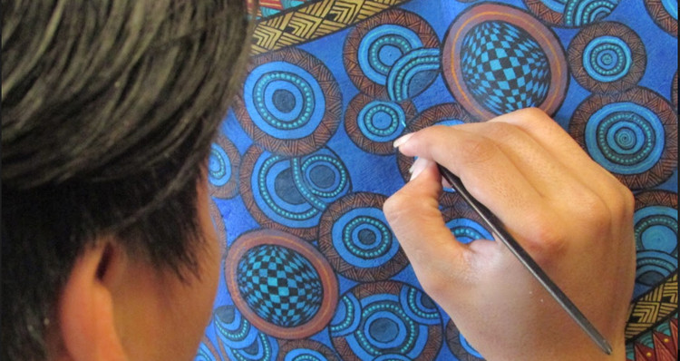

Designers
A compilation of products from designers and architects from various parts of the world who are basing their work on the upcycling process of wood. These projects have been selected for their compromise with the environment.
+ The Community Wood Recycling Project (Brighton, UK)
+ Esther Loag (Barcelona, Spain)
Save this picture!
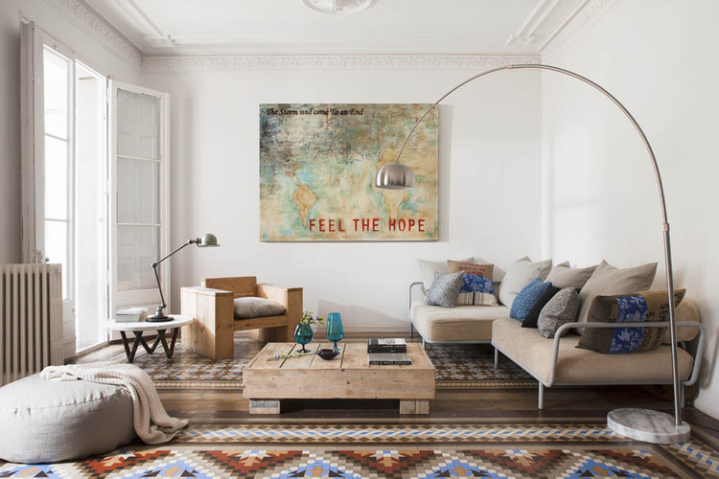
+ Jon Christie (Wormit, UK)
+ Curro Claret (Barcelona, Spain)
+ Uhuru (New York, US)
Save this picture!
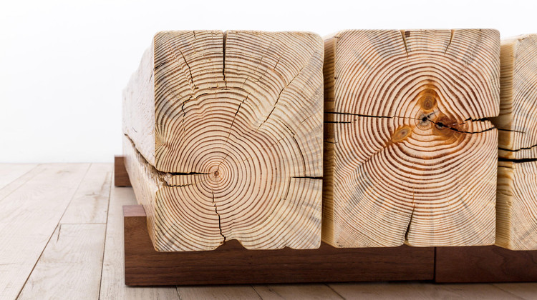
+ Gürilibis (Barcelona, Spain)
+ EleventyOneStudio
+ Michelle Peterson Albandoz (Chicago, US)
Save this picture!
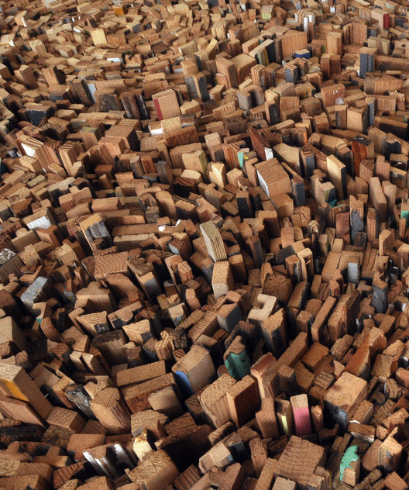
+ Serra Victoria Bothwells Fels (New York, US)
+ Bruno Sève (Barcelona, Spain)
Save this picture!
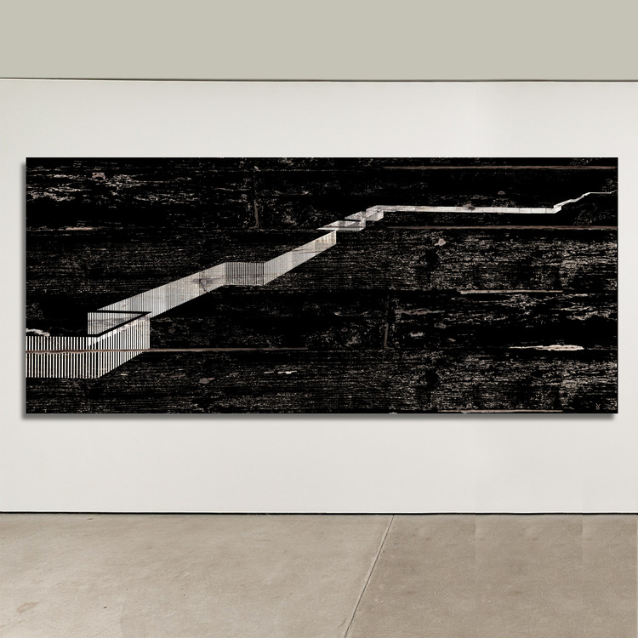
+ Most Architecture, (Rotterdam, NL)
+ March Studio (Melbourne, Australia)
Save this picture!
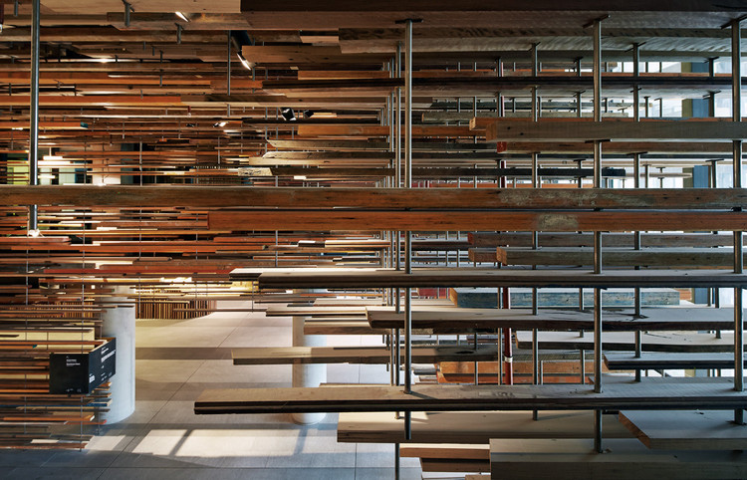
+ Buho Arquitectos (Madrid, Spain)
+ Pui Ngowsiri (Thailand) and James & Mau (Madrid, Spain)
This book started as a research project at the University of Girona in Spain and has involved designers, serious studies and data from all around the world and has now been published for the moment in Spanish by Icaria Editorial in Barcelona. The book provides notes and a significant bibliography.

