WIRECARD – THE “GERMAN ENRON” & A VERY PERSONAL HISTORY 2008-2020
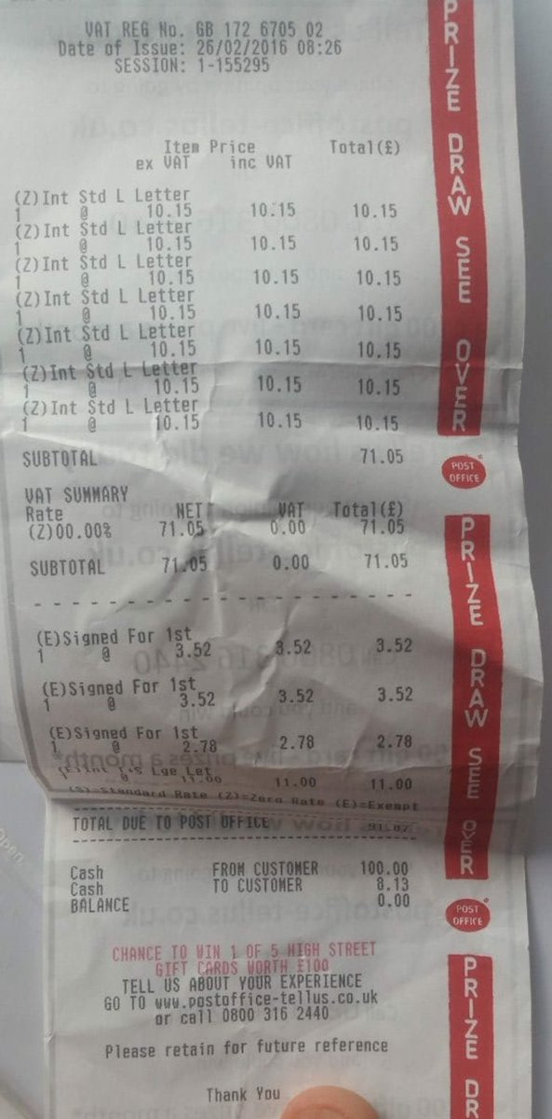

Posted on by memyselfandi007 36 comments
For those who just came back from a 15 year space mission: Wirecard is a German company that according to its website is ” one of the world’s fastest-growing digital platforms for financial commerce”. It managed (briefly) to achieve a market cap of close to 25 bn EUR and is part of the German Blue Chip index DAX 30. The stock lost -62,71% today which is most likely a record for a DAX company for a single day.
Backstory / Personal history 2008
This is an article I wanted to write for a long time but I was actually afraid to do so for several reasons.
Wirecard is a company/stock that I have been following for a very long time. My first “encounter” with the company ended in a kind of “5 minutes of fame” situation with some very unpleasant side effects.
The story starts in May 2008 when a post appeared under the pseudonym memyselfandi007 on Wallstreet Online, the largest German stock community/forum. (fun fact: This Thread seems to have been read 17,8 million times, so a lot more than all my blog posts on V&O combined….).
The post has been redacted/censored substantially but in essence the issues back then were the following:
- intransparent reporting (back then no payment volumes were reported, the structure of the report did not reflect the business, some cash flow items were reported in the wrong category etc., it was never clear what cash actually belonged to Wirecard and what was customer’s money)
- strange M&A activities toward year ends
- aggressive profit accounting (“too good to be true”)
- continuous capital raising despite reported profitability and “available cash”
- involvement of the CEO and the former head of the supervisory board in a dubious company/bankruptcy (a bankrupt company called 10tacle)
- rumors that the company was “money laundering” Online gambling profits for US citizens
- in summary, the company looked like a very dubious, low quality organization. The original post contained the German expression “Bumsbude”….
Wirecard directly tried to block anything negative and if one reviews the threat, some of memyselfandi007’s subsequent postings have been deleted despite only stating facts. Memyselfandi007 finally got kicked out of the forum.
What happened next was even more interesting: A guy called Markus Straub copied this post and published it in a financial newsletter as a short recommendation under his name. This financial publication was/is (?) part of a shareholder organisation (SDK) that claims to protect share holders. It seems that he and a hedge fund friend of him shorted stocks before publishing the short reports and he seems to have done this with others stocks as well. For this he had finally go to jail for market manipulation. But even still in 2008, Wirecard tried to aggressively sue everyone even only remotely connected, even the poor memyselfandi007, who only had written this fact backed post in this stock forum and had nothing to do with the subsequent publication and market manipulation.
The scandal back then hit even the front page of the major German financial magazine Handelsblatt and the anonymous blogger memyselfandi007 was mentioned as the starting point of the whole scandal (and got his five minutes of anonymous fame).
In between however, memyselfandi007 had the quite unpleasant surprise to be called directly at his work place by the German Criminal Police (similar to the FBI) and asked to show up in the Criminal Police HQ the very next day. Luckily, the police officers were quite friendly and at the end concluded that memyselfandi007 was just a witness with no relationship to anyone else although they didn’t mention this when they called him. They also mentioned that Wirecard desperately wanted to know who this memyselfandi007 was to sue the shxx out of him, but the police didn’t pass on the real identity.
Interestingly no one cared back then if the clearly observable issues at Wirecard were valid or not, both the police and the press only concentrated on the market manipulation of the evil short sellers
One little success back then was that Wirecard actually republished their annual report, correcting some of the more obvious mistakes that memyselfandi007 mentioned. However as a result, the report became even more intransparent.
Wirecard also tried to sue any other forum where memyselfandi007 was active and potentially negative things were written about the company.
The result of that episode was that poor memyselfandi007 was pretty scared to publish anything against the company but was convinced that the company was a fraud.
2008-2018
During the following 11 years, every other year, some reports from short sellers surfaced that shed light into some of the issues Wirecard had. Interestingly this only lasted for days and weeks and the share price always recovered.
Wirecard then smartly rode the fintech/payment wave and actually managed to build some real businesses on top the rotten core. memyselfandi007 followed the company but the reporting remained opaque and they never really explained how they make their money.
Based on their transaction volume, Wirecard was multiple times more profitable (on paper) than direct competitors. No one knew how they did it. One theory was that they were active in more “risky” areas such as online gambling and porn sites but no one cared as long as reported profits and the stock price went up.
2018 – DAX
The peak of this whole story in my opinion is that Wirecard made it into the Germany DAX 30 in September 2018. The stock syk-rocketed as we can see in the chart:
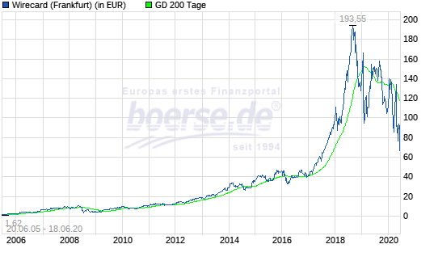
At its peak, this piece of shit company was “worth” close to 25 bn EUR.
2019 – FT – Dan McCrum / BAFIN
One of the very few persons who had the guts to openly criticize Wirecard was Dan McCrumm, who via FTAlphaville published some critical articles who were very well researched. If I am not mistaken, the earliest articles were published in 2015 before more substantial coverage came in in 2018 and 2019.
In typical fashion, Wirecard reacted in suing McCrumm and managed taht even the German regulator BAFIN to go after McCrumm as a market “manipulator”.
Nothing came out of this other that an official short selling ban for a period of time. Interestingly again, no one from BAFIn or the Police actually bothered to look at Wirecard itself. Personally, the FT for me gained “hero status” to not back down despite the massive effort to discredit them.
April 2020 – The KPMG report
In 2019, the boss of the supervisory board hired KPMG mainly to independently confirm that everything is splendid at Wirecard (E&Y is the auditor of Wirecard). This is the summary from Wikipedia:
In 2019, KPMG was hired by the German payments company for an independent audit to address the mentioned allegations. Wirecard claimed that KPMG concluded that no discrepancy was determined during the audit.[61] However, on April 28, 2020, Wirecard shares tumbled 26% when its auditor announced that it did not receive sufficient documentation to address all allegations of accounting irregularities.[62] Then on June 5th Wirecard’s headquarters was searched by police as part of a criminal investigation into potentially misleading statements to investors by CEO Markus Braun and three other board members regarding the audit.
I actually read the report in full and it was unbelievable. KPMG were denied access to most information and what they saw raised all alarm bells available. Any person familiar with the big 4 would understand that the language that KPMG used was so strong that there is now doubt that something was VERY wrong at Wirecard. The Wirecard statement just shortly before the release in my opinion was clearly a criminal act. My personal highlight of the report was an M&A transaction where Wirecard bought a company in India from an SPV for 300 mn USD that was acquired just one month before for 30 mn USD. Wirecard claimed that they didn’t know who the ultimate beneficiary of the sales price was. If I ever have seen something looking like explicit money laundering at a DAX company then it was this transaction.
Why I never shorted again
I have to confess that I was short the stock in 2008 but then never shorted again, even not after the KPMG report. The issue was that although I knew it was a fraud, the company got away with everything. There were enough stupid analysts/investors who didn’t care at all if the company was a fraud or not, as long as the share price kept rising. It was just impossible to tell when the company would go bust, especially as the management seemed to have an endless criminal capability. Combined with my obvious inability to time investments I decided not to short again since 2008.
Lessons to be learned
- even a pretty obvious fraud can go on much longer than one would think if the organizers are ruthless enough. My original short position would have gone against me 25x over 12 years and the share price even after today’s disaster would be higher than back in 2008 (just to be clear: the company is worth ZERO in my opinion)
- a company that goes against people who write negative articles as aggressively as Wirecard has something to hide
- if the profitability of a business can not be explained by its business model, then most likely something is very wrong (greetings Bernie Madoff)
- 99% of professional investors and analysts don’t care about these things even if you tell them. A lot of people knew that the company was fishy but hey thought they can make many anyway and a lot of people made a lot of money over the years
- Small companies with far flung operations in difficult geographies should be avoided (see Globo Plc) as this makes fraud difficult to detect for auditors
- A big 4 Audit firm is no proof of quality.
- The German BAFIN is not very smart and German financial regulation is substandard
- Short sellers are smart but are easy targets for fraudulent companies as the public doesn’t understand their function
Summary:
Overall I do think that it is very positive that this epic fraud has come to an end. It will be interesting to see if and who gets convicted. Personally I also find it interesting how some professional analysts and investors (hello DWS and Mr. Tim Albrecht…) will justify their part in this.
I guess the regulated part (i.e. the bank) will be rescued but the stock is fundamentally a clear zero. Although these days stocks who file for bankruptcy seem to be hot investments.
As a very funny side story, Wirecard now claims that they themselves have been defrauded but I guess that is a pretty weak defense.
I deeply hope that a good journalist will write a book about this and that they will make a movie about this “German Enron”.

Share this:
- Twitter
- Facebook

Related
Performance review 6M 2018 - Comment: "Skate to where the puck is going"In "Performance Review"
The German Dax at 10.000 - looking backIn "Anlage Philosophie"
All German Shares Part 18 (Nr. 351-375)In "Anlage Philosophie"
- Anlage Philosophie
- Short
- Uncategorized

36 COMMENTS
- ArtVestor
19. June 2020 14:09
Hi memyselfandi007, congrats to all the work – I have one question: you mention that the profitability here could not be explained by its business model. Would that imply that a company with the same business model, which is e.g. the Dutch company “Adyen” from what I understand, is potentially fraud as well? Many thanks!
Reply
  - memyselfandi007
19. June 2020 14:10
No, actually Adyen’s margins looked “Normal” the last time I looked at them.
Reply

- Wertanalyst
19. June 2020 13:43
Exzellent, der beste Beitrag zu Wirecard im gesamten Internet!
Reply
  - searching4value
19. June 2020 14:13
So hatte ich es einem slack channel auch ausgedrückt
Reply

- mike
19. June 2020 13:29
So in the end Wirecard was just another payment processor for high risk businesses, mostly Porn and Gambling sites in foreign countries. They brought the credibility as a big german DAX firm and Visa & Mastercard must have trusted them blindly. Also they present themselves on their website as a payment processor for legit companies (they may had a couple) but their core business was settling payments for these higher risk businesses. The high risk comes with the fact that they are dealing with illegal/barely legal entities in foreign countries in shady business fields which must have lead to so much shady accounting and cases of stolen/fraudulent payments which all mounted up in the end. Probably why Braun is now trying to spin it like they are being defrauded themselves. It’s astonishing they could keep this up for over 15 years to be honest.
It will make a killer movie though once this is full investigated and all the sites and companies are revealed which they processed payments for (and the companies that don’t exist and defrauded Wirecard). Imagine what kind of weird stuff they’ll discover and how big the discrepancy was between this and their supposedly clean side of business.
Fascinating to watch from the outside and kudos to you for being one of the first to uncover this in the German forum. Hope your “Bumsbude” makes it into the movie somehow. 
Reply
  - memyselfandi007
19. June 2020 14:09
I just remembered my original expression, it was actually “groteske Bumsbude” before censorship.
Reply
    - searching4value
19. June 2020 14:12
Even better 
Reply

- memyselfandi007
19. June 2020 13:04
CEO steps down:
https://www.handelsblatt.com/finanzen/banken-versicherungen/zahlungsdienstleister-wirecard-chef-braun-tritt-mit-sofortiger-wirkung-zurueck/25932240.html
Reply
- nbrice
19. June 2020 12:12
Great article and great job! Thanks for sharing your story.
It illustrates how hard short selling is:
-the stock can go up a lot before you are proven right, and the position grows in your portfolio…
-fraudulent companies are fighting dirty
Hence timing is paramount… but very hard to do!
Reply
- firede
19. June 2020 12:07
I had read your initial post on wallstreet online and also followed your updates on here on wirecard. One thing I find really interesting is the reaction of the online community to your initial posts and the subsequent attacks on anyone being critical of their „favourite“ company. I still do not fully understand the psychology behind it, but it amazes me that it always follows the same pattern and in the end a significant amount of people see themselves as the „innocent betrayed by the company“.
I also had read the book „Fooling Some of the People All of the Time: A Long Short“ from David Einhorn based on your suggested reading and it’s exactly the same story.
Reply
- eddie
19. June 2020 12:06
Great story, hope you will play a part in the movie !
Reply
- Meinolf Heptner
19. June 2020 11:42

Fraser Perring - Grand Poobah of “criminal” shorts@AIMhonesty
·
This receipt is from when I made German authorities aware of the fraud and misconduct @Wirecard. Look at the date and how many agencies. $WDI Note the date February 26 2016. If the lessons aren't learnt from #Wirecard, it will just keep happening. #AccountingFraud

Meinolf Heptner@MeinolfHeptner
Have you ever talked with memyselfandi? He was onto $WDI already in 2008 - fascinating story:valueandopportunity.com/2020/06/19/wir…
https://
ecard-the-german-enron-a-very-personal-history-2008-2020/
3

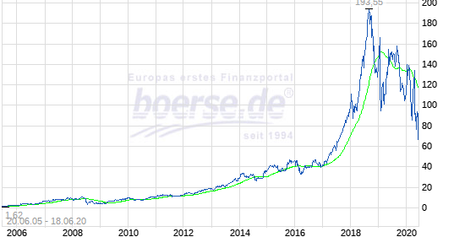

Wirecard – the “German Enron” & a very personal history 2008-2020
For those who just came back from a 15 year space mission: Wirecard is a German company that according to its website is ” one of the world’s fastest-growing digital platforms for fina…
valueandopportunity.com
See Meinolf Heptner's other Tweets
Twitter Ads info and privacy
Reply
- searching4value
19. June 2020 10:07
Sadly, it also destroys the possibility of a German champion with a more future oriented business model…
Reply
- Uh?
19. June 2020 09:29
What is your view of the future of regulatory policing in the age of anonymous internet forums? Some say that a reddit forum called wallstreetbets is getting away with murder.
Reply
  - memyselfandi007
19. June 2020 09:37
I think the focus in Germany should be currently on actually policing regulated financial entities. Once they can do that, they can start policing anything else.
Reply

- friendlyfollower
19. June 2020 09:27
A dear friend and I have a date for watching the Wirecard movie when/if it comes out so I 100% concur with you punchline as well as the rest of the article. However, as much as I am tempted to say “I told you so” to everyone who I told so, I am saddened to see what this will do to the reputation of the German stock market and the (uneducated) public opinion of stocks.
I will enjoy this story unraveling nonetheless!
Reply
  - memyselfandi007
19. June 2020 09:39
The upside is that maybe this whole affair creates the right consequences also with regard to German capital market law etc.
Germany’s stock market regulation is pretty substandard in my opinion anyway. No one gets ever convicted for insider trading etc. etc.
Reply

- memyselfandi007
19. June 2020 09:01
Bernie ähh Markus Braun with a Video Statement from last night: The poor guys have been defrauded themselves !!!
Amazing plan B after E&Y folded.

Reply
  - benny
19. June 2020 12:50
Jetzt haut er ab:
https://www.comdirect.de/inf/aktien/detail/news_detail.html?NEWS_CATEGORY=EWF&NEWS_HASH=1e1cee3ab565a927a16fa94a690234c883e3221&OFFSET=0&SEARCH_VALUE=DE0007472060&ID_NEWS=979331776&ID_NOTATION=12992081
Reply

- memyselfandi007
19. June 2020 08:58
A Twitter thread on Wirecard winners& losers:

Donut Shorts@DonutShorts
Thread:
1/The reality of the Wirecard $WDI fraud is now unavoidably obvious for even the most blinkered of observers.
There are profound lessons that should emanate from the $WDI story
But first, let’s call out the winners and losers:
1,191
523 people are talking about this
Twitter Ads info and privacy
Reply
- Sander Dassen
19. June 2020 08:48
Thanks for this, nice read
Reply
- friedm
19. June 2020 08:39
Really appreciate this post, thanks for sharing.
Reply
  - Axel
19. June 2020 10:24
Thanks a lot for this article.
Given your experiences with the company I can fully understand that you were hesitant to publish it earlier.
I fully agree with your conclusion that often times the people with the deepest knowledge (ie hedge funds) do have the lowest credibility in the public unfortunately… and therefore those fraudulent companies can sometimes thrive for a long time 
Reply

- Welju Grouv
19. June 2020 08:13
Yes, very good work by you even 12 years ago.
Wirecard has been a favourite of the German media for many years. Regarding Wallstreet Online, I can also confirm that their censorship at least until 2013 (when I deleted my membership) was strange and intransparent.
Reply
- cig
19. June 2020 08:01
Just wow.
And congratulations for resisting the urge to short with such a good case! I was short, with less conviction, for a few weeks circa 2015, and thankfully also quit and put it on the “too hard” pile.
A little anecdote is that there were struggling even with the legit biz: as a small client of their virtual visa card, they lost my KYC data and blocked my account (fortunately with very little on it) until I do KYC again from scratch. I refused and it took months to reach someone who could find my data and fix the problem.
I suspect the details of the implosion will be spectacular.
Reply
- Thomas
19. June 2020 06:59
Amazing Story. Congrats to you and keep up the great Work.
Reply
- behindtheshares
19. June 2020 05:02
Literally epic articel!!
Reply
- searching4value
19. June 2020 02:18
I knew I was reading a very good article as soon as I read the expression ‘bumbsbude’. I dearly hope this German word will be adopted by English language 
But seriously, a very nice article. I agree 100 % to (a) the public does not get the function of short sellers and (b) shorting is risky, since ‘the market can stay irrational longer than…’
Reply
- Robert C Ray
19. June 2020 01:28
‘The Smartest Guys in the Room’ is the book to read about Enron. Like Wirecard (and Tesla,…) it was pumped up by the media and Wall Street. It’s interesting how ordinary employees were willing to participate in the fraud (notably the fake Internet trading room Enron set up to impress visiting Wall Street analysts). Enron executives made the covers of all the financial magazines. The company was billed (by Fortune magazine) as the “most innovative company in the U.S.” Even when warnings came out (in ‘Barron’s ‘ magazine) they were ignored. A quick look at the financials didn’t reveal the problems but had enough red flags so that no one should have bought the stock (with a 10 % ROE) at something like 4 times book value.
Almost all reporters (even many at the WSJ) and most financial analysts are unable to read and understand company reports, or to analyze them.
An excellent job on your part.
Reply
- Chris K
19. June 2020 01:04
Thanks for sharing this. Very interesting indeed. Great conclusions as well.
Have been skeptically following wirecard for roughly the same time.
“the reporting remained opaque and they never really explained how they make their money.”
This is it. Warren Buffett’s wisdom comes to mind: Only buy things you understand.
Shocking that they got W:O to ban you. But, as you probably read, they’ve also hired indian hackers to go after people that write negatively about them – so consider yourself lucky.
Reply
- Caute
19. June 2020 00:58
Thanks for sharing your amazing personal story!
Looks like DWS partly managed to dodge the bullet selling at least 60% before the collapse. Still bad though!
https://www.wiwo.de/unternehmen/banken/wirecard-dws-prueft-rechtliche-schritte/25930146.html
Reply
  - memyselfandi007
19. June 2020 07:57
I guess the internal pressure got too big after the KPMG report. Still a big scandal in my opinion for DWS.
Reply
    - benny
19. June 2020 10:56
Shortseller hat 2% augestockt. DWS hat 40% von 2,5% verkauft. DAX-Anteil hat sich deutlich verringert ==> BlackRock muss bei den ETFs anpassen. Könnte auch zu einer netten Überreaktion führen. V.a. wenn die FCFs werthaltig sind. 97% des Umsatzes wurden ja testiert.
Reply
      - memyselfandi007
19. June 2020 11:35
Es gibt kein cash und kein fcfs. Und blackrock muss aktuell gar nichts anpassen. Und der Wert des Testats ist analog der aktie gleich Null. Bis dahin kann gezockt werden.
      - benny
19. June 2020 11:54
Ich bin gespannt Die Frau in dem CEO-Video sah jedenfalls nicht gerade entspannt aus. Jetzt jedenfalls bei 19 Euro. 2400 mio für 600-700 mio FCF (falls es einen gibt). Am besten gefällt mir immer noch der Unterschied NetCash und langfristiger NetCash.

- Dave
19. June 2020 00:54
Congrats mmi and thanks for sharing. Unbelievable.
Reply

LEAVE A REPLY

